Creating The Jabberwocky Animation

Introduction
In this report, I will write about how I personally contributed to the 3D animation project, that was created based upon the animatic that was made in the previous course titled, Jabberwocky. I will explain how I created the models for the characters and environments, camera animations and previz renderings for the animation project.

Modelling and Sculpting
In this section of the report, I will explain how I modelled the characters and environments that were used in the animation project.
When the animation project began, we discussed and agreed that we would make the animation using low poly models, this is because it would allow us to get the scenes, objects, characters, animation etc. done at a much faster pace, then if we had available time, we would be able to replace the low poly models with higher versions later on, this previz stage, would also allow us to plan the shots out with continuous refinement until we were satisfied.

Beginning the model
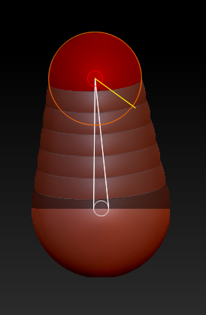
One of the various models that I had created was a tree model, I had different approaches when it came to modelling the Bandersnatch and wolf. However, with one of the tree variants that were in the scenes, I used Zshpere’s in combination with unified skin, to essentially sculpt the tree.
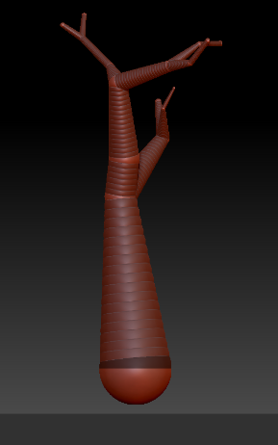
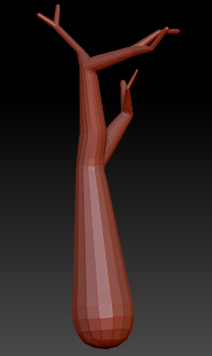
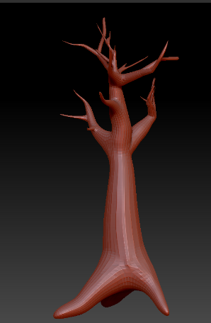
The images above show the Zshperes progress in action, I moved and created Zshperes into the basic shape of a tree, I then used unified skin to make it into an individual polymesh, I then used the sakehook tool to modify the object, as well as the move tool.
With the wolf model I used basic poly shapes to make a low poly 3D previz model, however, with the Bandersnatch I used Zbrush to sculpt the model, I tried using just Autodesk Maya, but nothing I created looked anything close to organic, so I relied on my abilities and knowledge with Zbrush to create the Bandersnatch model. You can see the process below (note create process below)

Unlike the trees I modelled, I forwent the use of Zshperes and used guides instead from I quick rig that was created through Human IK, by placing small spheres in top of the bone joints and using GoZ, I was able to create a guide that I could base the mesh I would create on, I only needed to delete the guides when it came to rigging the character up.
I built the character into different sections, legs, feet, torso, arms neck head etc. and merged then all at the end with a dynamesh and zremesher to clean the geometry a bit.
At the end of the sculpting and modelling, all 3D objects, went through the Zremesher in order to cut on the number of polygons used, as well as to tidy up the model as my knowledge on manual poly clean-up is very limited.
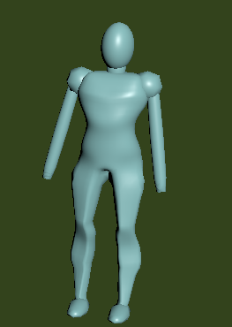
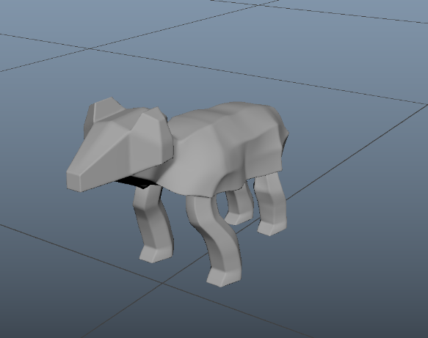

Animating the scenes
In this section of the report, I will explain how I animated the objects in the animation project.
The team, agreed to split the work load, into sections, Karol and I decided to work together to create half the animation whilst, Teigan and Kierra worked on the latter half, however me and Karol decided to further cut the work load, by doing half each, however we still worked together, sharing assets, giving feedback to each other etc.
I worked on 4 scenes in the Jabberwocky animation, these were: Scene 3, in this scene I worked upon the camera animations, using a combination of stepped and curved animation types in the animation graph editor. Scene 9, in this scene I worked on the camera animations and minor character animation clean up. Scene 5, in this scene I worked on everything in the scene and finally scene 10, in this scene I again worked on everything in the scene.
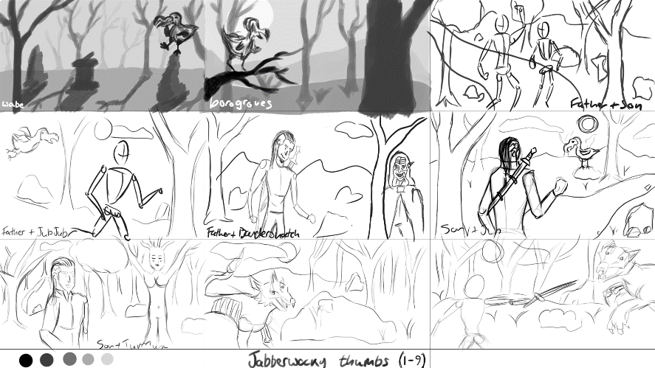
The image to the left, is part of the animatic that was created for the first assignment.

Animating the camera
In this section of the report I will explain how I animated the camera for the Jabberwocky animation.
The first thing I did after setting the scene and adding additional animations to the characters that are used for the animation, I added a camera. I really like how the camera system within Autodesk Maya preforms, over other software such as, Blender 3D, where the camera is separate from the viewport, in Autodesk Maya the camera is the viewport, regardless of which camera is currently selected, so I can use the navigational controls instead of like Blender where I have to manually manipulate the camera as if it were an object.
I created a key-frame for the beginning shot, and I moved the camera to where I wanted the camera to end up and added another key-frame and allowed Autodesk Maya to create the in-betweening for me. I tweaked the speed, control etc. of the camera with the animation editor, switching between linear and stepped, as well as implementing both so that I could have a fluid camera animation as one point and a stepped animation on another, this allows me to skip out on a lot of editing that would later be used, instead of animating 2 cameras and switching between then in Adobe Premiere or After Effects I could do it in Maya and skip on a lot of time that would be used in a timeline editor.
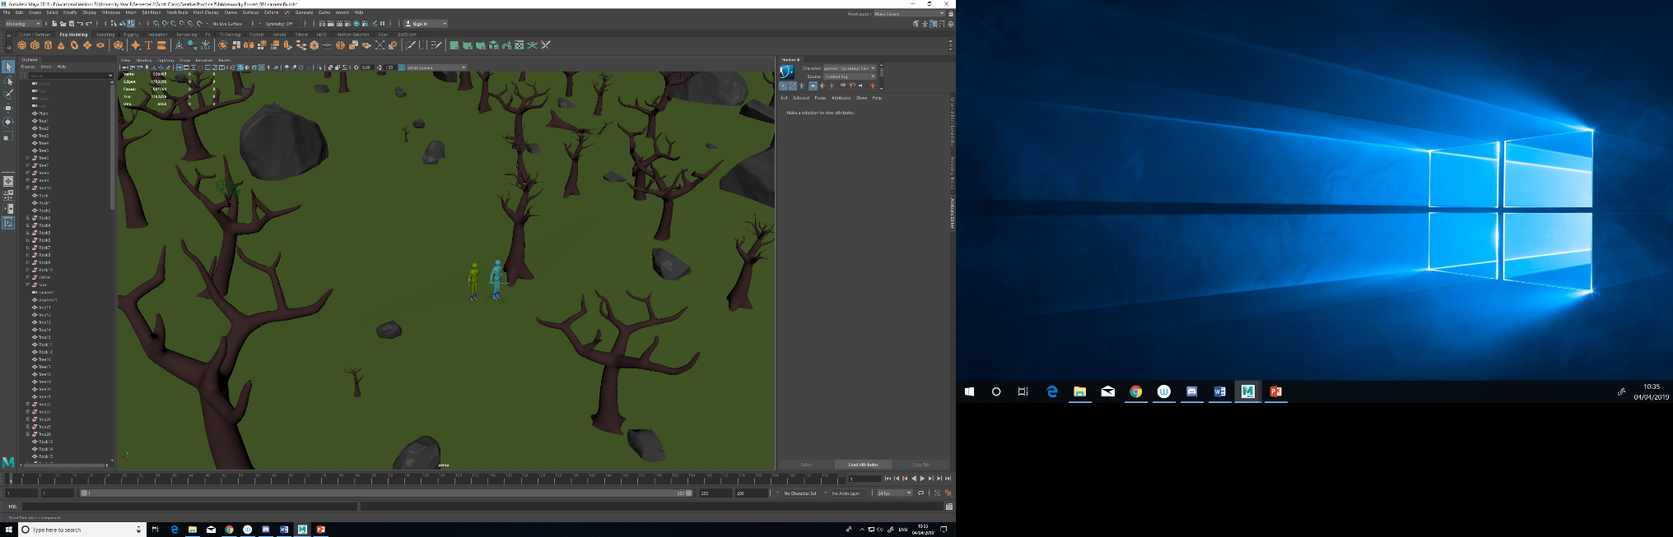
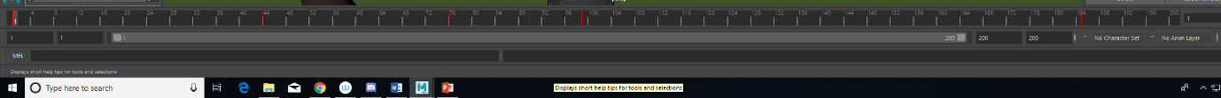
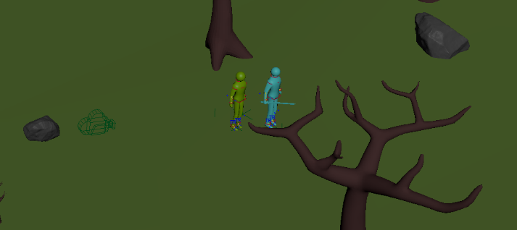
The images above so the camera movement.

Conclusion
In this section of the report, I will give my personal conclusion for the animation project that we created, I will explain my thoughts on the matter as well as explaining what I think could be improved should we hypothetically recreate this animation.

In conclusion the 3D animation that we created for this course went decent, we only managed to get to the previz stage, however we created some pretty decent camera movements, as well as dome basic character animations for the project.
I believe there is a great deal of things that could be improved for the next time, an attempt like this is created, for one, we seemingly had a schedule, however none of us seemed to stick to it, which resulted in scenes that were meant to be done, earlier being missed.
Another thing that could be improved is out teamwork, which was lacking the further we went into this, it became difficult to know what part to do, or what was done, because of this.
References
(accessed 02/04/2019) October 9th 2016, ARTV_Tutorials https://www.youtube.com/watch?v=xzmg0grXHyE
(accessed 02/04/2019) February 6th, 2018, Alessio Merlo 3D https://www.youtube.com/watch?v=oNWIKACJ-5k

