Student name: Tanjila Haque
Student ID: 2210226
Module Number:5003
Course Name: International Hotel Management
Lecturer name: Haidi Prosser
Assignment title: Intercultural Competence

Summary:
This report will highlight Spain cultural and social activities. Why employee should have knowledge about Spain cultural activities. The different between Uk and Spain culture and lifestyle. Staff awareness to avoid cultural misunderstanding in the workplace. Why staff at the hotel should be aware of Spanish festivals and other activities. The importance of cultural intelligence and sensitivity in leadership. What are the benefits in the hotel industry and how leadership skills will affect the business. This report will also reflect the Spain population time keeping compared to Uk, how they are greeting unknown for the first time. Staff at the hotel should have good communication skills to understand the culture and communicate with customers.

Contant table:

1.0. Introduction.........................................................................................................................1
2.0. Spain culture …...................................................................................................................1
3.0. The importance of cultural intelligence and Sensitivity in Leadership.......................2
3.1. What is cultural intelligence.......................................................................................2
3.2. Cultures within organization.....................................................................................2
4.0. Cultural intelligence is important to leadership in an organization ….......................3 5.0. Spain cultures and social practice...................................................................................3
5.1. Naming tradition.......................................................................................................3
5.2. Split the bills and tipping........................................................................................3
5.3. Daily life in Spain....................................................................................................4
5.4. Greeting ….............................................................................................................4
5.5. Being Late & Taking Time...................................................................................4
6.0. Conclusion...........................................................................................................................4
7.0. Recommendation................................................................................................................5
8.0. Reference …........................................................................................................................6

1.0. Introduction:
This report will discuss about the Diversity Hotel & Spa Spain, which is 5 stars Uk based company. Diversity Hotel & Spa London recently expanded in Spain. This report will highlight about the Spain cultural difference, customs, and behavior compared to England. In Spain Catholicism is the main religion. The official language is Castilian (Spanish). Spain whether is different than England warmer in the summer. Spain cultural and social activities are more relax then UK there for employee at the hotel should have good understanding of the consumer. Spain population are more relax, they take time for their friends and family no rushing, goes as it comes.

2.0. Spain culture:
Spain is rich in cultural heritage. A huge religious festival before Easter is Holy week or Semana Santa. Spain has vibrant and warm culture; population are passionate and loving. They priorities family time to enjoy company with their loved ones as well over food. They take things slowly to enjoy life. They are proud of their artistic, historic, and cultural heritage, they do not hold back to celebrate their festivals (Shreya,2019). In Uk lifestyle are different compared to Spain. UK populations are busier, they make Schedule to have family times and plans everything advance to fit their busy lifestyle (Bailey,2019).

p/1

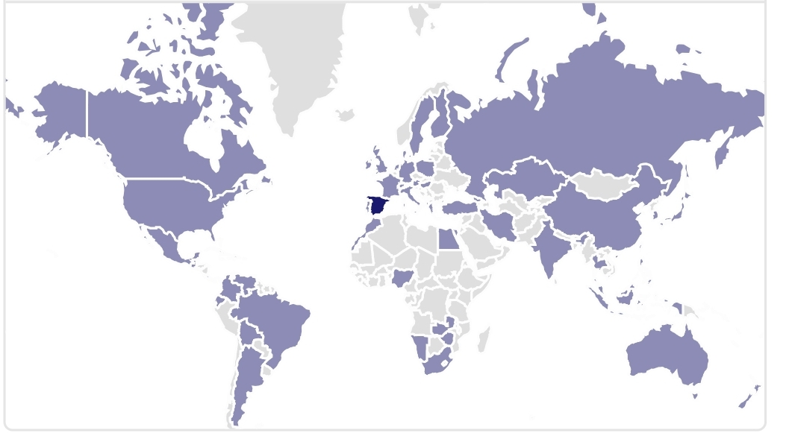
Above images are showing Spain in the Globe project, (Globe,2020). Spain is highlighted with dark in the map.
3.0. The importance of cultural intelligence and Sensitivity in Leadership:
To drive the organization leaders need acknowledge about the cultural awareness. Leadership is more digital and global than before. At the workplace cultural intelligence always been important but nowadays framework become progressively global (Walker,2022a).
3.1. What is cultural Intelligence:
Work effectively across culture at work, simply connect and relate with cultures. It contributes to better understanding, communication, and effective leadership. A great leadership can manage the business wonderfully as well as increase the sales.
3.2. Cultures within organization:
In the organization there are also multiple cultures. For example, every department of the organization’ often has their own ways of working and communicating and interacts with their own cultures or silos ‘(Walker,2022b).
p/2
4.0. Cultural intelligence is important to leadership in an organization:
According to, (Martins,2022) Leader must have knowledge and good communication skills to organize the workplace and teach other employees.
1. Better communication and Flow of information.
2. Stronger interpersonal relationship.
3. Culturally sensitive leaders make better managers.
4. Targeting top talent in a competitive Marketplace.
5. Global success.
5.0. Spain cultures and social practice:
‘’Spanish culture has contributed powerfully to the evolution of the Spanish language’’, state on (Godoy,2021). Spanish language is the popular language around the world. To understand the Spanish culture, it is important to understand the Spanish language. Spain has five famous cultural activities those are San Juan (Saint John's Day), Carnival, Semana Santa (Holy Week), Las Fallas Valencia and La Tomatina, information based on (Travel &Culture,2021).
5.1. Naming tradition:
In Uk people usually addressed first name and surname but in Spaniards have two surname, father surname uses first, and mother surname use as second. Women in Spain does not change their surnames after marriage (Aaron,2011).
5.2. Split the bills and tipping:
Usually, the person who is hosting the event will pay the bills. It is quite rude to haggle over the bills in Spanish culture. People who want to pay can pay next time by hosting an event. In the UK it is quite common for guests to pay their won bills at the restaurant even though they are being invited to attend a party. Tipping is not common in Spain but in the Uk, it is quite common.
p/3
5.3. Daily life in Spain:
Spanish people have light breakfast then mid-morning snack, most people have lunch at 1:30 p.m. and lunch break usually one to two hours long. However, lunch having at 3pm is common because lunch is their main meal. Having a long break at lunch time is an idea of siesta (GoinGlobal,2023). But in small cities siesta will last three hours and no shops will open till Five. Dinner around 9pm is also common in Sapin. Uk population quite different then Spain daily life. In England dinner is the main meal, usually around 6:30 pm.
5.4. Greeting:
Spanish people greet each other with light kisses for the first timer, by touching right cheeks then left with the other person and makes the kissing sound. Women gives other women checks kiss, but man usually do not give other man kiss (Evason,2018). In the UK people shake hands when they are greeting new people.
5.5. Being Late & Taking Time:
As in British culture punctuality is essential and late is unacceptable. In Spain being late 5 to 10 minutes means its ok. The Spanish culture is more relax, is all about taking life as it comes. Spaniards take time when they see their friends or family no matter the event (Travel Pedia,2023).

6.0. Conclusion:
The information above makes clear that working in a hospitality industry staff should have cultural awareness and sensibility about other cultures. Each country has different cultural beliefs and social activities. There for staff at the hotel should have knowledge about the Spain to serve the customer best. As the diversity hotel extended in Spain, employee should be aware of, do not compare cultural and social activities with England. Both countries have different beliefs and styles.

p/4
7.0. Recommendation:
Diversity Hotel & Spa London based in Uk and extending in Spain there for, lot of activities will be different then Uk. Staff should be trained and acknowledged before they start their first shift. Employee should remember do not compare with Uk culture. Spain has its own culture and staff should be carry on with their way. Employee should also be aware of the time keeping in Spain is not strict as Uk. Managers of the hotel have responsibilities to train the staff about the cultural awareness and social activities, promote them to learn about the culture and communication skills for batter performance. The manager should also make sure staff at the hotel are comfortable and not hesitate to inform HR of any issues at the hotel.

p/5

Reference:
GLOBE, (2020)’ Global Leadership and Organizational Behavior Effectiveness.’. Available at:https://globeproject.com/about#globe2020_cci last accessed:09/11/2023.
Travel Pedia, (2023)’ Is it common to be late in Spain’ available at:https://lovethemaldives.com/faq/is-it-common-to-be-late-in-spain last accessed:09/11/2023.
Nina. E,(2018) Spanish culture., Greetings. available at:https://culturalatlas.sbs.com.au/spanish-culture/spanish-culture-greetings last accessed 09/11/2023.
GoinGlobal ,(2023) Daily Life [Blog]. available at:https://www.goinglobal.com/career-guides/spain/daily-life last accessed:09/11/2023.
Aron, (2011)’Spanish Naming Conventions the Basics’MyHeritage [Blog]. available at:https://blog.myheritage.com/2011/07/spanish-naming-conventions-%E2%80%93-part-1-the-basics/ last accessed:09/11/2023.
Travel & Culture, (2021) Top 5 cultural festivals in Spain. available at:https://www.workingabroad.com/blog/top-5-cultural-festivals-in-spain/ last accessed:09/11/2023.
Sofia. G,(2021)’A Brief Introduction to Spain culture, Tradition, and Beliefs ’Spanish academy . available at:https://www.spanish.academy/blog/a-brief-introduction-to-spanish-culture-traditions-and-beliefs/ last accessed:09/11/2023.
Julia. M,(2022)’ Building Cultural Intelligence makes you a better manager’. available at.https://asana.com/resources/cultural-intelligence last accessed:09/11/2023.
Ruby. R.W, (2022 ,a.b)’ The importance of cultural intelligence and sensitivity in leadership’ ,Brainz . available at:https://www.brainzmagazine.com/post/the-importance-of-cultural-intelligence-and-sensitivity-in-leadership last accessed:09/11/2023.
Grant. B,(2019)’ millions of Brits feel’ Overwhelmed’ By life pressure, study finds'. Independant. Available at:https://www.independent.co.uk/life-style/stress-work-pressures-busy-social-calenders-financial-worries-survey-a8167446.html last accessed 09/11/2023.
Shreya,(2019)’Expat guide to Spanish culture and traditions’, housing anywhere. available at:https://housinganywhere.com/Spain/spanish-culture-and-traditions last accessed:09/11/2023.
p/6

