
MBA – Master of Business Administration
Marketing Management
LCMB7001

Assessment – 2

Student Name: Aswathy Vadakkedath Appu
Student ID: 2217024

Table of Contents
1. Introduction 3
2. A Brief Glance to the History of Adidas 3
3. Macro Environmental Factors Affecting Adidas 3
3.1. Political Factors Affecting Adidas 3
3.2. Economic Factors Affecting Adidas 4
3.3. Social Factors Affecting Adidas 5
3.4. Technological Factors Affecting Adidas 5
3.5. Legal Factors Affecting Adidas 6
3.6. Environmental Factors Affecting Adidas 6
4. Micro Environment Factors Affecting Adidas 7
5. Porters Five Forces Model of Adidas 7
6. Conclusions and Future Recommendations 10
List of References 11
Appendix 13

1. Introduction
The analysis of the macro as well as micro environmental factors that affect the marketing of adidas has been discussed in detail in this study.

2. A Brief Glance to the History of Adidas
Adidas AG is a company that makes and sells athletic footwear, apparel, and accessories. Its product lines include of Adidas, Reebok, and TaylorMade-Adidas Golf, among others. Adolf Dassler established the corporation in 1920, and maintains its headquarters in Herzogenaurach at that time.When asked what they want to achieve, Adidas says "to dominate the sporting goods market worldwide with brands that reflect an enthusiastic commitment to the sporty way of life. Our brands and goods will continue to be fortified in an effort to raise our competitive standing." (Adidas, 2021).

3. Macro Environmental Factors Affecting Adidas
Being a recognised name on a worldwide scale may bring with it a number of complications, from political to cultural in nature. To succeed in today's interconnected world, businesses must navigate a complex set of challenges. The PESTLE study delves into some of the most important factors that might affect the adidas operation's surroundings. (PESTLE analysis of Adidas, 2021).

3.1. Political Factors Affecting Adidas
- Tariffs on Imports and Exports Under the Trump Administration- The fact that Adidas is a German multinational firm has nothing to do with the dispute between the United States and China. It's no secret that the United States is Adidas's largest market for sportswear. The Trump administration's nationalist policies reflect the views of its leadership. The Trump administration levied tariffs on almost all imports from China. Adidas has factories in China where it makes its wares. In the eyes of the average American, a product that was manufactured in China and exported to the United States is of Chinese origin. This results in hefty tax bills for the company. (Bromiley et al., 2021).
- Code of Conduct for the Supply Chain- Because of its international reach, Adidas must ship its goods across national boundaries. When it comes to international commerce and supply chains, each country has its own set of rules and regulations. The company's bottom line would take a serious hit if the intricacy of the supply chain system wasn't resolved. (Mansaray et al., 2021).
- Laws of the Government- The rules imposed by various countries vary. Terrorism, nationalism, patriotism, poor acceptability, tight social structure, and fanaticism all play significant roles. These indicators reveal much about a country's security and business climate. There is no room for foreigners in a tight, patriotic society. (Seta et al., 2021)

3.2. Economic Factors Affecting Adidas
- Contagious Pandemic Economic Decline- The global economy has entered a recession due to the widespread impact of the covid-19 outbreak and the subsequent closure of enterprises throughout the globe. As 2020 winds down and 2021 begins, companies are still operating below their potential. Adidas is a financially secure brand, but it has seen a significant drop in yearly sales and net income in recent years. As of 2020, the company's yearly sales were down around 12.83%, while net profit was down about 75.31%. (Aquidawatiet al., 2020).

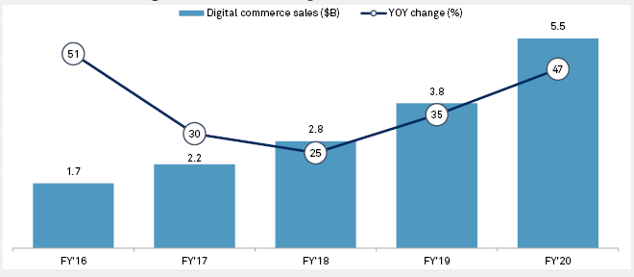
Figure 1 Digital Commerce Performance of Adidas (Aqidawati et al., 2020).
- Rate of Exchange- As a German company, Adidas does business in Euros across Europe. All transactions between the company's Asian suppliers and the global market are conducted in US dollars. As a matter of fact, it occurs often. Even for businesses, dealing with fluctuating exchange rates is a daily occurrence. Exchange rate fluctuations are caused by economic downturns and other factors such as pandemics. A seemingly little shift in exchange rates between the US dollar and the Euro may have a profound effect when multiplied by millions. (Bromiley et al., 2021).
- Matters of The Local Economy- Adidas, a popular sportswear manufacturer, has branches all around the world. Many economic indicators, such as interest and inflation rates, as well as unemployment rates, vary from one country to the next. As a result of falling sales, the corporation is making less dollars. This has been the case for the last several months of the epidemic. (Singhvi et al., 2021).

3.3. Social Factors Affecting Adidas
- Satisfaction of The Health-Conscious Buyer- In recent years, there has been a growing awareness of the value of health and fitness pursuits. Golf, the gym, jogging, and other exercise groups are popular examples of health and fitness organisations that individuals join today. As a result of the pandemic and subsequent lockdown, many individuals have been forced to stay inside their homes. As soon as everything is back to normal, they want to begin doing things outside again. (Singhvi et al., 2021).
- Social Services for the Community- The communities and people in which Adidas operates are important to the company. The corporation itself has initiated several community service projects to improve people's well-being. (Mosca, 2016).
- Financial Support for the Olympics- Adidas uses its sponsorship of international sporting events to get widespread exposure among sports lovers. The company reportedly invested over 100 million pounds in the 2012 Summer Olympics. The investment paid off handsomely for the firm. As a consequence, the company saw an increase in sales of its product. (Mahdi et al., 2015).

3.4. Technological Factors Affecting Adidas
- Transforming in Form to Accommodate Modern Technology- In today's fast-paced R&D environment, businesses often have to introduce new products every three months or so. The competition would gain an advantage if they didn't. They'll slowly but surely steal all of the market share out from under them. To maintain competitiveness in today's economy, businesses must quickly adapt to emerging technologies. One of the reasons for Adidas' success is the company's willingness to adopt new technologies. (Kull et al., 2016).
- Raw Material for Intelligent Devices- There are a lot of scientists trying to perfect the tech raw material. The sportswear industry might recycle the material by melting it and using it again and again. The new synthetic material would be a tremendous boon for Adidas if they can figure out how to create it. (Lynch, 2018).
- Mobile E-Commerce Application- Since the pandemic and subsequent closure of companies, consumers have come to appreciate the value of e-commerce sites and web stores. Adidas has an established online store. It's not at the same level as major competitors like Nike, Amazon, or Walmart. This is a chance that the corporation should seize. (

3.5. Legal Factors Affecting Adidas
- Brand Image Determination- The company's trademark and emblem, which has three parallel stripes, were challenged in court and found to be invalid by the General Court of the European Union. The corporation could not prove to the court that its trademark three stripes emblem is well-known among its clientele. For the business, its importance was immense. Brand counterfeiting on the global market has increased after the trademark was abandoned. (Ansary et al., 2018).
- Autonomous Rights to a Patent- There is an IP system in place, and Adidas owns the intellectual property rights. For the business, this means less worry about knockoffs, copied designs, and intellectual property violations. In the sportswear sector, counterfeiting is widespread. The corporation is protected by patents and the law, reducing the likelihood of loss. (Seta et al., 2021).
- Endorsing Activities and Personalities- The sportswear company Adidas has a history of using high-profile people to promote its goods. Millions of people will join a cause or group if a famous person or admirer of that person is involved.

3.6. Environmental Factors Affecting Adidas
- Plans for Minimal Waste-According to Adidas, none of its factories ever generate anything illegal or harmful to the environment. FutureCraft Loop, Parley for the Oceans, Adidas Formation Technology, Dyeing Processes, Biosteel Fiber, and Sports Infinity are just a few of the zero-waste initiatives the firm has implemented. All of these initiatives work toward the same goal of switching to oil-based plastic, which helps cut down on carbon emissions and results in a more compact and effective end result.
Standard & Poor's (S&P) has provided Adidas with a very favourable ESG (environmental, social, and governance) review, awarding the company a score of 85/100. Of the 27 organisations with public ESG profiles, it is the latest to do so and the only one in the sports sector. (in appendix).

4. Micro Environment Factors Affecting Adidas
Analysis of strengths, weaknesses, opportunities, and threats (SWOT) provides insight into Adidas' top priorities for growth. The company's long-term objective is to dominate its industry on a global scale. (Mahdi et al., 2015).

Figure 2 SWOT Analysis of Adidas (Created by author).
The Adidas SWOT analysis reveals that the company has to invest more heavily in R&D and move some of its manufacturing operations overseas if it wants to maintain its present position as the market leader in sporting clothing. To get there, Adidas has to include these concerns into its SWOT analysis as part of its strategic planning process. (Lynch, 2018).

5. Porters Five Forces Model of Adidas
Michael Porter's Five Forces Model was created with the intention of assisting company owners in creating a solid business strategy via the analysis of external factors. This is why the Porter's Five Forces Analysis is so effective. (Porter, 2008). The following table 1 summarizes the porter’s Five Forces Model for Adidas.

Table 1 Porter’s Five Forces Model of Adidas (created by author).
Competitive Rivalry | Asics, Nike, Puma, and New Balance are some of Adidas's primary rivals in the athletic shoe industry. To put it in perspective, Nike and Under Armour, who together control 62% of the US Sports Footwear market, are the company's key rivals in the footwear sector.
Bargaining Power of Suppliers | Adidas' vendors produce their wares in Asia. The firm is now paying more for its raw materials, which makes it tough to keep expenses down while still generating enough profits. For instance, Adidas produces 70% of its own shoes, making the company vertically integrated.
Bargaining Power of Buyers | Adidas primarily sells to mass merchandisers, niche businesses, and consumers directly. Despite the growth of internet shopping, 58 percent of Adidas' overall income still comes from traditional storefronts. Adidas goods also get considerable exposure at several major sporting events. Due to the infrequency of these occurrences, they have little effect on day-to-day life. However, it does boost brand awareness, which may result in more loyal customers for businesses that have contributed to the growth of certain sports.
Threat of New Entrants | Because of how important a reliable distribution network and widespread familiarity with the Adidas brand are to its success, these factors prevent Adidas from competing with newcomers. If Adidas doesn't adapt to changing consumer preferences, it might lose ground to rivals. One example is Nike, which has found more success by expanding beyond its initial sportswear and equipment emphasis into the broader lifestyle market.
Threat of Substitutes | When it comes to sportswear, not all labels or even manufacturers are created equal. As an example, Adidas shoes aren't universally interchangeable with Puma or Asics footwear. The same holds true for many types of sports footwear, such as soccer cleats and running shoes.

The data suggests that Adidas has had a favourable market correlation, as the brand is presently seeing rising demand, making it simple to sell items and generating net income. Adidas has a leg up on the competition because to the durability of its brand name, the originality of its designs, and the cheap cost of its manufacturing, all of which contribute to the company's high profit margin

Porters Five Forces Analysis
SWOT and PESTLE Analysis


Figure 3 Overall Results of the Analysis (Created by author).
The aforementioned figure 3 outlines the overall results of analysis conducted by the author.

6. Conclusions and Future Recommendations
Sportswear has many of the same development challenges as other businesses, including b2b trading, supply chain simplification, and security issues. Adidas prioritises innovation in operations, services, and products to address market challenges. Adidas' e-commerce net sales come from numerous product categories. E-commerce encompasses online purchasing and selling as well as any follow-up services, negotiations, marketing, or delivery of digital or physical items. Adidas employs user and benefit-based positioning to win customer loyalty. This recognises product quality when the firm has maintained brand integrity. Adidas AG's emphasis on eco-friendly materials and online sales could boost income. E-low commerce's search, menu, dynamic pricing, and transactional expenses help businesses compete in today's traditional markets.
Adidas is criticised for supporting low wages in underdeveloped countries. They won't slow it down since it saves raw materials. Another problem is counterfeit Adidas products. Adidas' design patents prevent the sale of copies. They want health-conscious customers. They change their appearance to remain current. Adidas will explore new sectors as more people use fitness-focused smart technologies. Federal, state, and local laws are followed.
Adidas's SWOT analysis reveals that the company has to invest more heavily in R&D and move some of its manufacturing operations overseas if it wants to maintain its present position as the market leader in athletic clothing.
- The business has to pay attention to both cost management and increasing consumer involvement.
- Increased market share in Asia is crucial to the company's long-term success.
- Therefore, Adidas should limit its reliance on outsourcing and instead manufacture its products in-house to avoid potential negotiating and financial headaches.

List of References
- Adidas, https://www.adidas.com/us/best_sellers?grid=true. Accessed 2nd January, 2023.
- Ansary, A., and Nik Hashim, N. M. H., 2018, Brand image and equity: the mediating role of brand equity drivers and moderating effects of product type and word of mouth, Review of Managerial Science, vol.12, no. 4, pp. 9691002.
- Aqidawati, E Wahyudi S, and Eko P, 2020, Lesson Learned in Developing and Implementing Business Strategy to Commercialize Battery Swap Technology: A Comparative Study, Proceedings of the 5th NA International Conference on Industrial Engineering and Operations Management Detroit, Michigan, USA, August 10 – 14.
- Arga Seta A.S., Wahyudi Sutopo, and Muhammad Hisjam, 2021, Lessons Learned in Developing and Implementing a Business Strategy in Outdoor Gear Companies: A Comparative Study, Proceedings of the Second Asia Pacific International Conference on Industrial Engineering and Operations Management, Surakarta, Indonesia, September 14 - 16
- Bromiley, P., and Rau, D., 2016, Operations management and the resource-based view: Another view, Journal of Operations Management, vol.41, pp. 95–106.
- ESG Evaluation Adidas AG, 2022, https://www.spglobal.com/ratings/en/research/pdf-articles/211104-esg-evaluation-adidas-ag-100674163, Accessed on 2nd January, 2023.
- Kull, A. J., Mena, J. A., and Korschun, D., 2016, A resource-based view of stakeholder marketing, Journal of Business Research, vol.69, no. 12, pp. 5553–5560.
- Lynch, R., Strategic Management 8th New edition, 2018, London: Pearson Education, ISBN: 978-1292211404,
- Mahdi, H. A. A., Abbas, M., Mazar, T. I., George, S., and Professor, A., 2015, A Comparative Analysis of Strategies and Business Models of Nike, Inc. and Adidas Group with special reference to Competitive Advantage in the context of a Dynamic and Competitive Environment, International Journal of Business Management and Economic Research (IJBMER), vol.6, no. 3, pp. 167–177.
- Mansaray, D, Wahyudi S, and Muhammad H, 2021, Consumers’ Perception on Quality Service Delivery of Two Major Telecommunication Companies in Sierra Leone: A Comparative Study, Proceedings of the Second Asia Pacific International Conference on Industrial Engineering and Operations Management, Surakarta, Indonesia, September 14 - 16,.
- Mosca, M., 2016, Industrial organization, Handbook on the History of Economic Analysis, 3rd Edition, pp. 291–304,
- PESTLE analysis of Adidas. http://pestleanalysis.com/pestle-analysis-adidas. Accessed 2nd January 2023
- Porter, M. E. 2008, The five competitive forces that shape strategy. Harvard business review, 86(1), 78.
- Singhvi, V., and Srivastava, P., 2020, Comparative assessment of consumer perception on sports brands using data mined from online communities, In Communications in Computer and Information Science: Vol. 1192 CCIS. Springer Singapore,

Appendix
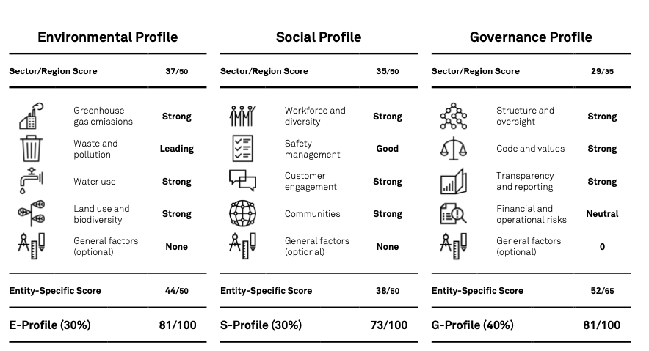
Figure 4 ESG Rating of Adidas (SP Global, 2021)

