Assignment 1 – Mock Interview
Module code and name : LCLM4005 Employability and Career Development

Lecturer: Dr Lizeta Demetriou

Job Description: Amazon – Security & Loss Prevention Specialist.
Our operations network, known for our speed, accuracy, and exceptional service, delivers millions of packages and smiles to Amazon customers every day. To keep our operations network secure and assure operational continuity, we are looking for hands-on and detail-oriented professionals who want to join our team as Loss Prevention Specialists.
In this key role, you will deliver security as a service to our operational sites across the end-to-end supply chain to protect our people and prevent loss.
Key job responsibilities
• Support resilience of our business operations by contributing to emergency and crisis planning for sites within your area of responsibility
• Contribute to the identification of vulnerabilities (e.g., loss, associate experience, process improvement) and define appropriate mitigating actions while ensuring compliance with legal and ethical standards
• Serve as point of contact for and coordinate measures to manage risk with local management and external parties (e.g., law enforcement agencies and industry associations) on all security-related matters
• Ensure compliance of your assigned sites with Amazon global security standards
A day in the life
As a Loss Prevention Specialist, you will join a team of Security and Loss Prevention professionals providing security as a service to business customers across multiple business units within a dedicated geographical area. You perform regular physical security audits and investigate policy violations, security-related incidents, and loss events. During your investigations, you collect information by monitoring systems and tools, analysing data reports, and conducting interviews.
Your findings help to identify vulnerabilities in our processes, for which you contribute to the development of mitigating measures. You play a key role in maintaining the physical integrity of our sites by auditing and monitoring the health status of our systems and, jointly with subject matter experts and external suppliers, maintain their functionality.
You interact on a daily basis with our external security service providers to ensure delivery of high-quality security services and a smooth customer experience. You also act as point of contact for multiple internal and external departments (e.g., legal, HR, security service providers, local law enforcement) and subject matter expert in Security and Loss Prevention-related matters.
Finally, you deliver loss prevention-related education and awareness programs to other teams and liaise with various stakeholders on policy and procedure across all management levels.
About the team
Sitting within the World Wide Operations Security organisation, Security and Loss Prevention supports the accomplishment of Amazon´s business targets and the strengthening of our brand by effectively protecting against relevant threats and by managing security and loss prevention risks that could:
• Put our associates and customers under jeopardy
• Disrupt the continuity of our business operations
• Inflict damage to our assets
• Have adverse impact on our brand reputation
Working in partnership with our stakeholders, we secure the Amazon supply chain end-to-end and promote security during business conversations. We do this by preventing security and loss prevention-related risks and vulnerabilities as early as possible, intervening in unfolding incidents to minimize any negative impact as well as thoroughly investigating security-related incidents to identify and remove root causes, preventing reoccurrence.

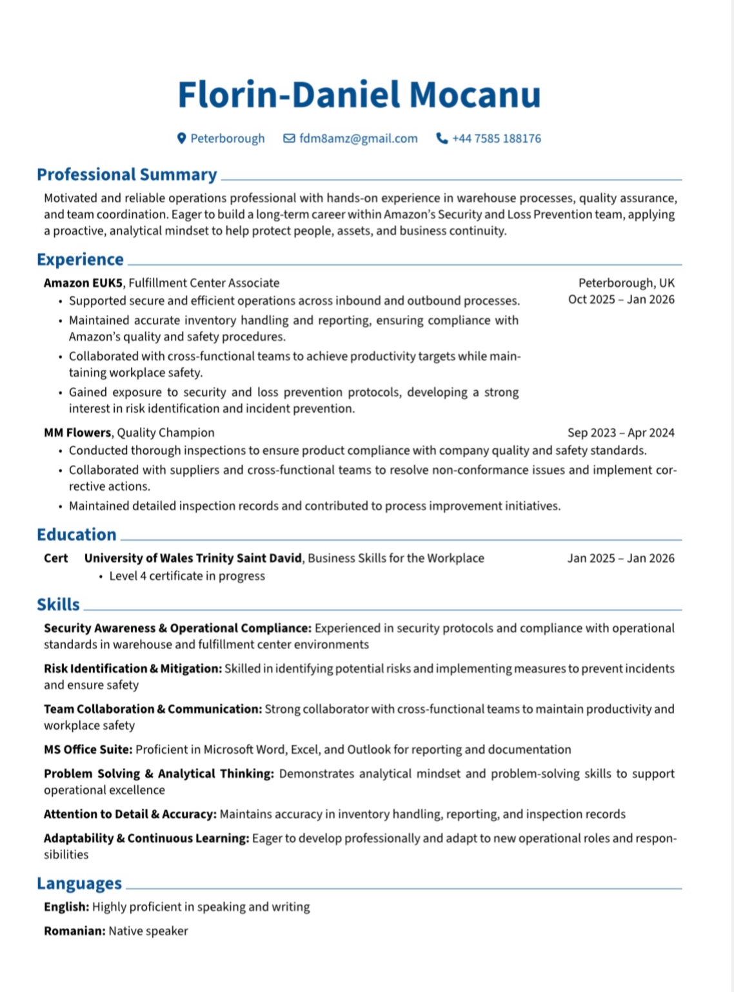
CV

Cover Letter
FLORIN-DANIEL
MOCANU
fdmofficial28@gmail.com
07585188176

Dear Hiring Manager 13 October 2025

Amazon

I am writing to express my interest in the Loss Prevention Specialist position at Amazon. As a dedicated
Fulfillment Center Associate at Amazon EUK5 in Peterborough, I have gained valuable first-hand experience
in warehouse operations, compliance, and safety procedures. I am eager to expand my contribution to the
company by helping protect our people, assets, and operations through proactive loss prevention and security
measures.
Working within Amazon’s fast-paced and safety-focused environment has strengthened my attention to detail,
accountability, and commitment to operational excellence. I have developed a strong understanding of
Amazon’s culture of integrity, efficiency, and respect for safety — values that align perfectly with the Loss
Prevention team’s mission.
Throughout my time at Amazon and in my previous role as a Quality Champion at MM Flowers, I have
consistently demonstrated reliability, teamwork, and a methodical approach to identifying and resolving
issues. I am confident that these skills, along with my proficiency in MS Office, process monitoring, and data-
driven analysis, will enable me to effectively support risk assessment, compliance audits, and incident
reporting as part of the Security and Loss Prevention organization.
I am especially motivated by the opportunity to build a long-term career within Amazon and continue
developing my skills in security and risk management. I take pride in contributing to safe, efficient, and resilient
operations — and would be honored to bring my commitment and enthusiasm to your team.Thank you for considering my application. I look forward to the opportunity to discuss how I can contribute to
maintaining and strengthening Amazon’s world-class standards for security and loss prevention.

Sincerely,
Florin-Daniel Mocanu

