Part 1

Managing Bevaviour and Learner Engagement

The main aims of this paper are threefold: to discuss psychological theories as they relate to behaviour management in post-sixteen education, how those theories are put into practise by teachers, trainers and learning facilitators. And lastly, to reflect on my own teaching practises with regard to managing behaviour in the classroom, and how I can improve them in the future.

Before we begin to look at any of those things however, perhaps we should first look at government guidance and legislation on this subject. The government paper, Developing behaviour management content For initial teacher training (ITT) (Bennett, 2016), outlines the ways that student teachers should be taught behaviour management skills during their training, and emphasises the importance of practical experience when dealing with students who present challenging behaviour in the classroom. It should also be noted that this paper concentrates solely on behaviour management, and does not tie it in with the ways teachers can engage students with the subject being taught and the learning materials; something which is undoubtedly a vital tool for student teachers to learn, and in invaluable tool when managing student behaviour in the classroom. The paper breaks down behaviour management into three areas or strategies, which it calls the “Three Rs.” They are routines, responses and relationships. The paper then goes into detail about strategies within these three areas, and how teachers can use them to manage classroom behaviour. It is interesting that the paper appears to pick up on the fact that teaching is very much a practical rather than an academic skill, by emphasising the importance of “on the job” training and experience for student teachers. Historically, the government has been very good at legislating theoretically, seemingly without any real thought as to how their rules would be actioned, but this paper gives direct and valuable advice for the training of student teachers.

As I stated earlier, the paper dose not make any ties between student engagement and behaviour management in the classroom, nor does it distinguish between the education of children and adults; a subject covered in greater detail by practising teachers such as Merv Lebor. In his blog post titled The Battle Against Being Educated he says, “College is a more adult environment where, it is assumed, negative behaviour will not take place” (2018). It would be easy but incorrect to assume that students in the post sixteen learning environment would present fewer traits of challenging behaviour, simply because they have chosen to be there. However in reality it is possible that a class could be entirely populated by students who have been in some way forced to take the course. Students may be attending the course as mandatory training for their job, or if unemployed and in receipt of Universal Credit or another state benefit, they may have to attend the course as part of their commitment to find work in order to continue to receive their benefit payments. Students could even be taking the course only to placate their family. Any and all of these scenarios are distinctly possible, and it would therefore be a more accurate assumption that the average student cohort would be made up of a mixture of people with various reasons for attendance. Even students who have freely chosen to take the course may present challenging behaviour due to difficulty in absorbing the source material, or perhaps an additional or specific learning need. We must remember that challenging behaviour, from a teaching standpoint, Is not restricted to misbehaviour. The mere fact that each individual student in a cohort is an individual with a unique set of life experiences is challenging in itself. A teacher also needs to take into consideration the different ways individual students learn, or prefer lessons to be presented. All this means that challenging behaviour, from a teaching perspective, is not confined to the realm of students attempting to disrupt a lesson. It can be, in the right circumstances, simply the personalities of the mix of students in a cohort. In other words, every cohort a teacher encounters will present some form of challenging behaviour, the only thing that will change from group to group is the ways in which those behaviours manifest. The view that responses are one of the keys to behaviour management is echoed in the paper, Unravelling quality culture in higher education; a realist view, which includes and cites ideas by Harry Wong along with original research (Bendermacher et al, 2017). That paper asserts that (semantics notwithstanding) routine, reflection and reaction (Wong, 2017) are key to managing behaviour in the classroom. In a different publication Wong also talks about routine in the realm of learner engagement as well as behaviour management, stating that if the teacher spends the first few weeks establishing classroom routines, that time will be won back many fold, freeing the teacher to put their energy into teaching the students rather than keeping them under control (2017).

The most effective way for a teacher to minimise or even completely avoid a manifestation of challenging behaviour is by doing everything they can to ensure that all the students in a class are engaged with the material being presented. This means the teacher must employ as many different strategies as possible to effectively include every type learning preference when putting together their lesson plans. Rather than relying on the so-called chalk and talk lesson structure, teachers should include interactive activities using web apps such as Mentimeter and Whiteboard, individual and group work, and kinaesthetic learning activities.

Another important factor in behaviour management is that of transactional analysis. This psychological theory postulates that in any given interaction, the people involved take up one of three basic positions, that of parent, adult, or child (Berne, 1961). The parent and child also have sub categories, of controlling or nurturing, and adaptive or free respectively, but they are not relevant here. In adult education, the teacher must strive to keep all interactions in the realm of adult to adult. That will bring about the desired outcome as swiftly as possible and prevent any misunderstandings. Again, it would be easy to assume that the position of adult to adult would come about naturally; if the interactions take place in the post sixteen classroom setting, then all parties involved in the conversation will be adults. However, transactional analysis being a post-Freudian psychodynamic theory, deals with the subconscious in the form of the id, ego and superego (Breuer & Freud, 1893). The id in transactional analysis being the child, ego the adult, and superego the parent. There is something of a paradox when it comes to transactional analysis in the classroom because the theory deals with the subconscious, but in the classroom it is the teachers responsibility to be conscious of their role and to maintain the position of adult at all times.

In summary, there are many resources available for teachers which contain established methods for managing behaviour in the classroom, those methods, plus a knowledge of basic psychology gives teachers all the tools they need to effectively pass-on knowledge in a safe and well structured environment.

Reference list

Bendermacher, G.W.G. Egbrink, M.D.A. Wolfhagen I.A.H.P. Dolmans D.H.J.M. (2017). Available at: https://www-jstor-org.ezproxy.uwtsd.ac.uk/stable/pdf/26447586.pdf?refreqid=fastly-default%3A293806645c96dcc03e62858d1ef08cf2&ab_segments=0%2Fbasic_search_gsv2%2Fcontrol&origin=&initiator=search-results&acceptTC=1
(Accessed 20/02/2023)

Bennett T. ITT Behaviour Working Group (2016). Developing behaviour management content For initial teacher training (ITT), available at: https://assets.publishing.service.gov.uk/government/uploads/system/uploads/attachment_data/file/536889/Behaviour_Management_report_final__11_July_2016.pdf (Accessed: 16/02/2023)

Berne, E. (1961). Transactional Analysis in Psychotherapy: The Classic Handbook to Its Principles. London: Condor

Breuer, J. Freud, S. (1893). The Complete Psychological Works of SigmundFreud Volume 1. Available at: https://archive.org/details/standardeditiono01freu (Accessed: 20/02/2023)

Lebor, M. (2018). The Battle Against Being Educated. Available at: https://www.bera.ac.uk/blog/the-battle-against-being-educated
(Accessed 20/02/2023)

Wong, H. (2017). Available at: https://study.com/academy/lesson/harry-wong-classroom-management-theory-plan.html (Accessed: 20/02/2023)

Part 2

Reflective account

When watching other teachers with the specific intention of noting how they managed student behaviour and kept the class engaged, I realised two things very quickly; first, that I had always looked out for behaviour management in my previous observations, but secondly and more importantly, that I had never up to this point taken particular note of methods of learner engagement during lessons. Almost as quickly as I realised this last point, I realised a cascade of failings, or perhaps (to be kinder to myself) gaps in my knowledge of the psychology of teaching and learning. I had not, up to now, really considered that mature students would need to be ‘kept entertained’ by the content of lectures, in order to maintain their engagement with the subject. I remember in the first year of my undergraduate qualification, as we went into one particular module the teacher warmed us that the subject was ‘rather dry,’ and we should prepare ourselves for that as there was no way around it. Personally, I did not find that module at all dry, and I think I can pinpoint that as the moment I formed an unconscious attitude towards adult learning; that it was the responsibility of the student to show interest in whatever information is relevant to the subject they were learning, and that it was not a prerequisite for the teacher to take responsibility for student engagement.

Teacher A
Learner engagement was certainly of paramount importance to the teacher on my first observation. Even though it was the tart of the module, the class seemed lethargic and apathetic at the start. The teacher picked up on this very quickly, and although I didn’t see their lesson plan, I am guessing that they changed their delivery of the material to encourage the students to be more participatory. I am surmising this because I have been through many of these introductory lectures in the five years I have been in education, and have noticed a pattern, with the teacher being more passively engaging, presumably to put the student’s at ease in the unfamiliar environment. The approach of the teacher in this instance was although still very reassuring towards the students, was more animated and less ‘mollycoddling’ towards the students. There was a definite attempt to engage all the students in the class, rather than leave alone students who weren’t joining in. This is something that has always interested me because I am aware it is as difficult tightrope to walk for a teacher. One has to bear in mind that a student might have social anxiety or other issues, and yet students still nee to be actively engaged in the learning. I believe that in certain practical subjects, where the ultimate aim is to gain skills for a job that in itself demands effective social interaction, or in this case, effective communication, the teacher must have some leeway to assume the students in the group are comfortable in social situations. Equally though, that doesn’t not mean that they Weill work well in groups. Teacher A asked the class as a whole to develop some class rules. I noticed that they we’re paying attention during the answers to note which students were collaborating and interacting, which were giving their suggestions unilaterally and which students weren’t contributing at all. The teacher adjusted their communication style to suit each personality type and tried to form a cohesive group within the cohort. Their approach to this was interesting to observe and I will certainly be taking elements from that into my own teaching.

Teacher B
Teacher B was presented with an entirely different situation, which I found particularly interesting. This basic situation had arisen twice on the module. The class had been engaged and throughout the module and seemed to have, in some cases at least, felt that they had friendship with the teacher that meant they could take liberties with some elements of their behaviour. The students concerned brought up the subject of an ongoing teachers’ strike, Teacher B had made it clear several times previously that they were not a member of the striking union and therefore all their lessons would take place as timetabled. However, the week prior to one of the scheduled strikes, certain students said that they would be unable to attend the lesson the following week because their children’s teachers were striking and so would be at home. The teacher simply stated in reply to this that while she understood the position of the students concerned, then university attitude would be that they had known about the strike well in advance, and that any student absences due to the strike would not be looked upon with any additional sympathy, as there had been plenty of time for them to organise childcare. In terms of transactional analysis, there was never a moment when the teacher moved from the position of addressing the class as adults. Nor did they change their tone or delivery of the information away from the way they would normally deliver information in a lecture. There was no loss of the friendliness they normally show to the class, but at the same time they successfully asserted themselves and their position as as a staff representative of the university. This was a rare thing for me to witness, as when I had seen similar situations in the past, the teachers had either taken up a passive position such as, “Yeah that’s OK, I understand.” Or an authoritarian position of, “The lesson is running so you’re expected to attend.” And although I could not think of a better way to have dealt with the situation myself, I was aware that both those approaches were unsatisfactory. I was then, very pleased to have witnessed the best way to deal with the situation, and can now carry that forward into my own practice, extrapolating it out to fit different situations I may encounter.

My own lesson
I have now presented the same lesson on academic essay writing, to three different classes, and I will choose to reflect on only one of those three here. The most challenging of the lessons was presented to a very small group of seven students. I was unfamiliar with the equipment I would be using for the lecture but used my limited preparation time to become as familiar as I could with it, as I felt that the smooth running of that aspect of the lesson would be paramount to keeping the class engaged. It was an early morning lecture and I could tell as the students were coming into the room that they were somewhat lacking enthusiasm for the lesson ahead. Taking a leaf from Teacher A, whom I had observed around a week prior, I made myself extra animated, while at the same time keeping a calming tone to my voice. My introduction caught the class’ attention, especially when I told them about my autism, and how it has been an advantage for me when dissecting a good essay to analyse the components. I then capitalised on that attention by following it up with a Mentimeter poll as an interactive element. That also seemed to work and I held their attention as I went into the introductory of exactly what they would learn from the lesson. I could tell that about half of the students were barely engaged as I got into the main part of the lesson and with only a PowerPoint for focus, I kept myself mobile and made constant, sweeping eye contact with all the students to maintain their attention. As the lesson continued, I began to notice one of the students in the back row who I initially thought was having trouble staying awake, but after a couple of minutes I realised the student appeared to be upset and was trying to hide their tears. As gently as I could, I asked if they were alright. They initially said, “yes” but my drawing attention to them made them begin to cry more. I told the student they could leave the room if they needed to, and encouraged the person sat next to them, who I had noticed talking to them, to accompany them to the toilets. They left, and the other teacher went with them as well. I then gave the other students a few minutes to explain to me what was wrong. I didn’t ask them to, they simply volunteered the information. I expressed my regret at learning about the situation of the student concerned, thanked them for telling me, and continued with the lesson. The rest of which went smoothly.

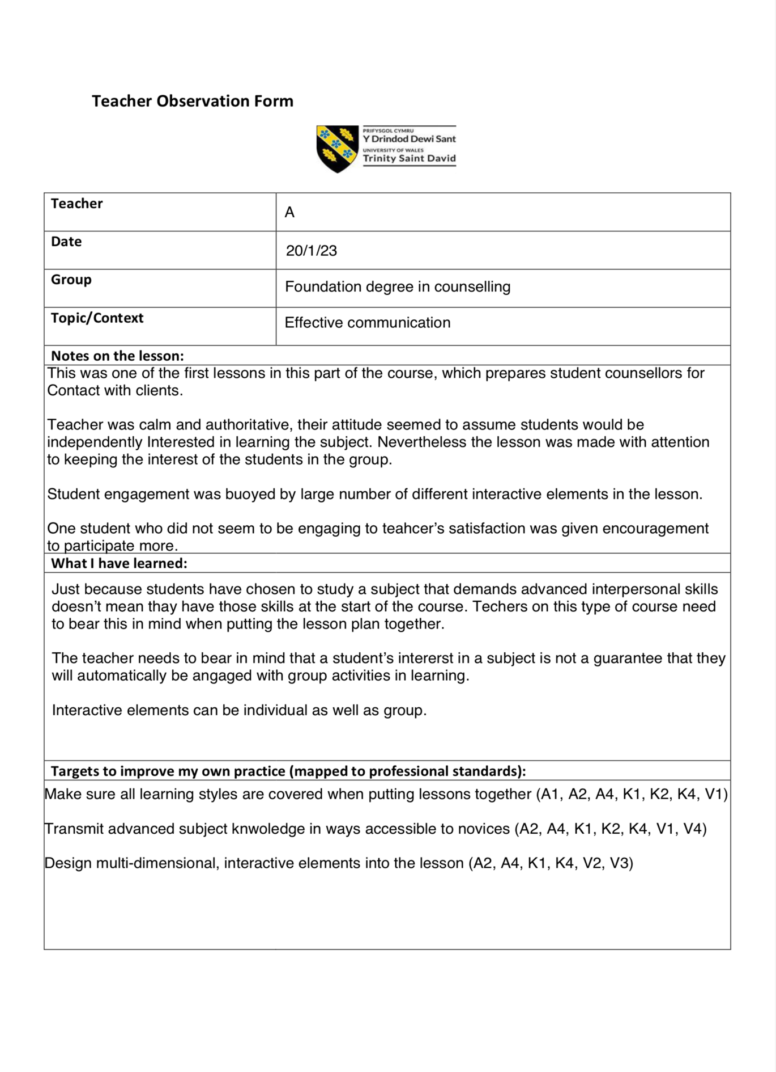
Appendix A

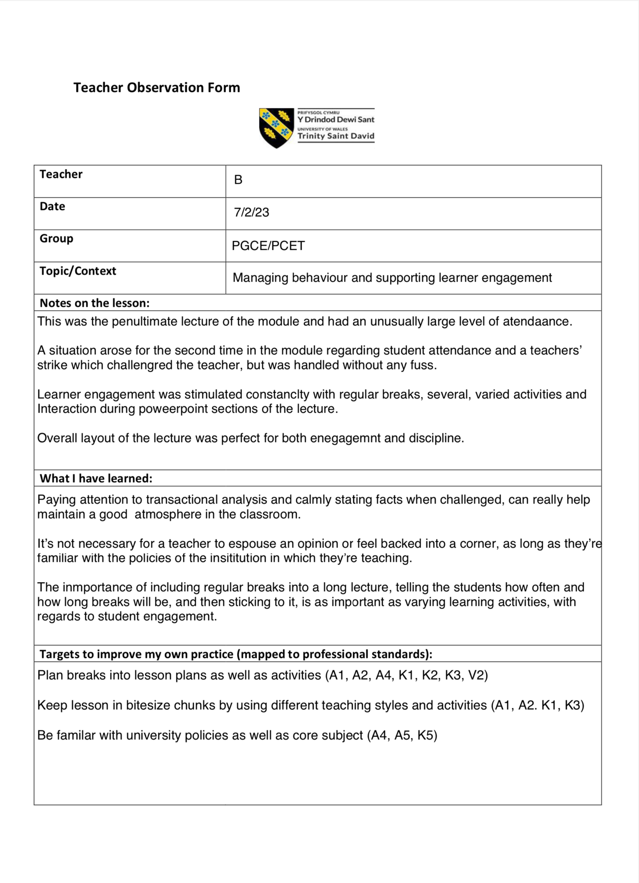
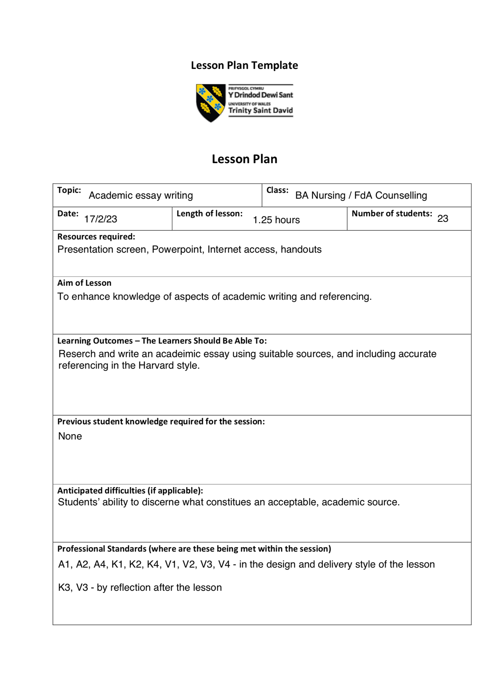
Appendix B

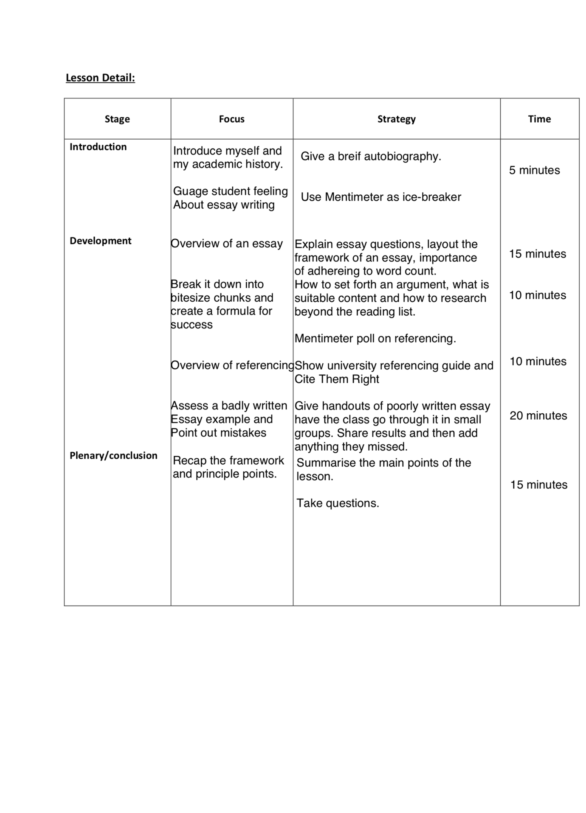

Appendix C

Moving forward, and taking on what I have learned from the theory of classroom management, seeing it in action and experiencing it myself, I have pinpointed several areas for improvement. I need to make my lessons more varied and interactive. I need to become more au fait with use of teaching technologies available. I have recently started to use Mentimeter in my lessons, and am aware that there many more resources available such as Padlet, Whiteboard, Nearpod etc. I will learn how to use these apps and others to introduce more and varied interactive elements to my lessons.

I also learned the importance of including breaks into the lesson schedule. This was a particular revelation to me as all the way through my degree I had a succession of teachers who either promised us breaks but then got so engrossed in the lesson that we didn’t get them, or at best we had ad hoc breaks, never knowing if or when they were coming or how long they would be. There was seldom an actual meal break, even in a three hour lecture. Experiencing breaks built into the lesson every hour made a massive difference to my stamina and my ability to make it through the lesson, giving my full attention.

One of the other things I have experienced during the behaviour management module is the option of giving short research projects to the class. Several times on this module we were split into small groups and sent away to research a subject, put together a short presentation, and then present it to the class. The whole cone pcet of this had a massive effect on me, I can not think of any other teaching activity that covers so many different teaching and learning styles. It is something I will definitely be adding to my lesson plans in future. I also saw some new (to me) ways of interacting with the class, and will be taking them into my trenching practise in future. Finding the right level of animation to stimulate an otherwise apathetic group, and increasing the amount of andragogy in the lessons with the use of individual and group work. Giving the class a jumping off point and them trusting them to effectively teach themselves, with presentations being not only a learning tool for the group as a whole, but also an excellent formative assessment tool at the same time.

