Teacher Dr Renunga Jayakumar
Kamal Sharif:1712895

Digital Skills and Research Methods

Table of Contents
Introduction 1
1. Definition and Example of Modern Technologies 2
2. Effectiveness of Using Modern Technologies within the Workplace 3
3. Social Media as a Tool for Marketing, Information Gathering and Communication 6
4. Creating Own Professional Online Presence 9
Conclusion 11
References 12

Introduction
Modern world is greatly influenced by the inventions of modern science technology. Inventions of modern science and technology has made human life easier, People are greatly dependant on the inventions of modern science and technology (Bucher, 2015). Business world in this modern era is also greatly dependant on modern science and technology. Invention of internet, social media and a number of scientific devices are now frequently using by the business organizations in every stages of their business. Modern science has made it easy for the organizations to provide better services to the customers at the shortest possible time (Lomborg, 2014). Customers also prefer to buy the products or take the services of the organizations that are using modern technologies to render greater service. This assignment has discussed about modern science and technology (Miller, 2011). Effectiveness of using modern science and technology in the workplace has been discussed by using the example of Tesco, a popular chain super shop in the UK. Organizations now search for the employees who are efficient in using modern technologies and are able to work for the betterment of the organization. All the employees need to develop their digital skills to increase their employability to the employers (Sakshi, 2017). Social media are greatly using by the modern organizations as a tool for marketing. My online presence has been shown in this assignment to prove my employability.

1. Definition and Example of Modern Technologies
Modern technologies have brought a great change on the life of people in the society. Internet, mobile phone, computer and other electronics devices have become part and parcel on the life of people (Sousa and Wilks, 2018). People, cannot think of their days without these things. With the changing on the habit of people, business organizations has also become more technology oriented that they were in the previous days. The main concern of operating business activities is to satisfy customers with the best quality service or products (Tapscott, 2010). And the inventions of modern science and technology have made it possible for the organizations to provide customers the best service in the shortest possible time. Retail organizations operating in the United Kingdom can be a good example of successfully using modern technologies in their business. Tesco is one of the largest retail chain shops in the United Kingdom. They are providing services to their customers with quality products. With the adoption of modern technologies by the other business organizations in the market, they have also developed their technologies which are more efficient than the previously used technologies. To examples of using modern technologies in the business organizations has been shown in the following section.
Communication System
A great change has been monitored in the communication system due to the advancement of science and technology (Deursen, 2016). People can now easily communicate with the people living in the other corner of the world. Invention of telephone, mobile phone, internet, and social media, all as made the communication process so much easy for general people (Tuten, 2018). Tesco also use these devices to communicate with their employees, customers and all other related parties. Retail organizations like Tesco now a day also do online selling to the remote customers by using internet.
Social Networking System
Invention of computer, mobile phone, internet and social media has made it possible for the business organizations to perform their marketing activities online (Bucher, 2015). By using the social networking platforms, they can reach to the customers in the remote areas.
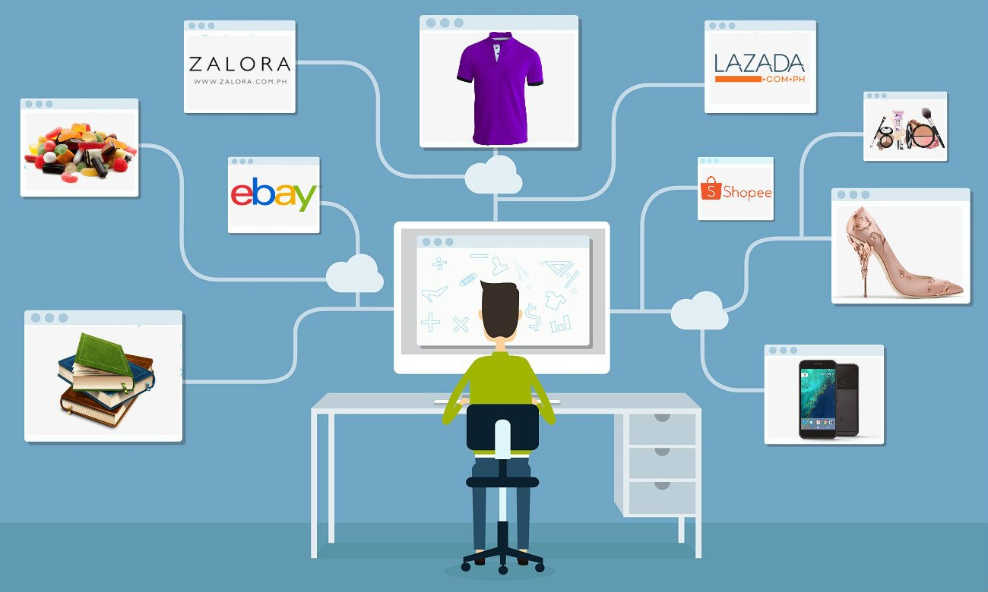
Figure 1: Online Selling by Using Social Networks
Source: (Lomborg, 2014)
Not only the marketing activities, organizations also do online selling now-a-days to extend their market (Miller, 2011). A customer living at a remote place can also now buy products from Tesco by using social networks and their website.

2. Effectiveness of Using Modern Technologies within the Workplace
With the advancement of modern science and technology, business world has also changed a lot in operating their business activities (Sakshi, 2017). Especially the marketing activities of the business organizations have seen a great change. Service providing activities have become more developed than the previous years. Modern business organizations are more customers oriented (Sousa and Wilks, 2018). They believe to develop their business by developing their services to the customers. Inventions of modern science and technology have made it possible for the employees to give the best service to the customers and that is also in e shorter period.
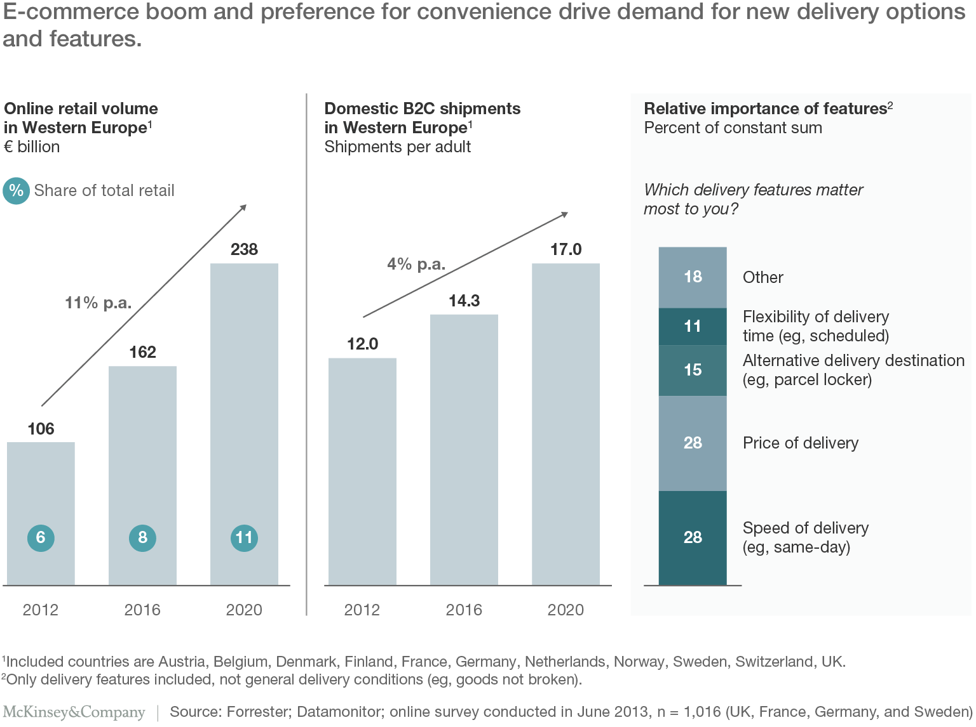
Figure 2: E-Commerce Trend in UK
Source: (Tapscott, 2010)
Understanding the benefits of using modern technologies, business organizations in the UK are becoming largely depended on it. The above figure shows the increase of e-commerce in the UK and a forecast has also been added based upon research and analysis (Tuten, 2018). E-commerce is increasing in the United Kingdom at a significant rate and the number will be continued to increase in the following years. The following sections describe the effectiveness of using technologies in the workplace.
Communication
Communication system has become more developed with the advancement in science and technology. This has become beneficial for the business organizations too. Now the employees can communicate easily with other via, telephone, email, mobile phone and internet (Deursen, 2016). Tesco uses these technologies to communicate with their employees, customers and other related parties. Marketing is one type of communications and Tesco also uses these technologies for marketing.
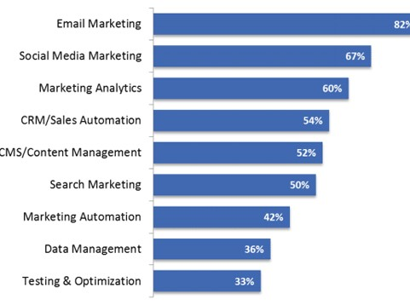
Figure 3: Modern Marketing System using Technologies
Source: (The Telegraph, 2018)
Servicing
Inventions of modern technologies have made the servicing activities more easy and efficient for the business organizations (Bucher, 2015). Organizations like Tesco can use modern technologies to provide better services to the customers with the shortest possible time. They also sell their products online, which has made the organization more reachable to the customers.
Employee Efficiency
With the help of inventions of modern technologies, employees working in the business organizations can provide better service to the customers (Lomborg, 2014). Managers of Tesco monitors performance of the employees by using technologies and that make the organization able to take measures to improve the efficiency of the employees. Employees also work with greater effort when they now that they are being monitored.

3. Social Media as a Tool for Marketing, Information Gathering and Communication
Social media is another addition of modern science in the life of people. People are staying connected with the other peoples via social media like Facebook, twitter, LinkedIn, etc. These social sites have now become part and parcel of the people in this modern generation (Miller, 2011). A large number of people around the world are now using social Medias as a tool for connecting with others. Researches show that around 4.5 billion people in the world are connected with internet (The Guardian, 2018). The following figure shows growth in the percentage of men and women of different ages who are using internet.
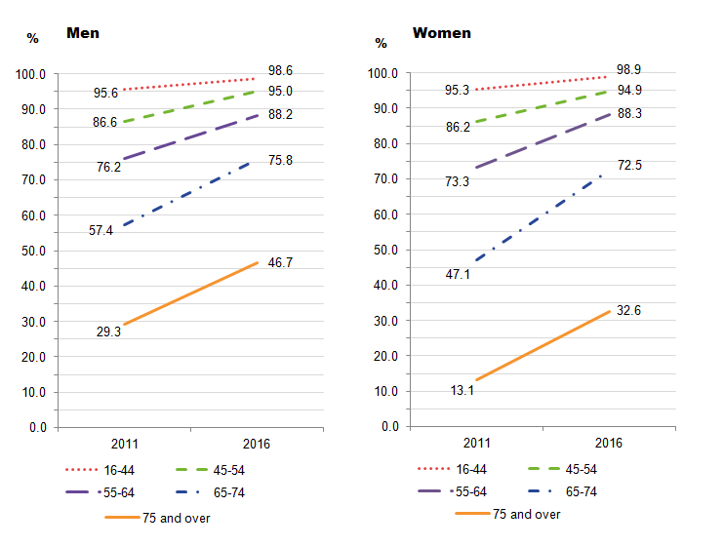
Figure 4: Trend of Using Internet
Source: (The Telegraph, 2018)
Social Medias like Facebook, twitter, LinkedIn are being used by almost 3 billion people round the world as a tool for connecting with each other (The Guardian, 2018). As there are a large number of people are currently connected with social Medias, modern business organizations are now also using this arena as a tool for marketing. Social Medias as a tool for marketing, information gathering and communication has been described below.
Marketing
Using social media as a tool for marketing is now a common trend among the modern business organizations. It is great field for the business operator to grab a huge number of customers by social media marketing (Bucher, 2015). Like the other organizations, Tesco also use social Medias as a tool for marketing their organization. The following picture shows an example of Tesco’s advertisement of social media.
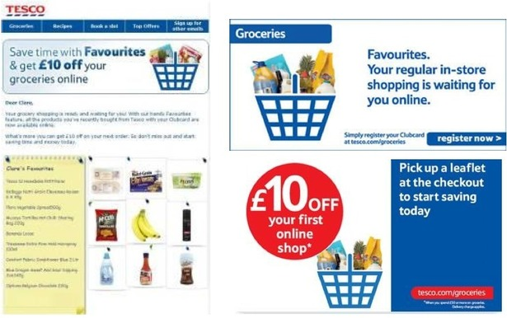
Figure 5: Usage of Social Media for Marketing
Source: (Tesco 2018)
Information Gathering
Gaining more customer satisfaction is the main the objective of most of the modern business organizations. It is crucial for the business organizations to know about the opinions of the customers for providing them products and services according to their need (Lomborg, 2014). Many organizations like Tesco sometimes gather information about consumer trend and demand of the consumers from social media sites. The following figure shows the use of social media for marketing.
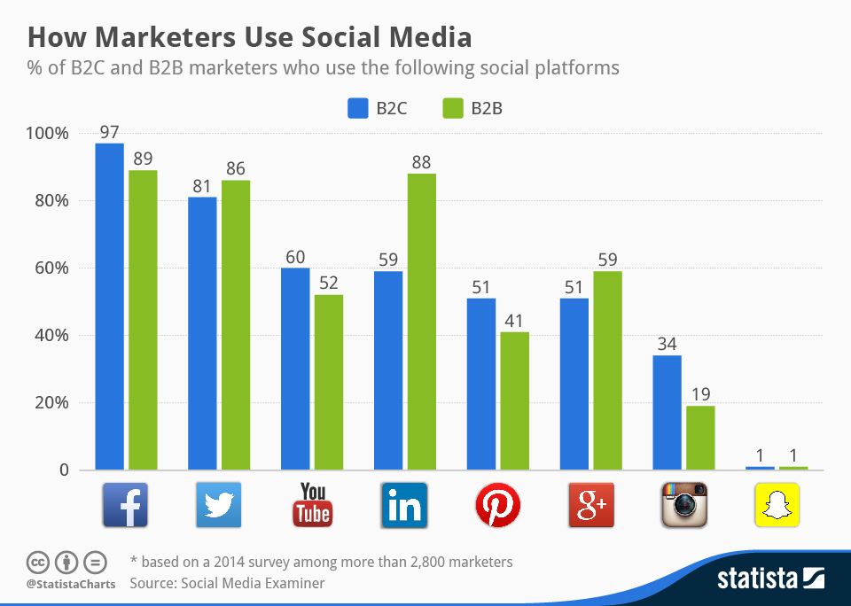
Figure 6: Usage of Social Media for Marketing
Source: (The Guardian, 2018)
Communication
The main features of all the social media sites are to make connected people with one another. Modern business organizations also use social media sites as a tool for communicating with the customers, employees and other related parties (Miller, 2011). The following picture shows an example of Tesco’s using social media as too l for staying connected with the customers.
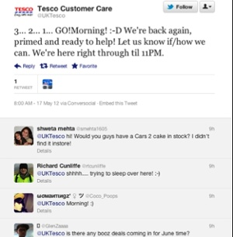
Figure 7: Usage of Social Media for Communication
Source: (Tesco 2018)

4. Creating Own Professional Online Presence
People in this age are more technology oriented that they were in the previous years. Inventions of modern science and technology have made the day to day activities easier than before. And these features have made people more technology oriented (Sakshi, 2017). Computer, smart phones and other devices have become part and parcel of human life. Internet is one of the greatest inventions of modern science. World has become smaller with the invention of internet and social media. People can stay connected with the other peoples on the remote corner of the world. Almost 4.5 billion people use internet to stay connected with others (Sousa and Wilks, 2018). With the advancement of science and technology, modern business organizations also changed their trend of marketing. A huge number of people around the world are now using social media sites for keeping connection with other people. This has created a great area for the business organizations to do their marketing activities (Tapscott, 2010). Business organizations can grab a huge number of audiences at a time by using social media which is not possible in regular marketing process. In this age of marketing organizations also search for the employees who are great at using internet and social media. Online presence is necessary for the employees especially who are working in the marketing department of any organizations (Tuten, 2018). A professional account in the social sites helps an employee to stay connected with the customers, managers and the other employees. He/she can gather information about consumer trend, demand of the market and can use the information for developing products and services of the organization. I have also my own professional account on social sites that can be used for my professional activities.
This is the professional account in Facebook as an evidence of online presence.
Link: https://www.facebook.com/profile.php?id=100023191653362
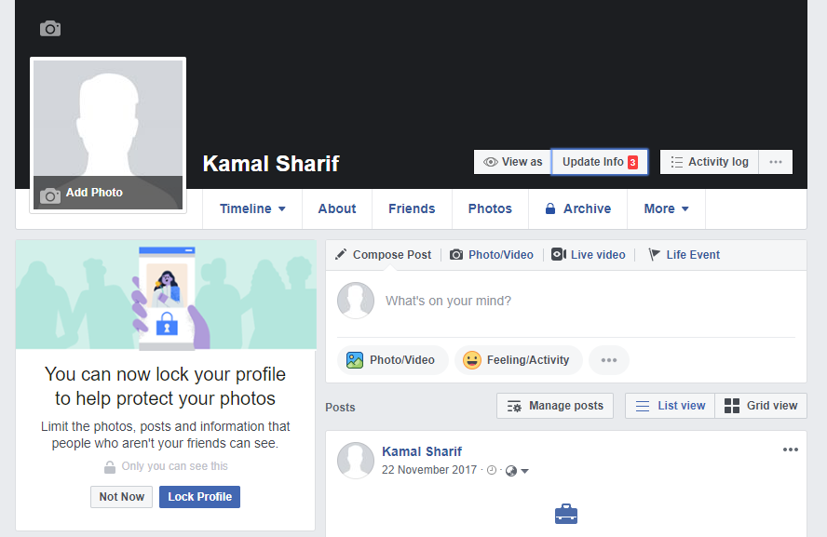
This is the professional account in LinkedIn as an evidence of online presence.
Link: https://www.linkedin.com/in/KamalSharif-45b93a285/
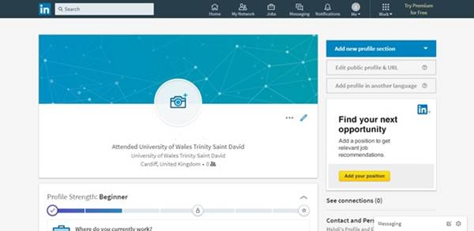
Kamal Sharif

Conclusion
Modern Business world is now mostly depended on the inventions of science and technology. These inventions have made the business operational activities easier for the business operators and satisfactory for the customers. Business organizations now-a-days are more efficiently doing their job by using these technologies. Invention of internet and social media has opened a new horizon to the business sector. It has created a wider market for the business organizations. Using the social media, business organizations can reach to the individuals from the other corner of the earth. Many popular organizations are now marketing and selling their products and services online. With the advancement of science and technology, business world has also being advanced. And to survive in the advanced world organizations need employees who have efficient level of digital skills to make the organization competitive in the market. This assignment has described about the digital skills that are to be possessed by the employees of the modern organizations. Importance of using these skills has also been described. Social presence is required for the employees especially for the marketing employees. Prove of presence in social media has also been attached to the assignment to prove job readiness.

References
Bucher, T. (2015). Networking, or What the Social Means in Social Media. Social Media + Society, 1(1), p.205630511557813.
Lomborg, S. (2014). Social media, social genres. New York, NY: Routledge.
Miller, J. (2011). Millennium intelligence. Medford, N.J.: CyberAge Books.
Sakshi (2017). Social Media: The Future of Marketing. International Journal of Contemporary Research and Review.
Sousa, M. and Wilks, D. (2018). Sustainable Skills for the World of Work in the Digital Age. Systems Research and Behavioral Science, 35(4), pp.399-405.
Tapscott, D. (2010). Grown up digital. New York: McGraw-Hill.
the Guardian. (2018). Latest UK news | The Guardian. [online] Available at: https://www.theguardian.com/uk-news [Accessed 30 Aug. 2018].
The Telegraph. (2018). Telegraph. [online] Available at: https://www.telegraph.co.uk/ [Accessed 1 Sep. 2018].
Tuten, T. (2018). SocialL Media Marketing. [S.l.]: Sage Publications.
Van Deursen, A. (2016). Digital skills. [Place of publication not identified]: Palgrave Macmillan.

