University of Wales Trinity Saint David
Wales Institute of Science & Art


Material Selection Report
Engineering Design and Materials ACHA4001

Elliot Woodhouse

Student ID: 1908452
Date: 03/2022

Contents
1. Introduction 2
2. Material Properties 3
3. Material Selection 6
3.1 Cast Iron 6
3.2 Low Carbon Steel 7
3.3 Aluminium Alloy 8
3.4 Final Material Choice 9
4. Manufacturing Processes 10
4.1 Advantages/Disadvantages of Manufacturing Processes 10
5. Conclusion 12
6. Reference List 13

Introduction
The piston is one of the most important components of an internal combustion engine. The piston’s role is to convert the compression forces from the expansion of gases in the combustion chamber into linear kinetic energy of the piston, gudgeon pin and connecting rod which can then be converted into rotational kinetic energy via the crankshaft.
This report will outline the requirements of the piston’s material, taking into account the forces and temperatures that the piston will be exposed to. This information will then be used to consider different materials that would be suitable for the manufacture of a piston, eventually selecting a final material. The final section of this report will discuss the varied ways a piston can be manufactured, discussing the benefits and disadvantages of certain methods over others.

Material Properties
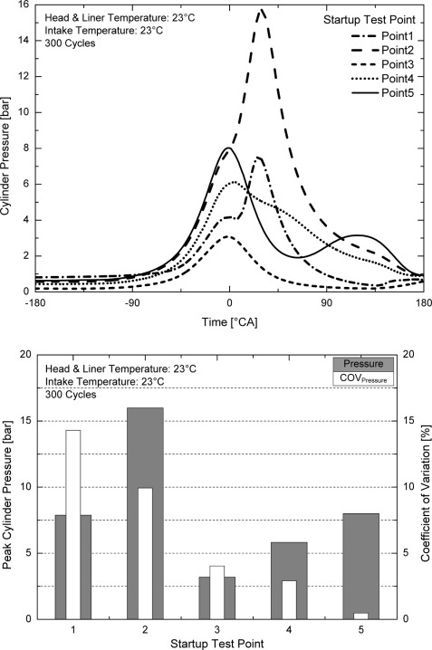
During the operation of an internal combustion engine (ICE), the piston is directly exposed to extreme changes in pressure and temperature. This means that the piston must be able to function correctly across a wide temperature and pressure range.
Figure 1 - Cylinder Pressures of an engine during cold start up (Efthymiou P. et al.(2013)

As Figure 1 shows, during the cold start of an engine the in-cylinder pressures can reach up to almost 16 bar. This however increases when the engine has warmed up and the RPM’s of the engine are increased. This can be seen in Figure 2, reaching almost 65 bar at 2250RPM (T. Le Anh, I.K. Reksowardojo, K. Wattanavichien,2016).
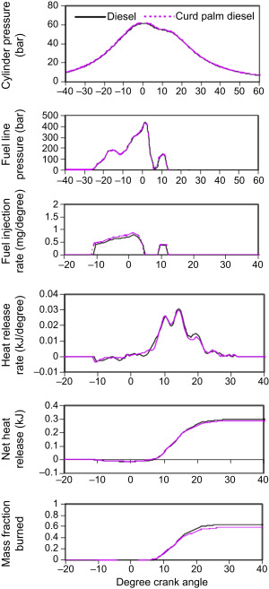
The average pressure inside the cylinders of an engine are much lower, as the peak pressures only occur during the combustion of the fuel for a split second, however the material for the piston must have enough compressive strength, tensile strength and fatigue strength to withstand these pressures without failure.
Figure 2 - In Cylinder Pressures of a Diesel Engine (T. Le Anh, I.K. Reksowardojo, K. Wattanavichien,2016)
Whilst being strong, it is also important for the piston to be light weight to reduce the inertia of the piston as much as possible. Inertia forces in an engine only become more prevalent at higher RPM’s, however these forces can be extremely high when the piston is reaching top dead centre (TDC) and bottom dead centre (BDC) as the piston has to come to a complete stop and change direction. If the piston is exposed to these extreme inertia forces for prolonged periods of time, the connecting rod can bend and break (Bari et al., 2017). This is why it is vital to choose a low-density material for the piston to reduce these forces. Having a lighter piston will also assist to increase the performance and efficiency of the engine, as less mass has to be moved, therefore wasting less of the power produced by the engine.
The material used for the manufacture of the piston must also have a high thermal conductivity. As stated by Cameron (2021), having a piston manufactured out of a material with a higher thermal conductivity will transfer the heat to the cylinder walls at a faster rate than that of a piston made of a material with low thermal conductivity. This will assist to keep the engine cool, preventing build-up of carbon deposits on the piston, to reduce engine knock events (detonation) and also reducing how much the air being drawn into the engine is heated. Air is denser at a cooler temperature, meaning more air can be drawn in during the intake stroke, increasing the power the engine can produce.
The piston will be under fluctuating loads whilst the engine is running and should be designed to last hundreds of thousands of miles if the engine is maintained correctly. For this to occur, the piston will have to designed for fatigue.
There are multiple ways a piston can be manufactured; the two primary ways being casting and forging (Acosta,2021). After the piston has been manufactured using either of these two methods, it can then be machined to produce an improved surface finish and ensure the piston is within the design tolerances. This means that the material used to manufacture the piston must be easily machinable and easy to cast.

Material Selection
Since the invention of the ICE, there have primarily been three materials pistons have been manufactured from; cast iron, steel and aluminium alloys (Nash,2022).

Cast Iron
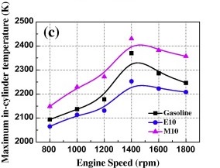
As stated by Cameron(2021), before 1911 it was common to manufacture iron pistons. It was believed that cast iron was a superior material for pistons as the melting point of grey cast iron is much greater than aluminium’s; cast iron melting at 1,230ºC whilst aluminium alloys typically melt at around 550ºC. It was believed that due to the engine temperatures peaking at over 2000ºC when ignition occurs, as shown in Figure 3, aluminium would melt and so cast iron was used.
Figure 3 - Maximum in-cylinder Temperature (Feng D. et al., 2014)
Cast iron properties(Matweb,2022):
Density=7.23g/cc
Ultimate Tensile Strength(UTS)=90-1650MPa,average=497MPa
Yield Tensile Strength(YTS)=65.5-1450MPa,average=428MPa
Young’s Modulus of Elasticity=62.1-250GPa,average=148GPa.
Compressive Yield Strength=220-2520 MPa,average=991MPa
Fatigue Strength=68.9-510MPa,average=260MPa
Shear Strength=149-1480MPa,average=545MPa
Thermal Conductivity=8.50-53.3W/m-k,average=26.1W/m-k
Cast iron typically has a much greater UTS than aluminium alloy, ranging from 90–1650 MPa, averaging at 497MPa (Matweb,2022). This is whilst aluminium alloys typical UTS is only around 310MPa (Chattopadhyay M., Sonar D.K., 2015). This means that cast iron can typically experience more tension before failure.
As reported by Sabhadiya(2022), cast iron has a high fatigue strength meaning that it can experience high stress for a prolonged period of time without breaking. Cast iron is also very easily castable, as it is composed of a higher percentage of carbon it is more fluid when in it’s molten state. This makes it much easier to cast complex shapes as there is less chance of the metal solidifying before it fills the mould completely. It is also very easy to machine cast iron as it is elastic almost up until its UTS. This means that when being machined, short chips are broken off of the material easily (Sabhadiya,2022).

Low Carbon Steel
Low carbon steel properties (Matweb,2022):
Density=7.6g/cc
UTS=241-2450MPa,average=716MPa
YTS =140-2400MPa,average=519MPa
Young’s Modulus of Elasticity=183-213GPa,average=202GPa.
Compressive Yield Strength=152-1800MPa,average=1480MPa
Fatigue Strength=758-772MPa,average=765MPa
Thermal Conductivity=25.3-93.0 W/m-k,average=49.6W/m-k
Steel’s properties are very similar to cast iron. However, steel has a higher YTS and UTS. This means that a steel piston would be able to experience more tensile force before going past it’s elastic limit and also before breaking completely. Steel also has a much higher compressive yield strength. This is ideal for pistons as they are exposed to extreme pressures during the combustion of the fuel at TDC.

Aluminium Alloy
Aluminium alloy properties(Matweb,2022):
Density=2.54g/cc
UTS=0.700-1600MPa,average=344MPa
YTS=1.24-730MPa,average=278MPa
Young’s Modulus of Elasticity=0.048-342GPa,average=77.4GPa.
Compressive Yield Strength=0.138-3400MPa,average=95.7MPa
Fatigue Strength=20.7-517MPa,average=151MPa
Thermal Conductivity=1.48-255W/m-k,average=149/m-k
Aluminium alloys have a much lower density than both cast iron and steel, at only 2.54g/cc compared to cast iron’s 7.23g/cc and steels 7.6g/cc. For the same volume of material, an aluminium alloy piston will have a mass one third the mass of cast iron and steel. This reduces the inertia forces experienced in the engine whilst also increasing the performance and efficiency of the engine.
Aluminium alloys also have a much higher thermal conductivity than cast iron and steel, resulting in much faster heat transfer from the piston crown to the cylinder walls. As steel and cast iron are so poor at transferring heat, it is common for them to glow red hot. The heat of the steel/cast iron piston then combined with spark ignition systems typically caused combustion knock, which could potentially lead to the engine being destroyed (Cameron, 2021).
Aluminium alloys however do expand a lot more when heated to high temperatures compared to steel and cast iron as it has a higher coefficient of expansion (Gruenewald,1915). He reports that when engines using aluminium pistons with the same clearances as cast iron pistons were held at high RPM’s for extended periods of time the aluminium pistons would expand too much, ceasing them against the cylinder walls and therefore ceasing the engine. To counteract this, greater clearances with tight tolerances were introduced for aluminium pistons, along with improved piston cooling methods including adding ribs to the piston for more cooling surface area, as well as more modern-day designs of oil cooling jets spraying the underside of the piston with oil (Cameron, 2018). One downside of having greater clearances for the thermal expansion of the piston is that when the engine is in it’s warm up phase, it may be possible to hear the engine “rattle” as piston slap occurs due to the piston not being a high enough temperature to expand to it’s correct size.

Final Material Choice
Considering all materials mentioned, aluminium alloy would be the best material for the manufacture of a piston.
Despite the fact that aluminium has considerably lower strength than steel and slightly worse than cast iron, the benefits gained from using aluminium far outweigh the drawbacks. Although aluminium alloy has lower tensile, compressive and fatigue strength than steel and cast iron, it is still strong enough to withstand the forces experienced when a petrol ICE is running.
Aluminium alloy is significantly less dense than both steel and cast iron, assisting to improve the efficiency and performance of the engine, whilst also reducing the inertia forces the engine components experience.
Gruenewald (1915) states that aluminium pistons have excellent wear resistance, wearing only ¼ of a thousandth of an inch (6.35μm) after 14,000 miles of average work. He also notes that the cylinder walls were in significantly better condition after the prolonged use of aluminium alloy pistons over cast iron pistons, as aluminium alloy is a much softer material than cast iron.
There are however many different types of aluminium alloy, containing varying amounts of silicon, magnesium, copper and iron to tailor the characteristics of the alloy to their specific needs, for example to increase the strength and thermal conductivity of the material (Gruenewald, 1915). In their report, Sagare et al. (2018) state that aluminium silicon carbide (AlSiC) has greater heat transfer, experiences less deformation and less stress than pure aluminium, making it a superior material for the manufacture of pistons. This is also supported by Senthil S., Raguraman M. and Thamarai Manalan D. (2020) in their journal, stating AlSiC has low density, high stiffness, high strength and good wear resistance, ideal for pistons.

Manufacturing Processes
Primarily there are two ways to manufacture aluminium pistons; casting and forging.
Casting is the process of pouring molten metal into a mould, allowing the molten metal to take the shape of the mould before cooling and solidifying, then removing the cast from the mould. The cast piston can then be machined down to the correct dimensions (Acosta,2021).
Hot forging to produce a piston is the process of heating up the billet of aluminium almost to the temperature that the piston will experience when the engine it is being designed for is running at full power. This billet is then placed into a pre heated forge. The die is lowered onto the billet of aluminium with up to 500 tons of force (for a lightweight forge), compressing the billet to the shape of the die. The billet is then blasted to check for imperfections, excess material is removed and it is sent to be heat treated close to it’s melting point to then be quenched so that the material is hardened. The piston is then sent to be machined down to its correct dimensions (MED Race Technologies, 2019).

4.1 Advantages/Disadvantages of Manufacturing Processes
Omega Pistons (2011) state that the benefit of forged pistons over cast pistons is that the metal isn’t brought to its melting point, like it is during casting. Therefore, the grain isn’t free to expand, leading to a more organized and even grain structure of the material (MilwaukeeForge,2022). This increases the strength of the material significantly.
Milwaukee Forge(2022) state that when the same material is used to produce the same parts, the forged parts have a 26% higher tensile strength, 37% higher fatigue strength and 1.5x the yield strength of their equal cast parts.
Another downside of die cast pistons is that there are many ways for a cast to fail. Some defects include(Wong, 2018):
- Blowholes/pinholes, as seen in image 1, which occur when air is trapped in the molten metal and then released, leaving a hole behind when the part cools
- Shrinkage defects, occurring due to metals being less dense when molten, meaning that when the cast solidifies, gaps can be left behind from when liquid metal used to be.
- Hard spots, occurring when one section of the cast cools faster than the material surrounding it.

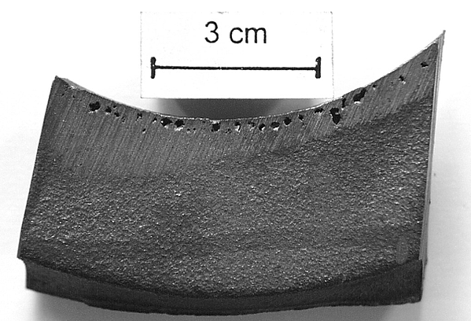
Image 1 - Pinholes created during the casting process (Wong,2018)

However, as stated by Omega Pistons (2011) cast pistons are significantly cheaper to produce than forged pistons whilst they still are typically strong enough for standard road use vehicles. Forged pistons are more expensive due to the complex forging process, requiring more machinery and man hours to complete. This makes casting a much more cost-effective way for companies to mass produce pistons for road going vehicles.

Conclusion
There are several different factors to consider when choosing the material for a piston, however it is clear that with modern cooling techniques and precise machining that AlSiC is the best material of choice for petrol ICE’s.
The benefit gained from an extremely lightweight piston as well as having excellent thermal conductivity compared to other materials outweighs the benefits gained from using other materials such as steel, as AlSiC is strong enough to endure the compressive forces and reduce inertia forces in an ICE, whilst modern cooling techniques reduce the amount the piston expands, eliminating seizure.
Whilst forged pistons are significantly stronger than their counterpart cast pistons, the cost of manufacturing these pistons is too expensive for mass production. An ideal use of forged pistons is for racing, as these engines are constantly at peak power, putting an enormous amount of force on the pistons and therefore the extra strength will be required. This is whilst cast pistons are ideal for mass production road vehicles as they do not require the extra strength.

Reference List
Acosta G. (2021) Modern Piston Materials, Manufacturing, And Coatings With UEM. Available at: https://www.enginelabs.com/news/modern-piston-materials-manufacturing-and-coatings-with-uem/ [Accessed 23/03/2022]
Bari, K. et al., (2017) Case Studies in Engineering Failure Analysis, Volume 9, Forensic Investigation of a failed connecting rod from a motorcycle engine, Elsevier Ltd. [Accessed: 24/03/2022]
Cameron K. (2018) How Do Piston-Cooling Oil Jets Work? Available at: https://www.cycleworld.com/how-do-piston-cooling-oil-jets-work/ [Accessed 16/03/2022]
Cameron K. (2021) Pistons, Hot and Cold. Available at: https://www.cycleworld.com/story/blogs/ask-kevin/how-motorcycle-piston-temperature-affects-engine-power/ [Accessed 16/03/2022]
Chattopadhyay M., Sonar D. (2015) International Journal of Engineering Science Invention, Volume 4, Issue 6, pp. 52-61 [Accessed: 16/02/2022]
Efthymiou P. et al. (2013) Internal Combustion Engines: Performance, Fuel Economy and Emissions. An optical investigation of a cold-start DISI engine startup strategy, Woodhead Publishing [Accessed: 15/03/2022]
Feng D. et al. (2014) Applied Energy, Volume 132, Experimental investigation on the combustion and emissions characteristics of 2-methylfuran gasoline blend fuel in spark-ignition engine, Elsevier Ltd. [Accessed: 15/03/2022]
Gruenewald E. (1915) Transactions (Society of Automobile Engineers), Volume 10, Part II, Aluminium Alloy Pistons, SAE International, pp. 135-142 [Accessed: 23/03/2022]
MatWeb (2022) Overview of materials for Aluminum Alloy. Available at: https://www.matweb.com/search/DataSheet.aspx?MatGUID=ab8aeb2d293041c4a844e397b5cfbd4e [Accessed: 25/03/2022]
MatWeb (2022) Overview of materials for Cast Iron. Available at: https://www.matweb.com/search/datasheet_print.aspx?matguid=6291a24572754cae94ff365ed99b96f9 [Accessed: 25/03/2022]
MatWeb (2022) Overview of materials for Low Carbon Steel. Available at: https://www.matweb.com/search/DataSheet.aspx?MatGUID=034970339dd14349a8297d2c83134649&ckck=1 [Accessed: 25/03/2022]
MED Race Technologies (2019) How it’s made – Omega forged pistons – part 1. Available at: https://www.youtube.com/watch?v=Jr6qk5wCPEQ [Accessed: 27/03/2022]
Milwaukee Forge (2022) Forged vs Cast – What’s the Difference? Available at: https://www.milwaukeeforge.com/forged-vs-cast-whats-the-difference/ [Accessed: 28/03/2022]
Nash J. (2022) What Metals Are Engine Pistons Made From? Available at: https://itstillruns.com/metals-engine-pistons-made-from-12178964.html [Accessed: 15/03/2022]
Omega Pistons (2011) Pistons. Available at: https://www.omegapistons.com/pistons.php [Accessed: 28/03/2022]
Sabhadiya J. (2022) What is Cast Iron? – Definition, Properties, And Uses. Available at: https://www.engineeringchoice.com/cast-iron/ [Accessed: 16/03/2022]
Senthil S., Raguraman M., Thamarai Manalan D. (2020) Materials Today: Proceedings, Manufacturing Processes & Recent Applications of Aluminium Metal Matrix Composite Materials: A Review. Elsevier Ltd. pp. 5937-5938. [Accessed: 27/03/2022]
Le Anh T., Reksowardojo I.K., Wattanavichien K. (2016) Handbook of Biofuels Production (Second Edition), Processes and Technologies, Utilization of biofuels in diesel engines. Woodhead Publishing [Accessed 15/03/2022]
Wong S. (2018) 21 Casting Defects and How To Prevent Them In Your Products. Available at: https://www.intouch-quality.com/blog/21-casting-defects-and-how-to-prevent-them-in-your-products [Accessed 28/03/2022]

