Wendy Barrier 2019211

BMSW5102

Developing relationships and workplace achievement

Sujeewa Herath

First direct farming company report

Table of content

1 introduction………………………………………….. Page 3

2 Recruitment process ………………………………. Page 3

3 HRM models ………………………………………… Page 4/5
A, Armstrong work force planning flow chart
B, The standard causal model of HRM
C, The HR value chain

4, people resourcing ………………………………… Page 6
A, Strategic resourcing
B, Workforce planning
C, Recruitment and selection
D, Talent management

5, Motivation, Reward strategy, and training. … Page 7

6, Conclusion………………………………………….. Page 7

7, PDP…………………………………………………… Page 8

8, SWOT ………………………………………………... Page 9

References ……………………………………………. Page 10

1 Introduction
Human resource management or HRM is about how a company employs and managing people. The term HRM has been criticised as people should not be classes as resources as a resource is something to be used, and many companies prefer the title of people management, however they both mean the same; how companies employ, manage and develop people to meet the needs of their business.
First direct are a Birmingham based farming company, they sell produce directly to customers via an online ordering platform. During the covid epidemic they experienced an unexpected rise in sales and decided to employ a considerable number of new staff. Unfortunately, after the recruitment process productivity went down, orders were late and for the first time since the company started trading, they were receiving customer complaints. This report will investigate this issue and find out what has occurred to cause this situation. The report will be investigating what was done right and wrong in the recruitment process. It will talk about how the recruitment progress could have been improved. The report will look at how first direct implement HRM or people management, does their strategy benefit the farming company. It will look at two HRM models to see which would better help first direct plan their people management. In the second part of this report there will be a completed example of a SWOT analysis and a personal development plan (PDP) for first direct to consider using on their employees.

2 first direct recruitment process

First direct needed to employ staff at a quick pace due to the increase in orders, they advertised for farmhands and requested a CV to be emailed to the company. After the candidates were chosen, they were invited to a twenty-minute online video interview to determine skills and suitability. Successful candidates were then to begin work side by side to an existing staff member for one day and given a tour of the farm. After this they were given individual responsibilities. The entire recruitment process has taken just two weeks.
The company started in 2010 and by 2020 were employing over one hundred members of staff. There were no late orders and no customer complaints. So, the staff they employed were doing their jobs correctly at the time. There seems to be little strategy to the way first direct have recruited the staff there was not any workforce planning. People resourcing is the process of choosing the right people for the jobs when employing people, you need them to fit the right criteria for the jobs available. The first thing noticeable was that interviews were done via video calls. This was not the best way to see how physical the people being interviewed were, and as the work was manual it was far from ideal. The interviews took just twenty minutes for each recruit suggesting little was discovered about the people they employed. There seems to have been very little in the way of planning there is no records of which staff were needed and for what positions. First direct just basically gave positions to people that applied for the positions with out a clear plan of whom was needed and where they were needed. Learning and development are the process of making sure people have the knowledge and skills and they must be engaged to do the job they are doing. First direct had no learning and development plans in place the new recruits were simply buddied up with an existing staff member to be shown their role in the company.

3 HRM models

A, Armstrong work force planning flow chart

Armstrong’s flow chart shows how to plan for a successful workforce, starting with a business plan and working its way through what staff are needed to fill the demand, when using this staff be able to cover the supply demand, then the forecast of requirements, moves on then to the actual recruitment planning and after implementing it finally looks at monitoring and evaluation. This is where after the staff are employed training and monitoring comes into play. Armstrong’s is one of many HRM models this report will look at two other models The standard causal model of HRM and the HR value chain.

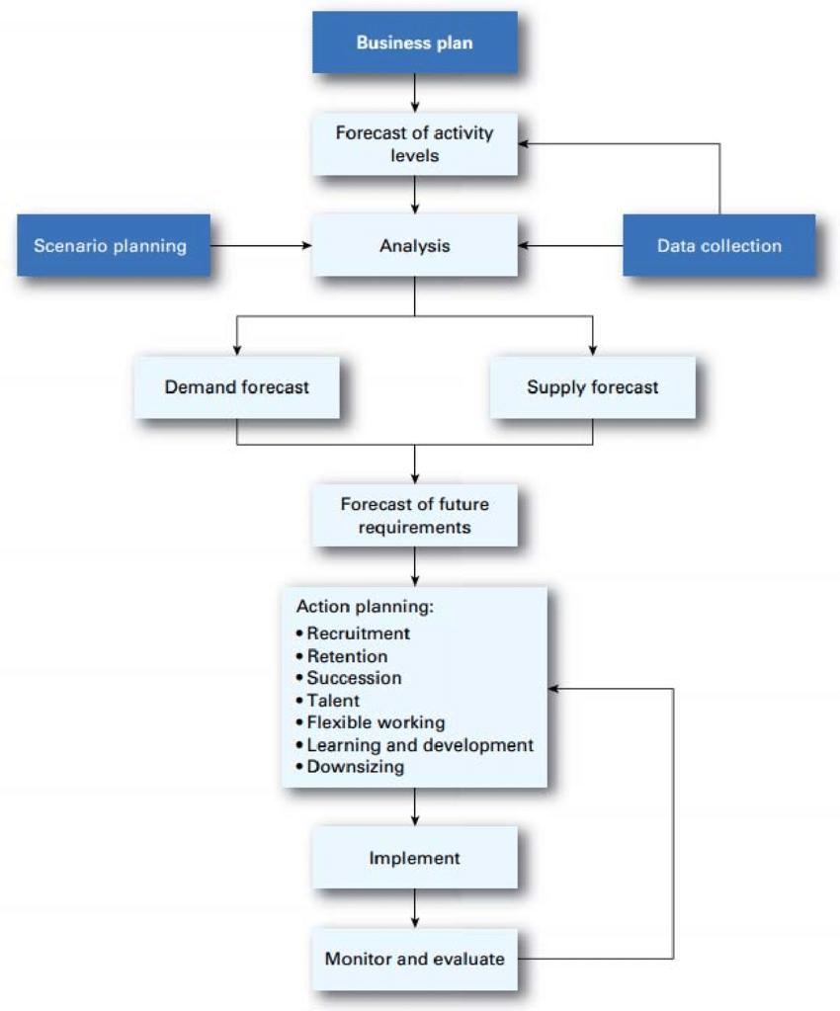
(Damnjanovic, 2016)

B, The standard causal model of HRM

This model is derived from many similar models it shows the chain of events starting with the business strategy and ends with improved financial performance.

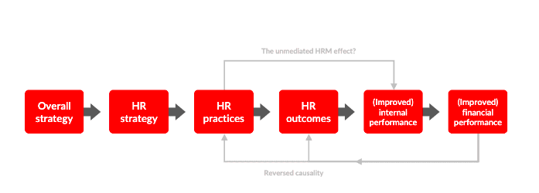
The HR practices follow the HR performance including hiring, training, appraisal and compensation. These will lead to certain outcomes including commitment, quality and engagement. The HRM outcomes lead to improved internal performance being productivity and quality. This model can be looked at in reverse as the improved financial performance can in turn lead to more investment for HR and this leads to better HR outcomes. The relationships in this model are not always unidirectional. But overall, this model shows that how HR strategy s formulated can impact on the internal processes and financial outcome of the business.

C, The HR value chain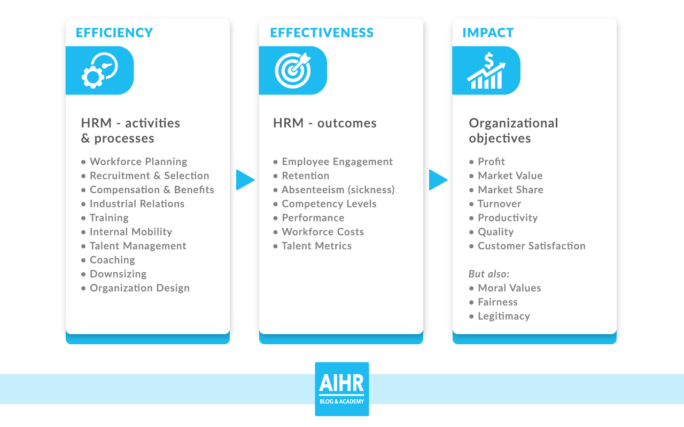

The HR chain value is one of the most well-known HR models, it is based on the work of Paauwe and Richardson in 1997. (van vulpen, 2022). The HR chain looks at everything we do, and measure can be divided into two categories HRM activities and HRM outcomes. HRM activities include recruitment, training and planning. These are often measured in HR metrics for example the cheaper we hire the faster we can train. HRM outcomes are the goals that the company will try to achieve. They recruit, they train, and they plan to achieve the company goals. This will include staff motivation and retention. If a company were to just focus on the HRM activity’s it will automatically focus on reducing costs. However, focusing on the HRM outcomes will help to align the processes and the goals.

The main goal of any organisation is to maximise the wealth of its stake holders. Financial performance of any company depends largely on its operational performance, this means functional people in the right position for the skills and abilities the hold.
(Anantharaman, 2003). By using the HRM models we can keep track of the staff and evaluate their needs to perform as the company needs them too. But is this always the best way? HRM models have been criticised for being essentially harmful to employees and impacting negatively on their wellbeing, (Armstrong,2019). Proving that HRM uses the workforce to its own advantage. Support is needed for those who’s well being is effective, however other employees may revel in the progression they will make.

People resourcing

A, Strategic resourcing, the farm knew it needed more staff Using these models how could first direct have stopped the inconsistently that came after new staff were employed. and which direction it was planning to go moving forward. On knowing this they should have been aware of the number of people needed, and the skills they must have. Ideally creating a talent pool of the potential people available. Being prepared is necessary to restructure the farm in case of cultural changes. With all this planning and information, the company can and should integrate the business and the resource strategy (Armstrong, 2020).
B, Workforce planning, planning the workforce is crucial, they needed make clear links between the business needs and the people they were recruiting, knowing the staffing costs and the number of people they needed to employ whilst maintaining the current staff profile. (Marchington, et al., 2016) the recruitment process is very expensive so knowing the amount of people needed and the skills they have is very important. The staff they already employ may have skills that the farm need in other positions. It could have been possible that using internal strategy’s using overtime and moving people around they may not have needed to recruit new staff at all. But first direct only looked at the short time objective when recruiting they didn’t consider the long-term objective, although even in the short term this did not work successfully.
C, Recruitment and selection, recruitment starts with the job advertisement. First direct needed to work out a job description, once the correct and full description is in place then the position or positions can be advertised. If the job description is not clear people with the incorrect knowledge and experience may apply. Once the applicants have a applied the talent pool can then be selected. By looking at CV’s the decision of who to interview can be made. Decisions are not final at this point and things can and probably will change at the interview stage. Various models can be used at the interview stage, along with the interview itself, skill tests, group exercises, ability tests and pre interview references.
D, Talent management. Once the recruitment process is complete and the staff are in place by training and evacuating staff the company would earn rewards on the investment, they have used in employing staff, talent management is the act of managing the staff the company has in developing their talents to be used in the correct position for the company’s needs.
Going through a lengthier recruitment process may have left the company needing staff but in rushing they were greeted by the wrong measure of people. Once the workforce was in place first direct did not look to train staff, they partnered them with an experienced staff member to be shown the ropes. If first direct staff had, had no training then they could possibly be showing the new staff the wrong way to do things, also even with previous training bad habits can be form which would be passed on to the new staff. A training program monitored in a personal development plan should be in place, this ensures staff are trained in the areas they need to be. When sales went down and complaints were coming I, the people managers would have instantly been able to see where the problem was, and instantly corrected it.

5, Motivation, Reward strategy, and training.
Employee motivation is the key to a company’s success. It brings a level of commitment from the employees towards the company. It brings with it drive and energy, unmotivated staff will likely deliver low productivity and fail to reach company goals. Lack of direction and not knowing what is expected from the staff can be confusing and cause low motivation. First direct place each new member of staff with a partner for just one day, the company has been running and developing for over ten years so to learn what is needed and expected in one day would be impossible. Clear targets and expectation will help to motivate staff also giving the control of some aspects of their work once they are clear on what’s needed. (Why employee motivation is important & how to improve it, 2022) Staff wellbeing is extremely important and staff with no direction can easily become stressed. Fully trained staff that have clear direction will be much more motivated to perform better. Recognising and rewarding good work make employees feel valued and raises their self-esteem. What is a reward? It is basically can be anything tangible or intangible that the organisation gives to an employee for their contribution to the company. It can be a financial reward such as a bonus or pay rise, it can be a career progression, training or development. It can also be a social reward possible time off or invited to a social event. This offers a great form of motivation. There are four foundational theories of motivation Maslow’s Hierarchy of Needs, Herzberg’s Two-Factor Theory, McClelland’s Three Needs Theory, and McGregor’s Theory X, Theory Y. (johnson,2022) Maslow’s Hierarchy of Needs suggests we are motivated by our needs starting with the basic needs of food, water , shelter and goes higher when each need is fulfilled at the top of the hierarchy is our own personal growth which can be Intrinsic or Extrinsic. Intrinsic motivation is defined as the doing of an activity for its inherent satisfaction rather than for some separable consequence. When intrinsically motivated, a person is moved to act for the fun or challenge entailed rather than because of external products, pressures, or rewards. (kaplan, 2022) Extrinsic motivation is when we are motivated towards a reward being financial or progression(gans, 2022) In the 1940’s psychologists such as Clark Hull focussed on an incentive theory that motivate workers more than any other. The thought was for example you are likely to be motivated by food if you are hungry. (cherry, 2022) However two people may act differently to different rewards, some one looking for progression is less motivated by financial rewards and would respond better to promotion.

6, Conclusion.

When employing staff members planning is essential, first direct need to use a planning vehicle. This will firstly insure they have the correct people for the positions they are filling, plus the training will support the new staff and motivate them to do well. In not planning first directs came up with problems that need not have happened. This report looked at how important motivation is for a company to prosper. Working through a model such as The HR value chain would help the business to recruit, employ and develop staff members. Following the model will enhance the way first direct recruit and employ new staff. Once the staff are employed the model will go forward with training and monitoring, I suggest the training and monitoring aspect should be also implemented for the existing staff members, as again this will only serve to improve staff knowledge and motivation. When working on staff development models such as personal development plans (PDP) or SWOT analysis can be very useful tools. Below are some examples of these I have prepared for first directs benefit.

7, Personal development plan (PDP),
People are generally motivated by self development, by creating a PDP the employee and company can monitor the development and the areas of need to develop. It is essinetail that the PDP is followed with careful monitoring as it will not be sucsessful unless it is regularly evaluated and updated. Below is the example of a personal development plan I would suggest frist direct use on each staff member that they employ. The aim of the plan is to ensure all staff meet the company needs. This should be measured and evaluated in the time frames set out on the PDP. The area for development is a suggestion and should be made personal for each individual member of staff. Employee development plans are action plans, working documents used actively by both the employee and line manager. They ensure the employee is growing personally, developing their ability to achieve more in the workplace, retain your top talent and meet the organisation’s goals.
(Employee development plan, 2022)

Personal develpoment plan

Name: Joe Mcdonald Date:08/04/2022

Area for development | What date will I complete this | How will I achieve this | Whats happening now | How will I know if I’m sucsessfull | Progress
Gain NVQ lvl 1 in agriculture | 08/04/2022 | Enrol via this company training plan | Applying for place on course | Results
Enhancce comunication skills | Ongoing  be reviewed monthly | Assistance from senoiors | Poor comunication skills due to not knowing farming terms and equiptment | Easier comunication with peers
Improve in risk management | Ongoing to be reviewed monthly | Assistance from senoiors  Gain understanding of how machines work | Gets nervous around farm amchinary | Performance and knowledge gained

8, Swot analysis

Below is an example of a completed Swot anaylsis for and new staff member at first direct farming company. This shows the strentghs and weaknesses for the new staff member it also show the opportunies this possition will create for the new stafff member but also the threats that could possibly occur thoughout working in the company. When creating a swot analysis, you it is important to consider how broad or narrow you want it to be. For a new employee at first direct I would suggest four points for each area as too many may confuse a new staff member for each area. Make a list with the employee for each area and choose the ones best suited. Multiple SWOTs can be done. The employee may want to work on their own SWOT for the benefit of their personal career development. This should also be completed for the existing staff members so first direct can monitor all the staff they employ.
(examples: career choice, potential new career, skills needed for promotion, or quarterly self- review)
PERSONAL SWOT ANALYSIS
SWOT Analysis for:
Name: Joe Mcdonald
Date: 08/04/2022

Strengths  1 Work experience.  2 Eduacting in agriculture.  3 Enhanced personal skills.  4 Transferable skills. | Weakness  1 Lack of job knowledge.  2 Lack of work experience.  3 Weak interpersonal skills.  4 Limiited technical knowledge.
Opportunities  1 Enhanced education in farming.  2 Abilty to move and progress in job field.  3 Enhanced personal development.  4 opportunities within the company. | Threats  1 Competition in your field.  2 Training obstacles.  3 Lack of advancment.  4 Limited possitions in your area.

(Sampletemplates.com. 2022)

Referance list

Armstrong, & Taylor, S. (2020). Armstrong’s handbook of human resource management practice (15th edition.). KoganPage.

cherry, k., 2022. The Incentive Theory of Motivation Explains How Rewards Drive Actions. [online] Verywell Mind. Available at: <https://www.verywellmind.com/the-incentive-theory-of-motivation-2795382> [Accessed 9 April 2022].

gans, s., 2022. Extrinsic vs. Intrinsic Motivation: What's the Difference?. [online] Verywell Mind. Available at: <https://www.verywellmind.com/differences-between-extrinsic-and-intrinsic-motivation-2795384> [Accessed 10 April 2022].

Investors in People. 2022. Employee development plan - everything you need to know. [online] Available at: <https://www.investorsinpeople.com/knowledge/employee-development-plan/> [Accessed 9 April 2022].

kaplan, f., 2022. What is intrinsic motivation? A typology of computational approaches. froniters in Neurorobotics.

Paul, A.K. and Anantharaman, R.N., 2003. Impact of people management practices on organizational performance: analysis of a causal model. The International Journal of Human Resource Management, 14(7), pp.1246-1266.

Perkbox. 2022. Why employee motivation is important & how to improve it. [online] Available at: <https://www.perkbox.com/uk/resources/blog/why-employee-motivation-is-important-and-how-to-improve-measure-and-maintain-it#:~:text=Employee%20motivation%20is%20the%20level,to%20keep%20their%20employees%20engaged.> [Accessed 9 April 2022].

PhD Aleksandar Damnjanovic MANAGEMENT OF THE WORKFORCE AND BUSINESS PLANNING 2016 avalible @ https://www.researchgate.net/figure/Workforce-planning-flowchart_fig3_309134471

Sampletemplates.com. 2022. [online] Available at: <https://www.sampletemplates.com/business-templates/analysis/sample-employee-swot-analysis-templates-pdf-word.html> [Accessed 9 April 2022].

Stars.library.ucf.edu. 2022. [online] Available at: <https://stars.library.ucf.edu/cgi/viewcontent.cgi?article=1000&context=motivationforpublicservants> [Accessed 10 April 2022].

van vulpen, e., 2022. 5 Human Resources Models Every HR Practitioner Should Know. [online] AIHR. Available at: <https://www.aihr.com/blog/human-resources-models/> [Accessed 9 April 2022].


HELPFUL | HARMFUL
STRENGTHS
1. 1. 2. 2. 3. 3. 4. 4. 5. 5. 6. 6.
STRENGTHS
WEAKNESSES
INTERNAL ORIGIN
Your personal strengths and weaknesses.
EXTERNAL ORIGIN
External things that may impact you and/ or your choices.
WEAKNESSES
1. 2. 3. 4. 5. 6. | 1. 2. 3. 4. 5. 6.

