HND ELECTRONICS AND ELECTRICAL ENGINEERING

‘The sorting device’
GROUP PROJECT

FINAL REPORT

SAMIH ALTIGANY
Table of contents page
Introduction……..………………………………………………….…3
The necessity of recycling …………………………………………….3
Team organization ………….. ………………………………………..3
Assigning research roles……………………………………………… 4
Design brain storming and research.…………………………………4
Initial design ideas……………………………………..4
The mechanical side…………………………..4
The drop designs ………….…………….4
The sorting mechanism designs ..….…..5
The electronic side ……..…………………….7
Refining and selecting the potential design .………..……………....7
Implementing the design ………………………………………….…9
Implementing the electronic design side …………………………...9
The colour sensor ……………………………….…………..9
The functional block diagram………..……………..10
The working principle ….……………………….….10
The electronic circuit……….………………………11
The component list………………………………….11
Calibrating the circuit………………………………12
The flowchart………………………………………..12
The code……………………………………………...13 Implementation of the mechanical part ……………………………..16
Testing the prototype………….………………………………………16
Conclusion …………………………………………………………….16
References ………………………………………………………………17

Introduction
recycling is the process of converting waste into reusable materials, and that by collecting separating and marketing these materials. (help save nature).
This report takes an in depth and closer look into the recycling process generally, and the separating stage of the recycling process specifically, as an attempt to create a micro size sorting device in respect to the industrial waste sorting machines, this device separate the plastic according to the colour and the metal and glass according to the material. The existence of such a device as a house appliance or embedded in the bins on the roads, would help the sorting process in the waste recycling plants and make it faster and more efficient.

The necessity of recycling

To reduce the global warming
The process of manufacturing generally includes polluting the environment by releasing greenhouse gases such as carbon dioxide which is a major contributor to the global warming. But recycling the materials instead of manufacturing new products, reduces the carbon dioxide emissions significantly. And the best example for that is the aluminium, as recycling aluminium products releases 95% carbon dioxide less than manufacturing new aluminium products. (help save nature).

Protecting the environment
This is more related to recycling plastic which is not degradable as it can stay buried under ground for hundreds of years, therefore, it is more logically to reuse what is already exist rather than manufacturing more plastic and scaling the size of the problem up. In addition, the rate at which we produce trash is overwhelming as for example the Americans alone produce 2.5 million plastic bottles every hour. This rate requires using more areas as landfills and if there are no efficient recycling plans, we will be surrounded and living in landfills. (help save nature).

Saving energy
Recycling the products saves more energy than making new products, for example manufacturing paper consumes 65% more energy than recycling it, and recycling one pound of steel saves enough energy to light 60W bulb for a day. (help save nature).

Team organization
The team assigned to achieve this task consists of three members and we are all have the same level of knowledge and experience about the task which is barely nothing.
Therefore, we did not lean to assigning a team leader to avoid putting burdens on one member and leaving the other members relaying on the team leader and also to ensure that all the members have the privilege of participating and sharing their opinions and ideas in order to take this task to a safe shore and taking the most advantage possible by learning from this task.
Our strategy is to utilise the time. So, we planned for the steps and stages of the project as shown in the Gantt chart blow, sharing all the topics that we thought researching about them individually would consume more time and also to avoid ideas overlapping. In addition, we left some areas for individual research for big parts of the project.
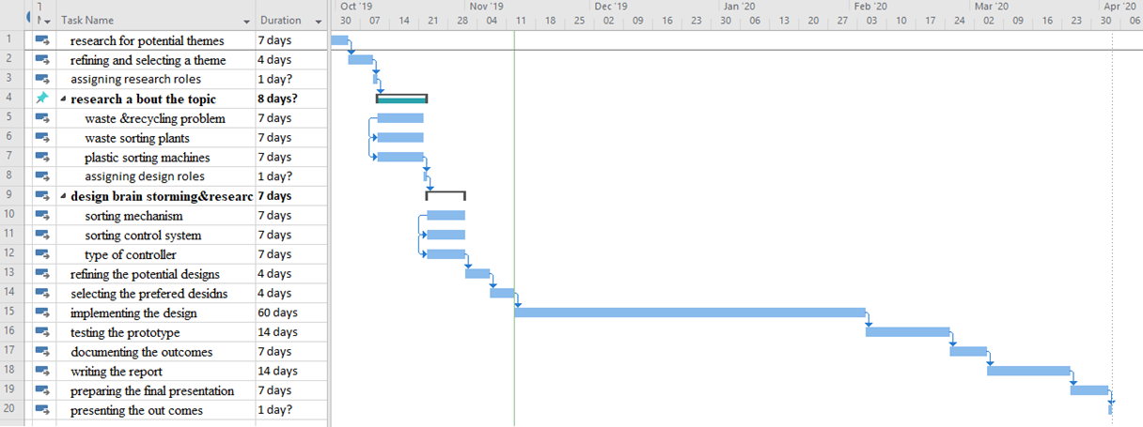

After forming the team, we spent the first few weeks in brain storming and coming up with potential ideas for the project theme and refining and selecting themes, and after we agreed to this project, we set this Gantt chart as a guide line which specifies all the milestones toward completing the project as follows:
- Assigning research roles:
This is was just an overview of the aspects related to the project in regard to waste and recycling issues and their effect on the environment, and reasons why recycling is vital also research about waste sorting plants in the UK and the types of machinery involved in the process, this was three individual research started on the 11th of October and ended by the 21st of October.
- Design brain storming and research:
This was held on the 23rd of October to the 31st of October, and also it was individual research but in three different prospects which are the sorting mechanism, the sorting control mechanism and the controller type which was as follows:

Initial design ideas:
The design for a system to segregate the objects according to their material if they were metal or glass, and according to the colour if they were plastic, could be divided into mechanical side and electronic side.

The mechanical side
- The drop designs
Which is a device receives and transfers the objects to the sorting mechanism in order to be segregated. This device could be thought of as:
- Conveyor belt
It is a relatively easy solution for moving and transferring materials, as the speed of the motor of the conveyor could be controlled to a certain speed, which gives time allowances for the sensors which will be placed on top of the conveyor belt to detect the objects. But on the other hand, the low speed is a down side to the conveyor as in return the efficiency of the system will be low.
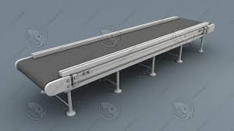
(Google).
- Auger conveyor
It is similar to the conveyor belt in terms of the speed and the efficiency
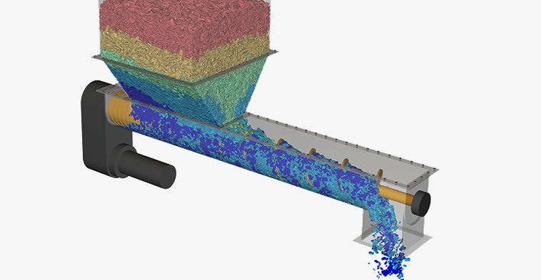
(Google).
- Vertical cylinder
It depends primarily on the gravity as the objects will be dropped from the top of the cylinder to rest on the sorting mechanism, and meanwhile the sensors located on the holes on the side of the cylinder, will detect the objects according to their material and colour. As shown on the graph below drawn using Autodesk Fusion 360
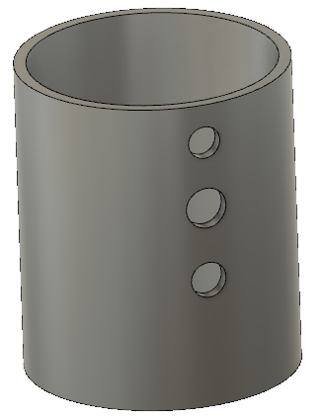
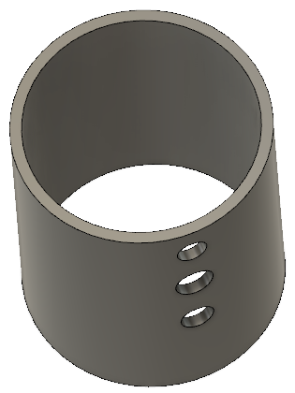

- The sorting mechanism designs
Taking advantage of the rotary motion, a rotary device on any of the three dimensions, could be made to segregate the objects such as:

- Horizontally rotating mechanism: where the cone rotates constantly creating centrifugal force pushes everything falls into the circular ring around the cone to the gates leaving the device. These gates there should be some doors attached to them and open and close using servo-motors according to the material and colour of the object fell into the device.
This device has no entrance gate as the objects will fall directly into the ring around the cone using any type of dropping devices mentioned before, while it has an advantage of a possibility of making exit gates all around the cone. As shown on the graph below drawn using Autodesk Fusion 360

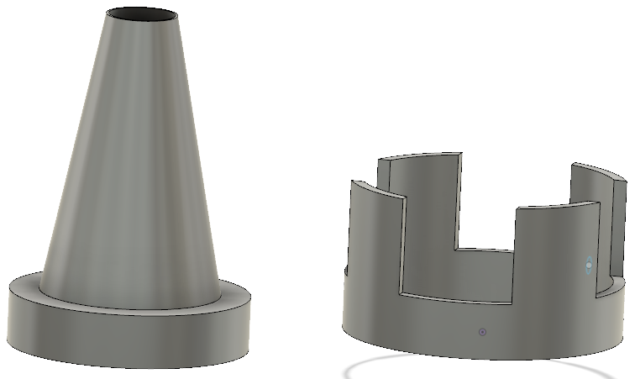
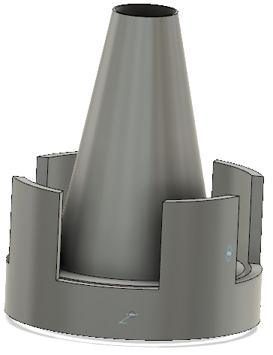
- Vertically rotating mechanism: which has the same principle as the previous device, just in a different dimension which is the vertical dimension which implies using the gravitational force to force the items to leave the device, instead of using the centrifugal force.
But it has down side as the entrance gate should be on the top half of the circle, then using the gravitational force requires the exit gates to be on the bottom half of the circle otherwise the objects will remain inside the device. This condition reduces the number of the exit gates to half of what the horizontal device has. As shown on the graph below drawn using Autodesk Fusion 360

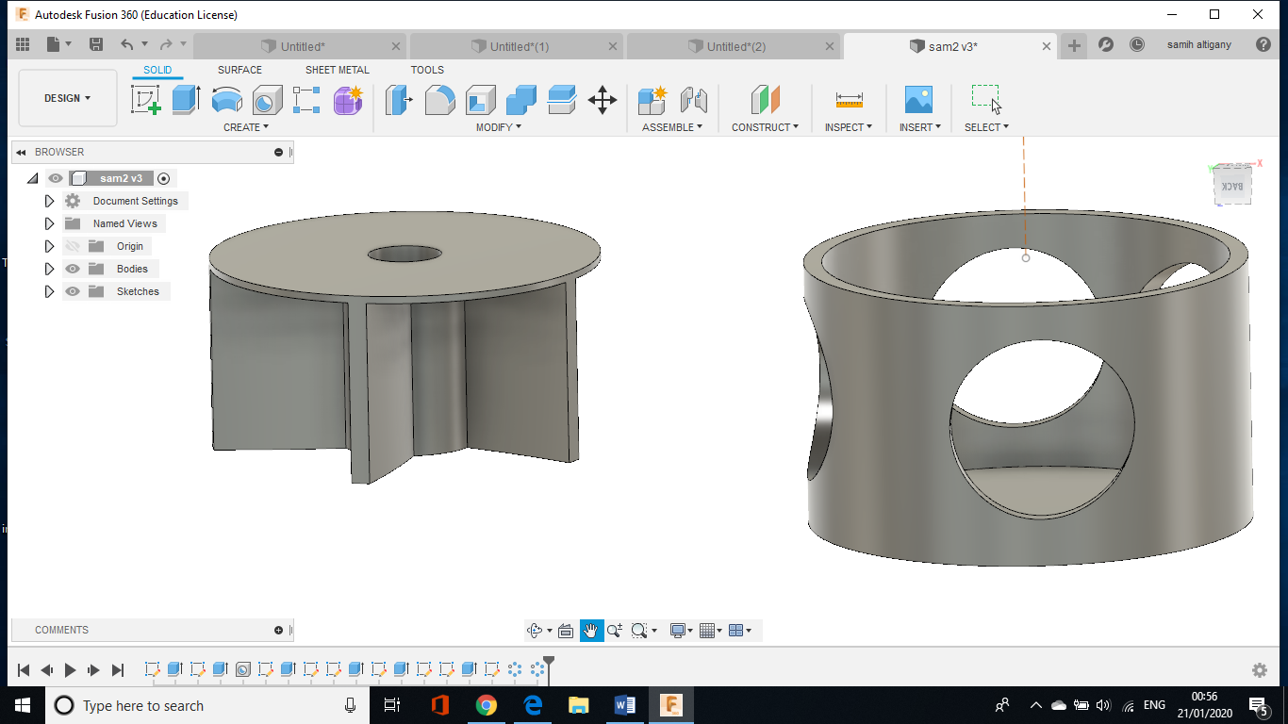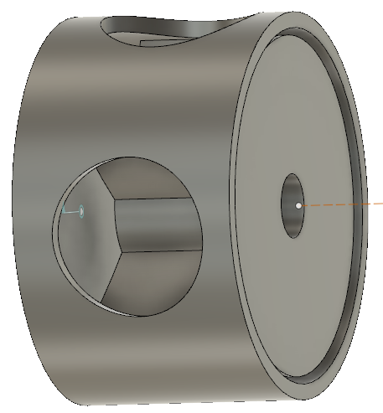

- The deflector:
It is just a tube connected to a servo-motor. Therefore, it’s much easier to control the rotation in the circumference of the servo-motor where bins will be located to collect the objects. As shown on the graph below drawn using Autodesk Fusion 360

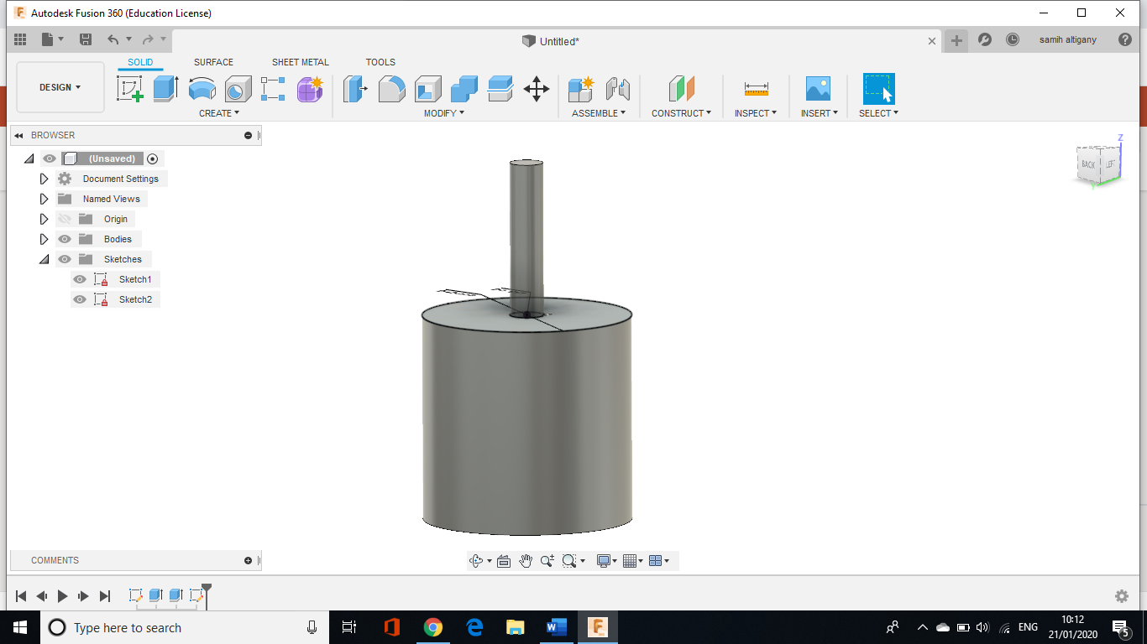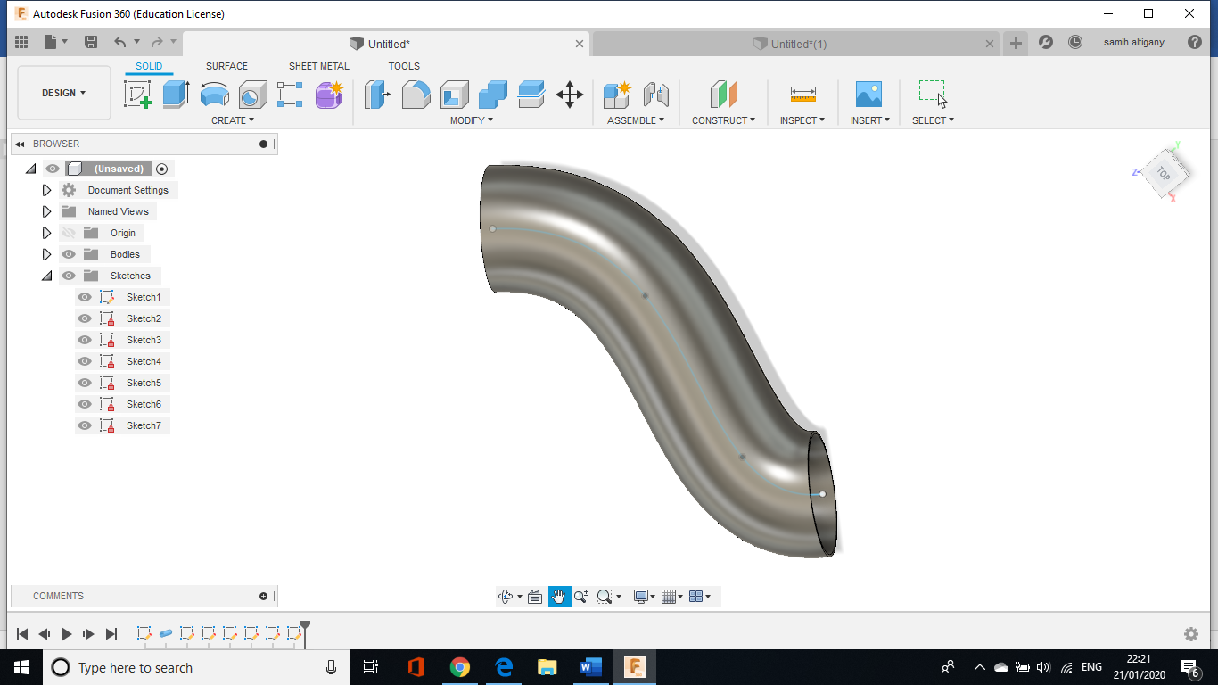

The electronic side
- The sensors: there will be three types of sensors colour, metal and glass sensor. These sensors will be made using passive components with the aid of microcontrollers.
- Controlling devices: there are many options to choose from as a controller such as plc, PIC, Arduino, etc.

- Refining and selecting the potential design
This stage of the progress of the project started on the 1st of November to the 6th of November, and the discussion resulted in the following:
- In respect to the drop mechanism, the options we have are the vertical drop represented in the tube and the horizontal drop represented in the conveyor and the auger conveyor. Therefore, the vertical drop is eliminated due to the speed of the items falling through the tube which does not allow enough time for the sensor ‘which the team suppose to make from passive components’ to identify the objects unless high quality industrial sensors are used which defeat the point of this project which is making a device from passive components.
On another hand, the auger conveyor was also eliminated as it requires making it and dive more into mechanical design aspects drive us away of electronic route, we intend to go in. therefore, the only option left is the conveyor belt which is simpler and more convenient.
- In respect to the sorting mechanism, two of the designs were eliminated which are:
The vertically rotating mechanism:

And the horizontally rotating mechanism:
Which both require sharp mechanical skills and accuracy, which implies manufacturing these models either by 3D printing which is accurate but expensive regarding the required size of the prototype which is considerably big, or making prototype from appropriate size of scrap tins which is possible, but would not be functional as all the exits have to be covered with doors controlled to open and close by the controller which is slightly difficult to make by hand. Which left us with the deflector as our only option.

- The electronic side
- Arduino microcontroller is a better option as we are decided to make glass sensor, metal sensor and colour sensor from passive components using microcontrollers and also to control the whole system.

- The resulting system
After this filtering and elimination process the resulting parts of the system are a conveyor belt driven with servo-motor as transmission for the objects and detection area using the sensors, then using the deflector as segregating mechanism which runs with a servo-motor. as shown below
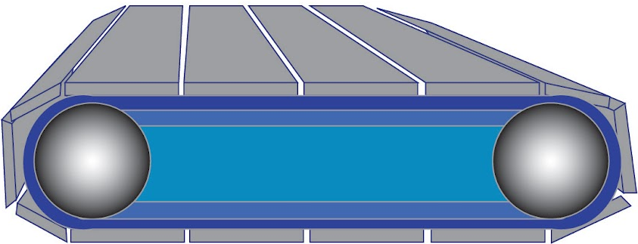

- Implementing the design
This stage stared on the 13th of November starting with the electronic part of the project splitting it into three individual tasks as follows:
- Glass sensor: Buthaina took the initiative of designing and implementing her design into a functional circuit.
- Metal sensor: Noor was in charged of the design and implementation process.
- Colour sensor: Samih took the initiative of making it.
All the sensors should be located on the conveyor belt and connected to the microcontroller as well as the deflector servo-motor and the conveyor motor.

Functional Block diagram
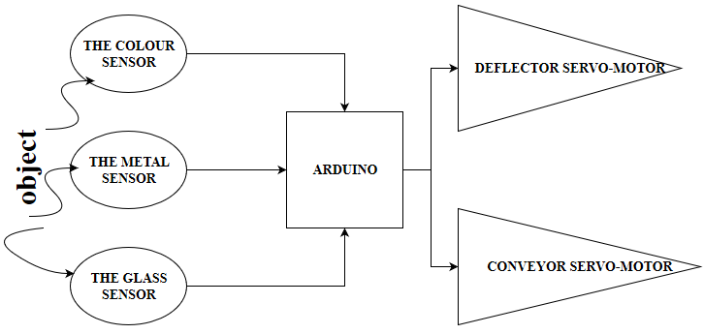

From the block diagram, it’s clear that whenever the sensors are exposed to an object, they identify the material whether it is metal or glass. If it is neither of them then the colour sensor identifies the colour, this data will be sent as an input to the controller and accordingly the controller will send an output in form of moving the conveyor belt and rotating the deflector to the desired position.

- Implementing the electronic design side
The colour sensor:

The demonstration video shows that using passive components like resistors, photo resistor, LEDs, and with the aid of Arduino microcontroller, a colour sensor has been made.

Functional Block diagram:
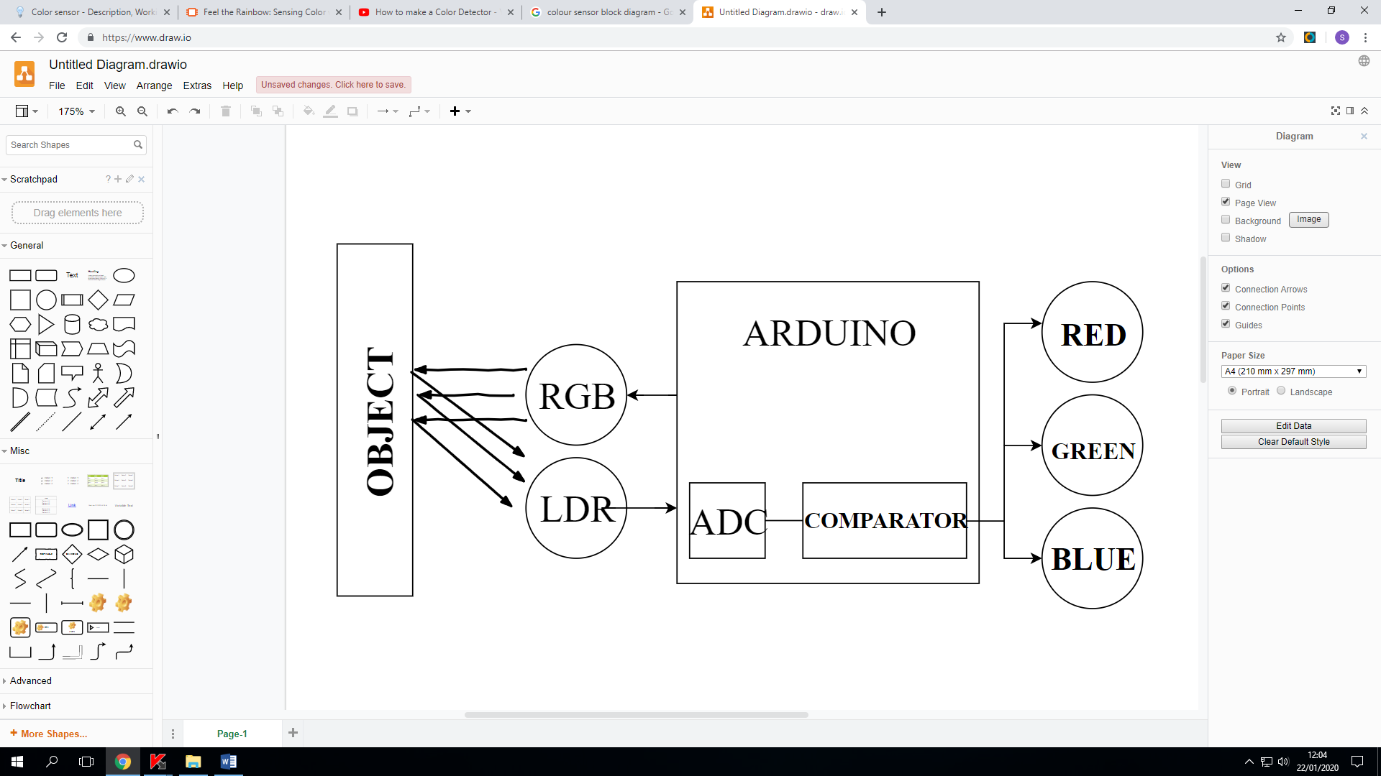

Working principle:
Since different light colours have different wavelengths and different intensities, as shown in the photo below
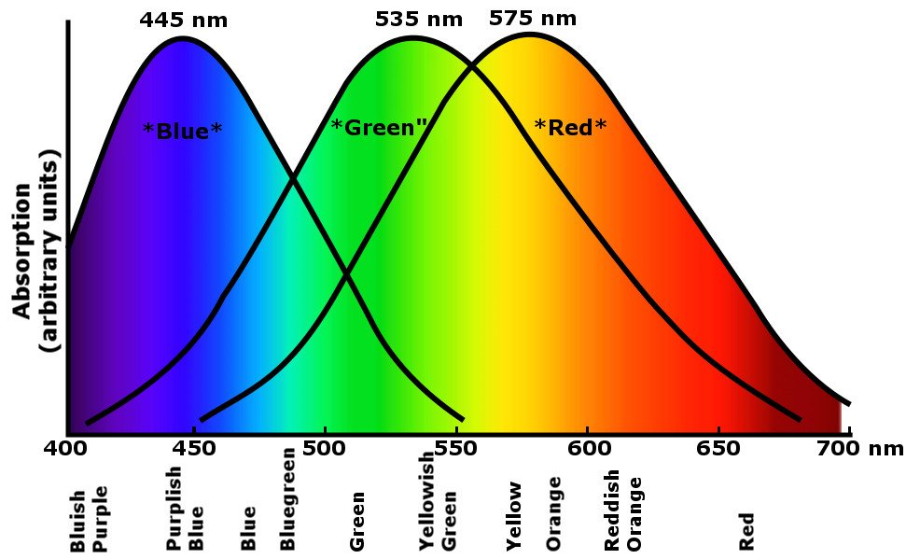(Google).

Using a light dependant resistor LDR “photo resistor” which is a resistor whose resistance varies inversely with intensity of light, or its conductivity increases with the intensity of the light. Putting this information in consideration, when an object is present in front of the RGB and the LDR, the RGB flashes red, green then blue and the light reflects back from the object to the LDR, and depending on the colour of the object, the most reflected light will be the same as the colour of the object or has the highest intensity.
The process of measuring the intensity of each colour will be done by the ADC analogue to digital convertor inside the microcontroller. Then after identifying the highest intensity colour, a similar colour LED will flash on.

The electronic circuit:
The circuit below was drawn using Autodesk TINKERCAD.
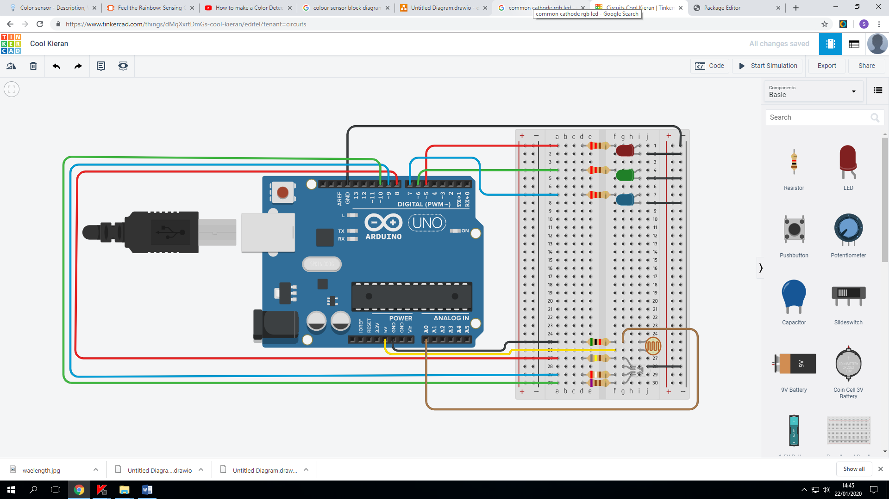

Component list:
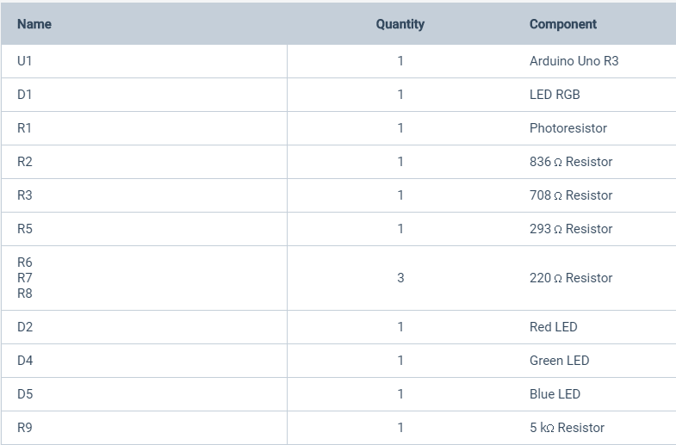

Calibrating the circuit:
In order to get the exact same intensity from the red, green and the blue light, a hardware calibration has to be done by measuring the resistor connected to each leg of the RGB led using a multimeter in the dark at night to avoid any interference of infrared light IR or ultraviolet light UV, until getting the same reading from the three colours which in return required using 836Ω resistor for the red leg, 708Ω resistor for the green leg and 293Ω resistor for the blue leg.

The flow chart:
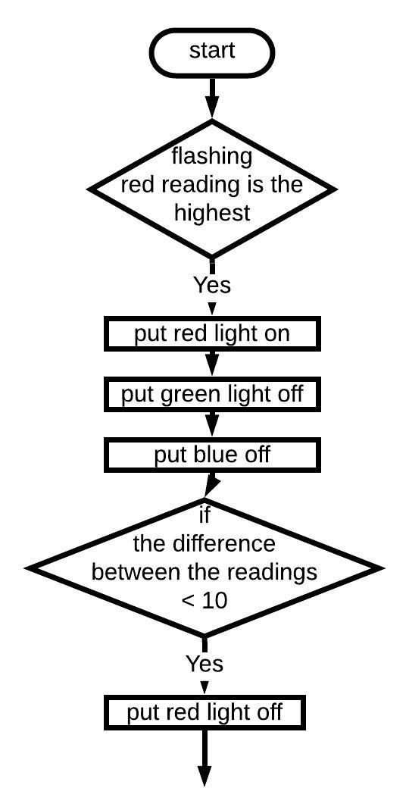
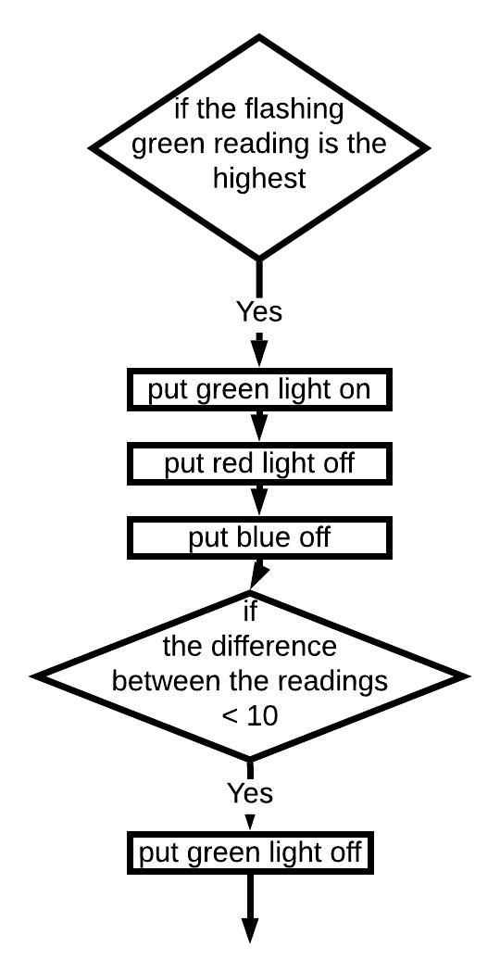
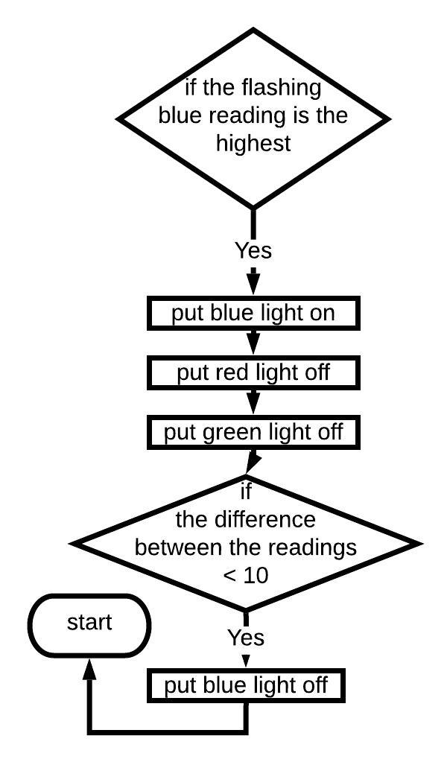

The programme is fairly simple and basic starts by measuring the resistance of the LDR when the red flashes then when the green flashes then when the blue flashes, then comparing these readings and choosing the highest which indicates the colour of the object in front of the LDR, and accordingly the sae colour of LED will be lit up.
Then readings will be taken again and if they are the same this would indicate that there is no object in front of the LDR, but practically, the LDR is calibrated using resistors to insure getting the same reading from all the colours but resistors have standard sizes which lead to slight difference in the readings on the three colours, therefore to avoid this difference a threshold is set and the command will be the difference between the three readings should be less than 10, and if this condition is true then all LED’s will be put off.
This process will be repeated for the three colours one after the other then the programme will start over again.

The code
/*
This programme simulates the control process of a coulour sensor
Written by Samih Altigany
*/

int lightpin = A0; // analouge input pin connected to the LDR
int redval; // it is the value of the reading when the RGB flashes red
int greenval; // it is the value of the reading when the RGB flashes green
int blueval; // it is the value of the reading when the RGB flashes blue

int red = 8; // pin number of the red leg of the RGB
int green = 9; // pin number of the green leg of the RGB
int blue = 10; // pin number of the blue leg of the RGB

int wait= 200; // delay time after putting a leg of the RGB HIGH
int slow = 200; // delay time after putting a leg of the RGB LOW

int outred = 4; //pin number of the red LED
int outgreen = 5; //pin number of the green LED
int outblue = 6; // pin number of the blue LED

int lastlight = HIGH; // constant value

void setup() {
// put your setup code here, to run once:
pinMode(lightpin,INPUT); // assign the pin as an input
pinMode (green,OUTPUT); // assign the pin as an output
pinMode (red,OUTPUT); // assign the pin as an output
pinMode (blue,OUTPUT); // assign the pin as an output

pinMode (outgreen,OUTPUT); // assign the pin as an output
pinMode (outred,OUTPUT); // assign the pin as an output
pinMode (outblue,OUTPUT); // assign the pin as an output

Serial.begin(9600); // put the serial moniter on
}

void loop() {
// put your main code here, to run repeatedly:
digitalWrite (red,HIGH); // put the red leg of the RGB on
delay (wait); // delay so the reading does not interfer with the coulour of the RGB was on before
redval = analogRead (lightpin); // read the value for the intensity of the red leg of the RGB
Serial.print (" red is "); // print on the serial moitor "red is "
Serial.print (redval); // print on the serial moitor the value of the red RGB reading
digitalWrite (red,LOW); // put the red leg of the RGB off
delay (slow); // delay so the reading does not interfer with the coulour of the RGB was on before

digitalWrite (green,HIGH); // put the green leg of the RGB on
delay (wait); // delay so the reading does not interfer with the coulour of the RGB was on before
greenval = analogRead (lightpin); // read the value for the intensity of the green leg of the RGB
Serial.print (" green is "); // print on the serial moitor "green is "
Serial.print (greenval); // print on the serial moitor the value of the green RGB reading
digitalWrite (green,LOW); // put the green leg of the RGB off
delay (slow); // delay so the reading does not interfer with the coulour of the RGB was on before

digitalWrite (blue,HIGH); // put the blue leg of the RGB on
delay (wait); // delay so the reading does not interfer with the coulour of the RGB was on before
blueval = analogRead (lightpin); // read the value for the intensity of the green leg of the RGB
Serial.print (" blue is "); // print on the serial moitor "blue is "
Serial.println (blueval); // print on the serial moitor the value of the blue RGB reading
digitalWrite (blue,LOW); // put the blue leg of the RGB off
delay (slow); // delay so the reading does not interfer with the coulour of the RGB was on before

if (redval>greenval+20 & redval>blueval+20) // question is red reading is the highest
{digitalWrite (outred,lastlight); // put the red LED on
digitalWrite (outgreen,LOW); // put green LED off
digitalWrite (outblue,LOW);} // put blue LED off
if (abs(redval-greenval)<10 & abs(redval-blueval)<10 & abs(greenval-blueval)<10) //checking the absolute value of the difference between the readings
{digitalWrite (outred,LOW);} // put the red LED off

if (greenval>redval+5 & greenval>blueval+5) // question is green reading is the highest
{digitalWrite (outgreen,lastlight); // put the green LED on
digitalWrite (outred,LOW); // put red LED off
digitalWrite (outblue,LOW);} // put blue LED off
if (abs(redval-greenval)<10 & abs(redval-blueval)<10 & abs(greenval-blueval)<10) //checking the absolute value of the difference between the readings
{digitalWrite (outgreen,LOW);} // put green LED off

if (blueval>greenval+20 & blueval>redval+20)
{digitalWrite (outblue,lastlight); // put blue LED on
digitalWrite (outred,LOW); // put red LED off
digitalWrite (outgreen,LOW);} // put green LED off
if (abs(redval-greenval)<10 & abs(redval-blueval)<10 & abs(greenval-blueval)<10) //checking the absolute value of the difference between the readings
{digitalWrite (outblue,LOW);} // put blue LED off

}

// THE END

- Implementation of mechanical part of the project
The progress on this side wan not as expected as the college had to close down but in terms of the conveyor belt, we have managed to fix a broken conveyor belt was in the lab had its motor broken. With the help of the staff in the metal workshop using the laths we managed to produce a fitting for the motor as the replacement motor had different fitting than the one on the conveyor.
In respect to the deflector, it was considerably easier as all what we needed is stepper motor and a piece of metal in a slide shape, we had the stepper motor ready but we did not manage to finish the sliding part.
This stage was meant to finish by the 4th of February but the research on the design procedure about the glass sensor and the metal sensor took longer than we expected.

- Testing the prototype
The only parts have been tested are the colour sensor and the conveyor belt which are fully functioning but due to the college closing we did not have the opportunity to put them together forming a system to sort materials according to the colour as the other two sensors has not finished.

Conclusion
Despite the fact that we did not finished this project and we did not meet the intended design goal, but personally it has been a steep learning curve as I learned how to turn and convert an idea into a design then into a product, and the strategies included in the design and implementation process starting from brain storming, going through elimination and refining process, ending with the implementation process and producing a prototype then testing it.
Also, through the implementation process I learned how to use the test, measurement and inspection equipment such as the multi-meter, also it was a great opportunity to look in depth into the practical use of the electronics components and see the beauty of making useful things out of very basic and passive components.

References
(Help save nature).
Available at: https://helpsavenature.com/why-should-we-recycle
(Accessed:22nd January 2020).

(google).
Available at: www.google.com
(Accessed: 15th December 2019).

