NAME: ELENA CARMEN ANGHEL
STUDENT NUMBER: 1905217
MODULE LECTURE NAME: LEADERSHIP AND MANAGEMENT THEORY AND PRACTICE
ASSIGNMENT TITLE: ASSESMENT 2
LECTURE NAME: Dr TAYE OSADIYA

Good leaders are very crucial in the management of a business organisation and acquiring desired results. As stated by Harrison (2018), self-evaluation among leaders is very important for understanding individual strengths and weaknesses. As has been determined, Jeff Bezos is an effective leader due to self-analysis and accepting their failures flawlessly. In this regard, he has possessed better ideas about different steps to do the business successfully and consistently (Gallo, 2021). Leaders who are not afraid to fail are more capable of trying new things and thus, innovative steps can be easily generated.
Similarly, a continuous learning atmosphere within the business operations can be undertaken, and hence, overall development can be obtained. In this context, successful leaders including Jeff Bezos have been implementing the "Situational Leadership” theory where they act according to the situations, and hence, desired results can be achieved (Walls, 2019). Effective leaders are often free from bias and they possess an open attitude in accepting things hence, new things can be executed within the business (Anggorowati et al. 2020). Similarly, Jeff Bezos has been successful in creating a positive working environment where all the employees can openly communicate with the hierarchy and share their perspectives without any fear.
The unique quality of Jeff Bezos is that he can accept the challenges of different situations and take action accordingly. The implementation of situational leadership strategy in his company is visible and he embraces various policies to cope with the situations (Rüzgar, 2019). Firstly, the step of guiding is taken and in this, the leader guides the employees about what is needed and what is not. The conveying of direction is another way of tackling different situations. The direction and providing guidance to the employees require proper collaboration and communication with them. Hence, it can be said that Jeff Bezos is an employee-friendly leader that makes the employees participate in the development of the company (Oko-Otu et al., 2020).

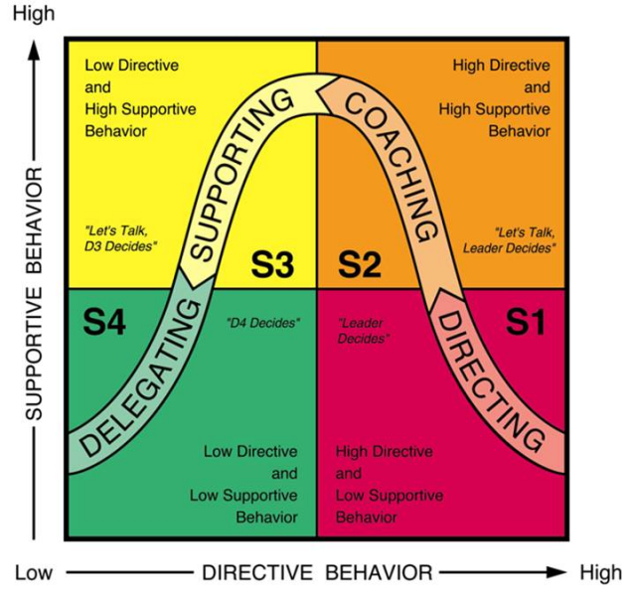
Figure 2: Situational leadership
(Source- learningpointing, 2022)
The empowerment of the employees is quite needed when it comes to tackling the different situations. The employees are to be given the power to convey their thoughts and give their opinions. In that way, they feel valued and they become more inclined towards determining the welfare of the company. Jeff Bezos as the CEO of a globally recognised company like Amazon adopted this way of leadership to provide his employees with a healthy environment where their opinions and presence would be valued. So, the "situational leadership" theory is useful when it comes to the welfare of a company like Amazon (Rosenshield, 2020.).

Gallo, C., 2021. How Jeff Bezos Consistently Communicates Four Core Values That Made Amazon A Success. Available from https://www.forbes.com/sites/carminegallo/2021/02/11/how-jeff-bezos-consistently-communicates-four-core-values-that-made-amazon-a-success/?sh=221ea00a6e24. Accessed on 13/4/2022.
Anggorowati, R., Komariah, A. and Permana, J., 2020. Educational Leaders‟ Outlook on Strategic Communication Skills. organization, 8, p.10.
Rüzgar, N., 2019. LEADERSHIP TRAITS OF SULEIMAN THE MAGNIFICIANT, IN TERMS OF “GREAT MAN” THEORY. Osmanlı Mirası Araştırmaları Dergisi.
Oko-Otu, C.N. and Chidume, C.G., 2021. OBJECTIVITY AND THE GREAT MAN THEORY IN HISTORIOGRAPHY. Cogito, 13(3), pp.124-138.
Rosenshield, G., 2020. Crime and Punishment, Napoleon, and the Great Man Theory. Dostoevsky Studies, 23.

