Student name: Kerris Adina Smith Student ID number: 1915100

Assignment Title: Health Assessment Report

Programme: BSc Health and Social Care

Module: Introduction to Physiology

Module code: BMHP5003_BIRM

Lecturer: Giridhar Katti

Content Page

Introduction …………………………………………………………………………..Page 3
Nervous System and stroke………………………………………………………...Page 3
Case……...……………………………………………………………………………Page 4
Assessment Report…………………………………………………………………..Page 4
Diagnostic Testing……………………………………………………………………Page 5
Recommendations……………………………………………………………………Page 5
Medications……………………………………………………………………………Page 6
Conclusion…………………………………………………………………………….Page 6
Appendix - Consent Form & Lifestyle Questionnaire …………………………….Page 7,8 & 9
Reference...……………………………………………………………………………Page 10,11 & 12

Introduction

In this report will be a care plan which has been developed for a woman aged 45 who has had a stroke. 1.3million people in the UK are currently living with stroke and in a year, there is around 100,000 people that have a stroke (NICE, 2021). The objective of this report is to collect data from the patient to formulate a care plan which will help and assist her in the future. The report will construct of a case study about the patient and their family background. This will lead to an assessment report which will include the findings and what caused these findings. Recommendations will be given to the patient, with ideas of how we can change the patient lifestyle to benefit them. Suggesting ideas that the nurses can do to help the patient. A conclusion will be given towards the end of the report of what will be done to help this individual and the advice which was given.

Nervous System and stroke
One of the nervous system disorders is a stroke, this occurs when the blood supply has a disruption to the nerve cells in the brain due to oxygen not getting to the brain. This can cause the function of body parts to have a permanent or temporary loss. One side of the body could become numb or weak, balancing can become difficult and there may be disturbance to eyesight and develop a slurred speech (Parker, 2009, p.124). Cells and nerves are what makes up the nervous system, this is also known as neurons. The purpose of these complex collections is to transmit signals to different parts of the body. People have known the nervous system to be the electrical wiring for the body (Zimmermann, 2018). The nervous system is made up of 3 parts the Central Nervous System (CNS), the Peripheral Nervous System (PNS) and the Autonomic Nervous System (ANS). Central Nervous System is consisted of spinal cord and the brain, and the Peripheral Nervous System consist of 31 pairs of nerves from the cord and 12 pairs of nerves from the brain. These nerves travel relaying information to every part of the body, to and from the CNS. Decision making and coordination is done by the CNS (Parker, 2009, p.78). The Autonomic Nervous System (ANS) regulates the rate of breathing and blood pressure and this happens naturally Low (2021).
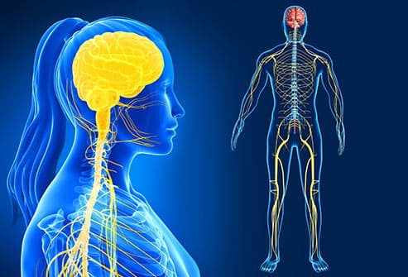
(Melinosky, 2019)
There are three types of strokes: Hemorrhagic is when blood is spilled in the tissue surrounding the brain by a ruptured or broken blood vessel Nall (2018).
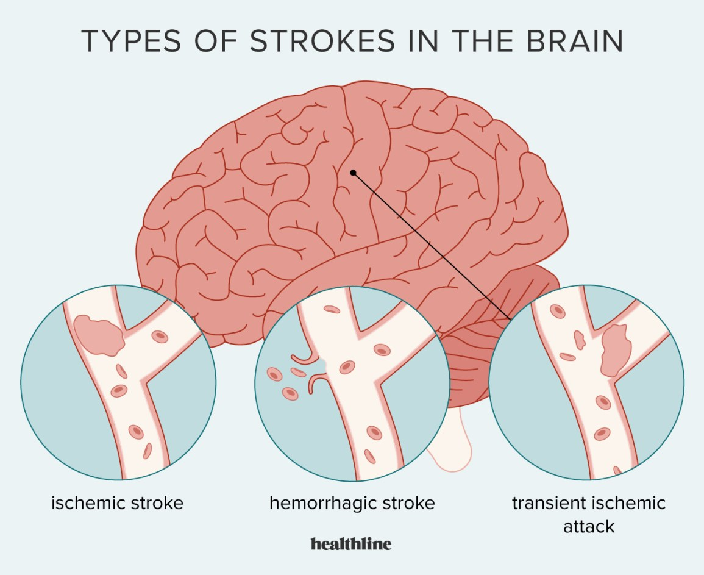
Holland (2021)
Ischemic Stroke is when the brain has no blood supply due to a blood clot. This occurs when the lining of a blood vessel has a build-up of fatty deposits Nall (2018).
Transient Ischemic Attack is also known as a ministroke, this is a blocked blood flow which is only temporary Nall (2018).

Case Study
Miss B is a 45-year-old, Black Caribbean female who lives alone. A false name has given to protect the identity of the female in this report. To the satisfactory of the Data Protection Act 2018, which regulates the personal information that was given to the carers. The UK completion of the General Data Protection Regulation (GDPR) is the Data Protection Act 2018 (GOV UK, 2021). Miss B also sign a consent form to be involved in this report. Please see the appendix for the consent form.
Miss B is 5 foot and 2 inch tall and weighs 14 stone, calculating at a BMI of 36 which suggests she is obese (National Health Service, 2021). Miss B has a stroke a year ago which has resulted into her not gaining any movement in the left side of her body. The type of stroke Miss B had was Ischemic Stroke. Miss B blood pressure was measure at 149/90 mmhg and she smokes around 20 cigarettes a day. She consumes around 3 to 6 units a day and is not involved in any exercise as she finds it difficult to move around due to not being able to move the left side of the body after a stroke. Due to Miss B not knowing how to cook, she eats fast food options everyday and does not consume any healthy options at all, even though she has been diagnosed with diabetes. When Miss B was asked about her family health history, Miss B mentioned that her Grandad suffered with stroke too and her mother has high blood pressure.

Assessment Report
High blood pressure and stoke are commonly linked (Lawes, Bennett, Feigin and Rodgers, 2004, p.776). Due to family health history, it was suggested to check Miss B blood pressure. Miss B blood pressure was measured using a device called the sphygmomanometer which a cuff is used around her arm which is then inflated until her circulation is cut off. By listening to the arteries for the blood pulsing through via a stethoscope the systolic blood pressure is measured. The blood pressure of the heart at rest indicates the diastolic pressure, both measuring in millimetres of mercury (mm Hg) Iliades and Haines (2021). Miss B blood pressure measured at 149/90 mmhg which is considered to be high. A useful source of information from the NHS suggests that diabetes is a known causes of high blood pressure (National Health Service, 2019). The reason Miss B could have high blood pressure could be due to many reasons. An unhealthy lifestyle, being overweight, smoking, drinking more than the recommended daily amount of alcohol and genetic (her mother having high blood pressure) can contribute to Miss B have high blood pressure (Parker, 2009, p.159). This is an indication that could have led to the stroke Miss B had a year ago (National Health Service, 2019). At the time of her stroke numerous tests was done to confirm the stroke. A scan to the brain was done to confirm whether stroke occurred due to either bleeding or clotting.

Diagnostic Testing
Computerized tomography (CT) was done on Miss B where the doctor pumped dye in her vein to identify any weak or thin spots on her artery. To see if there was any bleeding on the brain or any damaged brain cells the doctor took X-rays form different angles Beckerman (2021). The doctor noticed that there was a clot and requested for Miss B to have an immediate Magnetic resonance imaging (MRI). This is more effective than a CT scan and gives a more sharper image. The MRI gives a more detailed picture of the brain by using powerful magnets and radio waves Beckerman (2021). Because a clot was identified the doctor wanted to know where this clot had come from and had I idea that it may have travelled from Miss B heart to her brain. An Echocardiogram was done which is an imaging test on the heart to look for clots (American Heart Association, 2018). These tests confirmed that Miss B has suffered an Ischemic Stroke. A test was done to test Miss B sugar levels. This was done by a prick to the finger by a small needle called a lancet. A small amount of blood was deposited to a test strip which was then put on a meter which immediately show Miss B sugar levels Ambardekar, (2021). Miss B sugar levels was at 250 mg/dL which indicated she has type 2 diabetes. Miss B has diabetes due to the unhealthy lifestyle she has chosen Fletcher (2020) Diabetes is one of the causes of a stroke (Stroke Association UK, 2021).
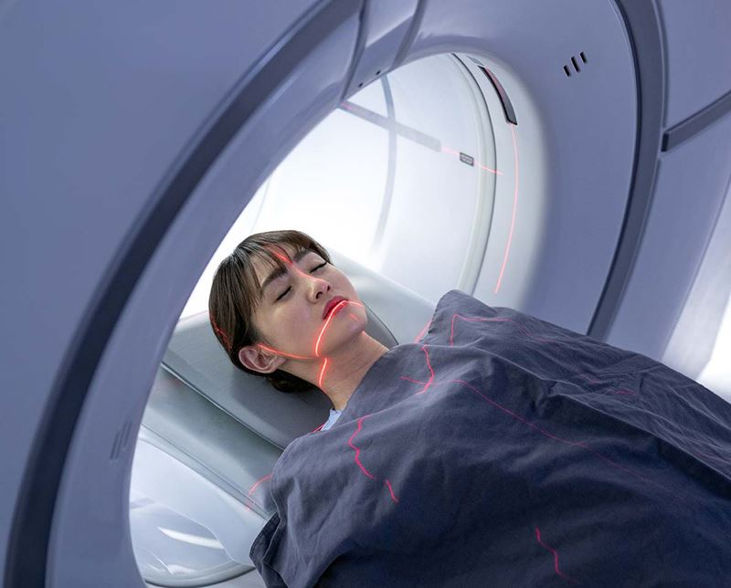
(American Heart Association, 2018)
Recommendations
A care plan is needed to ensure improve the quality and coordination of healthcare to an individual in order to have the best quality of life (Brummel‐Smith et al. 2015, p.15). A care plan has been made between all the healthcare professionals that have been involved in Miss B care. This care plan with support her so that she can have a better quality of life. Miss B has been given a meal plan to follow because the food intake that Miss B was eating was not good for her at all, especially because of all of the health complications she has. A health care assistant has been assigned to Miss B to go round to her home two times a day to help prepare her meals and assist with any household chores Miss B has been struggling with due to her not being able to move the left side of her body. Since Miss B previous stroke has had an effect on the left side of her body waist up, the healthcare assistant will be encouraging Miss B to go for short daily walks to promote physical movement to her body. This will be not only beneficial to her fitness level, but studies have proven along with a healthy diet to aim to lose weight and physical activity can benefit people that have type 2 diabetes (Tuomilehto et al, p.S210, 2011). Miss B has been advised to have her eyesight regularly checked due to her having type 2 diabetes. Unfortunately type 2 diabetes can cause nerve damage in the eye Dansinger (2021).
Miss B has been advised to attend physio to do arm rehabilitation exercise to improve the movement in her left arn. Repetitive practising opens the neutral pathways in the brain, even though it may be weak due to the stroke, continuous practise can make the pathway stronger Denslow (2021).
Excessive smoking can cause long term effects on Miss B body system. Continuing body complications can also occur. Miss B has been advised to stop smoking and has been prescribed patches to help her to stop smoking. Type 2 diabetes can progress more faster when smoking and also increase blood clots which leads to another stroke Pietrangelo (2019). Miss B and her family have been advised how detrimental it is for Miss B to stop smoking.
Pietrangelo and Raypole, 2021 stated that experts recommended people that have diabetes to stay away from drinking high volumes of alcohol. Miss B has been advised to stop drinking alcohol.

Medication
Angiotensin-converting enzymes (ACE) is prescribed to Miss B. This is to lower the blood pressure and improve the blood flow by opening and relaxing the blood vessels. This is to be taken orally Donovan (2021).
Due to Miss B having an Ischemic Stroke and the clot being surgically removed the long-term treatment is aspirin to help clots from returning Hersh (2018).
Metformin has been prescribed to Miss B to treat the type 2 diabetes to help maintain and control the high blood sugar. This will also lower the change of her getting a stroke again Dansinger (2021).
Conclusion
Miss B can have a good quality of life if she sticks to her care plan. Miss B needs to ensure that she takes her medication and attends her physio sessions. This will enable her to regain movement in her arm so that she can do more for herself. Having a healthy diet and exercising will maintain her blood sugars and her blood pressure. This will have an end goal of her not getting blood clots again resulting into a stroke. It is important that Miss B don’t mix her medication with alcohol and stops smoking. Keeping everyone involved in Miss B healthcare up to date as well as the care plan, all healthcare professions should be able to see a progress or down scale in Miss B health. Regular tests should be done to check Miss B blood sugars and her blood pressure to ensure she don’t have another stroke again in the future.

CONSENT FORM
Title of Project: Report
Name of Researcher: Kerris Adina Smith
Please initial box
- I confirm that I have read the information sheet dated.16th November 2021 for the
above study. I have had the opportunity to consider the information, ask questions and have
had these answered satisfactorily.
CMMM

- I understand that my participation is voluntary and that I am free to withdraw at any time
without giving any reason, without my medical care or legal rights being affected.
C

- (If appropriate) I understand that relevant sections of my medical notes and data collected during
the study, may be looked at by individuals from [University of Wales ], from regulatory authorities or
from the NHS Trust, where it is relevant to my taking part in this research. I give permission for
these individuals to have access to my records.
C
C
- (If appropriate) I understand that the information collected about me will be used to support
other research in the future, and may be shared anonymously with other researchers.

- (If appropriate) I agree to my General Practitioner being informed of my participation in the
study. / I agree to my General Practitioner being involved in the study, including any necessary
exchange of information about me between my GP and the research team.
C

- (If appropriate) I understand that the information held and maintained by
______NHS______ [(enter name of organisation(s) that will be
C
providing you with data, including any NHS/HSC organisations)] may be used to help contact
me or provide information about my health status.
C
- I agree to take part in the above study.

Christine Booth 17’11’21 Christine Booth
Name of Participant Date Signature

Kerris Adina Smith 17’11’21 Kerris Adina Smith
Name of Person Date Signature

LIFESTYLE QUESTIONNAIRE

Introduction:

In order to help us focus our Health Promotion activities in the practice, we would be grateful if you could fill in this short questionnaire. If you have already completed one on a previous visit, please return this questionnaire to the receptionist.

Name Miss B ………………………… Date of Birth 09/05/76…………………...

Do you smoke? |  | Yes[ | * | ] No [ ]
If Yes, do you –
smoke less than 1 | cigarette/day |  | [ | ]
1 – 9 | cigarettes/day |  | [ | ]
10-19 | cigarettes/day |  | [ | ]
20-39 | cigarettes/day |  | [* | ]
more than 40 | cigarettes/day |  | [ | ]
smoke a pipe |  |  | [ | ]
smoke cigars |  |  | [ | ]

If No, have you –

never ever smoked  given up smoking in the last year not smoked for more than 1 year |  | [  [  [ | ]  ]  ]
Do you have high blood pressure? | Yes [ | * | ] | No | [ | ]
Have you ever had a heart attack or suffered from angina? | Yes | [ | ] | No[ | * | ]

Have you ever had a stroke, “shock”
or any weakness down one side? Yes [* ] No [ ] Have any of the following – mother, father,
brothers or sisters had –
a heart attack below the age of 60 | Yes | [ | ] | No | [ | ]
a heart attack above the age of 60 | Yes | [ | ] | No | [ | ]
a stroke | Yes | [ | *] | No | [ | ]
 | Yes | [ | ] | No | [ | ]

(hyperlipidaemia)

My Grandad had a stroke ………………………………………

Practice Use Only
Health Education Smoking 20 a day ………….

BP 149 / 90

Height 5ft 2 Inches………….

Weight 13 stones

Healthy exercise usually involves activity that lasts for at least 20 minutes, raises your pulse and produces hard breathing. In younger people this might be running, cycling or sport, or brisk walking for older people.

Do you take this type of exercise –

daily [ ]
3 times weekly [ ]
once weekly [ ]
once monthly [ ]
seldom [ ]

I cannot take exercise because of disability [* ]

DIET
Please tick the one category which is closest to your usual eating pattern.

I eat no meat, fish, or dairy produce [ ]
I eat no meat [ ]
I eat a mixture including daily fruit and vegetables [ ]
I eat a mixture including regular chips and fries [ *]
I eat frozen meals (e.g. TV dinners) 3 or 4 times/week [ ]
I eat mainly snacks [ ]
I eat a special medical diet [ ]

Please specify eats fast food daily ………………………………………………………………………

ALCOHOL
Please tick the statement which most closely describes your usual average alcohol intake. (1 unit is 1 glass wine, ½ pint beer or a single measure of spirit.)

I never drink alcohol [ ]
I drink less than 1 unit per day [ ]
I drink between 1 and 2 units a day [ ]
I drink between 3 and 6 units a day [* ]
I drink between 7 and 9 units a day [ ] I drink more than 9 units a day on average [ ]

Reference

- Ambardekar, N. (2021) Diabetes and Blood Sugar Testing. Available at: <https://www.webmd.com/diabetes/guide/how-test-blood-glucose> (Accessed 13 December 2021).
- American Heart Association. (2018) Common diagnosis methods. Available at: Common Diagnosis Methods | American Stroke Association (Accessed 13 December 2021).
- Beckerman, J. (2021) How a Stroke Is Diagnosed and Treated. Available at: <https://www.webmd.com/stroke/guide/understanding-stroke-treatment> (Accessed 13 December 2021).
- Brummel‐Smith, k. et al (2015) Person‐centered care: A definition and essential elements. Journal of the American Geriatrics Society, 64(1), p.15. Available at: Person‐Centered Care: A Definition and Essential Elements (wiley.com) (Accessed 13 December 2021).
- Dansinger, M. (2021) Type 2 diabetes treatment. Available at: Type 2 Diabetes Treatments: Medication, Insulin, Weight Loss, More (webmd.com) (Accessed 13 December 2021).
- Denslow, E. (2021) Regaining Arm Movement After Stroke: Methods for Recovery. Available at: <https://www.flintrehab.com/regaining-arm-movement-after-stroke/> (Accessed 13 December 2021).
- Donovan, R. (2021) ACE Inhibitors for Heart Disease Treatment: Types and More. Available at: <https://www.healthline.com/health/heart-disease/ACE-inhibitors> (Accessed 13 December 2021).
- Fletcher, J. (2020) Recognizing the signs and symptoms of type 1 and type 2 diabetes. Available at: <https://www.medicalnewstoday.com/articles/323867> (Accessed 13 December 2021).
- GOV UK (2021) Data protection. Available at: Data protection - GOV.UK (www.gov.uk) (Accessed 10 December 2021).
- Hersh, E. (2018) Everything you should know about ischemic stroke. Available at: Ischemic Stroke: Symptoms, Treatment, Recovery, and More (healthline.com) (Accessed 13 December 2021).
- Holland, K. (2021) Stroke: Symptoms, Causes, Treatment, Types & More. Available at: <https://www.healthline.com/health/stroke> (Accessed 11 December 2021).
- Iliades, C. and Haines,C. (2009). How Is Blood Pressure Measured? - Hypertension Center - Everyday Health. Available at: <https://www.everydayhealth.com/hypertension/understanding/what-does-blood-pressure-measure.aspx> (Accessed 10 December 2021).
- Lawes, C., Bennett, D., Feigin, V. and Rodgers, A. (2004) ‘Blood Pressure and Stroke’, Stroke, 35(3), pp.776. Available at: <https://www.ahajournals.org/doi/10.1161/01.str.0000116869.64771.5a> (Accessed 10 December 2021).
- Low, P. (2021) Overview of the Autonomic Nervous System - Brain, Spinal Cord, and Nerve Disorders - MSD Manual Consumer Version. Available at: <https://www.msdmanuals.com/en-gb/home/brain,-spinal-cord,-and-nerve-disorders/autonomic-nervous-system-disorders/overview-of-the-autonomic-nervous-system> (Accessed 10 December 2021).
- Melinosky, C., (2019). Visual Guide to Your Nervous System. Available at: <https://www.webmd.com/brain/ss/slideshow-nervous-system-overview> (Accessed 10 December 2021).
- Nall, R. (2018) Types of Strokes: Causes, Symptoms, and Treatments. Available at: <https://www.healthline.com/health/stroke-types> (Accessed 11 December 2021).
- National Health Service (2019). Causes of high blood pressure. Available at: High blood pressure (hypertension) - Causes - NHS (www.nhs.uk) (Accessed 10 December 2021).
- National Health Service (2021) BMI Healthy weight calculator. Available at: BMI calculator | Check your BMI - NHS | Your BMI result (www.nhs.uk) (Accessed 10 December 2021).
- NICE (2021) Prevalence Background information Stroke and TIA NICE. Available at: <https://cks.nice.org.uk/topics/stroke-tia/background-information/prevalence/> (Accessed 10 December 2021).
- Parker, S. (2009) The concise human body book. London: Dorling Kindersley.
- Pietrangelo, A. (2019) The effects of smoking on the body. Available at: 26 Health Effects of Smoking on Your Body (healthline.com) (Accessed 13 December 2021).
- Pietrangelo, A. and Raypole ,C (2021) What are the ffects of alcohol on the body. Available at: Effects of Alcohol on the Body (healthline.com) (Accessed 13 December 2021).
- Stroke Association UK (2021) Diagnosis. Available at: Stroke diagnosis | Stroke Association (Accessed 13 December 2021).
- Tuomilehto, J., Schwarz, P. and Lindstrom, J. (2011) ‘Long-Term Benefits From Lifestyle Interventions for Type 2 Diabetes Prevention: Time to expand the efforts’. Diabetes Care, 34(Supplement_2), p.S210. Available at: <https://care.diabetesjournals.org/content/34/Supplement_2/S210.full-text.pdf> (Accessed 11 December 2021).
- Zimmermann, K. (2018) ’Nervous System: Facts, Function & Diseases’. livescience.com. Available at: <https://www.livescience.com/22665-nervous-system.html> (Accessed 9 December 2021).

