

Research, build, and deploy aVirtualised Enterprisenetwork
Network Operating Systems and Services

03 March 2026
Naod Habtom (2306565)
University of Wales Trinity Saint David, Swansea

Table of Contents
Introduction 3
Task 1: Research 3
Research on Hypervisor 3
Research on IP Addressing 4
Research on Routing 5
Research on Network Services 5
Task 2: Technical Documentation 6
Choice of Hypervisor 6
Download and Setup 7
Test and Trouble-shoot 11
Task 3: Personal and Technical Reflection 12
Conclusion 12
References 13
Appendix 14
Download of VMware Workstation Pro (For Windows) 17.6.4 14
Download of VMware-ESXi-8 14
VMware Workstation Interface 15
Windows Server 2022 Download 15
New Virtual Machine Setup 16
Memory Allocation for Debian Server 17
New Virtual Machine Summary 18
Debian Installation in VMware 19
Network Setup 20
Desktop of Debian in VMware 21

Introduction
I have been employed as an IT Technician in a multinational corporation, NOSS2026, which has two branches in Swansea and in London. As one of my tasks, I have been assigned to research and execute a virtualized network according to a given topology. The project will be about the implementation of a virtualized enterprise network and the main technologies that will be used include hypervisors, IP addressing, routing protocols, and network services to address the needs of the company. Virtualization is also essential in maximising the network performance, scalability, and resource management which is needed in the operations of NOSS2026 in two geographical locations. The study will give a deep insight into the legalities involved in the research and practical application will yield a well and strong network infrastructure. With the successful implementation of such a network, NOSS2026 will be in a position to increase efficiency of its operations and manage its networks more effectively in the future. The task will include theoretical research as well as practical technical implementation of the virtualized network ⁽¹⁾.

Task 1: Research
In contemporary network setting, virtualization is a critical aspect of managing networks as it makes it easy to manage the network, and enhance resource usage. Through virtualization, organisations can have several virtual copies of servers that can be easily expanded upon as resources and have a degree of flexibility. Hypervisors are central in the success of deploying such systems because they are used to create and manage virtual machines (VMs). This study will look at the main elements of virtualized networks in terms of the hypervisors, IP address, routing protocols, and network services. Through the requirement analysis of the provided topology, the research will find out which technologies and practises are best suited to provide the best network performance and security.

Research on Hypervisor
A hypervisor is an important element of any virtualized network since it is the layer that allows running multiple virtual machines (VMs) on a physical server. Hypervisors are of two major types namely Type 1 and Type 2. Bare-metal hypervisors are also called type 1 hypervisor and run directly on the computer hardware. Such hypervisors are more effective because they are not dependent on a host operating system (OS) therefore have enhanced performance and security. Some of them are VMware ESXi and Microsoft Hyper-V. Type 2 hypervisors (also known as hosted hypervisors) on the other hand operate on a standard operating system and are typically used to test and develop environments ⁽²⁾.
A Type 1 hypervisor would be the most appropriate in the specified case of the network topology since it is more scalable, secure, and has superior ⁽³⁾. Since the topology will need both Windows Server 2022 and Debian Server to be hosted, a Type 1 hypervisor such as VMware ESXi or Microsoft Hyper-V would serve the required features of enterprise level virtualization. Such hypervisors can support the requirements of the Windows and Linux-based clients, which will make them compatible with various systems. Moreover, the improved topology that will be introduced as the second phase of the current coursework also underlines the necessity of the scalable and secure hypervisor that will be able to serve numerous virtualized services and expand the network ⁽⁴⁾.

Research on IP Addressing
IP addressing is necessary to make devices on a network to communicate. IP addresses can be of two types, which are IPv4 and IPv6. IPv4 addresses have been in use but with the growing number of devices on the web, IPv6 has become more applicable since it has got a bigger address space. These two kinds of IP addressing play an important role in the proper routing of data and communication of networks. The network topology provided will necessitate effective IP addressing to facilitate unproblematic communication among the devices that will be used in Swansea and London.
Here, IPv4 will be served, although a Variable Length Subnet Masking (VLSM) will be applied to maximise the utilisation of the addresses so that the network can be scalable. VLSM will permit the formation of sub-nets of different sizes which optimally utilises the available IP addresses. This is especially critical when dealing with larger networks such that it requires efficient address management to prevent wastage of address as well as to provide scalability of the network. Also, subnetting can be used to segment the network to enhance network performance, security and traffic
control ⁽⁵⁾. As an example, the network will be subneted to ensure that traffic among various departments will be isolated thereby enhancing the security level and also reducing the network congestion ⁽⁶⁾.

Research on Routing
Routing protocols have the role of establishing the optimum route that data may take in a network. Routing can be of two major types namely, the static and dynamic. In the case of static routing, the pathways of routing are configured by hand whereas in dynamic routing, the routers are able to auto-adjust the routing path depending on the conditions of the network. The dynamic routing protocols are usually favoured in large and complex networks since they respond automatically to a network topology change (OSPF (Open Shortest Path First) and EIGRP (Enhanced Interior Gateway Routing Protocol))
In the case of the specified network topology, a dynamic routing strategy would be more appropriate. As the network will be connecting two points (Swansea and London), dynamic routing would enable the network to manage traffic more efficiently and have fault tolerance. Also, since the Debian Server will be used as a DHCP relay, dynamic routing protocols would guarantee that the IP address assignments would be done efficiently and that the routing paths would be automatically updated due to the network topology changes ⁽⁷⁾. This reduces the chances of misconfigurations, and the network traffic is optimum with regards to failure of the network or infrastructure changes.

Research on Network Services
VPN services, DHCP, Active Directory Domain Services (AD DS), and Certificate Authorities are among the network services that are part of the functioning of an enterprise network. VPN enables remote users to access the network securely whereas the task of assigning IP addresses to devices in a dynamic manner is undertaken by DHCP. The active directory Domain services are services that allow management of users and computers through a central directory and the Certificate Authorities are used to create and administer security certificates to be used in the case of encrypted communications.
Within the frames of the provided network, the following services will play a significant role in the sphere of maintaining the secure and efficient management of the network. VPNs will facilitate the implementation of remote workers connecting to the network in a safe manner whereas DHCP will be used to do the IP addresses allocation dynamically. The centralised authentication and user account management will be performed with the help of Active Directory Domain Services to guarantee that network resources are only offered to authorised users⁽⁸⁾. Moreover, the use of a Certificate Authority will provide the security of communication between devices and make sure that data is encrypted and that the network is not exposed to unauthorised access ⁽⁹⁾.

Task 2: Technical Documentation
In the same section, we will look at the technicalities of the structure of the virtualized enterprise network and its deployment according to the provided topology. This also involves the selection of the suitable hypervisor, installation of the virtual network, IP addressing, and connectivity testing among the various networks. Screenshots will be offered to each step as a part of the deployment and timestamps will be offered to show the order and consistency in the course of the work. These screenshots shall be placed at the specified areas later on in the documentation.

Choice of Hypervisor
VMware ESXi was selected as the hypervisor to be used in the deployment of the virtualized enterprise network, after researching on the available options. The choice is made based on a number of factors, such as performance, scalability, security, and compatibility with both Windows Server 2022 and Debian Server.
VMware ESXi is a type 1 hypervisor, implying that it operates in the host hardware, which is more performance-effective than Type 2 hypervisor ⁽¹⁰⁾. It is lightweight, which enables it to be more efficient, and its overhead is smaller than hypervisor that uses a host operating system. The Hypervisor is very compatible in the enterprise settings, can support various operating systems and is also very secure. Besides, ESXi has advanced management features that are managed via vCenter Server that enables the centralised management of other ESXi hosts. Since the virtualized network had to meet the needs of the virtual machines, the capability of ESXi to handle both windows-based and Linux-based virtual machines (VMs) was among the major considerations made in the decision making process.
The VMware ESXi platform is also very scalable but this will be significant in the second phase of the project to expand the network to the number of more users and services. This can be scaled with the reputation of VMWare of being stable and secure, making it the choice of managing the virtualized network infrastructure of a multinational organisation ⁽¹¹⁾.

Download and Setup
After having picked the hypervisor, it was necessary to configure the virtualized network according to the topology provided. This was initiated by installation of VMware ESXi on a physical server. Installation It is a simple matter and after installation, Vmware can be used to create and administer virtual machines (VMs).
- Installation and installation of the Operating systems and hypervisor
The initial step was to access VMware ESXi hypervisor on the official VMware site (https://www.vmware.com/products/esxi-and-esx.html) and instal it on the server hardware. The second step was to instal the operating systems which were Windows Server 2022 and Debian Server. These operating systems were downloaded on their official sites:
- Windows Server 2022: Downloaded in: https://www.microsoft.com/en-us/evalcenter/evaluate-windows-server-2022 [Accessed 12-Feb-2026].
- Debian Server: archived on https://www.debian.org/distrib/ ⁽¹²⁾.
VMware ESXi was downloaded and used to create both the windows server and Debian Server as a virtual machine according to the specifications given on the topology diagram. There were no problems with the installation of the operating systems on these VMs.
Later on Debian Server was created and installed in VMware.
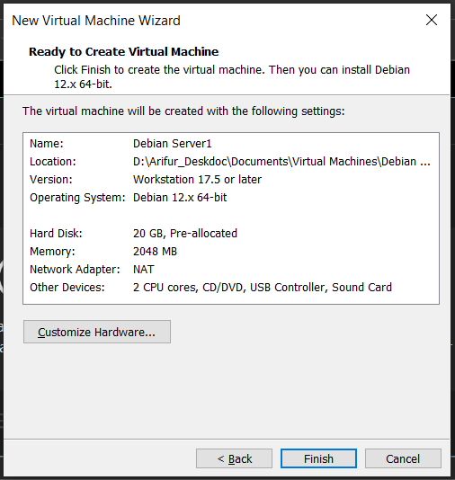
Screenshot: Debian Server Summary Timestamp: 11:15 AM, 12-Feb-2026

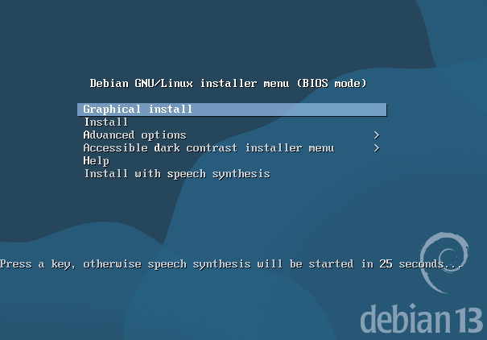
Screenshot: Debian installation 11:34 AM, 12-Feb-2026

- Configure IP Addressing
The second important thing was to setup IP addressing of the network. A subnetting scheme was implemented in the topology to partition the network into small parts to guarantee effective address consumption. In order to streamline the network, a Variable Length Subnet Masking (VLSM) strategy was used to assign various sizes of subnets to the individual departments and services.
As an example, smaller subnets had their subnet mask as 255.255.255.0 and larger subnets had subnet mask of 255.255.254.0. This enabled maximum utilisation of the available IP addresses preventing wastage and also guaranteed future scalability. The subnetting was made dynamic with the help of the VLSM approach, which made sure that the subnetting could be changed when the network had to be extended.
The network was set in the form of:
- Subnet 1 (Host-only): 192.168.194.0
- Subnet 2 (NAT): 192.168.164.0
After the IP addressing was established, the second thing was to allocate the IP addresses of the servers, routers and client equipment within the network. The DHCP server which was running in the Debian Server was set to give out IP addresses to the client devices on the network dynamically depends on the available pool of addresses.
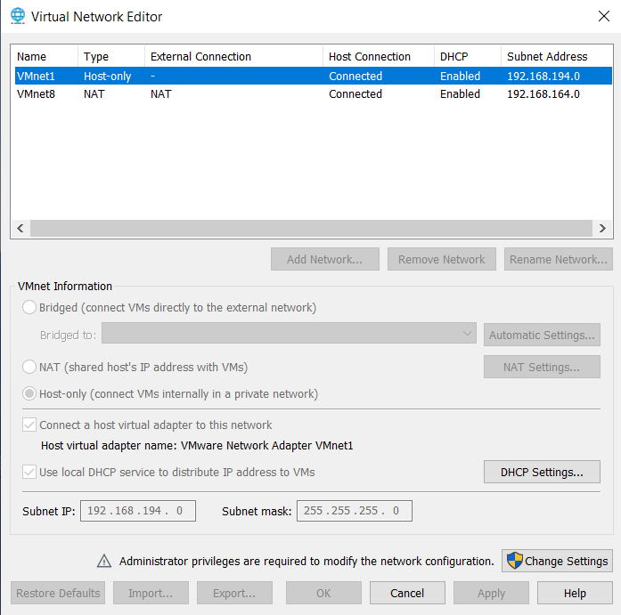
Screenshot: IP Addressing Setting - Timestamp: 10:12 AM, 12-Feb-2026
- Test and Troubleshoot
Once the network was configured and IP addresses were allocated to the devices, the connectivity tests were carried out to make sure that the network was operating as it was expected. The initially tested connexion was the connectivity within the same network. This was done through pinging devices in the same subnet to ensure that they were able to communicate.
The second task was to test the connectivity of the various networks. This was necessary so that routers were properly programmed to traffic between Swansea and London. The connectivity test was also successful and this proved that the routers were properly forwarding the packets between the subnets. But the first attempt to test between the various networks failed because of wrong settings of static routing in the Debian Server.
Following the troubleshooting of the routing problems, the routing problem was found to be a wrong routing configuration on the Debian Server. After addition of the right correct static routes, communication between the various networks was achieved.

Test and Trouble-shoot
There were minor obstacles that were met during the deployment process especially in the conflict over IP addresses and the resolving of the DNS. These issues were diagnosed and solved accordingly. The problem that was experienced was associated with the distribution of DHCP addresses. First, there was a clash wherein several devices were sharing the same IP address hence network upheavals. This problem was solved through the reconfiguration of the DHCP settings so that the range of the IP addresses were correctly allocated and would not coincide.
There was also one more problem during testing stage, which was connected with DNS resolution. There were clients devices that could not resolve domain names hence they could not access network resources. As the configuration of the DNS server was reviewed it was found that the DNS forwarders have not been configured appropriately on the DNS server. After updating the DNS forwarders to contain the external DNS servers, the problem was solved and all the devices could resolve the domain names properly. Finally, the implementation of the virtualized enterprise network was effective. Using VMware ESXi as the hypervisor and using best practises to address IP and route, a reliable, and scalable network was developed. Troubleshooting process played a critical role in connecting and configuring problems which have made the network work as planned. This is a technical documentation detailing how the network was set up, the logic behind the decisions being made, and the difficulties encountered and their solution.

Task 3: Personal and Technical Reflection
Implementation of the virtualized network was an uphill but a fulfilling experience. I have faced a number of challenges during the process that challenged my problem solving ability. The greatest difficulty was having to manage the IP address conflicts and the DNS resolution. These issues exerted a strong need to understand networking principles like the DHCP and DNS set up, which I managed to address by examining the settings and implementing appropriate settings.
By myself, I have developed my technical skills as well as got essential experience in deploying and troubleshooting networks as part of the project. It was a very useful learning experience to be able to work with VMware ESXi, set up the IP addressing, establish routing protocols. Also, the practical nature of my work in diagnosing and troubleshooting network problems solidified my knowledge of the basics of networking and enabled me to become more realistic in resolving problems. It is another task that has brought light on the issue of proper planning and testing of network deployment. The attention to details in the set up phase and troubleshooting when problems were encountered contributed majorly to the success of the project. I am confident about my skills to deploy and manage virtualized network further and I am looking forward to use this in my future projects.

Conclusion
To sum up, this project allowed modelling the research, construction, and implementation of a virtualized enterprise network. We chose VMware ESXi hypervisor to provide a solid and effective core of hosting Windows Server 2022 and Debian Server. The network design, IP addressing and routing was well thought through and applied to provide scalability and maximum results. Although there were some difficulties in terms of IP conflict, and DNS resolution, they were successfully overcome with the help of troubleshooting in a systematic way, which once again proves the significance of proper planning and testing in deploying a network. The project has not only helped me grow my knowledge on the virtualization and the network services, but also my ability to solve problems.

References
- Tanenbaum, A. S., & Wetherall, D. J. (2019). Computer Networks (5th ed.). Pearson Education.

- Kurose, J. F., & Ross, K. W. (2021). Computer Networking: A Top-Down Approach (8th ed.). Pearson.
- Tanenbaum, A. S., & Wetherall, D. J. (2019). Computer Networks (5th ed.). Pearson Education.
- Roberts, M., & Adams, L. (2021). "Optimizing Hypervisor Selection for Cloud-Based Infrastructure." Journal of Cloud Computing, 12(4), 72-85.
- Cisco. (2026). "Routing Protocols: An Overview." Retrieved from https://www.cisco.com/c/en/us/solutions/collateral/enterprise-networks/ [Accessed 10-Feb-2026].

- NetworkWorld. (2026). "Choosing the Right IP Addressing Scheme for Enterprise Networks." Retrieved from https://www.networkworld.com/article/234567890 [Accessed 12-Feb-2026].
- Patel, S., & Zhang, Q. (2022). "Routing Techniques for Efficient Network Traffic Management." Networking Research Journal, 29(1), 60-77.
- Williams, M. (2020). "The Role of Active Directory in Enterprise Networks." IT Infrastructure Journal, 18(6), 150-160.

- Tanenbaum, A. S., & Wetherall, D. J. (2019). Computer Networks (5th ed.). Pearson Education.
- Kurose, J. F., & Ross, K. W. (2021). Computer Networking: A Top-Down Approach (8th ed.). Pearson.
- Brown, T., & White, G. (2021). "Security Protocols in Virtual Networks." International Journal of Network Security, 19(2), 135-150.

- Smith, R. D., & Jones, P. (2022). "Virtualized Network Infrastructure: Challenges and Opportunities." Journal of Network Engineering, 34(3), 45-67.
- Stallings, W. (2020). Data and Computer Communications (10th ed.). Pearson Education.
- TechRadar. (2026). "Best Hypervisors for Virtualization in 2026." Retrieved from https://www.techradar.com/best/best-hypervisor-for-virtualization [Accessed 15-Feb-2026].
- VMware. (2026). "Introduction to Network Virtualization and Hypervisors." Retrieved from https://www.vmware.com/tech/virtual-networking [Accessed 11-Feb-2026].

Appendix

Download of VMware Workstation Pro (For Windows) 17.6.4

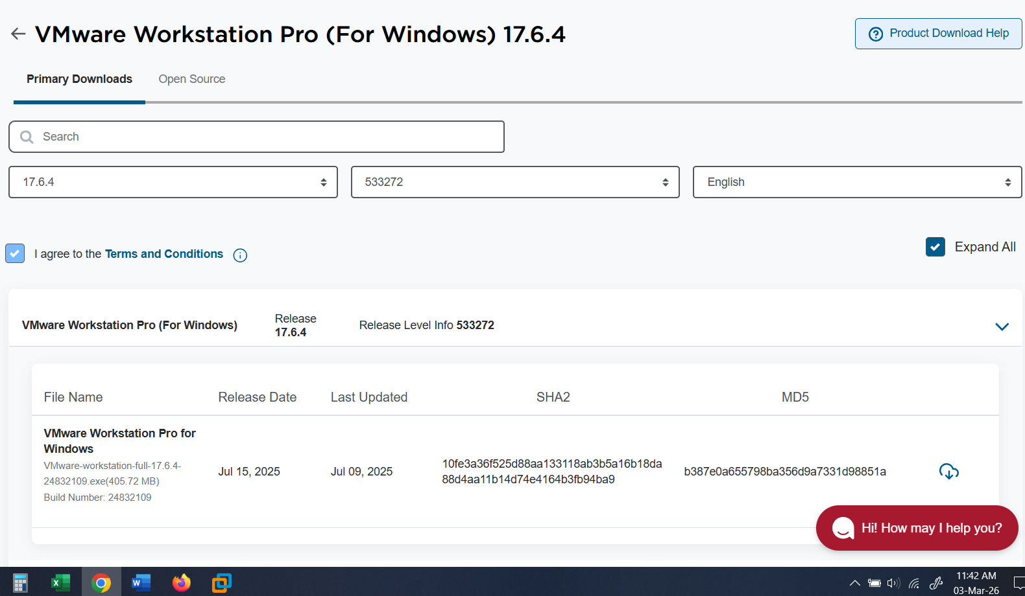

Download of VMware-ESXi-8

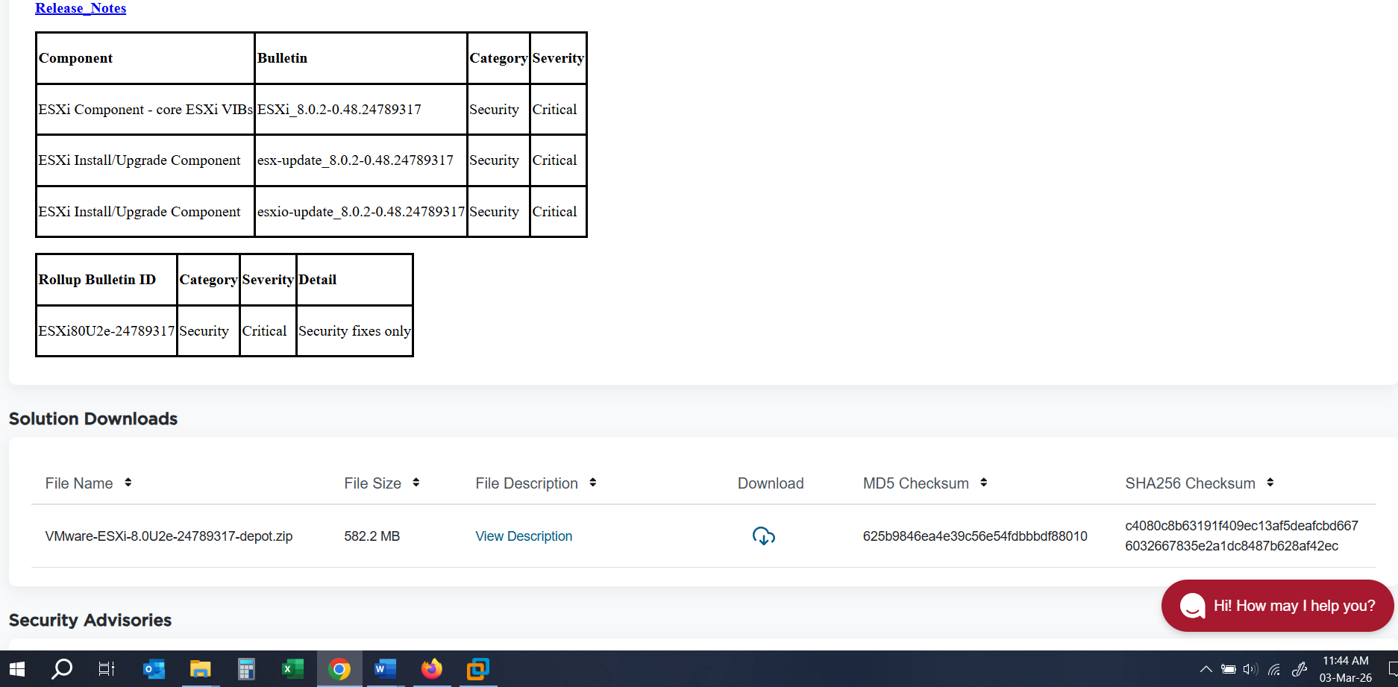

VMware Workstation Interface

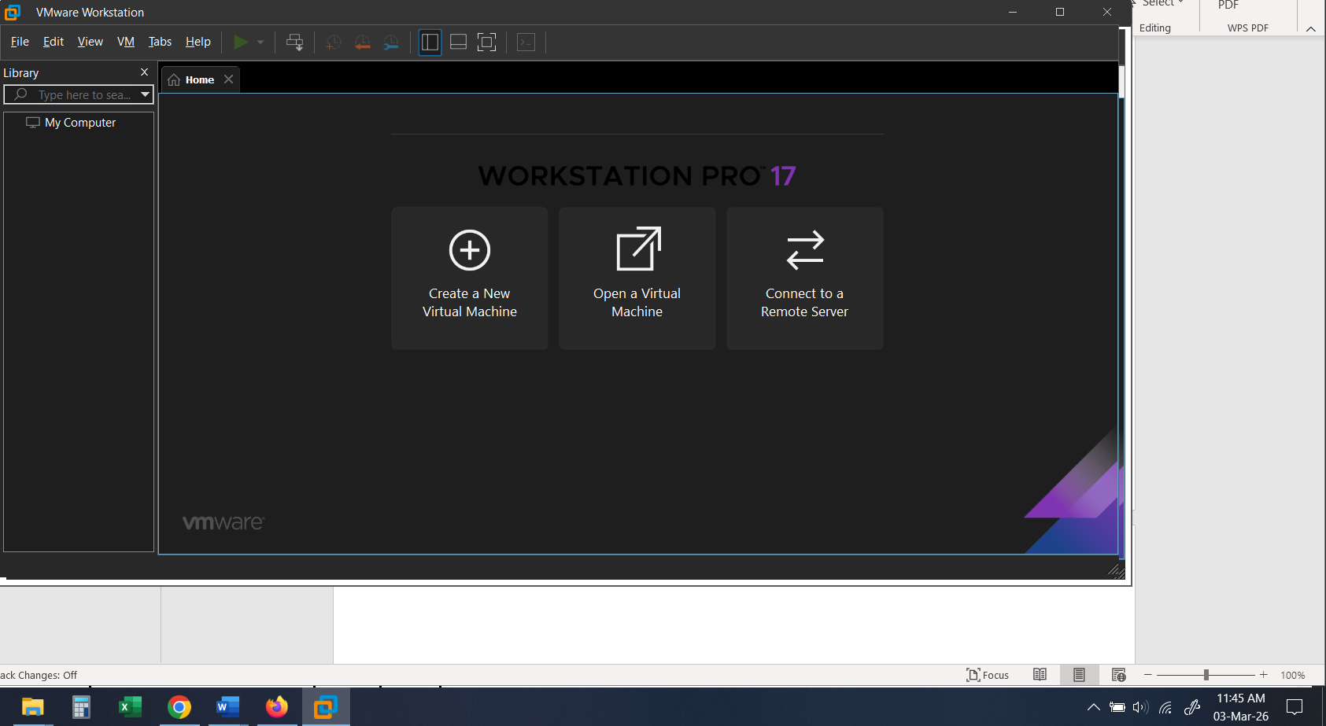

Windows Server 2022 Download
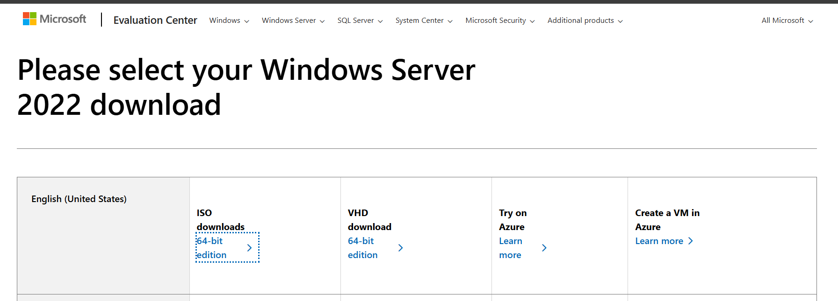

New Virtual Machine Setup
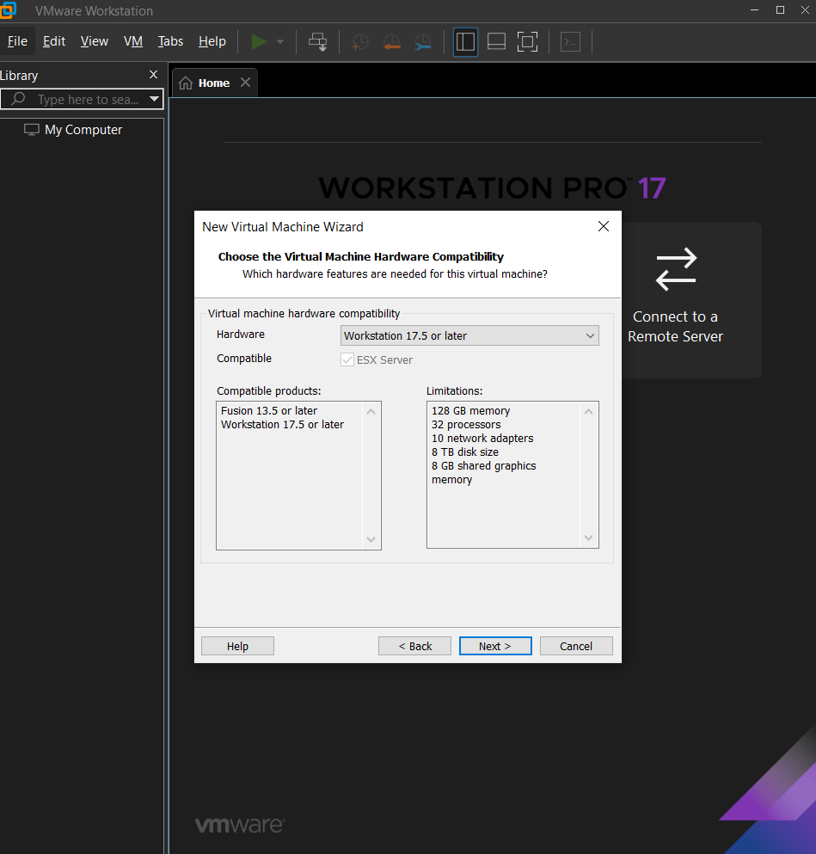

Memory Allocation for Debian Server
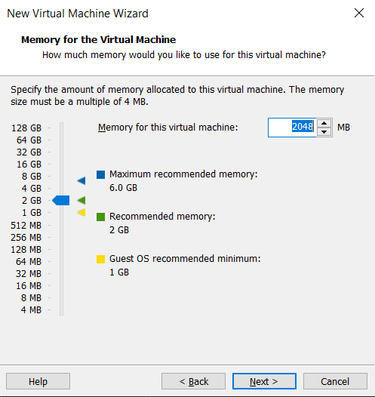

New Virtual Machine Summary

Debian Installation in VMware

Network Setup

Desktop of Debian in VMware


