Business Management
Community Engagement LCBB4002
Assessment 1
Anita Szabrina Petreus 2024822
My lecturer is Karen Howells

Table of Contents
Introduction
Planning and design
Quality standards for community engagement
Online tools
Tools to help choose methods
Methods and technics
Royal Voluntary Service
Conclusion
Reference list

In this essay will make a report about a community engagement programme, the way of planning and designing a programme, online tools used for advertising, how to overcome challenges. A guidance can show the issues which need to be considered when planning and designing community engagement. It focuses on quality and effectiveness of engagement, process planning and designing engagement made to that particular issue, level of participation needed to be achieved, what timeframe and which kind of stakeholders are affected.
This report shows us that community engagement works best where it is an ongoing cumulative process allow relationships and trust to build and strengthen over time. Individual engagement events should be planned and designed with this in mind and focus to contribute to the overall aims of the engagement process. Community or voluntary groups may want to participate at a range of levels – from providing advice to co-designing the process and from undertaking some aspects of the engagement to delivering projects to meet some of the outcomes.
When community engagement is planned need to be considered the following: level of participation, communication, resources, limitations, feedback, methods used. Community stakeholders can participate and influence different ways. Solution making, planning, identifying needs, delivering services.
When planning a community engagement process there are different important things to consider, stakeholders ability to participate, hard reachable groups: young people, old people, minority groups, rural isolation, techniques to consider, location and accessibility, transport requirements.
Communications are very important, communication methods should be in English and with an alternative language if possible. To have high level of participation communication is important, to make sure that different individuals and sections of society is not affected. Use existing community networks, forms of communication to publicise events. Easy way to community advertising is by using social media like Instagram, Facebook, Twitter, Linkedln, We could encourage participation and generating interest and ideas with, short interviews with people in different locations and times for radio or tv, invite people to submit a song, poem or art piece which describe their area, what changes they would like all this could be for a prize, adopt a popular TV game quiz show to test local knowledge, disposable cameras can be given to all ages to capture what they like and dislike in their areas. The outcome was that families and groups came out meet and work together socialise.
(Social media, CC BY, 2020)
Public meetings are useful it give the chance to consult with a large number of people, to have oral feedback, with opportunity for participants to ask questions.
Workshops are also to allow people to discuss their ideas in relaxed atmosphere, to exchange information, to discuss strength and weakness, opportunity and threats of the project. Workshop groups are good for people who don’t feel confident talking in a large group.

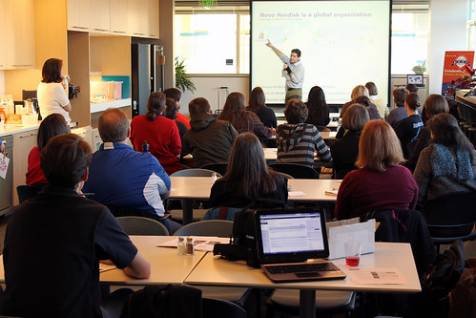
(Small group of workshop, CC BY 2018)

Community surveys

These are very useful to identify the needs and views of a large number of people. Stages are, type of information needed, design of survey, piloting the survey, post completion analysis of the results. Often the best to use a short questionnaire.
Strengths of a survey are: can gain the views of a large number of people, useful for obtaining quantitative data, the data can be compared over time or with results from elsewhere, useful for identify or evidencing needs.
Weaknesses of a survey are: needs to be well designed to get usable answers, large questionnaire surveys are time consuming, information may be limited, often get typical responds rates.
The best is to use surveys as part of a programme of other methods.

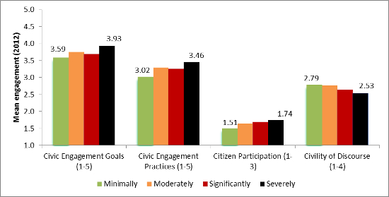
CC BY-NC

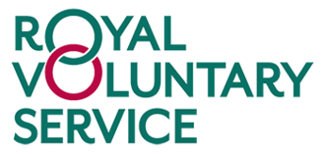
Royal Voluntary Service 2020 CC BY-SA

This section of the assessment presents about a non governmental non profit charity The royal voluntary service which works through all United Kingdom. In 1938 it was founded as British women organisation to help in the event of war, than in 1966 it got the name of Royal voluntary service and their activity became helping those in need and those who are limited to their houses and need help for everyday tasks, or food, transport, company. All this will support people to reduce loneliness and isolation, and help to cope with challenges. They give support for those after surgery, supporting them mentally and physically. They run shops and coffees in hospitals and giving their profits to the hospital. They help in time of disasters.
All this is done by volunteers, that is the base of charity work, and is made freely for the community. Volunteering is benefit for the community and the volunteers as well, after a study prove that is good for mental health and make people less depressed.
They have the opportunity to meet new people, improve team work, gain new skills, get experience. As Rochester, C. Paine and Howlett, S. mentioned in their book about volunteering as a global as well as national phenomenon.
( Rochester, C. Paine, A.E. and Howlett, S. (2009)
Volunteering and Society in the 21st Century Basingstoke: Palgrave
(Rochester, C. Paine, A.E. and Howlett, S. (2009)
Volunteering and Society in the 21st Century Basingstoke: Palgrave
Rochester, C. Paine, A.E. and Howlett, S. (2009)
Volunteering and Society in the 21st Century Basingstoke: Palgrave
(Rochester, Colin., Zimmeck, Meta.; Howlett. London 2009)
We need to understand what are the motivation of volunteers, why is important for the voluntary managers to understand them, what social and political forces can have impact on volunteering. Since 2003 the number of population that have volunteered at least once in the last 12 months is in growth. Woman be more likely to volunteer than man, but man give greater hours of volunteering. Those of higher socio economic status are more likely to volunteer. Perhaps those with lover socio economic status don’t confident that their skills would be valued by the voluntary sector.
Age is also important factor, from 50 to 75, and the drop of volunteering after this age is because of their difficulties of health and mobility. Also home workers are more likely to volunteer than those who don’t work from home.

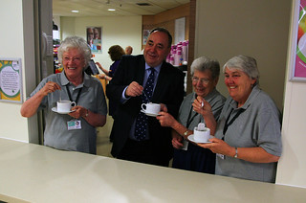
This Photo by Royal Voluntary Service 60-75 years old volunteers (2014) CC BY

A national survey on volunteer experience has shown the following, 7 in 10 people taking part in this survey have volunteered through a group, club or organisation at some point in their lives. Those from lower socio economic groups ( 30%) are less likely to have volunteered than those from higher socio economic groups (44%).
81% of volunteers give help locally, in their own neighbourhoods, 10% of volunteers give time through employer-supported volunteering. Volunteers combine different types of activities, organisations, causes, frequency of involvement which reflect their own lifestyle, values, priorities. Overall perceptions are very positive, some volunteers have less positive views about their experience, including younger volunteers, disabled volunteers, those volunteering through employers and public sector. 52% of volunteers see it as opportunities to make use of existing skills or experience, 50% see as opportunities to take part in fun and enjoyable activities, 44% see it as opportunities to combine volunteering with existing hobbies or interests.
(ncvo.org.uk , 2020)

Motivation of the volunteers at Royal Voluntary Service are different, they want to meet new people who share the same interest, they are driven by they own values and they believe by helping and making a good act they will get the same. Some want to develop or exercise new skills, some just want to help others and make difference.
Volunteers at Royal Voluntary Service said the following: Steve from Aberdeenshire : “Seeing clients smile is all I need”, Anna from London: “I feel better if I can help
There is many benefits in volunteering, for example: is a great way to learn and develop new skills, sometimes life changes make us isolated, by volunteering reconnects you with the community and help to make new friends, 80% of the volunteers at Royal Voluntary Service said their work improved their mental health, 50% think improved their physical health. The most important thing about volunteering is to enjoy it on your own terms and that is a rewarding experience.

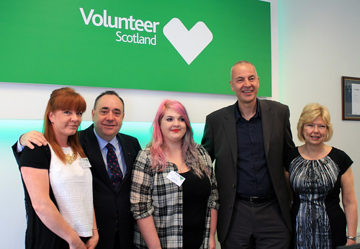
This Photo Royal Voluntary Service Scotland 2017 CC BY-NC
At Royal Voluntary service the volunteers participate at a range of levels: volunteers as full time, volunteers as part time, short term volunteering, working, occasional volunteers (this in case of major disasters).
93% of vulnerable people who received support from Royal Voluntary Service during the pandemic said it helped their mental health and wellbeing. This support is made possible with the generosity of firms like @CMS_laws who answered to the covid emergency appeal.

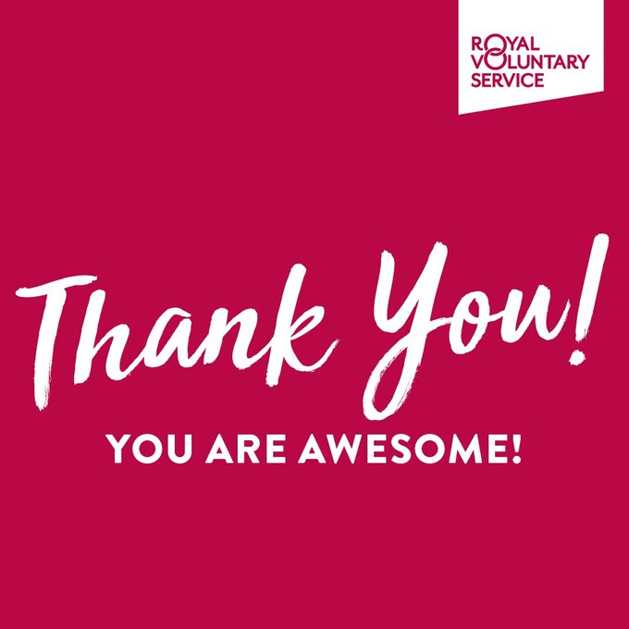
Elderly people are vulnerable and they need help also for socialising and activities to protect physical and mental health and one of the main activities of Royal Voluntary Service is helping elderly people. Evidence shows that staying active as much as possible and socialising are key in older years of life. That’s why Royal Voluntary Services runs by volunteers clubs, groups, events in local communities, these are great places for people to meet up with friends and make new ones in a warm welcome, with refreshments and interesting activities.
There is something for everyone in these clubs and places, some groups and clubs take place in Royal Voluntary Service and community cafes, others in villages halls, libraries and community sheds.
Programs and projects include Community cafes, where people can meet up with friends, enjoy snacks and take part in activities. Health happy life programme offer help people of all abilities improve their physical and emotional health and play an active role in our community. Activities include: sitting on a chair resistance exercise for strength and balance, a two course lunch with someone accompany and talking, cognitive stimulation therapy for mild to moderate dementia sufferers, with singing arts and crafts. Lunch clubs and social clubs and events are other programs which offer a wide range of activities, from dancing, crafts, gentle exercises. Other activity and hobby clubs play host music, organise trips to other venues to indoor bowls. Staying active and keeping in touch with friends is important at any age , but when you’re older is crucial.

It provides people with opportunities to try something new for free in their local community, and is aimed particularly at those aged 55 and over or those with underlying health conditions. The activities offer support physical and mental health and wellbeing and digital literacy because staying active and social is important to keeping fit as well at any age. All activities are gentle and beginner level.

For over 80 year Royal Voluntary Service has inspired around two million women and men to help others and donate. Royal Voluntary Service inspires people to work as volunteers in hospitals and in local communities.
This is very impressive and proved that voluntarist and charity services are in need and big help of the community, united we can make big changes.
I believe that such a voluntary community service is always present for peoples needs and is
very important in every community to have and it would be important to expand in other countries as well. The voluntary service is a great way to community to communicate, it connect people to project, places, and other people.
Encouraging more people to volunteer and make them understand why is volunteering so important is what can be improved in the future.

Reference list
https://en.wikipedia.org/wiki/Royal_Voluntary_Service
https://www.ncvo.org.uk/images/documents/policy_and_research/volunteering/Volunteer-experience
Community and everyday life, Day, Graham., London:, Routledge, 2006:,
Volunteering and Society in the 21st Century, Rochester, Colin., Zimmeck, Meta.; Howlett, Steven.; Paine, Angela Ellis, London
https://brand.legalandgeneral.com
Charitable Incorporated Organisations, Gareth. G. Morgan;. 2009
Fundraising the smart way: Predictable, Consistent Income Growth for your Charity;. Ellen Bristol, 2014

