PERFECT LITTLE TENTS

Business plan

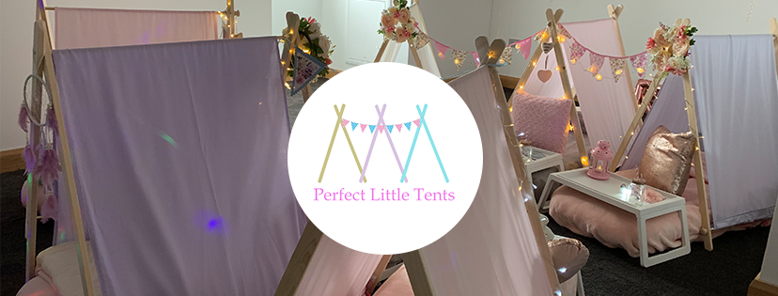

Introduction
Financial Information:
Marketing:
– How will you market your business?
– What is your USP (Unique Selling Point)?
– PEST and SWOT analysis
– Competitor Analysis
– What is your specific market segment?
– Who, what, where are you targeting?
– What is the size of your market?
– Marketing objectives
Revenue and Pricing Strategy:
– How did you arrive at your pricing strategy?
– How much will you charge for your goods and services?
– How many income streams will you have?
– How much will you get from each income stream?
Operations
– How much will you get from each income stream?
– Locations, premises, equipment
– Production and distribution processes
– People, staff, suppliers
– Systems and processes
– Health & safety, legal compliance
– Executive summary

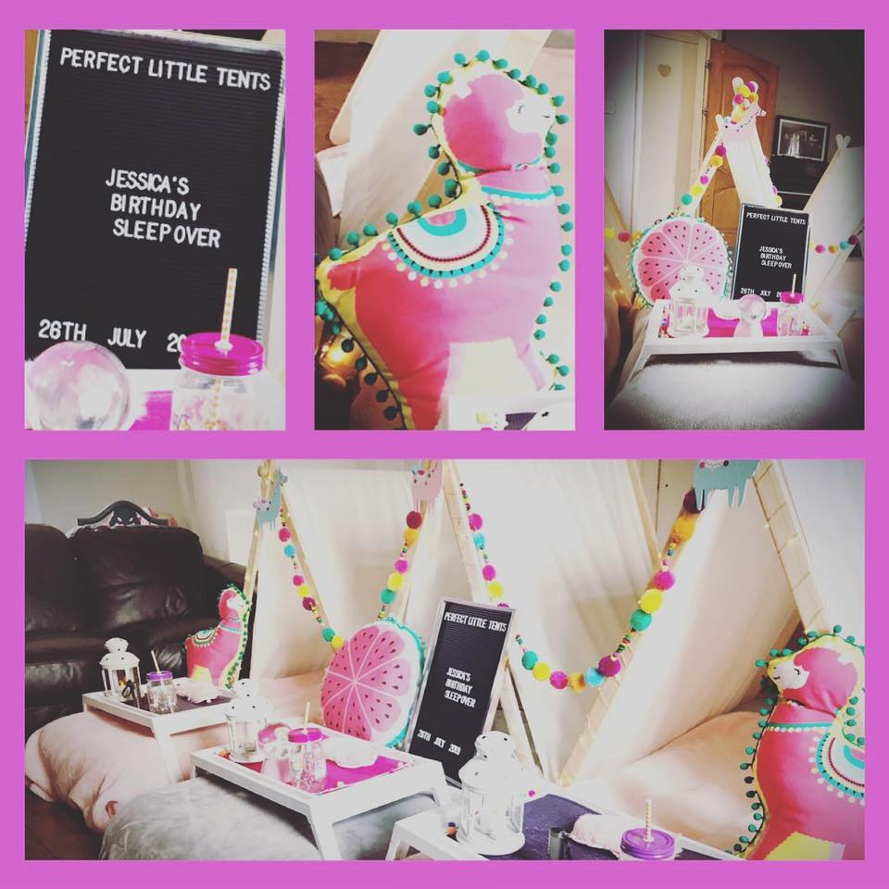

Introduction

It is not a novel concept to throw a sleepover; traditionally, a sleepover would involve you spending the night either top and tailing with your best friend or staying at your Nan’s house while your parents went out. I will be offering a one-of-a-kind experience for you. An adventure to share with family or friends. The sleepovers will be used for celebrations such as Birthdays, Easter, Halloween, and Christmas, which are all geared towards children. We are witnessing an increase in the number of households that are going above and above to celebrate a variety of holidays. Personally, I think that the celebration of holidays is gaining popularity as a direct result of our adoption of the values of the American culture, which believes bigger is better.

Business Details –
I will specialise in providing beautifully designed sleepover set ups. That will be lavish and elegant. The equipment will be of high quality and safe for children to use. I will offer set up or a do-it-yourself option to customers so it will suit a wider audience for affordability.

Legal Status of Business?
We will require public liability insurance to cover us while setting up and in the customers homes. This would be needed to cover us if we cause an accident or damage anything when on site. Once we have set up the legal responsibility of the sleepover is down to the parents who will need to always oversee the sleepover and children.

Ownership
The business will be set up as a sole trader on a self-employed basis when a tax returns of profit and loss will be submitted to HMRC yearly.

Product/Service details
I will prepare all items needed for the sleepover; at the end of the hire I will want all of the items to be returned in a state where they are ready to be cleaned. All the fabric items will be laundered at a laundrette, and the equipment will be thoroughly cleaned with cleaning chemicals that are safe for use around children so that there are no adverse reactions when the equipment is used again. Personalised products, such as sleep masks and snack packs will be offered at point of booking for an additional cost – These items will be kept by the client.

Layout and Structure

Operations
Sleepover Income – I will charge £30 per person. There will be a minimum booking of 2 per booking. Delivery is charged on every booking over 6 miles of our warehouse or the customer can collect free of charge. A set up service will be offered to every customer at £20 per booking regardless of how many tents are booked or the customer can use our do-it-yourself instructions.

Location, premises, equipment
A warehouse/ Storage room will be needed to start. Around 300 square foot of space will be needed initially. This has been prices at around £300 per month including VAT with Storage Giant in Llansamlet, this is a great central and professional looking location that will allow customer collections. This space will also allow me space to sanitise hired equipment and prepare for the upcoming hires.

Equipment
I will start with enough equipment to service 12 individual tents and 5 different themes, this will consist of 1 neutral theme, 2 themes for girls and 2 themes for boys.

Production and Distribution processes
Cleaning and preparing hires will be carried out Tuesdays, Wednesdays, and Thursdays. Fridays will be spent delivering and/or setting up the sleepovers. Mondays will be for collecting sleepovers. Sundays will also be an option for collection if customers are unavailable on the Monday due to work.

People, Staff, Suppliers.
I will be the only person working the business other than outsourcing the washing of the fabric items. This will be carried out by a laundrette.

Health & Safety, Legal Compliance.
All items must be maintained and in excellent condition ready for each hire with nothing damaged. Pictures are taken of equipment set up as proof that everything is set up safely. When a customer has a do-it-yourself set up, we ask for a picture to ensure again that all equipment is safely set up for the children to sleep on. The only legal compliance I must follow is that I need public liability insurance.

Marketing
I will market the business using all social media platforms, including Facebook and Instagram.
Business pages will be set up for the business – and images will be produced to advertise.
I will launch competitions where social media users can like, share, and tag pictures for a chance to win a sleepover.
I will search for local social media influencers and offer discounted or free sleepovers in exchange for exposure.
I will also register the business in all online directories that are free of charge to enhance exposure.
A website will be professionally built outlining everything we offer along with a booking system and deposit taking facility.

Unique Selling Point
I will offer a one stop sleepover shop where we can do it all or offer an affordable option where the customer can set up them selves saving on costs. The sleepovers are designed and ready to go with the same look every time taking away the need to be artistic and providing a perfect sleepover every hire. We provide a personalised board for each sleepover will say “Childs name’s” Perfect little Sleepover. This is part of the hire package and is returned at the end of the hire to be reused on future hires where the name is changed.

PEST Analysis

Political Factors – Currently there are no legislative laws to start a sleepover business other then having public liability insurance. During the covid pandemic, when the law stopped houses mixing this would have been an issue but currently no issues.

Economic Factors – This is a service that would only be plausible for those who have a disposable income. For families who save us and are frugal with how they spend their money. There are a lot of families who will plan birthday and special occasions in advance to enable them to afford luxuries such as birthday parties. Payment plans will be offered to help assist customers affordability.

Labour costs – As this is just me, I will expect a living wage from the business and expect to reinvest profits for the foreseeable.

Laundrette costs – As energy and detergent costs raise, I will increase the cost of sleepovers to run along side this to offset additional costs when needed.

Social Factors – The service I provide will bring people together to celebrate. Every child has a birthday each year, lot’s will choose to have a party, and many will choose a sleepover as it’s controlled, in your own home and relatively inexpensive compared to a disco or hiring soft play.

Technological factors –
Technology has no impact on this business.

SWOT Analysis

Strengths – The business can have their own individual themes, that are bespoke to perfect little tents. With 12 tents this can be hired to several parties in 2’s, 4’s or even all at once. Unlike other sleepover hire businesses we hire for the weekend giving better value for money. Friday – Monday hires gives me the flexibility to spend time with my family.

Weaknesses – If a competitor charges less than me as they have lower overheads and are home based. If equipment is broken and we don’t have enough time to get replacement items intime for the following weekends hire. If I am sick and unable to work.
Opportunities – I can offer add On’s, such as personalised sleep masks, snack sacks and balloons. We can increase our inventory to service more customers. We can look at expanding into garden parties usings canvas bell tents, dressing the inside for a sleepover and offer a cinema package with a projector and screen.
Threats - If a global pandemic was to arise again and households weren’t allowed to mix this would increase the workload for deliveries as we would need to service more parties to ensure all tents are hired out to only sibling sleepovers.

Customer / Target Markets
The market we are targeting are parents with children ages 6 – 11 years old who like things thought out for them.

Competitor Analysis

There are only 2 local based companies who offer sleepover tents, both priced the same as me but are only offering 1 night hires and charging an additional fee for the 2nd night. I would assume that they are reusing equipment to maximise income however this would not fit what I’d like to achieve with having more family time.

What is your specific market segment?

Age Demographics

Although we offer children’s sleepover tents, our hirer is a parent. Our age demographics are there for mothers/Fathers aged between 25-55 years old.

Income Level

I believe that most of my customers will be higher earners and therefor booking me year on year for their children’s special occasion.

Location

Swansea, is my primary target market area.

Interests

Mums who are inspired by tv shows and/or movies. These types of shows inspire my target audience to have these themes for their little ones.

Who, what, where are you targeting?

Who (Customer Profile)
Parents or guardians of children aged between 6-11 years old. This can include families hosting parties at home.
What (Product/Service)
We provide a service that involves setting up indoor tents for children's parties or events. This will include tents, mattresses and setups include themed decorations, cushions, fairy lights. The service may also include the takedown of these setups after the event.
Where (Geographic Target)
We focus mainly within Swansea and the surrounding areas.

What is the size of your market?

Age Demographics
If we take the average percentage of the UK population that is aged between 3-12 years, it's around 11% (as of 2021). Applying this to Swansea's population gives us an estimated number of potential end-users in the range of 27,000.

Frequency of Use
I believe that once a client uses our service once, they will book for each birthday every year until the age of 11. Should the client have multiple children then they are likely to want us to provide a sleepover for them also. Clients with multiple children may also book a sleepover for other special occasions like Easter, Halloween and Christmas.

Marketing objectives
Increase awareness of our business within Swansea and the surrounding regions.
Establish partnerships with complementary businesses (such as party planning agencies, kids' entertainment providers, or local face painters) to cross-promote each other's services.

Revenue and Pricing Strategy:

How did you arrive at your pricing strategy?
Looking at my local competition I have decided to charge the same price but allow the hire to be used for the weekend rather than just the night. This gives me to freedom of having more family time and giving the customer better value for money compared to my competitors.

How much will you charge for your goods and services?
We will charge £30 per tent per hire. Free delivery within 6 miles of our warehouse. I will charge £20 to set up the sleepovers within the customer’s home. Personalised sleepover masks will be offered at £4 each and empty personalised snack bags at £5 each. Balloons garlands will be offered also the cost of £30 per 2 tents.

How many income streams will you have?
There will be 2 income streams.
Tent Hire
Personalised items and balloons to decorate the tents.

How much will you get from each income stream?

Should 12 tents be hired I will receive £360 per week, £1440 per 4 weeks.
Should the 12 tents be split into 3 different parties I will receive an additional £60 per week, £240 per 4 weeks.
Should every customer purchase add ons:
12 Personalised sleep masks I would receive £48 per week, £192 per 4 weeks.
12 Personalised empty snack bags I would receive £60 per week, £240 per month.
Balloon income would vary. Should every customer purchase the balloon add on based on £30 per 2 tents.
6 X £30 = £180 Per week totalling £720 per 4 weeks.

The figures below will show that on month 6 the Perfect Little Tent inventory will double therefore doubling the income.

Income demonstrated in the chart is all tent’s hired with around 60% tent hires purchasing the available additional extras.

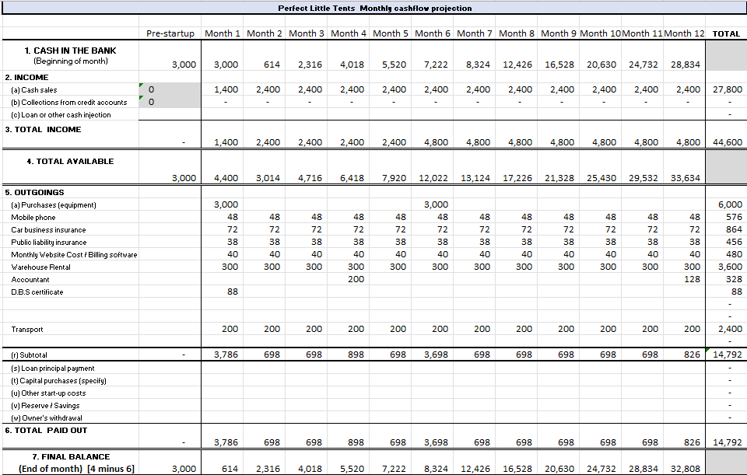

Operations

How much will you get from each income stream?

After the purchase of each theme and all the equipment the income will be the businesses as no additional costs would be involved other than manpower.

Add On’s income.
This would be around 60% of the income as there are costs involved in buying the products to personalise and then of course the time it takes to personalise the items.

Locations, premises, equipment
Locations
The service area would be Swansea. Our services would primarily be delivered at customers' homes.
Premises
Storage Space: We have a secure, clean, and dry location to store our sleepover equipment.
Office Space: Administrative tasks are managed from home.
Supplies This will include tents, mattresses, sheets, blankets, bunting, fairy lights, breakfast tables, scatter cushions, themed bunting.
- Transport – I own a Van that’s reliable and large enough to transport all our sleepovers to the customers home.
- Cleaning Supplies - Hygiene is crucial in this line of work, so suitable cleaning supplies is essential.
- Website & Booking System - An online presence is crucial for my businesses. Having a professional website with an efficient booking system has helped me attract and manage clients.

Production and distribution processes

Production Process:
- Consultation and Booking: The process starts when a client contacts you to inquire about a party.i’ll discuss their needs, the number of children, the date and location of the party, and any special requests. Once everything is agreed, they'll book the party.
- Preparation: Based on the booking I will start preparing the sleepover the Tuesday/Wednesday before the Friday.
- Inventory Management: I will check the inventory to ensure I have all the necessary supplies. If anything is missing, I’ll need to order it in time for the party.
- Final Checks: The day before the booking I will reconfirm delivery time, request payment and ensure all is packed and ready for the following day.
Distribution Process:
- Transport: On the day of the party, I will load your sleepover into the van and travel to the party location.
- Setup: Upon arrival, I will set up for the sleepover.
- Cleanup: I will return at a convenient time to pack away the sleepover and check all hired items are not damaged. Should anything be damaged, this will be listed for the customer.
- Follow-up: After the event, I will contact the customer thanking them for their booking. If damages need to be paid for this will be addresses.

People, staff, suppliers

People:
My main clientele will consist of parents or guardians of children within the age range I cater for. Establishing strong relationships with my clients is crucial for customer satisfaction and repeat business.

Staff:
Currently it will just be myself operating this business but as the business grows I will look at employing staff to help.
Suppliers:
I will need to establish relationships with suppliers for various aspects of my business:
- Equipment Supplies: These would include tents, decorations.
- Cleaning Supplies

Systems and processes

- Booking System: Having an online booking system will streamline the process of accepting and managing bookings. This system can capture all relevant information such as the date of the party, the location, the number of children attending, and any special requests.
- Inventory Management: On return of all hire Items they will be checked and re ordered if damaged or repaired. I will aim to have spare of most items.
- Transport Logistics: I will ensure that times for delivery are established before the van is packed for the customers sleepover.
- Billing and Payment Processing: My website will take payment’s and request the final payment before the sleepover.
- Communication: All communication will be carried out via phone and email.
- Quality Control: I will establish procedures to ensure all parties are of high quality. I will have sleepover checklists to follow when preparing the sleepover and email a survey to the hirer after the sleepover for feedback and ask if there is anything I could have done better.
- Data Management: All personal data from clients, will be stored on our secure website and within the data protection laws.
- Health and Safety Compliance: I will establish procedures for maintaining health and safety of all equipment. This will include routine equipment checks, a protocol for cleaning and sanitizing supplies, everything is always assessed for risk.

Health & safety, legal compliance

Operating perfect little tents will require us to ensure all hire equipment is in safe working order at all times.
Insurances
Public liability insurance is crucial to cover any injuries or damage to the customers property that might occur during the set up of the sleepover. Professional indemnity insurance can protect me if a client claims that my service caused them harm or loss.
DBS Checks
As working with children, I will have a Disclosure and Barring Service (DBS) check to confirm that I have no criminal convictions that would make me unsuitable for this work.
Risk Assessments
I will conduct a risk assessment for every party I set up, considering potential hazards related to your equipment.

Hygiene and Sanitation
Given that children will sleep in our tents, maintaining hygiene is crucial. I will have a sanitation protocol in place for all your equipment and ensure that any cleaning products I use are safe and suitable for children. Regular hand washing and usage of hand sanitizers will be promoted.

First Aid
I will look at available first aid courses in case of an injury during set up or collection.

Food Safety
I have no plans to offer food.

Data Protection
When collecting personal data from my clients (such as names, addresses, or payment information), I will comply with data protection laws. In the UK, this means following the General Data Protection Regulation (GDPR).

Executive Summary
My name is Rebecca Forshaw, a mother of two children aged 4 and 7 who is seeking to set up a business that will run alongside a busy mother’s life, giving me time to spend with my family while they aren’t in school while working minimal hours on weekends.

A children's sleepover company will be the focus of my business plan. To host a successful sleepover, I provide hire and personalised items. A tent, mattress, sheets, scatter cushions, breakfast trays, and themed items will be included. Sleepovers will be delivered on a Friday and set up for the customer for a setup fee or delivered for the customer to set up themselves. Our goal is to collect equipment on Monday if possible, or on Sunday if Monday is not convenient. As the children can enjoy the sleepover for the weekend rather than paying for one night, we aim to be an easy service that is good value for money.

