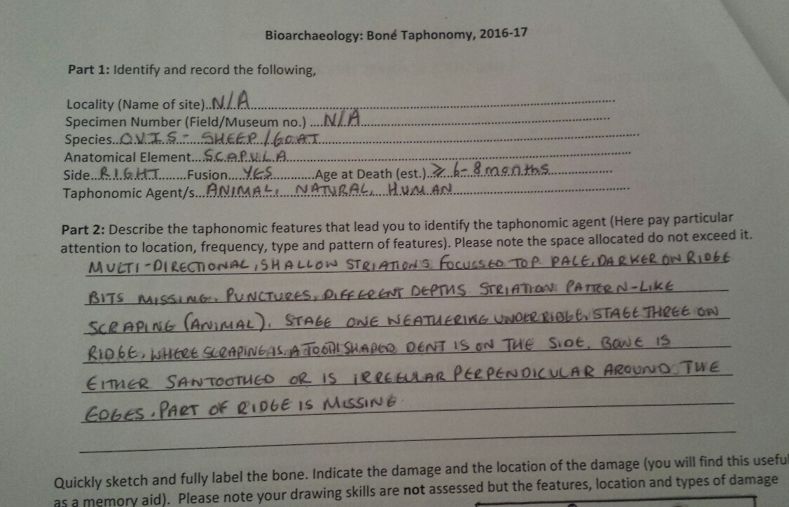

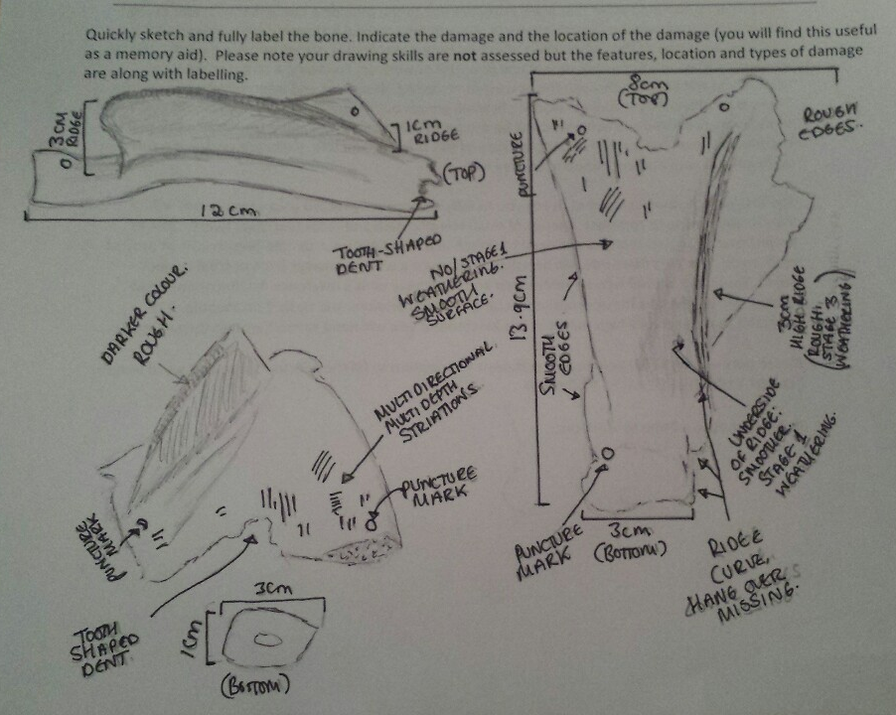

There are many difficulties that lay in the way of a bioarchaeologist or archaeozoologist when ascribing a taphonomic history onto a bone, especially when they are faced with one bone to work with. The bone which was used in the laboratory experiment had no context number, no site locality, or whether other bones were found alongside it of the same species or other species in general. When archaeologists send bones away to be analysed and don’t have the site, context number, or no information at all, the difficulties start almost immediately as there is no generalised history of the bone’s place of origins.
A problem can start with identifying the species by just one bone. Most animals look very similar to one another, which is a problem that occurred during the laboratory experience as there was little to no difference between an Ovis’ scapula, the species settled upon during the experiment, and a Cervus Elaphus, red deer’s scapula, except for size and an overhang of the ridge. As cited by Schmid (1972) “every bone has a specific characteristic which an animal can be recognised by.” However, due to a lack of overhang, as weathering had been predominant on the ridge in general, an argument caused was whether it was a juvenile red deer or an Ovis. With the information of no overhang which looked to be affected by weathering or snapping off, and the size, the final decision was it had to be an Ovis. This brings in a problem, however, that if two analysers were studying the bone they could have different opinions on what the animal could have been. Without other bones from where it was found it makes the analysing more difficult. Another problem related to species is, especially with an Ovis, it can be simple to establish its family, but may prove almost impossible to establish whether it is a sheep or goat.
Getting a bone down to its specific family however may help as they can then say whether it is domesticated or wild. In the example of the experiment’s bone, an Ovis, in Britain there are no wild sheep or goat and therefore, must be domesticated. These bring on the following questions: How or where was it found? Did it die by consumption of humans, or by domesticated animals; or was nature the reason for its death? Without context, knowing whether it was a single context or multi-context, whether it was found next to other animals (which may suggest consumption by humans if an abundant amount of animal bones were found), or if it was found on suggested farmland or near to a residential building, it becomes time consuming and difficult for the analyser to establish how it died and what played an important factor in the individual’s death. Had it been scavenged after death, did a wild animal kill it before making off with it, or had it died in its original field?
O’Conner (2000) states that, on a bone, dogs tend to chew and crunch repeatedly, therefore there will be areas of overlapping of toothmarks, in this instant: striations discovered on its topside, and will be shallow and wide. They also carry on mentioning that cats carry their pray and their toothmarks will puncture the bone where the cat has carried it elsewhere. O’Callaghan (2015) wrote a story for The Daily Mail about dog bones having human indentation on them proving that they ate dog meat. In one of their figures it shows how human teeth leave large, but few striations behind on the bone as they do not scrape. This rids the idea that humans ate off this bone and leaves the analyser whether it was dogs, as the bone shown in the drawings has overlapping of striations, and are shallow, or it could be a cat, as there are puncture marks near the striations. If the right resources are nearby, as it was in the laboratory, an individual can place jaws of carnivorous mammals where the punctures are and can go by whichever fits.
The next question which rises difficulty is whether the animal was killed by the mammal or was scavenged by it instead. Scavenged bones would typically be found away from its original source (Haglund 1997 cited in Rogers 2010) and, if the information was available, being able to distinguish whether the bone was in situ at its original site or not would be simple. But as the bone in question had no relative information an analyser can only go based by the assumption (in this case it was agreed on a fox had caused the indentation and striations) made by the markings provided the bone had been taken away from its source and therefore scavenged. Another problem is determining sex and age when it had died. With no other bone to examine with, its sex cannot be identified, but according to O’Conner’s (2000) table 8.2. of bone fusion, an Ovis’ scapula will fuse between the ages of 6 to 8 months. This however does not give an exact date except that it could be between those ages, or above.
Another difficulty is whether weathering or animal activity caused the bone to be in its shape. The bone was partially covered, which can be told from it’s ridge being at a stage 3 in weathering compared to under which was stage 1 (Lyman, 1994). But if it had been scavenged striations would cut through the darkened layer but observations prove to be the same colour.
The main difficulties face when ascribing a taphonomic feature, especially to the bone in question, are whether humans, animals, or nature was at fault for its death; distinguishing an exact age if bones are fused, as well as sex if there is only one bone; and deciphering what species it was if the bone is alike to other species.

References.
Lyman, R. 1994. Vertebrate Taphonomy. Cambridge: Cambridge University Press. pp. 355.
O’Callaghan, J. Our European Ancestors ate cats, dogs, and badgers. Human teeth marks animal bones dating just 3100 years. Available: http://www.dailymail.co.uk/sciencetech/article-2921648/Our-European-ancestors-ate-cats-dogs-BADGERS-Human-teeth-marks-animal-bones-dating-just-3-100-years.html#ixzz5A2VkumbH. [Last accessed: 14th March 2018].
O’Conner, T. 2000. The Archaeology of Animal Bones. Gloucestershire: Sutton Publishing Limited.
O’Conner, T. 2000. The Archaeology of Animal Bones. Gloucestershire: Sutton Publishing Limited. pp. 95. Table 8.2.
Rogers, C. 2010. Dating Death: Forensic Taphonomy and the Postmortem Interval. Wolverhampton: Wolverhampton University. pp. 52.
Schmid, E. 1972. Atlas of Animal Bones. New York: Elsevier Publishing Company.

