Proposed Restaurant, Ice Cream Parlour, and Managers Apartment on the Swansea Foreshore

Preliminary Study
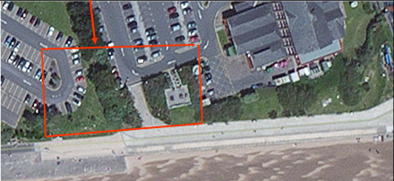
Image obtained from Client proposal
Word count: 2121

Creator: Alexi Young – Junior Construction Professional
Checker: Allan Nantel – Lecturer
Approver: Rhodri Thomas – Internal Verifier

Contents
- Introduction | 1
1.1. Project overview | 1
1.2. Scope of Works | 1
- Archival Study | 2 - 7
2.1. Site Details | 2
2.2. History of Site & Surrounding Area | 3 - 4
2.3. Weather conditions | 5
2.4. Hazardous Area Classification | 6
2.5. Existing Geotechnical/Services Data | 6 - 7
- Site Investigation | 8 - 10
3.1. Topographical Survey | 8 - 9
3.2. Geotechnical Investigations | 9
3.3. Site Specific Dangers | 9 - 10
- Site Specific Information to Aid in Survey, Design & Construction Phases | 11 - 13
4.1. Building Regulations & Codes of Practice to Adhere to | 11
4.2. Local Authorities & Services Contact Information | 12
- Suggested Foundations | 13
- Source List | 14-15

Introduction
The sections below give an overview of the aim of this site investigation for the clients: City and County of Swansea and Marriot Hotels.
  - Project Overview
City and County of Swansea and Marriot Hotels plan to undertake the engineering and construction of a new 2-storey attraction on the Swansea foreshore, between the Civic Centre and Delta Hotels Swansea. The lower floor is to have a restaurant, café-bar, ice-cream parlour, and all amenities required for these establishments, while the upper floor is to have a manager’s apartment, meeting rooms and staff welfare facilities.
  - Scope of works
This scope of works provides details for:
- Topographical survey.
- Geotechnical investigations.
- Preliminary foundation for the structure.
All supported by an archival investigation of the site and the surrounding areas.

Archival Study
2.1. Site Details
Location: 51°36'47.5"N 3°56'43.7"W
Land ownership: Unknown but assumed owner is Swansea City Council.
Present land use: Encroaches on two different carparks, may affect a bike-path and otherwise unused.
Proposed land use: Commercial.
Topography:
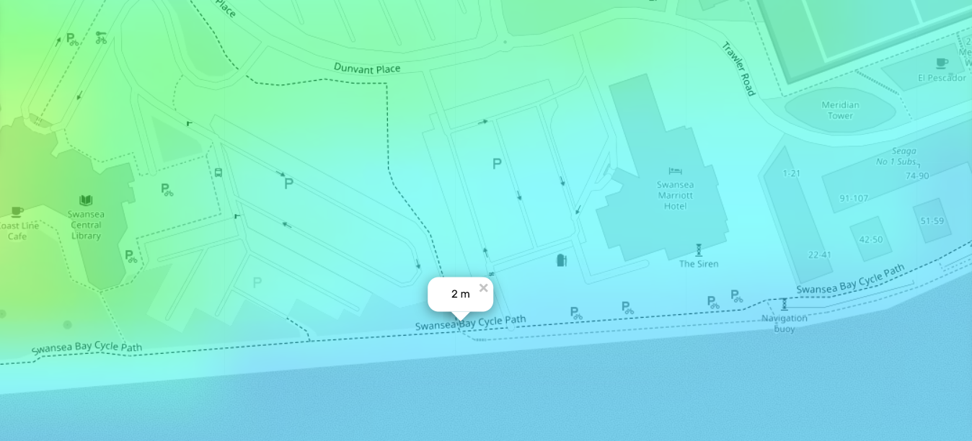
(topographic-map.com, 2026. See source list for link to map)
Access and other relevant information: The site can be accessed by vehicle from the north, and via the carpark to the west. Due to the carparks access for large vehicles is made much easier. See page 8 for site markup.

2.2. History of Site & Surrounding Area
In the early 18th century Swansea’s first copperworks was established near Landore, (Swansea Museum, 2025). Swansea was appealing for copper smelting due to its abundance of coal and water, and its ability to be accessed by boat with it being situated next to the sea (Canalrivertrust, 2023).
Surrounding areas started to accommodate the rapidly growing industry and by the mid-19th century 90% of the worlds copper was provided by Swansea copperworks (Walsh, 2025).
To aid in the expansion of Swansea copper, the Swansea canal was constructed and completed in 1798 which helped rapidly accelerate the industry’s growth (Canalrivertrust, 2025), the entrance to the canal from the sea is located just over a kilometre from the proposed site of this build, with the Tawe basin being about 250 metres from the proposed site.
With the amount of copper included in Swansea’s history, it suggests copper particulates may be polluting the sites soil, especially as according to an Ordnance Survey published in 1884 about 750 metres away from the site is a copper ore & goods shed, proposed site boxed in red, general area of copper ore & goods shed in green.
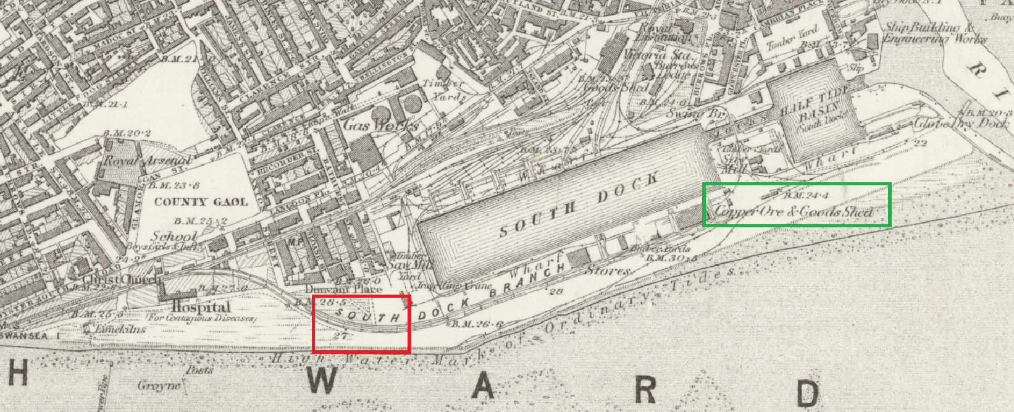
(National Library of Scotland, 2025. See source list for link to high quality map)
In the same view you can also see a hospital west to the site, and a gas works to the north. A hospital specifically for contagious diseases could indicate contaminated medical waste or human remains, however due to the large amounts of work done in the area since 1884 it is highly unlikely that remains will be encountered, and the distance to the hospital would imply that medical waste would not be found.
Gas works on the other hand could have contaminated the surrounding soil with hydrocarbons, inorganic compounds, metals and asbestos all of which could cause severe health issues to those exposed to them (Baylis, 2006).
In the map there is also what appears to be a railroad, but it is not clearly labelled, however in a later Ordinance Survey published in 1900 it becomes clearer.
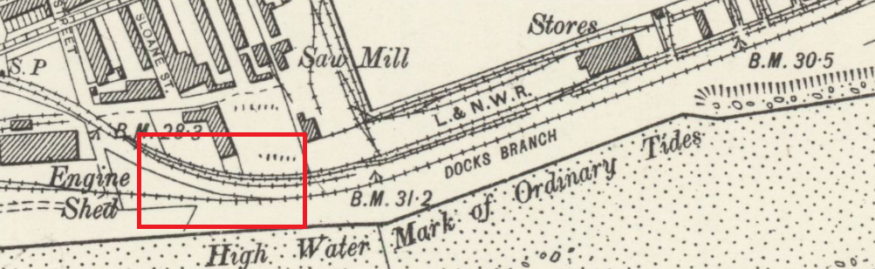
(National library of Scotland, 2025. See source list for link to high quality map)
In this map you can clearly see many different tracks going directly through the rough area of the proposed site, from the trains using these tracks likely polluted the area by transporting goods and burning coal.
Directly to the west of the site is an engine shed, this implies heavy locomotive traffic, the chemicals used to maintain the trains may have been carried out and seeped into the ground beneath the tracks.
The heavy industry involved in the past of the site could imply that the soil is contaminated and testing will need to be done to ensure the safety of the site and the longevity of the building.

2.2. Weather Conditions
From 1991 to 2020 the average annual temperature in Mumbles head is 13.72°C, the month with the highest average temperature is August with 19.67°C and the month with the lowest is January with 8.26°C (Met Office, 2022).
Despite the sites close location to the sea there is no flood risk due to sea water due to flood defences, instead there is a small flood risk due to surface water & small water courses (First image on this page).
These risks should be accounted for during the design phase and ideally resolved. Similarly, no floods have previously been recorded so there is no prior indication of flood risk. (Second image on this page)
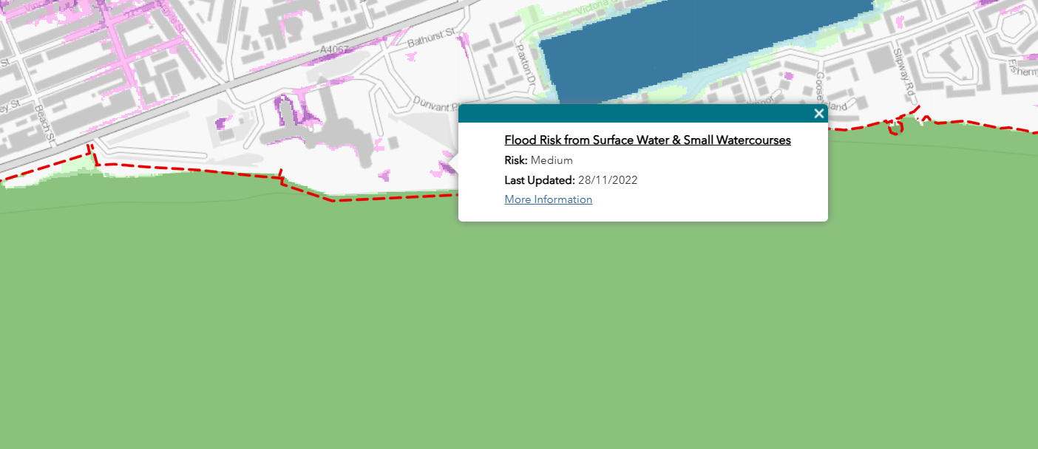
(flood-risk-maps, 2022)
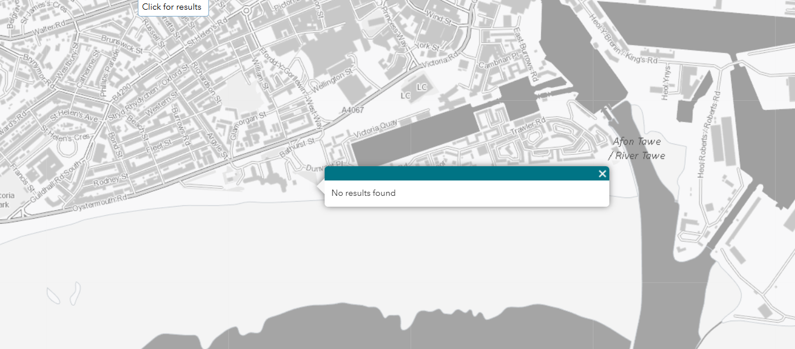
(flood-risk-maps, 2026)
2.3. Hazardous Area Classification
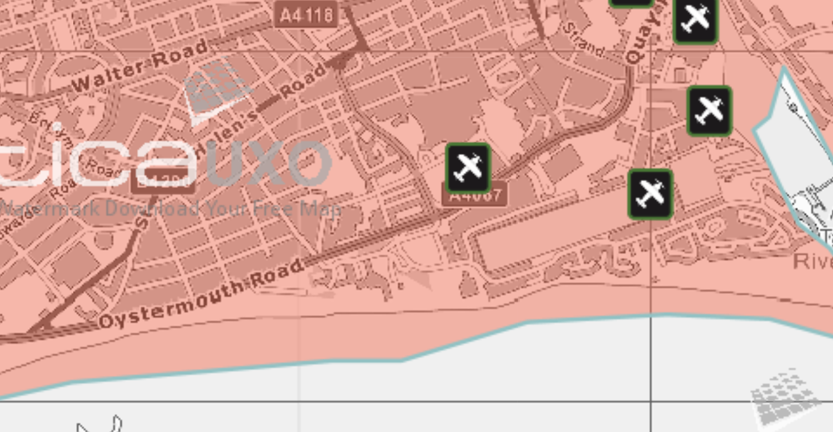
(Zetica UXO, 2026)
As seen in the image above, the site is a high risk for unexploded ordinances (UXOs) due to the fact the area was a Luftwaffe target during the second world war, prior to any construction extensive testing is likely to need to be done.
2.4. Existing geotechnical/services data
Existing services data indicates substations surrounding the site, despite the map not showing any underground cables, it is safe to assume there are cables connecting these substations back to the grid.
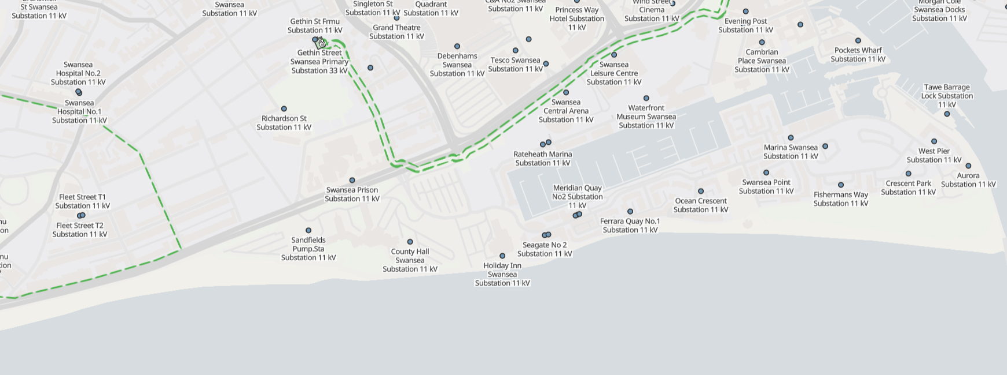
(Openinframap.org, 2026)
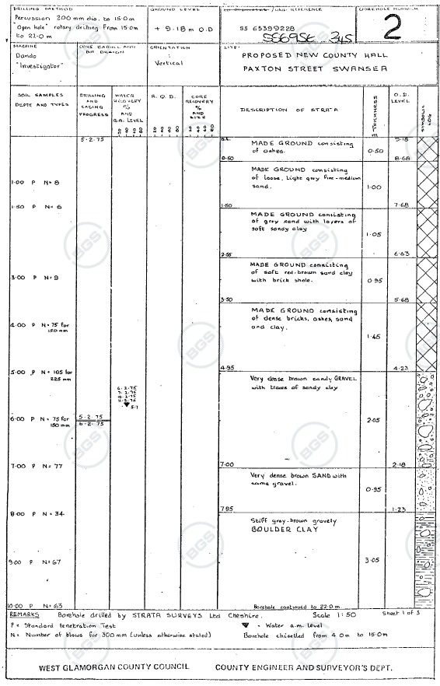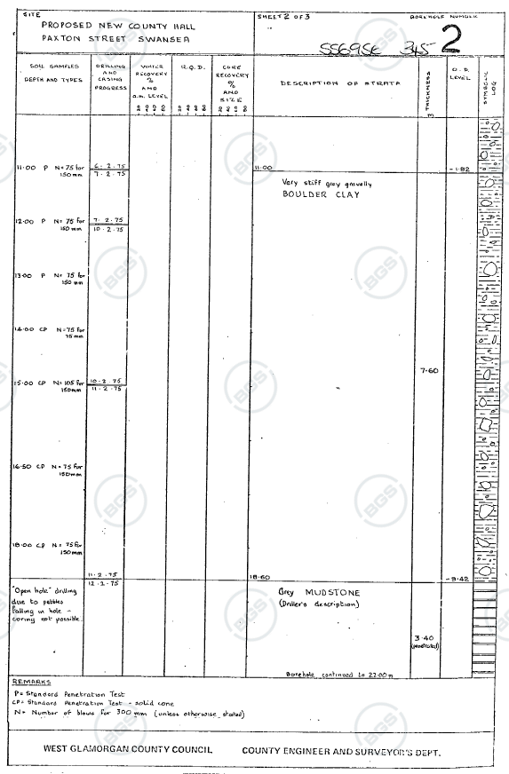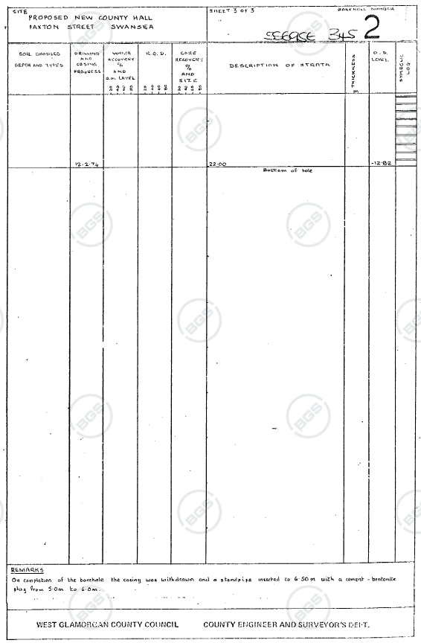
(British Geological Survey, 1975, see source list to access the full file)
This borehole indicated on the site plan indicates the first 4.95m of ground are made ground, this is where possible contamination is likely to occur, however on the bottom of the final page, it indicates that the borehole has a concrete bentonite plug from 5m to 6m. This implies that the new ground level is 5m below the original, completely removing all the potentially contaminated ground.
Following the made ground is 2.05m of very dense brown sandy gravel with traces of sandy clay, and the ground water level is at 5.7m this would mean that the ground water level is now 0.7m below ground level, however as half a century has passed by it would be safe to assume the water has adjusted to a new position further below the ground.
Borehole logs for the construction of the meridian tower are also accessible, and can be used for further analysis, however judgements are based off the above borehole due to the location of the borehole being within the boundaries of the site.

Site Investigation
Site mark-up for reference during this section.
Key:
Red hatch | Extents of GPRS survey | . | Red fill | Site entrances
Green fill | Extents of proposed site | . | Blue hatch | Existing structures
Red circle | Borehole | . | Red diamond | Trial pit location
Dark red circle | Existing borehole | . | Yellow diamond | Temporary benchmark
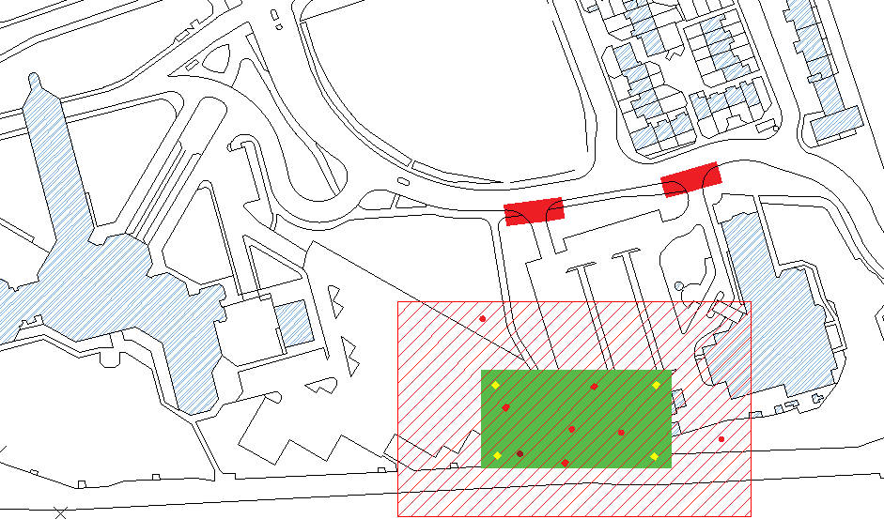
3.1. Topographical survey
Scope of works
The extents of the topographical survey of the area are shown as per the plot plan (Imaged above). The survey will be related to the existing buildings to the west and east of the site. Included in the survey should be the proposed area of the site, plus additional extents in all directions to allow for potential adjustments.
Four temporary benchmarks (TBM) should also be provided at the indicative spots on the mark up drawing.

Output of topographical survey
From the topographical survey, eastings, northings and elevations should be gathered, they should be relative to the site datums and not global datums. Contours of the topography should also be encapsulated where applicable. Furthermore, it should establish the station ID and the related details.
Significant features such as existing buildings, (fence/kerb/rail/bank/verge) lines, walls, and stations and monuments should be picked up, along with utility and statutory apparatus and vegetation.
Following the initial topographical survey, to aid in design; a point cloud scan is to be put together and coordinated with the topographical coordinates and datums.
3.2. Geotechnical investigations
The extents of the geotechnical investigations of the area are shown as per the plot plan (Imaged above). The geotechnical investigations should identify, the triaxial bearing capacity of the ground, and the soils geotechnical, resistive, and corrosivity properties.
The ground water level should be identified, and borehole logs should be produced. WAC testing should also be used to identify contaminants and identify sulphates.
3.3. Site Specific Dangers
As identified in pages 3 and 4, there is a risk of contamination at this site despite the original layer of made ground taken off as we do not know when the made ground was originally instated, possible contamination includes:
- Medical waste (needles, glass, bandages, contaminated cloth)
- Human remains
- Copper particulates
- Inorganic compounds (sulphuric acid, sodium hydroxide, cyanides, ammonium)
- Metals (arsenic, cadmium, lead, mercury)
- Asbestos
- Hydrocarbons
Although medical waste and human remains are highly unlikely, it is important to be aware of them and how to deal with them. All work must halt immediately, and do not disturb the area, for remains call 101, who may prompt you to call 999. And for medical waste call the environmental agency incident hotline.
Copper generally has a negligible effect on properly installed concrete, however, in the form of copper tailings and mixed with sulphides and chlorides it can impact the concretes strength and durability (Gutierrez, 2025). Copper tailings is a by-product of mining copper, as Swansea was involved in the smelting of copper and tailings would not have been shipped with the copper to the copperworks the likelihood of copper contamination affecting the finished product is unlikely.
Hydrocarbons can pose a significant risk to concretes strength due to the retardation of the hydration process. If found in soil, removal will be necessary and should follow the standard BS 10175:2011 (Concrete Society, 2025)
Inorganic compounds such as salts and acids can significantly deteriorate concrete foundations, causing long-term damage like cracking, surface erosion, and reduced load-bearing capacity (Amphoraconsulting.co.uk, 2026). The presence of these materials can significantly delay a project as they will need to be removed or immobilised before construction can begin to increase the longevity and safety of the building.
Heavy metals can slow concretes setting time and can weaken its overall structure, and in high concentrations some also reduce compressive strength (Puntke, 2001). Concrete can sometimes solidify and stabilise heavy metals due to its high alkalinity, but high concentrations can cause long-term issues.
To deal with asbestos if found, people on-site must abide by the asbestos safety guidelines outlined by the Health and Safety Executive (HSE) (HSE, 2012)

Site Specific Information to Aid in Survey, Design & Construction Phases
4.1. Building Regulations & Codes of Practice to adhere to
Overall site regulations & codes of practice:
- Building Act 1984
- Building Regulations 2010
- Health and Safety at Work Act 1974
- HSE Approved Codes of Practice
  - L153 – Managing health and safety in construction (CDM)
  - L101 – Safe use of lifting equipment (LOLER)
  - L22 – Provision and Use of Work Equipment (PUWER)
  - L5 – Control of Substances Hazardous to Health (COSHH)
- British standards & Eurocode
  - Eurocodes (EN 1990-1999) – Structural design
  - BS EN 206 – Specifying, producing and conforming concrete in construction
  - BS 9999 – Fire safety
  - BS 7671 (IET Wiring Regs) – Electrical installs
  - BS 5975 – Temporary works
  - BS 1186 – Woodworking
Topographical survey codes of practice:
- BS 5964-1 – Measuring instruments and measurements
- RICS Guidance Notes – Land Measurement
- Ordinance Survey & National Grid Requirements
- PAS 128:2022 – Specification for underground Utility Detection, Verification and Location
Geotechnical survey regulations & codes of practice:
- BS 5930:2015 – Code of practice for ground investigations
- Eurocode 7 – BS EN 1997 – General rules & Ground investigation & testing
- Contaminated Land & Environmental Regulations

4.3. Local Authorities & Services Contact Information
City and County of Swansea – Planning department
Address: Planning and City Regeneration, The Guildhall, Swansea, SA1 4PE
Email: Planning@swansea.gov.uk
Telephone: 01792635701
City and County of Swansea – Building Control team
Email: bcon@swansea.gov.uk
Telephone: 01792635636
City and County of Swansea – Street naming and numbering team
Address: Highway Network Management Group, The Guildhall, Swansea, SA1 4PE
Email: snn@swansea.gov.uk
Telephone: 01792635701
Natural resources Wales
Postal address: Customer Care Centre, Ty Cambria, 29 Newport Rd, Cardiff, CF24 0TP
Email: enquiries@naturalresourceswales.gov.uk
Telephone: 03000653000
Emergency contacts:
- Emergency gas – gas leak, broken pipe: 0800 111 999
- Emergency electrical – Hit live or dead electrical cable: 105
- Emergency drainage – Damaged drainage or spillage: 0800 085 3968
- Emergency water – Hit water main: 0800 085 3968

Suggested Foundations
If the made ground is still there, it would be unwise to put a pad foundation on top of made ground due to its unknown ground bearing pressure, made ground tends to have a lower ground bearing pressure the particles tend to be looser. On the other hand, piling could be very dangerous due to the possibility of contaminated particles being forced into the groundwater.
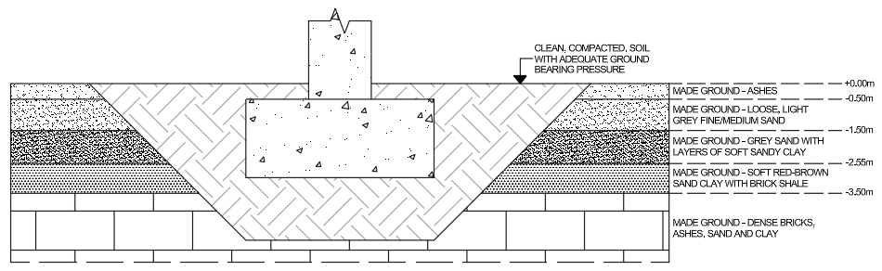
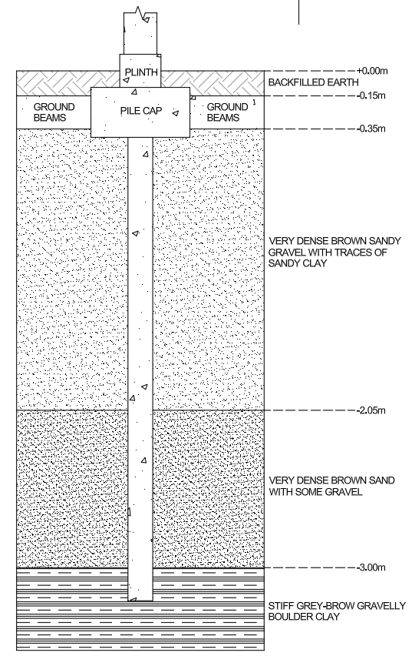
The above image shows a pad foundation underneath a structural pillar, made ground has been dug out and backfilled with clean, compacted soil. This prevents the contact of contamination to the concrete it also prevents the foundations from being directly on made ground and penetrating through the groundwater.
If the made ground has been removed, bored piling or piling would be best in this scenario as it provides much more structural integrity than pad foundations in higher quality soil.
This image shows an example of a pile in this situation, the pile depth however may vary following calculations, it may not need to be that deep or it needs to go down to bedrock (-18.60m), it is an unknown until calculations.

Source List
Amphoraconsulting.co.uk. (2026). Concrete Contamination: Inorganic, Organic, and Biological attack. [online] Available at: https://www.amphoraconsulting.co.uk/concrete-edu/detail/inorganic-organic-and-biological-contamination. Accessed: 28/04/2026
Baylis (2006). Gasworks remediation in the UK – a remediation contractor’s perspective. [online] Available at: https://media.geolsoc.org.uk/iaeg2006/ - PAPER 63. Accessed 02/04/2026
Canalrivertrust (2023). Canalopolis: Celebrating the 225th Anniversary of the Swansea Canal. [online] Available at: https://canalrivertrust.org.uk/news-and-views/blogs/waterfront/canalopolis-celebrating-the-225th-anniversary-of-the-swansea-canal. Accessed: 02/04/2026
Concrete Society (2025). Influence of hydrocarbon with concrete | Concrete Society. [online] Concrete Society. Available at: https://www.concrete.org.uk/fingertips/influence-of-hydrocarbon-with-concrete/. Accessed: 28/04/2026
Gutierrez, M.V., Gómez-Espina, R., Larenas, C., René Gómez and Siva Avudaiappan (2025). Effects of sulphuric-acid attack and chloride-ion penetration on cement mortar with copper tailings: mechanical properties and technical considerations for uses in shotcrete. International Journal of Mining, Reclamation and Environment, [online] Available at: https://www.researchgate.net/publication/389896506_Effects_of_sulphuric-acid_attack_and_chloride-ion_penetration_on_cement_mortar_with_copper_tailings_mechanical_properties_and_technical_considerations_for_uses_in_shotcrete Accessed: 28/04/2026
HSE (2012). HSE: Asbestos - health and safety in the workplace. [online] Hse.gov.uk. Available at: https://www.hse.gov.uk/asbestos/. Accessed: 28/04/2026
Met Office. (2022). Mumbles Head (Swansea) Location-specific long-term averages. [online] Available at: https://www.metoffice.gov.uk/research/climate/maps-and-data/location-specific-long-term-averages/gcjjm7j5g. Accessed: 20/04/2026
National Library of Scotland (2025). Glamorgan XXIV [online] Available at: https://maps.nls.uk/view/102342508. Accessed: 02/04/2026
National Library of Scotland (2025). Glamorgan XXIV.SW [online] Available at: https://maps.nls.uk/view/102183147. Accessed: 02/04/2026
Natural Resources Wales (2020). Story Map Series. [online] flood-risk-maps.naturalresources.wales. Available at: https://flood-risk-maps.naturalresources.wales/?locale=en. Accessed: 20/04/2026
Openinframap.org. (2026). Open Infrastructure Map. [online] Available at: https://openinframap.org/#14.94/51.61534/-3.94392. Accessed: 20/04/2026
Puntke, S & Schneider, M. (2001) The behaviour of heavy metals in cement and concrete. [Online] Available at: https://www.researchgate.net/publication/288727964_The_behaviour_of_heavy_metals_in_cement_and_concrete. Accessed: 28/04/2026
Swansea museum (2025). The Beginning of the Copper Industry. [online] Available at: http://www.swanseamuseum.co.uk/whats-on/past-exhibitions/copperopolis/the-beginning-of-the-copper-industry. Accessed: 02/04/2026
topographic-map.com (2026). Swansea topographic map, elevation, terrain. [online] Topographic maps. Available at: https://en-gb.topographic-map.com/map-733q/Swansea/?center=51.61355%2C-3.9456&zoom=18&popup=51.61316%2C-3.94543. Accessed: 20/04/2026
Walsh, R. (2025). Discovering Britain: Swansea, the ‘Copperopolis’ of Wales. [online] Geographical. Available at: https://geographical.co.uk/news/discovering-britain-swansea-the-copperopolis-of-wales. Accessed: 02/04/2026
Zetica UXO (2024). Risk Maps. [online] Zetica UXO. Available at: https://zeticauxo.com/guidance/risk-maps/. Accessed: 20/04/2025

