John Muir Assessment

The John Muir Award is an environmental award scheme which encourages educational, social, and active participation in environmental activities, by challenging participants to discover the wilderness of places, explore them, connect themselves to nature and share their experiences with others. (John Muir Trust, 2023)

-Discover a wild place

In this section, I will name and locate the place, discuss what I liked about it, why I think that it is special and worth my attention.

We chose to do a beach clean at Llansteffan beach, which is only 14km from Carmarthen. It makes sense to me to do it here as it is the closest beach to where I live and will impact my community positively. The Beach itself was ideal because it wasn’t too far away to drive to, and the access to it was easy too. “The Green and Scott’s Bay are the two main beach areas at Llansteffan” (Baxter, 2023). We started our beach clean at the car park and walked our way around the Llansteffan castle, all the way to Scott’s Bay.

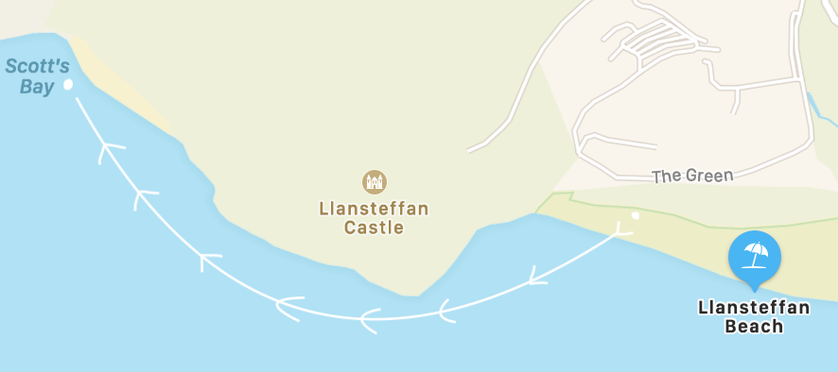

The white line represents the direction we took in order for us to pick up as much litter as possible.

NB. We didn’t access Llansteffan Beach when it was at High tide.

The sand at Llansteffan is fine and golden, becoming much firmer towards the sea. Llansteffans beach main stretch is backed by a flat grassy area with picnic benches and children's play park. Along with plenty of facilities close at hand, Llansteffan is a great family beach (UK Beach Guide, 2023). The reason we chose this beach was that Llansteffan is quite a popular tourist beach, with a good number of visitors that come and go, including locals which consequently means that there is often waste or litter to be picked up. Another point as to why we chose this beach, was because the difference between high tide and low tide means that the beach has more to offer in the sense that we had more areas to access. I think the reason why this beach was worth going to is primarily that it’s the closest beach to UWTSD and knowing that beaches are an important element of tourism connecting them to nature, it would be nice to have a beach like Llansteffan which is clean and nice to go to for some fresh air, to relax. To add to that, the beach is worth my attention because it’s one of the most scenic beaches I’ve visited in South Wales more precisely, Pembrokeshire.

-Explore its Wildness

In this chapter, I will be showing evidence of my visit to Llansteffan and what I have done to get to know this wild place. I will highlight the key natural characteristics of the beach itself.

YouTube private link: https://youtu.be/gpS6WY0sAH8

Before going to Llansteffan beach I did some research on the place to see if there was any important information I needed to know before going to do the Beach Clean. Firstly, I checked the weather in case of precipitation or rain coming through the Pembrokeshire area. I then checked the tide times, making sure we went for our beach clean safely knowing that it was low tide and without risk. Most of all I ensured before I left that I had a good layering on considering it’s nearly winter and the temperature is slowly dropping.
In terms of the natural terrain of this beach, it could be described as a safe and very spacious beach with easy access thanks to the parking and other paths that join it from the mainland of the Llansteffan village. The surface of the beach is flat with slight inclines in certain spots, all along the greenery of the beach there are walls of rocks that protect the forest when the sea is at high tide.

In terms of the wilderness of this beach, there are certain animals that come and go to Llansteffan such as marine wildlife like seals, crabs, jellyfish, and starfish. On this beach, you could also encounter a lot of wildlife on land such as the breeding of linnets (birds) that tend to stay on the coast in the winter, grass snakes, common lizards, slow worms and other insects. (Carmarthen Nature Partnership, 2023) Coastal foraging is also common on llanstefan beach due to the range of foods available (sea and land) So I feel it is important to help preserve the beach as littering can harm the wildlife, meaning a lack of foraging as well as impacting the food chain.

-Conserve and take responsibility

In this part, I will demonstrate the practical measures I have taken to conserve or otherwise protect the place.

As we started our beach clean, we tried to pick up as much litter as possible by spreading out away from each other for us to be more efficient. By using that technique, we were able to get a good amount of rubbish that was left on the ground to put into bin bags. After filling our rubbish bags and finishing our beach clean at Llansteffan we ensured our bags were in the general waste and not in the recycling bins. We also made sure the litter that was situated on the borderline of the beach was collected to ensure that it didn’t blow back into the sea. This was an important task to all of us, in order to show care and respect to the marine wildlife and help to keep the Pembrokeshire coast as clean as possible.

“A lot of rubbish that doesn’t go to landfill or a recycling centre ends up as litter, contaminating our land, waterways and oceans. Plastic litter is especially damaging to wildlife as it doesn’t fully break down” (North Wales Wildlife Trust, 2023). After looking up different beach cleans, I found several organisations that protect and promote, the maintenance of clean beaches, such as The Million Mile Beach Clean and the Marine Conservation Society. As a student living in Carmarthen, I support the importance of keeping coastlines clean and I would encourage others to do the same. “the Million Mile Clean is an annual action bringing Ocean Activists together to tackle plastic pollution head-on” (Surfers Against Sewage, 2023).
For future projects, I would go through the Million Mile Beach Clean organisations, because I would be able to do my own beach clean with their support considering they offer free equipment to use and bin bags. “Our rivers and seas are incredibly important to all of us, and together with our partner the Marine Conservation Society, we want our waterways to be cleaner and healthier” (Jones, 2023)

“They can end up in the food chain, showing up in animals big and small. Now a host of new studies show that microplastics can break down rapidly. And in some cases, they can alter entire ecosystems” (Stevens, 2020). Microplastics have also been something very important in the impact of wildlife such as those who either live close to or in the sea. More and more animals have these plastics thinking they are elements of food even though they are an easy way to kill wildlife. Llansteffan beach is also susceptible to larger amounts of rubbish being deposited due to it adjoining an estuary. This means that it is not only an issue about the rubbish on the beach but also litter being transported from upstream making its way to Llansteffan. For this reason, I will return to do more litter picks and potentially raise this issue with resources for Wales on stopping rubbish from the river from getting to the beach.

-Share your experiences/Conclusion

On arrival at the beach parking of Llansteffan, I was quite unsure about what I would find there. Whether I would find litter and general waste that washed up on the edge of the water, coming from somewhere else. As I started picking up rubbish, I realised there wasn’t that much on the ground which made me quite happy. It made me reflect on the fact that most people respect their environment and the tourist beaches and areas that they visit. From my experience, I do feel like there is still some effort to be made by others when it comes to taking care of natural spaces. Luckily, along the Pembrokeshire coastline, the majority of the public beaches remain quite tidy and well-maintained thanks to several litter-picking organisations who organise and implement specific days to go and care for their local environment.

Doing beach cleaning as I did is very important for the protection of the environment. “It provides food to billions and jobs to millions” (WWF, 2023). Saving our planet provides us with vital resources such as food, clean air and fresh water. By looking after our planet we support a variety of wildlife such as animals, insects, and plants, which are essential to the health and well-being of our planet. In the future when going in outdoors, I will now always think about the sustainability of my planet and Its wildlife, meaning that I will be mindful of the environment in which I live, taking care of it and not leaving any trace behind like litter or trash. I will continue to support beach clean organisations and share my experiences and opinion with others. To add, being somebody who always goes in outdoors and does sports such as windsurfing or surfing, seeing litter in the water makes my impact towards the environment more and more important too.

I feel as though this project was very useful, it made me think differently about certain aspects of information on beach cleaning or the protection of wildlife. Keeping our planet, and in my case for this project, keeping beaches clean, can have a massive impact on our lives in the future and by doing this assignment, my incite when going in outdoors has changed and made me think more about the importance of our planet.

Bibliography:

Baxter, J (2023) West Wales Holiday Cottages
Available at: https://westwalesholidaycottages.co.uk/destinations/llansteffan

John Muir Trust (2023) John Muir Award, Engagement Initiative
Available at: https://www.johnmuirtrust.org/john-muir-award

UK Beach Guide (2023) The Beach Guide, Llansteffan Beach
Available at: https://www.thebeachguide.co.uk/south-wales/carmarthenshire/llanstephan-and-tywi-estuary.htm

Carmarthen Nature Partnership (2023) Wildlife in your Ward – Llansteffan
Available at: https://www.carmarthenshire.gov.wales/media/1225441/llansteffan.pdf

North Wales Wildlife Trust (2023) Take Action – Litter and Wildlife
Available at: https://www.northwaleswildlifetrust.org.uk/take-action/litter-and-wildlife

Surfers Against Sewage (2023) Million Mile Clean
Available at: https://www.sas.org.uk/plastic-pollution/million-mile-clean/

Jones, L (2023) Welsh Government. Marine Clean Cymru is Back! Keep Wales Tidy
Available at: https://businesswales.gov.wales/walesruralnetwork/news-and-events/marine-clean-cymru-back

WWF (2023) Why Oceans Matter – Our Blue Planet
Available at: https://www.wwf.org.uk/ocean-heroes/why-oceans-matter

