Appendices For Jessica Bray (Sanchez) Module 3 Submission

Appendix 1
(California Department of Education Sacramento, 2018) (Duane, D. D.,2001) & (British Dyslexic Association, 2024)
Skill | Presentation in Dyslexic Students
Phonological Skills | -Difficulty in distinguishing between similar sounds or phonemes.  -Problems with phonemic awareness, such as recognizing rhymes or segmenting words into their constituent sounds.  –Challenges in pronouncing words correctly or in producing speech sounds accurately.  -Struggles in blending sounds together to form words or in breaking words into their individual sounds.  ·
Rapid Naming - Poor rapid naming skills refer to difficulties or delays in quickly and accurately naming a series of familiar stimuli, such as objects, colors, or symbols. | · Poor Rapid naming skills- which could present challenges in processing and integrating visual or auditory information efficiently, leading to slower cognitive processing speed and difficulty in tasks requiring quick responses.  · Slow Retrieval of the correct words when writing or speaking  · Difficulties distinguishing left from right
Poor grapheme-phoneme association- challenges in processing and integrating visual or auditory information efficiently, leading to slower cognitive processing speed and difficulty in tasks requiring quick responses. | · struggling to accurately pronounce words based on their spelling, difficulty in decoding unfamiliar words,  · challenges in reading fluently and accurately.  · may have trouble understanding the relationship between letters and the sounds they represent, which can impede their reading and spelling abilities.
Poor Decoding of real words and non-words- Poor decoding of real words and non-words refers to difficulties or inaccuracies in recognizing and understanding written language. | - Difficulty in accurately identifying and pronouncing familiar words, leading to slow or labored reading, frequent errors, or a lack of fluency.  - challenges in accurately reading and pronouncing unfamiliar or made-up letter combinations.
Reading Comprehension- Poor reading comprehension refers to a difficulty or inability to effectively understand, interpret, and analyze written texts. | · Difficulty summarizing information, answering questions about the text, or applying knowledge gained from reading.
Oral Reading Fluency- Oral Reading Fluency refers to the ability to read a text accurately, quickly, and with appropriate expression. | · May struggle with accurately recognizing words, leading to frequent hesitations, repetitions, or substitutions while reading aloud.  · When reading may lack appropriate intonation, rhythm, and phrasing.  · They may read at a much slower pace, struggling to maintain a fluent and steady reading rate.  · Difficulty with Punctuation: Individuals may have difficulty pausing at appropriate punctuation marks, such as commas and periods, leading to choppy reading.  · Limited Sight Vocabulary: Poor oral readers may rely heavily on decoding words phonetically rather than recognizing them instantly by sight, resulting in slow and laborious reading.  · Lack of Comprehension: Because of the cognitive load associated with decoding words, poor oral readers may struggle to comprehend the text they are reading, even if they can pronounce the words accurately.  · Avoidance of Reading Aloud: They may actively avoid situations where they have to read aloud, such as in class or during group activities, due to embarrassment or anxiety about their reading abilities.  · Difficulty Reading Multisyllabic Words: Poor oral readers may have particular difficulty with longer, multisyllabic words, often stumbling over them or guessing incorrectly.
Spelling | · May often misspell words or write letters the wrong way round
Phonological Memory - The ability to store small amount of phonological information on a short term basis. | · Struggling to recall words just learnt  · Struggle to recall the spelling of a word just learnt  · May not be able to recall longer sequences of letters or numbers
Oral Language Skills | · Difficulties retrieving specific words which impacts their oral fluency. This can also present as having difficulties recounting a narrative or list if words orally.
Orthographic Processing- Orthographic processing refers to the ability to recognize and manipulate letters in written words. | · Dyslexia students often have difficulties in decoding words, recognizing sight words, and understanding the relationship between sounds and letters.  · Difficulty organizing written and spoken language
Additional Non Language characteristics within the Dyslexic Student
Memory and Cognition | · Poor memory for sequences especially from short term memory  · Thinks in images and emotion- not words or sounds  · Excellent long term memory for experiences both visually and emotionally
Behaviour | · Disorderly  · Displays unusually early or late at key developmental stages as a child  · Unusually high or low tolerance for pain  · Emotionally sensitive  · Mistakes will be affected by mood and emotion  · Often creatively intelligent- Art. Music, Drama  · Difficulty sustaining attention

APPENDIX 2
Safeguarding Policy taken from www.singwithjess.co.uk, Accessed: 13th December 2024
Sing with Jess
Safeguarding policy statement
Updated: September 2024

  - The purpose and scope of this policy statement
Within Sing with Jess lessons we aim to ensure your singing lessons are carried out in a safe manger that fully considers the welfare and safeguarding of each student.

The purpose of this policy statement is:

• to protect children and young people who receive Sing With Jess’ services from harm. This includes the children of adults who use our services

• to provide staff and volunteers, as well as children and young people and their families, with the overarching principles that guide our approach to child protection.

This policy applies to anyone working on behalf of Sing With Jess, including paid staff, volunteers, sessional workers, agency staff and students.

  - Legal framework
This policy has been drawn up on the basis of legislation, policy and guidance that seeks to protect children in England/Northern Ireland/Scotland/Wales [select the relevant nation]. A summary of the key legislation and guidance is available from nspcc.org.uk/childprotection.

  - Supporting documents
This policy statement should be read alongside our organisational policies, procedures, guidance and other related documents which can be requested via info@singwithjess.co.uk:

• role description for the designated safeguarding officer
• dealing with disclosures and concerns about a child or young person
• managing allegations against staff and volunteers
• recording concerns and information sharing
• child protection records retention and storage
• code of conduct for staff and volunteers
• behaviour codes for children and young people
• photography and sharing images guidance
• safer recruitment
• online safety
• anti-bullying
• managing complaints
• whistleblowing
• health and safety
• induction, training, supervision and support
• adult to child supervision ratios.

  - We believe that:
• children and young people should never experience abuse of any kind
• we have a responsibility to promote the welfare of all children and young people, to keep them safe and to practise in a way that protects them.

  - We recognise that:
• the welfare of children is paramount in all the work we do and in all the
• decisions we take
• working in partnership with children, young people, their parents, carers and
• other agencies is essential in promoting young people’s welfare
• all children, regardless of age, disability, gender reassignment, race, religion or belief, sex, or sexual orientation have an equal right to protection from all types of harm or abuse
• some children are additionally vulnerable because of the impact of previous
• experiences, their level of dependency, communication needs or other issues
• extra safeguards may be needed to keep children who are additionally vulnerable safe from abuse.

  - We will seek to keep children and young people safe by:
• valuing, listening to and respecting them
• appointing a nominated child protection lead for children and young people, a deputy and a lead trustee/board member for safeguarding
• adopting child protection and safeguarding best practice through our policies, procedures and code of conduct for staff and volunteers
• developing and implementing an effective online safety policy and related procedures
• providing effective management for staff and volunteers through supervision, support, training and quality assurance measures so that all staff and volunteers know about and follow our policies, procedures and behaviour codes confidently and competently
- recruiting and selecting staff and volunteers safely, ensuring all necessary checks are made
• recording and storing and using information professionally and securely, in line with data protection legislation and guidance [more information about this is available from the Information Commissioner’s Office: ico.org.uk/for-organisations]
• sharing information about safeguarding and good practice with children and their families via leaflets, posters, group work and one-to-one discussions
• making sure that children, young people and their families know where to go for help if they have a concern
• using our safeguarding and child protection procedures to share concerns and relevant information with agencies who need to know, and involving children, young people, parents, families and carers appropriately
• using our procedures to manage any allegations against staff and volunteers appropriately
• creating and maintaining an anti-bullying environment and ensuring that we have a policy and procedure to help us deal effectively with any bullying that does arise
• ensuring that we have effective complaints and whistleblowing measures in place
• ensuring that we provide a safe physical environment for our children, young people, staff and volunteers, by applying health and safety measures in accordance with the law and regulatory guidance
• building a safeguarding culture where staff and volunteers, children, young people and their families, treat each other with respect and are comfortable about sharing concerns.

  - Contact details
Nominated child protection lead
Name: Jessica Bray (Sanchez)
Phone/email: info@singwithjess.co.uk

Appendix 3
Goal | Development Opportunity to meet my Goal | Actions I will take to achieve this | Resources and Support needed | What Success will look like | Date of Completion
Connect with the wider Neurodiveristy Music Teaching community | To increase my knowledge of existing research and strategies in use amongst teachers of neurodiverse students | -Write an email to Elizabeth Hetherington who led a Voice Study Centre to ask for a possible Zoom meeting  -Arrange a zoom meeting with Elizabeth to discuss her theories from the lecturer to gain insight in to her research and to find any other possible studies or journals to read to further my knowledge in existing Music Teacher theory within Neurodiversity. | -contact email for Elizabeth from the Vocal Study Centre  -Finding Time within mine and Elizabeth’s schedule to coordinate a meeting  -Agenda for the meeting with Elizabeth to ensure aims of the meeting are met | -Will have met with Elizabeth Hetherington  -A list of neurodiverse specific education journals to read  -A list of research Elizabeth used for her methods | Jan 2024
Develop a better understanding of Neuroanatomy of the dyslexic brain | To increase my knowledge of neuroanatomy to better understand the research papers that I am reading to gain a better understanding of Dyslexia, which I am exploring within my research to build teaching strategies within this population | -Search the Voice Study Centre for any neuroanatomy courses  -schedule time for and watch the videos found  -research further neuroanatomy courses available online  -Contact any lecturers within the VSC videos for any further reading which would be useful to help understand the  -Revisit my previous Neuroanatomy books from my Physiotherapy Degree | -I will have watched any relevant videos found on the VCS library  -A nueroanatomy Guide to the areas of the brain discussed in Module 1, either via a source recommended by a lecturer  -Request a Neuroanatomy book from the library  -I will schedule 3x 1 hour long sessions to revise and learn my objectives set out. | -I will be able to map from memory an anatomically accurate map of the parts of the brain required for phonological processing  -I will be able to name the key areas of the brain mentioned within Module 1, and be able to recall what their functions are | Jan 2024
Extend my knowledge of teaching Neurodiverse students | -To gain further insight into other theories of teaching specific to music and increase my awareness of research already undertaken which could be applied to my research | -Subscibe to the Music teacher magazine updates to find any Nuerodiverse specific articles  -Research Educational journals specific to teaching Neurodivese students  -Research available publications through the university library | -Access to the university library  -Subscription approval to journals  -Request any possible routes to publications open to me through my university library | -I will have identified the key journals and subscriptions that would fit the category of knowledge wanted in this aread  -Read relevant journal articles when they are published within a month of publication of subscribed journals  -Monthly reviews of the subscribed journals to identify relevant articles | Made Routine to my learning schedule by Jan 2024
Understand the barriers faced when completing assignments due to my dyslexia | -To find additional support and understand the possible barriers I am facing due to dyslexia to help improve my academic writing | -Book regular catch ups in the run up to my assignment due dates with tutors  -Book a meeting with the Universitty student support team to get clarity on the support available through the university | -Scheduled dates of due assignments  -list of tutors in relation to make next assignment  -University Student support availability and funding in place from the SLC | -created a better methodology to research and comprehension of text  -adapted study schedule adapted to additional support advice  -arrange 1:1 student support sessions with academic tutor | Feb 2024
Explore the relationship between singing processes in the dyslexic brain | -To understand if there are research papers to support any changes in the processes within the dyslexia when specifically looking at act of singing song from score | -Conduct a search of singing and music teaching journals for any prior research  -Find academic texts to understand the neuroanatomy involved in singing  -create any comparisons across the typical and atypical brain | -Search for any neuroanatomy lectures within the course led library  -search for further reading within the university library collection  -seek recommendations from tutors of nuero speaclalists in singing and explore their work | -I will be able to map the neuroanatomy processed used for singing  -I will be able to map any differences seen between the typical and atypical brain  -To bring this understanding into further research on this subject within my own academic writing | Jan 2024

Appendix 4

British Dyslexic Association Advice Style Guide, 2024 Accessed on the 18th December 2024: https://cdn.bdadyslexia.org.uk/uploads/documents/Advice/style-guide/BDA-Style-Guide-2023.pdf?v=1680514568
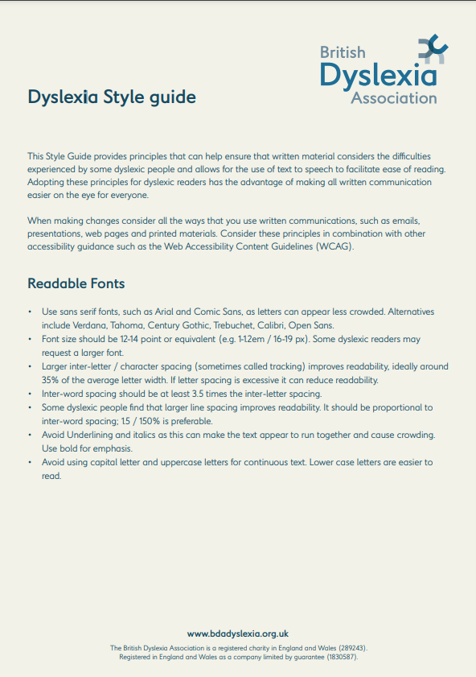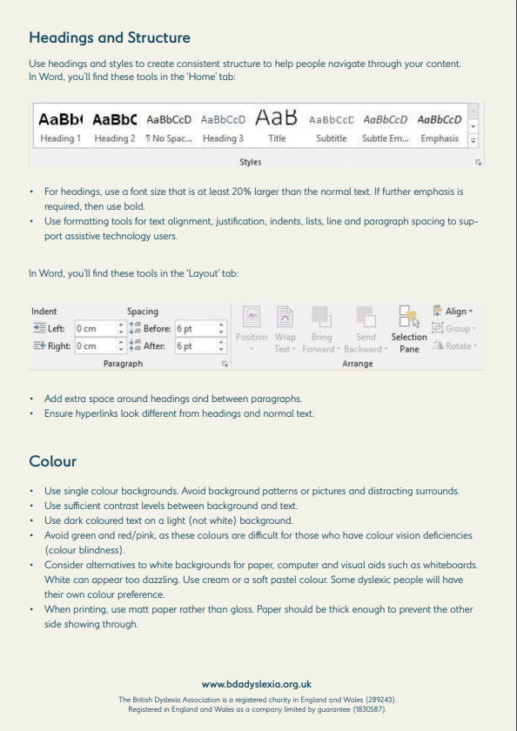
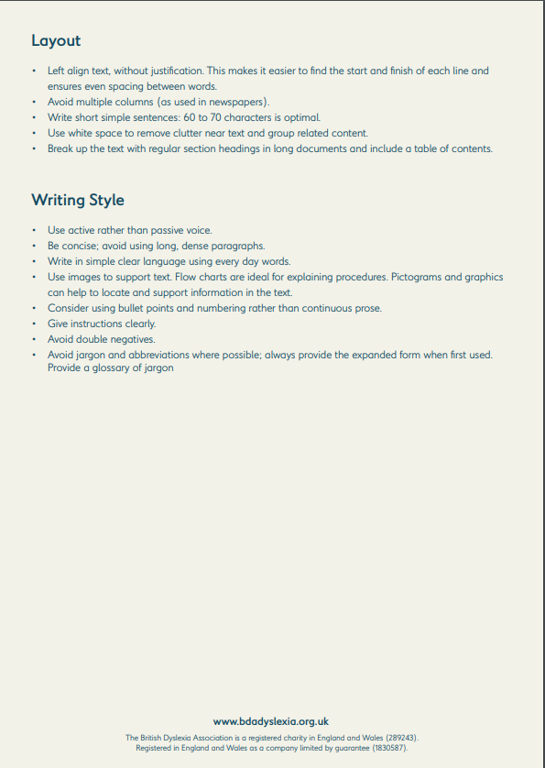

APPENDIX 5

Participant Information Sheets

Participants Information Sheet: Questionnaire(Adults)
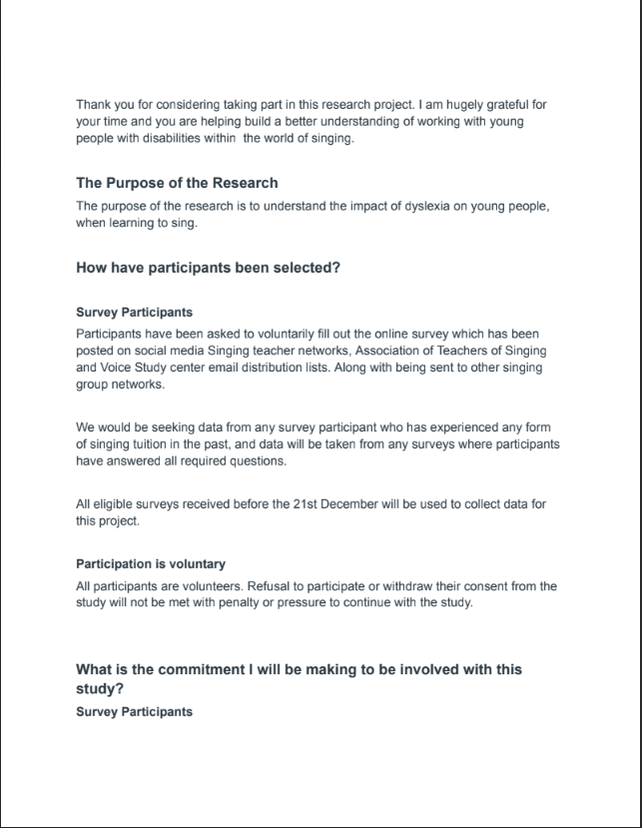
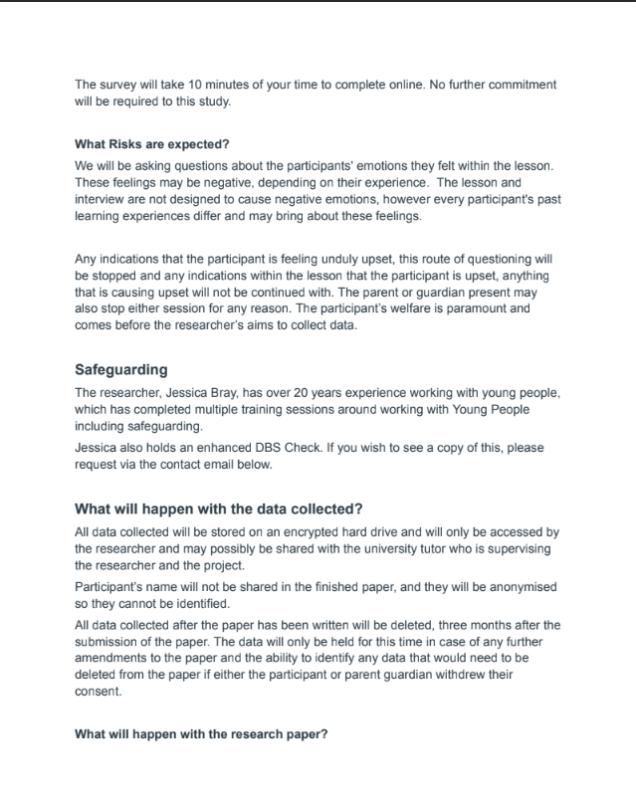
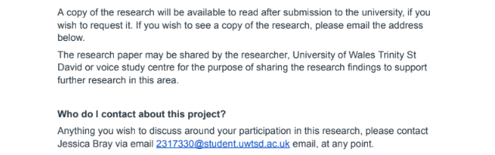

Participant Info Sheet- QUESTIONNAIRE PARTICIPANTS Parent/Guardian

Thank you for considering taking part in this research project. I am hugely grateful for your time and you are helping build a better understanding of working with young people with disabilities with the world of singing.

The Purpose of the Research
The purpose of the research is to understand the impact of dyslexia on young people, when learning to sing.

How have participants been selected?

Survey Participants
Participants have been asked to voluntarily fill out the online survey which has been posted on social media Singing teacher networks, Association of Teachers of Singing and Voice Study center email distribution lists.
We would be seeking data from any survey participant who has been undertaking one to one singing lessons for at least three months, and data will be taken from any surveys where participants have answered all required questions.
All eligible surveys received before the 14th December will be used to collect data for this project.

Participation is voluntary
All participants are volunteers. Refusal to participate or withdraw their consent from the study will not be met with penalty or pressure to continue with the study.

What is the commitment I will be making to be involved with this study?
Survey Participants
The survey will take 10 minutes of your time to complete online. No further commitment will be required to this study.

What Risks are expected?
We will be asking questions about the participants' emotions they felt within the lesson. These feelings may be negative, depending on their experience. The lesson and interview are not designed to cause negative emotions, however every participant's past learning experiences differ and may bring about these feelings.

Any indications that the participant is feeling unduly upset, this route of questioning will be stopped and any indications within the lesson that the participant is upset, anything that is causing upset will not be continued with. The parent or guardian present may also stop either session for any reason. The participant’s welfare is paramount and comes before the researcher’s aims to collect data.

Safeguarding
The researcher, Jessica, who will be leading these sessions and writing this project paper has over 20 years experience working with young people, which has included multiple training around working with Young People including safeguarding.
Jessica also holds an enhanced DBS Check. If you wish to see a copy of this, please request via the contact email below.

What will happen with the data collected?
All data collected will be stored on an encrypted hard drive and will only be accessed by the researcher and may possibly be shared with the university tutor who is supervising the researcher and the project.
The participant’s name will not be shared in the finished paper, and they will be anonymised so they cannot be identified. Further to this the recordings of the lesson and the interview will not be shared, and will only be used by the researcher to write up their analysis.
All data collected after the paper has been written will be deleted, three months after the submission of the paper. The data will only be held for this time in case of any further amendments to the paper and the ability to identify any data that would need to be deleted from the paper if either the participant or parent guardian withdrew their consent.
What will happen with the research paper?
A copy of the research will be available to read after submission to the university if you wish to request it. An email will be sent at the end of the research study, along with details on how to request this.
The paper maybe shared by the researcher, University of Wales Trinity St David or voice study centre for the purpose of sharing the research findings to support further research in this area.
Who do I contact about this project?
Anything you wish to discuss around your participation of this research, please contact Jessica Bray via email 2317330@student.uwtsd.ac.uk email, at any point.

Participant Information Sheet for Case Study- Parent Guardian
Information Sheet for Case Study Participants - Parent/Guardian

Thank you for considering taking part in this research project. I am hugely grateful for your time and you are helping build a better understanding of working with young people with disabilities with the world of singing.

The Purpose of the Research
The purpose of the research is to understand the impact of dyslexia on young people, when learning to sing.

Short Overview
Your child/ward’s participation in this research project will involve taking a 20 minute recorded Singing lesson with our researcher, followed by a 30-45 minute interview with the researcher who took this lesson where the young person will be asked about their learning experience in the lesson

More Detailed information on the participation in this study….

How have participants been selected?
Recorded lesson and interview participant
Participants have been invited to take part in this research from open calls to voluntarily participate from social media posts, email shout outs all through SInging Teacher networks. We have then reviewed the eligibility criteria below for each volunteer and selected participants if they fulfill this:
- Are aged 7-11 Years old
- Do not turn 18 years old before the 31st December 2024
- Are diagnosed as Dyslexic or receiving support for dyslexia from their full time education setting
- Have been having one to one singing lessons for 3 months prior to volunteering
Whichever comes soonest, 4 participants have been found or it reaches the date of the 14th December 2024- no more participants will be invited to take part.

Participation is voluntary
All participants are volunteers. Refusal to participate or withdraw their consent from the study will not be met with penalty or pressure to continue with the study.

What is the commitment I will be making to be involved with this study?
Participants will need to attend a free, online, one to one, 20 minute singing lesson with our researcher. Then the participant will need to take part in a 30 minute interview with this researcher within three weeks following this lesson. Both will be scheduled at a time convenient to the participant and will take place between the 1st and 23rd December 2024.

As the participant is under 18, a parent guardian will need to be present in the room whilst both the lesson and the interview.

What will happen during the one to one singing lesson?
You will be sent a link to a Microsoft teams meeting and a password to access this, along with a time and date the lesson will take place. The lesson will last around 20 minutes

We will start the lesson by checking
- Participant's name
- They have a parent or guardian present who can hear and see the lesson taking place and consents to the participant taking part
- The participant is happy to take part

During the lesson we will have a singing warm up and do some singing exercises.
They will not have to take part in anything they feel uncomfortable doing and may stop the lesson at any point.
The lesson will be recorded. This is for two purposes. To allow the researcher to make detailed observations after the lesson has taken place, and will also be used in the follow up interview for the participant and researcher to watch to help recall what happened in the lesson.
When the lesson has finished we will ask your parent/Guardian to agree a time for us to have a 30 minute chat about the lesson.

What will happen in the 30 minute Interview?
We will send you a Mirosoft Teams Zoom meeting link and password, and the agreed time and date for this to take place. Again, a parent or guardian will need to be present during this chat.
The participant will watch a recording of the lesson together with the researcher, and they will ask questions about things they enjoyed in the lesson and the things they didn't enjoy as they watch together. The researcher will ask how things made them feel in the lesson and they might ask why you did things. They don't have to answer every question and they can stop the interview at any point.
After the interview, you and the participant have the right to withdraw your consent to the research and any data which was gathered from your input will be withdrawn from the study.
The interview will be transcribed by a software tool called Edscribe and recorded for the researcher to be able to write up detailed analysis of the answers and the body language of the participant during the giving of their answers.

What Risks are expected?
We will be asking questions about the participants' emotions they felt within the lesson. These feelings may be negative, depending on their experience. The lesson and interview are not designed to cause negative emotions, however every participant's past learning experiences differ and may bring about these feelings.

Any indications that the participant is feeling unduly upset, this route of questioning will be stopped and any indications within the lesson that the participant is upset, anything that is causing upset will not be continued with. The parent or guardian present may also stop either session for any reason. The participant’s welfare is paramount and comes before the researcher’s aims to collect data.

Safeguarding
The researcher, Jessica, who will be leading these sessions and writing this project paper has over 20 years experience working with young people, which has included multiple training around working with Young People including safeguarding.
Jessica also holds an enhanced DBS Check. If you wish to see a copy of this, please request via the contact email below.

What will happen with the data collected?
All data collected will be stored on an encrypted hard drive and will only be accessed by the researcher and may possibly be shared with the university tutor who is supervising the researcher and the project.
The participant’s name will not be shared in the finished paper, and they will be anonymised so they cannot be identified. Further to this the recordings of the lesson and the interview will not be shared, and will only be used by the researcher to write up their analysis.
All data collected after the paper has been written will be deleted, three months after the submission of the paper. The data will only be held for this time in case of any further amendments to the paper and the ability to identify any data that would need to be deleted from the paper if either the participant or parent guardian withdrew their consent.

What will happen with the research paper?
A copy of the research will be available to read after submission to the university if you wish to request it. An email will be sent at the end of the research study, along with details on how to request this.
The paper may be shared by the researcher, University of Wales Trinity St David or voice study center for the purpose of sharing the research findings to support further research in this area.

Who do I contact about this project?
Anything you wish to discuss around your participation of this research, please contact Jessica Bray via email 2317330@student.uwstd.ac.uk email, at any point

Information Sheet for Child Participant- CASE STUDY
Information for Case Study Participants- Chidren
Thank you for helping with this project!
This study is about understanding how young people with dyslexia learn to sing. Your help will make a big difference in learning more about this!

What will I be doing?
If you join, you will:
🎤 Have a 30-minute online singing lesson with our researcher.
💬 During the lesson you will Chat with the researcher about your lesson.
Both will be recorded to help us understand your experience.

Who can take part?
We are inviting children who:
✅ Are 7-11 years old
✅ Have dyslexia or get dyslexia support at school
✅ Have had one-to-one singing lessons

Do I have to do this?
Nope! Taking part is your choice. You can stop anytime without any problems.

What happens in the singing lesson?
📅 You will get a link to join an online lesson.
👩‍👧 A parent/guardian must be with you.
🎶 You will do a warm-up and some singing exercises.
😃 If anything makes you uncomfortable, you don’t have to do it!
🎥 The lesson will be recorded to help us look back at what happened.

What happens in the chat during the lesson?
💻 You will join another online meeting with the researcher.
🎥 You’ll talk about what you liked and didn’t like.
🛑 You don’t have to answer any questions you don’t want to, and you can stop at any time.

Will this be safe?
Yes! If you feel sad, upset, or uncomfortable, you can stop. Your parent/guardian will be there to help, and they can stop the session too.

Who will see my information?
🔒 Your name will not be used in the final report.
📁 The recordings will not be shared and will be deleted after the study.

What happens to the research?
📜 The study will be shared to help people learn more about dyslexia and singing.
📧 If you want to read the research when it’s finished, we can send you a copy!

Who do I contact if I have questions?
📩 Jessica Bray (Researcher) – Email: 2317330@student.uwstd.ac.uk

Appendix 6-

Full Copy of the Questionnaire (screenshots Taken)

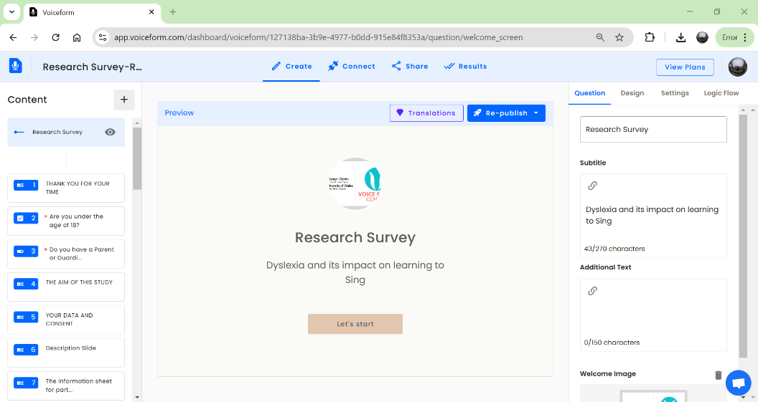
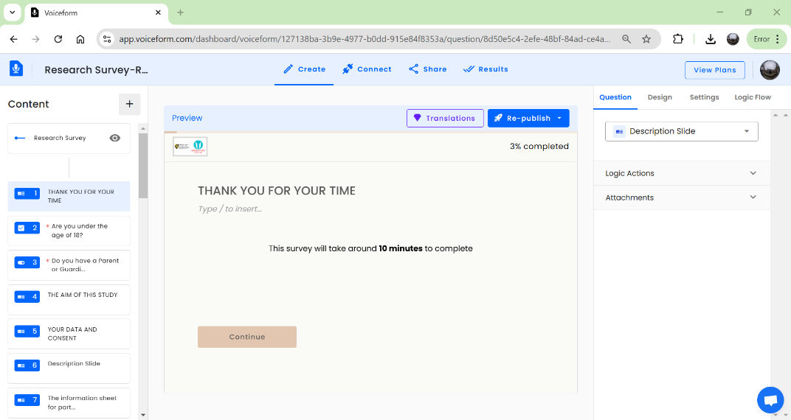
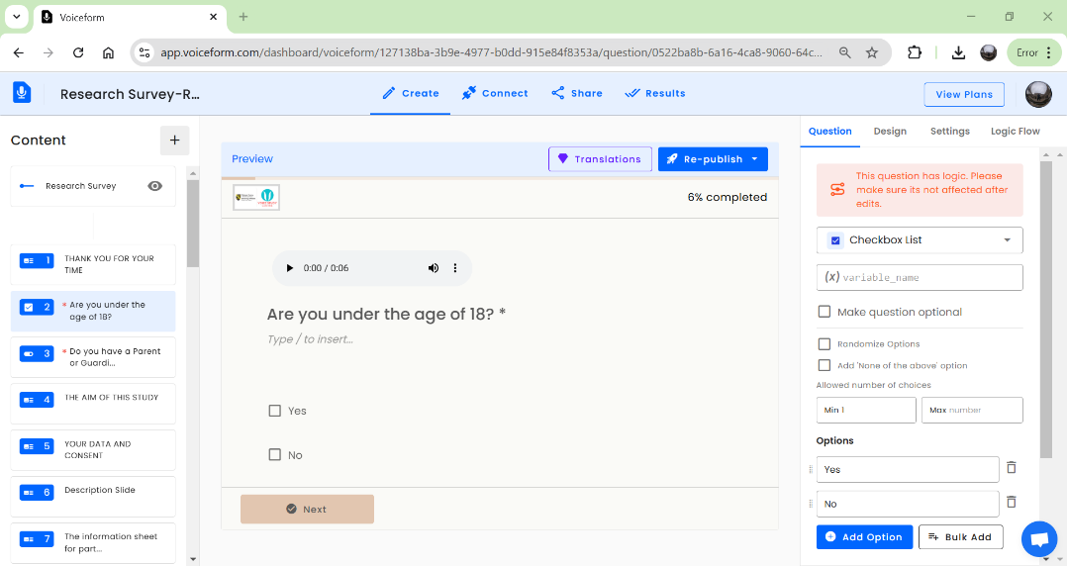
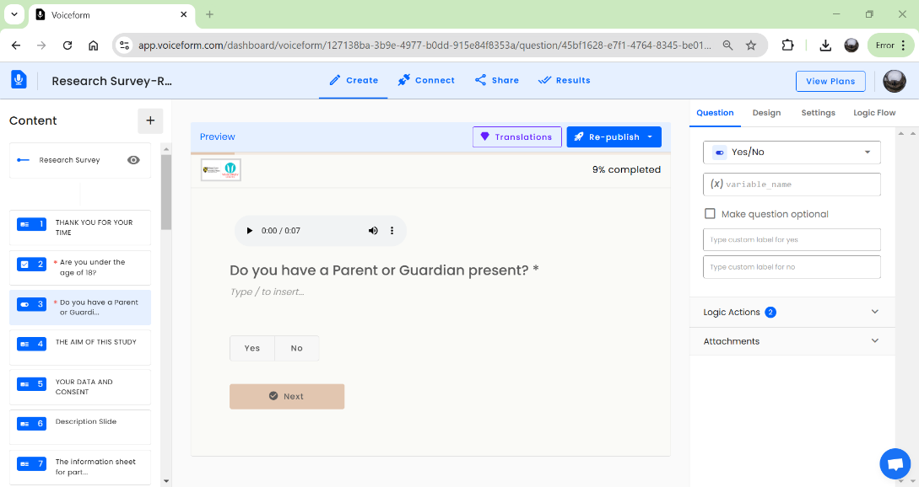
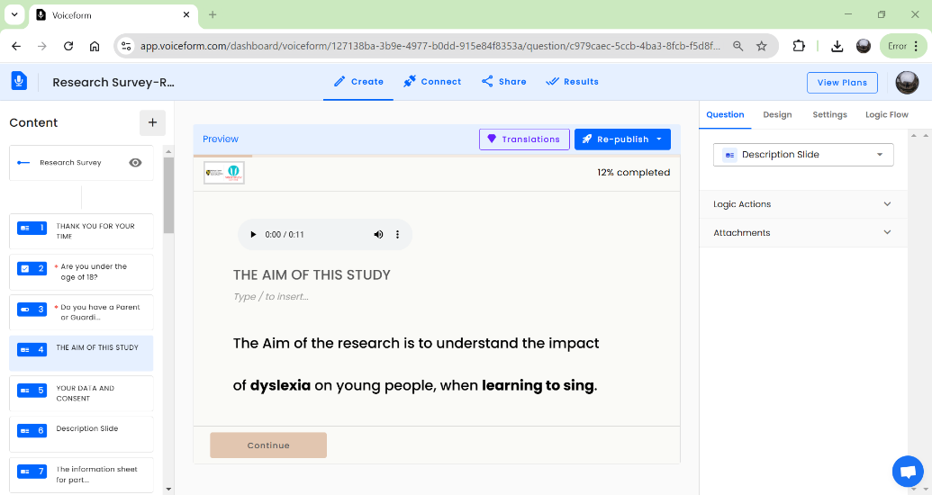
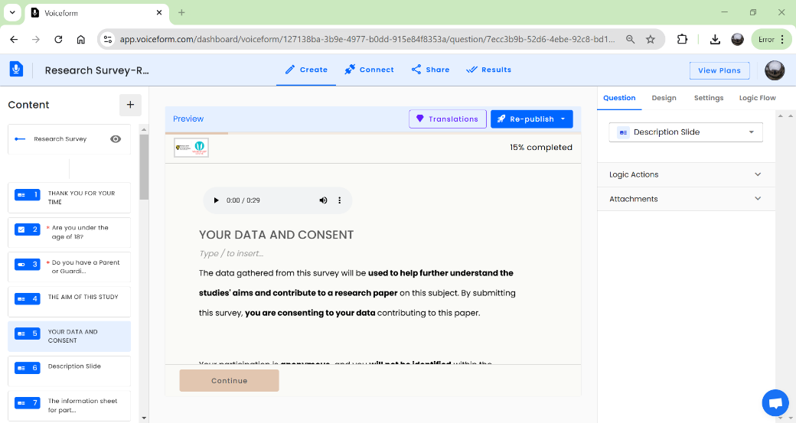
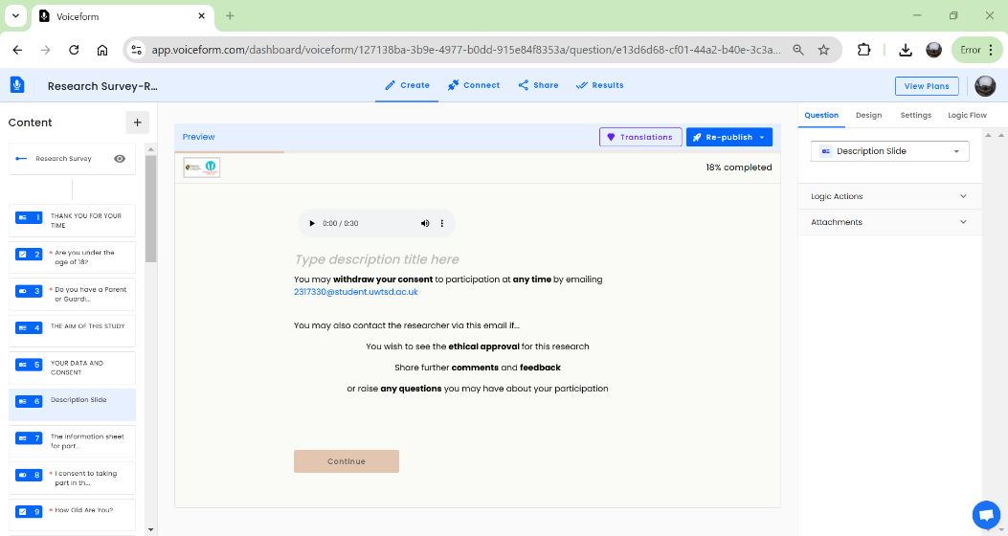
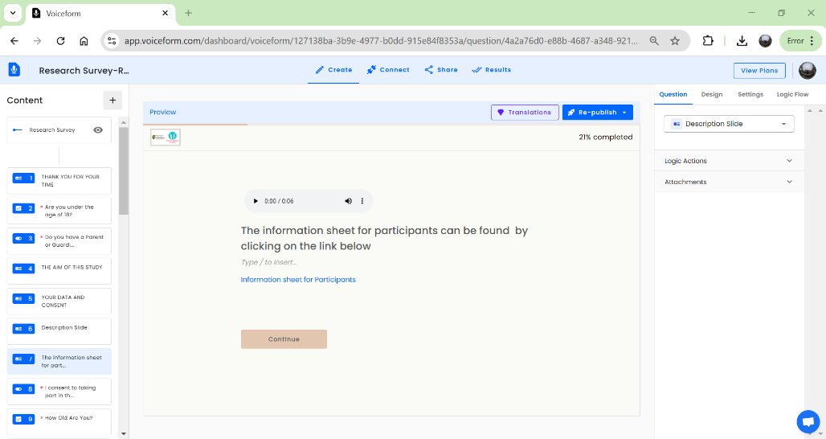
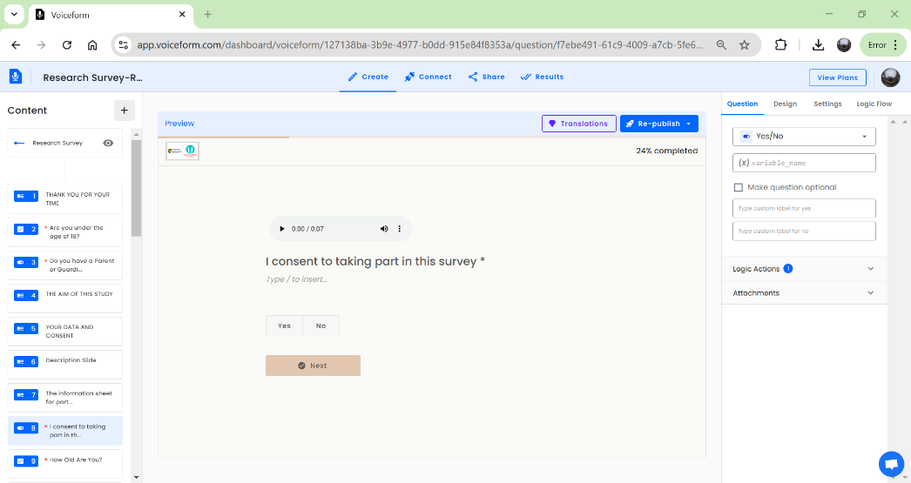
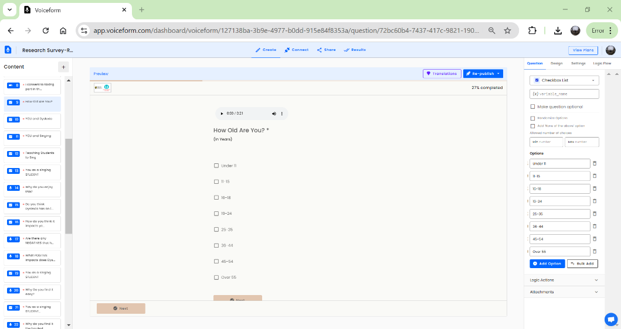
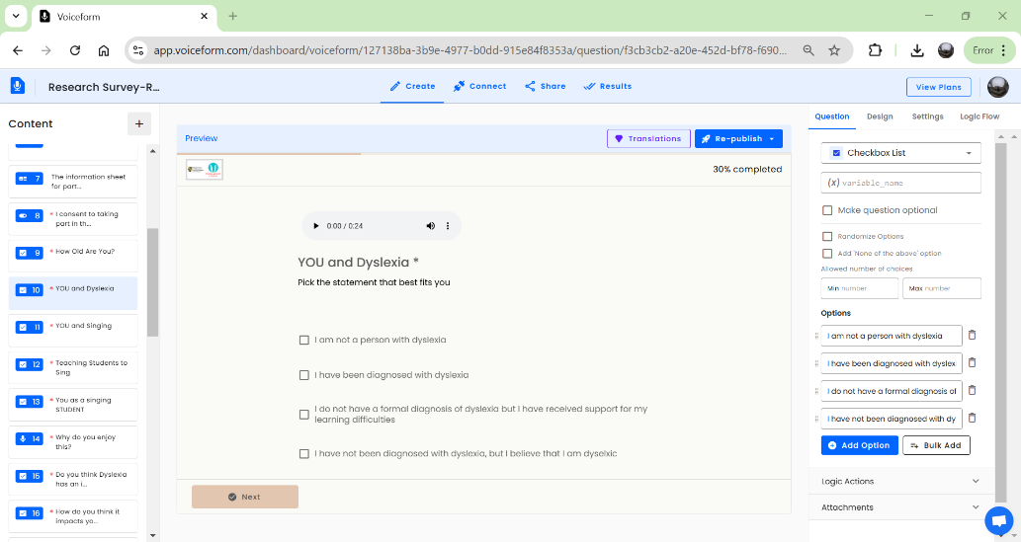
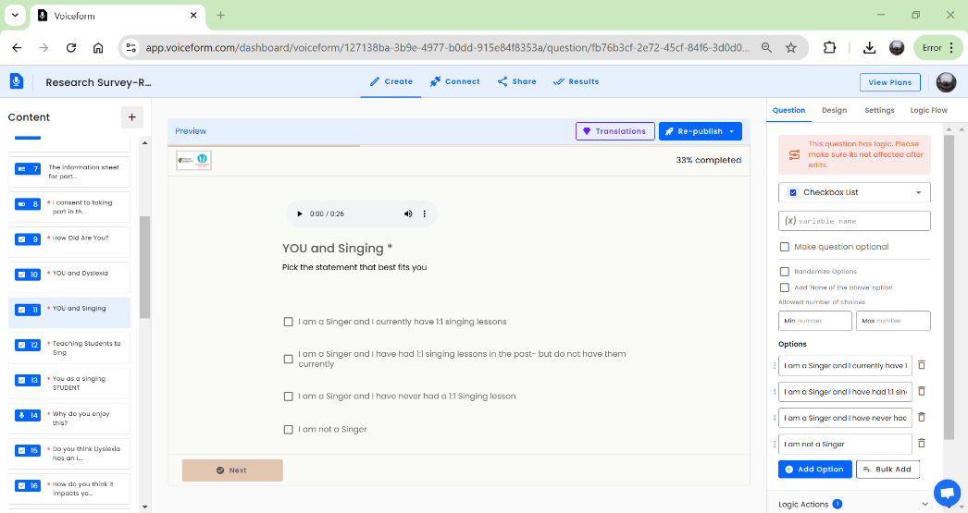
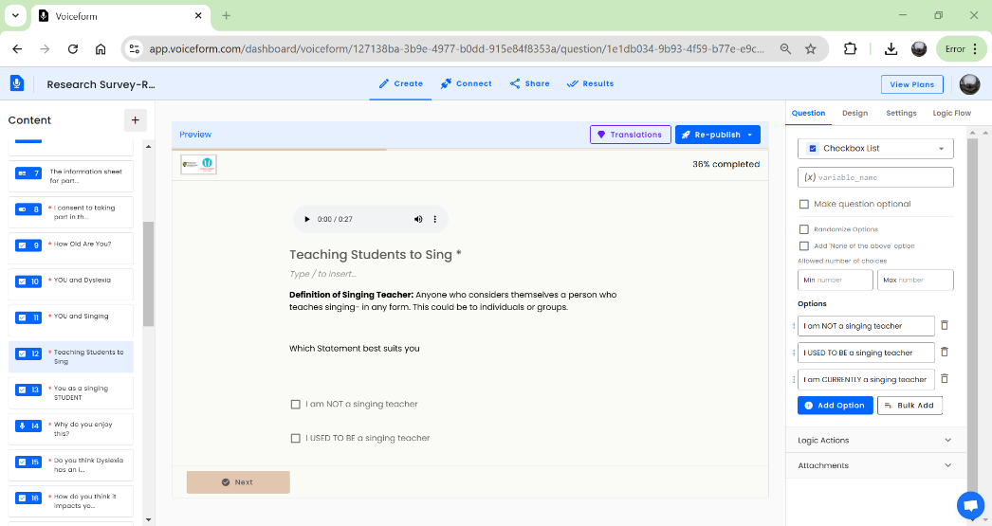
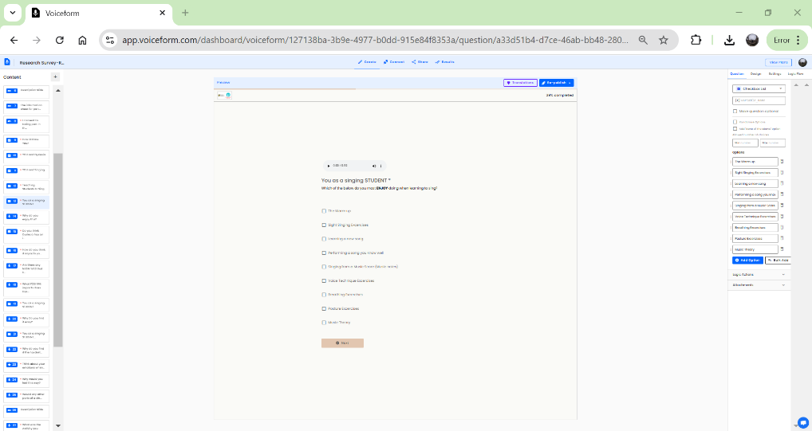
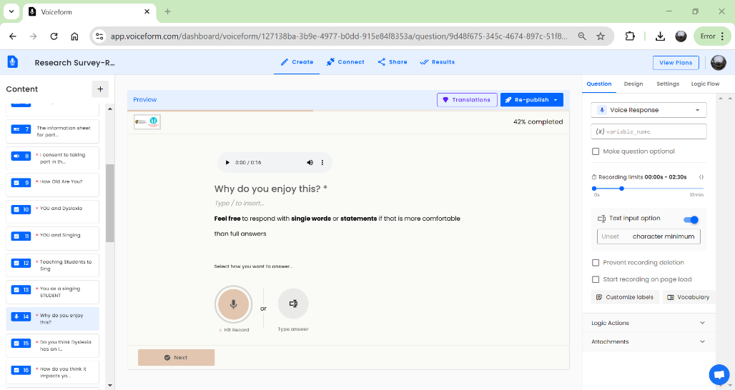
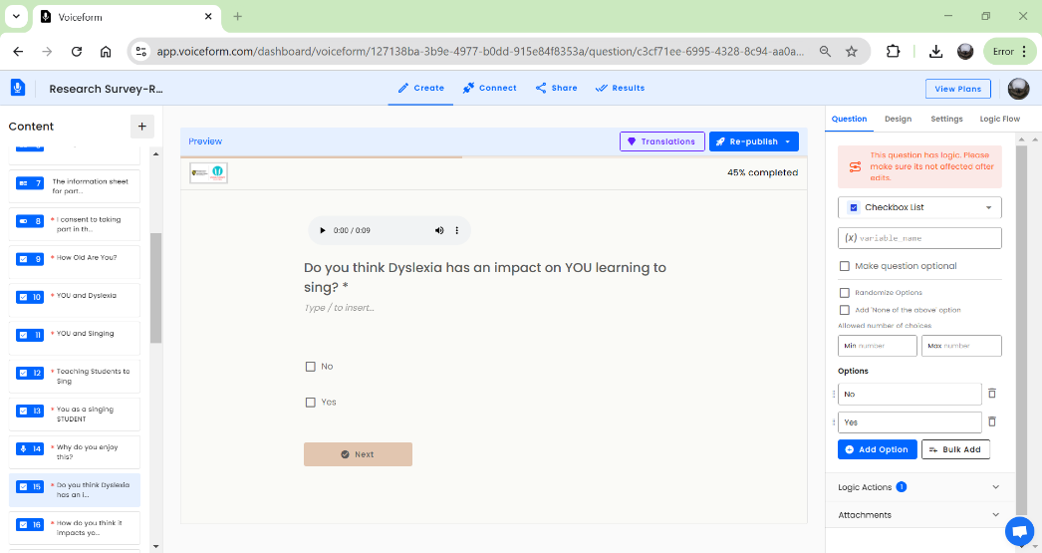
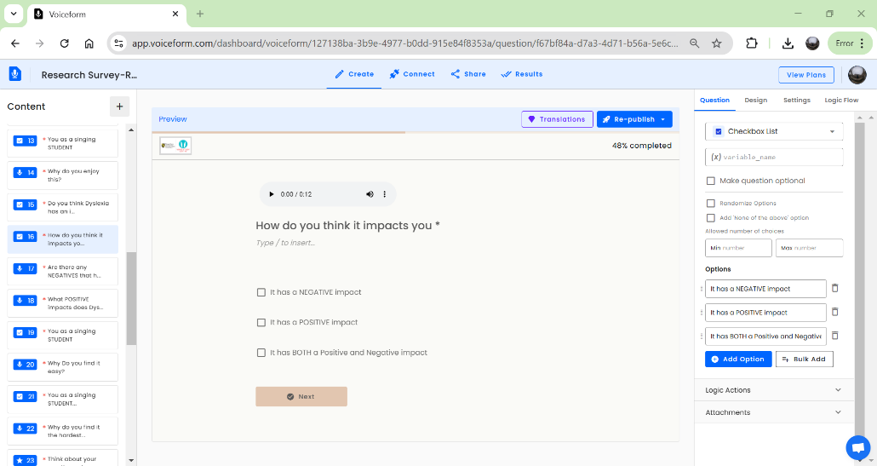

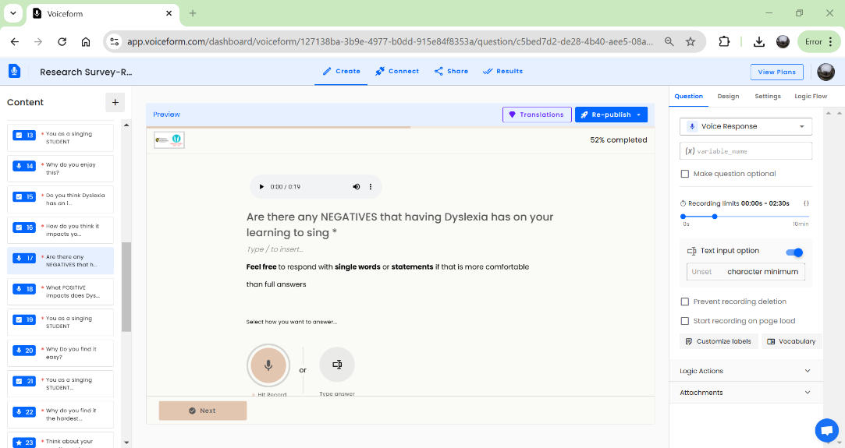
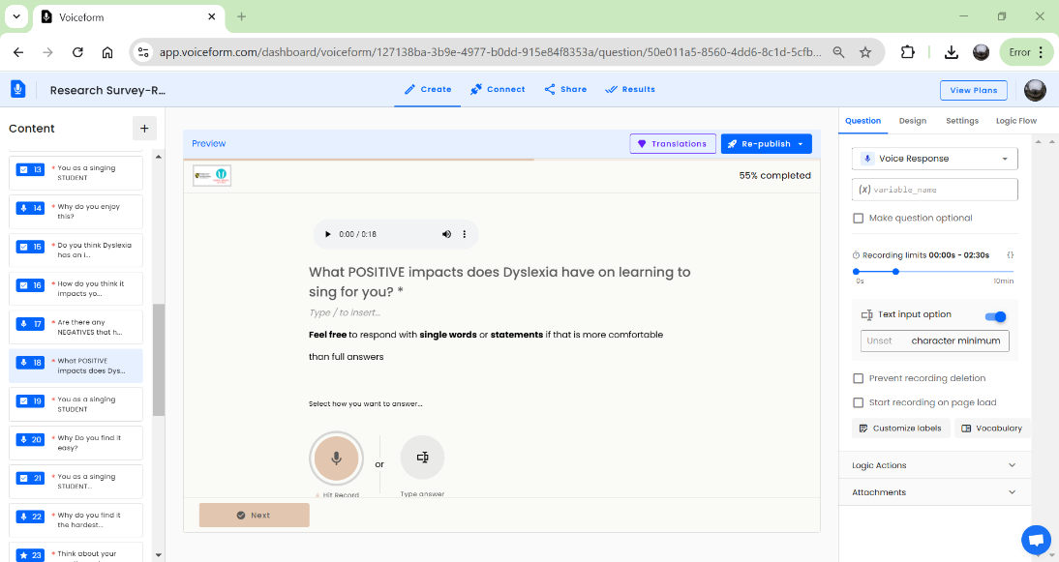
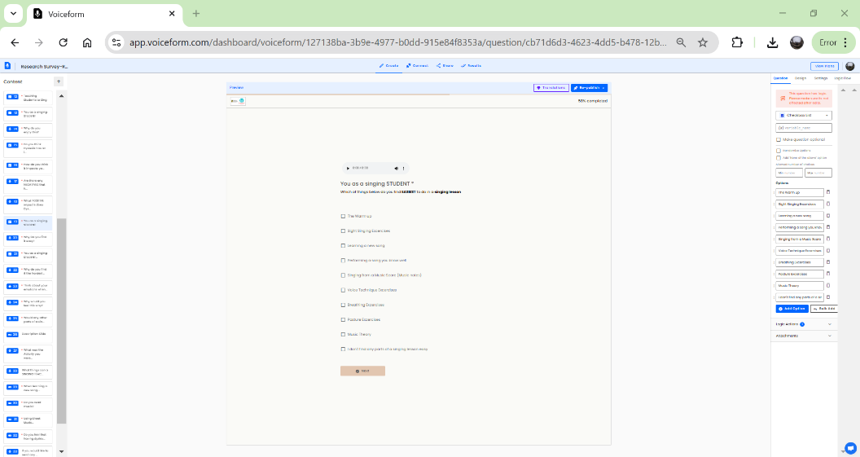
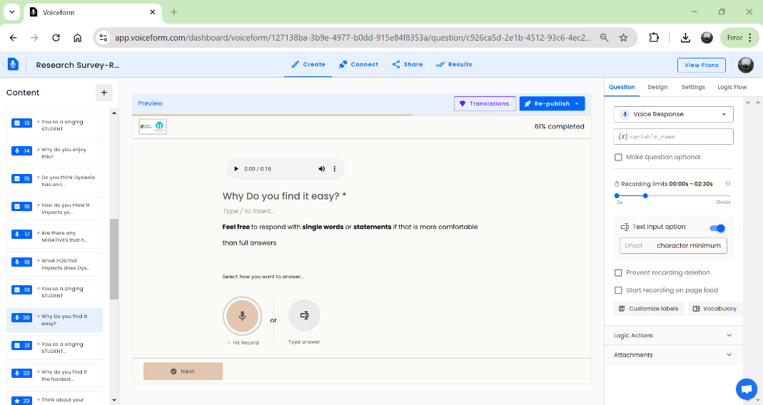
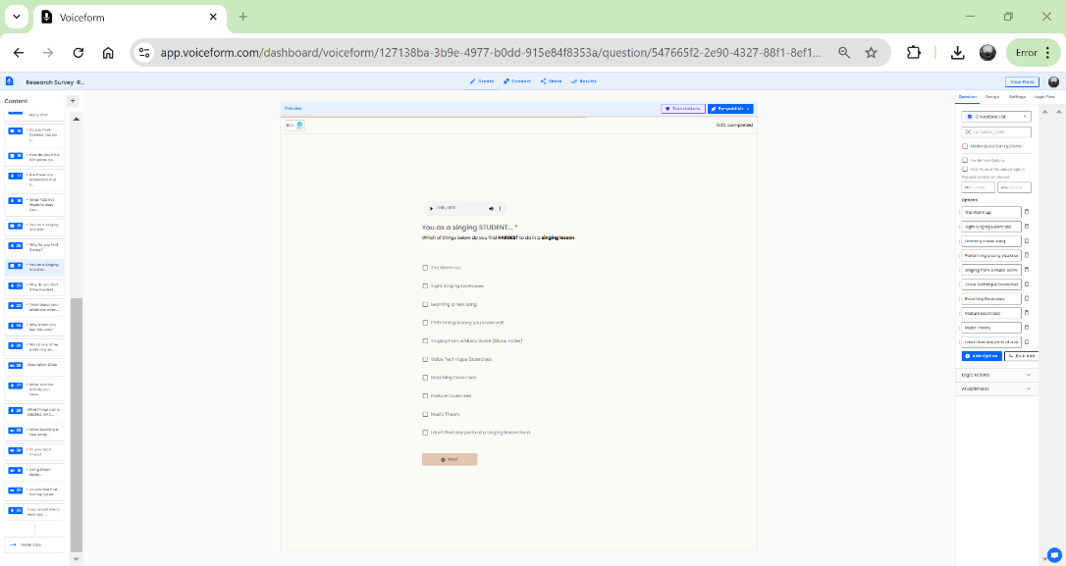
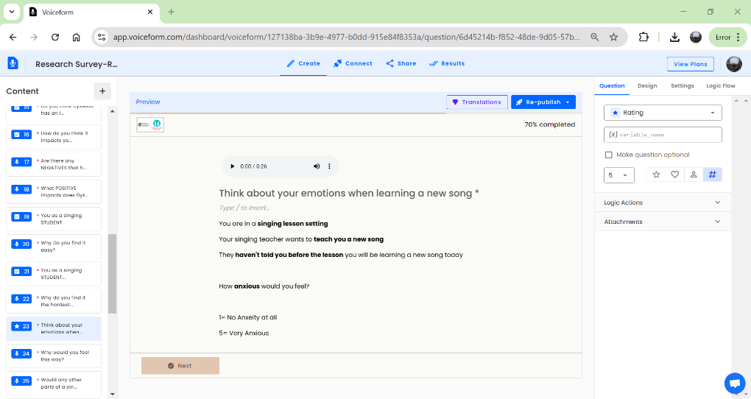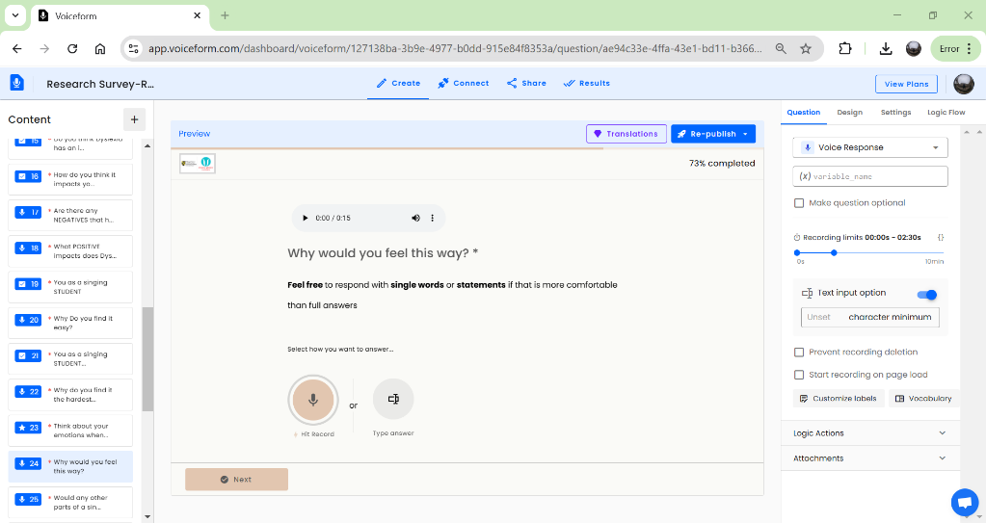
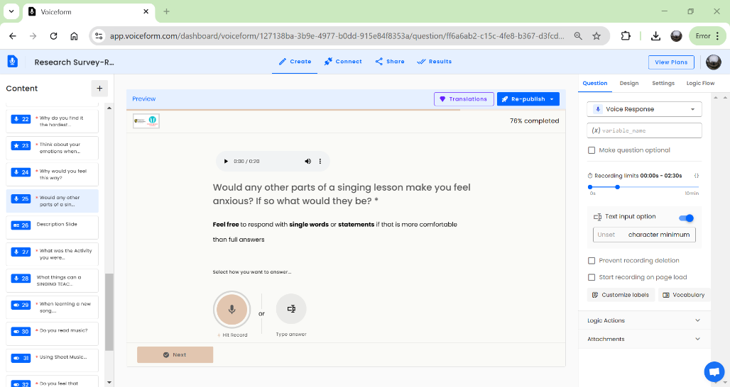
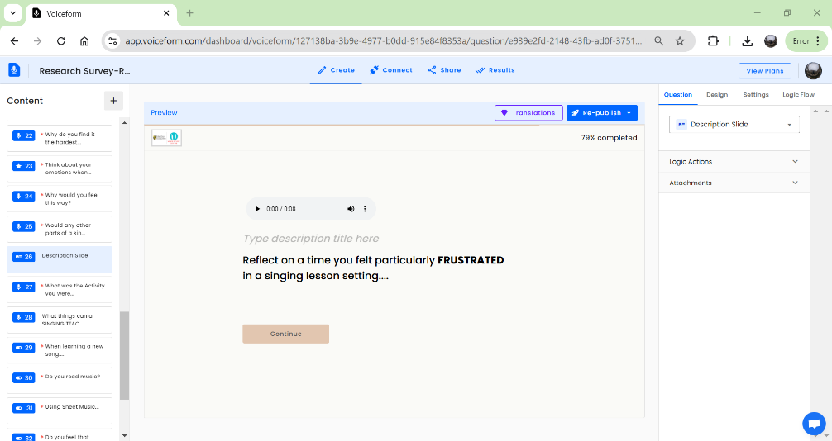
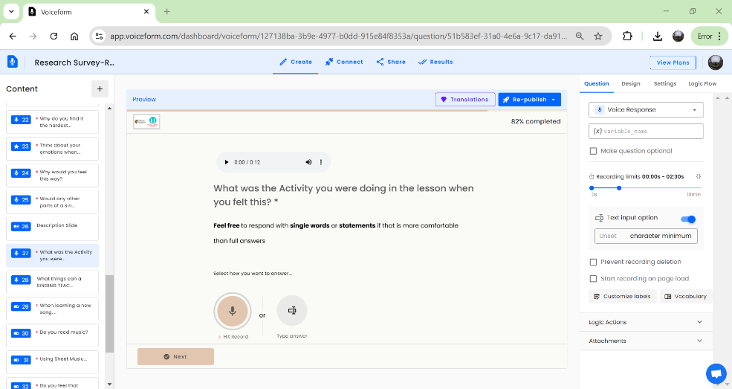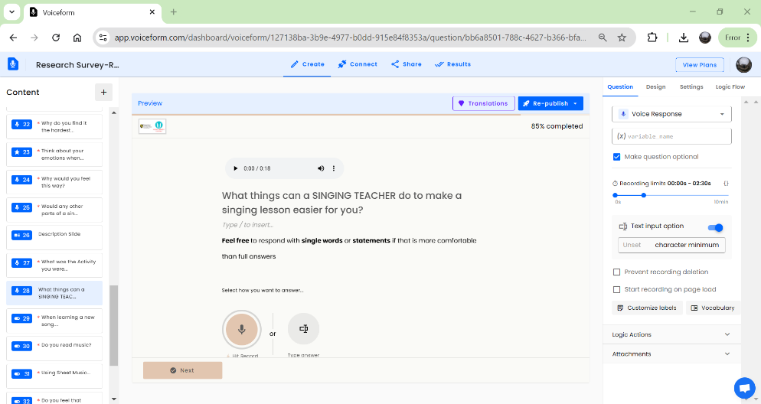
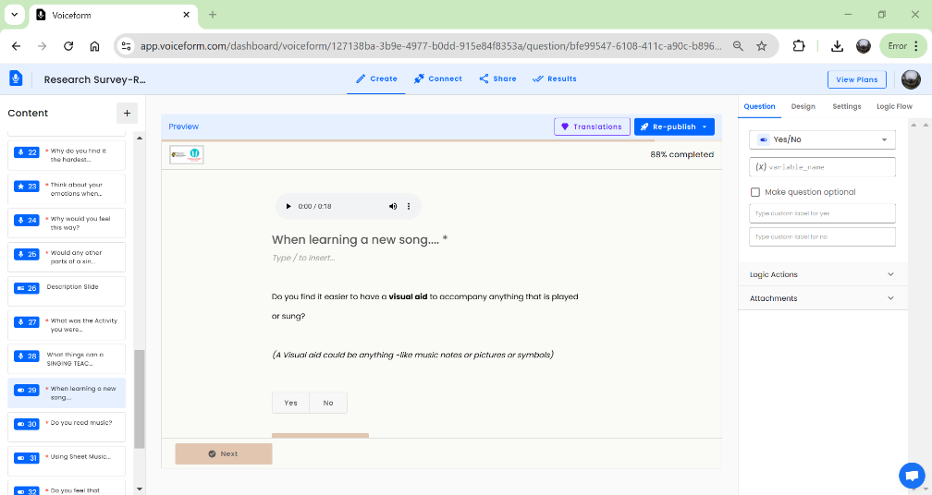
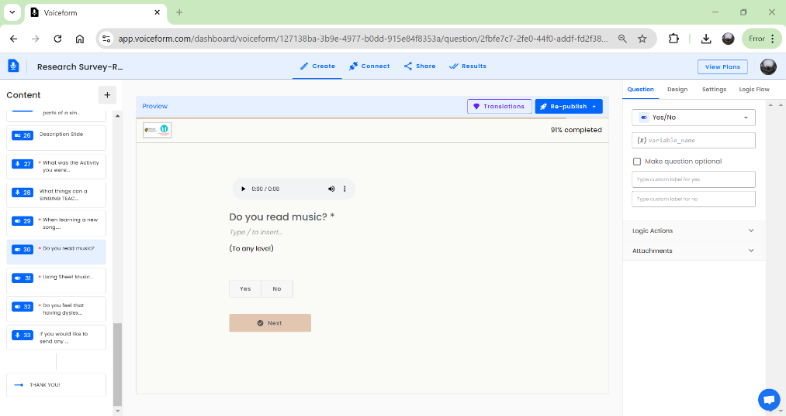
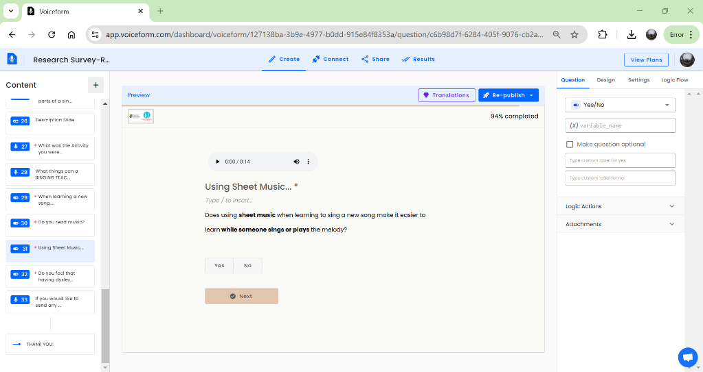
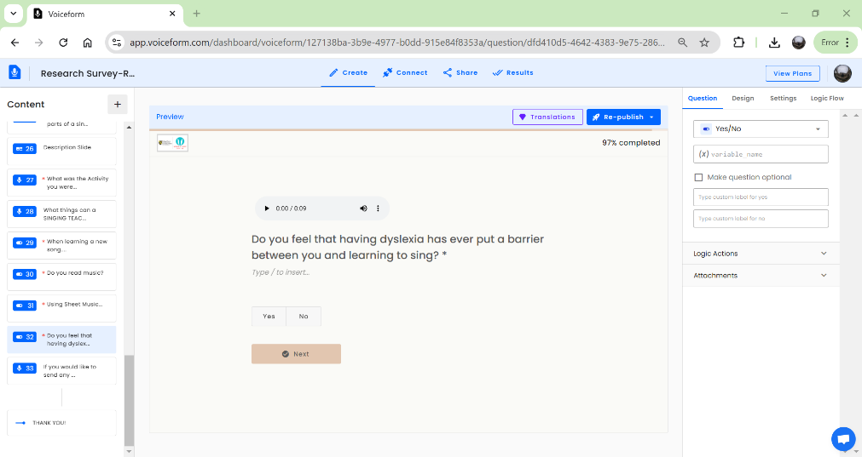
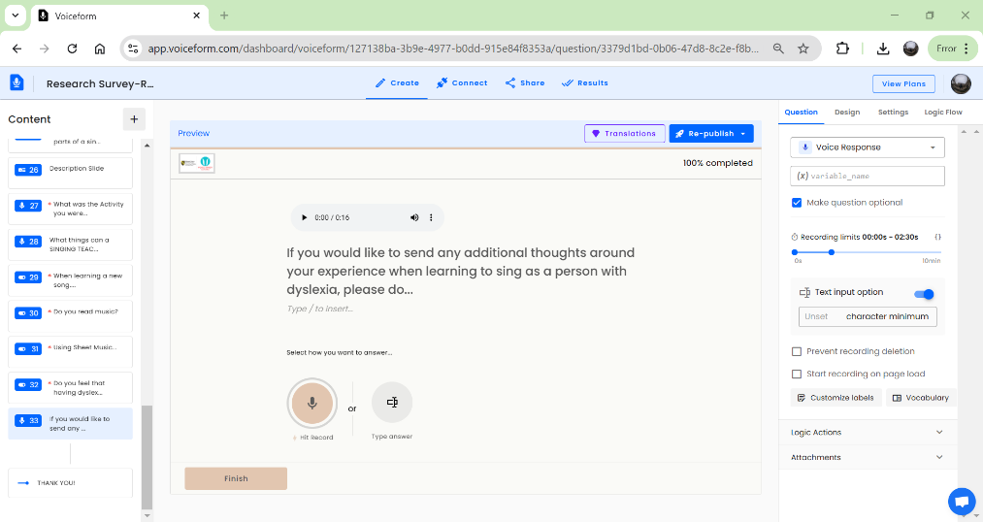
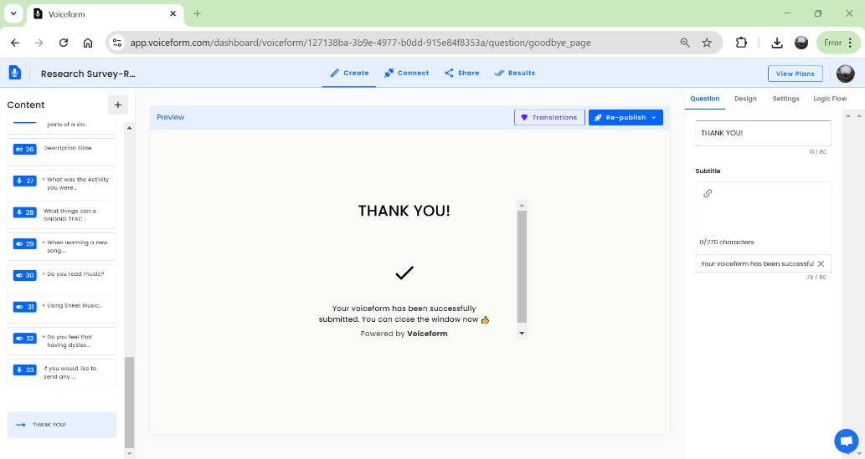

Appendix 7

List of Youtube Videos Used for the Case Study Singing Lesson
Warm Up Exercise: https://www.youtube.com/watch?v=CT8x2bdOtD8
Body Percussion Exercise: https://www.youtube.com/watch?v=kqof84_WR1s&pp=ygUJI2JvZHl3YWl0
Learning A Song (without Visual Aid- this was played without sharing the screen): The most beautiful melody to learn the treble clef in 5 min. For piano with the right hand
Learning A Song with Musical Notation: Beautiful melody to practice Singing and Sight Singing

Appendix 8
Quirkos report from thematic Analysis of Questionnaire Responses

Quirkos Report
This report was generated by Jess S on Sat Feb 15 2025 23:55:16 GMT+0000 (Greenwich Mean Time) for the following file: Open Survey Responses.

Quirks Summary
Quirk Title | Total Codes
Format of the Music Score/Words | 2
Requires Aural input before learning new songs | 2
Difficulties with Score/Music Notation | 11
Enjoy learning new techniques | 1
Anxeity from learning new songs | 9
Time to process Melody and Lyrics | 3
Reading text/Words/Lyrics | 3
Rewarding achieving something difficult | 1
Sight singing anxiety | 9
Recalling sequence of melody | 2
Long Term Memory Advantages | 1
short term memory -melody learning | 1
Learning melody by ear | 1
Different approaches to learning | 1
Positive multi sensory learning | 1
Dyslexia makes me a more emotive performer | 2
EASY- Repitition and familularity | 4
EASY- Breathing excercises | 3
Negative Multiple tasks/sensory | 2
Enjoyment in performance | 2
Struggle to sit still | 1
Increased time needed to learn new things | 7
Enjoy learning new things | 1
Feeling pressured/anxiety when learning new things | 3
Never Felt Frustrated in a singing lesson | 1
Frustration from learning Musical Theory | 2
Speed of Music- Frustration | 1
Embarrassed from failure | 1
TOTAL NUMBER OF CODES
TOTAL NUMBER OF QUIRKS

Properties Summary

Text Sorted by Theme

Difficulties with Score/Music Notation
lt- but it’s very rewarding when you do finally learn it Reading new lyrics. I usually just lis
Source: Source 2

Sight Singing Excercises from a music score- Sight singing
Source: Source 5

Sight Singing Excercises from a music score- Having dyslexia has made it hard for me to learn the notes and match them to the sounds in my head
Source: Source 5

Source: Source 2

t does not involve sheet music is good as I really struggle to sight read I am
Source: Source 1

icult I find
Source: Source 2

different approaches to learnin
Source: Source 3

how to read scores. Not being able to sight read well Find sight sing
Source: Source 2

both reading music dots and reading
Source: Source 2

3- Whether they would be teaching from music or by listening would be important
Source: Source 6

Sight Singing excercises, Learning a new song, Music Theory - All reading from a paper. I can't concentrate on everything
Source: Source 5

Time to process Melody and Lyrics
lt- but it’s very rewarding when you do finally learn it Reading new lyrics. I usually just lis
Source: Source 2

easy, able to not have to think about the words and just use emotion instead.
Source: Source 1

have had time to process the order of the words and structure of the son
Source: Source 1

Anxeity from learning new songs
Sight Singing Excercises from a music score- Having dyslexia has made it hard for me to learn the notes and match them to the sounds in my head
Source: Source 5

2- Sometimes I can be put on the spot and have to sing without the words
Source: Source 6

4- I potentially haven't listened to it
Source: Source 6

lt- but it’s very rewarding when you do finally learn it Reading new lyrics. I usually just lis
Source: Source 2

3- Whether they would be teaching from music or by listening would be important
Source: Source 6

how to read scores. Not being able to sight read well Find sight sing
Source: Source 2

n't have to think about the words because they're already there Learning new songs take a long time and the stress botes me
Source: Source 1

have had time to process the order of the words and structure of the son
Source: Source 1

3- New things can be hard- going to have to try hard and potentially get things wrong
Source: Source 6

Enjoy learning new techniques
with my voice I like to E
Source: Source 1

Reading text/Words/Lyrics
en to soundtracks and learn songs that way Remembering the structure and
Source: Source 2

er to learn
Source: Source 2

different approaches to learnin
Source: Source 3

Rewarding achieving something difficult
lt- but it’s very rewarding when you do finally learn it Reading new lyrics. I usually just lis
Source: Source 2

Sight singing anxiety
icult I find
Source: Source 2

Sight Singing Excercises- I cant read the music fast enough or recall the sound differene of intervals fast enough
Source: Source 5

Sight Singing excercises, Learning a new song, Music Theory - All reading from a paper. I can't concentrate on everything
Source: Source 5

Trying to sight sing and not knowing where to start
Source: Source 7

trying to sight singing and got so overwhelmed and then very emotional
Source: Source 7

both reading music dots and reading
Source: Source 2

Trying to sight sing & do music theory
Source: Source 7

Sight Singing Excercises from a music score- Sight singing
Source: Source 5

Sight Singing Excercises- Struggle with sight- singing- too much going on especially if they expect words as well as notes
Source: Source 5

Recalling sequence of melody
Source: Source 2

s me and soothes me. Especially having adhd also Breathing Excerc
Source: Source 4

Long Term Memory Advantages
rough Visual learning
Source: Source 3

short term memory -melody learning
singing by ear More emotive in my si
Source: Source 3

Learning melody by ear
ging as good memory le
Source: Source 3

Different approaches to learning
g
Source: Source 3

Positive multi sensory learning
I can hear tunes and pick them up quickly good a
Source: Source 3

Dyslexia makes me a more emotive performer
Don’t always rely on paper copies, some learning can be done by ear- this is something I find makes me more expressive anyway
Source: Source 8

ts me sing the words without being constrained by the music all the time If i don't have to read. I love it.
Source: Source 3

EASY- Repitition and familularity
orming a song you know well, posture excersi
Source: Source 4

Sing the sing line by line
Source: Source 8

ly the same each class The Warm up, Learning a
Source: Source 4

- no reading involved- usually predictable notes Breathing Exce
Source: Source 4

EASY- Breathing excercises
ngs to think about- no orders of things to remembe
Source: Source 4

Source: Source 4

s me and soothes me. Especially having adhd also Breathing Excerc
Source: Source 4

Negative Multiple tasks/sensory
Sight Singing Excercises- Struggle with sight- singing- too much going on especially if they expect words as well as notes
Source: Source 5

Source: Source 4

Enjoyment in performance
ercises - The breath work and posture work are physical I find enjoyment in the performance Performing a song you know well, the Warm up - Already Confident with it The warm u
Source: Source 4

Source: Source 4

Struggle to sit still
posture Excercises- Struggle to sit still
Source: Source 5

Increased time needed to learn new things
5- Worried about understanding and getting it right & the etra time it takes me to learn things
Source: Source 6

Sing the sing line by line
Source: Source 8

Be understanding that it takes longer to process things and help by going over things multiple times till I am happy I understand things
Source: Source 8

Sight Singing Excercises- I cant read the music fast enough or recall the sound differene of intervals fast enough
Source: Source 5

3- Anything new requires me time to process
Source: Source 6

Taking the pressure away by going at your speed
Source: Source 8

learning a new song- It take me a long time to learn a new song
Source: Source 5

Enjoy learning new things
1- Like to learn new things
Source: Source 6

Feeling pressured/anxiety when learning new things
2- Sometimes I can be put on the spot and have to sing without the words
Source: Source 6

3- New things can be hard- going to have to try hard and potentially get things wrong
Source: Source 6

5- Worried about understanding and getting it right & the etra time it takes me to learn things
Source: Source 6

Never Felt Frustrated in a singing lesson
Not felt frustrated
Source: Source 7

Frustration from learning Musical Theory
Trying to sight sing & do music theory
Source: Source 7

Learning music theory for my grade 5. In the exam I cried. And walked out
Source: Source 7

Speed of Music- Frustration
Was a piece of music that was very quick and I couldn’t read the words fast enough. Literally got in wrong about 12 times in a row- frustrated, embarrassed
Source: Source 7

Embarrassed from failure
Was a piece of music that was very quick and I couldn’t read the words fast enough. Literally got in wrong about 12 times in a row- frustrated, embarrassed
Source: Source 7

Format of the Music Score/Words
time, change the format things are presented in
Source: Source 8

Have words in a good font- might need to read through the words first together with me. Don’t always rely on paper copies, some learning can be done by ear- this is something I find makes me more expressive anyway
Source: Source 8

Requires Aural input before learning new songs
Always play the tune for me
Source: Source 8

time, change the format things are presented in
Source: Source 8

Appendix 9
Full Questionnaire Responses
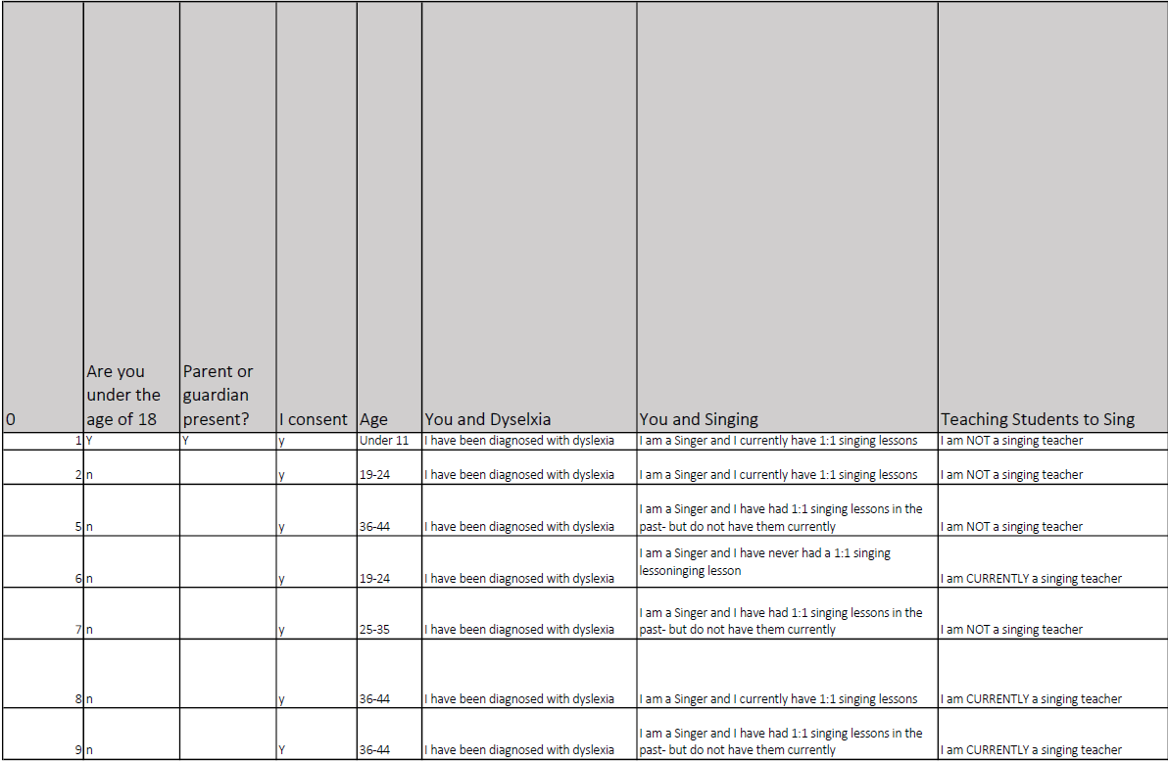
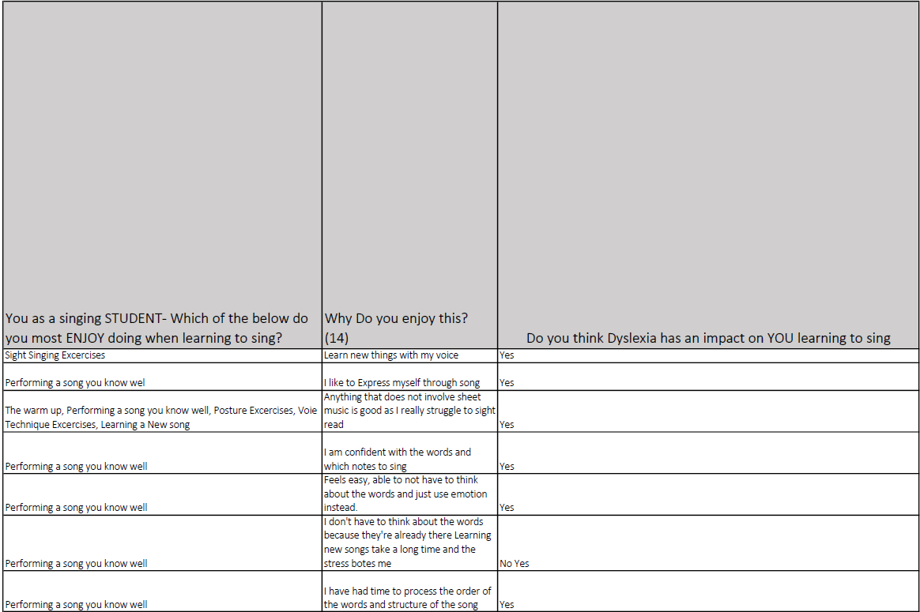

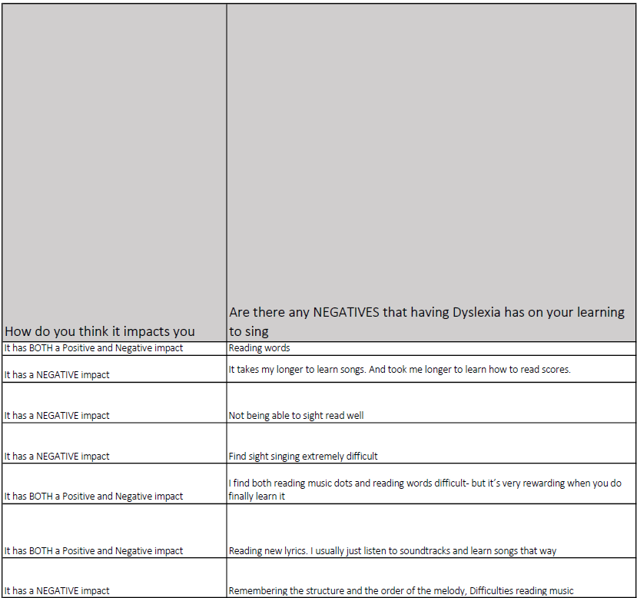

Appendix 10
Transcript of Case Study A
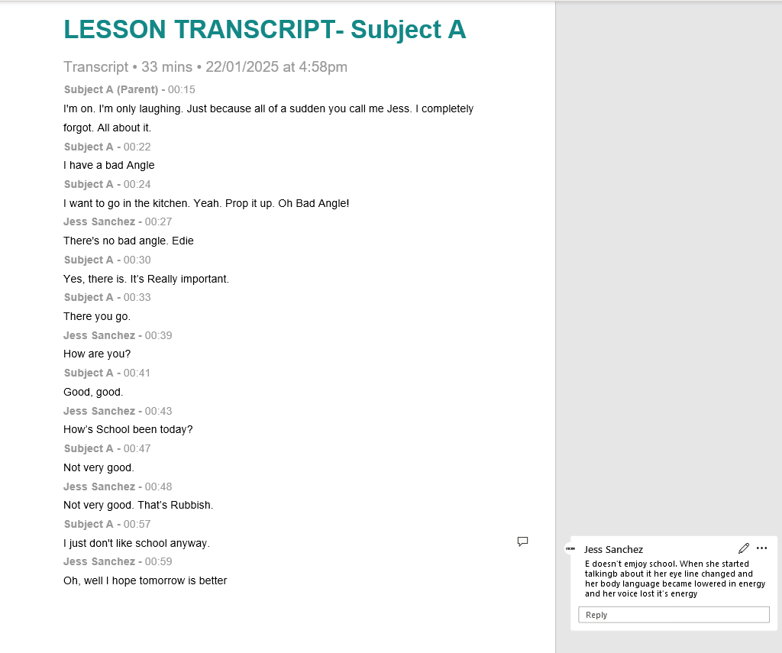
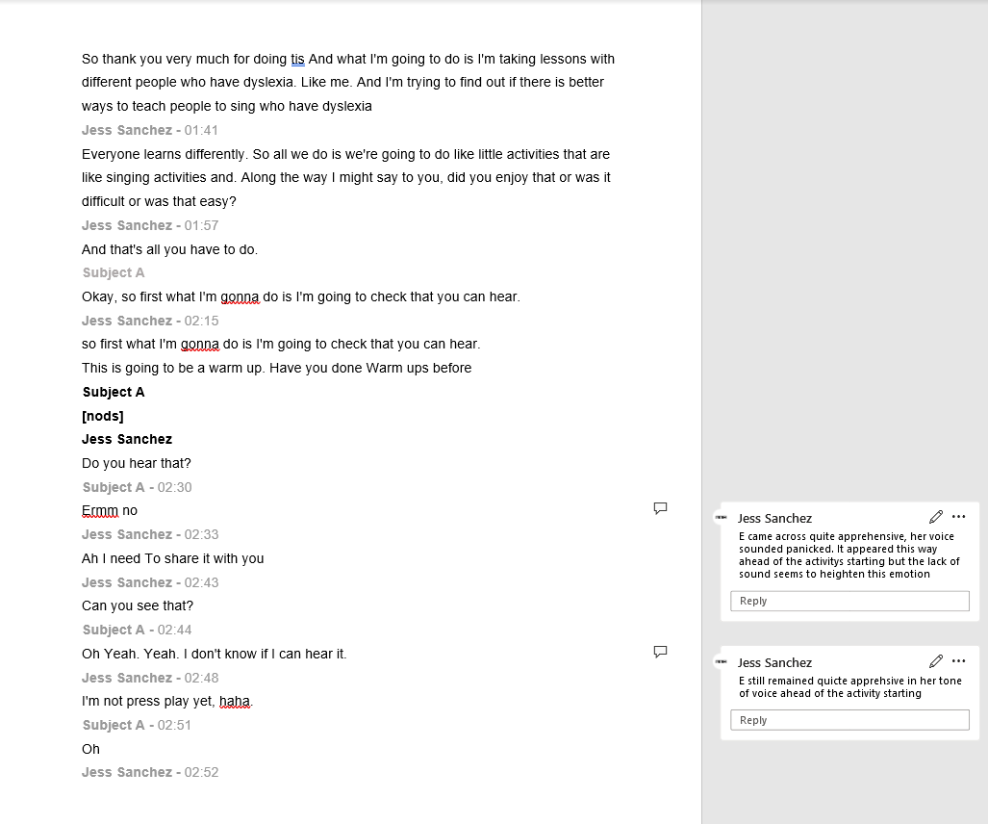
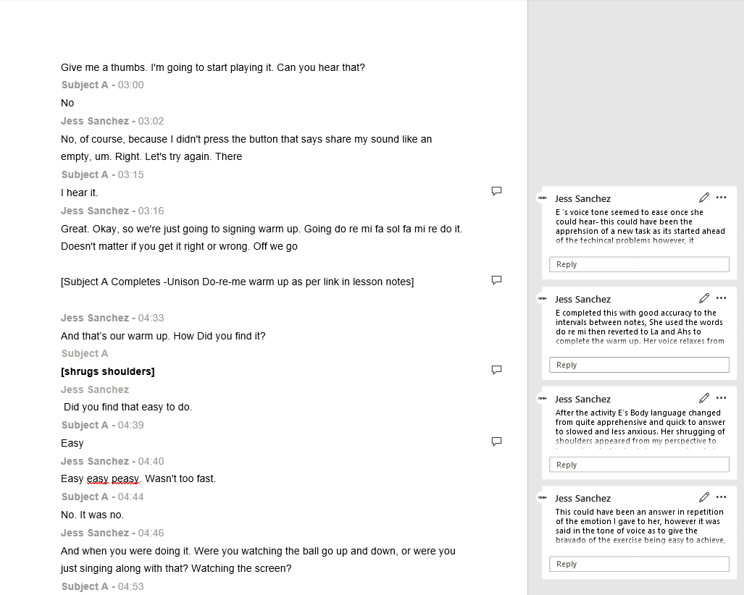
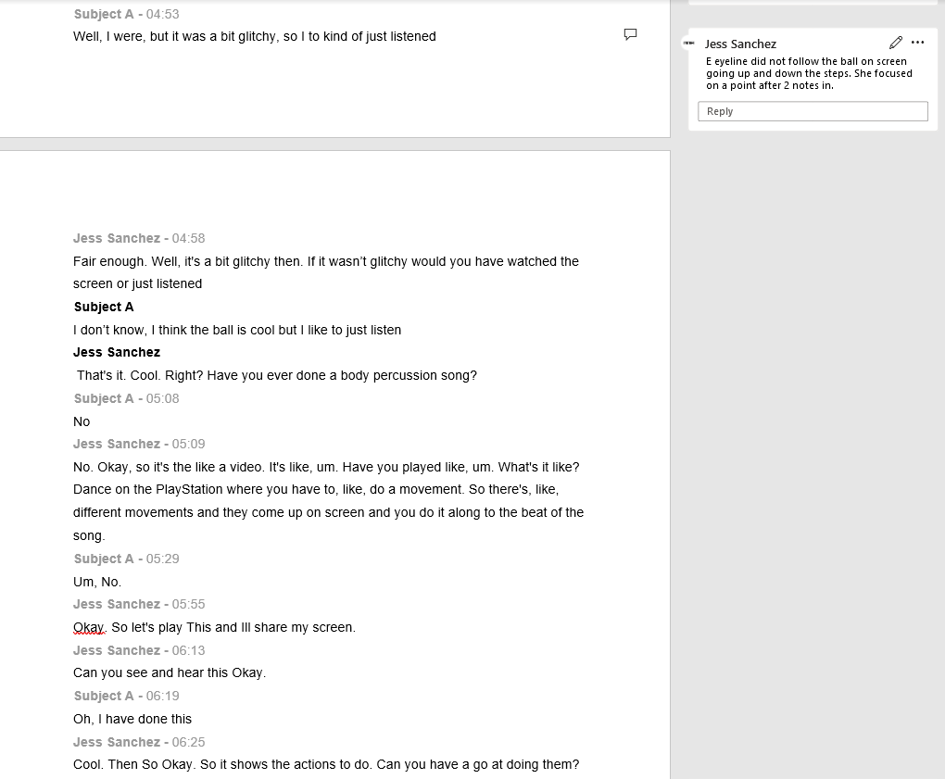
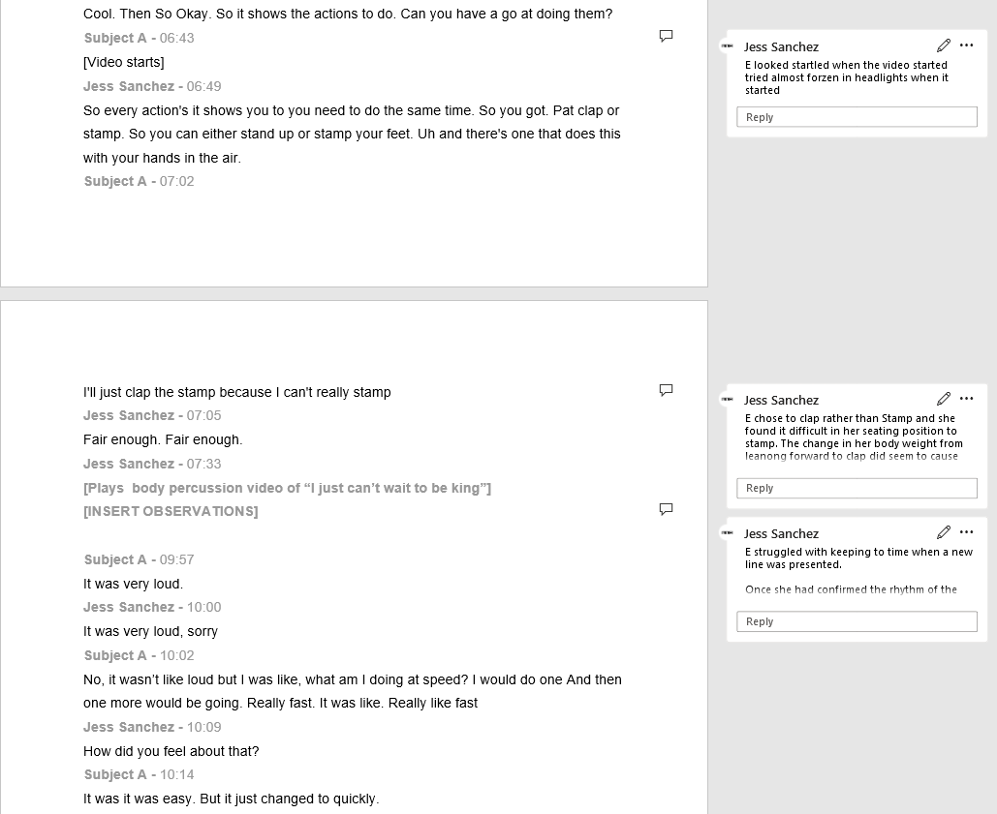
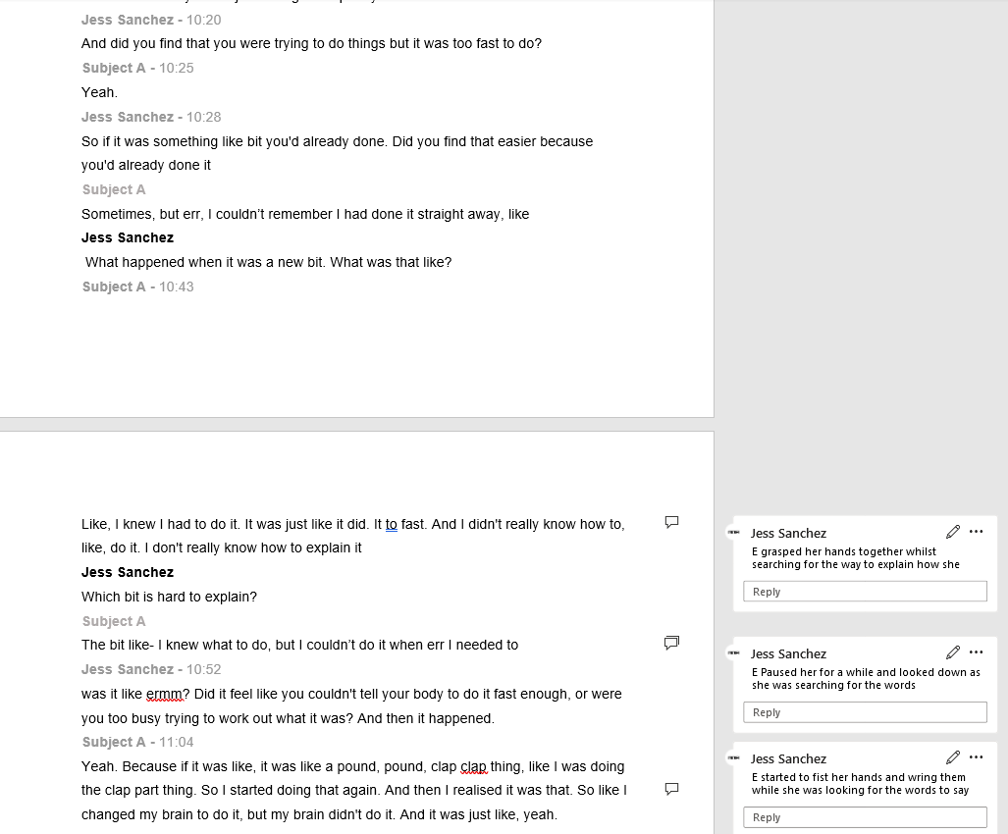
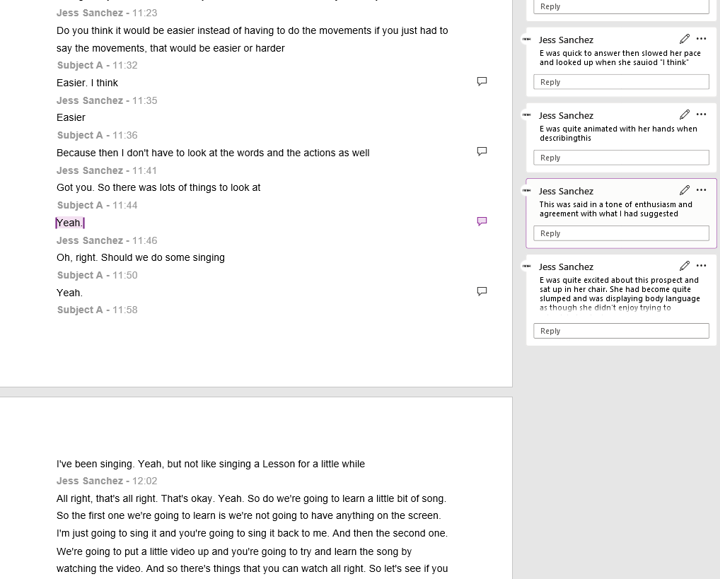
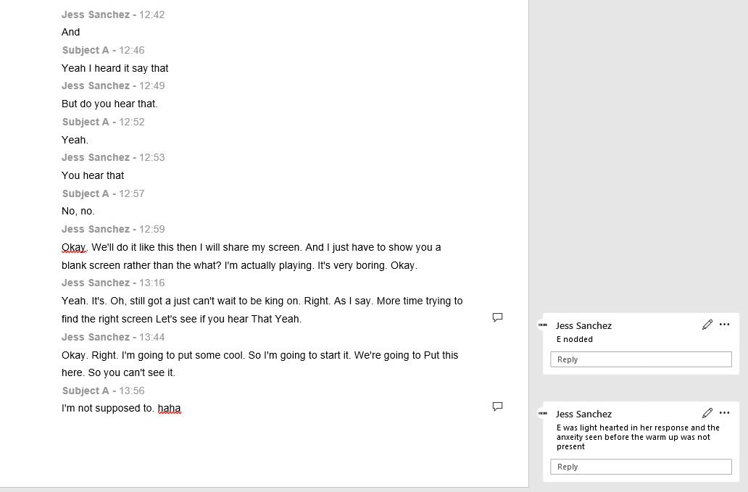
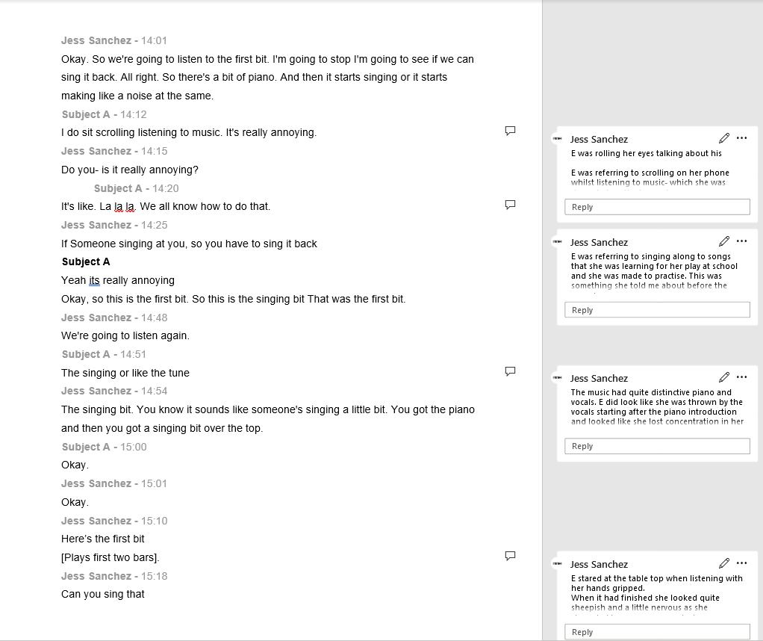
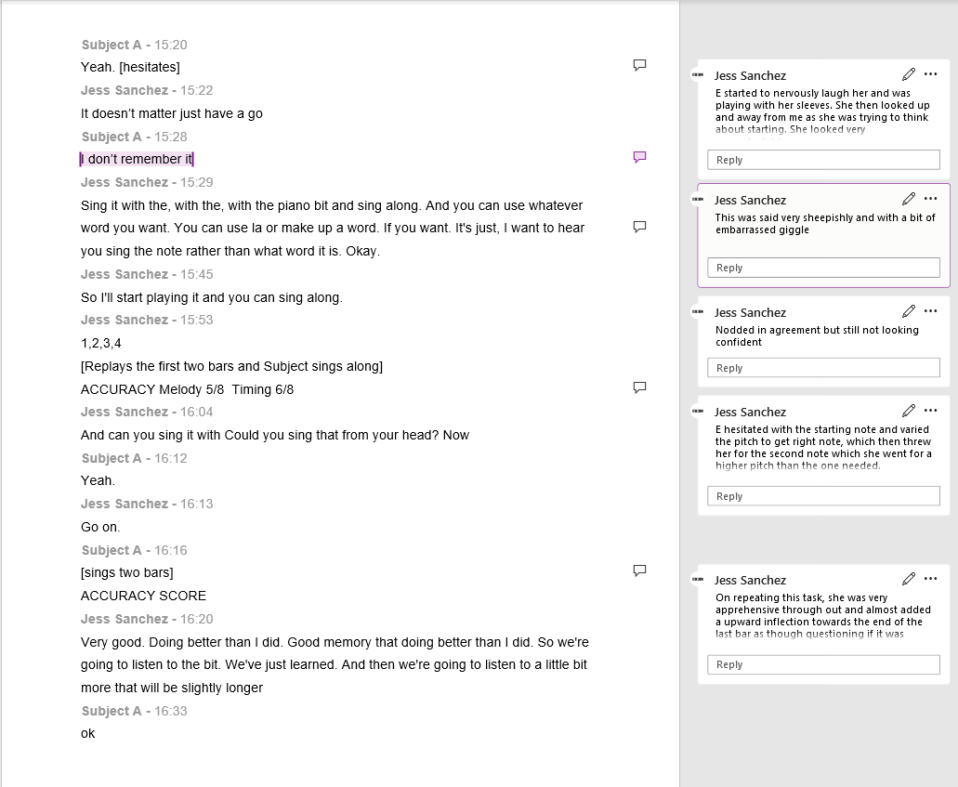
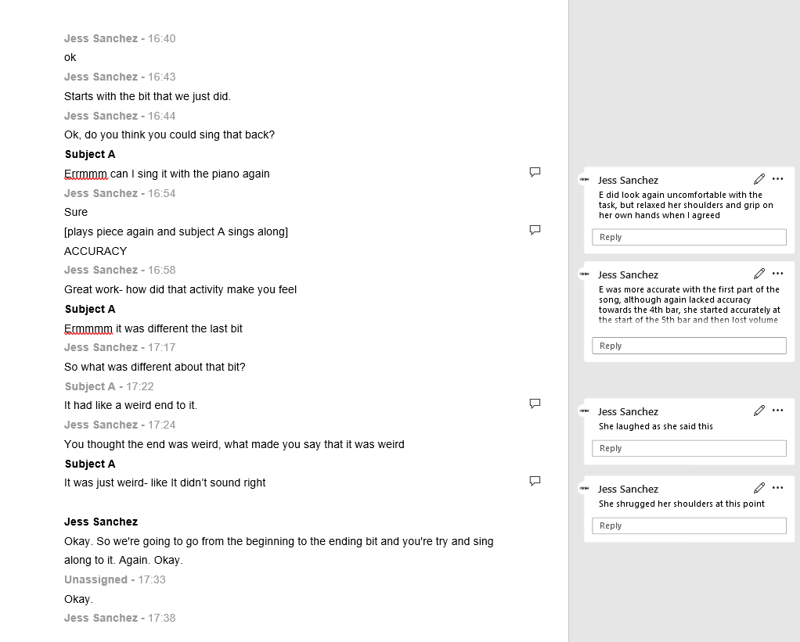
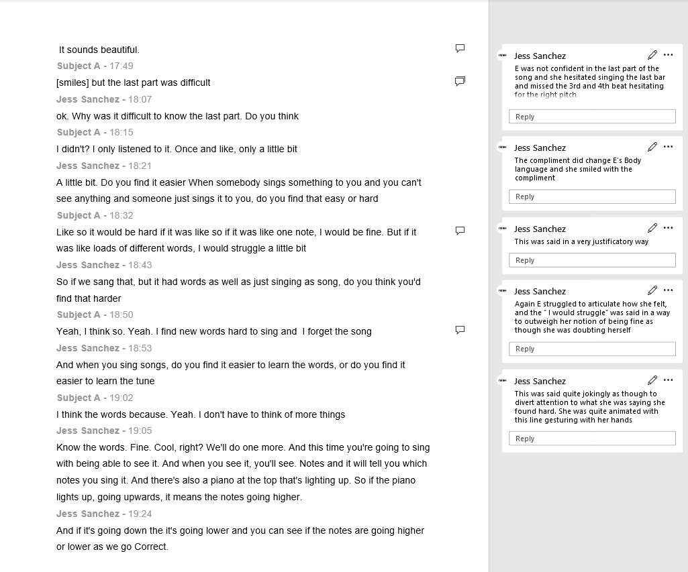
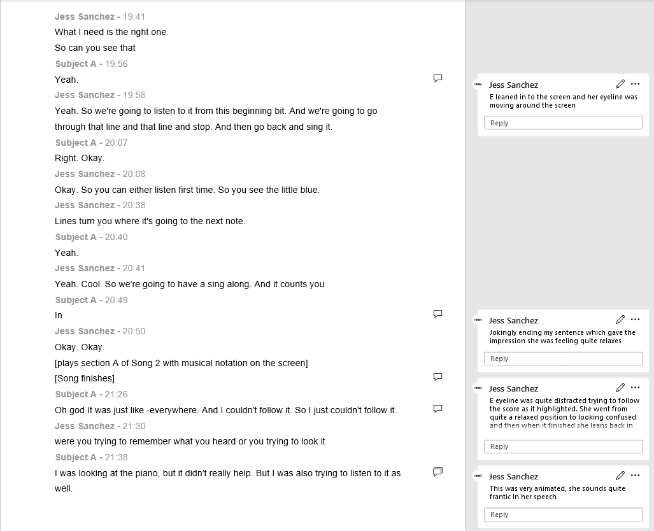
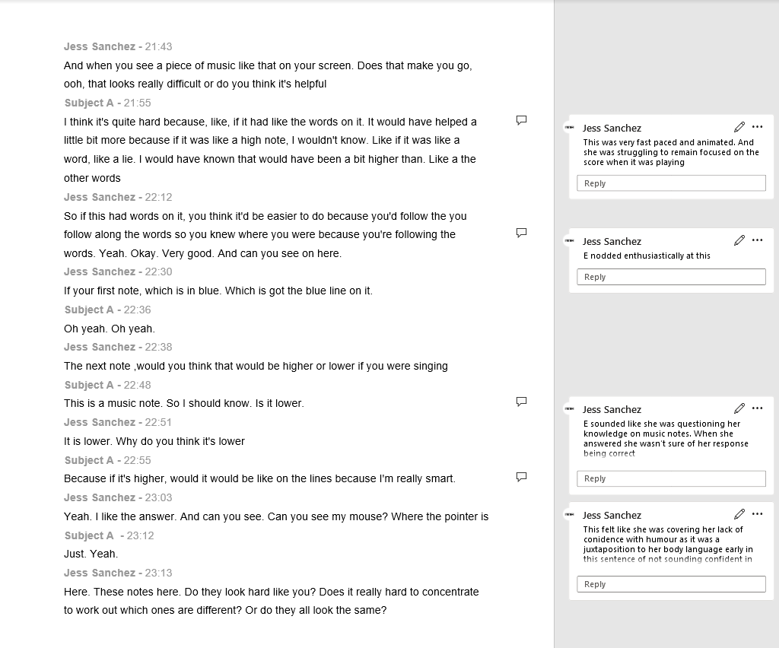
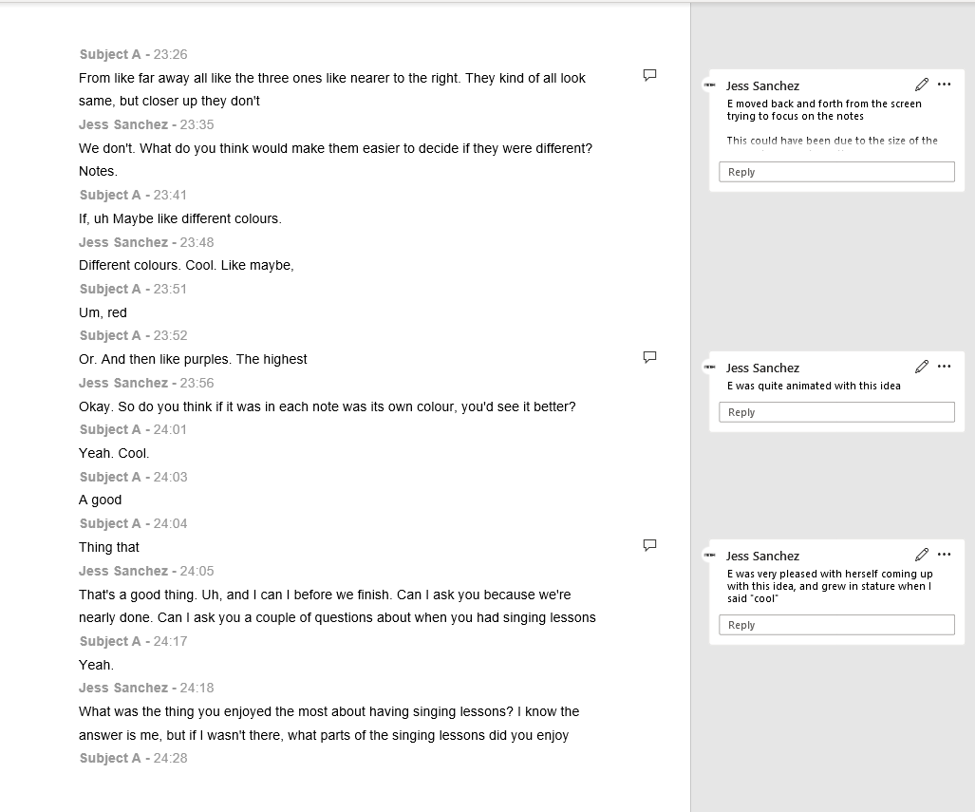
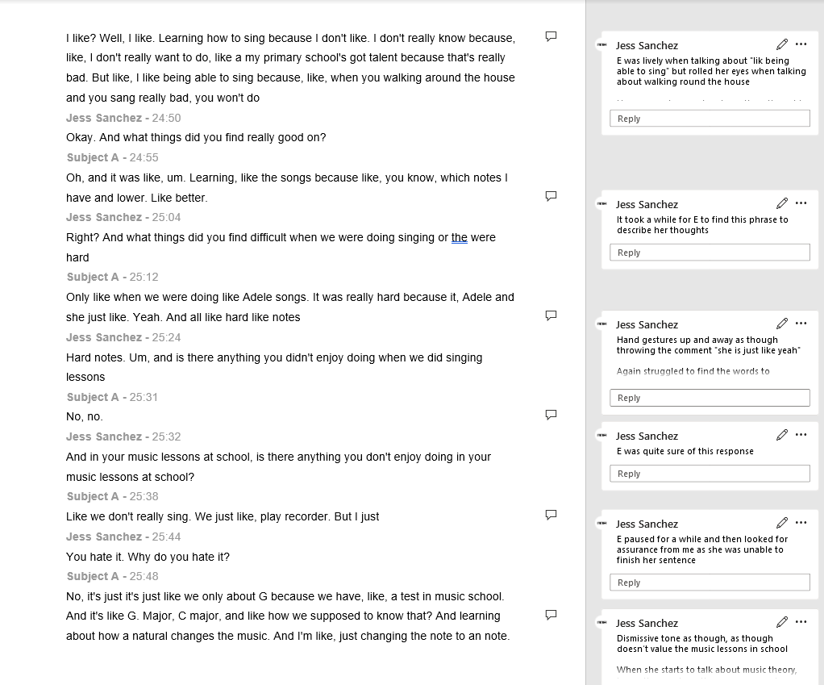
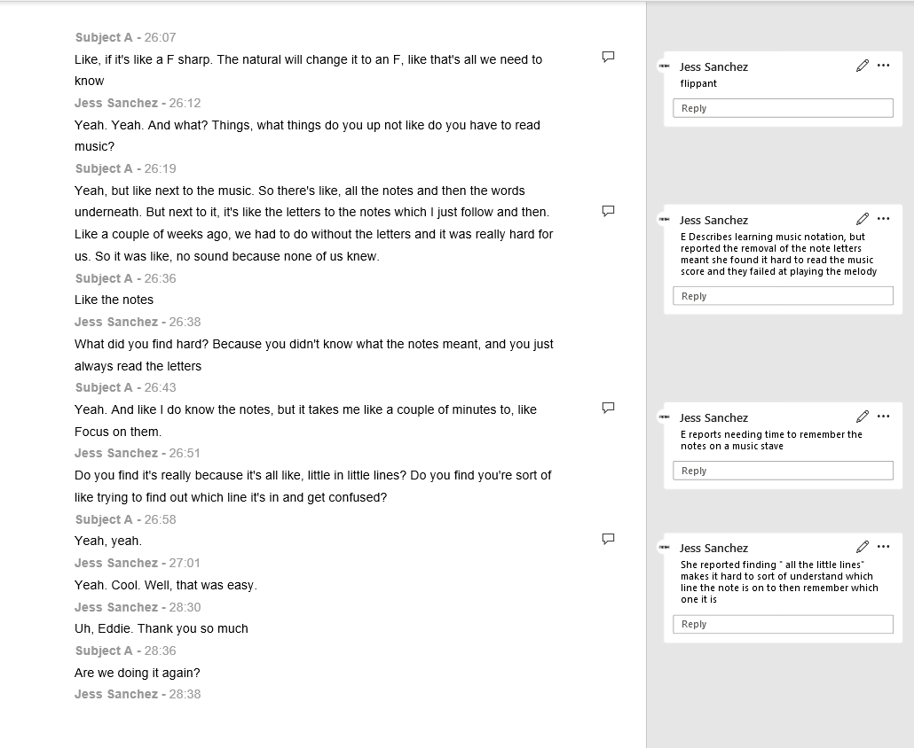
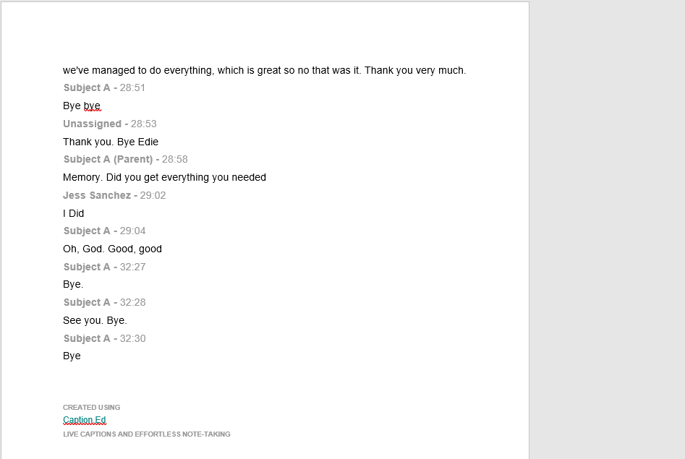

Appendix 11

Copy of the consent form for Parent Guardian of the Cast Study Filled out

Consent Form for Case Study Participants - Parent/Guardian
Aim of Research Study: Understanding the Impact of Dyslexia on Young People When Learning to Sing
Researcher: Jessica Bray
Contact Information: 2317330@student.uwstd.ac.uk

Introduction Thank you for considering your child/ward’s participation in this research study. Your involvement will help build a better understanding of working with young people with dyslexia in the context of singing.
Before you agree to participate, please read the following information carefully. This form explains the purpose of the study, what participation involves, any potential risks, and how data will be handled.

Purpose of the Research This study aims to understand the impact of dyslexia on young people when learning to sing. The research will explore their experiences during a singing lesson and follow-up interview.

Participation Details
- Your child/ward will take part in a 30-minute recorded online singing lesson with the researcher, which will involve interview style questions throughout to ask about your feelings and experience of the lesson
- Participation is entirely voluntary. You may withdraw consent at any time without consequences.
Eligibility Criteria Participants must:
- Be aged 7-11 years old.
- Be Self identifying as Dyslexic
- Have had one-to-one singing lessons for at least three months before volunteering.

What is Expected from Participants?
- Your child/ward will participate in a free, online, one-to-one, 20-minute singing lesson.
- A parent/guardian must be present in the room during both the lesson and the interview.
- The follow-up interview will be scheduled at a mutually convenient time between December 1 and December 23, 2024.

Procedure
Singing Lesson:
- Conducted via Microsoft Teams with a secure access link.
- The researcher will verify the participant's name and ensure parental presence and consent.
- A singing warm-up and exercises will take place.
- The lesson will be recorded for research purposes.
- They will discuss their experiences, including what they enjoyed or found challenging.
- Participants may decline to answer any questions and may withdraw at any time.
- The interview will be recorded and transcribed using Caption.ed software.

Risks and Safeguarding
- Discussing emotions during the lesson may lead to feelings of discomfort.
- The researcher will stop any line of questioning if distress is observed.
- The researcher, Jessica Bray, has over 20 years of experience working with young people and holds an enhanced DBS check. Copies of this check can be provided upon request.

Data Protection and Confidentiality
- All data will be stored securely on an encrypted hard drive.
- Data will only be accessed by the researcher and possibly the supervising university tutor.
- The participant’s name will not be disclosed in the research paper; all data will be anonymized.
- Recordings will not be shared and will be deleted three months after the research paper's submission.

Use of Research Findings
- A copy of the research paper will be available upon request.
- Findings may be shared by the researcher, the University of Wales Trinity Saint David, or the Voice Study Centre to support further research.

Consent Statement By signing below, I confirm that:
- I have read and understood the information provided about the research study.
- I understand my child/ward’s participation is voluntary and can be withdrawn at any time.
- I agree to my child/ward taking part in the recorded singing lesson and follow-up interview.
- I understand that all data collected will be securely stored and anonymized in the research.
- I consent to the use of anonymized data in the final research paper and any related publications.
Participant's Name: ____________________________
Parent/Guardian Name: ____________________________
Parent/Guardian Signature: ____________________________
Date: ____________________________

Researcher’s Statement I confirm that I have provided adequate information about this study and have answered any questions regarding participation.
Researcher’s Name: Jessica Bray
Researcher’s Signature: ____________________________
Date: ____________________________

For any further questions or concerns, please contact Jessica Bray at 2317330@student.uwstd.ac.uk. Thank you for your time and participation.

APPENDIX 12

Approval Ethics Form
APPLICATION FOR ETHICAL APPROVAL

RESEARCH STUDENTS
This form is to be completed by the student within SIX months for full-time students and TWELVE months for part time students, after the commencement of the research degree or following progression to Part Two of your course.

Once complete, submit this form via the MyTSD Doctoral College Portal at (https://mytsd.uwtsd.ac.uk).

This document is also available in Welsh.

RESEARCH STAFF ONLY
All communications relating to this application during its processing must be in writing and emailed to pgresearch@uwtsd.ac.uk , with the title ‘Ethical Approval’ followed by your name.

STUDENTS ON UNDERGRADUATE OR TAUGHT MASTERS PROGRAMMES should submit this form (and receive the outcome) via systems explained to you by the supervisor/module leader.

In order for research to result in benefit and minimise risk of harm, it must be conducted ethically. A researcher may not be covered by the University’s insurance if ethical approval has not been obtained prior to commencement.

The University follows the OECD Frascati manual definition of research activity: “creative work undertaken on a systematic basis in order to increase the stock of knowledge, including knowledge of man, culture and society, and the use of this stock of knowledge to devise new applications”. As such this covers activities undertaken by members of staff, postgraduate research students, and both taught postgraduate and undergraduate students working on dissertations/projects.

The individual undertaking the research activity is known as the “principal researcher”.

Ethical approval is not required for routine audits, performance reviews, quality assurance studies, testing within normal educational requirements, and literary or artistic criticism.

Please read the notes for guidance before completing ALL sections of the form.

This form must be completed and approved prior to undertaking any research activity. Please see Checklist for details of process for different categories of application.

SECTION A: About You (Principal Researcher)
1 | Full Name: |  | Jessica Sanchez (Bray)
2 | Tick all boxes that apply: |  | Member of staff: | ☐ | Honorary research fellow: | ☐
 | Undergraduate Student | ☐ | Taught Postgraduate Student | ☒ | Postgraduate Research Student | ☐

3 | Institute/Academic Discipline/Centre: | WAPPAR
4 | Campus: | Carmarthen
5 | E-mail address: | 2317330@student.uwtsd.ac.uk
6 | Contact Telephone Number: | 07961255105
 | For students:
7 | Student Number: | 2317330
8 | Programme of Study: | MA Professional Practice (Voice Pedagogy)
9 | Director of Studies/Supervisor: | Louise Emanuel/Julie Crossman/Debbie Winter

SECTION B: Approval for Research Activity
1 | Has the research activity received approval in principle?  (please check the Guidance Notes as to the appropriate approval process for different levels of research by different categories of individual) |  | YES | ☒ | NO | ☒
 |  |  |  |  | Date
2 | If Yes, please indicate source of approval (and date where known): Approval in principle must be obtained from the relevant source prior to seeking ethical approval | Research Degrees Committee |  | ☐
2 |  | Institute Research Committee |  | ☐
2 |  | Other (write in)  WAPPAR Ethics Board Representative |  | ☒

SECTION C: Internal and External Ethical Guidance Materials
 | Please list the core ethical guidance documents that have been referred to during the completion of this form (including any discipline-specific codes of research ethics, location-specific codes of research ethics, and also any specific ethical guidance relating to the proposed methodology). Please tick to confirm that your research proposal adheres to these codes and guidelines. You may add rows to this table if needed.
1 | UWTSD Research Ethics & Integrity Code of Practice | ☒
2 | UWTSD Research Data Management Policy | ☒
3 | [List any other relevant documents here] | ☐

SECTION D: External Collaborative Research Activity
If there are external collaborators then you should gain consent from the contact persons to share their personal data with the university. If there are no external collaborators then leave this section blank and continue to section E.
1 | Institution
2 | Contact person name
3 | Contact person e-mail address
4 | Is your research externally funded? |  | YES | ☐ | NO | ☐
5 | Are you in receipt of a KESS scholarship? |  | YES | ☐ | NO | ☐
6 | Are you specifically employed to undertake this research in either a paid or voluntary capacity? | Voluntary | YES | ☐ | NO | ☐
7 |  | Employed | YES | ☐ | NO | ☐
8 | Is the research being undertaken within an existing UWTSD Athrofa Professional Learning Partnership (APLP)? | If YES then the permission question below does not need to be answered. | YES | ☐ | NO | ☐
9 | Has permission to undertake the research has been provided by the partner organisation? | (If YES attach copy)  If NO the application cannot continue | YES | ☐ | NO | ☐

Where research activity is carried out in collaboration with an external organisation
10 | Does this organisation have its own ethics approval system? | YES | ☐ | NO | ☐
 | If Yes, please attach a copy of any final approval (or interim approval) from the organisation (this may be a copy of an email if appropriate).

SECTION E: Details of Research Activity
1 | Indicative title: | A case study based research project, exploring the impact dyslexia may cause to the learning experience to young people in the UK, within the 1:1 singing lesson setting.
2 | Proposed start date: | 26th September 24 | Proposed end date: | 31st January 25
Introduction to the Research (maximum 300 words per section)
Ensure that you write for a Non-Specialist Audience when outlining your response to the points below:
- Purpose of Research Activity
- Proposed Research Question
- Aims of Research Activity
- Objectives of Research Activity
Demonstrate, briefly, how Existing Research has informed the proposed activity and explain
- What the research activity will add to the body of knowledge
- How it addresses an area of importance.
3 | Purpose of Research Activity  To expand on the existing research on the impact of dyslexia within music pedagogy, with a particular view to explore the possible impact to learning of young people with dyslexia and there learning experience in the 1:1 singing lesson.  There are pedagogical texts which look to the possible impacts in this area, seen within teaching music as a broader subject to dyslexic young people, however there is a gap in the research looking at the specific impact to 1:1 singing lesson learning experience.  This research would aim to explore the impacts seen across data collected from participant case studies of 4-6 subjects, half with dyslexia and the other half not identifying with dyslexia when experiencing the same 1:1 Singing lesson when experiences are compared. It is a hope it will gain possible insight to reoccurring themes seen from this data collected when lesson experience is compared between the control sample of non-dyslexic students compared to the dyslexics when experiencing the same lesson. It is hoped, it would lead to possible further areas to explore; when researching the impact dyslexia has on young people when learning to sing in a 1:1 singing lesson setting, based on the comparison of data.  (this box should expand as you type)
4 | Research Question  Exploring the range of possible impacts, dyslexia can have on the learning process for young singing students with dyslexia, in a 1:1 Singing lesson setting Collecting qualitative data from 2-4 case study subjects within the UK, comparing Dyslexic and non- dyslexic young students.  (this box should expand as you type)
5 | Aims of Research Activity  The aim is to collect qualitive data through observation, literature review and Structured video prompted interviews from 2-3 case studies of young people with dyslexia and the same number of non-dyslexic case studies who have experienced a comparative 1:1 singing lesson.  It aims to collect data narrating all subjects and their experience within the lesson, as well as comparing that to students who experienced the same lesson who do not identify as dyslexic. It is hoped that the data will show possible themes of experiences which could point to both negative and positive impacts on their learning experience due to dyslexia.  (this box should expand as you type)
6 | Objectives of Research Activity  The aim is to collect qualitive data through three methods of data collection.  A case study sample size of 2-4 case study subjects will be sort from young people who attend lessons with singing teachers within the UK, on a 1:1 basis.  1-2 case studies will identify as dyslexic and an equal number of further subjects will identify as non-dyslexic, as control subjects. Each Dyslexic student will be matched to a non-dyslexic student of the same age, who is taught by the same singing teacher. Both subjects will take the same 15 minute lesson, with their singing teacher in a 1:1 setting.  The subjects will be recorded in their singing lesson with their usual singing teacher during a 1:1 singing lesson setting experiencing the same lesson. These lessons will then be viewed and observations of their experience and observed emotions will be collected from the researcher watching these lesson recordings.  The Subjects will then be interviewed by the researcher, alongside a structured interview using watching the lesson recording back as an audio-visual prompt. They will be asked about their emotions to parts of the lesson, alongside their opinion of their learning experience in this setting as part of a structured interview. The dyslexic case studies will be compared against their reflective control case study who experienced the same lesson.  The objectives are to gain quantitative data not only to compare impacts on learning between dyslexic and non-dyslexic students within this setting. But then to analyse any reoccurring themes that arise across all the dyslexic case studies when comparing their learning experience within their singing lesson.  (this box should expand as you type)
Proposed methods (maximum 600 words)
Provide a brief summary of all the methods that may be used in the research activity, making it clear what specific techniques may be used. If methods other than those listed in this section are deemed appropriate later, additional ethical approval for those methods will be needed. You do not need to justify the methods here, but should instead describe how you intend to collect the data necessary for you to complete your project.
7 | Three methods are proposed to collect data within this study. Firstly, I will conduct a literature review of teaching music to dyslexic students, with a focus on teaching singing and look for any identified themes to learning barriers within neurodivergent singers from qualitative data. I will use this literature to guide my structured interview questions and decide upon an age suitable for my case study subjects.  Secondly, the study proposes to record a 1:1 singing lessons between a singing teacher and a dyslexic student and then the same lesson repeated with a non-dyslexic student. We aim to compare 1-2 “sets” of case studies. A set comprising of 1 young person with dyslexia and 1 person without dyslexia.  The same 10-minute lesson plan will be provided along with the resources for all case studies. It will comprise of a vocal warm up, and a few bars of an unknown song to be taught to the student. This will aim to give the same learning experience to each case study, so the experience of learning song within a 1:1 music session can be gathered and possible impacts of dyslexia to their learning can be recorded. This lesson plan will be designed from previous research conducted with dyslexic students within a music lesson setting.  The lesson recording will be watched by the researcher, to record qualitive data around the subject’s emotional reactions to the lesson. Noting Body language observed, their apparent enjoyment of the lesson and also their language used in relation to the teaching strategies used. The aim is to record their observed experience, rather than quantitative data measuring outcomes such as how long it takes a student to reach objectives within the lesson.  Thirdly, a structured interview will be carried out with each subject, to collect qualitative data from the subjects exploring their learning experience during the lesson. This will take place over a Microsoft teams meeting, which will be recorded using ed.caption.  The interview will be structured alongside watching the recording of their lesson with the interviewer and they will be asked structured, open questions about their emotions and thought processes during sections of the lesson in relation to their experience of the lesson and comprehension of the tasks and skills involved.  This quantitative date will then be analysed between each dyslexic subject and their non dyslexic control subject; to look for differences between their learning experience. Then this data will then be analysed between case study sets, to identify any themes seen within the learning experience of dyslexic students, which could point to impacts (both negative and positive) possibly due to having dyslexia. The objective is to identify any possible further areas of research which could follow on from this looking at learning strategies specific to dyslexic young people learning to sing.  (this box should expand as you type)
Location of research activity
Identify all locations where research activity will take place.
8 | This research will take place within the UK. Subjects will be recorded within their usual singing lesson setting, with their usual singing teacher.  Interviews will be conducted over a virtual meeting platform where the recording of their lesson can be shared with the student during their interview and used as a visual stimulant to prompt responses.  (this box should expand as you type)
Research activity outside of the UK
If research activity will take place overseas, you are responsible for ensuring that local ethical considerations are complied with and that the relevant permissions are sought. Specify any local guidelines (e.g. from local professional associations/learned societies/universities) that exist and whether these involve any ethical stipulations beyond those usual in the UK (provide details of any licenses or permissions required). Also specify whether there are any specific ethical issues raised by the local context in which the research activity is taking place, for example, particular cultural and/or legal sensitivities or vulnerabilities of participants. If you live in the country where you will do the research then please state this.
9 | n/a  (this box should expand as you type)

10 | Use of documentation not in the public domain: Are any documents NOT publicly available? | NO | ☒
10 |  | YES | ☐
11 | If Yes, please provide details here of how you will gain access to specific documentation that is not in the public domain and that this is in accordance with the current data protection law of the country in question and that of England and Wales.  (this box should expand as you type)

 | Does your research relate to one or more of the seven aims of the Well-being of Future Generations (Wales) Act 2015? | YES | NO
12 | A prosperous Wales | ☐ | ☒
13 | A resilient Wales | ☐ | ☒
14 | A healthier Wales | ☐ | ☒
15 | A more equal Wales | ☐ | ☒
16 | A Wales of cohesive communities | ☐ | ☒
17 | A Wales of vibrant culture and thriving Welsh language | ☐ | ☒
18 | A globally responsible Wales | ☐ | ☒
19 | If YES to any of the above, please give details:
 | (this box should expand as you type)

SECTION F: Scope of Research Activity
 | Will the research activity include: | YES | NO
1 | Use of a questionnaire or similar research instrument? | ☒ | ☐
2 | Use of interviews? | ☒ | ☐
3 | Use of focus groups? | ☐ | ☒
4 | Use of participant diaries? | ☐ | ☒
5 | Use of video or audio recording? | ☒ | ☐
6 | Use of computer-generated log files? | ☒ | ☐
7 | Participant observation with their knowledge? | ☒ | ☐
8 | Participant observation without their knowledge? | ☐ | ☒
9 | Access to personal or confidential information without the participants’ specific consent? | ☐ | ☒
10 | Administration of any questions, test stimuli, presentation that may be experienced as physically, mentally or emotionally harmful / offensive? | ☐ | ☒
11 | Performance of any acts which may cause embarrassment or affect self-esteem? | ☐ | ☒
12 | Investigation of participants involved in illegal activities? | ☐ | ☒
13 | Use of procedures that involve deception? | ☐ | ☒
14 | Administration of any substance, agent or placebo? | ☐ | ☒
15 | Working with live vertebrate animals? | ☐ | ☒
16 | Procedures that may have a negative impact on the environment? | ☐ | ☒
17 | Other primary data collection methods. Please indicate the type of data collection method(s) below. | ☐ | ☒
 | Details of any other primary data collection method:  (this box should expand as you type) | ☐ | ☒
If NO to every question, then the research activity is (ethically) low risk and may be exempt from some of the following sections (please refer to Guidance Notes).

If YES to any question, then no research activity should be undertaken until full ethical approval has been obtained.

SECTION G: Intended Participants
If there are no participants then do not complete this section, but go directly to section H.

 | Who are the intended participants: | YES | NO
1 | Students or staff at the University? | ☐ | ☒
2 | Adults (over the age of 18 and competent to give consent)? | ☒ | ☐
3 | Vulnerable adults? | ☐ | ☒
4 | Children and Young People under the age of 18? (Consent from Parent, Carer or Guardian will be required) | ☒ | ☐
5 | Prisoners? | ☐ | ☒
6 | Young offenders? | ☐ | ☒
7 | Those who could be considered to have a particularly dependent relationship with the investigator or a gatekeeper? | ☐ | ☒
8 | People engaged in illegal activities? | ☐ | ☒
9 | Others. Please indicate the participants below, and specifically any group who may be unable to give consent. | ☐ | ☒
 | Details of any other participant groups:  (this box should expand as you type) | ☐ | ☒

Participant numbers and source
Provide an estimate of the expected number of participants. How will you identify participants and how will they be recruited?
10 | How many participants are expected? | It is intended to approach the Association of teachers of singing to send a request to their registered teaching membership, to ask for adult singing teachers to volunteer any young people they work with regularly in a one-to-one singing lesson setting who has identified as dyslexic, alongside students within the same age bracket who do not identify as dyslexic to also be observed. For the young people involved; participants’ guardians will be asked to consent to volunteer their ward for the research study. It is aimed to gain around 2-4 subjects from UK based singing teachers.  Each set of case studies will also require their singing teacher to be classed as a participant, as they will be recorded whilst carrying out the 10 minutes set lesson.  (this box should expand as you type)
11 | Who will the participants be? | My participants will be under eighteen and in full time education within the UK. A specific age limit will be guided by existing research within the literature review to identify a developmental age that correlates with preexisting literature on teaching students in music with neurodiversity.  They will participate in regular 1:1 singing lessons, and half of the case studies will identify as dyslexic.  The singing teachers involved will be registered with the association of teachers of singing and their case studies will be part of their regular cohort of 1:1 singing students.  (this box should expand as you type)
12 | How will you identify the participants? | The researcher will approach the singing teacher networks, via an email call out for participants, through their membership mailing list. This will be sent out on approval from the Association, and by their secretary to their mailing list. The email will provide contact details for anyone to get in touch if they have possible subjects who fall within the categories of age and identifying as dyslexic. The aims of the study will be outlined.  The email will ask for any teachers willing to participate who have a possible pair of students who fall into the categories below. The teachers will be informed that they will be recorded via a online video meeting link, so will need to use their own device (tablet, phone or laptop) to connect to the meeting recording invitation. They will not be required to store or record the lesson recording directly to their device, as this will be done by the researcher from the online recording connection. They will need conduct the same lesson to the control subject who did not identify as dyslexic. They will be provided with a 15-minute lesson plan to conduct with each student.  The inclusion criteria will be, young people, (age to be determined by the literature review, within full time education,) diagnosed as dyslexic. Dyslexia is to be self-declared- they will not be asked to provide any supporting paperwork to prove this, students must be having regular singing lessons with a singing teacher in a 1:1 session for at least 6 weeks prior to their recorded lesson. The inclusion criteria for the non-dyslexic case studies will be that they fall into the same age category and will not identify as dyslexic and be taught by the same teacher.  All participants, including teachers will be recruited as volunteers who have self-declared themselves as subjects.  (this box should expand as you type)

 | Information for participants: | YES | NO | N/A
13 | Will you describe the main research procedures to participants in advance, so that they are informed about what to expect? | ☒ | ☐ | ☐
14 | Will you tell participants that their participation is voluntary? | ☒ | ☐ | ☐
15 | Will you obtain written consent for participation? | ☒ | ☐ | ☐
16 | Will you explain to participants that refusal to participate in the research will not affect their treatment or education (if relevant)? | ☒ | ☐ | ☐
17 | If the research is observational, will you ask participants for their consent to being observed? | ☒ | ☐ | ☐
18 | Will you tell participants that they may withdraw from the research at any time and for any reason? | ☒ | ☐ | ☐
19 | With questionnaires, will you give participants the option of omitting questions they do not want to answer? | ☒ | ☐ | ☐
20 | Will you tell participants that their data will be treated with full confidentiality and that, if published, it will not be identifiable as theirs? | ☒ | ☐ | ☐
21 | Will you debrief participants at the end of their participation, in a way appropriate to the type of research undertaken? | ☒ | ☐ | ☐
22 | If NO to any of above questions, please give an explanation
 | (this box should expand as you type)

 | Information for participants: | YES | NO | N/A
24 | Will participants be paid? | ☐ | ☒ | ☐
25 | Is specialist electrical or other equipment to be used with participants? | ☒ | ☐ | ☐
26 | Are there any financial or other interests to the investigator or University arising from this study? | ☐ | ☒ | ☐
27 | Will the research activity involve deliberately misleading participants in any way, or the partial or full concealment of the specific study aims? | ☐ | ☒ | ☐
28 | If YES to any question, please provide full details
The subjects singing teachers will be asked to record the lesson using their own device (eg a mobile phone or laptop) via Microsoft Teams meeting link, Which will be transcribed using Caption-ed software to aid researcher note taking. The participants will be made aware of the software used in this recording.

The singing teacher participant will not be required to store or record the lesson on their own device.

(this box should expand as you type)

SECTION H: Anticipated Risks

Outline any anticipated risks that may adversely affect any of the participants, the researchers and/or the University, and the steps that will be taken to address them.

If you have completed a full risk assessment (for example as required by a laboratory, or external research collaborator) you may append that to this form.
1 | Full risk assessment completed and appended? |  | Yes | ☐
1 |  |  | No | ☒
2 | Risks to participants  For example: sector-specific health & safety, emotional distress, financial disclosure, physical harm, transfer of personal data, sensitive organisational information
 | Risk to participants:  Data Protection  Emotional response  Transfer of personal data  Ability to give fully informed consent  Safeguarding | How you will mitigate the risk to participants:  All Data will be stored on an encrypted hard drive. Any recorded meetings will be sent via an encrypted link with a password protected access to the meeting link. Contact details will be of the parent/guardian not of the subject who will remain anonymous.  As the interview will ask about emotional responses to experiences within the lesson setting, this would bring about an emotional response if they found the lesson difficult. I will therefore ensure the participant is aware that they will remain anonymous, and ensure they have the ability to stop an interview session of withdraw consent. Any emotional response will be reported to their parent/guardian and  When gathering contact details from subjects, these will be held on an encrypted spreadsheet and they will be informed of how the data will be stored, its purpose and for how long the data will be stored which will form part of their consent.  The recorded lesson will not be recorded using the participants’ devices, as will be recorded directly to an encrypted hard drive by the researcher through the online meeting software. The meeting will be held via a password protected meeting link, which will be sent to the singing teacher participant ahead of the observed lesson. The recording of the lesson will be deleted in line with the university’s GDPR retention rules. All Participants will be given a privacy protection notice which will state how the date will be stored, how it will be used, who will have access and how long it will be stored for,  As this project will involve children. The literature around consent will be age appropriate so support them being able to give fully informed consent. All participants will be given the right to withdraw at any point of the research project  Ensure that effective child protection or safeguarding protocols are established from the beginning of the study. Researchers working with children undergo proper training in child protection and be aware of when and how to report concerns. Ensure that the researchers have procedures in place to handle any safeguarding issues that may arise in line with university policy. Researcher will also have a DBS check in place ahead of working with the young people in this study.  (this box should expand as you type)
3 | If research activity may include sensitive, embarrassing or upsetting topics (e.g. sexual activity, drug use) or issues likely to disclose information requiring further action (e.g. criminal activity), give details of the procedures to deal with these issues, including any support/advice (e.g. helpline numbers) to be offered to participants. Note that where applicable, consent procedures should make it clear that if something potentially or actually illegal is discovered in the course of a project, it may need to be disclosed to the proper authorities
n/a
(this box should expand as you type)
4 | Risks to the investigator  For example: personal health & safety, physical harm, emotional distress, risk of accusation of harm/impropriety, conflict of interest
 | Risk to the investigator:  Conflict of interest  Risk of accusation of harm  Personal Data | How you will mitigate the risk to the investigator:  This research is being conducted as a practitioner piece of research, and therefore the researcher has an interest in the subject area which may bring about conflicts of interest in my own practices as a singing teacher and raise possible  If a subject were to come distressed during their interview, I would ensure parents and guardians were informed, and they would have been given an outline of the research’s goal as part of their consent. Parents will be asked to be present during the interview to ensure the researcher is not working along with the child online.  Personal details of the researcher will not be shared with participants. Any communication will happen via an email set up for the project and not via personal email addresses.
5 | University/institutional risks  For example: adverse publicity, financial loss, data protection
 | Risk to the University:  1.Data protection | How you will mitigate the risk to the University:  All Data will be stored on an encrypted hard drive, with the lesson recordings being directly saved to the researchers encrypted drive, so no data needs to be stored outside of this workflow.  Email accounts and drives will be protected with a double encrypted password. Access to the meeting links will be password protected and sent via email to the participants that require it. Data storage and retention will follow the University’s guidance on GDPR  (this box should expand as you type)
6 | Environmental risks  For example: accidental spillage of pollutants, damage to local ecosystems
 | Risk to the environment:  n/a  (this box should expand as you type) | How you will mitigate the risk to environment:  (this box should expand as you type)

 | Disclosure and Barring Service
 | If the research activity involves children or vulnerable adults, a Disclosure and Barring Service (DBS) certificate must be obtained before any contact with such participants. | YES | NO | N/A
7 | Does your research require you to hold a current DBS Certificate? | ☒ | ☐ | ☐
8 | If YES, please give the certificate number. If the certificate number is not available please write “Pending”; in this case any ethical approval will be subject to providing the appropriate certificate number. | 001735953521

SECTION I: Feedback, Consent and Confidentiality

1 | Feedback  What de-briefing and feedback will be provided to participants, how will this be done and when?
I will provide my participant parent/guardians with my university email address so they may contact me requesting details of the results from the study. This will also apply to the teachers involved in the study.

(this box should expand as you type)
2 | Informed consent  Describe the arrangements to inform potential participants, before providing consent, of what is involved in participating. Describe the arrangements for participants to provide full consent before data collection begins. If gaining consent in this way is inappropriate, explain how consent will be obtained and recorded in accordance with prevailing data protection legislation.
I will provide the subjects parent/guardians, the subjects and the teachers (participants) with a consent form via email that will be held on an encrypted hard drive when returned via email. This consent form will describe the purpose of the study, the nature of how the data will be collected. This will be collected ahead of their participation in the study.
The email that will be used will be only accessible via a double encrypted password with only the researcher having access to the inbox.
Participants being recorded during the singing lesson will need to sign consent for filming which will detail the storage of the recording, how the recording will be used and the data which will be gathered, stored and retention period. They will also have the right to withdraw their consent and therefore the involvement with the study.
The participants will also be asked to consent to the recordings being transcribed by Caption-Ed an accessibility tool used by the researcher due to their learning difficulties that aids notetaking supplied by Access to Work.

(this box should expand as you type)
3 | Confidentiality / Anonymity  Set out how anonymity of participants and confidentiality will be ensured in any outputs. If anonymity is not being offered, explain why this is the case.
I will be anonymising all participants. The videos in which their name may be used will not be published and any quotes within my conclusions will not include names or identifying features of the children involved. Singing Teachers will also remain anonymous.

(this box should expand as you type)

SECTION J: Data Protection and Storage

 | Does the research activity involve personal data (as defined by the General Data Protection Regulation 2016 “GDPR” and the Data Protection Act 2018 “DPA”)? | YES | NO
1 | “Personal data” means any information relating to an identified or identifiable natural person (‘data subject’). An identifiable natural person is one who can be identified, directly or indirectly, in particular by reference to an identifier such as a name, an identification number, location data, an online identifier or to one or more factors specific to the physical, physiological, genetic, mental, economic, cultural or social identity of that natural person. Any video or audio recordings of participants is considered to be personal data. | X | ☐
 | If YES, provide a description of the data and explain why this data needs to be collected:
2 | I will be recording my subject’s singing lesson to be able to make observational notes of the lesson and then use the recording during my interview with them as an audio-visual stimulant to ask them about their lived experience during the lesson. The recordings will be made via a secure online meeting programme, and stored directly on to an encrypted drive. A transcription of both the recorded lesson and the interview by Caption-ed, An accessibility tool used by the researcher due to their dyslexia.  This data needs to be collected in this way, so I can record lessons happening in other parts of the UK that I could not finically resource visiting in person. I also have learning difficulties myself and I would be unable to make considered observational notes due to the barriers I have writing. It will also allow the lesson to run in the most natural circumstances possible without my presence in a lesson possibly distracting the natural course of the lesson and my presence causing either the singing teacher or student will be less likely to change their behaviour due to a stranger’s presence in the lesson room.  It is also been decided that a audio-visually stimulated interview will be the most appropriate way to gain data from possible dyslexic students, as part of the symptoms of dyslexia is problems with recall and short term memory retention. Therefore the use of video stimulation alongside the interview will possibly allow for the participants to recall their lesson experience more thoroughly,  (this box should expand as you type)
 | Does it involve special category data (as defined by the GDPR)? | YES | NO
3 | “Special category data” means sensitive personal data consisting of information as to the data subjects’ –  (a) racial or ethnic origin,  (b) political opinions,  (c ) religious beliefs or other beliefs of a similar nature,  (d) membership of a trade union (within the meaning of the Trade Union and Labour Relations (Consolidation) Act 1992),  (e) physical or mental health or condition,  (f) sexual life,  (g) genetics,  (h) biometric data (as used for ID purposes), | ☐ | x
 | If YES, provide a description of the special category data and explain why this data needs to be collected:
4 | (this box should expand as you type)

 | Will data from the research activity (collected data, drafts of the thesis, or materials for publication) be stored in any of the following ways? | YES | NO
5 | Manual files (i.e. in paper form)? | ☐ | ☒
6 | University computers? | ☐ | ☒
7 | Private company computers? | ☐ | ☒
8 | Home or other personal computers? | ☒ | ☐
9 | Laptop computers/ CDs/ Portable disk-drives/ memory sticks? | ☒ | ☐
10 | “Cloud” storage or websites? | ☐ | ☒
11 | Other – specify: | ☐ | ☐
12 | For all stored data, explain the measures in place to ensure the security of the data collected, data confidentiality, including details of backup procedures, password protection, encryption, anonymisation and pseudonymisation:
All data will be kept in password protected external hard drive, which will not be shared. Audio/visual data will be transcribed and would be shown to participants to check accuracy of reporting. Any Hard drives used to store or transfer data will be password protected. All participants will be given a unique identifier to ensure confidentiality and this list will be kept securely in the password protected folder.

(this box should expand as you type)

 | Data Protection
 | Will the research activity involve any of the following activities: | YES | NO
13 | Electronic transfer of data in any form? | ☒ | ☐
14 | Sharing of data with others at the University outside of the immediate research team? | ☐ | ☒
15 | Sharing of data with other organisations? | ☐ | ☒
16 | Export of data outside the UK or importing of data from outside the UK? | ☐ | ☒
17 | Use of personal addresses, postcodes, faxes, emails or telephone numbers? | ☒ | ☐
18 | Publication of data that might allow identification of individuals? | ☐ | ☒
19 | Use of data management system? | ☐ | ☒
20 | Data archiving? | ☐ | ☒
21 | If YES to any question, please provide full details, explaining how this will be conducted in accordance with the GDPR and Data Protection Act (2018) (and any international equivalents, where appropriate):
All data will be kept in password protected external hard drive, which will not be shared. Audio/visual data will be transcribed and would be shown to participants to check accuracy of reporting. Any Hard drives used to store or transfer data will be password protected. All participants will be given a unique identifier to ensure confidentiality and this list will be kept securely in the password protected folder. The data will be stored until the completion of the project and then deleted. In accordance with the DPA2018, participants will have the right to ask to see what data is held relating to them, and this data will be deleted immediately if the participant requests this, in which case the data will not be used in the project.

(this box should expand as you type)
22 | List all who will have access to the data generated by the research activity:
Jessica Sanchez (Bray)- principal researcher

(this box should expand as you type)
23 | List who will have control of, and act as custodian(s) for, data generated by the research activity:
Jessica Sanchez (Bray)- principal researcher

(this box should expand as you type)
24 | Give details of data storage arrangements, including security measures in place to protect the data, where data will be stored, how long for, and in what form. Will data be archived – if so how and if not why not.
.

All data will be kept in password protected external hard drive, which will not be shared. Audio/visual data will be transcribed and would be shown to participants to check accuracy of reporting. Any Hard drives used to store or transfer data will be password protected. All participants will be given a unique identifier to ensure confidentiality and this list will be kept securely in the password protected folder. The data will be stored until the completion of the project and then deleted. In accordance with the DPA2018, participants will have the right to ask to see what data is held relating to them, and this data will be deleted immediately if the participant requests this, in which case the data will not be used in the project.

(this box should expand as you type)
25 | Please indicate if your data will be stored in the UWTSD Research Data Repository (see https://researchdata.uwtsd.ac.uk/ ). If so please explain. (Most relevant to academic staff)
No

(this box should expand as you type)
26 | Confirm that you have read the UWTSD guidance on data management (see https://www.uwtsd.ac.uk/library/research-data-management/) | YES | ☒
27 | Confirm that you are aware that you need to keep all data until after your research has completed or the end of your funding | YES | ☒

SECTION K: Declaration
The information which I have provided is correct and complete to the best of my knowledge. I have attempted to identify any risks and issues related to the research activity and acknowledge my obligations and the rights of the participants.

In submitting this application I hereby confirm that I undertake to ensure that the above named research activity will meet the University’s Research Ethics and Integrity Code of Practice which is published on the website: https://www.uwtsd.ac.uk/research/research-ethics/
1 | Signature of applicant: | Jessica Sanchez | Date: 01/09/2024

For STUDENT Submissions:
2 | Director of Studies/Supervisor: | Laura James | Date:  22.10.24
3 | Signature: | Laura James | Date:  22.10.24

For STAFF Submissions:
4 | Academic Director/ Assistant Dean: |  | Date:
5 | Signature: |  | Date:

Checklist: Please complete the checklist below to ensure that you have completed the form according to the guidelines and attached any required documentation:
☐ | I have read the guidance notes supplied before completing the form.
☐ | I have completed ALL RELEVANT sections of the form in full.
☐ | I confirm that the research activity has received approval in principle
☐ | I have attached a copy of final/interim approval from external organisation (where appropriate)
☐ | I have attached a full risk assessment (where appropriate) ONLY TICK IF YOU HAVE ATTACHED A FULL RISK ASSESSMENT
☐ | I understand that it is my responsibility to ensure that the above named research activity will meet the University’s Research Ethics and Integrity Code of Practice.
☐ | I understand that before commencing data collection all documents aimed at respondents (including information sheets, consent forms, questionnaires, interview schedules etc.) must be confirmed by the DoS/Supervisor, module tutor or Academic Director.

RESEARCH STUDENTS ONLY
Once complete, submit this form via the MyTSD Doctoral College Portal at (https://mytsd.uwtsd.ac.uk).

RESEARCH STAFF ONLY
All communications relating to this application during its processing must be in writing and emailed to pgresearch@uwtsd.ac.uk , with the title ‘Ethical Approval’ followed by your name.

STUDENTS ON UNDERGRADUATE OR TAUGHT MASTERS PROGRAMMES should submit this form (and receive the outcome) via systems explained to you by the supervisor/module leader.

APPENDIX 13

Letter of Approval


