Name: Syed Raza Abbas
Student ID: 2513491
Module: International Business Concepts
Module Code: LCMB7034

Section 1 – International Business Report

Introduction
In this report, the competitiveness of the United Arab Emirates (UAE) renewable energy sector is assessed, and the entry of Samsung, a foreign multinational corporation (MNC), into the industry is also analysed. The federation of seven emirates in the oil-rich state of the UAE has undertaken a radical transformation to clean energy. Infrastructure projects, such as the Mohammed bin Rashid Al Maktoum Solar Park and the Al Dhafra solar project, have made the UAE a regional leader in renewable energy. This report seeks to analyse the growth of the industry, its market size, economic importance and competition conditions within the industry using Porter's five forces model, PESTLE, Cage and competitive strategy models. It will discuss condition of factors, demand, supporting industries, firm strategies, government role and chance events which determine global competitiveness. Part 2 critically evaluates a strategic entry of Samsung into the market of renewable energy in the UAE and evaluates the market attractiveness, competitive strategy, risks and success factors.

Industry and Country Overview

2.1 Industry in Country Context
Historically, the electricity industry in the UAE was based on natural gas and oil, yet in the mid 2000s, energy security issues, water resource shortages, and climate commitments spurred the transition to more clean energy. In 2006, Abu Dhabi created Masdar, and in 2009, IRENA based its headquarters in Masdar City, further solidifying the role of the country in the global focus on clean energy (International Trade Administration, 2024). In 2013, the first commercial-scale solar project, Shams 1 (100 MW CdTe), started operating, and Dubai plans to increase its Mohammed bin Rashid Solar Park to 8 GW by 2030 (Rahman, 2025). Al Dhafra (2 GW) and Abu Dhabi PV3 (1.5 GW) have reinforced the solar capacity, as well as the Barakah nuclear power plant, which provides 25 per cent of electricity and eliminates more than 22 Mt CO2/per year (S, 2025). As of 2024, the renewable capacity was 6.8 GW, with 5.6 GW nuclear, and the UAE aims at 19.8 GW of clean energy by 2030, according to the Energy Strategy 2050 (Dubai Electricity and Water Authority, 2025; Tazikeh et al., 2024). Massive solar prevails in the market, backed by hydrogen and waste-to-energy projects, such as the 200 MW plant in Dubai (Dufo-Lopez et al., 2023; Bojarajan et al., 2024). The UAE leads the world in clean energy through competitive tariffs and mass implementation (MBRSIC, 2022; Reuters, 2021; IMARC, 2024).

2.2 Size, Scope and Economic Importance
In 2024, the UAE renewable energy market is estimated to be USD 4.8 billion, projecting to USD 12.0 billion in 2033, with a CAGR of approximately 10.8 % (IMARC, 2024). Solar resources, coupled with increasing electricity demand and favourable national policies such as the Energy Strategy 2050 and commitment to net-zero by 2050, are projected to drive installed capacity to over 19.8 GW in 2030, as compared to 6.8 GW in 2024 (Maka, Ghalut and Elsaye, 2024). By 2050, the government has committed USD 163 billion in clean energy investment and USD 54 billion in renewables by 2030, with cumulative domestic renewable infrastructure commitments estimated at USD 54 billion. Over USD 3 billion has been raised in two sovereign green bonds to fund clean-energy development (Ahmad et al., 2025).
Though oil and gas still dominate, renewables play an indirect role, through diversification, potential investment and potential export. Although no formal GDP share is indicated, the sector underpins manufacturing, construction, finance and services. By 2030, renewable energy is projected to generate approximately 50,000 green jobs (UAE Government, 2022). The sector is projected to generate 110,000 jobs in 2030, up from 3,510 in 2018, solar employment growing to 49,000 jobs in 2021 and 81,372 jobs in 2030 (Oustry, 2023). Nonetheless, a skills gap remains, with a current pool of approximately 1,000 specialised professionals and a forecasted demand of over 11,000 by 2030 (Sabarwal et al., 2025).
Political stability, well-developed infrastructure, and pro-business policies make the UAE attractive to FDI. In 2023, FDI inflows stood at USD 30.7 billion, second among countries in the world in terms of greenfield investment (WAM, 2024). It is open to full foreign ownership with tax incentives backed by currency stability and moderate inflation rates (UAE Embassy, 2025; state.gov, 2025).
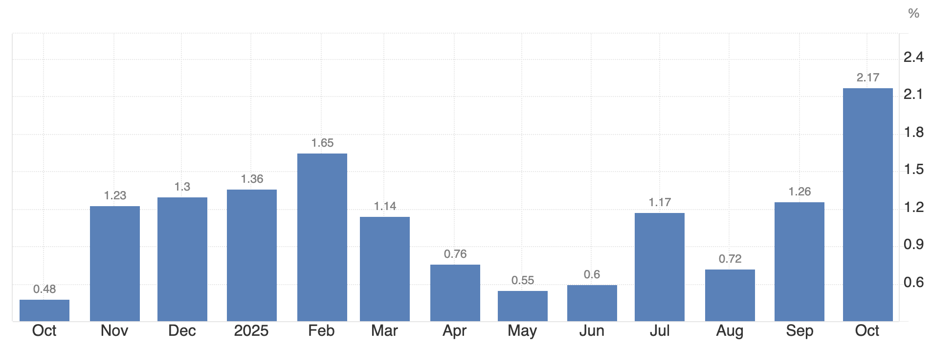
Figure 1: inflation rate in the United Arab Emirates; Source: (Trading Economics, 2025)

2.3 Key Firms and Competitive Positioning
The renewable energy landscape comprises state‑owned champions, local private firms and foreign investors. Table 1 summarises major players and their strategic positioning.

Table 1: Key Players
Firm | Market share | Strategy | Target market | Performance & competitive position
Masdar (Abu Dhabi Future Energy Company) | Global capacity ≈65 GW across 40 countries; aims for 100 GW renewables and 1 Mt of green hydrogen by 2030. Joint owner of Al Dhafra (20 %) and MBR solar park phases; invests in hydrogen and waste‑to‑energy (Reuters, 2026). | Differentiation through global partnerships and innovation; invests across solar, wind, hydrogen, and waste‑to‑energy. | Regional and global markets; government‑backed but operates commercially. | Strong financial backing from ADNOC, Mubadala and TAQA; record‑low tariffs; significant growth pipeline.
TAQA (Abu Dhabi National Energy Co.) | Owns 40 % of Al Dhafra; portfolio includes PV, wind, and transmission assets; majority shareholder in EWEC (EWEC, 2026). | Cost leadership via large‑scale generation and integration of transmission assets. | Domestic and regional market; invests in export opportunities (hydrogen). | Stable revenue from regulated utilities; leverages government support; invests in grid upgrades.
DEWA (Dubai Electricity and Water Authority) | Developer of MBR Solar Park; holds 51 % stake in Phase 4, partnering with ACWA Power and China’s Silk Road Fund (Oommen, 2021). | Differentiation through technology (parabolic trough, tower, PV) and world‑record tariffs. | Dubai’s utility customers; sells excess power to national grid. | Publicly listed; high profitability; invests in hydrogen pilot plant.
ACWA Power (Saudi) | Partner in MBR Phase 4 (25 %) and developer of large projects (e.g., Sakaka, Al Shuaibah). | Cost leadership and innovation; early mover in PV and CSP; leverages Saudi financing. | MENA and Asia; bids for global tenders. | Achieved record tariff of USD 0.056/kWh in MBR Phase 2; strong pipeline; intense competition, but maintains low costs.

Porter’s Diamond Model – Global Competitiveness

3.1 Factor Conditions
For the UAE, there is high solar irradiance (more than 2,100 kWh/m² yearly) and expansive land that can be used to develop large-scale renewable projects, with desert heat and dust augmenting maintenance expenses (Farag and Bansal, 2022). Expansion is supported by strong financial capacity, as measured by sovereign wealth funds and FDI inflowsof USD 30.7 billion in 2023. There is a high level of internationalisation of the workforce, with 81% of it being expatriates, which leads to the diversity of skills and reliance on foreign experience (Oustry, 2023). By 2030, the number of job opportunities in renewable energy can exceed 110,000, even considering the existing shortage of skills (Mai et al., 2025). Moderate inflation and currency stability facilitate development, but grid congestion is a limiting factor (Trading Economics, 2025).

3.2 Demand Conditions
The increasing population, industrialisation and the emergence of energy-intensive data centres are increasing the domestic demand for electricity at a high rate. According to the International Energy Agency, the Middle East electricity demand will increase 50 per cent by 2035. The 5 GW of power needed to support AI and cloud computing applications, such as the Stargate data-centre cluster, could trigger the government to increase renewable investment (Narayanan, 2025). The excellent per-capita income (GDP per capita ≈ USD 552.3 in 2024) and the desire of the UAE population to accept sustainable solutions influence readiness to buy clean energy (World Bank, 2026). Advanced corporate clients, including aluminium smelters and desalination facilities, require long-term contracts to purchase green power. Exporters are also forced to use renewable energy to satisfy international customers who require decarbonised products (e.g., green aluminium or ammonia).
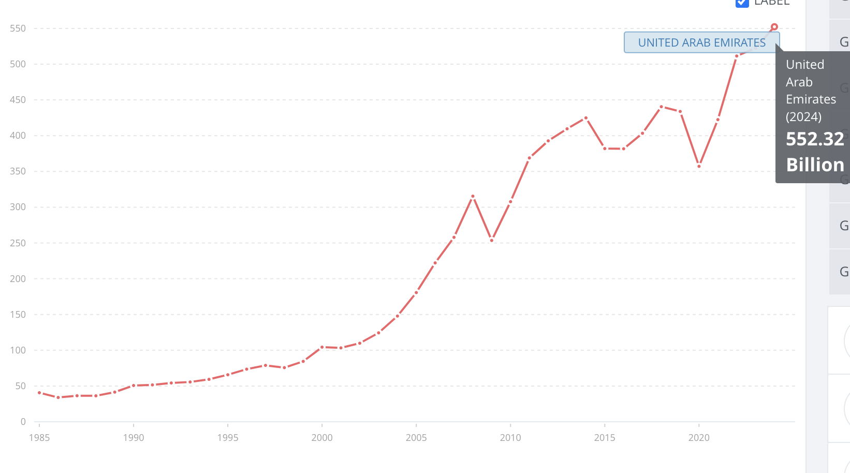
Figure 2: GDP of the United Arab Emirates; Source: (World Bank, 2026)

3.3 Related and Supporting Industries
The UAE has developed renewable energy, chemicals, logistics and finance clusters. Masdar City accommodates research centres, IRENA headquarters, start-ups and innovation hubs. The chemicals cluster in Al Ruwais (TA’ZIZ) is designed to generate methanol, ammonia, polyvinyl chloride and other derivatives using clean energy. Engineering companies (ACWA Power, Siemens, GE, Samsung) offer equipment, EPC services and innovation. In Dubai and Abu Dhabi, financial services provide project finance and green bonds; sovereign funds fund early-stage ventures. Universities (Khalifa University, UAE University) and labs are funding desalination, solar, and hydrogen R&D, but general R&D expenditure is below OECD levels. Digital infrastructure will be expanded to enable AI-based grid management.

3.4 Firm Strategy, Structure and Rivalry
Independent power producer (IPP) and public-private partnership models are used to run the renewable energy industry. Tariffs in state-owned utilities (DEWA, EWEC) are determined in competitive tenders, promoting strong competition among international bidders. Low tariffs (record-low USD 0.0132/kWh at Al Dhafra; record-low USD 0.0299/kWh at MBR Phase 3) mean stiff competition and efficiency (Stoker, 2020). Companies seek cost leadership through economies of scale and the availability of cheap capital. Others distinguish themselves by innovation (hybrid photovoltaic/CSP plants, battery storage, hydrogen). Corporate forms focus on joint ventures: ACWA Power and the Silk Road Fund own 25 and 24 per cent (respectively) of MBR Phase 4, and DEWA holds 51 per cent (Kraemer, 2023). Samsung E&A collaborates with TAZIZ (EPC contract) and Nel Hydrogen (green hydrogen solution) SAMSUNG. Export markets also bring competition; Masdar and ACWA Power compete over projects in Asia and Africa.

3.5 Government Role
The government policy is central. The UAE Energy Strategy 2050 aims to increase the proportion of clean energy to 50, enhance energy efficiency by 40, and cut carbon emissions by 70 (International Trade Administration, 2024). The refreshed plan (2023) invests between AED 150 and 200 billion by 2030 and aims at 19.8 GW of renewable capacity. The purpose of a national hydrogen strategy is to generate 14-22 Mt of low-carbon hydrogen by 2050. The government has eliminated the local sponsor requirement, allowing 100 per cent foreign ownership in most sectors, and provides free zones with tax exemptions and full repatriation.
The income tax imposed on corporations is 9 %, and the minimum tax rate on large MNCs is 15 (Torkington, 2024). The incentives consist of long-term (Golden and Blue) investor, scientist, and sustainability contributor visas; green bonds; and selective subsidies on research and training (state.gov, 2025). Distributed generation is promoted by regulatory frameworks, including feed-in tariffs and net-metering programmes. The UAE is involved in international climate negotiations, hosting COP 28 and promoting the UAE Consensus to triple the world's renewable capacity (Samuel, 2025).

3.6 Chance Factors
Competitiveness is also determined by chance factors that cannot be controlled by the government or companies. The COVID-19 pandemic brought a halt to the execution of projects, although the emphasis was on energy resilience. World technological advancement lowered the costs of solar and battery and allowed tariffs to be very low. The regional cooperation is affected by geopolitical changes (Iran-Gulf relations, Israel-UAE rapprochement) (Jones, 2025). Domestic renewable resources became more appealing with the global energy crisis, like the 2022 oil price rush (Magazzino and Giolli, 2024). Climate change is causing excessive heat and water shortage, which is why solar-powered desalination is being implemented at a high rate. The AI and data centres demand new baseload demand (IEA, 2025).

Foreign MNC Evaluation – Samsung

4.1 Introduction to Selected MNC
Samsung is a South Korean-based diversified conglomerate in electronics, construction engineering, financial services and chemicals. The group has been majoring in energy transition technologies with subsidiaries Samsung Engineering (since 2023, renamed Samsung E&A), Samsung C&T (Engineering and Construction group), and Samsung SDI (battery manufacturing). Samsung E&A is a global player in petrochemical and green-energy projects, and Samsung C&T is an EPC contractor of power stations and infrastructure. The current sustainability reports highlight a proposal, E&Able Zero, to increase carbon-free fuels, including green hydrogen, ammonia and sustainable aviation fuel. Samsung has industrial and clean-energy initiatives in the UAE. In February 2025, TAZIZ awarded Samsung E&A a USD 1.7 billion EPC contract to construct a 1.8 million ton/annum methanol facility at Al Ruwais. The plant will use clean energy and become the first methanol plant in the UAE. Samsung E&A introduced CompassH2-P, a 100 MW proton-exchange membrane (PEM) green hydrogen solution, at the ADIPEC exhibition in Abu Dhabi in November 2025. Created with Nel Hydrogen, the solution yields high-purity hydrogen (99.9995%) at 30 bar and maximises plant footprint. In July 2025, Samsung C&T, too, entered into an MoU with Emirates Nuclear Energy Corporation (ENEC) to collaborate on investment in nuclear projects, small modular reactors and hydrogen production. These projects reflect the desire of Samsung to gain a presence in the energy change in the UAE.
Samsung initially penetrated the UAE in construction projects in the 1990s. It constructed the Burj Khalifa and other landmarks, which helped it form relationships with developers. The company has been involved in energy with the Barakah nuclear plant (2009) being part of a Korean consortium headed by the Korea Electric Power Corporation (KEPCO); Barakah is now supplying 25% of the electricity in the UAE. Samsung has its first large renewable-feedstock project in the UAE with the 2025 methanol project. The collaboration with TA'ZIZ is strategically aligned with the goal of the UAE to create a chemicals value chain based on clean energy.

4.2 Market Attractiveness Analysis (PESTLE / CAGE)
Political environment:
The UAE is a federal monarchy with a stable political system and pro-business policies. Power changes are peaceful, and there is a precedent when Sheikh Mohammed bin Zayed assumed the succession of his brother in 2022. (Wang, 2024) The government actively pursues energy diplomacy, developing alliances with the US (USD 100 billion investment framework in AI, semiconductors and energy), Israel, China and Korea. Foreign ownership is now complete, thanks to the elimination of local-sponsor requirements, and free zones provide tax breaks and simplified processes. A distinct policy direction is presented by the Energy Strategy 2050 and the hydrogen strategy. Nevertheless, some strategic industries, including banking, insurance, oil and gas, remain at 40-49%foreign and 20% foreign bank emirate-level taxes (Zubi et al., 2025). State ownership in energy projects means that the foreign companies will be consorting with government-owned enterprises, proving less autonomous but less risky in terms of politics. The involvement of the UAE in global conventions (ICSID, New York Convention) provides investors with a right to courts (David and Ridwan, 2025).
Economic environment:
Diversification, tourism and logistics drive growth; non-oil industries expanded powerfully in 202225. Inflation was moderate at 2.17% in October 2025, and the peg of the Dirham to the US dollar minimises currency risk (Trading Economics, 2025). Corporate tax is low (9) with high exemptions. In 2023, confidence is indicated by an inflow of USD 30.7 billion FDI (AISU, 2024). Most sectors are further attractive with the removal of local-sponsor requirements and 100% foreign ownership rights. Nonetheless, a 15% domestic minimum top-up tax on large MNCs will be introduced in 2025, which is compliant with the OECD regulations and can have an impact on profitability. Skyrocketing labour expenses on competent expatriates and the scarcity of renewable-energy experts are also problems.
Legal environment:
The civil law system in the UAE provides protection to investors. Contracts are enforceable, and the country is a member of the arbitration conventions. The Corporate Income Tax Law (effective 2023) levies 9 % on profits exceeding USD 102,000 and exemption on free-zone income. Competition Law No. 36 of 2023 deals with anti-competitive behaviour in industries. Bankruptcy reforms (Federal Decree Law No. 51 of 2023) create a specialised bankruptcy court and streamline the insolvency procedures (Govt.UAE, 2023). Expropriation Laws compensate for owned property used by the state. There are no restrictions on foreign investors remitting profits back home. However, arbitration awards are slow to enforce, and the free-zone laws differ across emirates, necessitating legal knowledge.
CAGE considerations:
Korea and UAE have similar cultures in terms of business structures where business relationships are highly valued, yet in differences in language, they need to be very careful in their language communication. South Korea is more individualistic, uncertain, and long-term oriented, whereas the UAE has more power distance and achievement orientation, which means that their business culture is more hierarchical but goal-oriented than the structured and future-oriented one of Korea (Hofstede cultural Insight, 2026).
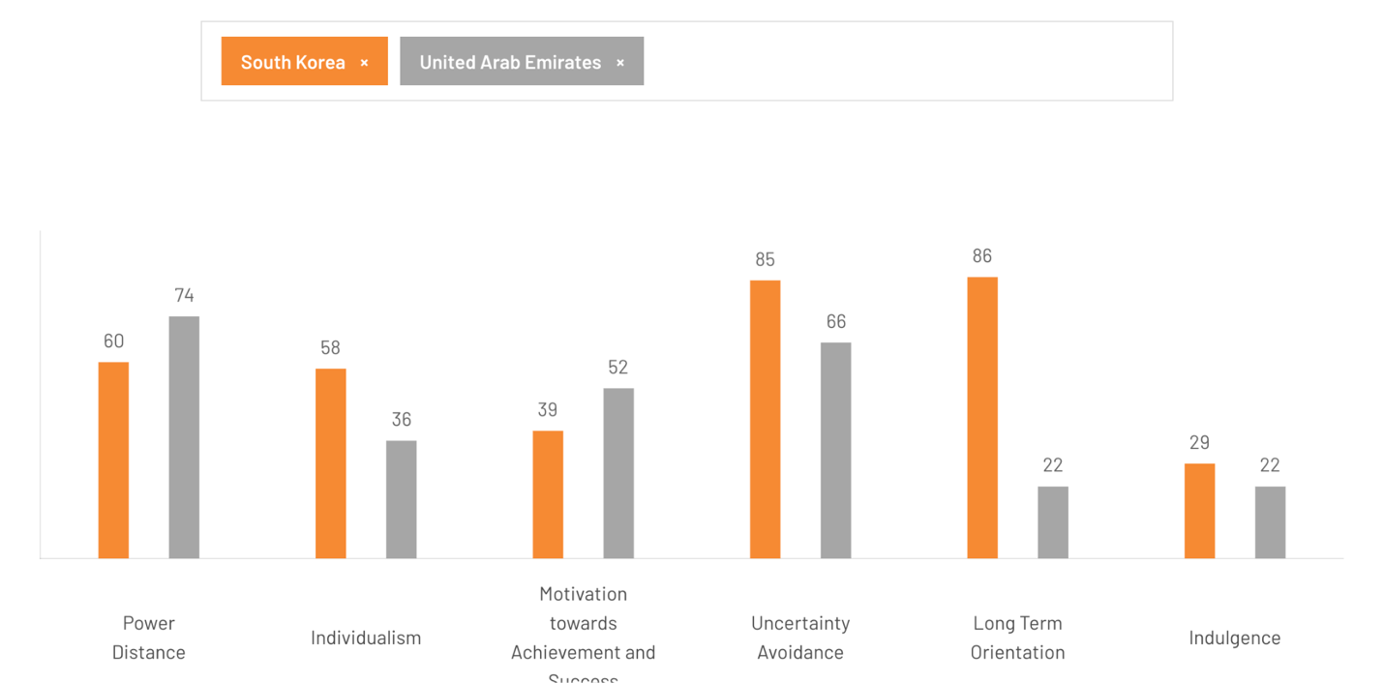
Figure 3: Cultural Difference between UAE and Korea; Source: (Hofstede cultural Insight, 2026)
Both are administratively balanced, though they have different legal systems (civil law vs. Korean mixed system). Administrative distance is reduced by the pro-business policies in place in the UAE, but local partnerships are frequently favoured in public procurement.
Geographically, the distances between Seoul and Abu Dhabi (7,000 km) require local offices and supply-chain management.

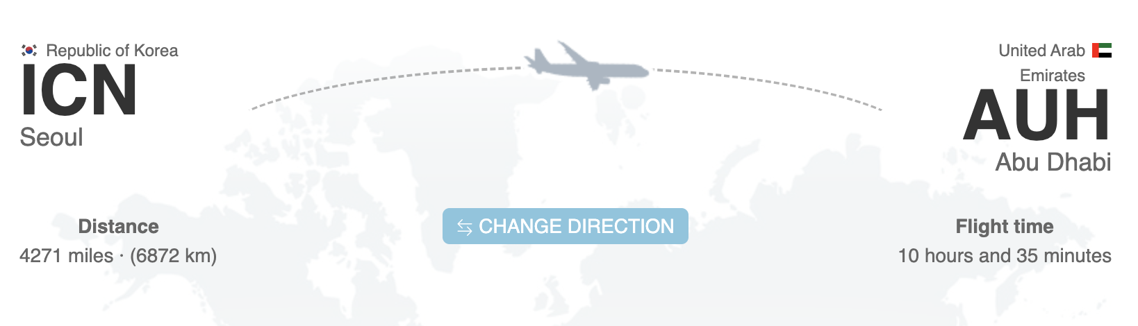
Figure 4: Distance between Seoul and Abu Dhabi; Source:(FLIGHTSFROM, 2026)
Economically, both countries are high‑income; the UAE’s tax regime is more favourable, but local content requirements in strategic sectors may constrain foreign suppliers. Overall, the CAGE analysis suggests moderate distance, manageable through partnerships and localisation.

4.3 Competitive & Strategic Analysis
Competitive Advantage
The strength areas of Samsung are technology innovation, engineering, financial capacity and EPC expertise. Through its experience with large-scale projects, including the Burj Khalifa and the Barakah nuclear plant, the company gains credibility (Samsung, 2025a). Its CompassH2-P system is also a high-purity hydrogen with a smaller footprint, serving companies that require flexible hydrogen solutions. The international collaboration of Samsung with Nel Hydrogen, TA’ZIZ and ENEC, among other,s offers access to local networks and entry de-risking. Through the combination of green hydrogen generation and downstream chemicals (methanol, ammonia), and possible SMR initiatives, Samsung would be able to leverage economies of scope and develop a differentiated value proposition (Lee and Kim, 2021).
Entry strategy:
The market entry of Samsung in the UAE renewable industry is based on joint venture and partnership strategy. The company is an EPC contractor to the methanol plant, and it collaborates with TA’ZIZ (ADNOC and ADQ joint venture) (Reuters, 2025). This model relocates market and political risk to the local partner and secures feedstock, permits and grid connection. In the case of hydrogen technology, Samsung cooperates with Nel Hydrogen to co-create equipment and introduce integrated solutions; the product was introduced at a large industry conference to meet customers and regulators (Lee and Kim, 2021). The MoU with ENEC illustrates the interest in investing in nuclear and SMR projects, which may be co-investment or consortia. Samsung, therefore, seeks strategic partnerships, as opposed to complete acquisitions, showing knowledge-seeking and risk-sharing interests in line with the eclectic paradigm.
Local vs global strategy:
Samsung localises its products. The methanol facility will utilise clean electricity from the UAE grid and provide chemicals to the regional markets. CompassH2-P is capable of working on intermittent renewable energy, which is essential in the UAE to deal with the demand variability (Alnaqbi and Alami, 2023). Meanwhile, Samsung plans to sell hydrogen technology to the rest of the world, with the UAE serving as a test base. The company investigates international projects with ENEC (US, Romania) in the nuclear field. In this way, Samsung is between local adaptation and global replication, which is consistent with the transnational strategy by Porter (Ali and Anwar, 2021).
Value chain positioning:
Samsung concentrates on upside EPC and supply of supply chain technologies as opposed to downstream utility operations. Samsung is in charge of engineering and construction in the methanol project, but transfers ownership to TA’ZIZ (Reuters, 2025). In the case of hydrogen solutions, Samsung is the equipment supplier and project developer. Samsung can also be an investment partner with ENEC in prospective SMR projects. This technology and design positioning results in high design and technology margins and reduces the vulnerability to commodity price changes (Gaudenzi, Zsidisin and Pellegrino, 2020). It also uses Korean export credit and supply-chain financing.
Competitors:
Samsung also competes with international corporations in the EPC and technology sector that include Siemens, GE Vernova, Technip Energies, and the Chinese state-owned corporations (Danko, 2025). Other competitive solutions to hydrogen technology are offered by such companies as Nel Hydrogen, Plug Power, and Chinese manufacturers of electrolysers (Guo, Zhu and Zhang, 2024). The local champions (Masdar, DEWA, TAQA) and regional players (ACWA Power) control the renewable market of the UAE; they are well supported by the government and have their own pipelines. The differentiation that Samsung needs to make is based on innovation, reliability and strategic partnerships.

4.4 Risks and Challenges
Political and regulatory risk remains relevant despite the UAE’s stability, as energy projects require government approvals and evolving hydrogen and SMR regulations create uncertainty. Market risk arises from intense tariff competition and fluctuating global demand for green fuels, although data-centre growth supports long-term demand (D’Orazio, 2024). Financial risk is linked to reliance on PPAs, tax reforms and interest rate increases, despite currency stability. Operational risk stems from harsh climate conditions, specialised labour shortages and strict safety requirements. Cultural differences and workforce turnover may affect partnerships. Reputational and ESG risk persists, as any environmental or safety incident could harm Samsung’s credibility and alignment with sustainability expectations (Rawal, 2026).

4.5 Success Factors
Samsung’s success in the UAE renewable energy market will hinge on several factors:
The hydrogen strategy and industrial diversification should be supported by the projects. The methanol plant contributes to the creation of a home-based chemicals value chain with clean energy; hydrogen technology will enable the realization of net-zero objectives. Moreover, collaboration with TA ZIZ, ENEC and Masdar will enable access to permits, land and financing and shared risk. Joint ventures help to overcome regulatory and cultural obstacles (Jin, Park and Lee, 2020). Samsung can differentiate itself based on technological innovation and reliability, offering high-efficiency equipment, such as PEM electrolysers of reduced size and high purity compared to competitors. Well-established engineering bases reduce project risk. To be more specific, local talent recruitment and training may assist in reducing skill gaps and meeting Emiratisation requirements. The long-term presence may be enhanced through formation of a regional training centre or headquarters. In terms of financial power, access to Korean export credit, sovereign funds, and green finance instruments can be used to secure competitive financing (Oh and Kim, 2019). Arranging projects in a manner that assists in tax exemptions and free-zone benefits will boost returns.

4.6 Critical Evaluation
The decision by Samsung to venture into the UAE renewable energy market is promising, yet it should be managed with caution. The firm enjoys robust engineering capabilities and a diversified portfolio; its USD 1.7 billion methanol project will place it in the path of UAE industrialisation (S, 2025). Although the CompassH2P solution demonstrates technological leadership (Liedtke, 2025). The ENEC MoU has the potential to create new prospects in nuclear and SMR projects, which would deliver long-term revenues and knowledge exchange. The alliance-based strategy of Samsung fits the UAE demand in joint ventures and political backing.
However, Samsung is strongly competing with established actors (Masdar, ACWA Power, Siemens), and needs to compete in terms of price, quality and localisation (Putra et al., 2023). The high capital intensity of the renewable sector and long payback periods increase financial risk, especially a 15% mandatory tax on MNCs (Chiocchetti et al., 2025). The labour and cultural issues are also to be considered by the company; the creation of the local labour force and the relationships with the governmental stakeholders will be of great importance. The changing policies on hydrogen and nuclear demand adherence and active participation.

5. Conclusion
The renewable energy sector in the UAE has evolved to become a worldwide leader with mega-projects in solar energy, favourable policy and high goals that originated in the early years of the 2010s. The renewable capacity was 6.8 GW by 2024, and the target is 19.8 GW by 2030. The favourable investment environment is enabled by government policies such as the Energy Strategy 2050 and hydrogen roadmap, as well as incentives such as 100% foreign ownership and tax exemptions. Large companies such as Masdar, DEWA, TAQA and foreign companies are in a rivalry, forcing tariffs to record lows. The diamond analysis by Porter reveals that there are good factors (sunlight, capital, infrastructure) and favourable government policy, and data centres and industrial diversification drive further growth. The issues are skills shortages, gridlock and reliance on expatriate labour.
The entry of Samsung in this landscape presents opportunities and threats. The company capitalises on its engineering background to roll out a USD 1.7 billion methanol plant that uses clean energy and presents a new green hydrogen solution of 100 MW. Cooperation with TA’ZIZ and ENEC offers an opportunity to enter the market and be consistent with national priorities. Nonetheless, the firm has to contend with stiff competition, changing regulations and cultural issues. Strategic alignment, technological innovation, strong partnerships and localisation initiatives are the foundation of success. Altogether, the renewable energy market of the UAE has significant potential to attract foreign investors, and the initiatives of Samsung demonstrate how multinational companies may invest and gain in the green transformation of the country.

Section 2 – Reflective Report
The following reflection adopts Gibbs’ reflective cycle to evaluate the research and learning process during this assignment.

6.1 Description
This task was to create an international business report about the renewable energy industry in the UAE and a critical assessment of the entry of Samsung as a foreign MNC. I started by conducting an analysis of the assessment specification and determining the necessary sections and frameworks. Then I did a thorough research with reliable sources such as government Web pages, World Bank data, IMF reports, scholarly journals and industry publications. The UAE government websites providing policy information, the U.S. Department of State (2025) annual investment climate statement to obtain legal and tax information, PR Newswire and utility publications to find information about projects, and the National News to find recent capacity numbers were taken into consideration as Key sources. I got quantitative data on market size, employment, FDI, tariffs and capacity and synthesised the same into a report. Lastly, I have organised the report based on the brief and composed a reflective section.

6.2 Feelings
I was initially thrown into confusion about the scope of information that was to be covered: macroeconomic analysis, industry specifics, competitive positioning and critical evaluation of an MNC. I feared that I would not be able to find recent information, as the field of renewable energy is developing fast, and the UAE policy environment is dynamic. I felt more confident as the research went on and credible sources were found. The finding of good data (e.g., FDI inflows and recent capacity numbers) was gratifying and reinforced the analysis. Assessing Samsung, however, was a tricky task since the company is relatively new in the renewables business in the UAE; I was unsure of using a few resources. Altogether, I was helped to develop my research skills and feel the complexity of international business settings.

6.3 Evaluation
What worked well?
The assignment requirements were systematically mapped so that each section was covered. The frameworks, like Porter's diamond and PESTLE, gave a framework and depth to the analysis. The credibility was enhanced when searching governmental sources of data; e.g. the U.S. Department of State report had abundant data on foreign ownership, tax and visa laws. The National News report provided recent installed capacity of renewables, and utility magazines covered Samsung projects. Using several sources has minimised the chances of inaccuracies.
What did not work well?
Some data could not be accessed without a paywall or dynamic websites. Full reports were not available, so I had to use other sources or summarised figures. The amount of information on the renewable projects that Samsung has in the UAE was also scarce, which limited the depth of critical analysis. The time wastage when attempting to reach sites that are not accessible could have been used wisely.

6.4 Analysis
The assignment has also led to my greater understanding of the nexus of macroeconomic variables, policy frameworks and industry dynamics of international business. Research on the UAE showed that the government policy in shaping investment climates is very significant, the effect of government policy, to FDI, is very high through policies such as 100% foreign ownership and tax exemption. The review confirmed the usefulness of the diamond model and PEST framework developed by Porter in determining the competitiveness and market attractiveness. I was educated on how to integrate qualitative (e.g., cultural) and quantitative data (market size, employment). This experience made me more critical of the strategy of a MNC by using internalisation theory and eclectic paradigm. The assignment has improved my information synthesising ability, reference and writing skills analytically.

6.5 Conclusion
This reporrt made me realise that renewable energy in the UAE is not only a technocratic initiative, but much policy and finance-oriented, culture and global trends-influenced. The industry needs additional investment, a skilled workforce and favourable regulation to expand. I also understood that it is of great importance to consider numerous variants on how an MNC can be considered in terms of its capability to penetrate the foreign markets; it is not only the capabilities of firms but also the consideration of the local priorities and stakeholder connections that are likely to make an MNC successful. My research skills have also grown, particularly in finding credible information and applying research models.

6.6 Action Plan
For future research and professional development, I plan to:
Notably, access paywalled reports via institutional libraries by referencing academic databases or scheduling study periods. Acquire expertise in statistical software to process big data. Secondly, participate in webinars or courses regarding renewable energy technologies, hydrogen economies and energy policy to create technical knowledge. Keep track of the latest news initiated by IRENA, the International Energy Agency and the UAE regulators. Third, become an intercultural communicator/negotiator, especially in the Middle East and East Asian cultures. This will be useful in the analysis or dealing with multinational partnerships. Lastly, through practising further to write academic papers of proper format, critical thinking and proper referencing. Seek the advice of classmates and teachers to make it clear and well-argued. The action plan will help me increase the levels of my competence in international business analysis and will equip me better to pursue the professional parameters in the global industries.

References
Ahmad, F., Boumaiza, A., Sanfilippo, A. and Al-Fagih, L. (2025) ‘A comprehensive review on green finance and its impact on net zero energy transition: From the perspective of renewable energy development’, Energy Strategy Reviews, 62, p. 101948. Available at: https://doi.org/10.1016/j.esr.2025.101948.
Ali, B. and Anwar, K. (2021). Porter’s Generic Competitive Strategies and its influence on the Competitive Advantage. [online] ResearchGate. Available at: https://www.researchgate.net/publication/352181915_Porter.
Alnaqbi, S.A. and Alami, A.H. (2023). Sustainability and renewable energy in the UAE: A case study of sharjah. Energies, [online] 16(20), pp.7034–7034. doi:https://doi.org/10.3390/en16207034.
AISU (2024) UAE attracts record inflows of foreign investment... $31 billion in 2023 - Arab Iron and Steel Union, Arab Iron and Steel Union. Available at: https://aisusteel.org/en/27731/ (Accessed: 17 February 2026).
Bojarajan, A.K., Omari, A., Al-Marzouqi, A.H., Alshamsi, D., Sherif, M., Kabeer, S. and Sangaraju, S. (2024) ‘A Holistic Overview of Sustainable Energy Technologies and Thermal Management in UAE: The Path to Net Zero Emissions’, International journal of thermofluids, 23, pp. 100758–100758. Available at: https://doi.org/10.1016/j.ijft.2024.100758.
Chiocchetti, A., Chouc, P.-E., Delbecq, L., Moreau-Kastler, N., Parenti, M., Varaschin, G. and Zucman, G. (2025) Taxing Polluters: What is the Impact of a Global Minimum Tax on the Extractive Sector? Available at: https://solidaritylevies.org/app/uploads/2025/09/GSLTF___Min_Tax_Polluting_Firms_Main20.pdf (Accessed: 17 February 2026).
D’Orazio, P. (2024) ‘Addressing climate risks through fiscal policy in emerging and developing economies: What do we know and what lies ahead?’, Energy Research & Social Science, 119, p. 103852. Available at: https://doi.org/10.1016/j.erss.2024.103852.
Danko, T. (2025) ‘Ecosystem Entry Strategy Patterns and Resilience of Electrical and Electronic Industry Multinational Corporations under High Market Volatility’, 2025 IEEE 6th KhPI Week on Advanced Technology (KhPIWeek), pp. 1–4. Available at: https://doi.org/10.1109/khpiweek61436.2025.11288664.
David, S. and Ridwan, L. (2025) Dispute Resolution Mechanisms for Foreign Investors: A Comparative Analysis of Arbitration Practices in..., ResearchGate. unknown. Available at: https://www.researchgate.net/publication/394448654_Dispute_Resolution_Mechanisms_for_Foreign_Investors_A_Comparative_Analysis_of_Arbitration_Practices_in_the_United_Arab_Emirates_and_Jordan_under_International_Law (Accessed: 26 August 2025).
Dubai Electricity & Water Authority (2025) World Energy Day: Emphasising the UAE’s lead in promoting the transition to clean and renewable energy, Dewa.gov.ae. DEWA. Available at: https://www.dewa.gov.ae/en/about-us/media-publications/latest-news/2025/10/world-energy-day (Accessed: 17 February 2026).
Dufo-López, R., Lujano-Rojas, J.M., Bernal-Agustín, J.L., Artal-Sevil, J.S. and Martínez, C.E. (2023) ‘Utility-scale renewable hydrogen generation by wind turbines’, Renewable Energy and Power Quality Journal, 21(1), pp. 19–24. Available at: https://doi.org/10.24084/repqj21.208.
EWEC (2026) TAQA, EWEC, Masdar, EDF power solutions, and Jinko Power Complete US $870.75 million Green Bond for Al Dhafra Solar Plant, Ewec.ae. Available at: https://ewec.ae/blog/taqa-ewec-masdar-edf-power-solutions-and-jinko-power-complete-us-87075-million-green-bond-for-al-dhafra-solar-plant (Accessed: 17 February 2026).
Farag, M.M. and Bansal, R.C. (2022) ‘Solar energy development in the GCC region – a review on recent progress and opportunities’, International Journal of Modelling and Simulation, pp. 1–21. Available at: https://doi.org/10.1080/02286203.2022.2105785.
FLIGHTSFROM (2026) Direct (non-stop) flights from Seoul to Abu Dhabi - schedules - FlightsFrom.com, Flightsfrom.com. Available at: https://www.flightsfrom.com/ICN-AUH (Accessed: 17 February 2026).
Gaudenzi, B., Zsidisin, G.A. and Pellegrino, R. (2020) ‘Measuring the financial effects of mitigating commodity price volatility in supply chains’, Supply Chain Management: An International Journal, 26(1), pp. 17–31. Available at: https://doi.org/10.1108/scm-02-2020-0047.
Govt.UAE (2023) Federal Decree-Law No. (36) of 2023 Regarding Regulating Competition. Available at: https://uaelegislation.gov.ae/en/legislations/2117/download.
Guo, X., Zhu, H. and Zhang, S. (2024) ‘Overview of electrolyser and hydrogen production power supply from industrial perspective’, International Journal of Hydrogen Energy, 49, pp. 1048–1059. Available at: https://doi.org/10.1016/j.ijhydene.2023.10.325.
Hofstede cultural Insight (2026) Country comparison tool: UAE and Korea, Theculturefactor.com. Available at: https://www.theculturefactor.com/country-comparison-tool?countries=south+korea%2Cunited+arab+emirates.
IEA (2025) AI is set to drive surging electricity demand from data centres while offering the potential to transform how the energy sector works - News - IEA, International Energy Agency. Available at: https://www.iea.org/news/ai-is-set-to-drive-surging-electricity-demand-from-data-centres-while-offering-the-potential-to-transform-how-the-energy-sector-works.
IMARC (2024) UAE Renewable Energy Market Size, Share | Forecast 2032, Imarcgroup.com. Available at: https://www.imarcgroup.com/uae-renewable-energy-market.
International Trade Administration (2024) United Arab Emirates - Renewable Energy and Clean Energy, www.trade.gov. Available at: https://www.trade.gov/country-commercial-guides/united-arab-emirates-renewable-energy-and-clean-energy-0.
Jin, K., Park, C. and Lee, J. (2020) ‘What Determines Innovative Performance of International Joint Ventures? Assessing the Effects of Foreign Managerial Control’, Sustainability, 12(21), p. 8770. Available at: https://doi.org/10.3390/su12218770.
Jones, C. (2025) ‘Israel and the Gulf monarchies: a new Regional Security Complex or just complex regional security?’, Middle Eastern Studies, 61(3), pp. 321–328. Available at: https://doi.org/10.1080/00263206.2025.2455378.
Kraemer, S. (2023) DEWA inaugurates its 700 MW trough and Tower CSP project for Dubai, SolarPACES. Available at: https://www.solarpaces.org/dewa-inaugurates-its-700-mw-trough-and-tower-csp-project-for-dubai/.
Lee, D. and Kim, K. (2021) ‘Research and Development Investment and Collaboration Framework for the Hydrogen Economy in South Korea’, Sustainability, 13(19), p. 10686. Available at: https://doi.org/10.3390/su131910686.
Liedtke, M.S. (2025) Samsung E&A unveils CompassH2-P - Utilities Middle East, Utilities Middle East. Available at: https://www.utilities-me.com/news/samsung-ea-unveils-compassh2-p (Accessed: 17 February 2026).
Magazzino, C. and Giolli, L. (2024) ‘Analyzing the relationship between oil prices and renewable energy sources in Italy during the first COVID-19 wave through quantile and wavelet analyses’, Renewable energy focus (Online), 48, pp. 100544–100544. Available at: https://doi.org/10.1016/j.ref.2024.100544.
Mai, T., Lopez, A., Marquis, M., Gleason, M., Hamilton, A., Trainor-Guitton, W., Ho, J. and Sharma, S. (2025) ‘Land of Opportunity: Potential for Renewable Energy on Federal Lands’. Available at: https://doi.org/10.2172/2522746.
Maka, A.O.M., Ghalut, T. and Elsaye, E. (2024) ‘The pathway toward decarbonisation and net-zero emissions by 2050: The role of solar energy technology’, Green Technologies and Sustainability, 2(3), p. 100107. Available at: https://doi.org/10.1016/j.grets.2024.100107.
MBRSIC (2022) Solar Innovation Centre | Mohammed bin Rashid Al Maktoum Solar Park, www.mbrsic.ae. Available at: https://www.mbrsic.ae/en/about/mohammed-bin-rashid-al-maktoum-solar-park/.
Narayanan, N. (2025) AI set to double data center electricity demand by 2030: IEA, Arab News PK. Arabnews. Available at: https://www.arabnews.pk/node/2596675/business-economy (Accessed: 17 February 2026).
Oh, D. and Kim, S.-H. (2019) ‘Green Finance in the Republic of Korea’, Springer eBooks, pp. 629–658. Available at: https://doi.org/10.1007/978-981-13-0227-5_10.
Oommen, A. (2021) DEWA Opens Noor Energy 1 Visitors Centre At MBR Solar Park - MEP Middle East, MEP Middle East. Available at: https://www.mepmiddleeast.com/projects/dewa-noor-energy-1 (Accessed: 17 February 2026).
Oustry, A. (2023) The UAE’s Clean Energy Sector: Navigating Green Labour Market Dynamics, Challenges, and Policy Responses, The Oxford Middle East Review. Available at: https://omerjournal.com/2023/12/23/the-uaes-clean-energy-sector-navigating-green-labour-market-dynamics-challenges-and-policy-responses/.
Putra, E.Y., Putri, I.M., Mahendra, R.A., Sibagariang, M.I.B.A., Mey, N.A., Kusumo, P. and Hutagalung, R.M. (2023) ‘Analysis of Samsung’s Strategy in Dealing With Global Market Competition in International Business’, Journal Of Management Analytical and Solution (JoMAS), 3(3), pp. 111–117. Available at: https://doi.org/10.32734/jomas.v3i3.12167.
Rahman, F. (2025) UAE’s clean energy capacity to exceed 22GW by 2031 to power data-centre surge, The National. Available at: https://www.thenationalnews.com/business/energy/2025/12/16/uaes-clean-energy-capacity-to-exceed-22gw-by-2031-to-power-data-centre-surge/.
Rawal, N. (2026) ‘Green Commitments or Grand Illusions? The Role of CSR in True Sustainability’, World Sustainability Series, pp. 309–339. Available at: https://doi.org/10.1007/978-3-032-10212-6_15.
Reuters (2021) Abu Dhabi to build world s largest solar power plant, The Express Tribune. Available at: https://tribune.com.pk/story/2278805/abu-dhabi-to-build-worlds-largest-solar-power-plant (Accessed: 17 February 2026).
Reuters (2025) ‘TA’ZIZ awards $1.7 billion contract to Samsung E&A for UAE’s first methanol plant’, Reuters, 3 February. Available at: https://www.reuters.com/markets/deals/taziz-awards-17-billion-contract-samsung-ea-uaes-first-methanol-plant-2025-02-03/.
Reuters (2026) UAE’s Masdar reaches global clean energy capacity of 65 GW, Reuters. Available at: https://www.reuters.com/business/energy/uaes-masdar-reaches-global-capacity-65-gw-clean-energy-2026-01-13/.
S, M. (2025) UAE’s ENEC, Samsung C&T sign agreement to advance global nuclear energy collaboration - SaudiGulf Projects, SaudiGulf Projects. Available at: https://www.saudigulfprojects.com/2025/07/uaes-enec-samsung-ct-sign-agreement-to-advance-global-nuclear-energy-collaboration / (Accessed: 17 February 2026).
Sabarwal, S., Sri, S., Sribhashyam, R. and Kadiri, D. (2025) Official Use Only Are Green and Digital Skills a Pathway to Jobs in Middle East and North Africa? Available at: https://documents1.worldbank.org/curated/en/099090925144024784/pdf/P502135-500dac1d-030d-4ffd-8652-79ac4e684dec.pdf.
Samsung (2025a) Samsung C&T and UAE’s ENEC Partner to Advance Global Nuclear Energy Projects - Samsung C&T Newsroom, Samsung C&T Newsroom. Available at: https://news.samsungcnt.com/en/features/engineering-construction/2025-08-samsung-ct-and-uaes-enec-partner-to-advance-global-nuclear-energy-projects/ (Accessed: 17 February 2026).
Samsung (2025b) SAMSUNG E&A, Samsungena.com. Available at: https://saudi.samsungena.com/en/news/view?idx=15759 (Accessed: 17 February 2026).
Samuel, A. (2025) ‘The Normative Influence of Climate Movements on the UNFCCC COP Negotiations - White Rose eTheses Online’, Whiterose.ac.uk [Preprint]. Available at: https://etheses.whiterose.ac.uk/id/eprint/37881/1/AnnSamuel_S_Politics%26InternationalStudies_PhD_2025.pdf.
state.gov (2025) United Arab Emirates - United States Department of State, United States Department of State. Available at: https://www.state.gov/reports/2025-investment-climate-statements/united-arab-emirates.
Stoker, L. (2020) Abu Dhabi claims record low US$0.0135/kWh solar tariff for 2GW Al Dhafra project, PV Tech. Available at: https://www.pv-tech.org/abu-dhabi-claims-new-record-low-solar-tariff-of-us0-0135-kwh-for-2gw-al-dha/ (Accessed: 17 February 2026).
Tazikeh, S., Mohammadzadeh, O., Zendehboudi, S., Saady, N.M.C., Albayati, T.M. and Chatzis, I. (2024) ‘Energy development and management in the Middle East: A holistic analysis’, Energy Conversion and Management, 323, p. 119124. Available at: https://doi.org/10.1016/j.enconman.2024.119124.
Torkington, S. (2024) A minimum tax rate of 15% on the profits of multinationals., World Economic Forum. Available at: https://www.weforum.org/stories/2024/02/oecd-minimum-tax-rate/.
Trading Economics (2025) United Arab Emirates Inflation Rate, Tradingeconomics.com. TRADING ECONOMICS. Available at: https://tradingeconomics.com/united-arab-emirates/inflation-cpi.
UAE Embassy (2025) Starting a Business | UAE Embassy in Washington, DC, Starting a Business | UAE Embassy in Washington, DC. Available at: https://www.uae-embassy.org/business-trade/getting-started.
UAE Government (2022) UAE Energy Strategy 2050 - The Official Portal of the UAE Government, u.ae. Available at: https://u.ae/en/about-the-uae/strategies-initiatives-and-awards/strategies-plans-and-visions/environment-and-energy/uae-energy-strategy-2050.
WAM (2024) UAE takes second place globally in new FDI projects at 1,323 in 2023, Www.wam.ae. Available at: https://www.wam.ae/en/article/13z7663-uae-takes-second-place-globally-new-fdi-projects.
Wang, T. (2024) ‘The Arab Gulf States in Transition: Power Centralization, Economic Transformation, and Neo-Nationalism’, pp. 255–275. Available at: https://doi.org/10.1007/978-981-97-2835-0_10.
World Bank (2026) GDP (current US$) - United Arab Emirates. Available at: https://data.worldbank.org/indicator/NY.GDP.MKTP.CD?end=2024&locations=AE&start=1985.
Zubi, G., Kuhn, M., Makridis, S. and Dorasamy, S. (2025) ‘The UAE Net-Zero Strategy—Aspirations, Achievements and Lessons for the MENA Region’, Sustainability, 17(16), pp. 7510–7510. Available at: https://doi.org/10.3390/su17167510.

