

MODULE CODE: Digital Skills for Personal Development and Business Growth BMSW4008

ASSESSMENT COMPONENT: PORTFOLIO

STUDENT NAME: Martin Horvath

STUDENT NUMBER: 2315221

LECTURER: Philippa Fitzgerald

DATE:12th 23;59
Contents
Task 1 3
Assessment of Digital Skills 3
References 3
Task 2 4
LinkedIn Learning Certificates for Office365 4
Task 3 5
Essay on Relevance of Excel in professional and personal life. 5
References 5
Task 4 6
7 Minute Reflective Presentation 6
References 6

xamples of statements If you have not used AI
I confirm that I have not presented any AI generated materials as my own work.
I confirm that I have copies of my drafts, notes, and other resources I used, which I may be asked to provide in evidence.
Examples of AI statements if you have used AI
Example 1:
I acknowledge the use of Grammarly (https://www.grammarly.com/) on Date to check my work using the prompt(s):
1. Please check the following text for readability, grammar and syntax.
I confirm that I have not presented any AI generated text as my own work. I confirm that I have copies of my drafts, notes, and other resources I used before, and after the use of AI tools which I may be asked to provide in evidence.
Example 2:
I acknowledge the use of SciSpace (https://typeset.io/) on 7 March 2024 to support my research using the prompt(s):
1. Please provide me with materials on the biology of the liver.
2. Please provide me with materials on liver cells.
I confirm that I have not presented any AI generated text as my own work. I confirm that I have copies of my drafts, notes, and other resources I used before, and after the use of AI tools which I may be asked to provide in evidence.
Example 3:
I acknowledge the use of ChatGPT (https://chatgpt.com/) on 13 April 2024 to write my notes into submission format using the prompt(s):
1. Please write up these bullet points as an essay paragraph at university level.
I confirm that I have not presented any AI generated text as my own work. I confirm that I have copies of my drafts, notes, and other resources I used before, and after the use of AI tools which I may be asked to provide in evidence.
Example 4 - acknowledgement of the use of multiple AI tools:
I acknowledge the use of SciSpace (https://typeset.io/) on 28 June 2024 to support my research using the prompt(s):
1. Please provide me with materials on the American Civil War.
2. Please provide me with materials on the reception of Gone with the Wind.
I confirm that I have not presented any AI generated text as my own work. I confirm that I have copies of my drafts, notes, and other resources I used before, and after the use of AI tools which I may be asked to provide in evidence.
I acknowledge the use of Adobe Express (https://www.adobe.com/express/) on 24 June 2024 to edit photographic material:
1. Remove background from Figure 1.
I confirm that I have not presented any AI generated materials as my own work. I confirm that I have copies of my drafts, notes, and other resources I used before and after the use of AI tools which I may be asked to provide in evidence.

In this era, digital skills are very important for students and even workers. They help us with creating powerful and engaging power points, word document, and excel spreadsheets. Digital tools also help us study, stay focused, and makes studying easier. A lot of companies want people who are good with technology which requires digital skills as it is very important in workplaces and universities. My JISC digital capability assessment was good because it show me my skills, I am good at and skills I need to improve on so that I can be successful in university on work.

I was tasked with an actively to complete a JISC Digital Capability self-assessment, which gave me a report on my strengths that I am good at and weaknesses I need to improve on. My strengths are Digital skills for work and Digital wellbeing. And my weaknesses are Digital communications, Digital collaboration, and Digital participations. My strengths made me feel confident, but when I saw weaknesses, I knew I had to improve on them to be successful in university and my future career.
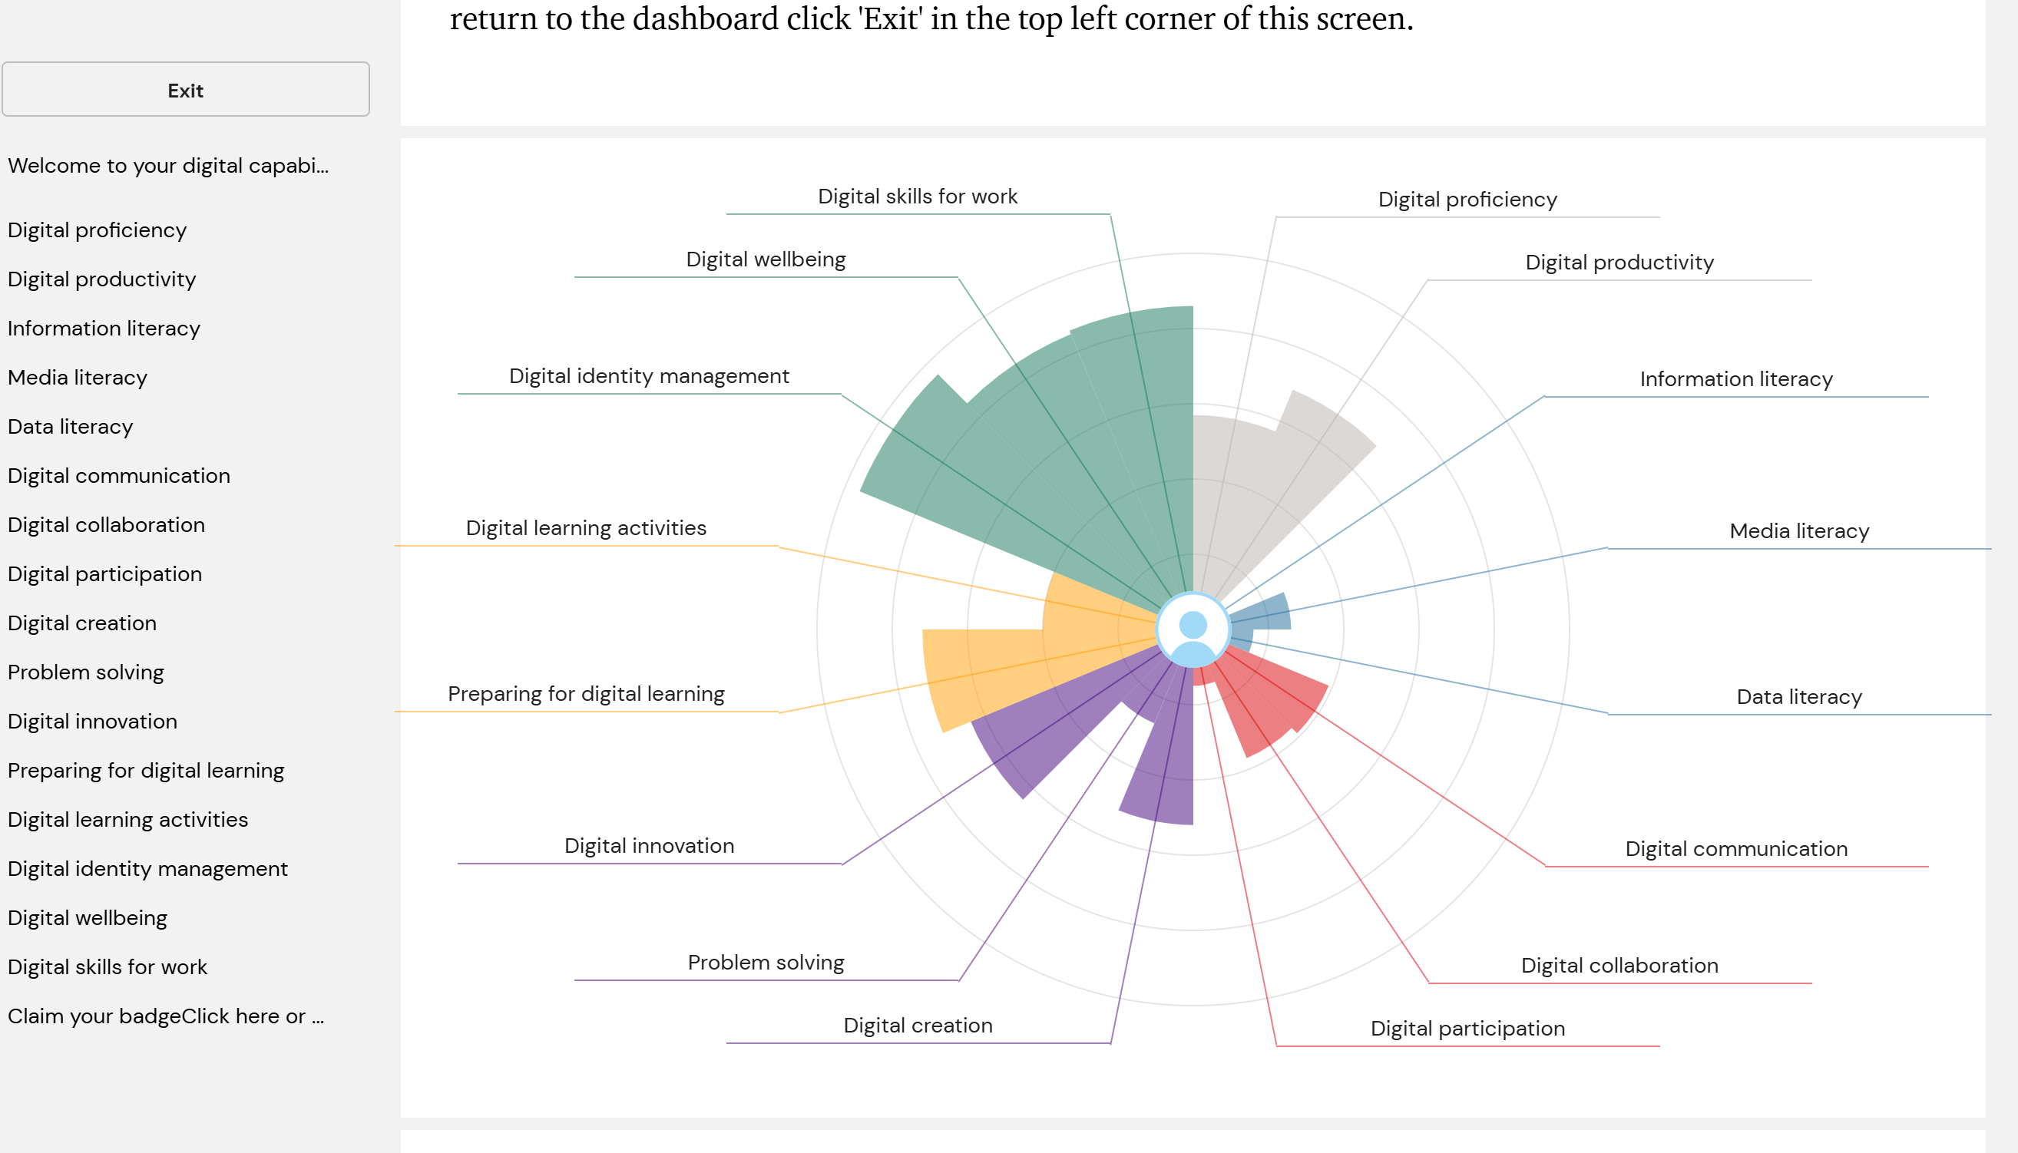

One of my strengths is I can find information online. I can use the CRAAP test to check if the information is trustworthy and I know how to reference it correctly. This helps me write good and engaging assignments and essays. Another strength is creating presentations. I know and have the skills to work my way through a power point. I can make a power point clear, easy to read, and add images to make it look more professional. This skill is useful in universities and workplaces where presentations are important.
One weakness is I a not that confident with excel. I can enter data, but I find some of the formulas, charts, and pivot tables difficult. This is something I need to improve on because many places such as schools, universities, and workplaces need this skill to analyse data. Another weakness is my online safety. I need to improve on this because there are many scammers and hackers trying to steal your information. Sometimes I would use simple passwords so I don’t forget them and I’m not always careful with risky emails or private texts that could be a scam. Cyber security is important today, so I must learn more about it to be able to tell if an email or text message is a scam so that I could act immediately and avoid getting scammed or hacked.
To improve on my weaknesses, I created a SMART goal. SMART means; specific, measurable, achievable, relevant, and time bound.
Goal | Excel skills | Online safety
Specific | Complete a excel course  and practice weekly | Complete the JISC cyber security and use password manager
Measurable | Do 10 practices a week | Check my accounts every day
Achievable | Easy to do with free access | Free and easy to set up
Relevant | Helps with studying and work | Protect my work and data
Time bound | Finish by the end of next term | Finish by the end of next term

These goals are clear and they will help improve on my weaker area’s step by step I will use my goals I created to help me improve on excel skills and online safety. This will make me more successful in academic and personal life. If I learn to stay safe online, I can prevent potential scams and if I learn how to use excel, I could analyse data and present it.

Getting better on excel skills will help me with my work in university that uses data and numbers. It will also make me more useful in workplaces. If I learn more about online safety, it will protect me from hackers who are trying to steal my information. With my strengths in presentation and research, I could be a good digital learner. I will be able to find information, check it correctly, present it, and protect it. This skill will help me improve in university and workplaces.
The JISC digital capability tool helped me understand my strengths and weaknesses. I am strong in creating power point presentations and researching, but I need to improve on my excel skills and online safety. Which I will use my SMART goals and follow them step by step to improve my digital skills. If I follow these goals, I will be more successful in my academic and future career.

REFERENCES
JISC, (n.d.). Discovery tool; Building digital capability. Available at; http://. digitalcapability.jisc.ac.uk/our-service/discovery-tool
UWE Bristol (n.d.) JISC digital tool for digital learning. Available at. http://digitallearning.uwe.ac.uk/teaching-tools/jisc-discovery-tool
University of Leeds library (N.D.) JISC discovery tool. Available at: http://library.leeds.ac.uk/info/99041/digital-capabilities/237/discovery-tool
TU Dublin (n.d.) Self uses your digital capabilities. Available at: http://www.tudublin.ie/explore/about/the-university/digital-education/building-digital-capabilities/self-assess-your-digital-capabilities
JISC, (2017). Digital capability framework questing. Available at: http://digitalcapability.ie.jiscinvolve,org/wp/files.2017/11/jisc-discovery-tool-digital-capability-question.pdf

Task 2

LinkedIn Learning Certificates for Office365
Add all the certificates from LinkedIn learning here

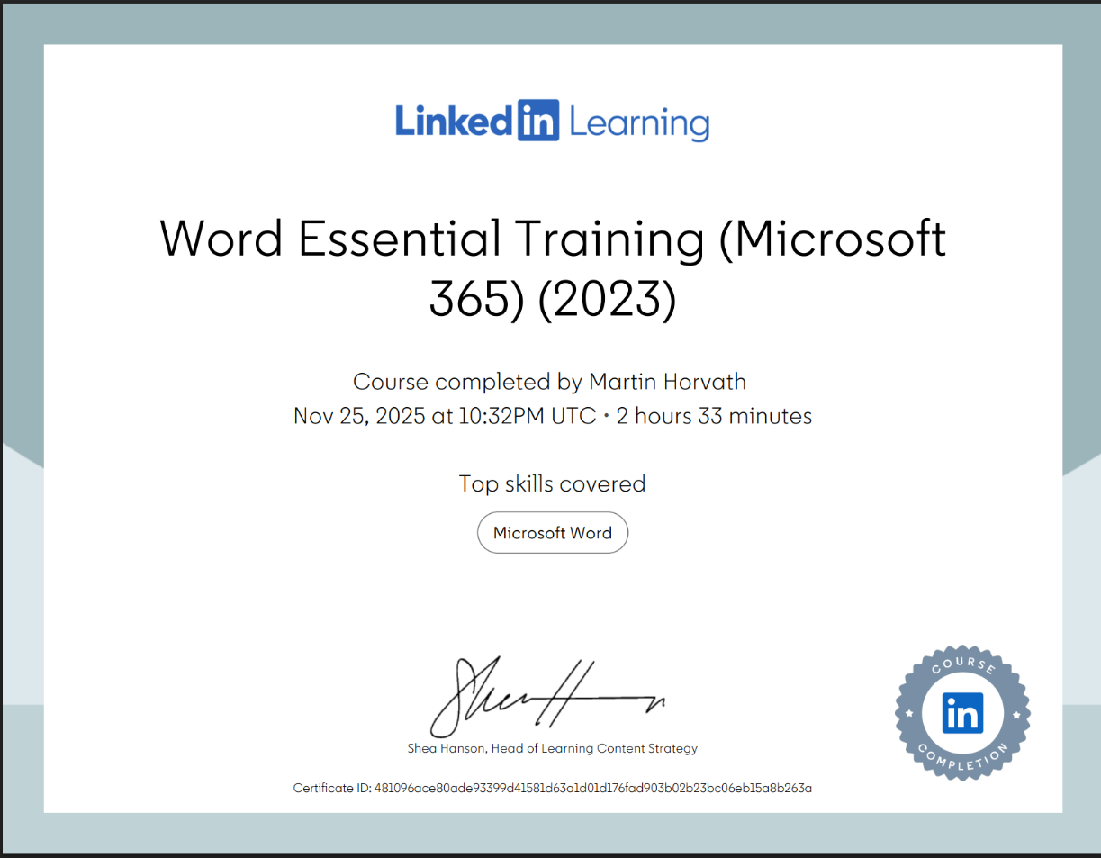
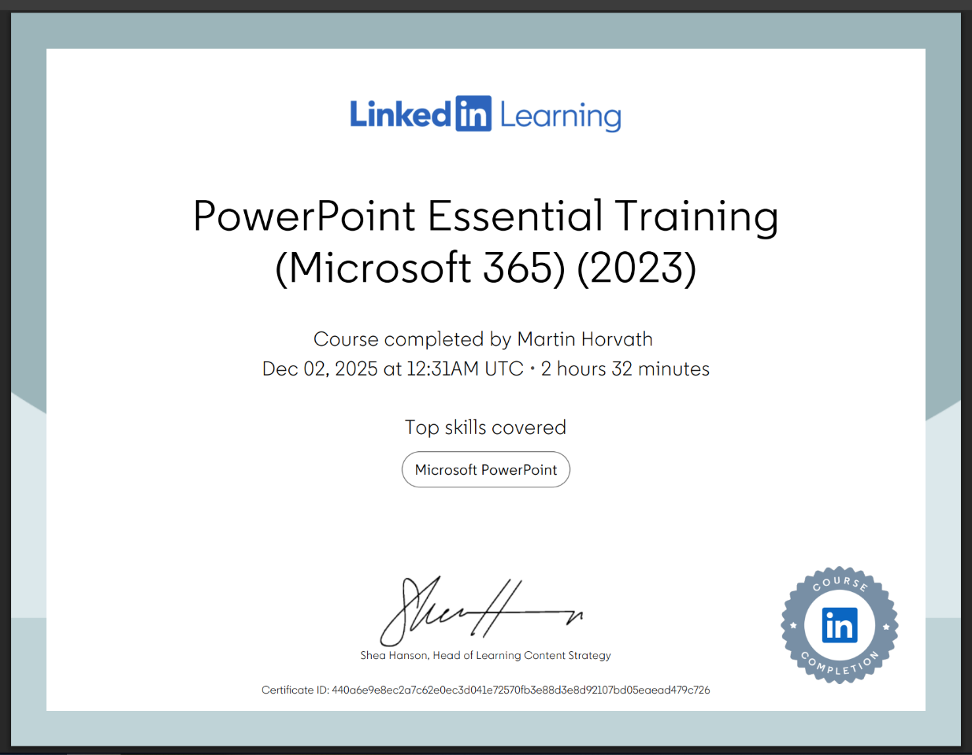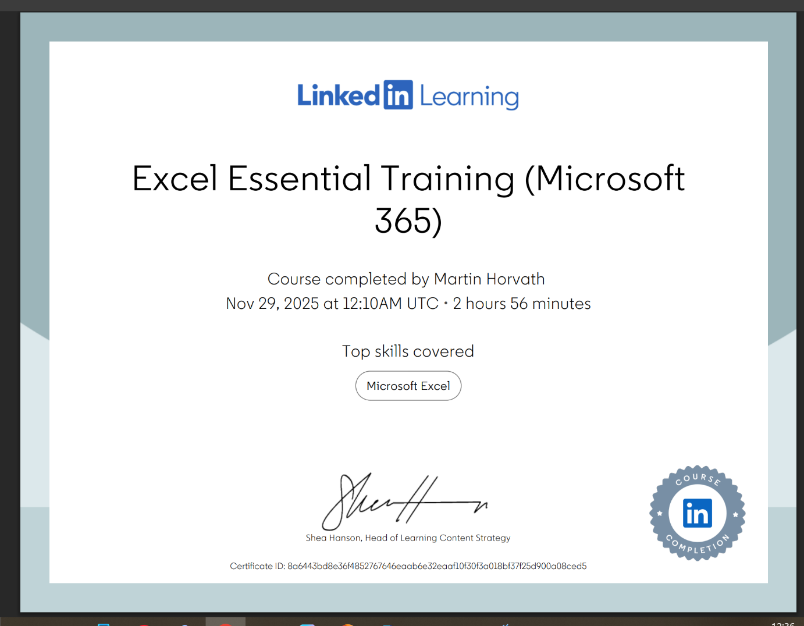

Task 3

Essay on Relevance of Excel in professional and personal life.
Microsoft excel is one of the most used tools in businesses, education, and everyday life. For a beginner like me, learning to use excel wasn’t just about typing numbers into columns. It was about understanding how data can be analysed this helps people understand and make better decisions. Excel is important because it helps us analyse data, budgeting, reporting, and decision making. Making it a skill that students, professionals, and families can benefit from. In this essay I will look at the relevance of excel. Show practical examples of how it is used, and household incomes and expenditures. Excel is more than just a spreadsheet. It is a tool to help people manage information. Businesses use excel to track sales, students use excel to organise assignments, and families use excel to mange budgets. According to experts. Excel remains a cornerstone of business management because it allows users to turn data into actionable strategies.
Excel grids layouts make it easy to enter data and formulas and charts allows us to transform numbers into meaningful insights. In today’s world being confident is considered a basic skill, but for these who don’t know much about excel makes it more difficult but it’s easy to learn. One excels most uses is formulas such as SUM, AVERAGE, and IF, people can quickly calculate averages, tables, or conditions. For example, a student could analyse income and expenditure by using formulas, charts, and pivot tables. Businesses use excel to analyse customer behaviour or sell trends. Excel also has tools such as pivot tables. Which allows us to summarise big details even as a beginner, I can use pivot tables to make it easier to find patterns without needing programming.
Budgeting is used the most by families. Families can track incomes and expenditure, making sure they don’t spend more than they earn. For example, if a household income is £4000 per month but they spend £2600, excel can help calculate the remaining balance. Using formulas such as =SUM (b5; b10) for totals incomes and =SUM (d5:510) for total expenditure. Excel makes it correct. Charts can show where most money goes. This makes budgeting accurate but also easy to understand.
Reporting means presenting information clearly and correctly. Excel lets users create charts, pivot tables, and graphs that make data easier to understand. For example, a lecture can report attendance using a bar chart, or a business can show monthly and annual profits using graphs. Charts are useful because they can turn numbers into visuals. Bar charts can compare incomes and spending. This makes reports easier to read.
Decision making often depends on data. Excel helps by keeping information organised so that choices are based on facts. For example, a business might use excel to make a decision whether to launch a project by analysing cost and expenditures. A student might use excel to decide how much time to spend on each task. By changing a variable, such as rent, users can instantly see how their budget changes.
To show my excel skills I created a spreadsheet showing the household income and expenditure for a family of four. Formulas I used was =SUM(b5;b10), =b13-d13, and =b12*12. And the charts compare the total income and expenditures. This spreadsheet demonstrates how excel can calculate totals, highlight balances, and present data. Even a beginner like me can use tables and charts even formulas.
As a 20-year-old learning excel skills. I find it challenging and exciting at the same time because even though I may not know all the formulas, yet I am excited to learn even more than what I already know. At first formulas were hard but after practicing I’ve began to understand and I also learned that excel is not just used by students, it’s also used by companies and families.
Microsoft excel is important because it allows us to analyse data, budgeting, reporting, and decision making. It is a tool used by students, businesses, and even families. Also excel allows people to keep things organised. My household income and expenditure spreadsheet shows how beginners like me can calculate totals and track spending.

Embed your excel here

References

GeeksforGeeks (2024) 7 Uses of Excel in Business with Real World Examples. Available at: https://www.geeksforgeeks.org/uses-of-excel-in-business
School of Coding UK (2024) Importance of Microsoft Excel in Business: 10 Reasons. Available at: https://schoolofcoding.co.uk/importance-of-microsoft-excel-in-business/
LinkedIn (2023) The Importance of Data & MS Excel in Modern Business. Available at: https://www.linkedin.com/pulse/importance-data-ms-excel-modern-business/
The Knowledge Academy (2024) Use of Excel in Business Analysis: Explained in Detail. Available at: https://www.theknowledgeacademy.com/blog/use-of-excel-in-business-analysis
DEV Community (2023) How Microsoft Excel Powers Data Science and Analytics. Available at: https://dev.to/tech/how-microsoft-excel-powers-data-science-and-analytics-3g2k
Microsoft Support (2025) Overview of Excel Functions. Available at: https://support.microsoft.com/en-us/excel-functions
Investopedia (2024) How to Use Excel for Budgeting and Financial Planning. Available at: https://www.investopedia.com/excel-budgeting-financial-planning-5188571

Task 4

7 Minute Reflective Presentation
My 7 minute Reflective presentation

References

JISC (2025) Discovery tool: Building Digital Capability. JISC, Available at http://digitalcapability.jisc.ac.uk/our-service/discovery-tool/
Linkedin Learning (2025) Excel Essential Training (office 263/Microsoft 365) Class Central. Available At http://www.classcentral.com/course/linkedin-learning-excel-essential-training-office-365-Microsoft-365-100060/

