Titration report
By Jack Twaddle
Jack Twaddle (2428017)
University of wales trinity saint david
Contents
Titration Report Draft 1 3
Introduction 3
State the purpose of the experiment 3
Write the hypothesis that are going to be tested 3
Define the variables and/or terms and show the equations that will be used in the report 3
Results 3
Present the experimental data in a clear and organized manner 3
Use tables, graphs or figures to illustrate the results effectively 3
Briefly describe the key findings and patterns observed in the data 3
Discussion 4
Interpret the experimental results and explain their significance 4
Describe the relevance of the experiment to OME and relate the findings to the existing scientific knowledge and literature (OME Specifically) 5
Adress any limitations or potential sources of error in the experiment 5
Conclusion 5
Summarise the main findings and evaluate whether they support the hypothesis or not 5
Suggest potential directions for future research based on the findings 5
References 6
Appendix 6
Materials and methods 6
Screenshot of data sheet 8
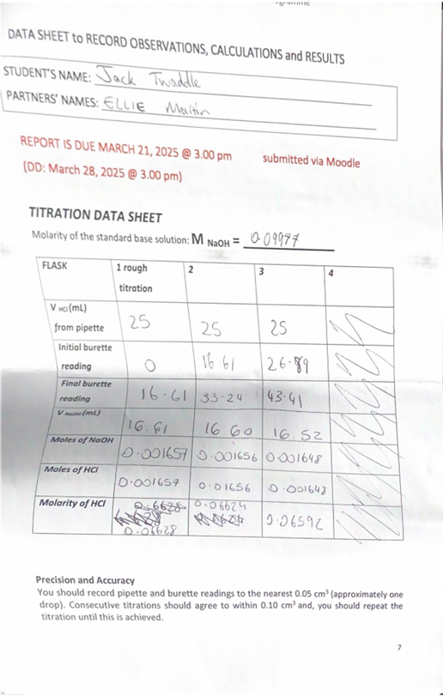 8

Titration Report Draft 1

Introduction

State the purpose of the experiment
The aim of the experiment is to determine the concentration of an undetermined sample of hydrochloric acid (HCl) by using a standard solution of sodium hydroxide (NaOH) using titration.

Write the hypothesis that are going to be tested
If a known concentration of acid is titrated with a base of unknown concentration, then the volume of the titrant required to reach the equivalence point can be used to determine the concentration of the unknown solution using the formula;
MAVA = MBVB

Define the variables and/or terms and show the equations that will be used in the report

For the independent variable, this would be the volume of the titrant added as it is measured and controlled during the experiment.
The dependant variable is the volume of the titrant that is needed to be able to reach the end point as that will determine when neutralisation happens.
And for the controlled variable, which would be the volume of the concentration that is in the conical flask.

Results
FLASK | 1 rough titration | 2 | 3 | 4
V _{HCl} (mL)  from pipette | 25 | 25 | 25
Initial burette reading | 0 | 16.61 | 26.89
Final burette reading | 16.61 | 32.34 | 43.41
V _{NaOH} (mL) | 16.61 | 16.60 | 16.52
Moles of NaOH | 0.001657 | 0.001656 | 0.001648
Moles of HCl | 0.001657 | 0.001656 | 0.001648
Molarity of HCl | 0.06628 | 0.06624 | 0.06529

Briefly describe the key findings and patterns observed in the data
As the moles of HCl were very similar to the moles of NaOH this shows that the equivalence point was reached when base (HCl) and acid (NaOH) were equal. Also, the experiment was performed well since by looking at the results of V NaOH (16.61mL, 16.60mL and 16.52mL) they are almost identical which means the results are reliable.

Discussion

Interpret the experimental results and explain their significance
To make sure the experiment was consistent 3 titrations were performed to make sure results were accurate and reliable.
The patterns observed from the data show consistency as the results from each of the 3 tests are very similar. This consistency shows reliability of the results and shows the test was carried out correctly.
The key findings found during the experiment were determining the endpoint. As the solution changed colour to a bright pink colour it was known that the reaction was complete and the endpoint was found. The volume of the titrant that was added to the HCl solution was recorded after as the final burette reading.
As the volume of NaOH used in each of the titrations were very similar this shows that the experiment was performed well and consistently. After finding the volume of NaOH, this meant moles of NaOH were able to be calculated using the molarity of the standard base solution (0.09977) multiplied by the V NaOH (L). Once calculating the moles of NaOH, the moles of HCl was identified and due to the results being the same this makes it clear that the titration was accurate and the equivalence point was found. This is known because once the equivalence point is reached the moles of HCl equals the number of moles of NaOH (moles H⁺ = moles OH⁻). Since the acid has positive ions and the base has negative ions, at the equivalence point both the positive and negative ions are equal.
By using the equation MAVA = MBVB and rearranging it to MA = MBVB / VA , the unknown concentration of HCl can be determined. MA stands for the molarity of the HCl. VA is the volume of HCl that is used, MB is the molarity of NaOH and VB is the volume of NaOH that was used. The units for the calculation are mol/L for concentration and litres for volume. After each test a calculation was made.
MAVA = MBVB
MA = MBVB / VA
MA = 0.0997 x 16.61 / 25
MA = 0.06628 mol/L

Describe the relevance of the experiment to OME and relate the findings to the existing scientific knowledge and literature (OME Specifically)
[2] Acid-base titration can be used in OME to find out the concentration of the components found in an explosive by reacting them with a solution where the concentration is known. By doing this, acidic impurities can be estimated and component interferences can be checked.

Adress any limitations or potential sources of error in the experiment
Human error can be introduced during this experiment, one reason for this could be not reading the burette correctly; by not reading the meniscus at eye level could lead to accidental errors. Another reason for human error is adding uneven drops from the burette to the HCl solution, this can cause errors as it makes it more difficult to find the endpoint and neutralise the solution.
A second source of error could be related to equipment. If the burette tap was faulty and the NaOH solution leaked into the HCl solution when not anticipated, this could lead to errors in results and cause the solution to go past its endpoint.

Conclusion

Summarise the main findings and evaluate whether they support the hypothesis or not
In conclusion the experiment was successful as the concentration of the unknown solution of hydrochloric acid (HCl) was calculated by using a standard solution of sodium hydroxide (NaOH) using titration.

Suggest potential directions for future research based on the findings
[1]A potential direction for further research for a future titration experiment would be instead of using phenolphthalein to determine the equivalence point of the reaction a universal indicator would be much more beneficial. When using phenolphthalein once the end point has been reached the colour of the solution will change very quickly to a bright pink colour. Whereas if a universal indicator was used a colour would be present at all times and would slowly change from red to green as the pH gets closer to neutral which would make it a lot easier to tell when the equivalence point is about to be reached and has been reached, this would then also make results more accurate and consistent.

References

[1] | P. R. B. S. D. D. R. D. B. P. e. a. Nag M, “Pharmacognosy Reviews,” A Review on Application of Natural Indicators in Acid-base Titration, vol. 17, no. 34, p. 12, 2023. Accessed (Online) 25/03/2025 PharmacognRev-17-34-308.pdf
[2] | S. S. G. K. J. S. A. M. R. P. A.K. Nandi, “Central European Journal of Energetic Materials,” Assay of the Insensitive High Explosive 3-Nitro-1,2,4- triazol-5-one (NTO) by Acid-Base Titration, vol. 10, no. 1, p. 10, 2013. Accessed (Online) 25/03/2025 Assay of the Insensitive High Explosive 3-Nitro-1,2,4-triazol-5-one (NTO) by Acid-Base Titration - Central European Journal of Energetic Materials - Tom Vol. 10, no. 1 (2013) - BazTech - Yadda

Appendix

Materials and methods

List all materials and equipment

- Safety Goggles
- Lab Coat
- Gloves
- 100mL of standard NaOH solution
- 100mL of HCl solution
- Phenolphthalein indicator
- 1x Burette, 50mL attached to a burette with clamp
- 1x pipette with pipette filter (10mL OR 5Ml)
- 3x Erlenmeyer flasks (100mL)
- 1x small funnel to fill the burette
- 1x plastic pipette
- 1x wash bottle with deionised water
- 1x graduated cylinder (100mL)
- 1x white tile or white paper to go under titration flask
- 1x beaker for the waste

Describe the experimental procedure in a detailed and stepwise manner

Step 1 – Wash
- Pipette with deionised water from the wash bottle followed by a small volume of HCl; discard the washings.
- Burette with deionised water from the wash bottle followed by a small amount of NaOH; use the funnel to pour a few mL of NaOH.
- Erlenmeyer (conical flask) with a small amount of deionise water.
Step 2 – Using a small funnel, fill the burette with standard NaOH solution running some of the solution through the tap, until the bottom of meniscus is just on the zero level. Ensure that there is no air bubbles trapped.
Step 3 – Using the pipette filler place 25mL of HCl solution in the three clean conical flasks.
Step 4 – Add 3-4 drops of phenolphthalein indicator to each flask with acid and swirl gently, then add approximately 10mL of deionised water using a graduated cylinder.
Step 5 – Using the tap of the burette run the NaOH solution in the first conical flask, mixing thoroughly, until the solution changes to the colour pink. This step is called rough titration and should allow you to estimate the volume of NaOH needed to neutralize the measured volume of HCl.
Step 6 – Repeat steps 5 for the next sample of HCl.
Step 7 – This time run the NaOH into the acid/indicator/water mix until the volume of NaOH is within 2mL of what it was in the rough titration.
At this point run the base at a slower rate (dripping it slowly and shaking the solution in the flask) so you can read the volume of HCl required to neutralize the solution to one drop (0.05mL). Take an accurate reading within 0.05mL and take the reading at the first colour change in the solution.

Step 8 – Repeat steps 6 and 7 until satisfactory results are obtained.
Two volumes of NaOH differ by no more than 0.10mL for the same volumes of HCl.

Screenshot of data sheet

