Student name
Student ID
Introduction to Web and Database Concepts

Contents
Introduction 2
2.1 Entities and Relationships 2
2.2 Entity Relationship Diagram: (High Distinction Version); 4
2.3 Database Design 5
2.4 Normalisation 7
2.5 Sample Data 8
2.6 Query Development 9
2.7 Forms 13
2.8 Reports 16
2.9 Validation and Testing 18
3 Reflection and Discussion 19
4 Conclusion 20
References 20

Introduction
This project aims to create and develop a complete functioning relational database management system on the MediLink Pharmacy with the use of Microsoft access. MediLink Pharmacy is an expanding community-based pharmacy network that at present uses manual means in handling its business process; stock control, prescription filling, customer records, and sales process. Such manual system has caused inefficiencies, inconsistencies in the data and a greater possibility of human error.
This project seeks to provide a simple solution to such challenges based on the use of structured database that will help in automating the data storage, reporting and retrieval processes. The system is created to handle the most critical information in operations i.e. medicines, suppliers, customers, prescriptions and sales. With the use of relational database model, the system will guarantee data integrity, minimize redundancy, and facilitate effective management of data.

2.1 Entities and Relationships
The MediLink Pharmacy database is designed by using the identification of the main entities that are taken out of the system requirements. All entities are real-life objects or concepts applicable to the operations of the pharmacy and defined under relevant attributes and relationships so that the data may be properly organised and with integrity.
Core Entities:
Customers
The Customers entity is used to store personal and contact data of individuals that buy medicines or get a prescription. Attributes are CustomerID (Primary key), FirstName, lastname, phone, address and date of birth. This is necessary to trace the activities of the customers and to associate transactions.
Medicines
The Medicines table includes information regarding the pharmaceutical products it contains the primary key that is the MedicineID, the MedicineName, the Category, the UnitPrice, the StockQty and its ExpiryDate. This party helps in inventory and it allows one to keep track of the stock levels and expiry dates.
Suppliers
Suppliers entity, holds the data related to the medicine suppliers such as SupplierID (Primary key), SupplierName, ContactName, Phone, as well as Email. This makes it possible to have medicine and its supplier linked to make procurement and supply chain management.
Sales
Individual transactions are registered by Sales entity. It has SaleID (Primary key), CustomerID (Foreign key), SaleDate and the total amount. This organization facilitates monitoring customer purchases and business in general.
SaleDetails
SaleDetails entity is a table of items included in every sale as individual medicines are associated with a transaction. It contains SaleDetailID (Primary key), SalesID ( Foreign key), MedicineID ( Foreign key), Quantity and LineTotal. This solves the many-to-many relationship between Sales and Medicines through the introduction of a junction table.
Prescriptions
Prescriptions entity contains the information about the prescriptions given to the customers in form of PrescriptionID (primary key), CustomerID (foreign key), DoctorName, and PrescriptionDate. This helps in the complies of the regulations and also offers traceability of prescribed medicines.
Statements Among Entities:
The database introduces a number of one to many (1:N) relationships:
- Every Customer can be associated to several Sales, though each of the Sales is linked to one Customer.
- A Prescription may be a part of several Customer but every Prescription is the part of a Customer.
- There is no limit on the number of SaleDetails present in a Sale but each Sale contains one SaleDetail.
- A Medicine may be a part of several SaleDetails, though a SaleDetail may refer to only one Medicine.
- Supplier may sell many Medicines, which creates a one-to-many relationship.
It is especially worth making use of the entity of SaleDetails, as it addresses issues with the many-to-many relationship between Sales and Medicines breaking it down into two one-to-many relationships. This design will guarantee the adherence to the principle of relational database and the ability to scale.

2.2 Entity Relationship Diagram: (High Distinction Version);
Entity Relationship Diagram (ERD) gives a graphical view of the database design which shows the entities, attributes, the primary key of the entities and the relationship among these entities.
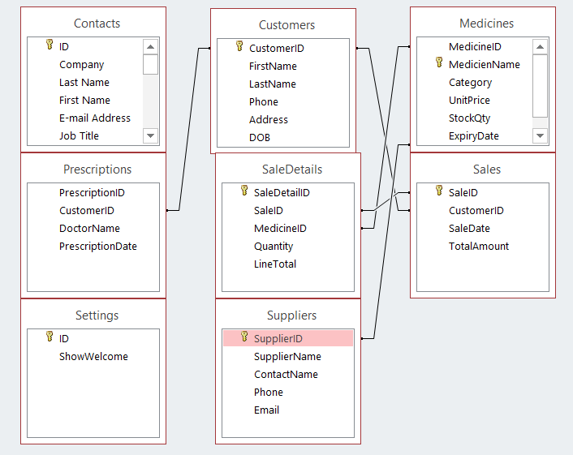Figure 1: Given below is the entity relationship diagram of MediLink Pharmacy Database.
All the key entities are also highlighted in the ERD such as Customers, Medicines, Suppliers, Sales, SaleDetails, Prescriptions with their respective primary keys. All entities are connected by clear relationships on the basis of foreign keys to grant referential integrity in the whole database.
For example:
CustomerID attribute is a foreign key in Sales table and the Prescriptions table where customer information is connected to a transaction and prescription.
SaleDetails table included the SaleID which associates every item with a particular sale.
The saleDetail MedicineID creates a correlation between sales and the medicines.
The SupplierID connects the Medicines with the Suppliers, which allows one to track the source of products.
The cardinality is also correct as illustrated in the diagram:
The reason why one-to-many relationship is used is to be realistic to the real world situation, like having a customer who makes repeated purchases.
Many-to many relationships Sales to Medicines This relationship is well addressed by the SaleDetails entity.
Also, the ERD displays the structured and normalised design as every entity has only pertinent attributes and dependencies are appropriately handled. This is so that the database remains in the Third Normal Form (3NF) so as to minimize redundancy and enhance data consistency.

2.3 Database Design
Apply your relationships/tables relationship in your preferred manner to display graphically as Figure 2 (this is done by inserting your tables/relationships screen shot here, in lieu of Figure 2).
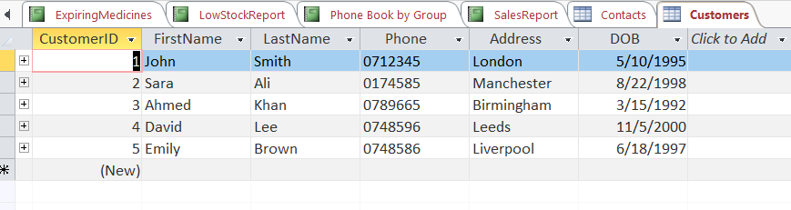
Figure 2: Database Tables and Relationships in Microsoft access.
All the tables were structured to have a primary key, which uniquely identified records. For example:
- CustomerID is a primary key in Customers table.
- Table form of Meditech utilizes MedicineID.
- Sales table uses SaleID
They used the foreign keys as a way of creating some kind of relationship between tables. For instance:
- The Sales table contains CustomerID that is used to identify the customer with a particular transaction.
- SaleDetails table includes pharmaceuticals that are linked to medicine using the MedicineID.
- The Medicines table contains SupplierID that connects medicines with suppliers.
One of the main design choices is the addition of SaleDetails table as it enables associating many medicines with one sale. This eliminates the redundancy of data and it provides some flexibility in dealing with complicated transactions.
- Each field was assigned an appropriate type of data:
- Name and address text fields.
- IDs and quantities are represented by the use of number fields.
- Price and total currency fields.
- Sales date/expiry date fields Date/time fields Fields dealing with sales dates and expiry dates.
Moreover, the primary key implementation and relational connection provide the assurance that:
- One cannot enter invalid data.
- Tables in records are consistent.
- The integrity of reference is ensured.
In general, the database design shows a properly designed relational model that can facilitate effective data storage, retrieval, and management.

2.4 Normalisation
To remove redundancy and remove uncertainties about the information, the database was normalised to the Third Normal Form (3NF).
First Normal Form (1NF)
Every table in the scheme is 1NF by ensuring:
- In any field, there are indivisible values.
- There are no repeated groups or multi values.
As an illustration, the customer data including name and phone number are not in form of a single value but separate fields are handled individually.
Second Normal Form (2NF)
- The database satisfies 2NF by making sure that:
- The primary key is entirely dependent on all the other non-key attributes.
For instance:
- Attributes like SaleID in Sales table like SalesDate and Totalamount are fully dependent on SaleID.
- The relationship between SaleID and MedicineID in SaleDetails table is composite, and therefore, Quantity and LineTotal is dependent on it.
Third Normal Form (3NF)
The database meets the requirements of 3NF by observing:
- None of the dependencies are transitive.
- The non key attributes are reliant on the primary key.
For example:
- Supplier information is stored in a Suppliers table instead of being duplicated in the Medicines table.
- No duplicate of information about the customers are present in Sales or Prescriptions tables, but rather connected with the aid of foreign keys.
This normalised structure:
- Reduces data redundancy
- Prevents update anomalies
- Enhances scalability as well as consistency.
3NF also provides efficiency to the database, logical structure, and approach to real-life applications.

2.5 Sample Data
This was filled with sample realistic data in order to emulate the activities of a pharmacy system.
(Please include your sample data screenshots in Figure 3)
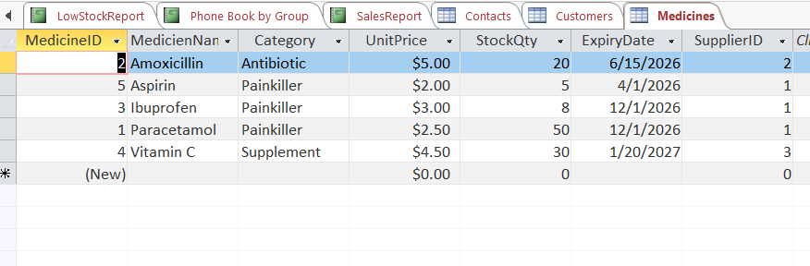
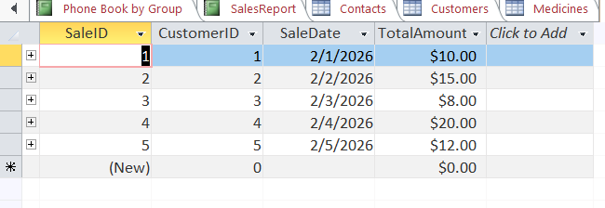
Figure 3: A Sample Data of medicines and sales.
The dataset includes:
- John Smith, Sara Ali, and Ahmed Khan are some of the customers.
- Medications such as Paracetamol, Ibuprofen, Aspirin, amoxicillin and Vitamin C.
- The recorded sales were done in a number of dates.
- Records that are attached to individual customers and physicians.
The number of records in each table is not less than five which will provide enough data to be tested in queries and reports.
- The sample data was drafted to be as realistic as possible, and included cases as:
- Inventory queries to be tested on medicines that have different amounts of stock.
- Drugs bearing expiry dates to work on expiry monitoring.
- Several sales Representations to test report capability.
This is a real data population that can be effectively used in testing the functionality of systems and illustrates how the database can be used in practical pharmacy activities.

2.6 Query Development
Various queries were constructed to show how the database could be functional and help in making decision as an operational and managerial tool.
Customers Prescriptions Query.
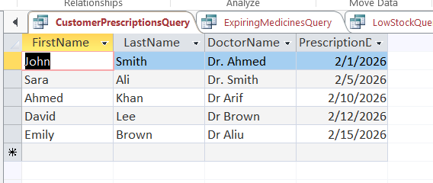
This query gives the customer information as well as the prescriptions such as the name of the doctor and the date of prescription. It enables the pharmacy to monitor prescription of the patients, and it also provides proper management of medical records.
Expiring Medicines Query
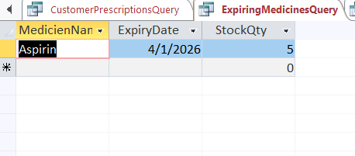
The IT manager presenting the proposal should also include screenshots of the proposal.
This query establishes drugs whose expiry dates are near. It will especially come in handy when used in situations like:
- Removing the sale of an out of date drug.
- Managing stock rotation
- Maintaining control of regulations.

Low Stock Query
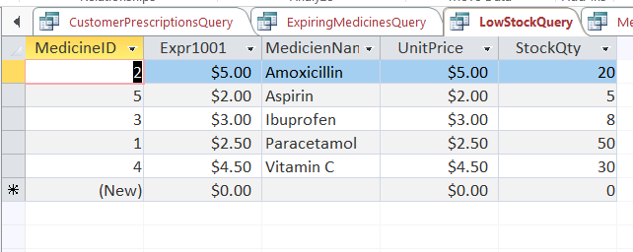This query shows those medicines that have low stocks. It assists in the management of inventory by:
- Pointing out the items required to be restocked.
- Preventing stock shortages
- Unloading supply chain efficiency.
Medicines by Supplier Query
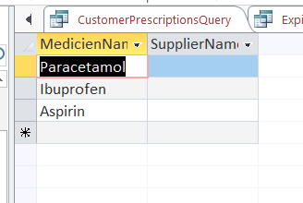
This query will connect the medication with the suppliers of the medication such that the pharmacy can:
- Get suppliers of the products.
- Control relations with suppliers.
- Automate the procurement processes.
Sales by Date Query
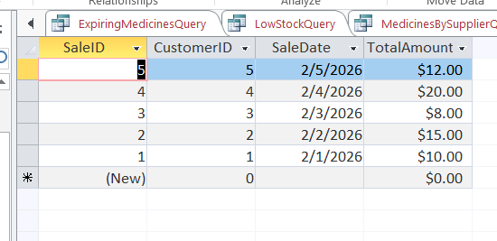
This query will bring out sales transactions that are sorted by date such as total. It helps:
- Observe sales performance on a daily basis.
- Analyse business trends
- Fiscal reporting assistance.
Evaluation of Queries
The questions were to solve major operational requirements of the pharmacy system. Each query demonstrates:
- Efficient utilization of the interconnections among tables.
- Accurate data retrieval
Indeed, applicability to practice.
All these queries combined help the database to be more functional since they help in converting raw information into information that can be used to make decisions.

2.7 Forms
In Microsoft Access, forms were created to offer an easy-to-use interface with which a user can use to interact with the database. The forms enable these users to add and edit data and even see data easily without accessing the data tables directly.
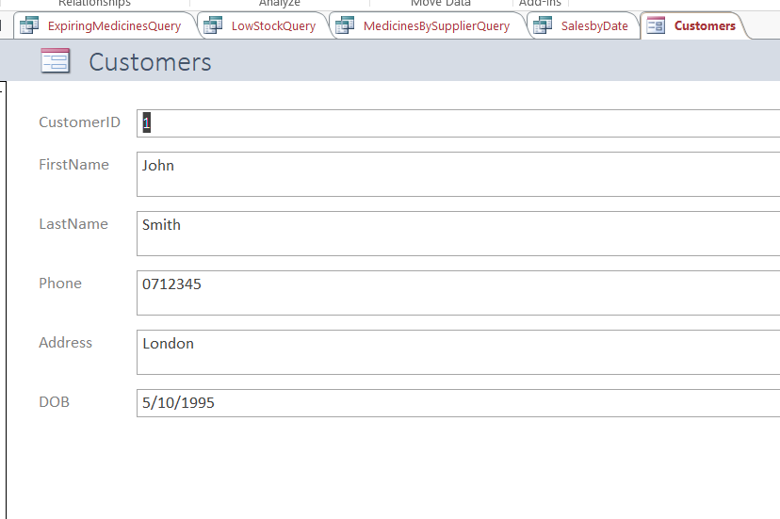
Figure 9: Customer Form
The Customer type enables the responsible party to add and update customer information which consists of name, phone, address, and date of birth. This enhances usability as there is orderly data entry layout.
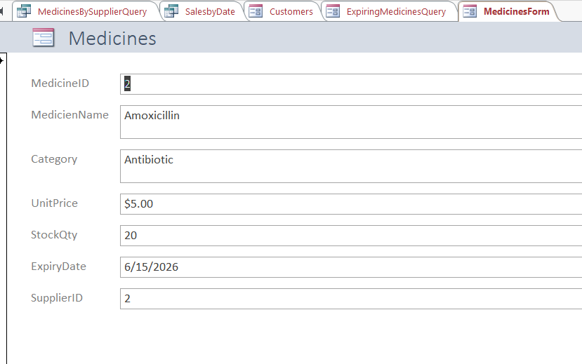
Figure 10: Medicines Form
Product Medicines form provides the latest product promotion data with significant information like medicine name, category, unit price, stock quantity, and expiry date. This facilitates easy tracking of inventory.
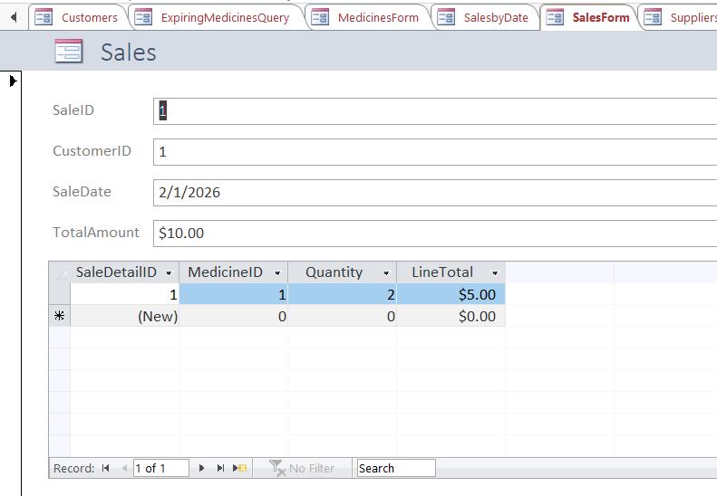
Figure 11: Sales Form
Sales form contains the information based on Sales table and SaleDetails table which means that the user can record the sale and objects related to it in the same interface. This is the utilization of relational data.
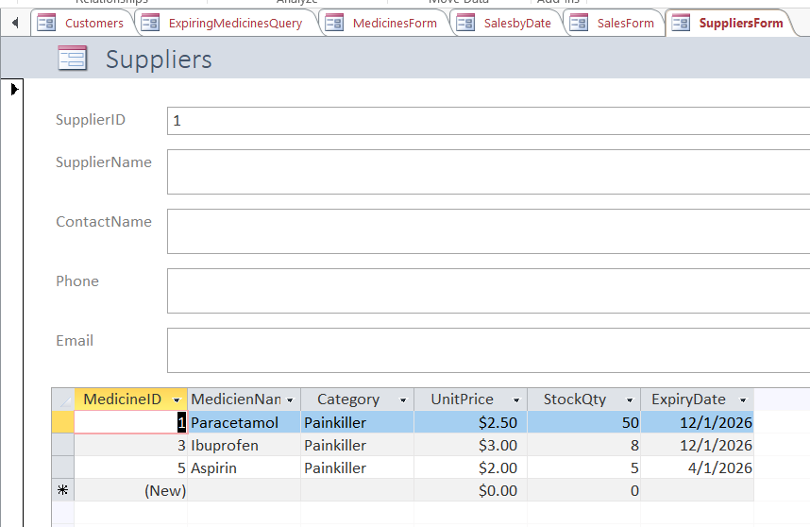
Figure 12: Suppliers Form
The Suppliers form enables management of suppliers information and the medicines associated to them which is useful in the operations of the supply chains.
On the whole, the forms improve the usability of the system as they make the entry of the data easier and minimize the possibility of the error with the entry.

2.8 Reports
Reports were prepared so that the raw data could be converted into meaningful and structured information as used by the management when making decisions.
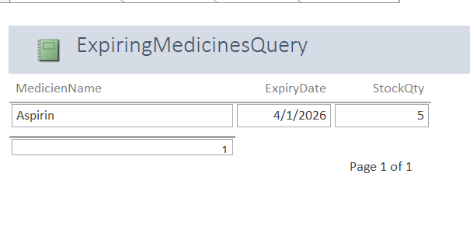Figure 13: Expiring Medicine Report.
This report brings to attention of the staff the medicines that are expired or are going to expire soon where they can take preventive measures like removing or prioritizing the stock.
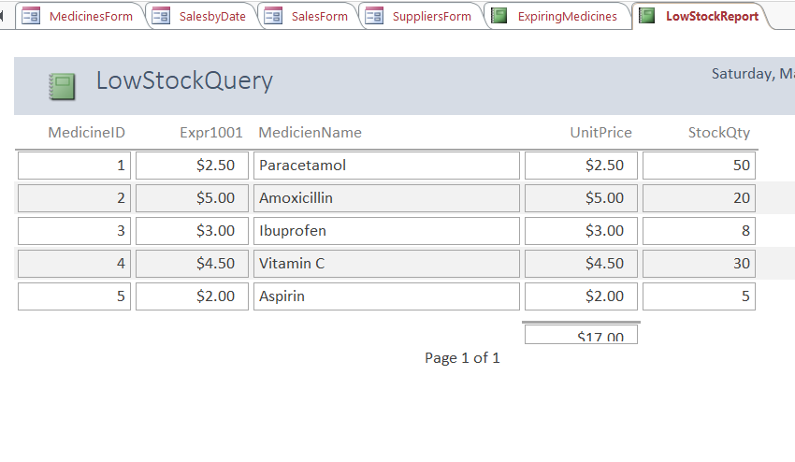
Figure 14: Low Stock Report
The given report shows the current stock levels of the medicines in the industry, which assists the management in spotting those that need restocking.
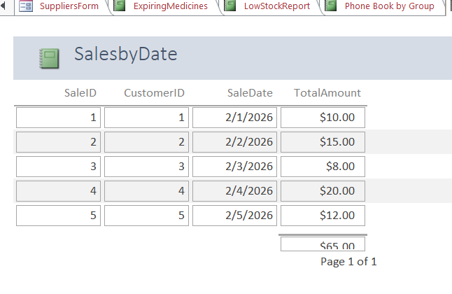
Figure 15: Sales Report
The sales transactions are also included in this report, allowing date and amount. It gives useful information about sales performance and revenues trends.

2.9 Validation and Testing
The validation and testing involves the development and testing of an engine system design as well as testing of available hardware.
The database system was tested so that it becomes functional and with data integrity requirements.
A number of validation checks were carried out:
Referential Integrity
Intertable relationship was done to test it so that foreign key links with related records correctly. As an illustration, there can be no sale without a viable customer.
Data Accuracy
The queries were written and run in order to ensure that appropriate results are being returned e.g. finding expiring medicines and low stock products.
Form Functionality
Forms were also tested in order to make sure that the user can add, edit and see data without mistake.
Report Output
It was done by generating reports to ensure that they show right and relevant information.
The testing procedure established the functionality of the system as required and satisfied the needs of MediLink Pharmacy.

3 Reflection and Discussion
Designing and implementation of the medilink Pharmacy database gave a great experience on designing and implementation of a relational database.
Strengths of the System:
- Optimisation of data organisation based on relational tables.
- Elimination of repetition or normalisation.
- Good application of queries as a way of retrieving information.
- Forms and reports provide user-friendly interface.
Challenges Encountered:
- Creation of the right relationships amongst tables.
- Enabling proper use of foreign keys.
- Formulating queries that will lead to retrieval of the necessary data.
Future Improvements:
- Introduction of auto reminder on shortage of stock and expired medicines.
- Home real-time sales expansion by scanning barcodes.
- Improvement of user interface design to be more usable.
Security functionality added like user authentication.

4 Conclusion
The findings of the paper suggest that emotional intelligence, and stress management do impact job success, work-related stress and professional development. It is possible to note that the MediLink Pharmacy was successfully designed and implemented as a comprehensive relational database system with the help of Microsoft Access. The limitations of the manual data management are effectively solved as the system offers a structured and efficient yet reliable system.

References
Connolly, T. and Begg, C. (2015) Database systems: a practical approach to design, implementation, and management. 6th edn. Harlow: Pearson.
Coronel, C. and Morris, S. (2019) Database systems: design, implementation, & management. 13th edn. Boston: Cengage Learning.
Microsoft (2024) Microsoft Access documentation. Available at: https://support.microsoft.com (Accessed: 20 March 2026).
Elmasri, R. and Navathe, S. (2016) Fundamentals of database systems. 7th edn. Boston: Pearson.
W3Schools (2024) SQL tutorial. Available at: https://www.w3schools.com/sql/ (Accessed: 20 March 2026).

