

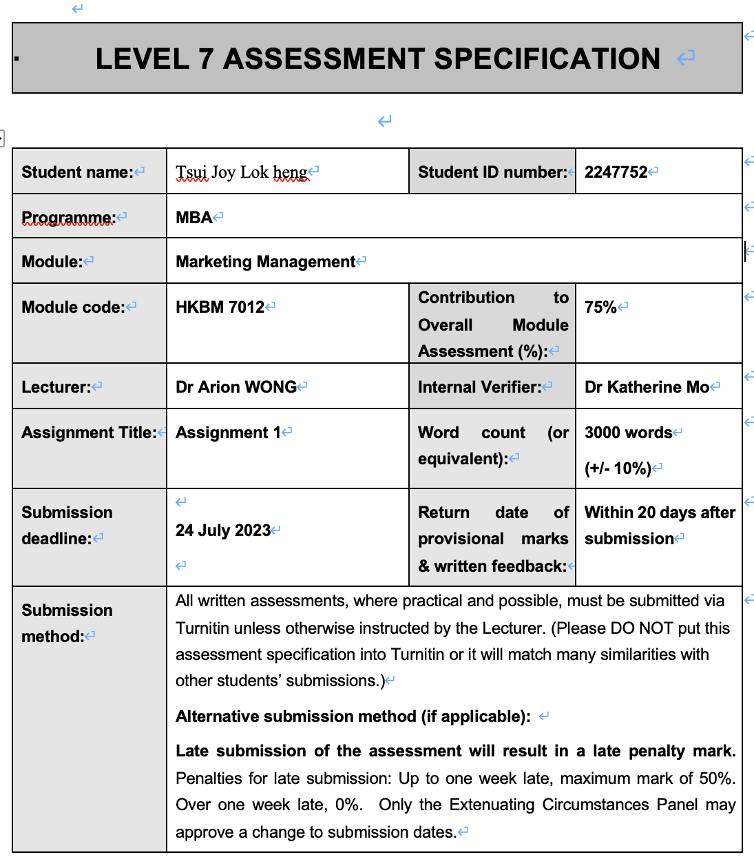
Academic honesty / referencing: | Academic honesty is required. In the main body of your submission you must give credit to authors on whose research and ideas your work is based. Append to your submission a reference list that indicates the books, articles, etc. that you have used, cited or quoted in order to complete this assessment.

- Introduction
Founded in 1996, Pricerite Group offers a wide range of home furnishing and lifestyle products (Celestial Asia Secerities Holdings Ltd, 2022). It comprises of multiple brands, including Pricerite, TMF, Pricerite Food, Pricerite Pet etc. Pricerite mainly sells household items, electrical appliances and furniture. The major competitors of Pricerite include IKEA and JHC, both of which sell household items, electrical appliances and furniture. IKEA and JHC are regarded as Pricerite’s competitors because all of them belong to group companies and have multiple branches.

  - Macro Environment Analysis
Macro environment composes of economic, political, social-cultural and technological environment (Kotler and Keller 2009). PEST analysis is a situational analysis tool to evaluate external business environment such that companies can better understand the industry’s attractiveness and market potential (Perera, 2017).

2.11 Political
Municipal Solid Waste (MSW) charging will be implemented in 1 April 2024. Furniture that cannot be wrapped into designated bags have to be attached with designated label that costs $11 each.

2.12 Economic
Due to surging interest rate and weakened market confidence, the trading volume of residential and non-residential building units has dropped to 59,619 in 2022, which is the lowest since 2016 (The land registry, 2023). The reducing volume of properties thus negatively affect furniture sales.

Figure 1 (By author, resources from The Land Registry)
2.13 Social
Hong Kong has the reputation of having some of the smallest apartments, with the median per capita living area being about 16m², way behind the 30-35 m² in some advanced Asian cities, such as Seoul, Singapore and Taipai (Legislative Council, 2022). The small flats of Hong Kong make multifunctional and space-saving furniture in increasing demand. Also, there is a surging interest in healthy and comfortable residence due to the significant change in lifestyle by the pandemic (Zarrabi et al., 2021).

2.14 Technological
Traditional online shopping limits products presentation, product trial and consumers’ try-on experience (Riar et al., 2023). The development of immersive technologies can reduce the negative impacts of the above problems. Pricerite launched an app called “Pricerite Space App” that incorporates Augmented Reality, Virtual Reality and Mixed Reality technologies to showcase furniture in a 1 to 1 ratio against the real environment. It allows customers to visualize the furniture and their features (size, color, shape etc.) in the intended environment, reducing mental intangibility (Heller et al., 2019), enhancing product information, providing personalized experience, increasing the usefulness perception of products (Kowalczuk et al., 2021) and reducing customers’ uncertainties of products (Adam and Pecorelli, 2018). All the above can positively influence customer’s decision in purchasing.

  - Micro Environment Analysis
Micro environment consists of elements that are directly linked to the companies and will affect its performance (Maqin and Hendri, 2017). Porter’s Value Chain is used here to analyze Pricerite’s microenvironment. The value chain consists of multiple of primary and secondary activities that create value for customers (Koc et al., 2017).

2.21 Inbound logistics
Although majority of Pricerite’s products are low-end products, it also offers certain premium quality products. An example is the Italian mattress LUSSO that utilizes cutting-edge technology to offer an almost massage-like feeling.

2.22 Outbound logistics
Pricerite is the first home furnishing company in Hong Kong to implement omni-channel (Pricerite, 2018). Omni-channel aims to coordinate processes and technologies across supply and sales channel, and to provide consumers a comprehensive view of all sales channels such that they can easily switch from one channel to another throughout their shopping experience (Saghiri, 2017). Pricerite provides product information including instant stock levels not only in physical stores, but also on its App and website. No matter which channels to purchase, customers can choose delivery or pickup at specified stores.

2.23 Operation
The product kiosks in its physical stores offer detailed product information, instant stock levels and their display locations. All products also have QR codes in their product tags to access product information and link to its e-shop. Pricerite’s e-commerce platform operates on Magento, which allows efficient performance and capacity for high-volume online transactions. Pricerite also enables self-checkout in its physical stores.

2.24 Marketing and Sales
Pricerite frequently offers temporary loyalty programmes (Bombaij, 2022) in which customers can save stamps and purchase products at a discounted price. It also offers point-based loyalty programmes (Berman, 2006) that members can earn one “P coin” for every dollar of furniture purchase and two “P coin” for every dollar of household purchase. The amount of P coin classifies members into three statuses, Silver, Gold and Diamond and they can receive different discounts. It also invites famous Hong Kong KOL, Master Seven to promote its storage furniture on its Facebook and Instagram through a rap in September 2021.

2.25 Services
Paid assemble services is provided for small office furniture and some large furniture. However, no wall mounting installation service is provided. Free delivery service is provided for purchasing $5000 or above in furniture and mattress, except to outlying islands and restricted area. For $5000 below purchase, $200 delivery service is charged. Pricerite also partnered with Zeek, a logistics platform that allow delivery to home to be as fast as 4 hours for specified products (Celestial Asia Secerities Holdings Ltd, 2021). 180 days free mattress service trial is provided for most mattress products that allow customers to switch to other types of mattresses of the same brand and size within 180 days.

2.26 Procurement
Pricerite Group has 379 suppliers in 2022. Pricerite conducts assessment for approving or disapproving suppliers. Before procurement decisions, Pricerite will evaluate each supplier to ensure that they comply with their targeted environmental, societal and ethical criteria. Pricerite also puts efforts to source environmental-friendly and healthy products to meet the needs of health-conscious customers nowadays, such as introducing E0-grade plywood, the highest standard of plywood with the least formaldehyde emission (Celestial Asia Secerities Holdings Ltd, 2020).

2.27 Technological Development
Pricerite introduced Pepper, a robotic ambassador at its flagship stores. Pepper can interact with customers by waving hello, shaking hands, taking photos and dancing. Moreover, it shares membership updates such as sales promotion. Pricerite introduced the payment method of cryptocurrency at offline stores in 2022. Upon registering TALK+ wallet, saving $200 in it and inviting a person to open TALK+ wallet, customers can enjoy a rebate of approximately $78 tether.

2.28 Human Resources Management
Pricerite set up “Best Staff” and “Best Manager” award schemes annually to recognize top-performing staffs. Some of them are able to represent the company to participate in competitions e.g. Service Talent Award by HKRMA (Pricerite, 2023). Moreover, it established Pricerite Professional Training Institute in 2007, which is dedicated to train staff and develop their retail professionalism. All new staffs are trained to learn about the company’s history, culture, quality management measures and rules and regulations (Celestial Asia Secerities Holdings Ltd, 2021). Pricerite also offers retail manager certificate course to train potential staffs to become managers. The company cares about its employee’s retirement needs and provides extra retirement benefits to them, which leads to them being awarded the “Good MPF Employer Award” organized by the Mandatory Provident Fund Schemes Authority (Celestial Asia Secerities Holdings Ltd, 2022).

3.0 Segmentation and Target:

Mass marketing is adopted for Pricerite.

The table below shows the comparison of the qualities of Pricerite and its two major competitors, IKEA and JHC. Five factors are included to measure the quality of service, including delivery service, warranty, installation service, variety of products and disposal of furniture.

Table 1. Comparison of quality of Pricerite, IKEA and JHC
 | Pricerite | IKEA | JHC
Delivery service | Home delivery service, pick-up at 17 stores | Home delivery service, pick-up service at stores, self pick-up locker, 7-eleven pick-up service | Home delivery service, pick-up service in over 280 stores
Warranty | 20 years of structural warranty for wooden furniture, factory maintenance for transformer furniture | Offers 10-20 years of warranty for furniture except for kitchen cabinets | None for furniture
Installation service | Available without wall mounting service | Available | Available  (Products do not require wall mounting)
Variety of products | Middle  e.g. 95 for leather and coated fabric sofa varieties | High  e.g. 144 leather and coated fabric sofa varieties | Low  e.g. 49 leather and coated fabric sofa varieties
Disposal of furniture service | Unavailable | Available | Available

Based on the above comparison of qualities, the quality-price relationship positioning map is drawn below.
Positioning Map (Quality Vs Price)
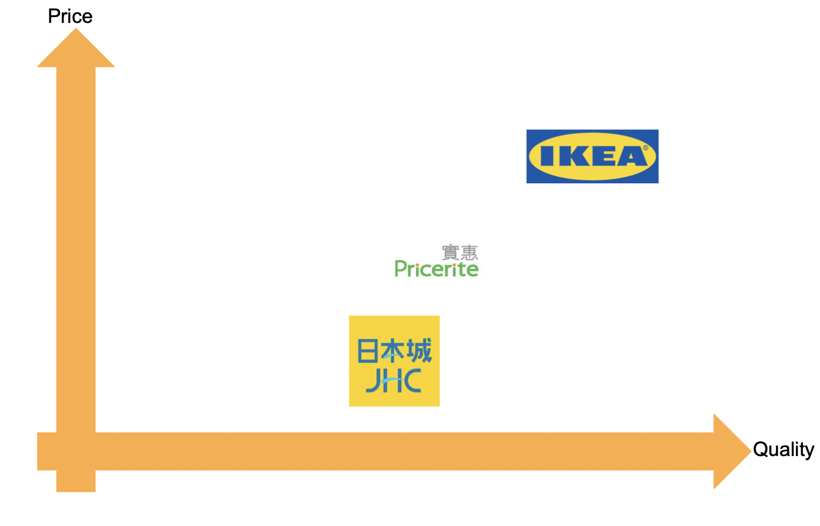

4.0 Marketing mix is different marketing decisions being used by a company to market its goods and services (Singh, 2012).

4.1 Product
To echo with the core values of Pricerite “Limited Space, Unlimited Creativity”, a lot of its products are space-saving and transformable. For example, it launched Space Cube in 2020, which consists of multiple multifunctional modular system that form raised platform to enhance home storage space. The modular system allows various combinations of formation of platform, which can better meet the needs of customers. Pricerite offers 20 years of structural warranty for wooden furniture, 30 days of warranty for specified furniture accessories and factory maintenance for transformer furniture. Pricerite also incorporated technology into its products by launching smart home devices. For example, the ZigBee Wireless Technology allows remote control of lighting, curtains etc. The incorporation of technology can attract younger generations. To cater to the needs of the elderly, the smart home devices can utilize voice control instead of mobile phone control.

4.2 Place
Place refers to how a company distribute its product or service to the end user (Goi, 2011). Currently, Pricerite has 17 physical stores in Hong Kong, including multiple flagship stores. The newest flagship store was opened in 2022 in Mongkok, which features large number of technological products. It also allows customers to experience its Pricerite Space App, further enhancing its online-to-offline business mode. Apart from physical store, it also enables online shopping through its website and App. In 2021, Pricerite partnered with TMALL HK and over 2000 products are available on the online platform. The multiple distribution channels increase the accessibility of its products to customers. Backward integration, a form of vertical integration in which a company expands its roles to fulfill supply activities, is also adopted in Pricerite (Lin et al., 2014). For example, Pricerite launched its house brand SOHO NOVO that offer products of higher quality that pass various quality tests. The adoption of backward integration allows Pricerite to better control its products’ quality (Lin et al., 2014). Currently, Pricerite enables online instant messaging enquiries and telephone enquiries. However, both methods are not efficient. The messaging online enquiry method does not enable direct communication to a person. Rather, it is an online chatbot that provides set answers and not able to answer questions.

4.3 Price
Promotional pricing is adopted frequently that certain types of products enjoy reduced price temporarily. Price lining is also used. For example, when purchasing specified chairs, seating pads will be provided for free. Customers can enjoy discount with specified payment methods, for example when customers purchase up to $100 in offline stores on Thursday in 2023 and pay by Octopus card, they can enjoy 5% off. Installment payment in 6 or 12 months is also available when purchasing $10000 or above furniture. Customers are also able to pay by cryptocurrency. These online payment methods are effective for Generation Y and Z, who always browse the internet and use cutting edge technologies (Williams and Page, 2011).

4.4 Promotion
Pricerite is involved in various public relations activities. For example, it collaborated with Caring for Children Foundation to launch a NFT Charity Sales in 2022, in which local famous artists were invited to create NFT arts. The profits of the sales of NFT will be donated to Caring for Children Foundation to aid children living in sub-divided flats. This act is in line with its principle, care about Hong Kong people, and helps to enhance the image of Pricerite. Also, sales promotion is frequently adopted by Pricerite including limited hour specials, contests and discounts. An example of contest is that contestants need to design and create a creative photo that features specified kitchen utensils. The photos are submitted to Google Form. Three winners will be selected according to their photo’s creativity and win various kitchen utensils. Pricerite also utilizes its social media platforms-Facebook, Instagram and YouTube to market its products regularly. Most of its promotional activities are targeted at young generations (e.g. NFT and creative photo design). To cater to the older generations, TV advertising is recommended. Other than using contest only, sweepstakes can also be used to cater to the mass market. The internet content can also be customized to meet the needs of older generation e.g. by using large fonts and providing more detailed information of products.

5.0 Future Developments in the Area of Marketing
The advancement of big data analytics can improve supply chain resilience, thus reducing the risk of inventory shortage and keeping a low level of inventory to provide financial liquidity (Bahrami and Shokouhyar, 2022). Customers’ data information is crucial in big data analytics. Pricerite can encourage higher usage of e-commerce to gather more statistics on customers’ purchasing behavior to provide better supply chain management. It can also implement strategies to encourage more customers to join the point-based loyalty programme as it allows Pricerite to gain more information about the customers, which can then predict more accurate and detailed analysis.

6.0 Conclusion and recommendation
Mass marketing is adopted for Pricerite but some of the marketing strategies only cater to certain age groups. More differentiated marketing strategies can be adopted in the future. For example, the use of big data analytics can help customize messages and content pushed to customers. More health products can be pushed to Baby Boomers while promotions of cryptocurrency can be pushed to younger generations. Due to the increasing awareness of ESG and MSW charging in 2024, Pricerite can consider launching collecting and recycling used household and furniture service to build its corporate image. The items can either be donated to the public and sold in secondhand market.

References

Bahrami, M. and Shokouhyar, S. (2022) ‘The role of big data analytics capabilities in bolstering supply chain resilience and firm performance: a dynamic capability view’, Information Technology & People, 35(5), pp. 1621-1651.

Berman, B. (2006) ‘Developing an Effective Customer Loyalty Program’, California Management Review, 49(1), pp. 123–148.

Bombaij, N.J., Gelper, S. and Dekimpe, M.G. (2022) ‘Designing successful temporary loyalty programs: An exploratory study on retailer and country differences’, International Journal of Research in Marketing, 39(4), pp. 1275-1295.
Celestial Asia Securities Holdings Limited (2022). Annual report 2022. Available at: https://www.cash.com.hk/en/investors/e_1049%20Annual%20Report%202022.pdf (Accessed :24 July 2023).
Celestial Asia Securities Holdings Limited (2021). Annual report 2021. Available at: https://www.cash.com.hk/en/investors/e_1049%20Annual%20Report%202021.pdf (Accessed :24 July 2023).
Celestial Asia Securities Holdings Limited (2020). Annual report 2020. Available at: https://www.cash.com.hk/en/investors/e_1049%20Annual%20Report%202020.pdf (Accessed :24 July 2023).
Goi, C.L. (2011) ‘Perception of consumer on marketing mix: Male vs. female’, Business and Economics Research, 1, pp. 95-99.

Koc, T. and Bozdag, E. (2017) ‘Measuring the degree of novelty of innovation based on Porter's value chain approach’, European Journal of Operational Research,
257(2), pp. 559-567.
Legislative Council of the Hong Kong Special Administrative Region (2022) Regulation on minimum home size in London. Available at: https://www.legco.gov.hk/research-publications/english/essentials-2022ise09-regulation-on-minimum-home-size-in-london.htm (Accessed: 24 July 2023).
Li, T.T. et al. (2021) ‘ESG: Research progress and future prospects’, Sustainability, 13(21), pp.11663.

Lin, Y.T., Parlaktürk, A.K., and Swaminathan, J.M. (2014) ‘Vertical integration under competition: forward, backward, or no integration?’, Production and Operations Management, 23(1), pp. 19-35.

Maqin, R.A. and Hendri, N. (2017) ‘Comparative Analysis: The Effect of Macro and Micro Environment on Marketing Strategy and Marketing Performance of Small Medium Enterprises (Survey on Group of Small Medium Enterprises of Food and Non-Food Products in Cianjur Regency, West Java, Indonesia’, International Review of Management and Marketing, 7(5), pp. 70.
Parikka-Alhola, K. (2008) ‘Promoting environmentally sound furniture by green public procurement’, Ecological economics, 68(1-2), pp. 472-485.
Perera, R. (2017) The PESTLE analysis. Nerdynaut.
Riar, M. et al. (2023) ‘Using Augmented Reality for Shopping: A Framework for AR Induced Consumer Behavior, Literature review and Future Agenda’, Internet Research, 33(1), pp. 242-279.

Saghiri, S. et al. (2017) ‘Toward a three-dimensional framework for omni-channel’, Journal of Business Research, 77, pp. 53-67.

Singh, M. (2012) ‘Marketing mix of 4P’s for competitive advantage’, IOSR Journal of Business and Management, 3(6), pp. 40-45.

The Land Registry (2023) Statistics of Agreements for Sale and Purchase of Building Units. Available at: https://www.landreg.gov.hk/en/monthly/agreement.htm (Accessed: 24 July 2023).

Williams, K.C. and Page, R.A. (2011) ‘Marketing to the generations’, Journal of behavioral studies in business, 3(1), pp. 37-53.

Zarrabi, M., Yazdanfar, S.A. and Hosseini, S.B. (2021) ‘COVID-19 and healthy home preferences: The case of apartment residents in Tehran’, Journal of Building Engineering, 35, pp. 102021.

