University of Wales Trinity Saint David
School of Engineering

On the Variables Affecting Bake Hardenable Steels
Engineering Applications & Study Skills (M4X02063)

Briony Morgan
1909573
01/11/2019

Abstract
Recently developed advanced high-strength steels with multiphase microstructures show interesting bake-hardening (BH) properties. This research work aims to quantify the effect of BH on dual-phase (DP) and transformation induced plasticity (TRIP) steel. Mechanical properties such as yield and tensile strengths, elongation and BH values in dependency of the BH parameters have been determined and related to specific microstructural features in order to characterize the age and strain hardening behaviour. (U.Prahla, 2014)

Sheets of DP600 and DP800 steels were cut and milled to produce tensile samples. These samples were pre-strained by 2% and then bake hardened in preparation for a full tensile test which determines the materials yield strength. Steels had greater yield strengths after baking for longer, such that bake hardening values ranged between 17.1 kPa to 36.1 kPa with respect to increasing the time exposed to heat. The length of time between the pre-strain process and bake hardening had little effect on the steel, between times of 5 minutes to 2 days. Steels with higher bake hardening values were observed when adjacent in the oven as oppose to being stacked. Modes of failure and sources of error were discussed; due to the nature of the test, the quality of the tensiles themselves will introduce the greatest error affecting gauge values. Alternative procedures complying with industrial standards were suggested, using alternative materials such as carbon fibres could not be undertaken due to limited resources. The test was concluded, ultimately discovering how variable factors will affect the bake hardening process.

Contents
Introduction 2
Literature Review 3
Methodology 4
Experimental Procedure 5
Results and Discussion 6
Error 9
Conclusions 10
Recommendations 11
Works Cited 12
Bibliography 13

Introduction

Bake Hardening
‘Bake Hardening is an advanced processing technique using heat energy to produce low carbon steels with a high yield strength’
Steel is work hardened during pre-straining, as elongation occurs dislocations are introduced into the carbon structure. A standard tensile test involves baking the samples for 20 minutes at 170°, during which time the carbon atoms present in the steel diffuse, fix the dislocations in place and thus preventing them from propagating strain. Evidently increasing the samples’ yield strength.
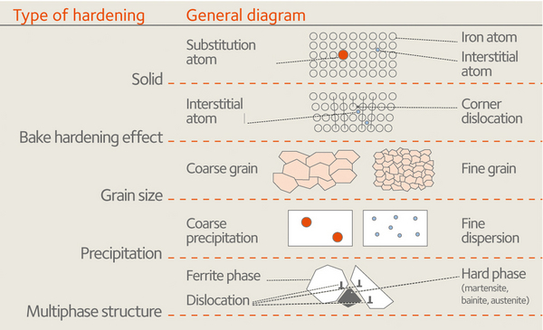
Strength
‘Strength is a measure of how well a material can resist being deformed from its original shape as a result of withstanding a tensile force’’
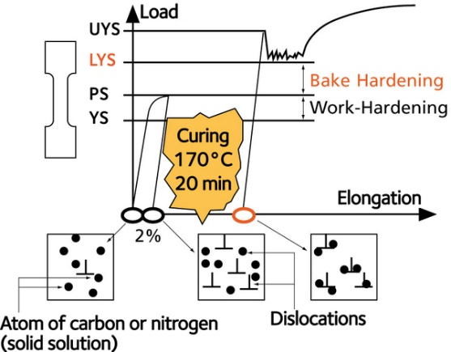

(U.Prahla, 2014)

Strength can be assessed more clearly using a stress against strain graph. Initially the slope is linear due to stress being directly proportional to strain; at this point the material will return to its original structure until its elastic limit is reached. After this the material deforms plastically so that elongation is permanent after its yield point; which is not always a single point but a range of values which can be difficult to calculate so is separated into an upper and lower yield stress. As the material continues to undergo more strain, necking occurs until reaching its ultimate tensile strength and the material breaks apart as it’s too weak. As a result, the graph plateaus due to small amounts of stress propagating more strain.

Literature Review

Youngs modulus
‘Youngs modulus states that an elastic material will have a proportional ratio of stress to strain up to its elastic limit’
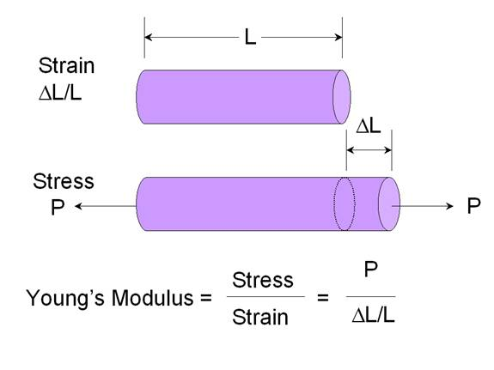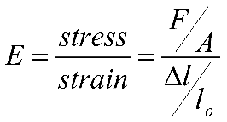
DP600 and DP800 steel is relatively ductile so that it has a large amount of elongation before fracturing. The E value is a numerical constant proving that when you increase the stress value on a material, the value of strain it propagates will also increase; therefore, making them proportional up to this point.
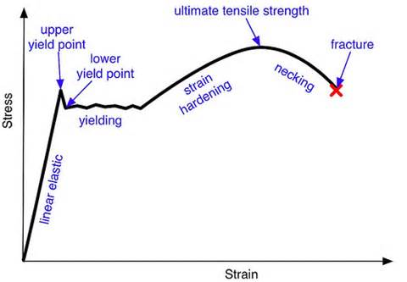
Auto Motive Products
Bake Hardening plays a vital role in car manufacturing, the steel needs to be ductile initially in order to be moulded into car frames but afterwards strong to withstand more force in case of a collision. This can be achieved simply by bake hardening the material after moulding.
Ultra-low carbon bake hardening (ULC-BH) steel has a broad range of applications, such as fenders and door panels in the automotive industry, because of its good formability before baking as well as high strength and dent resistance after baking. BH is one of the most important properties of ULC-BH steel. In most studies, the BH value is usually defined as the difference between the flow stress at a prestrain of 2% and the low yield stress after subsequent aging at 170 °C for 20 min. (Lva, 2018)

Tensile testing
It is humanly impossible to measure the strength of steel without using a machine. A tensile test applies a tensile force on to a sample until it fractures, simultaneously recording the force and plotting a stress against strain graph.

Methodology

The steel used for the study was taken from an industrial sheet from a steel production line. The Young’s modulus (YM) and internal friction change measurements were carried out using rectangular samples with sizes of 20mm×180mmcut out from a sheet along the rolling direction.
The YM of such a sample is related with the resonance frequency of its bending oscillations. (L.Kuzmina, 2007)

To calculate bake hardening values the ultimate tensile strength from the pre-strain test is subtracted from the lower yield stress of the second full tensile test. This measures the affect bake hardening has on the sample’s strength.
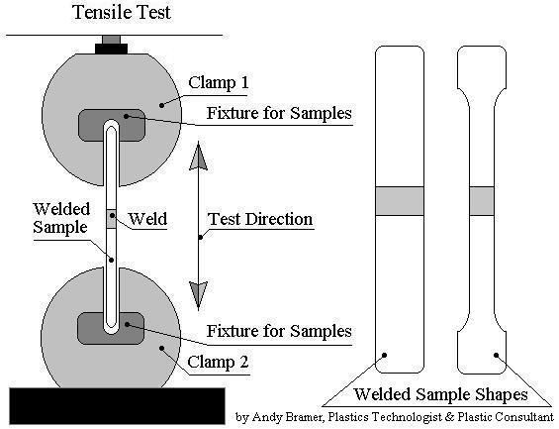
(U.Prahla, 2014)

Experimental Procedure

An initial roll of steel sample was recovered, and a schematic was composed, they were of the same carbon composition. The steel specimens were cut to equal size using mechanical shears. Using a Doosan MC-Vertical machine, the samples were all milled to equal size. It was imperative that the blades on each cutting tool were regularly maintained in order to ensure high quality samples for tensile testing. The samples were selected from the front of the coil sample to ensure a fair test. The samples were cut up into the desired 250mm by 38mm strips. The samples are then pre-strained by 2% which is a form of work hardening that introduces dislocations into the structure. The tensiles are baked at 170°c which fixes the dislocations in place before undergoing a full tensile test. This was repeated for each individual sample.
The following variables were then tested:
- The time period at which the samples were exposed to heat
- The time period between work hardening (pre-strain) and baking
- The position of samples while baking (stacked or adjacent)

Results and Discussion

In general, the industrially used BH effect is an ageing-phenomenon which is based on the diffusion of interstitial atoms in solid solution towards mobile dislocations. The dislocation mobility is therefore retarded or even suppressed, and the yield strength is increased. It is also known for conventional BH steels that a second stage of ageing after long ageing times occurs which is supposed to be controlled by precipitation effects. So especially the role of the carbon content, its interaction with the dislocations and the microstructure differences in both DP and TRIP grades must be considered. (U.Prahla, 2014)

Heat Treatment Time

It is expected that increasing heat treatment time will increase the effect of bake hardening. This is due to an increase in heat flux, also increasing the amount of carbon atoms diffusing, thus fixing the dislocations preventing them from propagating strain. As a result, the steel will have a higher yield strength after baking. The graph produced confirms that baking the samples for longer does increase the effect of bake hardening. Both steels were affected more during the baking periods of 5 minutes and 30 minutes shown by positive steep gradients. After baking the material for over 45minutes there was little change in in bake hardening values as the graph plateaus. When comparing the DP800 and DP600 steels, the results show that DP800 is affected consistently more by the bake hardening process; as at any simultaneous time the bake hardening value is greater for DP800 samples. However, between the baking times of 10 minutes and 30 minutes DP600 is affected at faster rate than DP800 as the gradient is steeper.

Time Period between Pre-strain and Baking

These graphs support that bake hardening has more of an effect on samples when baked shortly after pre-straining as oppose to a longer waiting period. This result was expected as if the samples remain at room temperature before the dislocations are locked in place for longer then there is a larger chance the dislocations will move back out of place so when eventually baking will not be fixed, thus having a lower yield stress. However, this data only supports this hypothesis to an extent; the range of bake hardening values referring to both materials is only small (2kPa) with respect to a large increase in time. To improve this test, a larger range of times should be tested in order to confirm stronger negative correlation.

Position of Samples while Bake Hardening

It is expected that while the samples are adjacent in the oven, bake hardening will have a larger effect on the yield strength. This is due to there being a larger surface area, thus increasing the flux of thermal energy. The samples are more exposed to this so the carbon atoms diffuse at a faster rate thus locking in more dislocations per unit of time; this will increase the value of the yield stress thus increasing the effect of bake hardening. These results were recorded using the averages, not considering the location of each standard in the stacks. Similarly, to other tests, the DP800 values are higher than the DP600 values confirming that this material has a higher strength.

When considering how the position within the stack will affect bake hardening it was found that samples at the exterior were more effected by baking due to more exposure to heat. Whereas the internal samples were less affected as they less exposed therefore there is less heat flux.

Error
A series of possible errors were taken into consideration, many were controlled in order to ensure a fair test was carried out. Maintaining a constant temperature in the oven was easily achieved by monitoring the settings. In addition to this the same machine was used for all pre-strain and full tensile tests to eliminate another variable. Alternative sources of error arose from the sample size, since the Doosan milling machine also mills other products between tensile samples. Such that the condition of the blades and accuracy of the machine need to be maintained throughout testing so that samples are not mediated towards the precise restrictions that a tensile test requires. In order to compare the data, all samples were taken from one original coil.
The main cause of error in this experiment is controlling the time period between the tests. When time is not the independent variable it needs to remain a constant value or can affect the correlation slightly. This factor is difficult to control as a tensile takes 3 minutes and same samples would need to go through the process simultaneously. An alternative solution would be to constrict the time taken to 5 minutes and test only one solution at a time, thus not allowing variance. It will be monitored with a timer to ensure repeatability.

Conclusions
Tensile impacts were created by shearing and milling cutting. They were then pre-strained by 2%, baked at 170°c before the bake hardening values were recorded during a full tensile test. It was determined that the largest source of error of the experiment was the time being miscalculated thus affecting results. Other errors were considered, and some suggestions were made. Batch standards were made up for future use.

In general, the industrially used BH effect is an ageing-phenomenon which is based on the diffusion of interstitial atoms in solid solution towards mobile dislocations. The dislocation mobility is therefore retarded or even suppressed, and the yield strength is increased. It is also known for conventional BH steels that a second stage of ageing after long ageing times occurs which is supposed to be controlled by precipitation effects. So especially the role of the carbon content, its interaction with the dislocations and the microstructure differences in both DP and TRIP grades must be considered. (U.Prahla, 2014)

Recommendations
If the experiemnt were to be repeated, testing a wider range of material would be preferable as dual phase steels act differently to bake hardening materials.
It must be considered that the data will only be valid for a fixed time period that given that simultaneously proceeding and interplaying processes of interstitial atom segregation on the dislocations and their desegregation from the grain boundaries result in complex behaviour of the investigated properties at the final aging stages. The investigation would be bettered by assessing further the affect of aging steels in addition to bake hardenable properties. (L.Kuzmina, 2007)

Works Cited
Coomana, A. D. (2000). Effect of dislocation density on the low temperature aging behavior of an ultra low carbon bake hardening steel. Zelzate, Belgium: Elsevier.
Honob, J. T.-h. (2013). Atom probe analysis on interaction between Cr and N in bake-hardening steels with anti-aging properties at RT. Ibaraki, Japan: Elsevier.
L.Kuzmina, A. A.-C. (2007). Nature of strain aging stages in bake hardening steel for automotive application. Seoul, Republic of Korea: Elsevier.
Lva, T. L. (2018). Effects of prestrain and grain boundary segregation of impurity atoms on bake hardening behaviors of Ti+V-bearing ultra-low carbon bake hardening steel. Hebei, China: Elsevier.
U.Prahla, A. S. (2014). Quantification of bake hardening effect in DP600 and TRIP700 steels. Dortmund, Germany: Elsevier.
Yan, L. Y.-a. (2016). Pre-aging on early-age behavior and bake hardening response of an Al-0.90Mg-0.80Si-0.64Zn-0.23Cu alloy. Beijing, China: Elsevier.

Bibliography
Coomana, A. D. (2000). Effect of dislocation density on the low temperature aging behavior of an ultra low carbon bake hardening steel. Zelzate, Belgium: Elsevier.
Honob, J. T.-h. (2013). Atom probe analysis on interaction between Cr and N in bake-hardening steels with anti-aging properties at RT. Ibaraki, Japan: Elsevier.
L.Kuzmina, A. A.-C. (2007). Nature of strain aging stages in bake hardening steel for automotive application. Seoul, Republic of Korea: Elsevier.
Lva, T. L. (2018). Effects of prestrain and grain boundary segregation of impurity atoms on bake hardening behaviors of Ti+V-bearing ultra-low carbon bake hardening steel. Hebei, China: Elsevier.
U.Prahla, A. S. (2014). Quantification of bake hardening effect in DP600 and TRIP700 steels. Dortmund, Germany: Elsevier.
Yan, L. Y.-a. (2016). Pre-aging on early-age behavior and bake hardening response of an Al-0.90Mg-0.80Si-0.64Zn-0.23Cu alloy. Beijing, China: Elsevier.

