DIGITAL SKILLS AND RESUARCH METHODS

Maria Jose Ayovi
Student Nº 2133891

Module code: BMSW4003

Leader: Fernando Suneth



Table of Contents
INTRODUCTION 2
OVERVIEW OF VIRTUAL LEARNING ENVIRONMENT 2
2.0 BACKGROUND (SECONDARY RESEARCH) 3
LITERATURE REVIEW – VIRTUAL LEARNING ENVIRONMENT 3
3.0 AIMS AND OBJECTIVES OF THIS RESEARCH 5
AIMS OF THIS RESEARCH 5
(The negative and positive impact of VLE on educational institutional in the UK) 5
OBJETIVES OF VIRTUAL LEARNING 6
4.0 METHOD (PRIMARY RESEARCH) 7
5.0 RESULTS 12
DISCUSSION 15
CONCLUSION 17
REFERECES 18
Teachtarget C. 2011 virtual learning environment (VLE) or managed learning environment (MLE) 18
https://www.techtarget.com/whatis/definition/virtual-learning-environment-VLE-or-managed-learning-environment-MLE 18

INTRODUCTION

OVERVIEW OF VIRTUAL LEARNING ENVIRONMENT

Virtual learning environment (VLE) is a set of teaching and learning tools designed to enhance a student’s learning experience by including computers and the internet in the learning process.
The first recorded use of the term was at the Cetis conference in 2004 how introduced this environment concept of acknowledges that the learners need to create their own learning environment and allows them to control this. This idea is particularly relevant for online learning where students may choose which technologies and services are most appropriate to them; this may, of course, include an institutional VLE.
Social networking software, which allows students to take control of their learning experience, offers ways to truly personalise their learning experience.

Virtual learning is a platform which is used in education to give access to education content online, can be via computers or mobile devices (tablets or phone or even game consoles).
VLEs are set up by a specific education institution. For example, a school, college, university.

The import research of virtual learning is allowing teachers to create curriculum content, access resources, plan their lessons, set, and mark assignments and manage lessons both offline and online. Students can be set work according to their individual abilities and needs and can access the network from home as well as in university.

2.0 BACKGROUND (SECONDARY RESEARCH)

LITERATURE REVIEW – VIRTUAL LEARNING ENVIRONMENT

- What is VLE technology services?

Teaching, learning.
Tools designed to enhance students to teachers.
computer Knowles.
Internet in the learning process.

- What are the benefits of VLE?

Administration and organisation. Integrating your VLE and MIS systems can deliver.
Planning and resource management.
Assessment and monitoring of students.
Personalised learning.
Discussion, support, and mentoring.

- What are the challenges of VLE?
(Student and teachers)
Share Time Management Apps and Resources for students.
Utilize Educational Technology.
Ineffective Time Management.
Not receiving clear instructions or expectations.

Sharing Course Material.
Ensuring students stay focused.
Providing Remote Maintenance and Support.

- What are the technologies used VLE?

Assistive technologies.
Presentation and multimedia technologies.
Social networking tools.
Mobile technologies.
Gaming, simulations, and virtual reality technologies.
Virtual learning environments.

- What are the risks of a VLE?

Not effective teach someone to use complicated piece of machinery.
Doesn’t offer human-to-human contact.
Limit the opportunities for team-building.
Limit role playing activities.
Brainstorming or discussion.

- What is the legislation type of VLE?

Content management; curriculum and assessment.
Learner engagement. Administration of learning information.
Communication tools. Collaboration tools. And real-time (live) teaching elements.

- What opportunities and benefits of using VLE?

Administration and organization. Integrating your VLE and MIS systems can deliver significant savings in time spent on administration.
Planning and resource management.
Assessment and monitoring of students.
Personalised learning.
Discussion, support, and mentoring.

3.0 AIMS AND OBJECTIVES OF THIS RESEARCH

AIMS OF THIS RESEARCH

(The negative and positive impact of VLE on educational institutional in the UK)

ADVANTAGES

The VLE method of study has several advantages. It is very convenient as both your and your teacher can interact from the convenience of tour respective home. You can also ask questions and raise queries as you use to do in the classroom.

The online study method became more important in case of a natural calamity of emergency. The perfect example in this regard is the recent COVID 19 pandemic that the world is still recovering from. To date, many educations environment are running online classes, for the safety of students. Online study is indeed a safer alternative institutional education.

DISADVANTAGES

Apart from numerous advantages, the online method of the study also presents certain disadvantages. It lacks the filled with enthusiasm kind of environment presented by a classroom. The lively and joyful ambience of a classroom is usually lacking in an online session. Teachers and students interact with each other only on subject matters on one-by-one basis.

Moreover, overexposure to gadgets presents its own health hazards like headache, weak eyesight, and lack of concentration, etc.

OBJETIVES OF VIRTUAL LEARNING

The objective of virtual classrooms is to improve access to advanced educational experiences by allowing students and instructors to participate in remote learning communities using personal computers; and to improve the quality and effectiveness of education by using the computer to support a collaborative learning.

4.0 METHOD (PRIMARY RESEARCH)

During my search, secondary search I have used and applied a collection of qualitative and quantitative date helping me understand the available technologies service required to have VLE, benefits, inconveniences, conveniences that university students, teachers, and admin face. In this case, various types of web pages and articles were referred and used to collect quantitative and qualitative (internet surfing) date. We accessed Moodle University and other sources available on the internet were used to collect relevant details (Virtual Learning Environments).

Subsequently, conduct a primary research approach to collect quantitative and qualitative date related to our University Moodle. Therefore, an online software tool was used to create a survey that included 10 questions related to the University’s Moodle and then distributed to colleagues and tutors for feedback. The survey was sent by email. The data was collected and stored in a table for the analysis process. 8 multiple choice questions and 2 open questions included in the questionnaire.

Here is my questionnaire:

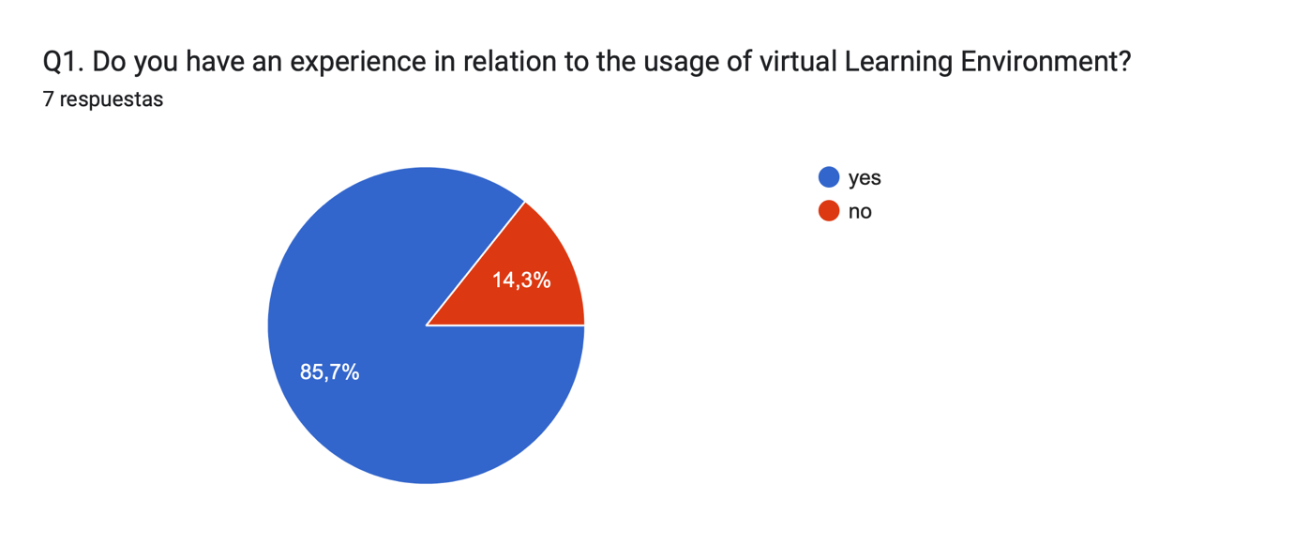
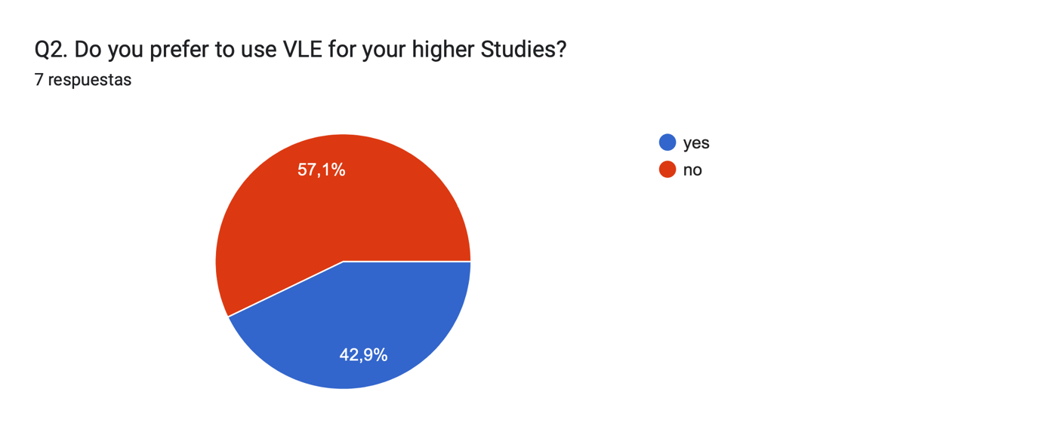

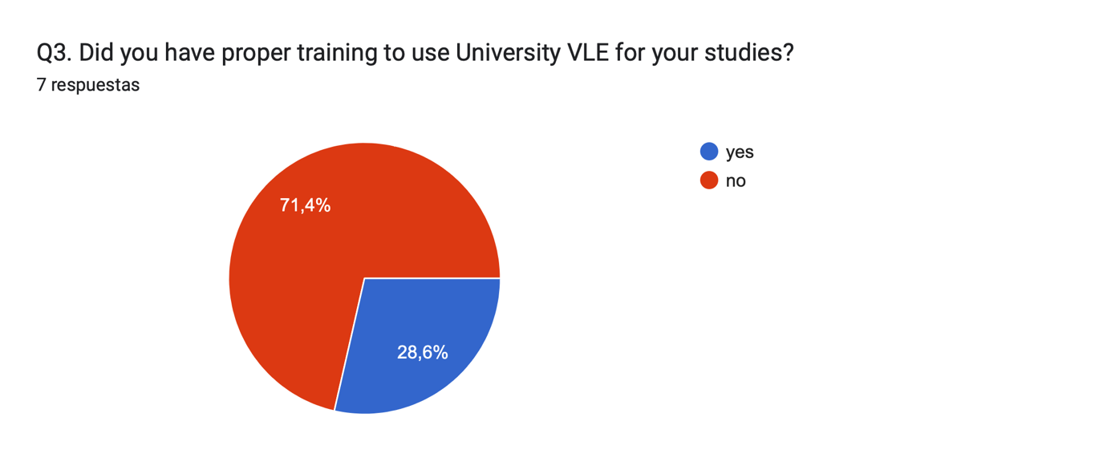

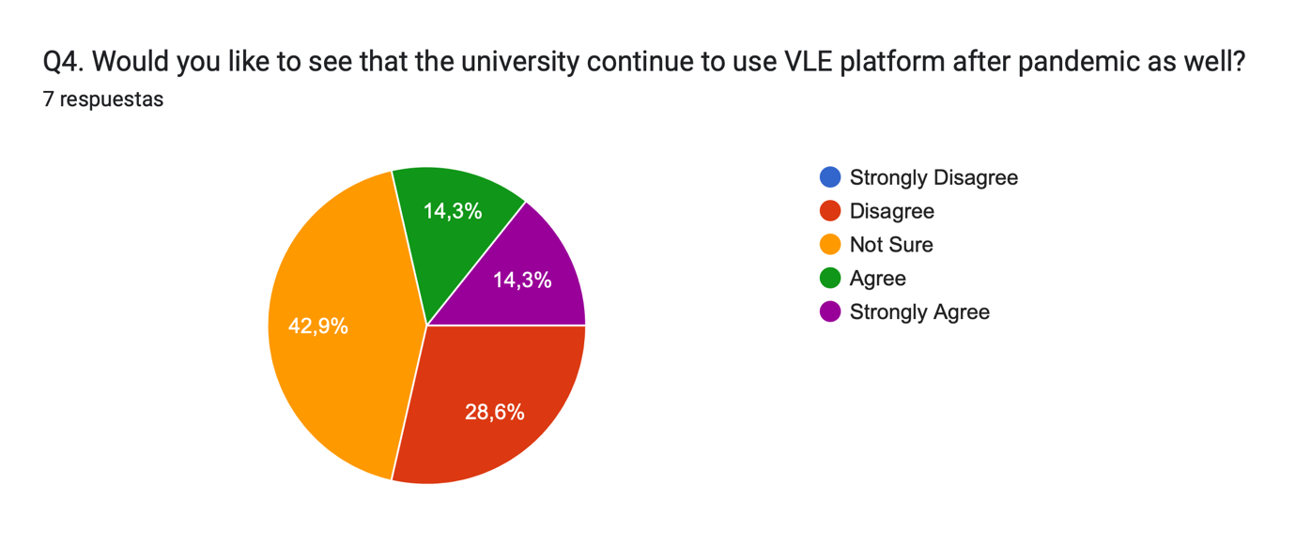

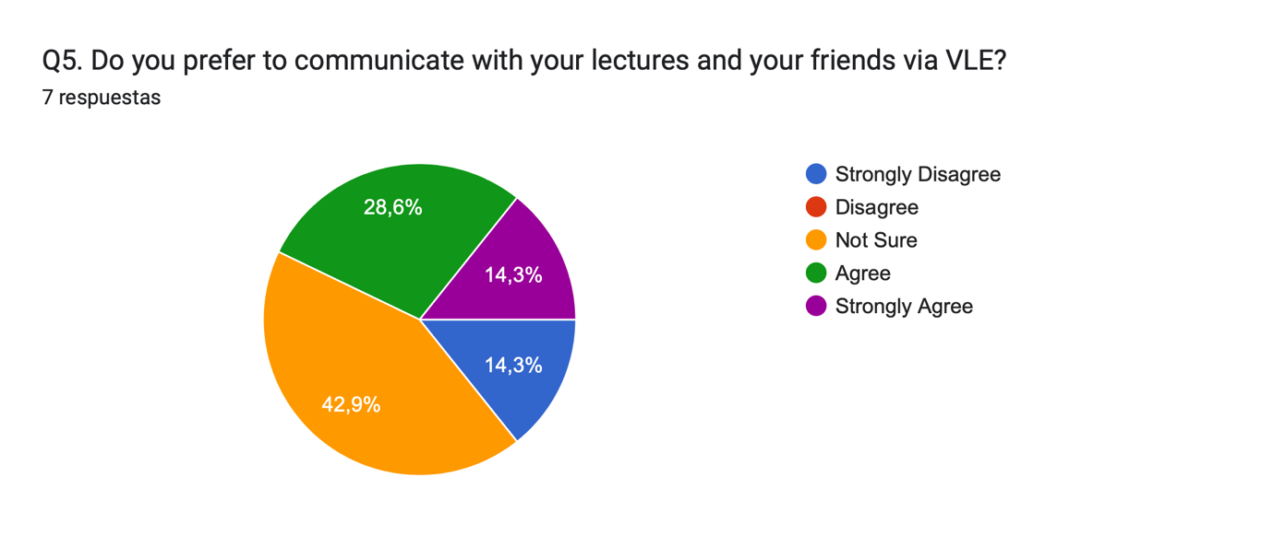

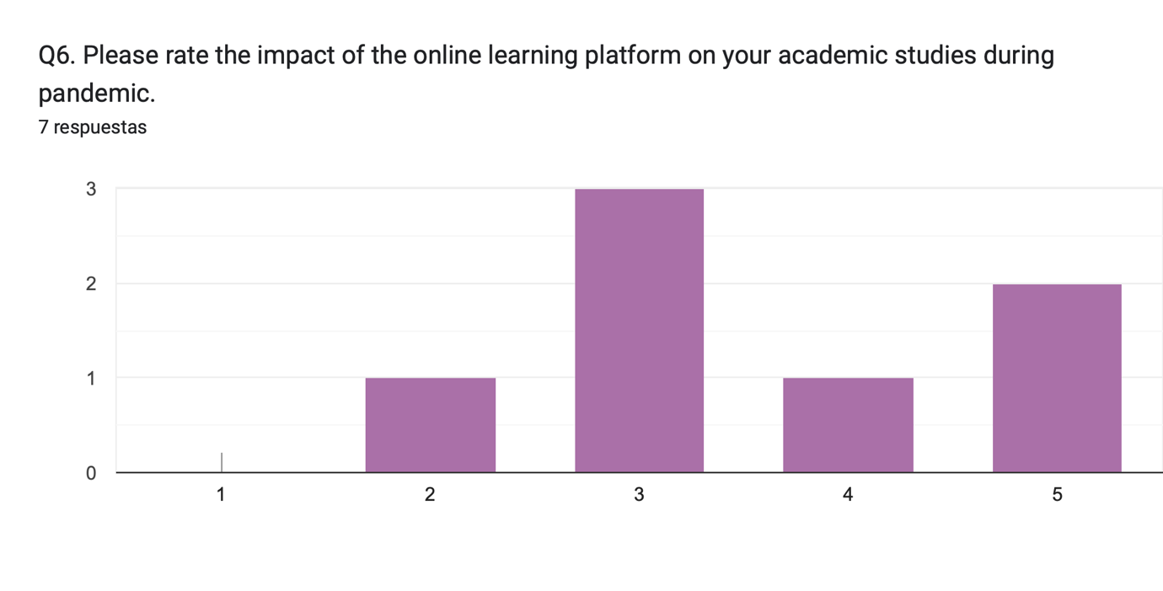

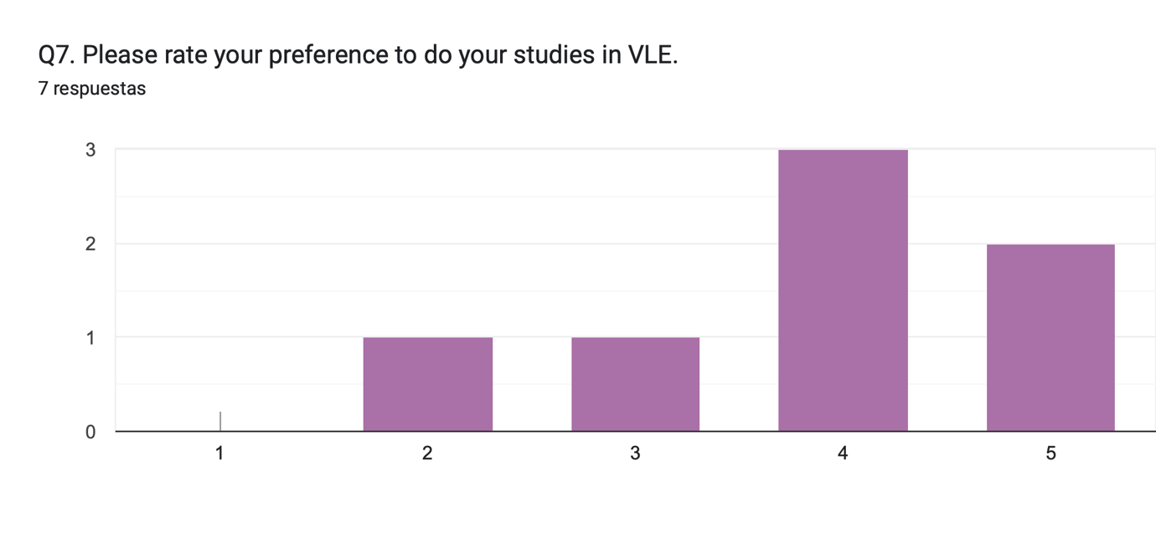

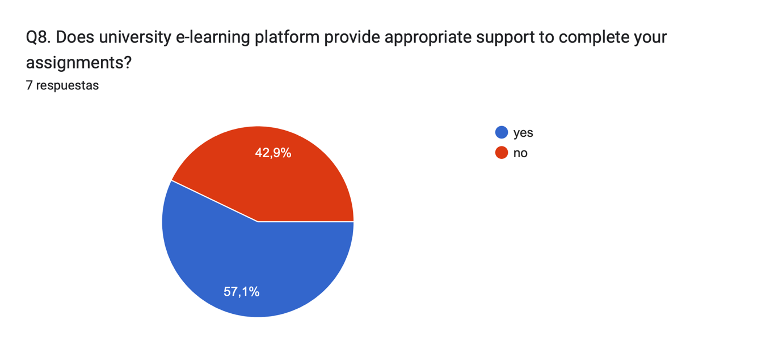

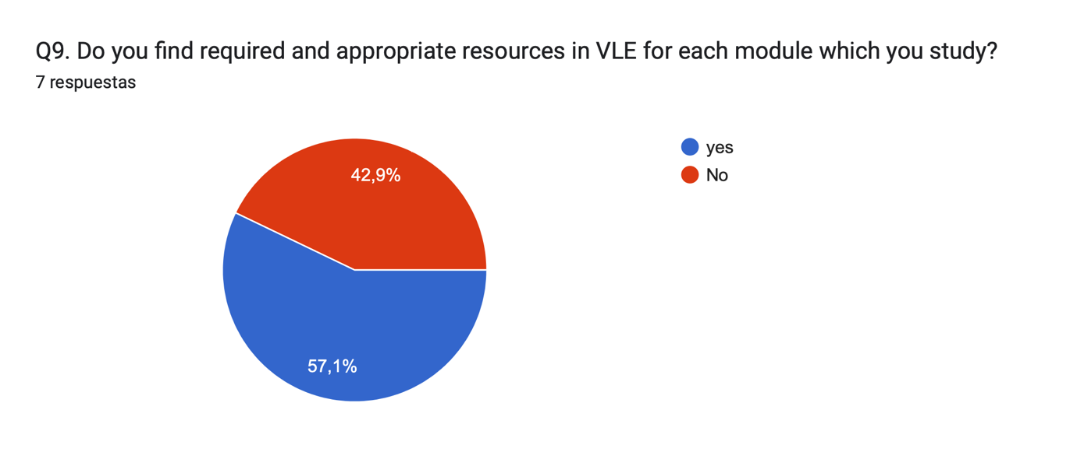

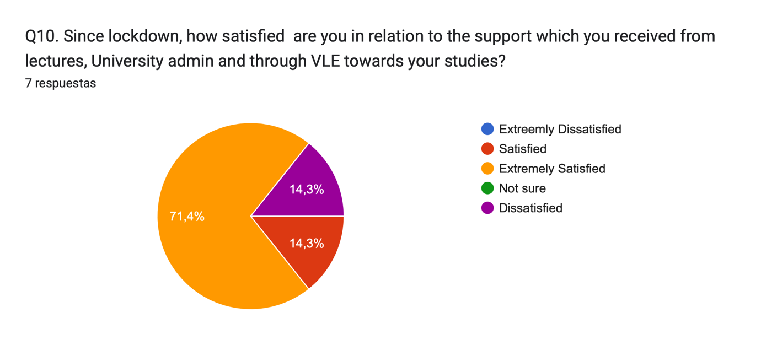

5.0 RESULTS

After having uploaded the questionnaire in the primary research, with the percentages of answered by my collages and tutors. I will now proceed giving exact numbers of the answering questions.

Results for Question 1,2,3,8 and 9

Questions
Yes / No
- Do you have an experience
in relation to the usage of VLE? 6 1

- Do you prefer to use VLE
for your higher studies? 3 4

- Did you have proper training to
use University VLE for your studies 2 5

8. Does University E-Learning platform
provide appropriate support to
complete your assignments? 4 3

9. Do you find required and appropriate
Resources in VLE for each module 4 3
which You study?

Results for Question 4,5 and 10

Questions

Responses (Yes) Responses (No)/Not sure

- Would you like to see that 2 2 3
the university continue to
use VLE platform after
pandemic as well?

- Do you prefer to communicate 3 0 3
with your lecture an your
friends via VLE?

10. Since lockdown, how satisfied 6 1 0
are you relation to the support
which you received from
lectures, university admin and
through VLE towards your
studies?

Observing the answers and analysing the questions 3,4,8,9 and 10, I realize that most students are very satisfied with the resources available in the virtual learning environment of the university.

Results for Question 6 and 7

Questions
1 2 3
- Please rate the impact of
the online learning platform 2 2 3
on your academic studies
during pandemic

- Please rate your preference
to do your studies in VLE 2 2 3

Since the rate responses of question 6 and 7 have taken and analysed, it is noted that the VLE was an impact for the student during the pandemic.

DISCUSSION

Virtual Learning Environments (VLEs) are web-based software systems that enable students to interact with their teachers and classmates, access learning resources without restriction of rime and place, and use cutting-edge information and communication technologies. Nevertheless, VLEs are costly to develop and maintain. Clearly, many features of VLEs may not be as useful to learners as designers and stakeholders might think, resulting in waste of resources. With this possibility in mind, the purpose of this study was to evaluate the effectiveness of the features of the VLE. To that end, first scale with 8 multiple choice questions and 2 open questions was developed and tested trough exploratory and confirmatory factor analyses to identify student perceived the guidance provided through it, (1) benefit, (2) satisfaction and (3) guidance respectively. Next, the scale was administered by questionaries to university colleagues and tutors to determinate whether the perceptions differed depending on time and situation. Finally, questions were also answers to pinpoint the features of the VLE that the students found most useful and beneficial. Data were analysed correlation and rank analyses. Results show that the most of students’ perception of the VLE is very useful and beneficial. And they agree with the university for used the technologies method.

In my experience in relation to using VLE is give me the gift of learning time, it´s highly adaptable, virtual learning can oftentimes better meet students where they are academically, emotionally, and socially. We can learn on us owns schedule as well as accelerate or slow down us pace
, but the difficulty is for pupils to understand the concepts taught, and online learning cause social isolation and results in pupils not developing the necessary communication skills.

During this term I have learned how to use the software system, among many other skills I have also learned how to use Microsoft word and PowerPoint, which have been very familiar to me because I had already used them before, but with the tutor, he has taught us different ways of how to make a report or a presentation with bullet point.

CONCLUSION

In this report, I have used primary and secondary research to find and explore different aspect of the environment during virtual learning used by the university. I collected, stored, and analysed the results of my search with the help of tools such as the appropriate software that have me recommendations to improve VLE services.

REFERECES

Teachtarget C. 2011 virtual learning environment (VLE) or managed learning environment (MLE)

https://www.techtarget.com/whatis/definition/virtual-learning-environment-VLE-or-managed-learning-environment-MLE
Jisc, 2021. Virtual learning environments (VLE)

https://www.jisc.ac.uk/guides/technology-and-tools-for-online-learning/virtual-learning-environments

Melanie E. 2020. What is a VLE (Virtual Learning Environment)? - 2021 Guide

https://www.learningladders.info/news/what-is-a-vle/

Becta, 2004. 2nd edition. What the research says about Virtual Learning Environments in teaching and learning

https://mirandanet.ac.uk/wp-content/uploads/2019/06/wtrs_04_vles.pdf

Akash G, 2022. Assay on advantages and disadvantages of online study.

https://www.essaybanyan.com/essay/essay-on-advantages-and-disadvantages-of-online-study/

