

ACCA7027

CLOUD ENGINEERING PRINCIPLES AND PRACTICE

Student Name :- GRAWAL YASH DEEPAKKUMAR
Student I’d :- 2511041

Table of Contents
Introduction 4
Part A: Containerisation and Cloud Engineering Foundations 4
1. Principles of Virtualisation 4
2. Principles and Benefits of Containerisation 5
3. Docker Images and Image Publishing 6
4. Volumes in Containers 6
5. Container Networking 7
6. End-to-End Demonstration (Integrated Example) 7
Part B: The Relationship Between Load Balancing and Scaling 8
Part C: Benefits of Combining Load Balancing, Scalability, and Application Gateways 9
Part D: Driving Forces Behind the Expansion of Cloud Computing and the Role of Serverless Functions 11
1. Key Driving Forces Behind the Expansion of Cloud Computing 11
2. Serverless Functions (Functions as a Service) 12
2.1 Definition and Core Characteristics 12
2.2 Benefits of Serverless Functions 13
2.3 Typical Use Cases for Serverless Functions 13
3. Containerisation in the Context of Cloud Expansion 13
4. Comparison Between Serverless Functions and Containerisation 14
4.1 Deployment Model 14
4.2 Scalability 14
4.3 Cost Model 15
4.4 Flexibility and Control 15
4.5 Use Case Alignment 15
5. How Both Technologies Support Key Cloud Driving Forces 16
Conclusion 16
References 18

Introduction
This report discusses key engineering principles associated with clouds as well as real-world technologies upon which contemporary cloud-based systems rely. This report aims to analyse the relevance of virtualisation and containerisation in efficient, scalable and reliable application deployment in the cloud environment. These notions are the basis of the modern cloud infrastructure and allow organisations to provide flexible and economically viable services. Virtualisation can be used as an approach to abstracting the physical hardware in several isolated environments to enable the shared hardware facilities to be utilised in a more efficient manner. Expanding on this, containerisation proposes a light and portable packing method of application. As a top containerisation platform, Docker offers the means of building an image with Dockerfiles, operating containers, and deploying applications on systems of various computing systems. Other fundamental principles of cloud computing introduced in the report also permit efficient and strong services. Load balancing distributes the traffic received to ensure availability, scalability enables the systems to change dynamically with the shifting demand and application gateways provide secure and intelligent routing to the new application. These principles can be combined to make the systems running in the clouds resilient, responsive, and scalable. This exploration has revealed that these technologies are important in sustaining effective cloud engineering practices, as brought about by the report.

Part A: Containerisation and Cloud Engineering Foundations

1. Principles of Virtualisation
Virtualisation is a modern technology under cloud computing, whereby a single computer can be divided to support a number of simulated computing environments. It works on a hypervisor, which is used to create and control virtual machines (VMs) by isolating underlying hardware equipment and assigning resources to each virtual machine, including CPU, memory and storage [1]. This abstraction enables the applications and systems to be independent of the physical hardware, which enhances flexibility, resource efficiency and separation of systems.
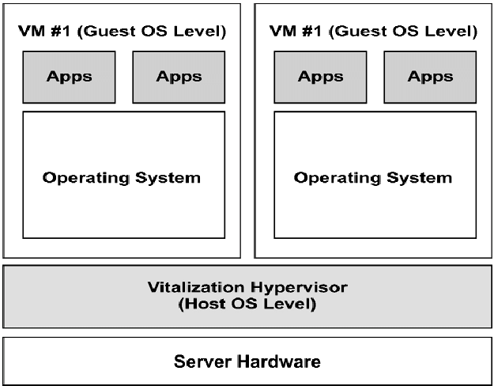
Several different types of virtualisation contribute to cloud infrastructure. Hardware virtualisation. The most widespread is hardware virtualisation, where a physical server is subdivided into more than one VM by a hypervisor, which is a platform that runs the OS kernel but does not provide containers. Hardware virtualisation is conceptually similar to containerisation technologies, although technically different. Network virtualisation is an abstract concept that allows virtual switches, routers and network interfaces to be programmed. Storage virtualisation brings together several physical storage devices into one logical storage pool that is needed to support high availability as well as scalability in a seamless manner [2].
One real-world scenario of the use of virtualisation is the use of a physical server by many tenants within the cloud environment. Virtualisation enables a single server to provide several virtual machines that have varied OS and applications instead of allocating a single server to one workload. This setup enhances hardware usage and lowers infrastructure expense, while also having a high degree of isolation amongst workloads. Virtualisation is therefore establishing its foundation in elastic compute services used in cloud providers to ensure that resources can be dynamically allocated and that various applications can be effectively hosted.

2. Principles and Benefits of Containerisation
Containerisation is a less heavyweight way of workload isolation, as opposed to virtual machines. An application is packaged by means of a container into a portable, self-contained unit. Containers do not have an operating system installed in them, unlike VMs; they use the operating system kernel installed on the host, but have independent user-space capabilities [3]. This architectural variation lowers overhead costs, enhances performance and speed through in-service application.
Containerisation in cloud engineering has proved to be necessary to enable the scalability of the modular and portable software. Containers boot up faster compared to VMs, need fewer resources, and can be cloned or substituted within a short time. These features are the most suitable ones when it comes to microservices architectures, where applications are separated into small units that can be deployed independently. Containerisation also ensures consistency since a containerised application is consistent in all development, testing and production environments.
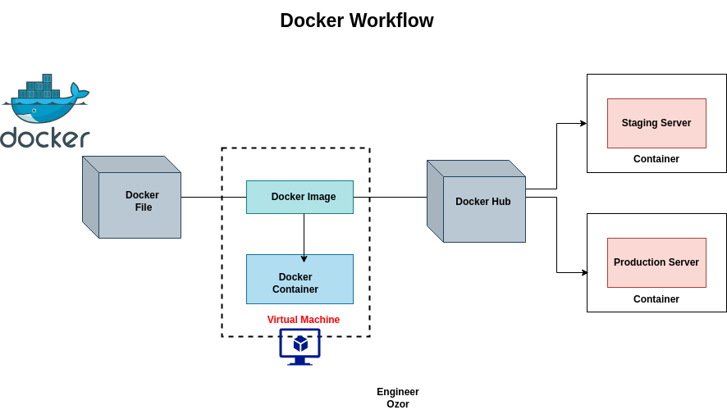
One of the differences between a virtual machine and a container is in resource consumption. VMs also place hardware in software form, posing the challenge of having an exact copy of an operating system per instance, and thus, overhead. Containers are virtualised on the OS level, which provides the same host kernel and allows for saving a lot of memory and storage [4]. VMs offer great isolation and work well in system environments involving heterogeneous operating systems, whereas containers are better at scale-out quickly, portability and underutilization of the compute resources.
One such place of containerisation is the building of a Dockerfile, a script that spells out the building directions of a container image. An impatient example of a Dockerfile could consist of a base image, e.g., nginx:latest, a copy of an HTML web page in the server’s document root, and a port to receive the incoming traffic on. Once the Dockerfile is run with the help of the docker build command, a lightweight image is created that can be run as a container. This operation explains the effectiveness and repeatability that containerisation adds to the cloud engineering processes.

3. Docker Images and Image Publishing
A Docker image is the design type on which obtainer boxes are initiated. It consists of all files, dependencies, binaries and environment settings that are needed to execute an application [5]. After the construction, an image is fixed and cannot be modified, so that every container spawned on it will act in the same way in a platform-independent way.
Images are built in layers, and every command in the Dockerfile creates a new layer. These data layers are shared and or cached across images, which allows optimisation of storage space and the time spent building. The system of immutability and layering includes reusability and version control in addition to effective application updates. In another example, when a security patch is necessary, it is not necessary for the whole layer to get rebuilt, and only those layers that are affected must be rebuilt.
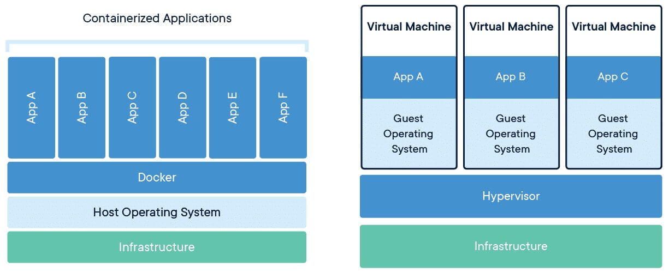
This is because images are very important in cloud deployments. Applications done using cloud-native tend to run within container orchestration platforms like Kubernetes that then draw images from registries prior to deploying them as running containers. The application makes this workflow automated and allows it to be scaled [6].
The process of releasing an image entails pushing an image to a container repository like DockerHub. Once the image has been tagged with a predetermined repository name, a basic command like docker push username/image-repository:tag is used to upload the image to the registry. This enables one to access the image via any remote system or cloud service. As an example, the image of a specific web server can be constructed by a development team and deployed to DockerHub to be pulled by a Kubernetes cluster in the cloud when it is deployed. This centralised method of sharing helps in teamwork and in a systematic sharing of containerised applications.

4. Volumes in Containers
Containers are temporary and are deleted in the power of their end. To maintain storage, Docker relies on the help of volumes that are external spaces that are controlled by the container engine [7]. Volumes ensure that vital information like application data, logs and database files can still be intact even on the removal of a container. This is essential in stateful applications such as MySQL or PostgreSQL, and internal container storage can be lost, resulting in loss of data.
The data contained in the container might be ephemeral, and it might be deleted along with the container; the data in volumes is persistent. Volumes would be preferable since they can be carried around and are well under control. One of the applications of a Docker volume is to create a volume with the following command: docker volume create my volume, and to run a container with it, by using the command docker run -v myvolume:/usr/share/nginx/html nginx. This provides resilience of data within containers [8].

5. Container Networking
Container networking facilitates the communication between the containers and the hosts, as well as with the outside world. Several networking modes can be found in Docker, which are the bridge, host and overlay networks. The default is bridge networks, which puts the containers in isolated virtual networks to which they can communicate with different internal IP addresses. Host networking enables a container to have access to the network stack of the host, where it achieves better performance under certain scenarios. Overlay networks are multi-host networks and are imperative to distributed systems with container orchestration systems.
In microservice architectures, networking can be significant as the various services will have to communicate effectively and safely, commonly through REST APIs or with message queues. Container networking provides services such as resource addressing, service resolution, DNS resolution and traffic routing [9].
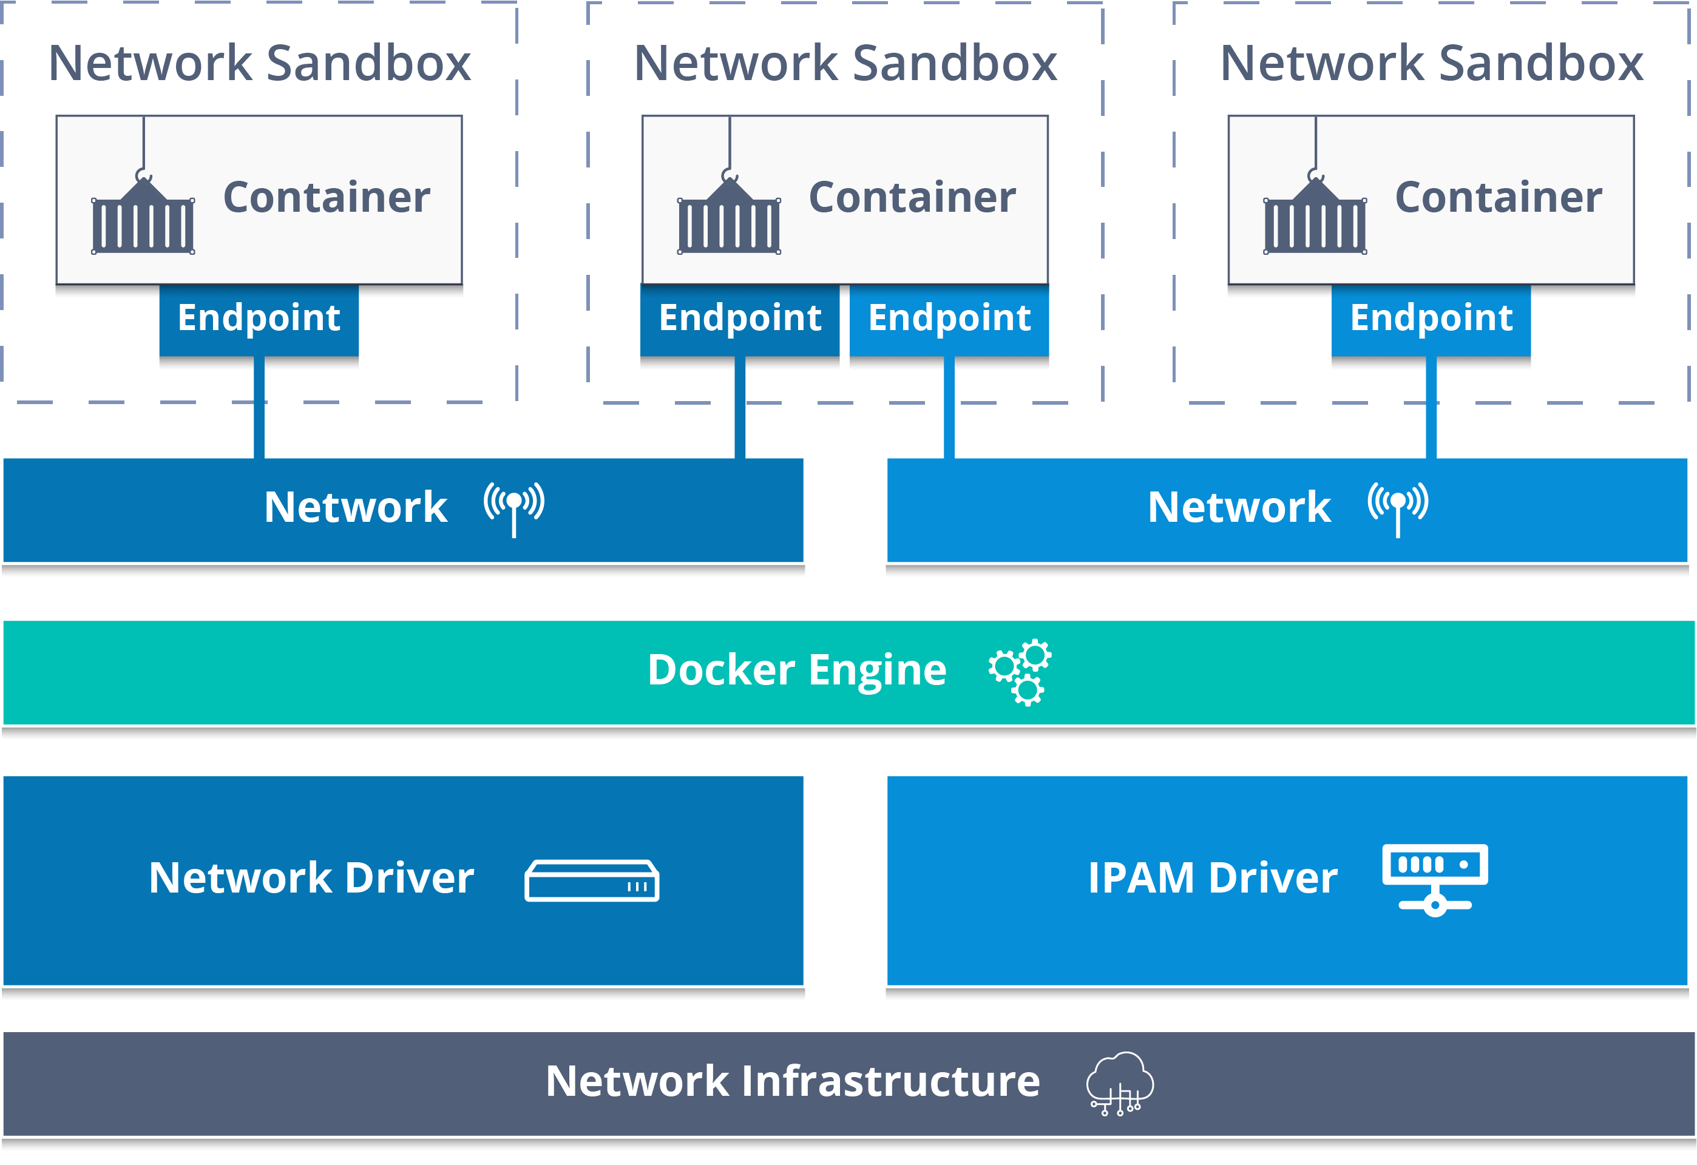
This can be included by rendering a custom Docker network with the command docker network create mynetwork. Containers with a flag of--network mynetwork can easily communicate with names. Examining the network using docker network inspect mynetwork will provide information about other containers connected and configuration, which will be useful in developing applications such as a web server that is connected to a database.

6. End-to-End Demonstration (Integrated Example)
This workflow can be illustrated with the creation of a simple web server with the help of Docker. In this example, several concepts are incorporated, including containerisation, image construction, networking, volumes, and image publishing.
It starts by creating a Docker file that is based on an NGINX foundation and transfers an HTML page into the server directory. Once the Dockerfile is created then the image can be built through a docker build -t customwebserver [10]. After this is constructed, the container can be run with docker run -p 8080:80 customwebserver, and one can access the web page via a browser.
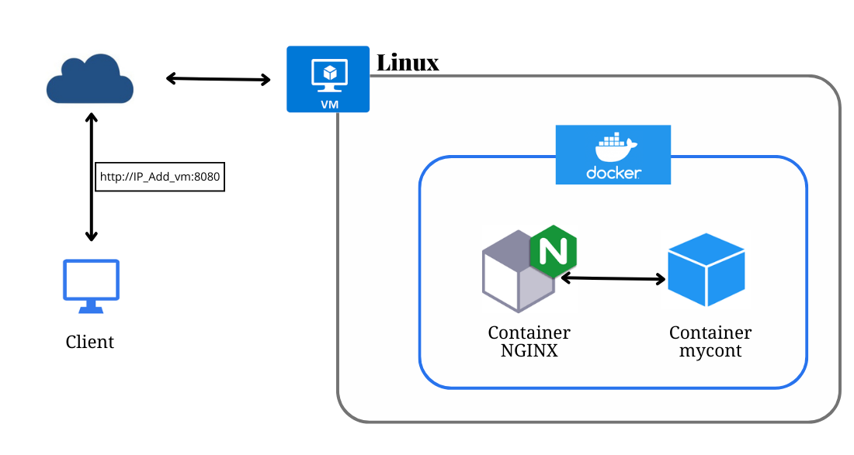
Persistent storage requires mounting a volume of HTML directory inside the container and then creating the contents of the persistence volume, in theory of updating the webpage contents without having to rebuild the container. The container can also be configured into a custom network that the container can use to communicate with other services to ensure that there is separation in the network and the communication is well structured. It is also easy to push the image to DockerHub, where it is tagged and can be deployed to cloud platforms with ease, and the application is portable, scalable and can be orchestrated using tools such as Kubernetes [11].

Part B: The Relationship Between Load Balancing and Scaling
Two main pillars to support the effectiveness, durability and scalability of cloud-based applications are the concepts of load balancing and scaling. Even though they have different functions, the overall functioning of systems yields systems that are dynamically responsive to changing work numbers, high performance, as well as limit the chances of downtime of the services. The complementary effect is particularly significant under the conditions of constantly shifting or unstable demand.
Understanding Load Balancing:
Load balancing spreads the arriving traffic or workloads of several computing resources among a group of computing resources, including virtual machines, containers, or physical servers. Load balancers help to distribute the demand across all the resources, thus avoiding the overloading of a particular resource. The distribution is useful in keeping the systems responsive, and latency minimisation and general user experience are enhanced [12]. Load balancing is also useful in improving availability since it auto-serves traffic around unhealthy instances to healthy instances, and maintains the availability of services even in the event of partial breakdowns of the system.
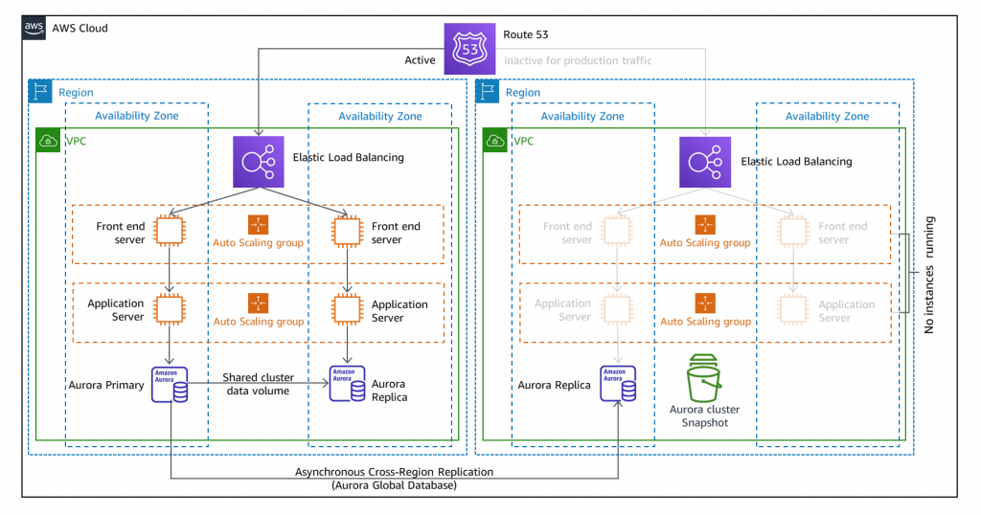
Depending on the network configuration, load balancers can be employed at various layers of the network stack: round robin, smallest connections, adaptive routing or some other algorithm is used to choose the direction the traffic should follow. The given flexibility enables cloud environments to cope with a variety of traffic patterns and application designs present.
Understanding Scaling:
Scaling defines that the system can adapt its capacity depending on the workload. Cloud environments allow horizontal (adding or removal of instances) and vertical (adding or removing resources of an instance) scaling. These adjustments are automatically taken by using auto-scaling technologies that track the performance indicators like CPU usage, memory usage, or request rates [13].
Scaling will ensure that adequate power is provided when there is peak demand and that the excess power is scaled back when they are not in demand. This is an adjustive mechanism that enhances cost-efficiency without affecting performance.
Why Load Balancing and Scaling Are Complementary:
The two functions of load balancing and scaling coincide with each other in the fact that one cannot operate effectively without the other. Load balancing makes the distributed resources utilised effectively, avoiding any bottlenecks and gives a balance to the traffic among the scalable infrastructure. In the absence of load balancing, the additional instances will not be of much use, and the traffic could still find itself channelised on only a few of the resources. Scaling, on the other hand, offers the extra capacity that load balancers need to redistribute the load effectively in case there is a surge in demand (Bhalla, 2025).
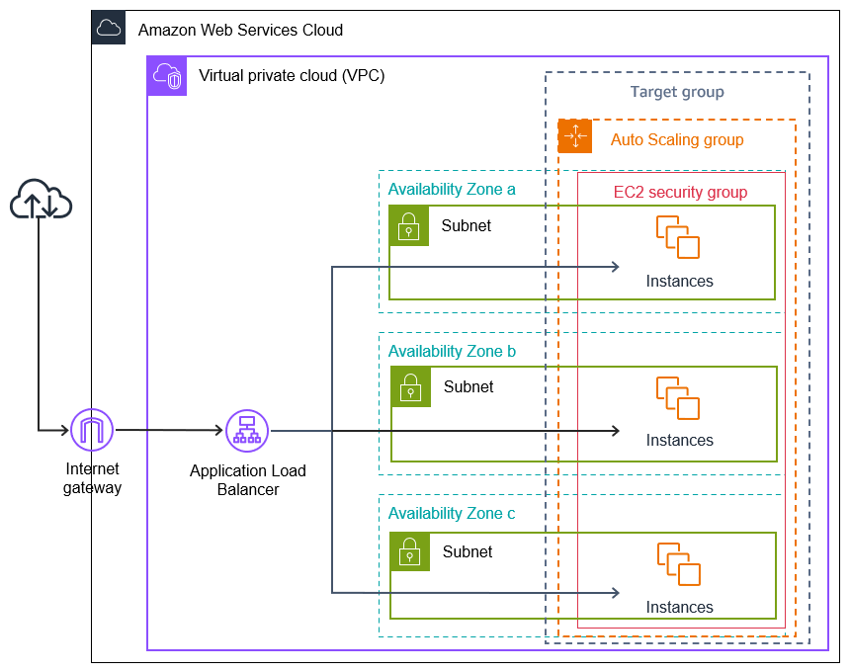
When integrated, the technologies form a strong and adaptive environment that can adapt to real-time changes. The load balancing serves to maintain an even distribution, health check and failover and scaling to the demand capacity required by the workload applied. Combined, they optimise performance, cut downtimes and facilitate cost-effective cloud operations, and this is all a critical partnership in current cloud engineering.

Part C: Benefits of Combining Load Balancing, Scalability, and Application Gateways
Load balancing, scalability and application gateways integration create a robust architecture of providing high-availability, high-security, and high-efficiency cloud-based services. These three technologies combined with each other yield an infrastructure that can manage the changing traffic requirements, safeguard the applications against attacks, and provide the users with consistent and reliable user experiences. This is a totality strategy that organisations need in order to deliver robust digital services to their customers.
Enhanced Performance and Reliability:
Load balancing will make sure that traffic coming in is spread out among several copies of an application in such a way that a single instance does not get overloaded, and other resources are not used as a performance bottleneck. Combined with scalability, one can provision additional instances automatically whenever there is a high demand [14]. This implies that the load balancer can reallocate traffic on demand, and this allows the system to expand or shrink accordingly, which ensures the best response time and service reliability.
Application gateways are seen as complementary to this process; they deal with more sophisticated routing decisions as well as layer 7 traffic control. This allows processing of requests intelligently, e.g. when sending traffic according to URL paths, host names, or application rules. The two technologies together guarantee customers fast, stable and continuous service even at the time of traffic spikes.
Improved Security and Traffic Management:
The application gateways bring on board the improved security features, such as the termination of the SSL, Web Application Firewall (WAF) integration, and filtration of malicious traffic. When load balancers are used to divide the workload, and capacity is adjusted by scaling, the application gateway provides a gateway through which only safe and valid requests are passed to the backend resources [15]. This multi-layered security system safeguards customer information and avoids interruptions brought about by cyber attacks.
Moreover, with support of the gateway, centralised authentication and logging are employed, which provides precise information on traffic patterns and potential weaknesses. Combined with load balancing and scaling, organisations are able to acquire an efficient operation as well as a strong security posture, leading to safer service delivery.
Optimised Cost Efficiency and Resource Utilisation:
These three technologies are also compatible in their collaboration to bring about cost-effective cloud operations. Auto-scaling also guarantees that the added resources are only given out when needed, and in cases where they are not needed, they, thus saved on resources lying idle in the clouds. Load balancing ensures that these resources are utilised efficiently, and the application gateways simplify the routing process and eliminate undesirable packets before overloading the backends, which would otherwise burden the backend systems [16].
This leaves the customers with services that are efficient and responsive without paying too high operational costs. The combination enables organisations to provide scalable, secure and high-performance applications to meet customer expectations and remain financially viable.

Part D: Driving Forces Behind the Expansion of Cloud Computing and the Role of Serverless Functions
Cloud computing has changed the way organisations design, implement, and operate digital services. Some of its most important drivers are the low cost, high degree of operational flexibility, scale, global access, and low requirement of infrastructure management, which have led it to have rapid growth. These motivating forces have promoted the creation of new service models, such as serverless functions or Functions as a Service (FaaS). This part explores these forces in depth and compares a serverless computing approach and the containerisation one in detail in relation to the changing demands of a cloud user.

1. Key Driving Forces Behind the Expansion of Cloud Computing
Cost Efficiency:
One of the strongest incentives to adopt the cloud is cost efficiency. Conventional on-prem infrastructures demand massive initial investment into hardware, software licenses, maintenance, energy usage, physical security and dedicated IT staff members. These expenses may be prohibitive, particularly to small and medium-sized enterprises [17].
Cloud computing gets rid of numerous capital costs through a move towards a pay-as-you-go system. Compute power, storage, networking and other resources are charged according to actual consumption, and this has helped to eliminate any underutilisation and overproviding resources. Moreover, the cloud providers maintain hardware upgrades, energy consumption, cooling, and data centre operations that save operational costs. The scaled resources are able to expand or contract, which also minimises unwanted expenses by matching the resources to the live demand. This flexibility causes the cloud to be a cost-efficient option to organisations that want to manage to maximise their financial resource without sacrificing performance.
Flexibility and Elasticity:
Cloud computing allows organisations to adapt swiftly to the dynamics of the business environment with the help of designated resource allocation. This dynamism enables the provision of any kind of compute instances, storage capacity or network throughput, which is dynamically adjusted without service disruption [18].
To development teams, the cloud offers the option to spin up testing environments on demand, deploy changes quickly and add new capabilities without the protracted cycle of procuring hardware. Such flexibility makes innovation more rapid, as well as decreases the time-to-market of new products and services. Elasticity also makes the system constant even when there is fluctuation in demand. As an example, in times of seasonal e-commerce surges, cloud platforms can have horizontal scaling to sustain their performance and even roll down during downturns. This responsiveness can hardly be realised based on classical on-premise infrastructure.
Global Reach and Availability:
The cloud providers have data centres that are geographically distributed, which allow the delivery of the services globally with low latency and high availability. The applications can be deployed on multiple regions, thus guaranteeing quick response to the global users and reducing the chances of failure due to regional outages [19].
Redundancy, failover, and distributed load balancing are also used to increase the high availability. This international infrastructure enables organisations to go global with digital services, not necessarily by establishing physical infrastructures in every position.
Reduced Infrastructure Management:
The cloud systems also ensure that the burden of infrastructure businesses no longer have to fix their systems, and they can concentrate on developing applications and innovating their services. Managed services that are offered by cloud providers normally include tasks like patching, updating systems, security monitoring, and backups. This leads to a minimisation of operational overhead and higher value work by the technical staff.
Rapid Deployment and Innovation:
Cloud computing enables fast application development with the help of automation tools, container orchestrators, infrastructure as code, and continuous integration/ continuous deployment (CI/CD) pipelines [20]. The feature promotes experimentation, rapid prototyping, and product improvement. Constant innovation allows businesses to soon adjust to the changes occurring in the market and stay ahead of rivals.

2. Serverless Functions (Functions as a Service)

2.1 Definition and Core Characteristics
Functions as a Service (FaaS) or serverless computing is a form of computing in cloud computing where the application logic is implemented in stateless functions that activate on call. There is no need to provision, configure or manage servers because the cloud provider automatically deals with resource allocation, execution, and scaling. The examples of serverless technologies that are widely used are such platforms as AWS Lambda, Azure Functions, and Google Cloud Functions. One sign of serverless computing is that it is frequently event-based, i.e. functions are developed upon certain events (an HTTP request, a database update, a file upload, a message queue event or a timer) [21]. The platforms also have automatic scaling, where thousands of executions can take place concurrently. Only upon running functions, costs are incurred and played by a pay-per-execution pricing model in terms of resource utilisation and execution time fees. Moreover, the functions are stateless, and each call is independent, serving as the employer of external storage services to store persistent data.

2.2 Benefits of Serverless Functions
The benefits of serverless computing are also consistent with the major drivers to use cloud technologies. The cost efficiency is obtained by the use of a pricing model, using which the actual time of execution is only charged without the costs associated with non-use of resources and making the model especially applicable to applications where the workload varies. There is increased flexibility in the operations since the cloud provider does the infrastructure work, like scaling, patching and fault tolerance, and the development can be focused on application code and not on system maintenance [22]. Another tremendous advantage is the possibility of instant scalability, as serverless platforms do not need to be configured to respond to decreasing or increasing traffic. This feature has a sustained high performance even when there is a sudden increase in demand. Moreover, serverless functions can allow a quick deployment process, which means that new code can be released in a few seconds. This encourages rapid development and testing, which fits in agile development processes and the lifecycle of previous-generation applications.

2.3 Typical Use Cases for Serverless Functions
The scope of workload that serverless computing suits is quite broad, which includes API backends, microservices-based applications, real-time data or file processing, automated scheduled tasks, and mobile or web application backends. Serverless computing can be effectively applied to lightweight and highly dynamic cloud-based services, where these features work well in multiple scenarios: event-based executions, inherent scalability, and low operation overhead of serverless platforms [23].

3. Containerisation in the Context of Cloud Expansion
Containerisation has been of importance in the development of cloud computing as it allows applications with their dependencies to be bundled into small and easily transportable units. Docker and orchestration services using Kubernetes are a few of the technologies that have facilitated the shift to microservices-based and distributed architectures.
Strengths of Containerisation:
Containerisation has a number of strengths that are consistent with the expansion of clouds. It is portable, a fact that allows it to retain the same behaviour in all its applications in development, testing, and production. The host operating system kernel sharing leads to resource efficiency, consumes less memory and computation than virtual machines. Containers also have a high level of scalability, and orchestration frameworks like Kubernetes include autonomous scaling, automatic upgrades, self-mending features, and effective cluster management [24]. Their consistency with microservices promotes resilient, modular and scalable application genres, and the large-scale customisation permits complete command of the runtime environments and settings. The benefits of containerisation are that it is good for long-running services, distributed systems of complexity, and workloads known to be flexible and controllable on the fly.

4. Comparison Between Serverless Functions and Containerisation

4.1 Deployment Model
Serverless functions and containerisation are two different ways of implementing cloud-based applications. Serverless functions are executed as events within an event-driven setting rather than running constantly, and thus application logic is only executed upon an event, eliminating the necessity to manage servers or runtime environments. These applications are usually stateless and short-lived and perform in isolated environments that the cloud provider creates automatically. Containerisation, by comparison, is the process of wrapping up an application and its requirements in a portable unit that can be easily run in multiple environments [25]. The services most often placed in containers are long-running ones, microarchitectures, or applications that are continuously available. Whereas serverless computing is concerned with low operation overhead and disposable execution, containers offer stable, permanent environments that could support more intricate workloads.

4.2 Scalability
Both functions, with no server and containers, could be scaled automatically, but the mechanisms and flexibility are different. Serverless platforms can be scaled in real time according to the incoming events and provide an execution environment to each request without having to rely on manual interventions. This type of scaling is very granular and fast, so that it almost instantaneously scales to demand bursts. Containers are orchestrated using orchestration platforms, like Kubernetes or Docker Swarm, that will add and/or remove active container instances depending on targeted metrics. Container scaling is not as immediate as serverless scaling, but it provides a more effective control over strategy, thresholds and resource allocation [26]. Consequently, serverless computing is more efficient in the case of unpredictable workload, whereas the scaling behaviour of containers is more optimised and predictable.

4.3 Cost Model
There is a significant difference in the cost basis of serverless functions and containerised environments. Serverless computing is pay-per-execution, meaning that it is billed by how many times the function was called, and the time of execution. This renders serverless especially cost-efficient when the load is on-demand or unpredictable in general, since no fee is imposed when the functionality is not in operation. Containers, though, are charged on the basis of the compute resources that they are allocated, whether used or not. Even idle container instances are resource-consuming, and their costs go on. Serverless functions are therefore more likely to be cost-efficient when used with infrequent workloads, and containerisation is more cost-effective when dealing with long-lasting or permanently running applications [27].

4.4 Flexibility and Control
Containers have much more control and flexibility over serverless functions. Containerisation enables complete management of the operating environment, libraries, configurations, networking, storage, as well as security configurations. Such a high degree of customisation is needed in applications that have specialised dependencies or applications with complicated operational needs. Servers, but with more exciting features. Serverless functions offer a more touched, or rather a managed service, smaller configuration possibilities, but are much easier to deploy and maintain. The trade-off is the choice between the various use cases of the target, since serverless functions are particularly friendly to simplicity and automation, whereas containers are friendly to customisability and operational control.

4.5 Use Case Alignment
Serverless and containerisation are most appropriate in use depending on application features. Serverless functions achieve a good fit in event-driven processes, automated tasks, background processes, API frontends, and lightweight microservices with a scalable requirement and low operational cost [28]. On the other hand, complex applications, long-running services, migrations, and workload demands of persistent state or specialised configuration are numbered with containers. Obviously, both methods are capable of covering scalability together with flexibility; however, depending on application design, operational requirements and workload patterns, the strength of both methods varies. Consequently, most current cloud architectures have integrated serverless functions and containerisation to create optimal performance, cost-efficiency, and agility.

5. How Both Technologies Support Key Cloud Driving Forces
Cost as a Driving Force:
Both serverless computing and containerisation allow cutting down on costs, albeit differently. Serverless completely removes the costs of idle resources, which makes it appropriate for unforeseeable workloads. Containerisation saves operational costs by making optimal use of resources and contributing to the increase in workload density. A combination of these models gives the possibility of cost optimization in a variety of forms of applications [29].
Flexibility as a Driving Force:
Serverless computing is flexible enough because it eliminates the issue of infrastructure and allows a quick deployment. Containerisation is flexible, whereby applications can be run in stable and customisable environments, isolating them behind the infrastructure. Both of them endorse agile development workflows and quick turnaround.
Innovation and Speed:
Serverless architecture supports fast prototyping because, within several seconds, code deployments can occur. The containers also make it easy to rapidly test entire application environments, making integration and delivery fast. They both help in accelerating innovation processes [30].

Conclusion
Scalability, cost-efficiency, and flexibility, the necessity of cloud computing to serve the modern services of digital solutions, have determined the further development of this phenomenon. Virtualisation, containerisation and serverless computing are technological advancements that have been critical in attracting these requirements. Virtualisation created the abstraction of resources and offered an efficient use of the shared hardware and workloads across a variety of demands. Containerisation built upon this base by providing a lightweight, portable, and highly configurable environment, which is much better suited to calculus and distributed architectures. This has rendered it a necessity to adopt cloud-native application strategies due to their capability of guaranteeing consistency between the development and production environments. The latest innovation of the cloud is called serverless computing, which provides automatic scaling, event-driven execution and pay-per-use billing models, with which the idle resources are no longer listed in the expenses table. Its simplicity and quick deployment ensure it is of great operational benefit, especially where there is a variable or unpredictable workload. In comparison to containerisation, serverless computing puts into focus the move towards increasing abstraction and automation of cloud platforms. Combining these technologies, it is possible to see the wide range of opportunities to create resilient, scalable, and efficient cloud-based systems. A combination of their influence keeps growing and expanding the use of cloud computing, which contributes to providing organisations with high-performing, globally available, and flexible digital services.

References
- Arogundade, O.R. and Palla, K., 2023. Virtualization revolution: Transforming cloud computing with scalability and agility. IARJSET.
- Pacheco, M., 2021. Advances in Virtualization Technologies for Modern Advanced Computing Systems. Journal of Advanced Computing Systems, 1(9), pp.1-8.
- Berestovenko, O., 2024. Virtualisation and network management: Best practices for improving efficiency. Technologies and Engineering, (6), pp.41-52.
- Mangalampalli, S., Sree, P.K., Swain, S.K. and Karri, G.R., 2023. Cloud computing and virtualization. Convergence of cloud with AI for big data analytics: foundations and innovation, pp.13-40.
- Nejad, B., 2022. Virtualisation. In Introduction to Satellite Ground Segment Systems Engineering: Principles and Operational Aspects (pp. 199-209). Cham: Springer International Publishing.
- Sikder, A.S. and Hudson, R., 2023. Uncovering the Adoption and Implications of Virtualization Technologies in Data Center Environments for Enhanced Resource Efficiency, Energy Conservation, and Cost Savings.: Virtualization Technologies in Data Center. International Journal of Imminent Science & Technology., 1(1), pp.100-115.
- Baloni, D., Bhatt, C., Kumar, S., Patel, P. and Singh, T., 2023, November. The Evolution of Virtualization and Cloud Computing in the Modern Computer Era. In 2023 International Conference on Communication, Security and Artificial Intelligence (ICCSAI) (pp. 625-630). IEEE.
- Montasari, R., Macdonald, S., Hosseinian-Far, A., Carroll, F. and Daneshkhah, A., 2021. Network and hypervisor-based attacks in cloud computing environments. International Journal of Electronic Security and Digital Forensics, 13(6), pp.630-651.
- Bentaleb, O., Belloum, A.S., Sebaa, A. and El-Maouhab, A., 2022. Containerization technologies: Taxonomies, applications and challenges. The Journal of Supercomputing, 78(1), pp.1144-1181.
- Waseem, M., Ahmad, A., Liang, P., Akbar, M.A., Khan, A.A., Ahmad, I., Setälä, M. and Mikkonen, T., 2024. Containerization in multi-cloud environment: roles, strategies, challenges, and solutions for effective implementation. arXiv preprint arXiv:2403.12980.
- Raikar, M.M., Patil, P., Guggari, S., Shavi, P., Mudavi, S., Patil, N. and Rangannavar, V., 2024, November. Leveraging Docker Containers for Deployment of Web Applications in Microservices Architecture. In 2024 First International Conference for Women in Computing (InCoWoCo) (pp. 1-6). IEEE.
- Pamadi, E.V.N., Khan, S. and Goel, E.O., 2024. A comparative study on enhancing container management with Kubernetes. International Journal of Advanced Research and Interdisciplinary Scientific Endeavours, 1(3), pp.116-133.
- Kaul, D., 2024. AI-Driven Self-Healing Container Orchestration Framework for Energy-Efficient Kubernetes Clusters. Emerg. Sci. Res, 2024, pp.1-13.
- Bhalla, J.B., 2025. Understanding Cloud Growth Strategies: Elasticity vs. Scalability in Modern Cloud Infrastructure.
- Sharma, M., 2025. Streaming Queries: Enabling Real-Time Elastic Scaling in Modern Applications. Journal of Computer Science and Technology Studies, 7(3), pp.319-326.
- Purchina, O., Poluyan, A. and Fugarov, D., 2022. Securing an Information System via the SSL Protocol. International Journal of Safety & Security Engineering, 12(5).
- Murkomen, T., 2024. Performance, privacy, and security issues of TCP/IP at the application layer: A comprehensive survey. GSC Advanced Research and Reviews, 18(3), pp.234-264.
- Risco Gallardo, S., 2024. Serverless Strategies and Tools in the Cloud Computing Continuum (Doctoral dissertation, Universitat Politècnica de València).
- Batchu, K.C., 2022. Serverless ETL with Auto-Scaling Triggers: A Performance-Driven Design on AWS Lambda and Step Functions. International Journal of Computer Technology and Electronics Communication, 5(3), pp.5122-5131.
- Kodakandla, N., 2021. Serverless architectures: A comparative study of performance, scalability, and cost in cloud-native applications. Iconic Research and Engineering Journals, 5(2), pp.136-150.
- Zhang, S., Pandey, A., Luo, X., Powell, M., Banerji, R., Fan, L., Parchure, A. and Luzcando, E., 2022. Practical adoption of cloud computing in power systems—Drivers, challenges, guidance, and real-world use cases. IEEE Transactions on Smart Grid, 13(3), pp.2390-2411.
- Abd Alnabe, N. and Zeebaree, S.R., 2024. Distributed systems for real-time computing in cloud environment: A review of low-latency and time sensitive applications. The Indonesian Journal of Computer Science, 13(2).
- Rausch, T., Rashed, A. and Dustdar, S., 2021. Optimized container scheduling for data-intensive serverless edge computing. Future Generation Computer Systems, 114, pp.259-271.
- Lin, Z., Hsieh, K.F., Sun, Y., Shin, S. and Lu, H., 2021, October. Flashcube: Fast provisioning of serverless functions with streamlined container runtimes. In Proceedings of the 11th Workshop on Programming Languages and Operating Systems (pp. 38-45).
- Agarwal, S., Rodriguez, M.A. and Buyya, R., 2025. Dynamic Function Configuration and its Management in Serverless Computing: A Taxonomy and Future Directions. arXiv preprint arXiv:2510.02404.
- Mohammadian, V., Navimipour, N.J., Hosseinzadeh, M. and Darwesh, A., 2021. Fault-tolerant load balancing in cloud computing: A systematic literature review. IEEE Access, 10, pp.12714-12731.
- Mushtaq, S.U., Sheikh, S., Idrees, S.M. and Malla, P.A., 2024. In-depth analysis of fault tolerant approaches integrated with load balancing and task scheduling. Peer-to-Peer Networking and Applications, 17(6), pp.4303-4337.
- Tawfeeg, T.M., Yousif, A., Hassan, A., Alqhtani, S.M., Hamza, R., Bashir, M.B. and Ali, A., 2022. Cloud dynamic load balancing and reactive fault tolerance techniques: a systematic literature review (SLR). IEEE Access, 10, pp.71853-71873.
- Attallah, S.M., Fayek, M.B., Nassar, S.M. and Hemayed, E.E., 2021. Proactive load balancing fault tolerance algorithm in cloud computing. Concurrency and computation: practice and experience, 33(10), p.e6172.
- Sapkal, A. and Kusi, S.S., 2024. Evolution of Cloud Computing: Milestones, Innovations, and Adoption Trends.
- Arogundade, O.R. and Palla, K., 2023. Virtualization revolution: Transforming cloud computing with scalability and agility. IARJSET.

