
Skills for the Workplace
Module Assignment Submission
Student Name: | GILJAR HUSSAIN
Student Number: | 1711419
Module No: | BMSK 4003 LECTURER: BALENDRAN KANDASAMY
Module Title: | Digital Skills and Research Methods
Lecturer: | Balendran Kandasamy

Statement of Confirmation of Authenticity
By the act of making this submission, the student declares that this is the work of the student named above. The work has not, in whole or in part, been knowingly presented elsewhere for assessment, or where assessment has been built on a previous assessment, this has been identified. Where materials have been used from other sources it has been properly acknowledged. If this statement is untrue, the student acknowledges that an assessment offence has been committed.
Attention is drawn to the plagiarism and unfair practice policies of both the University and of ILM.

Contents
Part 1 3
Introduction 3
Comparisons and Contrasts of Features between two Internet Based Mail Providers- Gmail and Yahoo 3
Contrasts of basic features 4
Comparisons in terms of improving workplace efficiency 5
Comparisons and Contrasts of Features between A Smartphone and A Tablet 7
Uses of Features in Businesses 7
Comparisons 8
Part 2 10
Demonstrating appropriate use of technology and its applications in the workplace 10
Creating professional accounts in the social networks 10
Evaluation of the possibilities for communication and collaboration in the workplace that use of these social networks might provide 14
Conclusion 14
Reference List 15

Part 1

Introduction
The creation of Internet and technology has paved a great place in this world with its excellent advantages. In this period, all the organisations prefer to program the way they work. It is an all agreed fact that technology is a great replacement of human effort and shows outstanding skill to rectify the human error in the workplace. In this part the assignment criteria is about the comparison and contrasts of features between two Internet based mail providers Gmail and Yahoo. Creation of mailing system is really a great thing, which has added a lot of benefits and dimension to the work procedures. The advantages of using Internet based mailing service are not only for the official or work purpose; it seems very significant for the personal aspects as well.

Comparisons and Contrasts of Features between two Internet Based Mail Providers- Gmail and Yahoo
The creation of Gmail and Yahoo has added a great dimension in the business organisations regardless of the type. There are some utmost requirements in every business organisation, proper and quick communication is one of those. And here the Internet based mailing services have shown excellence (Peek et al, 2014). The another great fact is that the mailing services not only act as the quickest way of communication but also come with a formal form which is very much important for the businesses to share the basic information such as updated price list, regular work report, documentation, security guidelines, work instructions and so many other things related with the work between the employees, managers and other stakeholders of firms.
The assignment has selected two most popular mail systems; Yahoo mail and Gmail. In the next lines, the contrasts and comparisons of these two systems are properly described.
Yahoo mail: Yahoo mail was introduced into the genre in the 1977 by the American patent company Yahoo. The mailing system is also known as ‘Ymail’. Generally, there are four different email plans in the yahoo-mailing regime; the first three is about the personal usages (basic, plus and Ad free) and the rest one is about the business purpose. By December 2011, it achieved the place of third largest web based mailing service all across the world. Presently near about one billion people are still using yahoo mail services for their personal and business purpose.
Gmail: Gmail is one of the most popular mailing systems of today. Google develops the service. Generally, it is an advertising supported email service. It was introduced into the genre in first April of 2004. Presently there are near about 1.2 billion people are using this mailing service. (Mwasilu et al, 2014)

Contrasts of basic features
When it comes to Yahoo mail then it is earlier mentioned that the service if offering four types of mailing styles; first three are for the personal usages and the fourth one is about the business purposes. Generally, in the free Yahoo mail service, it has 1 TB capacity of storage and one can attach maximum 25 Megabyte file. This mail system also offers adding protection and security. On the contrary, the storage capacity of Gmail is 15 Gigabyte and a single mail can be of 25 Megabytes (including attachment). But if the user wishes to send any large file then can use the services of Google Drive.

Comparisons in terms of improving workplace efficiency
Presently the question is which mailing service is better (Yahoo mail/Gmail) and in which ways. In the next lines, the advantages and drawbacks of these mail services are properly described and this will help to come to a decision (Kramers et al, 2014). In order to make the decision properly analysing the below mentioned facts is truly important.
Incorporation of IM and Email- The utmost advantage of using Gmail over the Yahoo mailing service is Gmail allows the users to send instant messages to more than one contacts. The Yahoo mail offer IM but this is not so easy in access. The IM and mailing service is completely separate in the Yahoo system. During the working hours, one employee can face need of small conversation with another employee (from different place) and for this purpose always using the formal mail format is not appreciated. This problem has best recognised by the Gmail team and has enabled a great texting option for the users.
Flexibility with attachment- in the attachment regimes Gmail is also way more advanced than the Yahoo mailing regime. A user of Gmail can easily add several attachments within a very short span of time and without roaming a lot of screens. But a user of Yahoo mail cannot process this as quickly as a Gmail user (Bollen et al, 2017). Generally, a Yahoo user has to roam different screens in order to proper attachment of necessary files. There are also restrictions, as the user cannot attach more than five files at a time. But a Gmail user can easily add a lot of files and send within a short span of time.

Size restrictions of attachment- in this part, the Gmail is again a step convenient than the Yahoo mail. Generally, Gmail allows larger file attachments. In the free version of Gmail one can attach up to 20MB. But in the free version of Yahoo mail one can hardly add 10MB. For the larger file attachments advantages a lot of organisations prefer Gmail service over the Yahoo mail service. (Abdelnour-Nocera et al, 2015)
Folder organisation- particularly in this section, Yahoo mail is more superior to the Gmail regime. Yahoo mail offers better folder formation and organizing opportunities. Actually, here Gmail only allows the users to label the folders and the storage place is also same and this creates problems and users feel difficulty. But Yahoo mail allows the user to create and organize the folders as per the need and preference of the user.

Through this analysis of several points related to the advantages and drawbacks of Gmail and Yahoo mail, it is now getting clear that Gmail is the winner and probably that’s why most of the business organisations regardless of the type prefer to use the Gmail services over Yahoo mail (Yagcitekin and Uzunoglu, 2016). And Gmail is a step more professional in approach than the Yahoo mail.

Comparisons and Contrasts of Features between A Smartphone and A Tablet
Smartphones and Tablets are the latest outcome of the technology and have changed the way of communication and operating other services, people were used to in. The rapid changes and innovation in the technology has enable this much opportunity in this decade. Regardless of the type all the business organisations prefer better communication regime and these latest outcomes have made the way better. A smart can be defined as mobile phone, convenient and hassle-free for the usages. Here the user get a lot of services such as run applications, touch screen interface, few functions of a computer, internet and others. But a Tablet acts as a minimized form of a computer along with most of the services of Smartphones. But there are significant differences in size, calling service and facilities between a smartphone and a tablet. In order to compare and contrast different features of a smartphone and a tablet, the assignment has focused on the features and usages of Samsung Galaxy J5 and Apple ipad pro. (Crook, 2016)

Uses of Features in Businesses
A lot of business organisations use the smart phone facilities to perform different tasks. Actually, for the smart phones there are a lot of apps available in the market and any one can avail the advantages just by investing a small amount and often few apps come with free of cost facility. The mentioned smart phone is Samsung S6 and with the help of this phone, the managers and rest employees of an organisation can communicate with each other through the calling apps and carrier network. The mentioned smart phone enables the advantages of GPS system as it help the user to get sales appointment in due time and seems cost and time effective too as it is able to offer traffic updates instantly (Scardamalia and Bereiter, 2014). Here a user can easily use several apps to fix and manage the business meetings. It also offers better communication facilities in both verbal and non-verbal way. At any time business information can be added to the slides instantly. One can easily access email and other formal communication regimes with the help of a smart phone.

With the help of facilities of an apple ipad one can easily make the way easier of order, delivery and payment. Generally, it comes in a big size with portable style and easily can be used to present presentation in a business meeting. Here the user also can use the time tracking apps to manage the time at work. Tablets are considered as the proxies of the computer as here the important documents can be accessed and edited within a short span of time.

Comparisons
Design
Device type | Smart phone (Samsung S6) | Tablet (Apple ipad Pro)
OS | Android 5.0.2 | iOS (11.x, 10.x, 9.x)
Dimensions | 143.4x70.5x6.8 mm  5.65x2.78x0.27 inch | 12 x 8.68 x 0.27 inches (304.8 x 220.5 x 6.9 mm)
Features | Face detection  Touch focus | Fingerprint (touch)
DISPLAY
Physical size | 5.1inches | 12.9 inches
Technology | Quad HD  Super AMOLED | IPS LCD
HARDWARE
System chip | Qualcomm Snapdragon 410 8916 | Apple A9X
Built-in storage | 32GB | 128GB
BATTERY
Capacity | 2550mAh | 10307 mAh
CONNECTIVITY
Bluetooth | 4.1 | 4.2
Wi-Fi | 802.11 hotspot | 802.11 a, b, g, n, ac, dual-band
Positioning | GPS, A-GPS, Glonass, | GPS, A-GPS, Glonass, Cell ID, Wi-Fi

Part 2

Demonstrating appropriate use of technology and its applications in the workplace

Creating professional accounts in the social networks
Social networking sites are not only for making new friends and sharing their own personal views to a large number of people but also social sites help to promote the business and get more clients. The most popular social sites of this decade are Facebook, Twitter and LinkedIn. (Coffing and Bonfiglio, 2017)
Facebook is more of a social media website whereas LinkedIn is more of a marketing website where one can connect with genuine recruiters for a job. Hence LinkedIn is more preferred over Facebook for marketing purpose.(digitalmarketingdeal,2017)
LinkedIn are basically for professionals, business, job hunter, and students. It specially establishes a positive marketing and business environment. It is a platform where a businessman can interact with others for B2B marketing, partnership, presenting business quality, and many more. It helps in brand awareness also. Business can take advantages of expert’s words.
Although both platforms are used on the social media network LinkedIn is catered for the professional environment where an individual company charity can up load there details and start to network with like minded individual.

https://www.facebook.com/profile.php?id=100017192673472

Twitter- Twitter is the latest trending short messaging website which has promoted the word Hashtag. On an average there are over 500 million tweets per day on Twitter. People tweet about latest topics and share short inspirational quotes. But when it comes to marketing, Twitter seems to lag behind as the tweets are mainly on latest news or trending topics. Twitter users can tweet about their products on the site. But when it comes to interacting with users or customers, Twitter seems to be lagging behind LinkedIn. The main disadvantage of Twitter is that when a new topic trends, people start following it and forget about earlier topics.

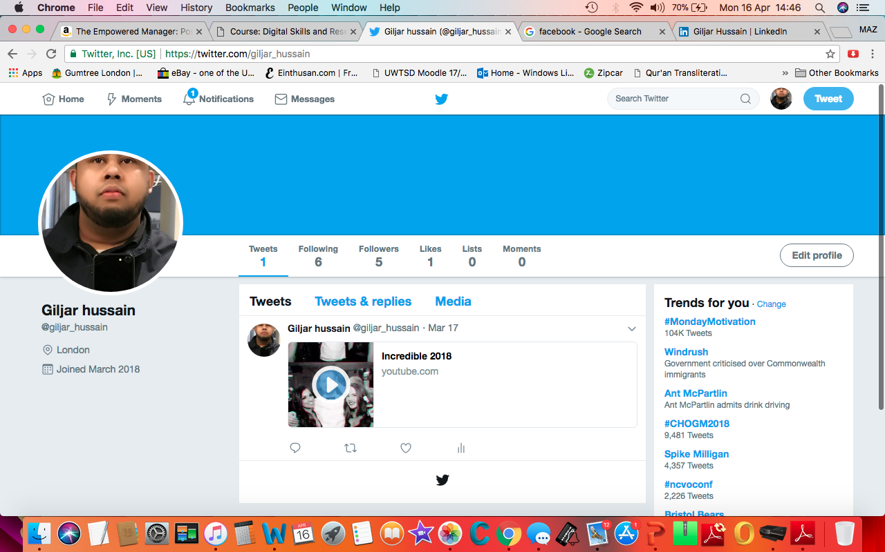

https://twitter.com/giljar_hussain

LinkedIn-
LinkedIn have many advantages and more effective than Facebook when it comes to publicising. As compared to Facebook, LinkedIn is more secure which means that your profile is safer. We often hear about Facebook profiles being hacked as compared to LinkedIn. Hence people prefer LinkedIn over Facebook.
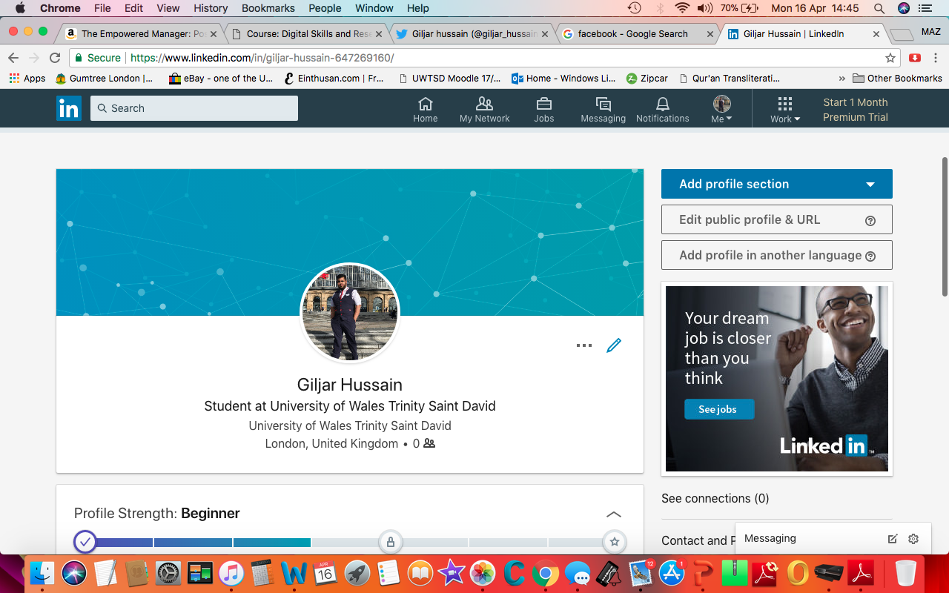
https://www.linkedin.com/in/giljar-hussain-647269160/

Evaluation of the possibilities for communication and collaboration in the workplace that use of these social networks might provide
In order to run any business, the management has to avail better communication regime. And the introduction of social networking sites has made the way of communication better than ever. Just with a social networking account in the mentioned sites, one can get connected with a lot of people who are truly important for the business (Lento et al, 2016). With a small invest here one can promote his/her service to a large number of people and this automatically increases the possibilities of getting more clients and profits.

Conclusion
The rapid inventions and innovation in the genre of technology has made the way better in all aspects. All the business organisations prefer to keep their workplaces and working procedures up-to-date. With the advantages of technology and Internet an organisation can enjoy the best productivity through the employees. When the working procedures get easy automatically the productivity level increased and matches the desired level. The modernization approach such as enabling the modern technology is really a great step for the business organisations to reach the goal within a short span of time.

Reference List

Abdelnour-Nocera, J., Baricelli, B.R., Lopes, A., Campos, P. and Clemmensen, T. eds., 2015. Human Work Interaction Design: Analysis and Interaction Design Methods for Pervasive and Smart Workplaces: 4th IFIP 13.6 Working Conference, HWID 2015, London, UK, June 25-26, 2015, Revised Selected Papers (Vol. 468). Springer.
Bollen, M., Rönnberg, S., Zavoda, F., Langella, R., Djokic, S., Cuifo, P., Meyer, J. and Cuk, V., 2017, September. Consequences of smart grids for power quality: Overview of the results from CIGRE joint working group C4. 24/CIRED. In Innovative Smart Grid Technologies Conference Europe (ISGT-Europe), 2017 IEEE PES (pp. 1-6). IEEE.
Coffing, D. and Bonfiglio, L., 2017. Transaction system for business and social networking. U.S. Patent 9,600,674.
Crook, C., 2016. The discourse of a'smart'technology: implications for educational practice. International Journal of Smart Technology and Learning, 1(1), pp.4-20.
LinkedIn.(2017)digitalmarketingdeal[online]available at http://digitalmarketingdeal.com/blog/why-linkedin-is-more-effective-marketing-tool-than-other-social-media-platforms/
Kramers, A., Höjer, M., Lövehagen, N. and Wangel, J., 2014. Smart sustainable cities–Exploring ICT solutions for reduced energy use in cities. Environmental modelling & software, 56, pp.52-62.
Lento, T.M., Smith, S.A. and Braginsky, D.E., Facebook Inc, 2016. Creating groups of users in a social networking system. U.S. Patent 9,450,993.
Mwasilu, F., Justo, J.J., Kim, E.K., Do, T.D. and Jung, J.W., 2014. Electric vehicles and smart grid interaction: A review on vehicle to grid and renewable energy sources integration. Renewable and Sustainable Energy Reviews, 34, pp.501-516.
Peek, S.T., Wouters, E.J., van Hoof, J., Luijkx, K.G., Boeije, H.R. and Vrijhoef, H.J., 2014. Factors influencing acceptance of technology for aging in place: a systematic review. International journal of medical informatics, 83(4), pp.235-248.
Scardamalia, M. and Bereiter, C., 2014. Smart technology for self-organizing processes. Smart Learning Environments, 1(1), p.1.
Yagcitekin, B. and Uzunoglu, M., 2016. A double-layer smart charging strategy of electric vehicles taking routing and charge scheduling into account. Applied energy, 167, pp.407-419.

