How does poor nutrition play a role in disadvantaging a child's physical development?
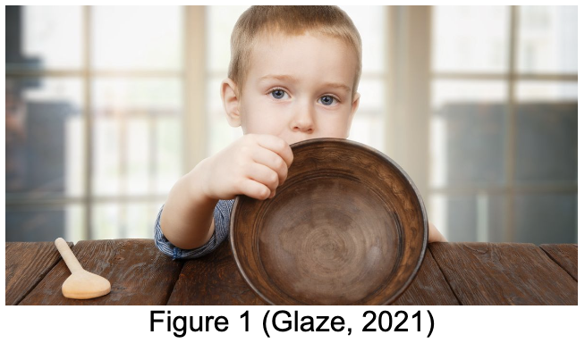
An alarming research study from UNICEF published in 2019 has raised massive concerns across the world. They found that on a global scale, "1 in 3 children under five is either undernourished or overweight." This is equal to over 200 million children. How is this the reality of the time we are living in?
This UNICEF study goes on to explain how over 60% of children aged between 6 months and 2 years are not fed an adequate amount of food to support their growth and development. Another study reported that such severe undernourishment which is reflected in these figures puts children at risk of stunted growth, poor brain and intellectual development and weak immune system leading to increased infection rates (Brands, B. et al. 2016, p. 31-39). These statistics are extremely concerning and raises questions about how we can put a stop to these growing trends.
There are many factors that can contribute to a child receiving poor nutrition such as poverty, lack of access to resources and poor parental/guardian understanding of the importance of good nutrition and how this affects a child's physical development. As someone who works with young children, I am shocked and saddened by how many children are affected by this. I can't stress enough the importance of recognising the signs and symptoms of undernourishment in children and the responsibility we have to report concerns to our seniors to ensure that every child is safe.
The term poor nutrition is often used to describe someone who is underweight and undernourished however this term does not solely reflect this, as the NHS defines poor nutrition as consuming a diet that does not contain the recommended amount of nutrients. Therefore, poor nutrition can also mean excessive consumption of food with poor nutritional value which can lead to obesity and an overwhelming number of health complications in later life.
Understandably, there are many reasons for childhood obesity and some factors that can contribute to this include poor diet, lack of exercise, poverty, parents using convenience foods and psychological factors such as stress (Roth, E. 2022).
Childhood obesity and over nutrition can result in lifelong health complications such as developing type 2 diabetes, high cholesterol and high blood pressure which all increase the risk of coronary heart disease, whilst also increasing the risk of developing arthritis, asthma and liver disease (Mayo Clinic, 2022). These conditions are very serious and increase mortality therefore a change needs to be made very soon.
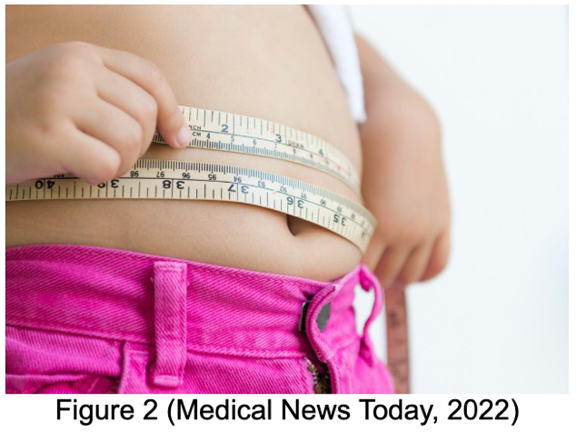
The UK Government found that in 2017, over 30% of children between the ages of 2 and 15 were classed as overweight according to their body mass indexes which led to the generation of the sugar tax and the target for companies to reduce sugar content by 20% by 2020. Unfortunately, the average sugar reduction from all food categories was a measly 3% (Public Health England, 2020). This shows that these changes made no difference to national sugar consumption and is therefore not a sustainable way of reducing obesity rates. The government need to act on these results and come up with a much better solution.

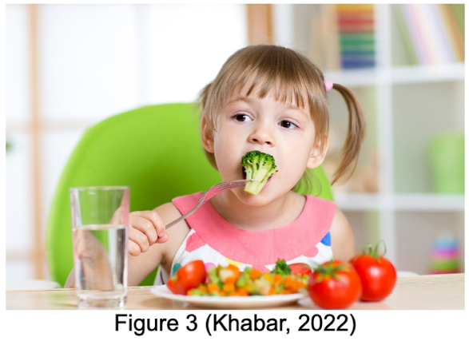
From my experiences during primary school placements and jobs working with children with additional learning needs, I have encountered and helped many children who were over-nourished. A particular experience springs to mind was the time I was taking care of an 11 year old child who has dysphagia, Down's syndrome, global developmental delay and immobility. During the time he was under my care, we were concerned about his weight in relation to his height. Following discussion with my senior we concluded that it would be best to have a discussion with his parents to consider how best we can help him. We all agreed that developing a healthier meal plan and encouraging more exercise by supporting him out of his wheelchair to allow him to crawl to his toys during playtime.
This was really rewarding as I was able to watch him and his parents progress through making these small changes which had a very positive outcome. It helped improve his weight, gave him more energy during playtime and he now seems happier within himself. I learned a lot from this experience as it opened my eyes to see how simple changes can make a big difference to people's lives. I also learnt the importance of a healthy lifestyle and how it is my responsibility to ensure every child within my care has access to good nutrition.
I am highly motivated about preventing childhood obesity from happening at a young age and encourage you to help in anyway possible. There are many ways we can help children follow a healthier lifestyle such as educating parents about the importance of a balanced diet and stressing the effect obesity can carry on into later life. Children learn by example therefore by us eating a healthier meal in front of our children and encouraging family time to be outdoors walking or playing games rather than sitting inside in front of the tv. These small changes have a mass effect on both a child's physical and mental wellbeing. And we can all benefit from these changes by breaking the chain of poor nutrition culture for future generations.
For more information on how to help please refer to the following resources:
- https://www.nhs.uk/live-well/healthy-weight/childrens-weight/very-overweight-children-advice-for-parents/
- https://www.youtube.com/watch?v=IcHyyEWE5Fg
- https://www.who.int/news-room/fact-sheets/detail/obesity-and-overweight

References
UNICEF (2019) Poor diets damaging children’s health, warns UNICEF. Available at: https://www.unicef.org.uk/press-releases/poor-diets-damaging-childrens-health-warns-unicef/ (Accessed: 28th December 2022)

National Health Service (2020) Malnutrition. Available at: https://www.nhs.uk/conditions/malnutrition/#:~:text=Malnutrition%20is%20a%20serious%20condition,getting%20more%20nutrients%20than%20needed (Accessed: 28th December 2022)

Brands, B. et al. (2016) ‘The effect of diet on the physical and mental development of children: views of parents and teachers in four European countries’, British Journal of Nutrition, 122, pp. 31-39. DOI:10.1017/S000711451500032X

Mayo Clinic (2022) Childhood Obesity. Available at: https://www.mayoclinic.org/diseases-conditions/childhood-obesity/symptoms-causes/syc-20354827 (Accessed: 28th December 2022)

Roth, E (2022) Childhood Obesity. Available at https://www.healthline.com/health/weight-loss/weight-problems-in-children (Accessed: 28th December 2022)

Public Health England (2020) Sugar Reduction: report on progress between 2015 and 2019. Available at: https://assets.publishing.service.gov.uk/government/uploads/system/uploads/attachment_data/file/984282/Sugar_reduction_progress_report_2015_to_2019-1.pdf (Accessed: 28th December 2022)

National Health Service (2018) What can I do if my child is very overweight? Available at: https://www.nhs.uk/live-well/healthy-weight/childrens-weight/very-overweight-children-advice-for-parents/ (Accessed: 28th December 2022)

mDhil Med (2015) Preventing Obesity in Children. Available at: https://www.youtube.com/watch?v=IcHyyEWE5Fg (Accessed: 28th December 2022)

World Health Organisation (2021) Obesity and Overweight. Available at: https://www.who.int/news-room/fact-sheets/detail/obesity-and-overweight (Accessed: 28th December 2022)

Figures
1. Glaze, B (2021) Create Food Security Minister post so poorest families have enough to eat, says MPs. Available at: https://www.mirror.co.uk/news/politics/create-food-security-minister-post-23862653 (Accessed: 28th December 2022)

2. Medical News Today (2022) Childhood obesity rates rise 10-fold since the '70s. Available at: https://www.medicalnewstoday.com/articles/319710 (Accessed: 28th December 2022)

3. Khabar, M (2022) Nutritional Guidelines for Kids of Every Age. Available at: https://english.makalukhabar.com/2022/11/79632/ (Accessed: 28th December 2022)

Have we considered the impact attachment has on the cognitive development of children?
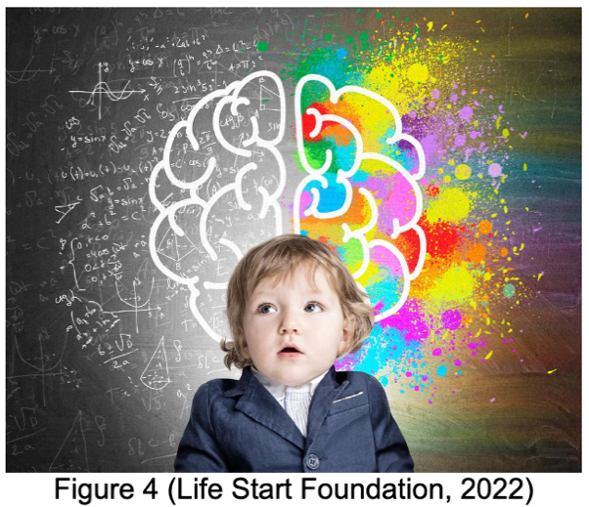
Attachment is a word that is commonly used in childhood and can be defined as a “lasting psychological connectedness between human beings” (Bowlby, 1969). Attachment between a baby and parent develop from birth and continues throughout childhood where each stage of attachment is different. But have we considered the impact that attachment has on the cognitive development of children?

English psychoanalysist, John Bowlby, released his maternal deprivation attachment theory in 1958 which involved research and analysis about the effect of attachment on the development of a child. He proposed that continued attachment deprivation between a baby and parent could result in irreversible developmental difficulties in cognition, as well as social and emotional development problems (McLeod, 2017). With reference to this theory, McLeod explains the potential lifelong consequences of attachment deprivation which include reduced intelligence, depression, affectionless psychopathy, aggression and poor behaviour in school (McLeod, 2022). It has been found that as a child with attachment issues gets older, they may find it harder to ask for help, struggle to form positive relationships with others, unable to calm themselves down during stress and anger, withdraw from activities and struggle to concentrate in school (The National Society for the Prevention of Cruelty to Children, 2021). These domino effects are irreversible and will carry on into adulthood if the trigger of attachment deprivation and other factors are not corrected.

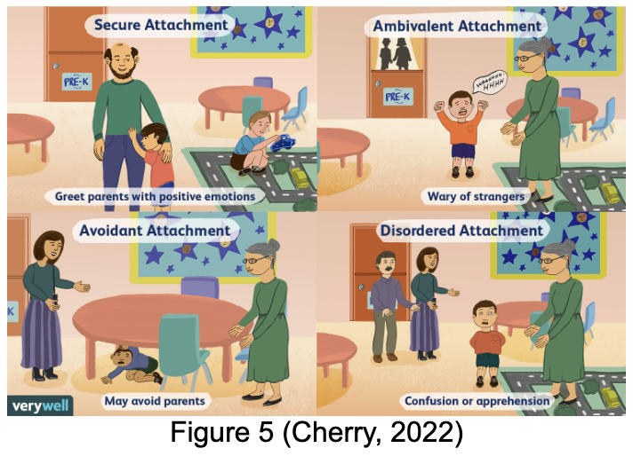
Included in Bowlby’s Attachment Theory there are 4 different types of attachment style which include secure, preoccupied, dismissive and fearful. A great video to explain this can be found here: https://www.youtube.com/watch?v=2s9ACDMcpjA. The main one I will discuss today is secure attachment as this is the most important attachment style we would like our children to have. There are 5 conditions needed for your child to be securely attached to you which includes feeling safe in your company, feeling seen by you, finding comfort in you, feeling valued and feeling supported to explore (The Attachment project, 2020).

We know the consequences of attachment deprivation and its potential for affecting and dictating the way a child learns and behaves in school, job prospects and ability to form positive relationships. We really need to address
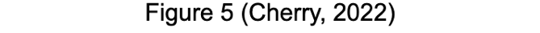
this if we have any concerns about a child, but when is it too late?

The time period from birth up to the age of 5 is considered a crucial time for brain growth and development, 90% of brain growth occurs here by age 5. This is the time where major neurodevelopmental milestones take place which create the ability for a child to learn and form relationships (First Things First, no date provided). This is also the time where attachment formation is crucial. Jean Piaget’s 1936 theory of Intellectual and Cognitive Development explores the stages of a child’s cognitive development, which includes a chronological timeframe explaining when a child develops and gains intelligence. Here is a summary of each stage of development (McLeod, 2022):

Stage | Age | Development
Sensorimotor | Birth to 2 years old | Object permanence, self-recognition and deferred imitation
Preoperational | 2 to 7 years old | Symbolic thought
Concrete operational | 7 to 11 years old | Logical thought
Formal operational | 12 years to adulthood | Scientific thought
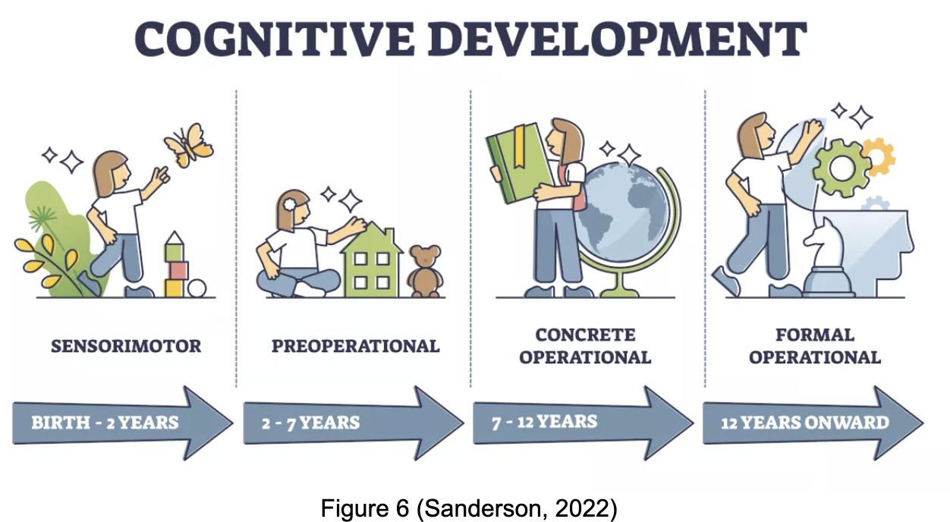

This shows that if there is attachment deprivation between a baby and parent/primary carer, it runs the risk of disrupting these neurocognitive developmental milestones to take place. This can deprive the child from developing to their full cognitive potential due to the direct impact attachment has on growth and development of the cognitive system. Why isn’t this talked about and more widely known?

From my experience working with children in a day nursery where the ages run between 5 months and 5 years, we understand the importance of supporting secure attachments to help aid their development as this age is a crucial point of their growth. Following training we were given advice on how to promote healthy attachments to help children feel safe and supported when away from their parents in order to have the confidence to explore and learn within their new environment. The best advice that I found to work was being sensitive towards the children to help build a trusting relationship by responding to their different signals including crying. We encouraged positive behaviour and after following this advice I have definitely noticed changes within my own working experience. I am now more aware of each child’s individual needs and how best I can help them during times of difficulty. I now know how best I can facilitate their growth and development on an individual basis due to the development of a secure attachment where the child now feels like they are in a safe setting and has the confidence to explore and play. This helps aid their cognitive development where they will develop through each milestone supporting their intelligence, learning ability, motor skills and emotional and social development.
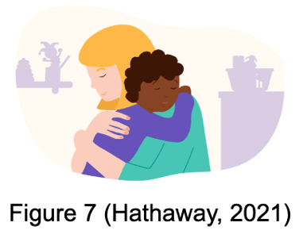
What you can do to help promote secure attachments with your child:
- Read and respond to your child’s signals such as crying
- Soothe children in distress
- Engage in physical contact such as hugging
- Play with your child, especially their favourite games
- Spend as much quality time together as possible
- Keep eye contact and share facial expressions during times of joy
- Be fully present - ditch the electronics for the day and maybe explore the outdoors

For more information, here are some useful links:
- https://www.parenta.com/wp-content/uploads/2020/10/The-Importance-of-attachment-and-how-to-promote-it-in-your-setting.pdf
- http://www.urbanchildinstitute.org/articles/features/4-ways-to-promote-healthy-attachment-in-infants
- https://www.himama.com/blog/promoting-healthy-attachments/#:~:text=Attachment%20is%20the%20unique%20bond,child's%20overall%20development%20and%20learning

References
Bowlby, J (1969) Attachment. Attachment and Loss, 1, pp. 1-326. Available at: https://mindsplain.com/wp-content/uploads/2020/08/ATTACHMENT_AND_LOSS_VOLUME_I_ATTACHMENT.pdf (Accessed: 29th December 2022). DOI not available.

McLeod, S (2017) Bowlby’s Attachment Theory. Available at: https://www.simplypsychology.org/bowlby.html#:~:text=include%20the%20following%3A-,Bowlby's%20maternal%20deprivation%20hypothesis%20suggests%20that%20continual%20disruption%20of%20the,to%20be%20permanent%20and%20irreversible (Accessed: 29th December 2022)

McLeod, S (2022) What is Attachment Theory. Available at: https://www.simplypsychology.org/attachment.html (Accessed: 29th December 2022)

The National Society for the Prevention of Cruelty to Children (2021) Attachment and Child Development. Available at: https://learning.nspcc.org.uk/child-health-development/attachment-early-years#article-top (Accessed: 29th December 2022)

The School of Life (2018) What is your attachment style? https://www.youtube.com/watch?v=2s9ACDMcpjA (Accessed: 29th December 2022)

The Attachment Project (2020) Secure Attachment - from childhood to adult relationships. Available at: https://www.attachmentproject.com/blog/secure-attachment/ (Accessed: 29th December 2022)

First Things First (date not provided) Brain Development. Available at: https://www.firstthingsfirst.org/early-childhood-matters/brain-development/ (Accessed: 29th December 2022)

McLeod, S (2022) Piaget’s Stages of Cognitive Development. Available at: https://www.simplypsychology.org/piaget.html (Accessed: 29th December 2022)

Parenta (2020) The importance of attachment and how to promote it. Available at: https://www.parenta.com/wp-content/uploads/2020/10/The-Importance-of-attachment-and-how-to-promote-it-in-your-setting.pdf (Accessed: 29th December 2022)

Urban Child Institute (2014) 4 Ways to Promote Healthy Attachment in Infants. Available at: http://www.urbanchildinstitute.org/articles/features/4-ways-to-promote-healthy-attachment-in-infants (Accessed: 29th December 2022)

Louis, A (2020) Promoting health attachments with children. Available at: https://www.himama.com/blog/promoting-healthy-attachments/#:~:text=Attachment%20is%20the%20unique%20bond,child's%20overall%20development%20and%20learning (Accessed: 29th December 2022)

Figures
4. Life Start Foundation (2022) Your Child's Brain Development. Available at: https://www.lifestartfoundation.org/parenting-tips/your-childs-brain-development (Accessed: 29th December 2022)

5. Cherry, K (2022) The Different Types of Attachment Styles. Available at: https://www.verywellmind.com/attachment-styles-2795344 (Accessed: 29th December 2022)

6. Sanderson, C (2022) Jean Piaget's Theory of Cognitive Development. Available at: https://www.wondriumdaily.com/jean-piagets-theory-of-cognitive-development/ (Accessed: 29th December 2022)

7. Hathaway, A (2021) What is Attachment Theory in Early Childhood? Available at: https://www.famly.co/blog/attachment-theory-early-childhood (Accessed: 29th December 2022)

Does poverty have a direct influence on the social and emotional development of a child?
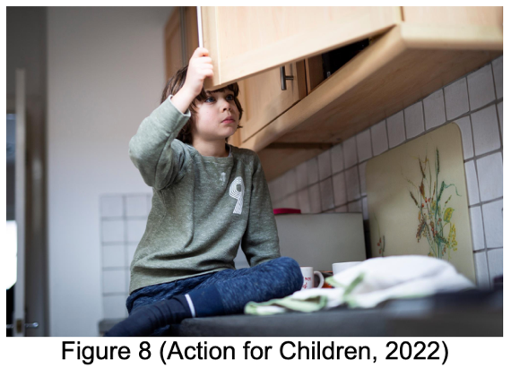
Poverty is a massive debate during the current economic crisis and recent statistics from UNICEF found that over 356 million children worldwide live in poverty and shockingly, Wales has a child poverty rate of 31%, the worst in the UK (Jackson, 2022). Whilst we are noticing the rising costs of daily living, have we really thought about the negative strain that poverty is putting on our children?

Poverty is causing mass effects on the development of children however one of the biggest causes of concern is their wellbeing. Causing us all to have the same question, does poverty have a direct influence on the social and emotional development of children?

Emotional development is defined as the “process of learning to recognise and express one’s feelings and to establish one’s identity as a unique person” and social development can be defined as “the process of learning to interact with others and to express oneself to others” (Greenway, 2014).

Some children growing up in low-income households are already placed at a disadvantage in life before they even have chance to start. They face increased risk of poor nutrition, poor mental health and social difficulties. This deprives them of reaching their full potential in terms of learning ability, relationship formation, confidence and self-belief. Living in poverty also has the effect of raising emotional and physical stress in children which can trigger a number of severe health conditions affecting the heart, endocrine system and higher cognitive function (Compassion, 2022).
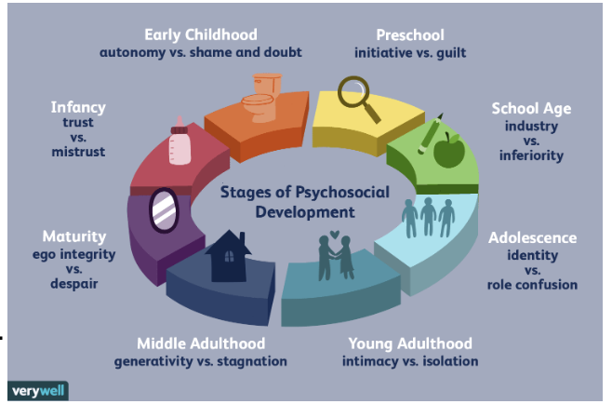
Erik Erikson developed the theory that personality develops in a set of chronological steps which take place when what he called a “psychosocial crisis” occurs and how the response can have a positive or negative impact on a child’s social and emotional development through to adulthood. This suggests that a child either matures with the desirable developmental characteristics or develops social and emotional difficulties in particular life aspects (McLeod, 2018). In the context of childhood poverty, Erikson stated that the fourth stage of psychosocial development occurs between ages of 5 and 12 where the psychosocial crisis is “Industry versus Inferiority” where the basic virtue of competency should be developed. Poverty is sadly linked with poorer school accomplishments, relationship formation, low confidence and increased struggle of developing specific skill competences which can lead to childhood bullying (The Children’s society, 2022). All these factors combined apply an extra burden to a child when they are trying to navigate their emotions through the stages of psychosocial development which makes it more difficult to achieve the desired outcome.

Bullying is sadly associated with children from poorer families due to the struggle of additional school costs such as meals, stationery and uniform replacements due to children constantly growing. Bullying is detrimental towards social and emotional development as it reduces a child’s confidence, appreciation of self-worth and increases the likelihood of developing poor mental health such as depression. It has been found that depression rates are proportionately linked with poverty as children are 5 times more likely to be unhappier if living around debt than children from wealthier families (The Children’s Society, 2022).

Childhood poverty has been linked with causing structural and functional changes to the key brain structures that are vital for emotion and stress regulation. This is due to the increased exposure to situations such as living in noisy and harmful environments, household money stress and school bullying. These structural changes impact the cognitive function of the brain and damage social and emotional development which can result in the inability to regulate your own emotions. Emotion dysregulation describes the inability to use healthy strategies to control negative emotions in response to stressful situations, causing people to suffer with a staggering amount of negativity and anxiety when facing hardship (Lloyd-Richardson, 2016). This can cause anger and anxiety to be dominant emotions when exposed to particular stimuli with little control on how to emotionally respond which can impact response to stressful and adverse situations which can then continue into adulthood (Evans, G. Kim, P. 2013).

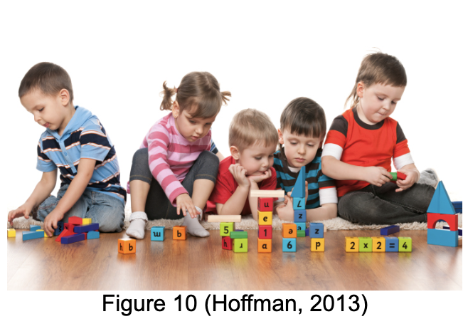
Reflecting on this research, I had never considered the mass effect of the impact of poverty on the social and emotional development of children. The consequences are overwhelming and are becoming increasingly concerning due to the current national economic crisis. It has made me realise how children need help more than ever now. The development of an emotional regulatory system is vital to a developing child as it carries so much importance for adulthood including how we learn, interact with others, form relationships and conduct our daily lives. It is so important that a child learns to regulate their emotions and learns to not react negatively to every adverse event as it helps build the foundation for a healthier mental health. Due to my inexperience in this field of childcare I have spent time exploring methods for helping children learn steps and methods for developing healthy coping strategies in order to achieve emotional regulation appropriate to their age group. I have found that we can help all children through a number of different methods such as giving children the name of the emotion they are feeling, explaining the cause of that emotion and also practising emotion labelling by describing the emotions of favourite film characters. There is so much we can do to aid the emotional and social development of children and I will implement this in my day to day work when working with children.

For more information, here are some useful links:
- https://camhs.rdash.nhs.uk/wp-content/uploads/2021/04/NL-Emotion-regulation-e-leaflet-02.21.pdf
- https://raisingchildren.net.au/toddlers/behaviour/understanding-behaviour/self-regulation
- https://helpmegrowmn.org/HMG/HelpfulRes/Articles/WayEncourageSocialDev/index.html

References
UNICEF (no date provided) Child Poverty. Available at: https://www.unicef.org/social-policy/child-poverty (Accessed: 30th December 2022)

Jackson, L (2022) 60 percent of people in Wales say their health has worsened due to rising cost of living. Available at: https://www.nhsconfed.org/news/60-cent-people-wales-say-their-health-has-worsened-due-rising-cost-living#:~:text=Wales%20now%20has%20the%20worst,insecure%20housing%20(Bevan%20Foundation) (Accessed: 30th December 2022)

Greenway, C (2014) SJTA5001 Applications of Psychology in the Classroom. UWTSD: unpublished

Compassion (2022) Effects of Poverty on Children. Available at: https://www.compassion.com/poverty/effects-of-poverty-on-children.htm (Accessed: 30th December 2022)

McLeod, S (2018) Erik Erikson’s Stages of Psychosocial Development. Available at: https://www.simplypsychology.org/Erik-Erikson.html#:~:text=Erikson%20maintained%20that%20personality%20develops,negative%20outcome%20for%20personality%20development. (Accessed: 30th December 2022)

The Children’s Society (2022) What are the effects of child poverty? Available at: https://www.childrenssociety.org.uk/what-we-do/our-work/ending-child-poverty/effects-of-living-in-poverty (Accessed: 30th December 2022)

Lloyd-Richardson, E. Rolston, A. (2016) What is emotional regulation and how do we do it? Available at: http://www.selfinjury.bctr.cornell.edu/perch/resources/what-is-emotion-regulationsinfo-brief.pdf (Accessed: 30th December 2022)

Evans, G. Kim, P. (2013) ‘Childhood Poverty, Chronic Stress, Self-Regulation and Coping’, Child Development Perspectives, 7(1), pp. 43-48. DOI: 10.1111/cdep.12013

Figures
8. Action for Children (2022) Where is child poverty increasing in the UK? Available at: https://www.actionforchildren.org.uk/blog/where-is-child-poverty-increasing-in-the-uk/ (Accessed: 30th December 2022)

9. Cherry, K (2022) Erikson's Stages of Development. Available at: https://www.verywellmind.com/erik-eriksons-stages-of-psychosocial-development-2795740 (Accessed: 30th December 2022)

10. Hoffman, A (2013) Five toys that can help with social development. Available at: https://www.friendshipcircle.org/blog/2013/04/09/five-toys-that-can-help-with-social-development/ (Accessed: 30th December 2022)

Link to online blog
https://www.blogger.com/u/1/blog/post/edit/preview/2417589897564398925/5763223114622102665

