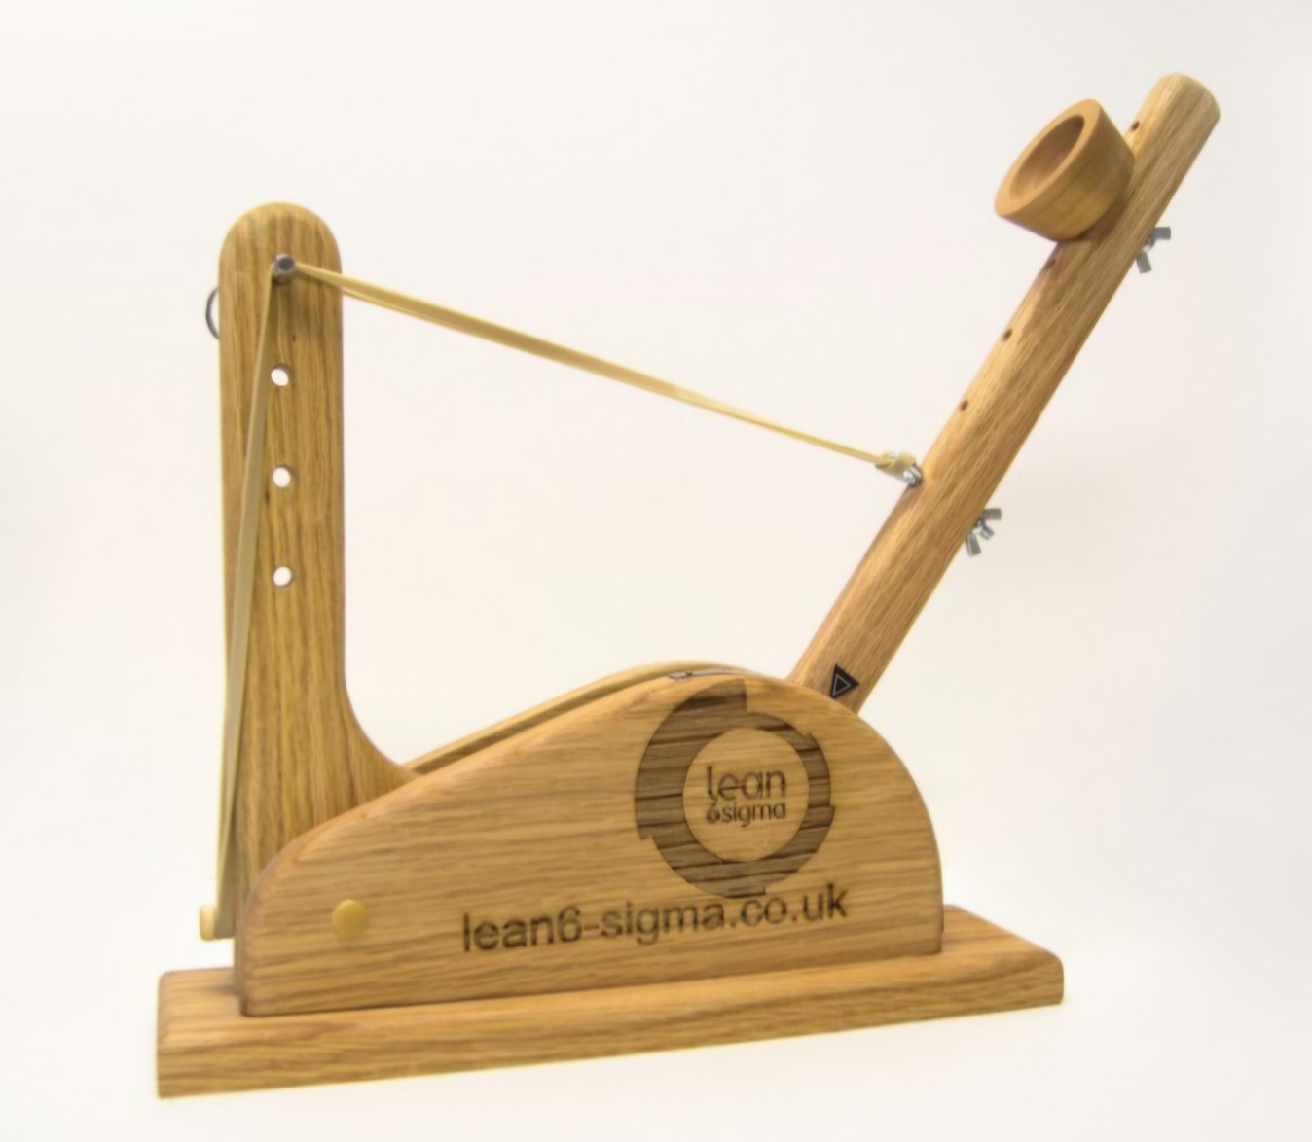

Taguchi Experiment
  - Catapult
Fraser Goodwin | Systems Engineering | 25/04/2025

Contents
Objective 1
Method 1
Apparatus 1
Method 1
Results 3
Discussion 4
Conclusion 4
Reflection 5
References 5

Figure 1 - Taguchi Array Experiment 1 3
Figure 2 - Experiment 1 data 4
Figure 3 - Experiment 1 variables 1 4
Figure 4 - Experiment 1 variables 2 4
Figure 5 - Experiment 2 key feature results 5

Objective
The objective of this task was to use a provided catapult system consisting of a catapult with adjustable settings, a ball, a rubber band to provide motive force, a measuring tape, and a G-clamp to hold it in place and determine the key control factors for the operation of the catapult. This is done by carrying out an experiment using the Taguchi Method which utilizes a type of matrix that efficiently organizes experiments to analyze multiple factors with the minimum number of trials. This is done through using an orthogonal array which negates the need to test every combination of factors, but instead a balanced subset of trials is pre-selected providing maximum experimental insight with minimal effort. Once the key control factors are determined, these are used to predict the performance of the catapult at a given setting

Method

Apparatus
- Catapult with adjustable:
  - Stop Position
  - Band Front Position
  - Band Anchor Position
  - Pull Back Scale
- Rubber Band
- Table
- Measuring Tape
- Ball
- G-clamp
- Laptop to record data

Method
Firstly, all apparatus was collected and set up with the catapult positioned at the end of the table secured to the table with the G-clamp. The measuring tape laid out on the table with the beginning of the tape at the start of the catapult and the ball placed in the firing position. The test consisted of 8 experiments of 7 independent variables that were assessed over 2 levels which were: band front position, band anchor position, 1, 2 interaction, stop position, pull back, 2, 4 interaction, and the operator.
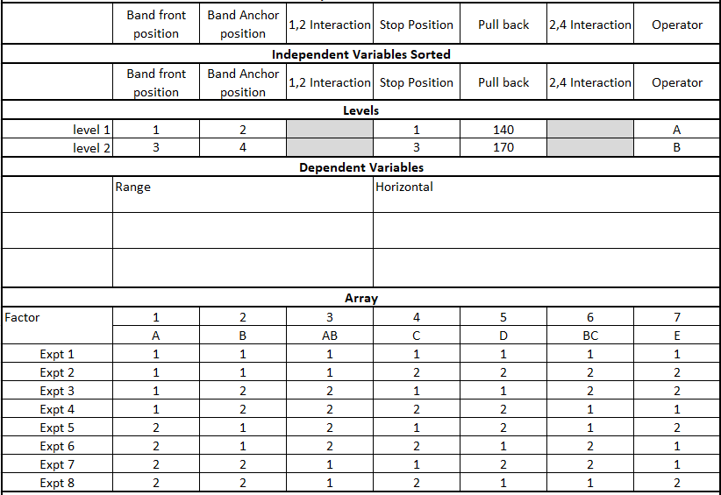
Figure 1 - Taguchi Array Experiment 1
It was entered into the Taguchi matrix at what setting each variable will be set at for the 2 levels and the layout for the first array of experiments can be seen in Figure 1. So for Expt 1, the setting for all variables was for level 1 so the band front position was set to 1, band anchor position to 2, stop position to 1, pull back to 140, and it was operator A who completed the experiment. Once this was completed and the ball was fired, the distance that its first bounce was recorded in the experiment data sheet then this was repeated another 2 times to give more accurate results. The same thing was done for all 8 experiments until a full set of data was achieved.
This then automatically populated the tables in the data spreadsheet for the 2 levels detailing the disparity between the values at both levels. The variables with the most difference between its values then become critical control feature due to their impact on the whole system.
2 key features were then selected, and a 2nd experiment was conducted to evaluate these. Once again thee experiment consisted of 2 levels selecting the maximum and minimum setting for each. The 2 key features were tested against each other using the Taguchi method 3 times and an average was taken. This then allowed for calculation of the mid-point of firing the catapult which was tested by putting key feature 1 at its mid-point and key feature 2 at its mid-point.

Results
Using the Taguchi array matrix in Figure 1, the data for the 8 Experiments can be seen in Figure 2.
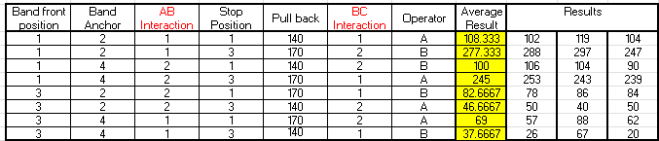
Figure 2 - Experiment 1 data
From the data in Figure 2, a series of graphs for each variable were produced and are shown in Figure 3 and Figure 4.
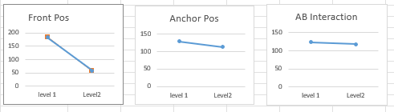
Figure 3 - Experiment 1 variables 1
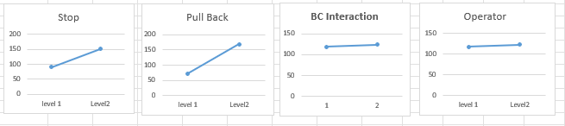
Figure 4 - Experiment 1 variables 2
From Figures 3 and 4, 2 key features were identified as the band front position and the pull back which were analysed against each other to produce the results shown in Figure 5.
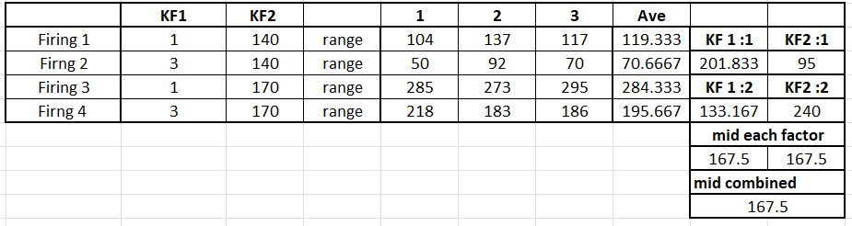
Figure 5 - Experiment 2 key feature results

Discussion
The Taguchi array seen in Figure 1 was used to evaluate all the independent variables to find out which ones changed the most between Levels 1 and 2. This then tells us what the most important feature controls are as they impact the output of the system the most. From Figures 3 and 4, it shows that Band front position and pull back are the 2 most critical features with the stop position coming just behind in 3rd.
The band front position effects the distance of the ball greatly as it changes the tension profile of the catapult. When the band is in the top position which was position 1, this allowed the rubber band to be put under more tension as it was the furthest away from the catapult loaded position and the rubber band angle when under maximum tension was closest to the initial direction of exit from the catapult of the ball.
The 2nd most critical feature for the performance of the catapult was the pull back scale. This had a large impact on the distance that the ball was launched as the further back the anchor was pulled it creates more tension on the rubber band meaning there will be a larger reactive force in turn making the anchor accelerate at a faster rate launching the ball further. On the contrary, if the anchor is not pulled back far, then there is minimal tension on the rubber band meaning the ball would launch with minimal velocity.
Another important feature is the stop position. This is because to achieve maximum distance for a launch from the catapult the launch angle would need to be exactly 45 degrees. The stop position was there to stop the anchor after it had been let go so anything other than 45 degrees would result in a decreased launch performance.

Conclusion
It is clear to see why organizations use the Taguchi method as a solution for engineering and manufacturing problems as its structured experimental design minimizes testing while allowing for maximum insight making it efficient and cost effective. [1] Through the use of orthogonal arrays, this approach allows organizations to design robust systems and are less susceptible to outside noise and variability. It also allows organizations to model for future scenarios as once an optimal setting is identified, future conditions can be simulated to predict long term performance. [2]

Reflection
During the task, my team and I worked well together throughout taking up different roles throughout the experiment to ensure that results could be captured quickly and efficiently. This is important as if the experiment was not carried out in a controlled environment such as outside, then taking too long to do the experiment could incorporate outside noises into your results such as wind direction/speed, temperature and humidity
The only negative was the data capture spreadsheet that was used was initially difficult to understand but after time was taken to digest this it made a lot more sense.

References

[1] | "What Is The Taguchi Method in Quality Control?," [Online]. Available: https://sixsigmadsi.com/what-is-the-taguchi-method-in-quality-control/. [Accessed 25 April 2025].
[2] | "The Guide to the Taguchi Method: A Robust Quality and Efficient Experimentation," 8 October 2024. [Online]. Available: The Guide to the Taguchi Method: A Robust Quality and Efficient Experimentation. [Accessed 25 April 2025].

