

Employability Skills
Carl Mitchell 1806399

January 11, 2019
University of Wales Trinity Saint David

BMSK 4001

Executive Summary
The purpose of this report is to investigate a number of the essential skills that an employer looks for in a jobseeker. Some skills are described as soft skills which can range from a positive attitude, self-confidence and communication skills where other skills are transferable skills which range from written, verbal, numeracy, research and analytical skills. This report will discuss and give a detailed description into several of these skills.

The overall conclusion discovered that a jobseeker can never have too many skills and that the skill set for each job may change with the times. This stresses the need for the jobseeker to research the skills needed for any given role or career as well as methods into how to improve skills already possessed by the jobseeker and to learn the new skills needed going forward into a future career.

Contents
Employability Skills 0
BMSK 4001 0
Executive Summary 1
Terms of Reference 3
Introduction 4
Findings 5
What is employability 5
18 of the most in demand Employability Skills. 5
Interpersonal Communication Skills. 6
Tech Savviness. 8
Negotiation Skills. 9
Team work. 11
Time Management Skills. 12
Franklin Covey Time Management Matrix. 13
Networking. 14
Conclusion. 15
References. 16

Terms of Reference
This report was requested by Laura James on 17th November 2018. The purpose of the report is to discuss the benefits of employability skills to employers as well as the employees in the catering and hospitality industry. This report was compiled by Carl Mitchell. This will investigate some of the problems that a jobseeker faces when advancing their job prospects and some methods into how to plan, prepare and review employability skills which most employers look for. Submission date 11th January 2019.

Introduction
This report will describe the benefits of employability skills for employers and employees working in the catering and hospitality industry. These are skills that go beyond qualifications and experience where education and experience may only make a person suitable to apply for a role but will need other skills to be successful in getting the role. This will include discussions on certain skills and subjects not limited to Interpersonal Communication Skills, Negotiation Skills, Time Management Skills and Networking. According to Skills You Need (2019) most people will hold jobs with different employers and different industries through their working life, making a career for life no longer an option. Thus, making the need to be more flexible in working patterns and prepare to change jobs and industries if better opportunities arise elsewhere. This also means that there are transferable skills that can be useful across all employment sectors.

Findings

What is employability
According to Jobs.ac.uk (2011), states that The UK Commission for Employment and Skills (UKCES) gives the simplest definition of employability as “the skills almost everyone needs to do almost any job”, also mentioning employability not being solely about skills but includes competencies, attitude, behaviour and capabilities. On the Youth Employment UK website, Mistry, L. (2017) explains that there are many types of jobs in the hospitality and catering industry which many employability skills are needed, these range from, counter service assistant, waiting staff, restaurant manager, catering manager and even food manufacturing inspector.

18 of the most in demand Employability Skills.
On the Career addict website, according to Zambas, J. (2018), she writes that the workplace is ever evolving and the professional skills that an employer looks for can change each year. The ability for a jobseeker to obtain new skills can help in staying ahead of the competition. She also quotes Jeff Vijungco, the Vice President of Global Talent at Adobe, believes that “having high IQ or hard skills alone isn’t sufficient”. Stressing the need to constantly discover new skills and advance the skills a jobseeker may already have. Zambas, J. (2018), has listed 18 of the most in demand employability skills. These are: Problem solving, data analytics, social media literacy, creativity, leadership, willingness to learn, emotional intelligence, attention to detail, humility, oral and written communication, teamwork, tech-Savviness, adaptability and flexibility, time management, positivity, determination and drive and organisation.
All these skills can fit into the several jobs that Mistry, L. (2017) writes about which involves cash handling, communicating to customers as well as fellow staff, giving advice, explaining menus and choices, teamwork and leadership skills as well getting things done in time to suit customers needs.
A few of these will be covered in a great more detail below.

Interpersonal Communication Skills.

Brownell, (1992) cited by Lolli, (2013) says that one of the most important skills to be a leader is having the ability to communicate properly and successfully. Cheesebro, O’connor & Rios, (2010) cited by Lolli says the term “communication” is defined as a shared understanding of a message between the sender and receiver. Lolli mentions that there are different types and styles of oral communication that may vary on the level of the leader from informal and formal methods, stating that less formal methods are used more on employees in a workplace on a day to day where more informal is used where the leader level is higher up.
On their website, Businesstopia (2018), explains other methods to Interpersonal Communication where the process of exchanging information, ideas and feelings between two or more people can be verbal but where the messages can be in a tone of voice as well as non-verbal such as facial expressions, body language and gestures. Businesstopia (2018), also mentions a certain relationship when communicating can affect the nature of what can be said, stating that an employee wouldn’t say things to a boss that would be said to a friend or say to a friend that would said to a family member.
Below diagram shows Elements of Interpersonal Communication.
Buisnesstopia (2018) explains the process.
Source-Receiver. The term Source-receiver is the dual role of a person as a source and receiver. Source formulates and sends messages while receiver, receives and understands the message.

Messages. For interpersonal Communication to work, the message must be sent and received. This can be from face to face, verbal and non-verbal through body language, movements and gestures. Online communication can be used with words, pictures, videos and audios.

Feedback. Information from messages can be monitored from nods, smiles and even confused looks. Feedback can be delayed in online communication.

Channel. This refers to channels used between source and receiver from face to face, voice and gestures.

Noise. Interference can occur when receiving a message this can by physiological to semantic even though noises can’t be completely eliminated, there can be ways to reduce it.

Context. An environment can influence the content and forms of communication.

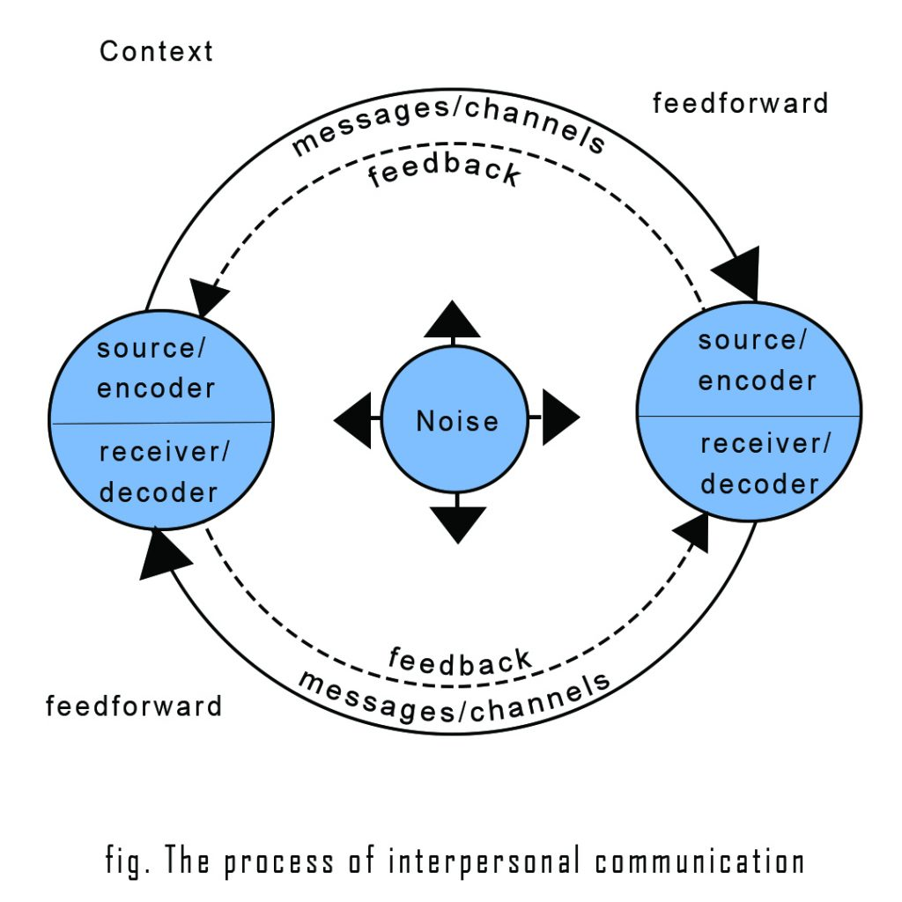
Copyright © 2018 Businesstopia

To summarise Businesstopia (2018), suggests there are many ways and methods to communicate as well as receiving the message. The need for practice, preparation and the ability to adapt to the relationship between source and receiver can be one of the best skills to have.
On the hotelogix website, Pathak, M. (2014), explains some of the benefits of effective communication in the hotel industry which are improved customer service, understanding instructions given from supervisors and other staff, greater understanding of the hotels technology, a boosted confidence in approaching guests, a more positive working environment and level of understanding between heads of department.

Tech Savviness.

According to Skills you need (2019), employers would expect some I.T. skills or the ability to use the basics of technology that is in use around the workplace. In a newspaper article from ABA Bankers News, Ginovsky, J. (2000), asks the readers how adept they are at using all the power of the computer or telecommunications they have, how productive could they be if they had the capability of using just a few things that the equipment could offer. The main question was how effective an employee would be with the ability to use all the technology available to be more productive. Ginovsky, J. (2000), informs that the ABA Bankers staff were given a challenge over a 3 month period to learn 50 new things about technology where the staff learned a lot about technology and about themselves as well. Starting with these questions for each new thing to learn, what is a thing? Relating to a feature, programme or tip. What’s the point of such a program? Making aware that technology keeps changing and to embrace it. How was the campaign structured? Basically, reward for the effort and get support for the challenge. Why 50 new things? To create more of a challenge knowing that the first 20 would be easy and get harder to find more than 30.
On the webpage, Gooster.net Munlak, A. (2018), explains a few advantages and disadvantages of tech in the hotel industry stating that hotels need to keep modifying themselves as to not fall behind as to benefit both staff and guests. One disadvantage is that employees see new technology as a less need for humans and a lack of job opportunities. Technology isn’t perfect so if the technology fails then the need for humans will still be needed otherwise the hotel would not run. This will benefit the employer if the worker is sufficiently skilled in use of the technology to ensure a smoother experience for guests.

Negotiation Skills.

In the journal Learning Negotiation Skills: Four Models of Knowledge Creation and Transfer, Nadler, J. Thompson, L & Boven, V, L, (2003) inform that due to a review of learning and training literature, it reveals that to train people to be an effective negotiating there are four common methods: didactic learning, learning from information revelation, analogical and observational learning. The methods were tested, the outcome was favourable for both parties when analogical and observational learning were better than experience alone. Didactic and information revelation outcomes did not differ from any other condition. The largest performance increases were due to observation learners.
However, Fisher, R. Ury, W. & Patton, B. Cited by Shonk, k. (2018), in her blog, Six guidelines for “Getting to Yes” argued that negotiation strategies can and should be looked for by bargainers to help both parties get more of what they want. This consists of treating each other fairly, listening closely to each other when exploring options that can increase value where negotiators can find better ways of getting to yes without the need for hard bargaining and unnecessary concessions.

Here is a brief description of the six skills.
1. Separate the people from the problem. Imagine the situation from the viewpoint of the person that is being negotiated with, considering the feelings, values and opinions.
2. Focus on interests, not positions. Find out the counterpart’s interests by asking questions that may motivate them and show interest. Don’t begin with stating your position.
3. Learn to manage emotions. Letting each person speak their mind will benefit both sides and express emotions related to the negotiation.
4. Express appreciation. Nobody likes to feel unappreciated, this is also true in negotiation. Express appreciation which will work to understand the others perspective.
5. Put a positive spin on your message. Speak as the individual and not for a group, this will show a person’s individual concerns and observations.
6. Escape the cycle of action and reaction. Avoid the trap of action and reaction in common negotiation. Use a skill called “negotiation jujitsu” which avoids escalation by refusing to react but channels resistance into more productive negotiation strategies for example, options for mutual gain, independent standards and interests.

Many negotiation tactics have many steps but have the same reoccurring similarities. These seem to consist of which learning method is more effective, how to communicate, show interest for both parties as well as see things from the other persons point of view. The more of these negotiation skills that are used seems to be the key to a successful negotiation (Fisher, R. Ury, W. & Patton, B. Cited by Shonk, k. 2018).

On Hospitalitynet, Mahmoud, A. (2016), writes of 5 successful tips which are: Understand the hotel brand and service value, this will benefit both employer and employee to deal with competitors and customers which could point out weak points in the brand. Know your sales strategy, this will help to solve customer problems with knowledge of products or services. Study the competition: Look for strengths and weaknesses from current and potential competitors which can create opportunities. Understand the customers behaviour and motivation: Each customer is different so the ability to using past experiences in the hospitality industry can benefit both parties when negotiating. Negotiate value, not price: Make a point of the value of services or products, this benefits the worker to better understand and sell the services or products before a price is even mentioned.

Team work.

Zambas, J. (2018), suggests every industry relies on working as team, so having the skill to work effectively as a team is essential to the employer. An employer may ask a potential candidate for examples of this skill in an interview.
According to Root, G. (2018), on the Smallbusiness.chron.com website, there are characteristics of effective teamwork, which can see the cohesion and productivity in a group when put into place. The group must be unified and committed to a goal by using the team’s resources where they can complete the task when they all come together. Everyone in the team must participate to make each member aware they are essential to the success of the team. Open communication, where all members do not talk behind other members backs but ensure respect for each person with face-to-face communication. Have a built-in decision-making system that helps situations more effectively where each member’s knowledge and ideas can contribute to the goal. Use of ideas and brainstorming is a good way for groups to gather information from each person and generate responses that the team can then use to get a general idea that can resolve the team’s solution.
On the Sandler Training website, Mattson, D. (2015), explains 6 benefits of teamwork in the workplace. Creativity and learning to use individual experiences and share with others, blends complementary strengths, builds trust, teaches conflict skills, a wider sense of ownership and healthy risk taking. These benefits in hospitality can help the worker to perform duties effectively and deal with customers, complete goals and targets.

Time Management Skills.

According to Arvidsson, N. (2016), time management is a skill that is used in everyday life obviously the better jobseekers are at time management, the more effective the duties can be. Employers not only look for this in employees but have methods to monitor their effectiveness. There a many techniques and resources to help improve Time management skills.
In the webpage in the Recruiter, Arvidsson, N. (2016), 7 Ways to Improve Your Time Management Skills he mentions the use of the 7 methods below.
1. Make a schedule and stick to it.
Organise the days and weeks in advance, there will be surprises but will give a general idea of the tasks and responsibilities. Avoid getting lost by spending a few weeks monitoring things that are done daily to help identify patterns and similar task that can be put into a schedule.
2. Prioritize. Identify the more important tasks and which deliver the best returns so that they create the right impact in short to long terms, be self-aware of these over the less important tasks.
3. Set boundaries. People can’t read minds so the need to inform people of when unavailable as to be able to work in peace and be more effective. Decide what counts as an emergency and when available to answer simple requests.
4. Account for good distractions. Nobody can work for hours on end and there will be distractions. Try to account for distractions into any schedule. Take a break to help stay productive, even a few minutes for fresh air or snack.
5. Stay away from bad distractions. Identify which distractions take up too much time. Some may take the worker away from the task and get way behind. Apps and inbox can be distracting as well as anything social media.
6. Get some tech help. Look for apps that can be of use to boost productivity, a calendar, toggl or even something simple as a to-do list on an app.
7. Never Procrastinate. Make the most of the allocated time, if it can be done today then do it. If any extra time is gained, then start a task earlier to finish the week earlier.
In the E-book, Best practices: Staying Focused on Time Management, Hoover, J. (2017), says that saving time is not much use if the time saved is focused on the wrong tasks. The key to effective time management is focus. When focused on a single goal, the mental and physical energy are all applied to achieving it. Keeping a clear focus on goals will fend off interruptions and demands from others that will try to stop workers from success. When focused, a worker is in control of the time and knows what is important and can put priorities first.

The Franklin Covey Time Management System.
On the website, Forbes, Krogue, K. (2013), discusses Time Management, he informs that Franklin Quest merged with Stephen Covey’s company to become Franklin Covey. Stephen Covey, also known for his book, The 7 Habits of Highly Effective People, promoted time management to a whole new level by adding a fourth level or four quadrants to the matrix, making the quadrant four model a very powerful time management tool. Krogue, K. (2013), explains that the urgent and non-urgent section may be both important but to know first things first by adding principles that were necessary in agnostic and realistic values. He also inserted roles into the model warning of the need to find time in important life roles for example, spouse, children, friends and self. His quicker visual demonstration of using 4 jars and adding big rocks first, pebbles then sand and pouring water on top to make all jars settling together is to illustrate that a person starts each week with big rocks, pebbles etc meaning each job and the bigger the item to put in the jar means which could be done first.

Franklin Covey Time Management Matrix.
Below is an example of the Franklin Covey Time Management Matrix.
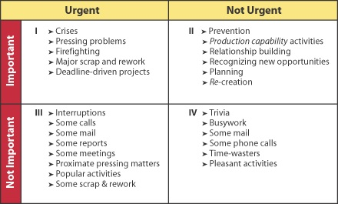

Time Management needs a strong attitude, planning and discipline as well as being resourceful in use of technology that can be used help with time as well as monitor and review any progress (Forbes, Krogue, K. 2013).
In the Toast Restaurant blog, Burns, D. (2018) writes 7 time management skills that actually work in a restaurant can be used to benefit the worker where as long as the worker plans ahead, has the discipline to use the time effectively, break the work down with a to-do list, the task can be completed more efficiently and the worker may gain more extra time in the process.

Networking.

Kennedy, E. (2019) suggests networking is the ability to create a relationship between the individual and other persons in business where each can gain from each other.
First impressions are important so knowing where, when and how best to start can be an essential skill. In the Career Confidential website Kennedy, E. (2019), writes about five ways to break the ice at networking events which can be intimidating for introverts. The five steps are…
1. Arrive early. There are fewer people present making it a little less intimidating to approach people also creating the opportunity to meet someone who could help or even introduce other people when they arrive.
2. Bring a friend or colleague with you. It can help break the ice and help gain more confidence where leaving the option to split up later to meet new people.
3. Be prepared with Questions. Listen to other people even if they may be more interested in themselves then engage with some follow up questions.
4. Be approachable. Don’t stand in the corner, out of sight or look uncomfortable, have copies of a bio or business cards, it may catch a person’s attention giving them their opportunity to break the ice.
5. Be yourself. Be yourself on paper as well as in person because most executives or networking experts can tell a fake person right away.
In the Balance Careers website, Wolfe, L. (2018), mentions not to go to a social or business event under the impression that it is solely to benefit someone who goes to them. It is not about making sales pitches but relationship building where both parties can benefit from it in some way.
Wolfe, L. (2018), talks about two most important and valuable networking skills to develop are listening and asking questions. Listening validates value and shows respect where talking too much can be rude so thinking about what questions to ask can show sincerity and build trust. A good listener needs to know a few things, for example, maintain eye contact, don’t fidget, shift weight or show signs of being bored. Nod to show agreement without interrupting. Asking the right questions can became an art where the wrong questions can offend easily. Keep the questions positive and focused and build trust by not changing subjects even if it may be a negative topic.
In the EHL Blog, Bruines, L. (2017) writes of several top benefits of networking for hospitality which are gain confidence where the employee can learn through practice and connect with people in person and online. Build friendships with people so the employee can relate to people in the same industry. The employee can then learn from others and gain even more experience. The employee can build a personal brand which will lead to more opportunities.

Conclusion.

As Skills You Need (2019), informs, there seems to be an ongoing demand for skills to keep up with the evolution of the job industry including the catering and hospitality industry as well as advancements in technology. As Jobs.ac.uk (2011) informs, employability is not the same as subject knowledge, experience or qualifications. Even a CV with degrees and a PHD doesn’t successfully secure a position stressing the need for the jobseeker to research and plan for what the employer desires from the candidate.

References.
Ardvidsson, N. Recruiter.com, (2016),’7 Ways to improve Your Time Management Skills’, [Online] https://www.recruiter.com/i/7-ways-busy-to-improve-your-time-management-skills/ (Accessed: 4 January 2019).
Businesstopia (2018),’Interpersonal Communication’,[Online] https://www.businesstopia.net/communication/interpersonal-communication-examples (accessed: 4 January 2019).
EHL Blog, Bruines, L. (2017), ‘Top Benefits of Networking for Hospitality Industry Professional’,[Online] https://blog.ehl.edu/top-benefits-of-networking-for-hospitality-industry-professionals (Accessed: 6 January 2019).
Ginovsky, J. (2000),’Boosting tech Savviness’, ABA Banker News, (Vol. 8, Iss. 12), 13 jun 2000, p5. https://search-proquest-com.ezproxy.uwtsd.ac.uk/docview/209648871/fulltext/FC8E91CDF44F4F42PQ/1?accountid=130472 (Accessed 5 January 2019).
Hoover, J. (2007) p.110,’Best Practices: Time Management,’ Set Priorities to Get the Right Things Done’. [e.book]. Available at:https://cstn.files.wordpress.com/2009/10/time-management.pdf (Accessed: 4 January 2019).
Jobs.ac.uk, (2011),’Employability: What are Employers Looking For?’, [Online] https://www.jobs.ac.uk/careers-advice/interview-tips/1515/employability-what-are-employers-looking-for (Accessed: 6 January 2019)
Kennedy, E. Career Confidential, (2019),’Five Ways to Break the Ice at Networking Events’,[Online] https://careerconfidential.com/five-ways-to-break-the-ice-at-networking-events/?utm_referrer=https%3A%2F%2Fwww.google.com%2F (Accessed: 5 January 2019).
Krouge, K. Forbes, (2013),’Level 5 Time Management: Beyond Stephen R. Covey and Ben Franklin’, [Online] https://www.forbes.com/sites/kenkrogue/2013/01/01/level-5-time-management-beyond-stephen-r-covey-and-ben-franklin/#7848e0597b0e (Accessed :5 January 2019).
Lolli, J. (2013),’Perceptions of the Importance and Preparedness of Interpersonal Communication Skills of the Entry-Level Hospitality Leader: Implications for Hospitality Educators, p 355.
Mahmoud, A. Hospitalitynet, (2016),’The Ultimate Sales Negotiations in 5 Successful Tips’, [Online] https://www.hospitalitynet.org/opinion/4079498.html (Accessed: 6 January 2019).
Mattson, D. Sandler Traing, (2015),’6 Benefits of Teamwork in the Workplace’, [Online] https://www.sandler.com/blog/6-benefits-of-teamwork-in-the-workplace (Accessed: 6 January 2019).
Mistry, L. Youth Employment UK, (2017),’What Types of jobs are there in the Hospitality and Catering industry’, [Online] https://www.youthemployment.org.uk/types-jobs-hospitality-catering-industry/ (Accessed: 6 January 2019).
Mundlak, A. Gooster.net, (2018),’Advantages (and disadvantages) of tech in the hotel industry’, [Online] https://gooster.net/2018/07/05/advantages-and-disadvantages-of-tech-in-the-hotel-industry/ (Accessed: 6 January 2019).
Nadler, J. Thompson, L. & Boven, L. (2003),’Learning negotiation skills: Four models of Knowledge creation and transfer’, Management Science; Linthicum, Vol. 49, (iss. 4), (April 2003), p529-540.
Root, G. N. III. Smallbuisness.com (2018),’Characteristics of Effective Teamwork’,[Online] https://smallbusiness.chron.com/characteristics-effective-teamwork-691.html (Accessed: 5 January 2019).
Shonk, K. (2018),’Six Guidelines for Getting to Yes’,[Online] https://www.pon.harvard.edu/daily/negotiation-skills-daily/six-guidelines-for-getting-to-yes/ (Accessed: 4 January 2019).
Skills You Need (2019),’Employability Skills’, [Online] https://www.skillsyouneed.com/general/employability-skills.html (Accessed: 4 January 2019).
Toast Restaurant Blog, Burns, D. (2018),’7 Time Management Skills for Restaurant Operatores that actually Work’, [Online] https://pos.toasttab.com/blog/restaurant-time-management-strategies (Accessed: 6 January 2019).
Wolfe, L. the balance careers, (2018),’The Two Most Valuable Skills You Can Develop to Network Successfully’, [Online] https://www.thebalancecareers.com/valuable-networking-skills-3515560 (Accessed: 5 January 2019).
Zambas, J. CareerAddict.com (2018),’The 18 Most In-Demand Employability Skills’,[Online] https://smallbusiness.chron.com/characteristics-effective-teamwork-691.html (Accessed: 5 January 2019).

