12/01/2026

Construction Technology: Medium-high rise Swansea Bay hotel proposal.

Produced by Louis James (2415463)
Construction Technology 2 (ACBA5019)
Table of Contents
1.0 Introduction 4
2.0 Site location & Local environment 5
2.1 Site location & Urban development 5
2.2 Local environment conditions 6
2.3 Ground Conditions 7
3.0 Foundations 9
3.1 Foundation consideration 9
3.2 Justification of selected foundation 10
3.3 Basement construction consideration 10
3.4 Waterproofing strategy 11
4.0 Superstructure: Structural frame and floors 12
4.1 Structural frame considerations 12
4.2 Selected Structural frame system 13
4.3 Structural floor systems 13
5.0 Building envelope 14
5.1 Performance requirements 14
5.2 Selected building envelope system 14
6.0 Construction methods 15
6.1 Off-site construction 15
6.2 Prefabricated Construction 15
6.3 Façade retention 15
7.0 Conclusion 15
References 17

Figure list
Figure 1.0: Aerial image of proposed site [Online]. Available at: https://digimap.edina.ac.uk/roam/map/aerial [Accessed 12/01/2026]
Figure 2.0: Mumbles station climate report 1991-2020 [Online]. Available at: https://www.metoffice.gov.uk/research/climate/maps-and-data/location-specific-long-term-averages/gcjjm7j5g [Accessed 12/01/2026]
Figure 3.0: Wind load and effect on structure [Online]. Available at: https://www.lesterbuildings.com/blogs/wind-loads/ [Accessed 12/01/2026]
Figure 4.0: Adjacent land Borehole log [Online]. Available at: https://mapapps2.bgs.ac.uk/geoindex/home.html?_ga=2.142945205.108690770.1731939977-1995514978.1731939977 [Accessed 12/01/2026]
Figure 5.0: Regional bedrock geology [Online]. Available at: https://geologyviewer.bgs.ac.uk/?_ga=2.155705720.2108851063.1768229622-1296208797.1768229622 [Accessed 12/01/2026]
Figure 6.0: Diagram of CFA pile foundation process [Online]. Available at: https://www.researchgate.net/figure/The-CFA-Piling-Process_fig2_240630246 [Accessed 12/01/2026]
Figure 7.0: CFA pile walls phased sequence [Online]. Available at: https://www.keller.co.uk/expertise/techniques/contiguous-pile-walls [Accessed 12/01/2026]
Figure 8.0: Building class table [Online]. Available at: https://www.gov.wales/sites/default/files/publications/2019-04/170403building-regs-approved-document-a-structure-en.pdf [Accessed 12/01/2026]
Figure 9.0: Diagram of composite steel concrete floor system [Online]. Available at: https://engineering.jhu.edu/pbd-fire-compfloor/about/ [Accessed 12/01/2026]
Figure 10.0: Diagram of rainscreen cladding [Online]. Available at: https://sculptform.com/en-gb/blogs/what-is-a-rainscreen-facade-system-and-what-are-its-benefits/ [Accessed 12/01/2026]

Glossary of Terms
WDR – Wind driven rain
CFA – Continuous flight auger
MMC – Modern methods of construction

1.0 Introduction
This report has been prepared to identify the client’s proposal of a medium-high rise hotel building located at Sketty Lane, Sketty, Swansea SA2 8QB. The client is inexperienced within construction technology, therefore requested a clear and concise evaluation on the suggested foundation, structural framework, building envelope and construction methods suitable.
The site’s location exposes the hotel development to adverse weather conditions including heavy rainfall, increased wind speeds and the overall concern of the proposed structures durability against chloride deposition. Additionally, the ground conditions and surrounding urban developments are to be considered to ensure the foundation will provide the stability and strength required to maintain the superstructure constructed.
The aim of the report is to justify the development of the hotel, in conjunction with Welsh legislative documents and British standards in order to produce a clear technical evaluation that justifies the construction of the hotel.

2.0 Site location & Local environment

2.1 Site location & Urban development
The proposed site location, Sketty lane, Sketty, Swansea SA2 8QB is situated along the Swansea Bay coastline. The site is currently unoccupied and adjacent to a main road providing direct vehicular access during construction and for guests once the hotel is in operation.
As visualised in figure 1.0, the surrounding urban development is predominantly non-residential buildings, however the site is in close proximity to Singelton Hospital, because of this potential traffic disruptions, noise and vibration levels from construction activities could disrupt the hospital and welfare of patients. The project manager should also consider working hours and site delivery schedules as they could also disrupt the hospital.
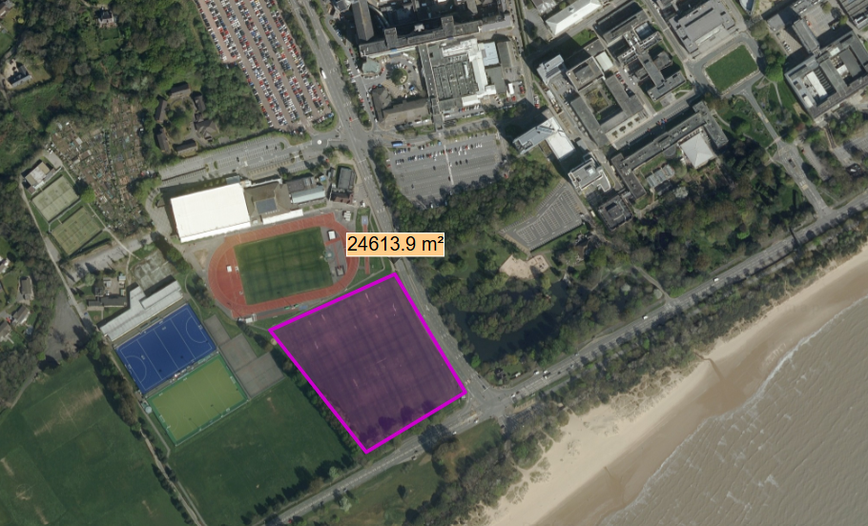
Figure 1.0: Aerial image of proposed site
The site’s surrounding infrastructure is low-medium rise, whereas the hotel is proposed to be medium-high rise, as a result of this the hotel is likely to experience strong winds due to there being no nearby obstructions.

2.2 Local environment conditions
The site’s coastal location increases the exposure to adverse weather conditions and chloride deposition compared to an inland location. Mumbles weather station provides statistics of the climate conditions from 1991-2020, from the table below, Swansea Bay is prone to high annual rainfall and strong wind speeds compared to other areas in the country (Met Office, n.d).
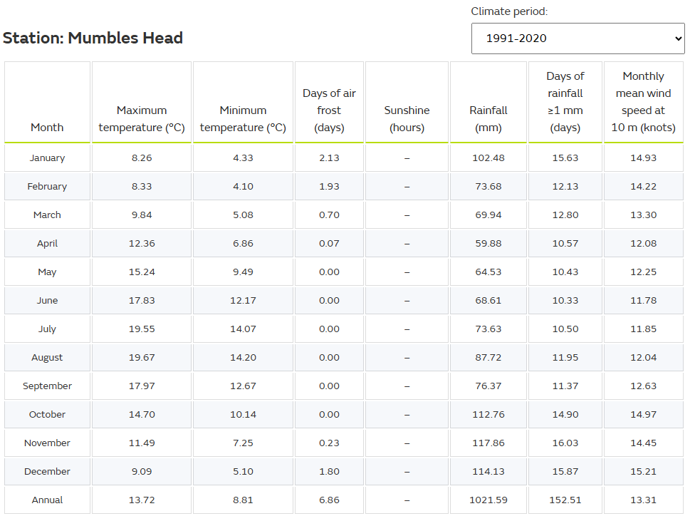
Figure 2.0: Mumbles station climate report 1991-2020
As wind speed increases with height and the hotel is medium-high rise it is essential wind loading is correctly evaluated when designing the structural system, façade and roof fixing to resist structural movement from uplift, shear and lateral loads.
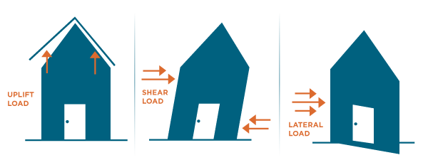
Figure 3.0: Wind load and effect on structure
In combination with elevated wind speeds, the expected annual rainfall poses a risk of WDR significantly damaging the building, research by (Elsevier, 2018) states WDR is the main source of moisture and damage to exposed elevations. In addition, due to the close proximity to Swansea Bay corrosive pollutants mainly salt exposure can drastically affect the durability of the structure and fixings, reducing the expected lifespan of individual components.
In order to mitigate these risks, it is suggested materials used in the development are resistant to corrosion, additionally incorporating waterproofing strategies and protective coats and sealants.

2.3 Ground Conditions
The proposed location is contaminated land and has had no historic ground condition surveys however, an adjacent structure has had a borehole log to a depth of 8m providing limited information due to the size of the proposed hotel development. As of this, a comprehensive site survey is to be carried out prior to development. The survey will include borehole logs, geological conditions and records of historic land use.
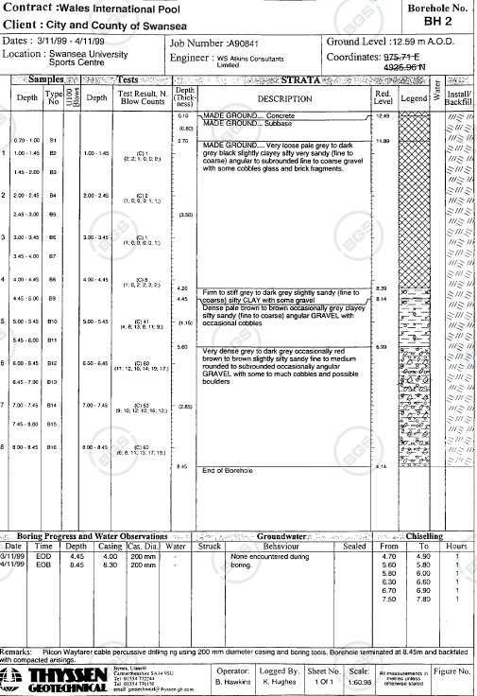
Figure 4.0: Adjacent land borehole log
(BGS, n.d) provides information on regional geological formation, figure 5.0 indicates the site is above sedimentary rocks such as mudstone, siltstone and sandstone which are characteristics of South Wales middle coal measures formation linking the area to historic coal mining.
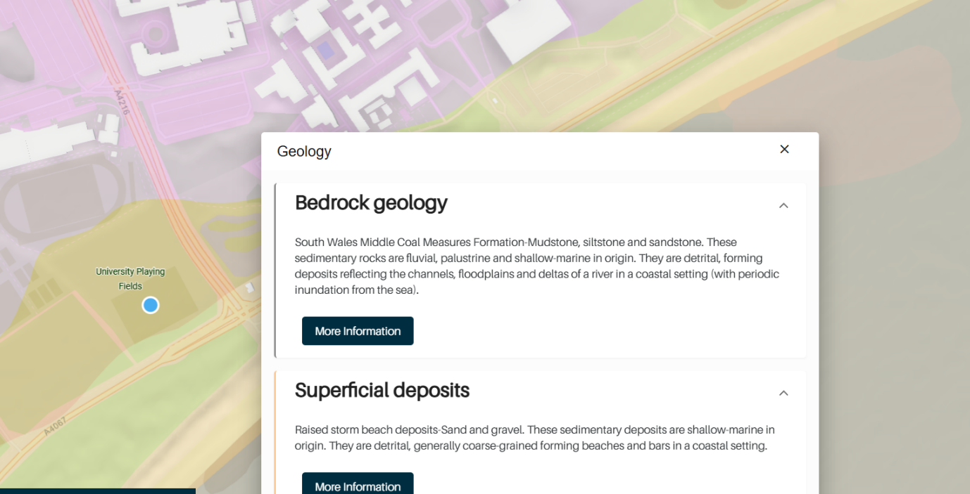
Figure 5.0: Regional bedrock geology
The combination of the site’s geology, nearby structures borehole logs and history of coal mining in the area poses the risk of differential settlement due to the load bearing requirements of the structure, therefore a deep foundation capable of transferring the structures load to deeper stratification is essential.

3.0 Foundations

3.1 Foundation consideration
There are several foundation systems which are suitable for medium-high rise buildings including shallow raft, pad foundations and deep pile foundations.
Raft foundations support the entire structure using a large reinforced concrete slab by evenly distributing the structures load, reducing pressure on the ground beneath minimising risk of settlement in areas where the soil is weak or unstable (Avery&Co, n.d), however on certain soils that contain clay minerals such as mudstone that are prone shrinking and softening can cause the raft foundation to move and crack causing damage to the structure above leading to it potentially being unsafe for use.
Pad foundations are typically used in large structures where raft foundations are unsuitable due to the large area of concrete required, pad foundations is a square reinforced concrete slab designed to transfer the building loads to a single point. (MacQueen.N, 2024) clarifies this type of foundation is used in areas where the soil beneath is dense and strong, however, in areas where the soil is unstable they can be prone to settlement and affected negatively against wind loads acting on the structure above.
Deep pile foundations such as CFA or rotary are long columns of reinforced concrete predominantly used for large structures where the building load is greater, by transferring loads to deeper, stronger stratification the risk of settlement is significantly reduced, improving overall stability, however due to the depth there is significant environmental impacts such as some deep foundations causing soil displacement. In addition, the potential of pile failure if not installed correctly, requiring specialised labour and equipment increasing cost (Civil Engineering, n.d)
Guidance from (BSI Standards publication, 2020) in accordance with (BSI Standards publication, 2013) state when selecting a foundation, the following factors are to be considered:
- Site location and surrounding urban development
- Nature and size of structure
- Ground conditions

3.2 Justification of selected foundation
As a result of the sites location constraints, geological conditions and the proposed structures building load, a CFA pile foundation is the most suitable choice. As shown in figure 6.0 the process involves drilling to the design depth using an auger, followed by pumping concrete as the auger stem is withdrawn forming the pile foundation with minimal soil displacement, finally to maximise stability and strength reinforced steel cages are placed into the concrete.
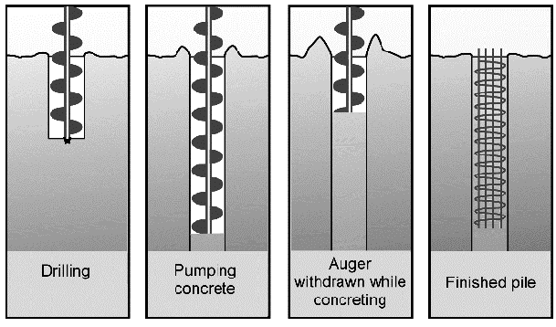
Figure 6.0: Diagram of CFA pile foundation process
This method allows the structural loads to pass the weak, unstable soils associated with the South Wales coal measures formation and transfer the loads to deeper, stronger stratification significantly reducing the risk of differential settlement.
According to (Midland piling, 2025) CFA piling offers characteristics that are suitable for the site conditions and constraints specifically, its reduced noise and vibration levels compared to other methods. This is a significant advantage due to the site’s close proximity to Singelton Hospital, where excessive vibration and noise can disrupt the welfare of patients.

3.3 Basement construction consideration
The proposed hotel construction does not include a basement, however it must be considered. As a plant room is required, if installed in the basement it will reduce the space used within the superstructure. The construction of a basement presents constraints as a result of the sites ground conditions and coastal location.
If a basement is incorporated into the design, a reinforced concrete box constructed within a contiguous pile retaining system using CFA piling techniques is suitable. (AARSLEFF, 2025) states this method would provide lateral support during excavation preventing potential ground movement therefore protecting adjacent infrastructure.
Visualised in figure 7.0, excavation would be undertaken in a phased sequence. The first phase is the installation of CFA Piles, followed by the installation of the contiguous pile wall system. Phase three is the excavation of the basement area and finally, the basement slabs and walls are constructed with reinforced concrete providing structural support within the substructure.
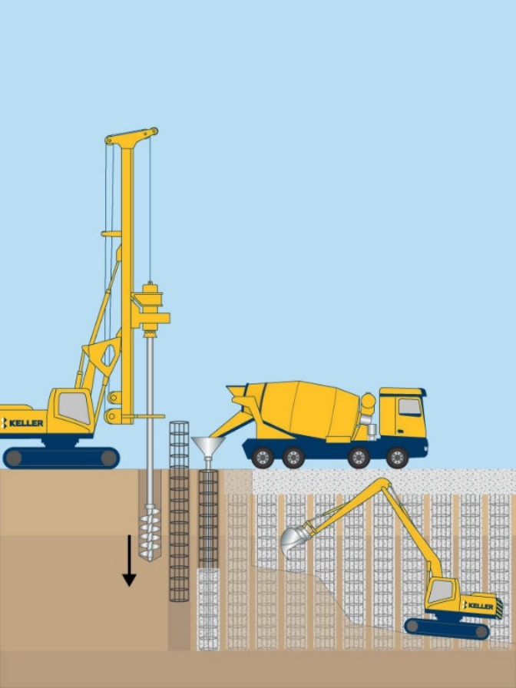
Figure 7.0: CFA pile wall phased sequence

3.4 Waterproofing strategy
Due to the sites coastal location, the risk of groundwater must be considered where underground construction is proposed. Guidance published by (BSI British standards, 2009) indicates a combination of type B and C waterproofing strategy.
Type B, using structurally integral protection such as concrete with a waterproof admixture will provide resistance to water ingress. Type C, drained protection in the form of a drained cavity membrane would manage residual water through controlled drainage.
The combination of type B and C protection reduces the amount of groundwater ingress within the substructure decreasing the risk of structural damage in turn improving overall durability.

4.0 Superstructure: Structural frame and floors

4.1 Structural frame considerations
The proposed medium-high rise hotel requires a structural frame capable of withstanding dead and live loads, in addition wind loads. (BSI Standards publication, 2010a) provides guidance on natural wind actions on buildings up to 200m tall including the structure as a whole as well as individual elements such as cladding.
As a result of the sites coastal location and surrounding urban development, wind loads can be significant therefore, the stability and serviceability of the structural design are to be considered in accordance with (BSI Standards publication, 2023), to minimise excessive movement that may result in occupant discomfort, non-structural and structural damage.
In addition, the robustness of the structure is to be considered. This is the buildings’ ability to withstand damage from human error, fire and impact without collapsing disproportionately in conjunction with building class 2B (Welsh Government, 2010 (1).
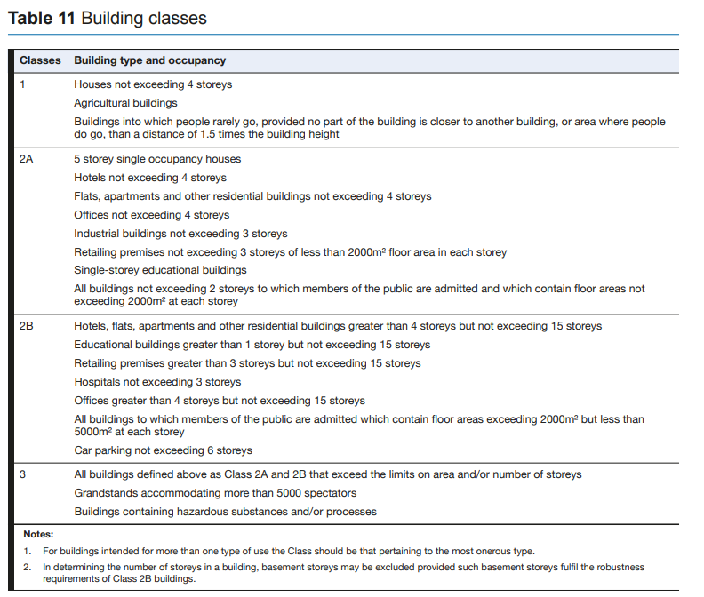
Figure 8.0: Building class table

4.2 Selected Structural frame system
A steel frame structure with a reinforced concrete core is proposed for the hotel development. The use of this hybrid system combines design flexibility and speed of steel construction with the robustness and durability of reinforced concrete, providing a suitable structure for the medium – high rise development in a coastal environment.
The steel frame structure allows for reduced on-site construction time due to off-site construction methods and erection speed, improving efficiency and buildability. As steel has a high strength to weight ratio, it enables for large open wide spans a key characteristic for the hotel development where open areas are required (MJPatch, 2025). Additionally, in comparison to a full reinforced concrete frame, steel reduces the overall buildings dead load in turn reducing foundation demand on the sites poor ground conditions.
The reinforced concrete core, provides the lateral stability system by resisting wind loads and transferring the structures loads to the foundations, limiting excessive movement and improving serviceability. As the proposed development is a hotel, fire safety is a major consideration. As stated by (South East Formwork, n.d) reinforced concrete has excellent fire resistance in comparison to other materials as it does not burn or emit toxic fumes, protecting fire escape routes however, in order to comply with Welsh legislation, the steel framework must be protected with industry standard coatings to ensure structural stability is maintained for a reasonable period as mentioned in approved document B, section B3 (Welsh Government, 2020a).

4.3 Structural floor systems
Composite steel concrete floors are proposed for the hotel, as visualised in figure 9.0 the floor system consists of a steel beam supporting the steel deck, An in-situ reinforced concrete slab is cast over the steel decking, the reinforcement manages potential cracking and improves load distribution. Shear connectors are fixed to the steel beam, enhancing the structural performance of the floor system through composite action (Fiveable, 2025).
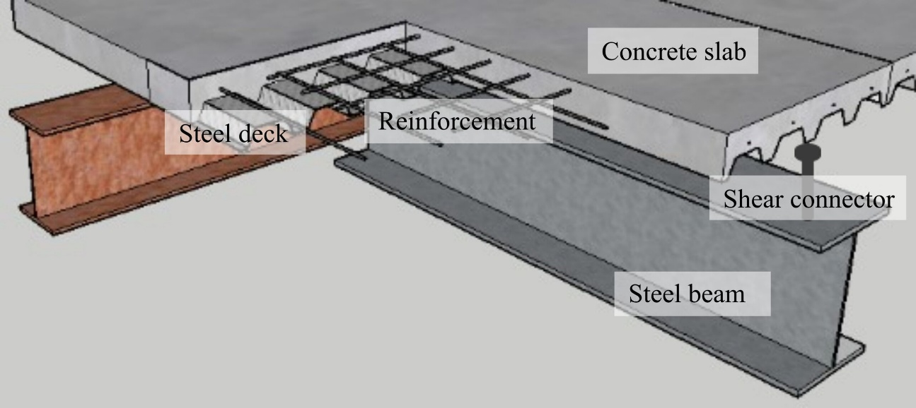
Figure 9.0: Diagram of composite steel concrete floor system
The mass of the reinforced concrete slab improves sound insulation as well as reducing vibration levels between floors, which is essential for a hotel development. This floor system also provides fire resistance through the concrete slab and steel elements if adequately protected, ensuring compliance with approved document B (Welsh Government, 2020b).

5.0 Building envelope

5.1 Performance requirements
The building envelope proposed must provide adequate resistance to excessive wind speeds and WDR whilst contributing the durability and fire resistance of the structure. As of the sites coastal location, the building envelope must be capable of resisting chloride deposition and moisture exposure. In addition, the envelope should complement the structural framework, by minimising additional dead load.
The building envelope is to be in accordance with Welsh legislation, approved document L (Welsh government, 2010(2) covers thermal performance in conjunction with energy efficiency and human comfort. The building envelope must also comply with approved document B (Welsh Government, 2020c) in which the spread of fire across external components is limited.

5.2 Selected building envelope system
A drained and ventilated rainscreen cladding system is proposed for the hotel, due to the coastal location WDR and moisture exposure is elevated, presenting a significant risk to the building envelope. As shown in figure 10.0, this cladding system consists of an external cladding panel supported by brackets, behind the panel there is a ventilated drainage cavity which allows for potential water ingress from WDR to drain away from the internal envelope, it additionally acts as a path for wind loads reducing pressure on the structure.
Insulation is placed behind the drainage cavity to mitigating the risk of water ingress, allowing it to maintain its thermal performance properties ensuring the structure remains compliant with approved document L.
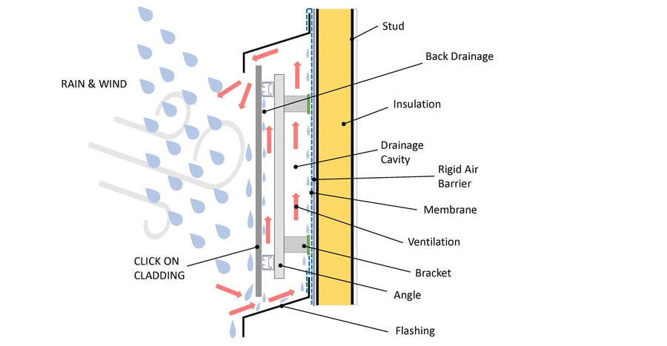
Figure 10.0: Diagram of rainscreen cladding
A flat roof is proposed for the development, consisting of a waterproof membrane and insulation in order to comply with approved document L. As a result of the elevated wind speed the flat roof must be in accordance with section 7.2.3 (BSI Standards publication, 2010b).

6.0 Construction methods

6.1 Off-site construction
MMC such as off-site construction is an alternative to traditional on-site construction, as stated from (Government commercial function, 2022) the use of MMC can improve the accuracy, quality and productivity of craftsmanship. Off-site construction is suitable for this development, due to the potential weather conditions the construction of the frame components can be carried out in a factory reducing the dependence on weather. As individual components of the frame are carried out off-site when it comes to the erection of the frame, site times are significantly reduced.
Additionally, off-site construction reduces on-site deliveries and overall work on site that can produce significant noise and vibration levels, which is a key advantage because of the close proximity to Singleton Hospital.

6.2 Prefabricated Construction
Prefabricated components such as bathroom pods, reduce on-site construction times which is beneficial against potential site specific constraints. Significant advantages of prefabricated construction are, improved site safety due to a reduction of trades required on site, additionally the projects construction time frame is reduced, benefitting nearby buildings such as Singleton Hospital but also the client (LetsBuild, 2023).

6.3 Façade retention
As the site is currently unoccupied, façade retention is not required for planning or heritage reasons. Should future use of the development change and retention be required the process would be carried out with temporary works such as scaffolding to support the frame of the structure. In accordance with (HSE, 2020) all temporary works must follow a procedure consisting of design briefs, temporary works register, production of temporary works design and a controlled pre-inspection of the temporary works.

7.0 Conclusion
The proposed site’s coastal location has four key constraints consisting of variable ground conditions, elevated wind speeds, WDR and surrounding urban development. A CFA pile foundation is proposed as the ground conditions are unstable requiring deeper stratification to withstand the buildings loads, additionally CFA piles reduce differential settlement and are minimal in noise and vibration levels during installation which is beneficial as a result of the surrounding urban development. The structural framework is steel with a reinforced concrete core, which provides lateral stability against wind loads and is fire resistant allowing the building to comply with approved document B. The building envelope is a drained and ventilated rainscreen system as it is resilient to wind loads and WDR mitigating risks of water ingress and potential damage to fixings. MMC is proposed over traditional methods to reduce construction time and site congestion benefiting the client, contractor and surrounding urban developments.

References
AARSLEFF (2025). What Are Contiguous Pile Walls? [Online]. Available at: What Are Contiguous Pile Walls? - Aarsleff [Accessed 09/01/2026]
Avery&Co. (n.d) Types of foundations [Online]. Available at: https://averysurveys.co.uk/types-of-foundations/ [Accessed 08/01/2026]
BGS (n.d). The Geological map viewer of Britain. [Online] Available at: BGS Geology Viewer (BETA) [Accessed 06/01/2026]
BSI British standards (2009). Code of practice for protection of below ground structures against water from the ground. [CIS] Available at: NBPJPCAAAAAAAAAA.pdf [Accessed 09/01/2026]
BSI Standards publication (2010). Eurocode 1: Actions on structures – Part 1-4: General actions – wind actions [CIS]. Available at: https://products.ihserc.com/tmp_stamp/00355548917/HWSFPDAAAAAAAAAA.pdf?sess=00355548917&prod=CIS1 [Accessed 10/01/2026]
BSI Standards publication (2013). Eurocode 7: Geotechnical design – Part 1: General rules. [CIS] Available at: https://products.ihserc.com/tmp_stamp/00336788881/TZJIIFAAAAAAAAAA.pdf?sess=00336788881&prod=CIS1 [Accessed 08/01/2026]
BSI Standards publication (2020). Code of practice for foundations. [CIS] Available at: https://products.ihserc.com/tm/p_stamp/00772296757/PCQEMGAAAAAAAAAA.pdf?sess=00772296757&prod=CIS1 [Accessed 08/01/2026]
BSI Standards publication (CIS). Eurocode – Basis of structural and geotechnical design [Online]. Available at: https://products.ihserc.com/tmp_stamp/00854443504/XYYKYGAAAAAAAAAA.pdf?sess=00854443504&prod=CIS1 [Accessed 10/01/2026]
Civil Engineering (n.d) Advantages and disadvantages of pile foundation. [Online] Available at: https://civiltoday.com/geotechnical-engineering/foundation-engineering/deep-foundation/449-advantages-and-disadvantages-of-pile-foundation [Accessed 08/01/2026]
Elsevier (2018). Characterisation of building exposure to wind-driven rain in the UK and evaluation of current standards. [Online] Available at: https://ora.ox.ac.uk/objects/uuid:5cd7bc54-067c-45c7-a864-4c15368d7414/files/mae0226d6e6d6a7661ee9c83db8ed6c8d [Accessed 06/01/2026]
Fiveable (2025) Composite action [Online]. Available at: https://fiveable.me/key-terms/introduction-civil-engineering/composite-action [Accessed 10/01/2026]
Government commercial function (2022). Modern methods of construction [Online]. Available at: https://assets.publishing.service.gov.uk/media/631222468fa8f5423fb0c7c0/20220901-MMC-Guidance-Note.pdf [Accessed 11/01/2026]
HSE (2020). The management of temporary works in the construction industry [Online]. Available at: https://www.hse.gov.uk/foi/internalops/sims/constrct/2_10_04.htm [Accessed 11/01/2026]
LetsBuild (2023). Ten benefits of prefabricated construction [Online]. Available at: https://www.aproplan.com/blog/ten-benefits-of-prefabricated-construction [Accessed 11/01/2026]
MacQueen.N (2024) What are pad foundations, why are they used and what do they cost? [Online] Available at: https://www.homebuilding.co.uk/advice/pad-foundations [Accessed 08/01/2026]
Met Office (n.d). Location specific long-term averages. [Online] Available at: https://www.metoffice.gov.uk/research/climate/maps-and-data/location-specific-long-term-averages/gcjjm7j5g [Accessed 06/01/2026]
Midland piling (2025). The advantages of CFA piling in modern construction [Online]. Available at: The Advantages of CFA Piling in Modern Construction | Midland Piling [Accessed 09/01/2026]
MJPatch (2025). 6 Key Advantages of Steel Framing Construction [Online]. Available at: https://www.mjpatch.co.uk/6-key-advantages-of-steel-framing-construction/ [Accessed 10/01/2026]
South East Formwork (n.d). Top 5 Advantages of Using Reinforced Concrete in Structural Projects [Online]. Available at: https://southeastformwork.co.uk/top-5-advantages-of-using-reinforced-concrete-in-structural-projects/ [Accessed 10/01/2026]
Welsh Government (2010 (1). Approved document A: Structure [Online]. Available at: https://www.gov.wales/sites/default/files/publications/2019-04/170403building-regs-approved-document-a-structure-en.pdf [Accessed 10/01/2026]
Welsh government (2010 (2). Approved document L: Volume 2 – Buildings other than dwellings – Conservation of fuel and power [Online]. Available at: https://www.gov.wales/sites/default/files/publications/2022-09/approved-document-l-vol-2.pdf [Accessed 11/01/2026]
Welsh Government (2020). Approved document B: Volume 2 – Building other than dwellinghouses – Fire safety [Online]. Available at: https://www.gov.wales/sites/default/files/publications/2021-12/building-regulations-guidance-part-b-fire-safety-volume-2-buildings-other-than-dwellinghouses.pdf [Accessed 10/01/2026]

