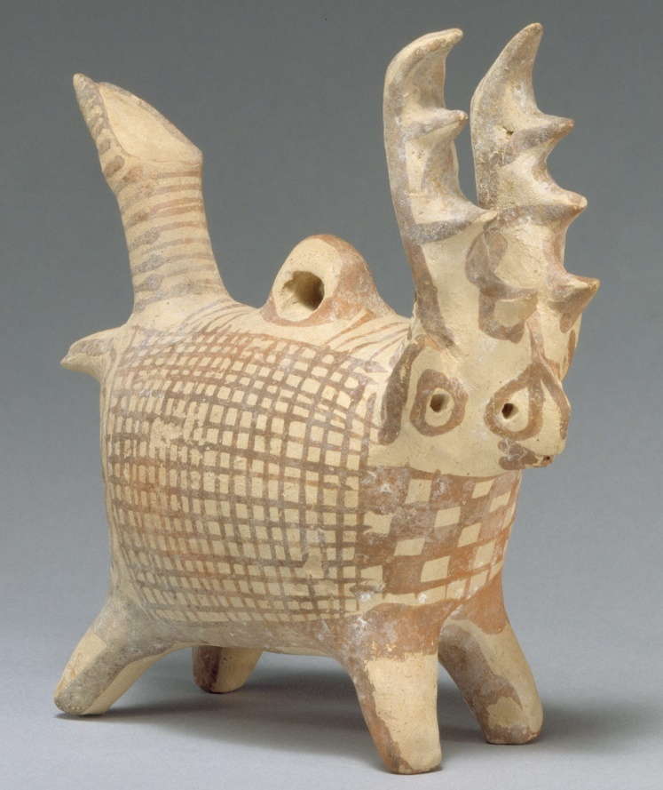
Object Analysis
Appearance
The object, a vase from the Middle Cypriot III era, can most accurately be referred to as a Terracotta Zoomorphic askos with antlers. It is dated from between 1725 – 1600 BC. Created out of a type of fired clay, terracotta, the object is quite small, standing at almost six inches tall. It is in an odd shape, being presumably “a native species of deer” (MetMuseum.org, 2020) to the Idalion area, where the item is thought to have originated from. Animal shaped vases were commonly made during this era and the “variety of form is endless: the most popular types are deer, cattle and horned sheep” (Myers, 1914).
The design on the askos is in keeping with the contemporary ‘White Painted Ware’ that rose to popularity during the Middle Cypriot era. In this art style, “linear geometric patterns decorate the entire surface of vases” (Karageorghis, Mertens, Rose and Cesnola, 2000) as can be seen on the deer type shape. There is a cross hatch pattern that is featured upon the body of the deer, whilst the face and antlers are emphasised by the hand painted features.
Purpose
The askos, or vessel they are otherwise known, were traditionally a type of pottery used to pour liquids, like oil. Usually the askoi were more of a jug type shape, often quite short and fat. Of course, this deer shaped vessel is different, and was more likely to have been used for either ceremonial or decorative purposes, due to its less practical shape and design. Most of “the objects in the Cesnola collection were primarily dedications in graves” (Picón, De Puma and Hemingway, 2007) and it is likely that this askos would have been one of the many things placed into a grave with a wealthy person when they died. This item would have most likely therefore been created for the wealthy and the elite, partly due to its unpractical nature, and partly because it would most likely have been used as part of a funerary hoard. The whole idea of a hoard being buried with someone suggests that they had both an excess of wealth and that they wanted a rather public death and burial. In ancient times the idea of having an heir and someone to pass your legacy on to was extremely important, and so any funerary hoards would be excess to what their heir and family would then need to survive.
Cultural Relevance
Because of its unique shape and design, it is more likely that the askos is a decorative object, rather than a practical one. “During the Bronze age… artistic production in Cyprus was flourishing” (Picón, De Puma and Hemingway, 2007) , which led to a rising in the use of both art and objects for more sentimental purposes. The use of belongings in such a way coincides with Morgan’s ‘Ancient Societies’ theory, which separates cultures into three different groups; the existence of such objects suggests that Cyprus had emerged into the ‘civilisation’ category, and could easily be differentiated from the ‘Savagery’ and ‘Barbarianism’ that civilised cultures are said to have previously existed in (Morgan, 1877).
This item also suggests the emergence of the ‘elite’ and hierarchal values in society, due to the wealth and glamour of having such possessions. “Of particular note is the use of clay; both figures and vases show what today appears to be a playfulness and pleasure in creating complex forms with elaborate decoration” (Picón, De Puma and Hemingway, 2007). This “playfulness” and the detail, time and talent that went into the creation of the item is that of a specialised craftsman, supplying his artwork for the elitist classes. During the early Stone Age society, it was most common that each person would make their own basic clothes, tools and ornaments, whereas with the emergence into the category of ‘civilisation’ (Morgan, 1877), there also developed the full-time craft specialists. Full time workers, along with the sophisticated art styles, suggests that Cyprus during this time was experiencing an ‘Urban Revolution’, which coincides with Gordon Childe’s idea of ancient societies (Childe, 1950). This ‘Urban Revolution’ doesn’t mean revolution in the modern context, but instead a progressive social and cultural change over a number of years. This change was most obvious in the social structure and organisation, including the development of a hierarchy.
The askos is a part of the Cesnola collection, based at the Metropolitan Museum of Art, New York, collated by Luigi Palma di Cesnola. Who, after several successful military campaigns, was appointed American Consul in Cyprus, and thus developed a collection of Cyprian antiquities. Cesnola soon became one of the leading collectors of antiques from this area and is said to have seen “his work as rivalling the work of Heinrich Schliemann at Troy” (MetMuseum.org, 2020), probably one of the most well known archaeologists, from the 19th century. The collection as a whole is of supreme importance, since the discovery and exhibiting of the items motivated many later expeditions to the Cyprian area, and also created great interest in the area’s history for the general public.
The significance of this deer-shaped zoomorphic askos is thus quite important, since it is not only a symbol of ancient Cyprian society and hierarchy, but also the later history and interest that was gained from the excavations. The object itself gives the impression of a sophisticated art style, White Painted Ware, where it is clearly a part of the contemporary styles and artistry influences. It also tells archaeologists and historians a lot about the social aspect of the contemporary society, since it suggests that people did indeed have an excess of money that enabled them to buy from external specialised craftsmen.

Bibliography
Childe, V., 1950. The Urban Revolution. Town Planning Review, [online] 21(1), p.3. Available at: <https://www-jstor-org.ezproxy.uwtsd.ac.uk/stable/40102108> [Accessed 6 April 2020].
Karageorghis, V., Mertens, J., Rose, M. and Cesnola, L., 2000. Ancient Art From Cyprus: The Cesnola Collection In The Metropolitan Museum Of Art. New York: Metropolitan Museum of Art, pp.33-34.
Metmuseum.org. 2020. Terracotta Zoomorphic Askos (Vessel) With Antlers. [online] Available at: <https://www.metmuseum.org/art/collection/search/240382> [Accessed 6 April 2020].
Metmuseum.org. 2020. The Cesnola Collection At The Metropolitan Museum Of Art. [online] Available at: <https://www.metmuseum.org/toah/hd/cesn/hd_cesn.htm> [Accessed 6 April 2020].
Morgan, L., 1877. Ancient Society, or Researches in the Lines of Human Progress, from Savagery through Barbarism to Civilization. The North American Review, [online] 125(259), p.590. Available at: <https://www.jstor.org/stable/25110148> [Accessed 6 April 2020].
Myers, J., 1914. Handbook Of The Cesnola Collection Of Antiquities From Cyprus. New York, NY: Metropolitan Museum of Art.
Picón, C., De Puma, R. and Hemingway, S., 2007. Art Of The Classical World In The Metropolitan Museum Of Art. New York: The Metropolitan Museum of Art, p.227.

