

MSc Public Health and Social Care in Practice

Module: Population Health and Digital Health Promotion

Component 1: Blog

Lecturer Name: Dr Ping Wu

Student ID: 2434363

Student Name: Ajay Bavabahi Mayani

BLOG 1: Can Calm Really Improve Mental Wellbeing? Evaluating a Leading Digital Mindfulness App
Public Health Problem: Anxiety & Sleep Challenges
Anxiety disorders are considered the most common class of psychological disorders. In 2023, globally, around 4.05% of the entire population had an anxiety disorder, which translates to around 301 million people (Javaid et al., 2023). It is essential to note that the affected numbers are known to have increased by more than 55% from 1990 to 2019 (Javaid et al., 2023). Such issues result in eroding overall productivity along with obesity, various cardiovascular diseases and hypertension, anxiety symptoms, among many other issues (Watson, 2020). Insufficient sleep can also result in large economic costs in terms of GDP loss, alongside lowering labour productivity (Hafner et al., 2017). One important challenge is that individuals do not perceive a need for treatment, which is widely evident in less wealthy countries (Alonso et al., 2018).
Description of Calm App
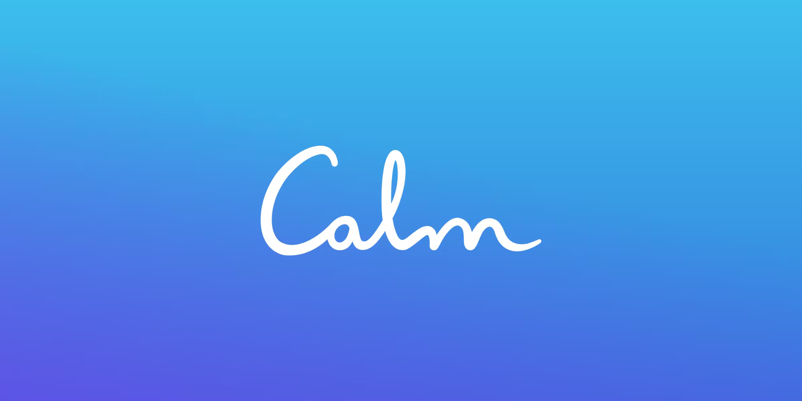
Calm is an app for sleep and meditation. The brand markets itself as the “#1 app for sleep and meditation.” The app’s library includes hours of guided meditations that cover sleep, anxiety, stress, gratitude, and much more (Calm, 2025a). There are more than 500 sleep stories in its library, along with new stories being added every week. Various exclusive music tracks are also present, regarding focus, relaxation and sleep. Various teachers are also available, who provide users with a daily dose of wisdom, gratitude and encouragement (Calm, 2025a).

Evidence of Its Effectiveness
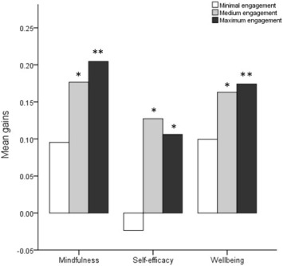
Mean Gain Scores in Mindfulness, Self-Efficacy, and Wellbeing by Course Engagement Level
(Source: Clarke and Draper, 2020)
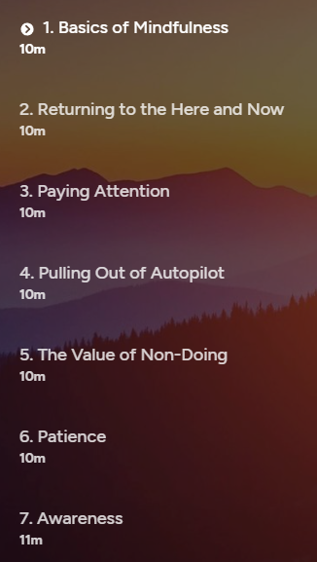
7 Days of Calm
(Source: Calm, 2025b)
A study by Huberty et al. (2019) reveals that 51% of the participants were helpful in reducing their stress in the short term, and these findings were similar for the long term. On the other hand, over 50% of the participants stated that Calm would be useful to help reduce stress in the future. Clarke and Draper (2020) also report that the app is associated with positive mental health outcomes. The mindfulness practice within the “7 Days of Calm” course resulted in improving well-being by facilitating increases in trait mindfulness.
Critical Discussion of Impact
Advantages
- The app has a significantly higher production quality along with accessibility. Its core features include guided meditation along with anxiety reduction, sleep stories along with breathing tools.
- The app also includes behaviour-change elements such as habit formation, along with daily streaks and personalised recommendations (Calm, 2025a).
- It is essential to note that it mainly targets the general adult and young adult population.
Limitations
- One major limitation is its higher subscription cost. The app mainly focuses on mindfulness, which also involves a learning curve.
- The various sessions might not be suitable for everyone, including individuals with severe mental health conditions. Another limitation is that the app has quite long sessions, which might result in time management issues for some individuals, along with the possibility to drop out after initial use.
- Its commercial model also raises various concerns regarding data monetisation.
Addressing Shortfalls
The app could focus on providing more adaptive alongside responsive content, which will help in maintaining long-term engagement (Pittman, 2024). It could also focus on integrating mental health screening tools, which will help people with mental health conditions (Neulinger et al., 2024). The app could also partner with various mental health services for providing additional support. By providing stronger privacy commitments alongside independent audits, it will be possible to rebuild overall trust.

BLOG 2: MindEase+: A Smarter, Adaptive Approach to Digital Mental Health and Sleep Support
Description of the Designed Technology
MindEase+ is a proposed next-generation mental health & sleep support system, which will be implementing heart-rate variability, voice patterns, and behavioural indicators for real-time stress detection. The platform will also include instant micro-interventions with 30-60 second stress resets. Users will be able to optimise their sleep using noise analysis along with bedtime routine tracking. There will also be a crisis-mode connection, which will connect with trained responders.
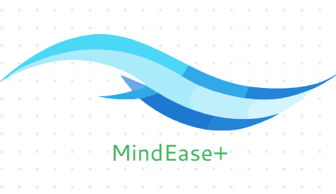
Application in Health Promotion
The platform will allow users with personalised sleep optimisation. It will be supporting preventing self-management of stress by analysing bedroom noise along with recommending ideal sleep routines and adjusting bedtime encouragements. The platform will also have a crisis detection mode, which will allow users to connect with trained responders with a single tap. The platform will also utilise adaptive learning for recommending various personalised actions. By implementing behavioural reinforcement, the platform will be able to build long-term resilience.
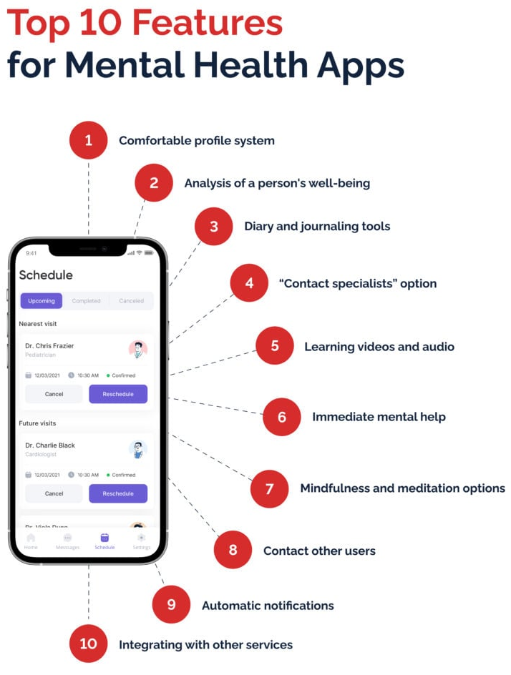
Source: Pletnov, 2022
Self-Created
Expected Impact: Critical Discussion
Advantages
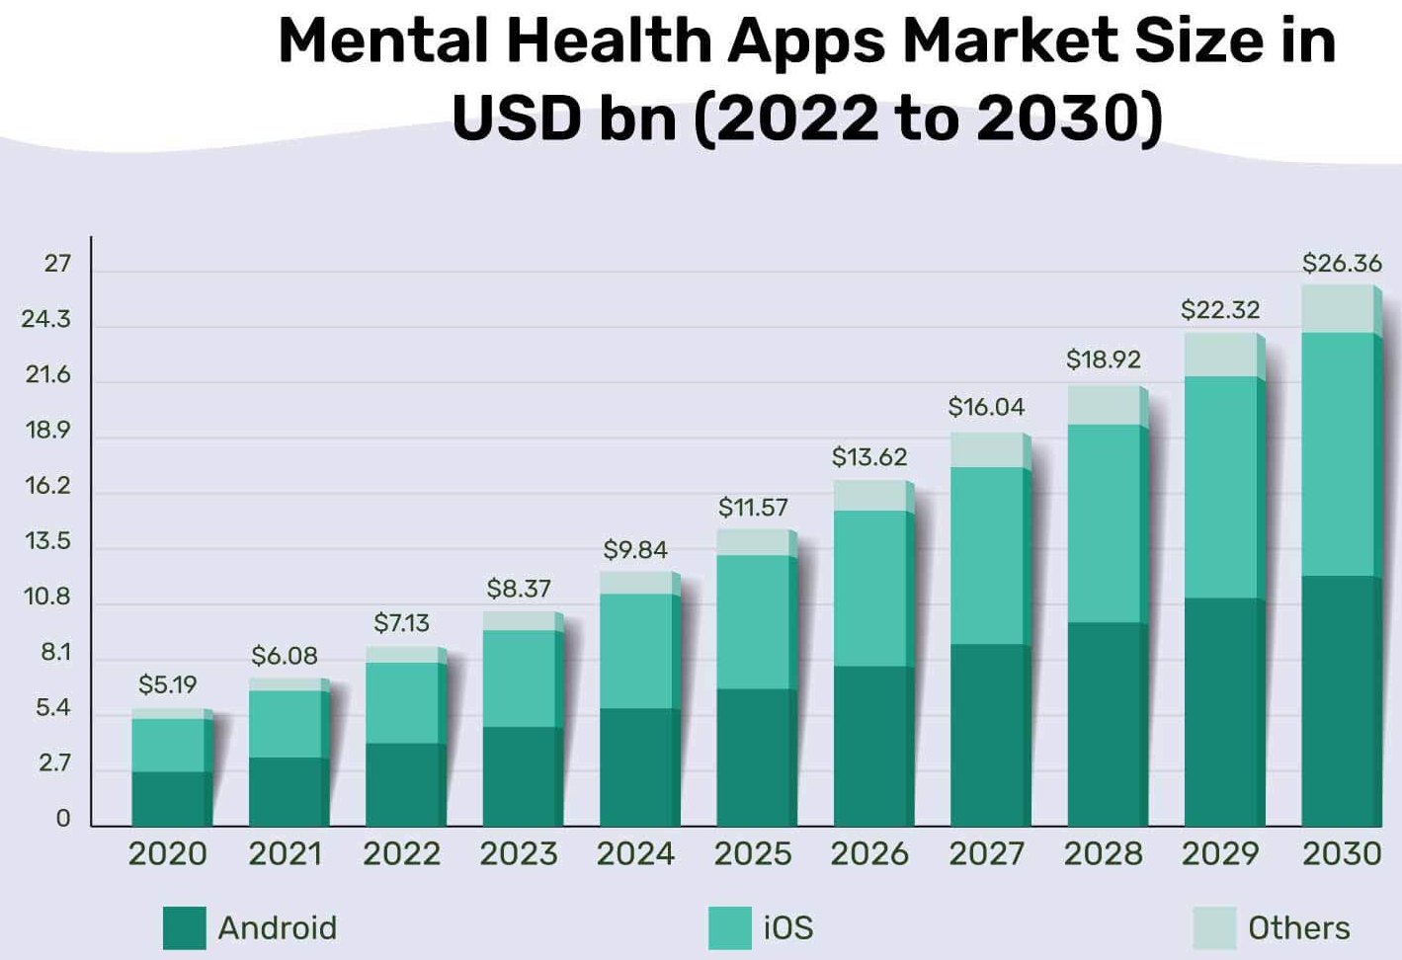
- The platform will have higher personalisation, which will help in driving better adherence (McKinsey, 2021).
Source: Patel, 2023
- The crisis mode will help in immediate interventions, which will be preventing various small stressors from turning into big ones.
- The platform will also be equipped with short and micro-content, which will help in gaining stronger adherence for busy individuals (Content Whale, 2025).
- It will also be supporting users with moderate distress more effectively, which will avoid making them feel generic.
Challenges
One possible major risk is the privacy concerns regarding constant monitoring (Zhang et al., 2025). There is also the risk of over-detection of stress, which could result in leading to alert fatigue (Krantz and Jonker, 2025). The platform will not be a replacement for clinical therapy. There will also be a risk of inequity for users with older devices.
Addressing These Challenges
Privacy concerns could be addressed through strict data minimisation, along with on-device processing if possible (Matomo, 2025). Over-alerting risks, resulting in alert fatigue, could be solved by calibrated thresholds and user-adjustable sensitivity. The platform will also implement clear signposting to professional services when required (Cantrell, Booth, and Chambers, 2024).

References
Alonso, J. et al., (2018). Treatment gap for anxiety disorders is global: Results of the World Mental Health Surveys in 21 countries. Depression and Anxiety [online]. 35(3), 195–208. [Viewed 18 November 2025]. Available from: doi: 10.1002/da.22711
Calm, (2025a). Calm - The #1 App for Meditation and Sleep [online]. Calm. [Viewed 18 November 2025]. Available from: https://www.calm.com/
Calm, (2025b). 7 Days of Calm [online]. Calm. [Viewed 18 November 2025]. Available from: https://www.calm.com/app/program/qK3IeqhiJP
Clarke, J. and Draper, S., (2020). Intermittent mindfulness practice can be beneficial, and daily practice can be harmful. An in depth, mixed methods study of the “Calm” app's (mostly positive) effects. Internet interventions, 19, p.100293.
Content Whale, (2025). The Power of Micro-Content: Engaging Bites for Busy Audiences [online]. Content Whale. [Viewed 18 November 2025]. Available from: https://content-whale.com/blog/what-is-micro-content/
Hafner, M., Stepanek, M., Taylor, J., Troxel, W.M. and Van Stolk, C., (2017). Why sleep matters—the economic costs of insufficient sleep: a cross-country comparative analysis. Rand health quarterly, 6(4), p.11.
Huberty, J., Green, J., Glissmann, C., Larkey, L., Puzia, M. and Lee, C., (2019). Efficacy of the mindfulness meditation mobile app “calm” to reduce stress among college students: Randomized controlled trial. JMIR mHealth and uHealth, 7(6), p.e14273.
Javaid, S. F., Hashim, I. J., Hashim, M. J., Stip, E., Samad, M. A. and Ahbabi, A. A., (2023). Epidemiology of anxiety disorders: global burden and sociodemographic associations. Middle East Current Psychiatry [online]. 30(1). [Viewed 18 November 2025]. Available from: doi: 10.1186/s43045-023-00315-3
Krantz, T. and Jonker, A., (2025). What Is Alert Fatigue? | IBM [online]. IBM. [Viewed 18 November 2025]. Available from: https://www.ibm.com/think/topics/alert-fatigue
Matomo, (2025). What is data minimisation? Definition, benefits and best practices - Analytics Platform - Matomo [online]. Analytics Platform - Matomo. [Viewed 18 November 2025]. Available from: https://matomo.org/blog/2025/10/data-minimisation/
McKinsey, (2021). The value of getting personalization right—or wrong—is multiplying [online]. McKinsey. [Viewed 18 November 2025]. Available from: https://www.mckinsey.com/capabilities/growth-marketing-and-sales/our-insights/the-value-of-getting-personalization-right-or-wrong-is-multiplying
Neulinger, B., Ebert, C., Lochbühler, K., Bergmann, A., Gensichen, J. and Lukaschek, K., (2024). Screening tools assessing mental illness in primary care: A systematic review. European Journal of General Practice, 30(1), p.2418299.
Patel, S., (2023). 7 Trending Mental Health App Ideas for Startups [online]. VLink. [Viewed 18 November 2025]. Available from: https://vlinkinfo.com/blog/trending-mental-health-app-ideas-for-startups
Pittman, M., (2024). Adaptive Content: Gaining the Edge - Brandon Hall Group [online]. Brandon Hall Group. [Viewed 18 November 2025]. Available from: https://brandonhall.com/adaptive-content-gaining-the-edge/
Pletnov, A., (2022). How to Create a Mental Health App and Succeed: The 2023 Guide [online]. Keen Ethics. [Viewed 26 November 2025]. Available from: https://keenethics.com/blog/mental-health-app-development
Watson, S., (2020). Sleep Deprived? Here Is What Lack of Sleep Does to Your Body [online]. Healthline. [Viewed 18 November 2025]. Available from: https://www.healthline.com/health/sleep-deprivation/effects-on-body#effects
Zhang, B., Chen, C., Lee, I., Lee, K. and Ong, K.L., (2025). A survey on security and privacy issues in wearable health monitoring devices. Computers & Security, p.104453.

