

Student name: Genabu Barri
Student ID: 2328229
Module Code: BMHP6027
Module name: Empowering the Older Person
Lecturer’s name: Christopher Mafuva
Assignment Title: Component 1: Individual Poster Presentation

 |  | Critical Evaluation of Care, Empowerment, and Support Needs  Support Needs: Wellbeing depends on functional ability, independence, freedom, and choice not just physical care (Grove, 2025). Autonomy Gap: 3.3 million over-60s need help with daily activities, but provision often favours safety over autonomy (Institute and Faculty of Actuaries, 2025)) |  | 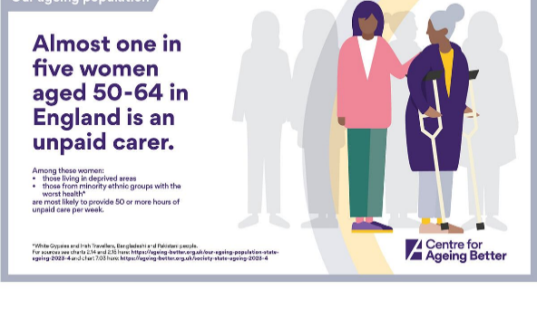
Introduction  An effective health and social care sector is required to help address the demands of the UK's ageing population (UK Parliament, 2025).  Policy Gap: There is a gap between well-rehearsed rhetoric about independence/choice and inadequately funded and poorly organized reality.  11-year gap between deprived and affluent areas (NIH, 2025).  3.3 million 60+ need help with daily activities (Grove, 2025).  Theoretical Frameworks:  Sen’s Capability Approach (1999): wellbeing measured in terms of what people can do and be.  Engel (1997) developed a Biopsychosocial Model, which integrates biological, psychological and social factors affecting health.  Key Statistics (Age UK, 2025): |  |  |  | Challenges to Maintaining Independence and Functional Ability  Unpaid Carers: 1.8 million aged 65+ in England are the care system's lifeline.  Burnout Crisis: 82% cannot take a break, experiencing burnout and breakdown (Care Rights UK, 2025).  Technology Potential: Telecare, remote monitoring, and wearables can support independence (DHSC, 2025).  Implementation Gap: Success requires adequate training and ongoing technical support (UK Parliament, 2026).  Evidence-Based Recommendations for Service Improvement  Casey Commission: Age UK urges earlier delivery, but the earliest is 2028 (Age UK, 2025).  Streamlined Assessments: Call for one person-centred assessment to simplify the process (Abello et al., 2021).
Critical Evaluation of Current Approaches and Interventions
Policy Shift: Government policy moves toward home-centred care (hospital to community, analogue to digital, sickness to prevention) as outlined in the 10-Year Health Plan (Grove, 2025).
Legal Framework: The Care Act 2014 places a duty on local authorities to promote wellbeing, independence and prevention of need as well as providing guidance updated in July 2025 (Department of Health and Social Care, 2025; Care Act 2014).
Biological Theory of Aging: Relying on the physical aspect of ageing, risking a deficit-style perception of older persons.
Activity of Aging (Havighurst,1961), Connects wellbeing with a sense of being active and involved in the community, supporting the move towards preventative, home based care (Grove, 2025).
These legal obligations and these theoretical goals are undermined by systemic Barriers. Underfunding and a 19% reduction in NHS District Nurses (Age UK, 2025)

References

Abello, E.V., Bartolome, E.A., Catibog, J.R., Dionisio, M.G., Inocentes, M.M. and Mapua, S.M. (2021) 'Profile of the elderly in home for the aged facility in Cavite based on modified Barthel Index and biopsychosocial model of George Engel', bachelor’s thesis, De La Salle Medical and Health Sciences Institute. Available at: https://greenprints.dlshsi.edu.ph/bspt/88/ (Accessed: 7-11 2026).
Age UK (2025) 'Financial Exclusion and Older People', Supplementary written evidence. Available at: https://webarchive.parliament.uk/ (Accessed: 7-11 2026).
Department of Health and Social Care (2025) 'Research and development work relating to assistive technology: 2024 to 2025'. Available at: https://www.gov.uk/government/publications/assistive-technology-research-and-development-work-2024-to-2025/research-and-development-work-relating-to-assistive-technology-2024-to-2025 (Accessed: 7-11 2026).
Engel, G.L. (1997) From biomedical to biopsychosocial: Being scientific in the human domain. Psychosomatics, 38 (6), pp. 521-528
Grove, H. (2025) 'Ageing Well in Place: A Capability Approach', Oxford Climate Research Network. Available at: https://www.climate.ox.ac.uk/publication/2128637/ora-hyrax (Accessed: 7-11 2026).
Havighurst, R.J. (1961) ‘Successful Ageing’, The Gerontologist, 1 (1), pp.8-13
Health and Social Care Committee (2025) 'Oral evidence: Healthy Ageing: physical activity in an ageing society', HC 1180, 29 October 2025. Available at: https://committees.parliament.uk/oralevidence/16633/html/ (Accessed: 7-11 2026).
Institute and Faculty of Actuaries (2025) Towards a new vision for social care: policy solutions for an ageing population’. Available at: https://actuaries.org.uk/news-and-releases/news-articles/2025/sep/23-sep-25-towards-a-new-vision-for-social-care -policy-solutions-for-an-ageing-population/ (Accessed: 11-7-2026)
Legislation.gov.uk (2014) Available at: legislation.gov.uk/ukpga/2014/23contents (accessed: 10-7-2026)
NIH (2025) 'Characteristics and population estimates of unpaid end of life carers: An observational study', PMC. Available at: https://pmc.ncbi.nlm.nih.gov/articles/PMC12640358/ (Accessed: 7-11 2026).
Policy Studies (2025) Purdam, K. and Ebrey, J. 'Means-Tested welfare policies and the quiet fear of poverty amongst older people: lessons from the UK', pp. 1-20. doi:10.1080/01442872.2025.2581829.
UK Parliament (2025) 'Casey Commission on adult social care consultation with local government', Written questions, answers and statements. Available at: https://questions-statements.parliament.uk/written-questions/detail/2025-01-10/23152 (Accessed: 7-11 2026).
UK Parliament (2026) 'Digital exclusion among the elderly population', Written questions, answers and statements. Available at: https://questions-statements.parliament.uk/written-questions/detail/2026-01-13/105491 (Accessed: 7-11 2026).

