

Rhydian Tomos Bowen

1701340

Transport Design

Contextual Studies

Ways of Perceiving

(M4X01559)

Several exhibitions in the past have succeeded in the prototype/concept department and advertising what the possibilities are within the automotive industries for example, the geneva motorshow displays upcoming vehicles in the industry and a few concept ideas of what to expect the following years. But within the industry those are mostly everyday vehicles which are expected to be seen on the road in the following year but what about the more unique concepts designed specifically to bring back a small piece of iconic history to the industry. Almost as if we re-live those years of excitement with all current modern technologies and materials. In a way you could say modernizing the past. In order to succeed in exhibiting such topic that would require a master plan including what iconic vehicles should be re-lived and a space that can show the theoretical side of the topic giving it purpose but also looking at the historical aspect of where they were once great, now to be re-lived to re-experience the thrill and excitement of the past.


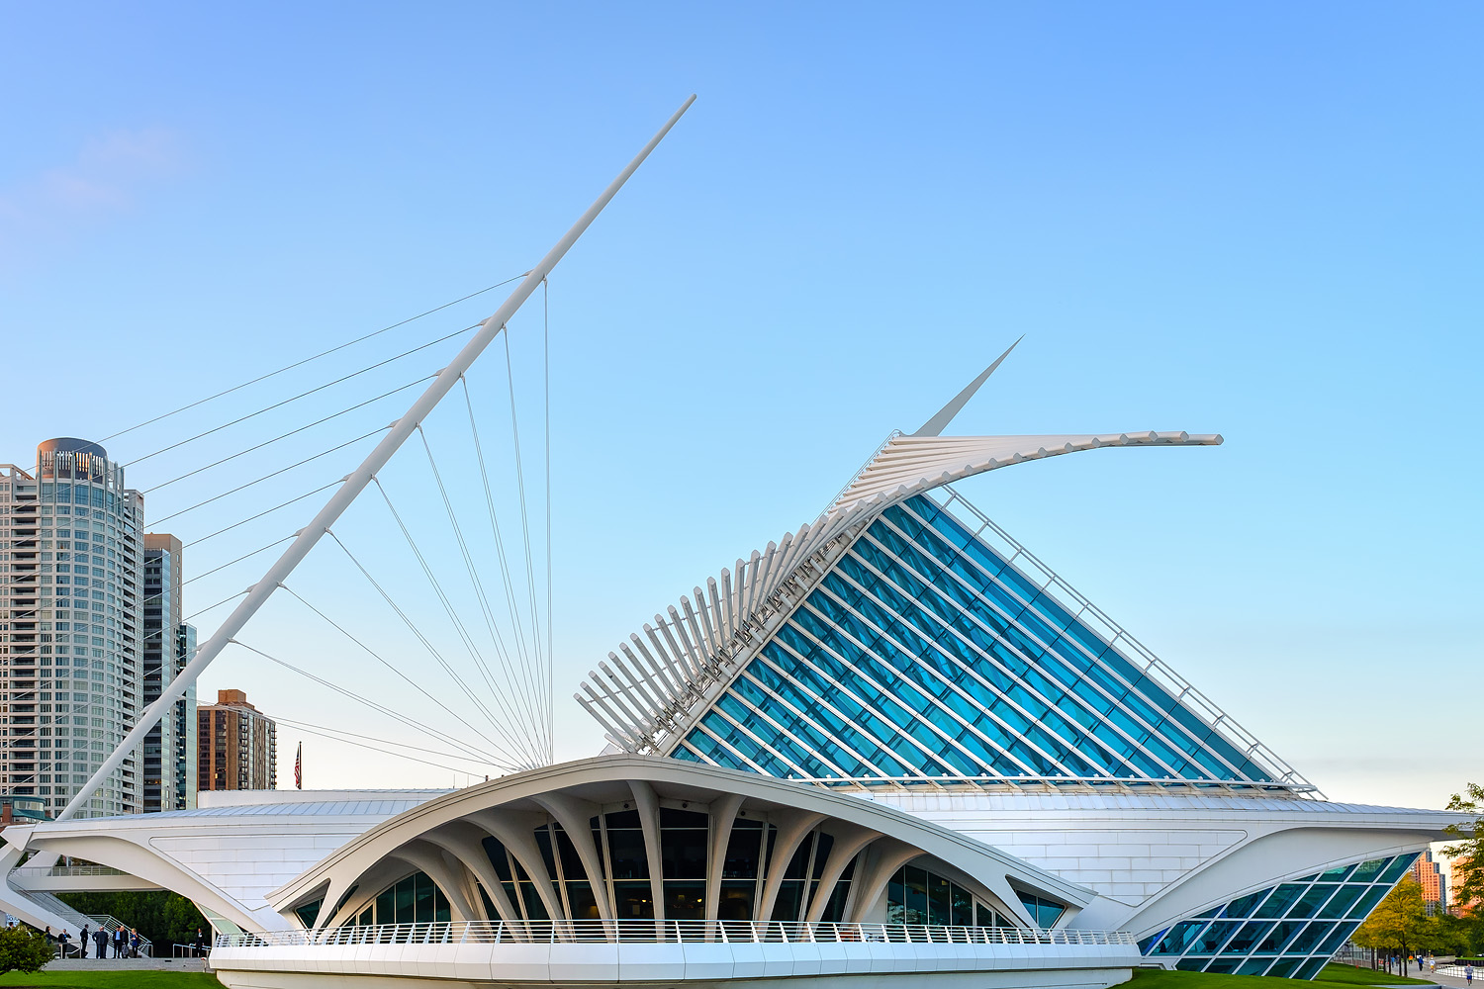
Several locations could be used in order to hold such an event but ive decided on using the Milwaukee Art Museum in Chicago not only for it’s soul purpose of having a large open space but of it’s history use and it’s potential. This museum was once used in the film Transformers 3 to represent an automotive industry, which helped pull my decision towards this location. It’s potential to hold such a large amount of clientel aswell as it’s futuristic aesthetic and design helps the purpose of the exhibition to display the insanely futuristic potential of the automotive industry.
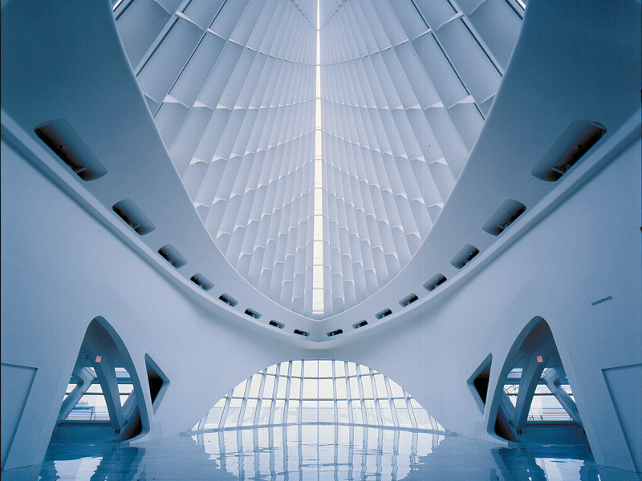

The exhibition will fill the entire area of the museum to display the future and potential of the automotive industry but with much loved iconic cars from the past that have been re-designed for the future. This then allows the younger generations to experience the past in all its glory with all the new modern technologies, which is more or less what this generation is interested in.

Iconic Cars will not only attract the younger generation to experience what the past has to offer but it will allow the generations of those eras experience those vehicles in today’s standards and the future.

Vehicle | Description | Era
Bugatti Type 57SC Atlantic | Possibly the most expencive car to date | 1938
Ferrari 250 GT berlinetta | Dominated LeMans 1960 First 4 places | 1953
Aston Martin DB5 | James Bond vehicle for several years | 1963
AC Shelby Cobra | Quarter Mile in 13.2 seconds | 1962
Alfa Romeo 33 Stradale | Best looking car ever | 1967
DeLorean DMC-12 | Back to the Future Car | 1985
Audi Quattro Rally | Most succesful Rally Car | 1980
Ford Shelby Mustang GT350 | Gone in 60 seconds / Carroll Shelby | 1965-66
Land Rover Defender | Success in WW2 | 1939
Lancia Stratos | Most Recognised Rally Car

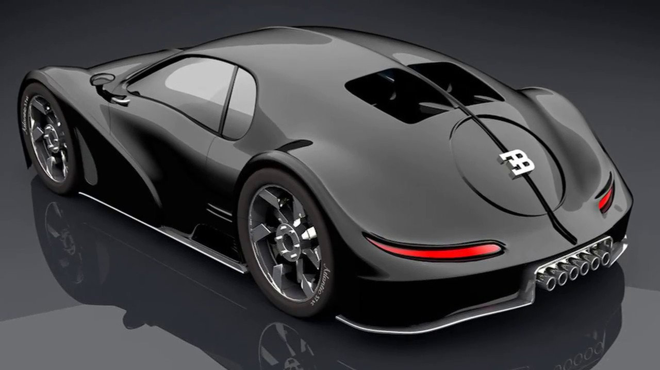
The first vehicle on exhibition is the Bugatti Type 57SC Atlantic, which is undoubtably one of the most recognised classic vehicle ever, made. It’s a car that could never be copied, or reproduced or emulated without utterly ruining the memory. In it’s day the type 57SC was nothing like anyone had seen before. Its design and intreging curves set it apart from the competition. The sheet metal alone would send you home drooling, as if you’d seen the most sensuous woman in the world. It now auctions north of 30 million dollars, which is possibly the most expencive car in the world. Althoughit being almost impossible to recreate there have been a few designs which have been developed to reimagine that era and excitement of the Type 57SC

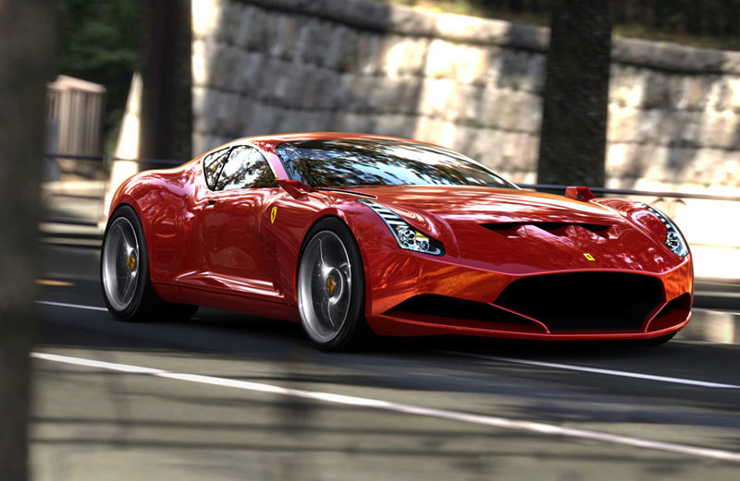
The second vehicle is the Ferrari 250 GT Berlinetta. It is quite possible that it’s the prettiest car ever created Pininfarina. Its elegance of style, luxury and speed made it the ultimate all rounder and set it apart during it’s glory days. Due to the fact of it being convertible helped it’s design feel at home when traveling around Italy with th classic looking architecture set this vehicle right in it’s comfort zone. This exact car went on to win the Le Mans 24-hour race in 1960 taking the first four positions. It dominated its era in every department, which is why it’s still such an iconic car. Further more due to it’s success it has been redesigned for a possible concept design in the near future.

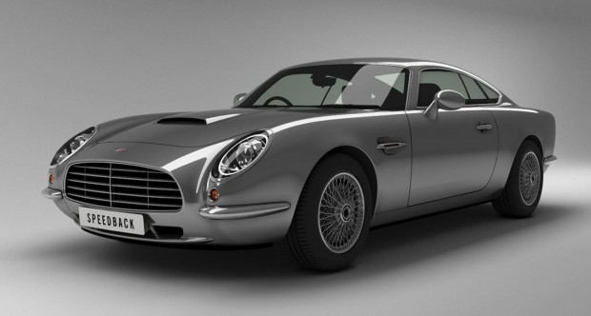
When 007 hit our television screens we had no idea what was going to hit us in the following years. James Bond British Spy was known for his licence to kill, his seduction with women and his high-speed car chases. Which is why Aston Martin snatched the opportunity to use they’re vehicle the Aston Martin DB5 in the Bond movies. Since the first ever film the Aston Martin is an iconic car that is seen in almost every movie. The DB5 design was so pretty to look at they thought it would be a perfect match for the films production. It’s speed and luxury set it apart from the other choices of that era. Now we can at least see the modern equivelant of that iconic car.
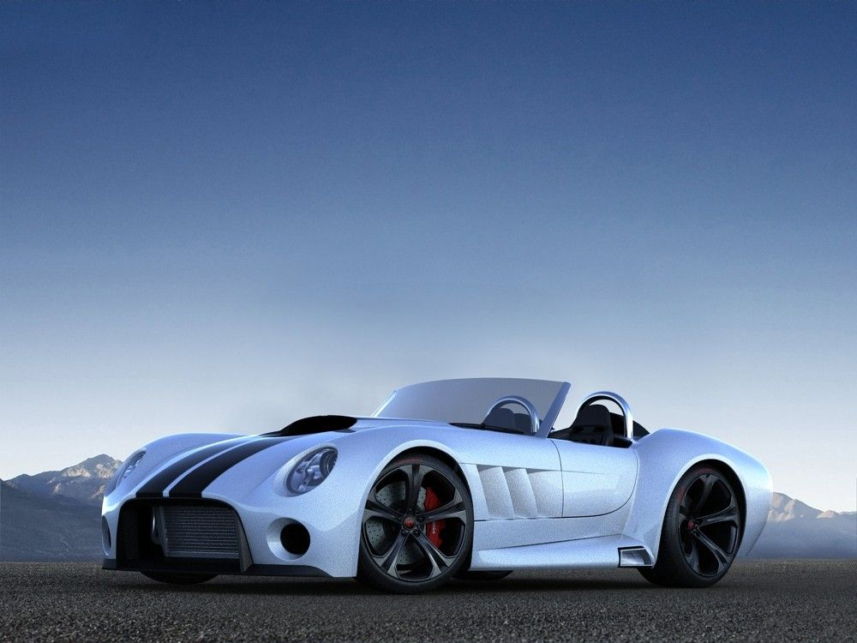
The AC Shelby Cobra says it all. When Carrol Shelby introduced Shelby engines in a small shell car of the AC Cobra the word of a car was not enough. It was a street legal racecar, which dominated the quarter mile drag race by setting a time of 13.2 seconds. Although the production of these mosnters ended in 1967, the automotive world would never be the same.

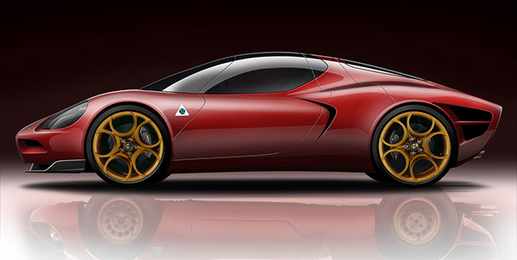
Widely considered to be one of the sexiest automobiles ever made, the car was not just a looker. Alfa Romeo produced the 33 stradale as a roadgoing version of the racingTipo 33 and introduced Alfa’s racing technolgy to the world. It cocked 60mph in 5.5 seconds and topped out at 160mph. Sadly only 18 were made which makes them so rare. Luckily automotive designers have considered the rebirth of the 33 stradale.

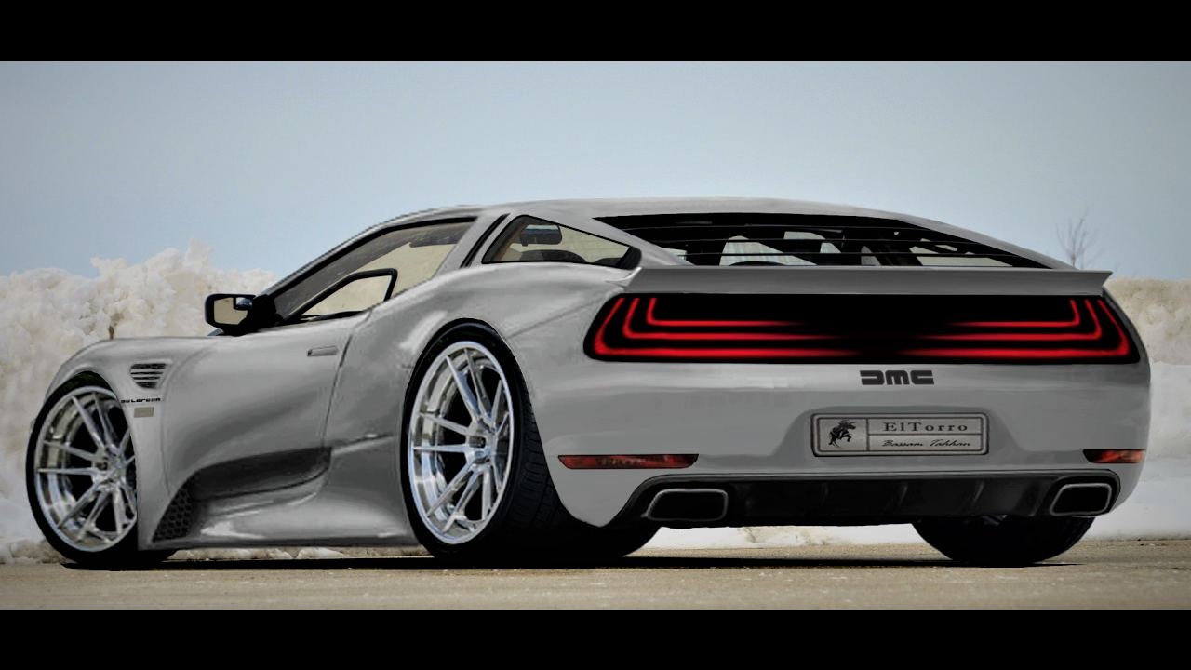
Now were going Back to the Past to look at the most iconic movie car ever. The Delorean DMC-12 was initially a failed production vehicle in the automotive industry. Yet once the franchise Back to the Future snatched the Delorean to use it as a time machine, it gave the brand a mega boost and every body wanted a piece of iconic movie history. It would only ever be fast if it were dropped off a cliff but never the less, as long as it hit 88mph everyone was happy.

I would love to continue naming all the vehicles in each iconic era but it would be impossible due to the sheer success of the automotive industry and the iconic cars of the past. By exhibiting these concepts doesn’t only show the public the possibilites of the industry but pushes the industry to focus on re-making cars from the past and restore them to they’re glory days.

BIBLIOGRAPHY

Kwon. A (2015) Gear Patrol – Here to Eternity: The 50 Most iconic Cars in Motoring History

Atchity. M (2008) Total Recall – Total Recal: 50 Most Memorable Movie Cars

(2010) Odometer – 15 Cars That Defined The 20th Century Classic

