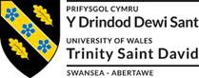
Mapping in Layers
MapInfo Tutorial 2

Beverley Holland

Mapping in Layers

The MapInfo map window is built up by placing a number of map layers or tables onto the screen at any given time. We can turn the necessary layers or spatial datasets on and off to give us different visualisation of the geographical data.

Objectives
- Understand Map Layers.
- Manage Layers of a Map.
- Reorder Layers.
- Add a Layer.
- View an Entire Layer.
- Use the Info Tool.
- Remove a Layer.
- Change the Appearance of a Layer.
- Set Zoom Layering.
- Create a Duplicate Map Window.
- Save a Workspace.

Start with a clean MapInfo session.

From the File menu, choose Open your workspace created in lesson 1.
The image on your screen should look something like this ….

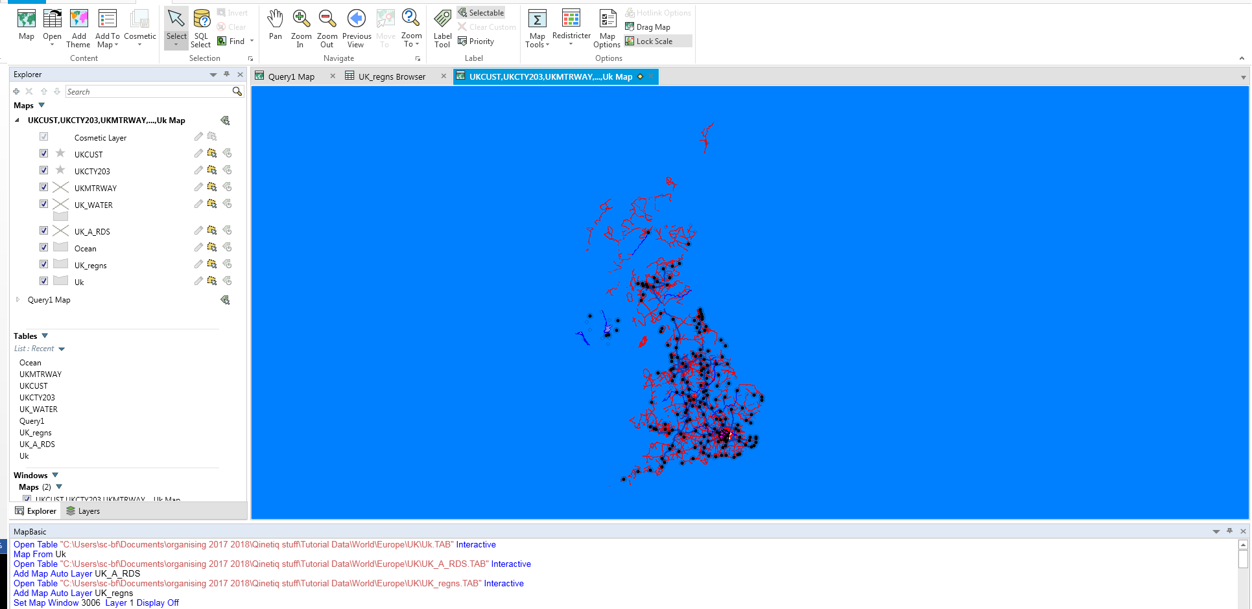

Your Map window has changed appearance for the worse as the ocean layer has covered many of the layers. We can fix this by using Layer control.

The cosmetic layer is always in a map and always the top layer it cannot be removed or reordered.
Note: If you move your cursor over a layer and pause, the .TAB file’s path information will display in an InfoTip bubble.

The Layer Control Check Boxes:

The Ocean layers are positioned on top of the of the UK_regnd maps.

- Select the OCEAN layer.
- Click the Down button from the Reorder group and move it underneath the WORLD layer.
- Click OK.

AS you move through the layers more detail becomes visible.

You can remove a layer by closing the table. You can also remove a layer using the Remove button in Layer Control. In this latter case, the data table itself is still open within MapInfo; it simply is no longer available in the Map window.
Remove the Ocean layer from our map window:

The layer is removed from the Map window but you should still see the table in the table list

You may want to change the appearance of a layer. It is possible to do this without permanently changing the table.
- From the Map menu choose Layer Control.
- Double click the Uk_regns layer.
- The Display Options dialog displays.

In this dialog you can override the default style settings that determine how this layer displays in a Map window.
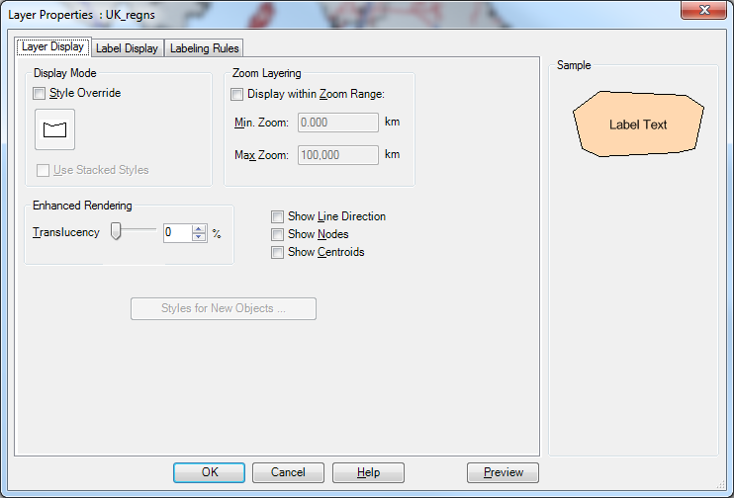

- Check the Style Override check box to override the default style of a layer.
- Click the Region Style button and the Region Style dialog displays.
- Click Foreground drop-down menu from the Fill group box.

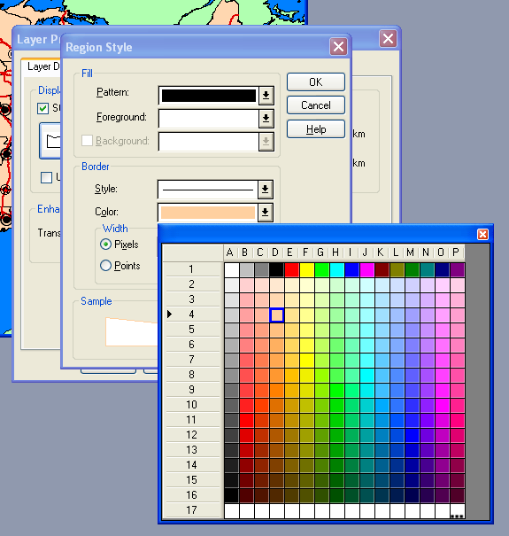

- From the colour palette, choose a new colour such as Yellow.
- Click OK to accept the colour choice.
- Click OK to accept the Display Options.
- Click OK to close the Layer Control dialog.

Many layers that you use in your map windows may only be appropriate to use at certain zoom levels. For example, if you take a street map and zoom out so that all of the streets are in the window, there is too much detail. To manage the level of detail that appears in a map you can use the zoom-layering feature. This feature allows you to specify a range of zoom levels for the layer to be displayed in.
In your map, if you zoom out too much, the UKCUST layer will cover up the south west London area. We will set up the Map window so that the layer is only visible if the map is zoomed in to view 300 KM or less.

- Open the Map menu.
- Click on Layer Control. .
- Click the Display button and the Display Options dialog box displays.
- Check Display Within Zoom Range.
- Enter 300 for the Max Zoom.
- Click OK to close the Display Options dialog box.
- Click OK to close the Layer Control dialog box.

The customer will only be displayed if the zoom level is 300km or less.

Once you have customized a view of your map, you may want to create a clone, or copy of the map window. In this way you are able to see two views of a map at the same time, perhaps choosing to zoom in for one view (to create an inset), while letting the other view provide the bigger picture.

- From the Map Menu choose Clone View.

A duplicate map appears. This feature can be handy when you need to produce a map with several insets. To see both map windows tile the windows.

- Open the Window Menu and choose Tile Windows

Since many new settings have been included in the map layers, your work needs to be saved in a workspace.

- Open the File menu and choose Save Workspace.
- Type myWorkspace.
- Press Save.

When you save a workspace, all layer control settings that you have applied to your maps will be remembered in the workspace. Layers based on a query made by select tools will not be saved.

To view all of the objects associated with a map layer within a Map window, use the View Entire Layer command.

- From the Map menu choose View Entire Layer.

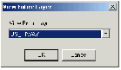

- Choose the ukcust layer from the View Entire Layer drop-down menu.
- Press OK.

Use the Info Tool to view tabular data associated with objects. The information displays in the Info Tool window. If more than one object is at the same geographic location, the Info Tool window indicates how many objects are at that location, and the table in which each resides. For example, you might click on a city using the Info Tool and simultaneously get information on its regional data too. Select the appropriate item.

- Select the Info Tool from the home tab.
- The cursor will now appear as a large cross on the screen.
- The cross can be places over a number of layers

- Click on a city in the Map Window. In the Info Tool window, a list of the map objects that were under your mouse pointer appears:

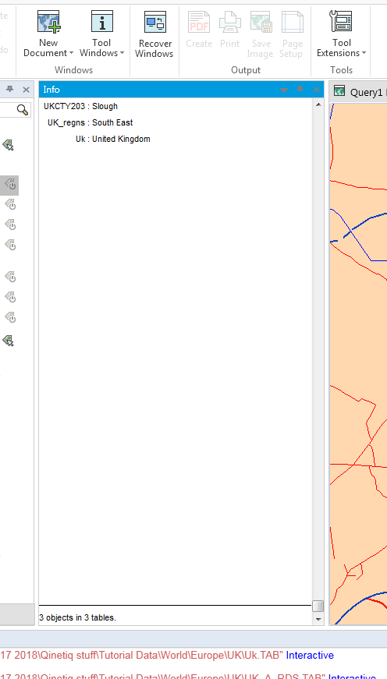
- To get further information on one of these objects, click the text (in the Info Tool window) of the object you want to see. All of the tabular data appears for that object.
- Close the Info Tool window
- Save your work

