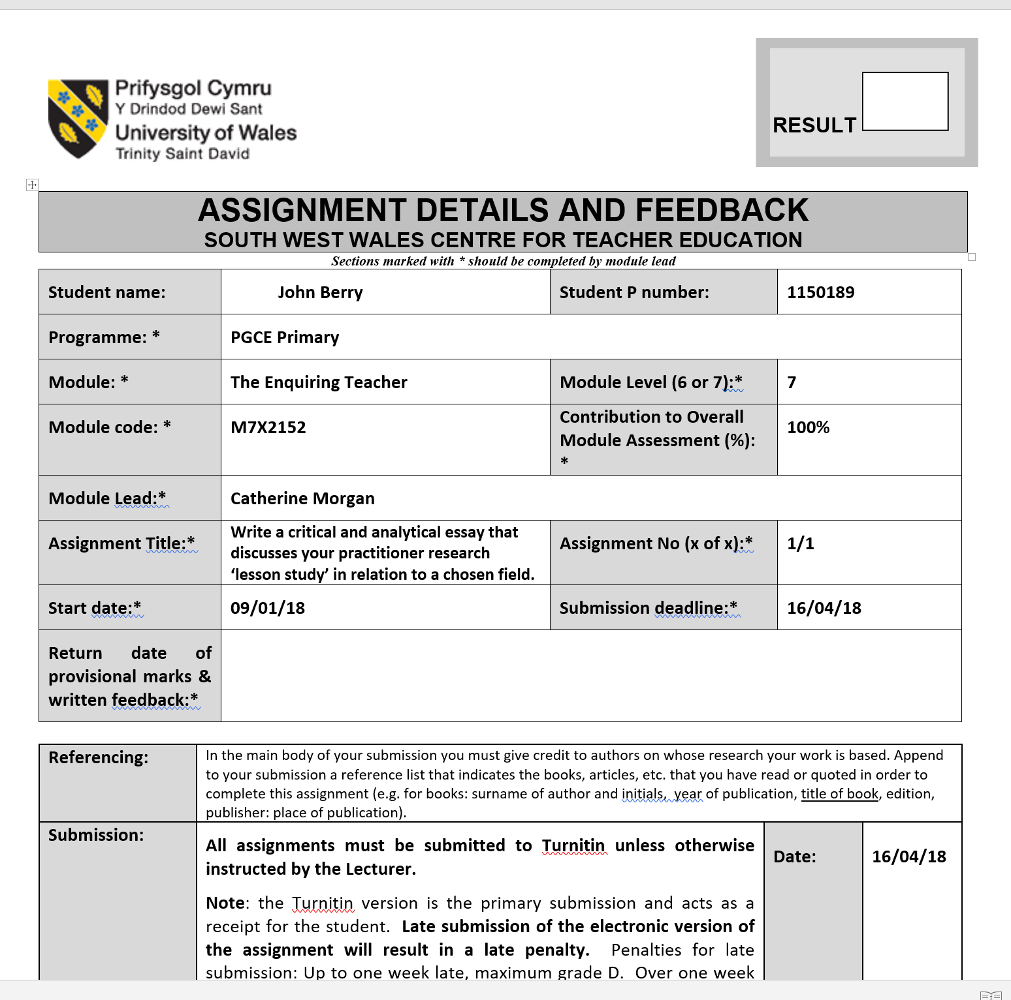

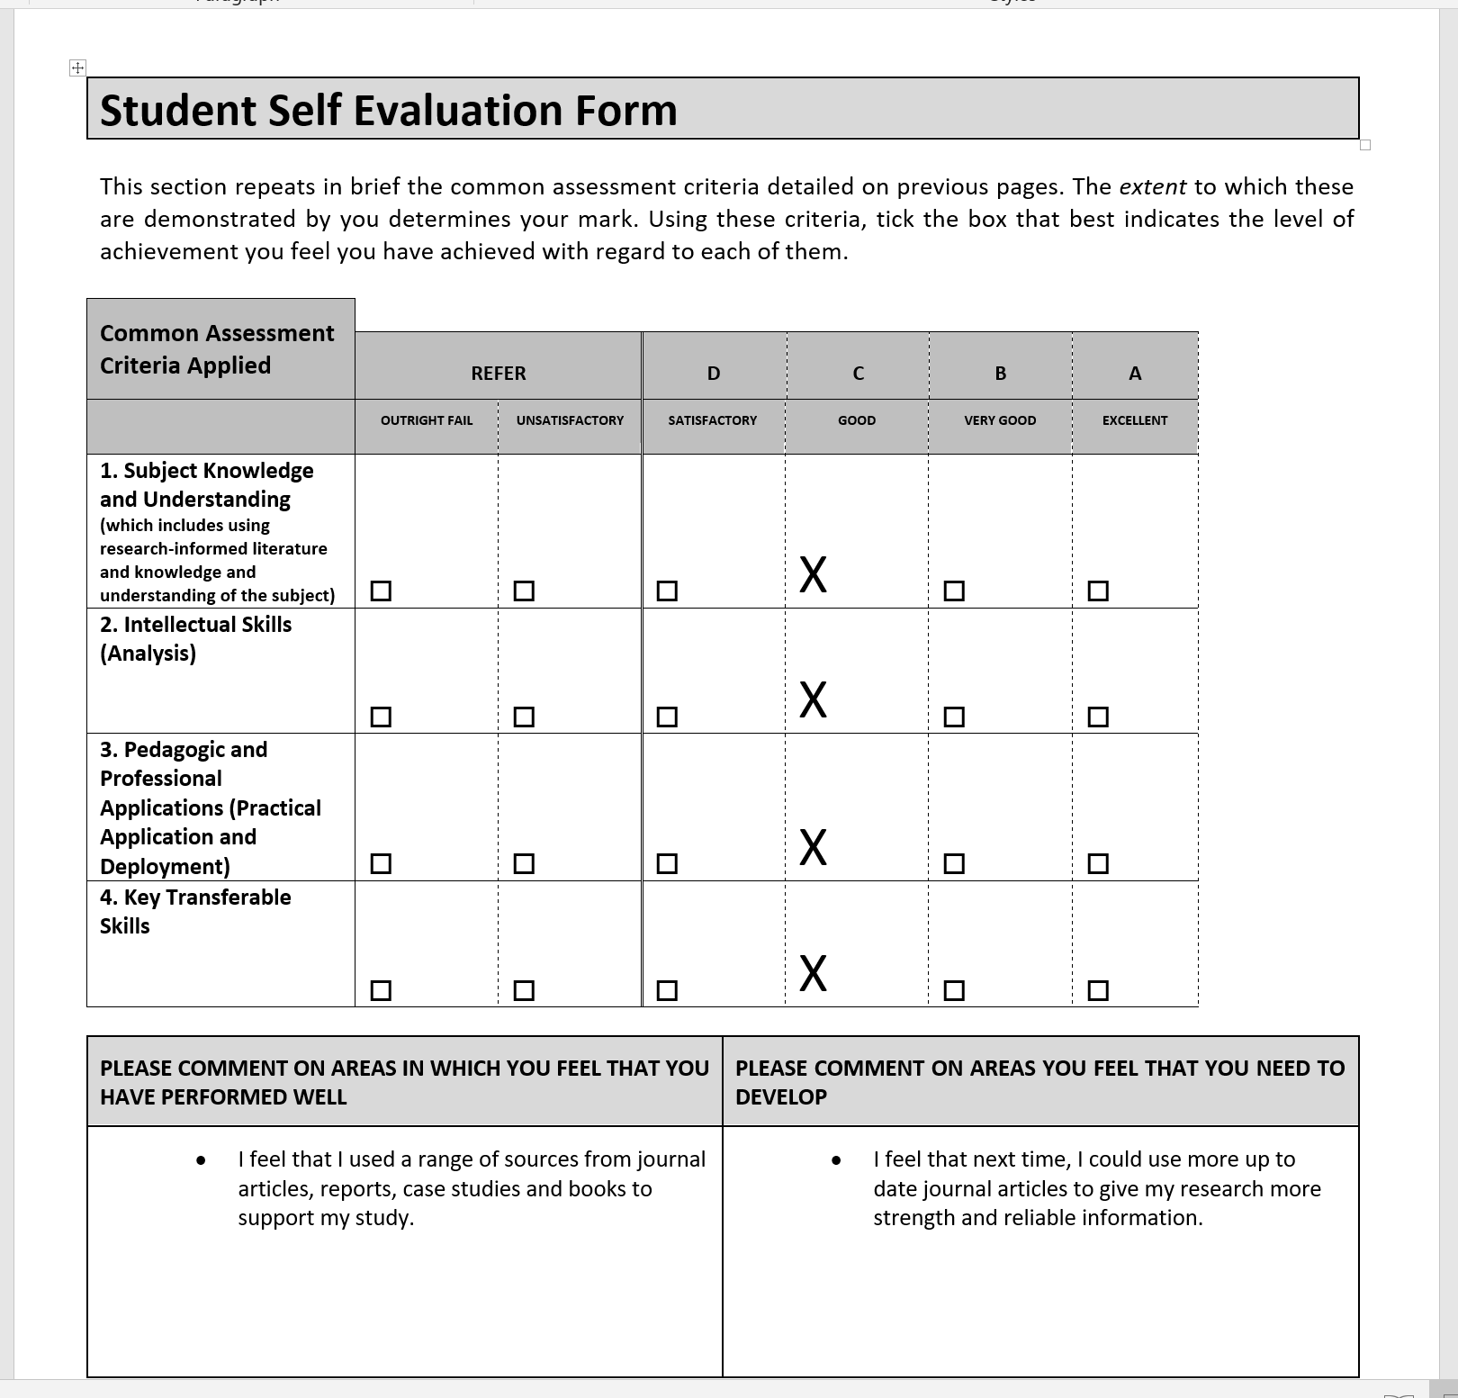

How can we improve pupil understanding of the learning outcomes, through the use of self-assessment?
Introduction
This small-scale study aims to investigate how the use of self-assessment can support pupils gain a greater understanding of the learning outcomes, within the foundation phase setting. The key features of self-assessment will be explored and the way in which it can aid learning and develop essential life skills in young people. During recent teaching experience in both foundation phase and key stage 2, it was apparent that self-assessment was under-used possibly due to time restraints or level of cognitive ability needed. Can self-assessment be effective in a foundation phase classroom or should it be left for those who more capable of calling on their higher order thinking skills that are not yet developed in the early years? One thing that can not be disputed is that every assessment should enable every child to succeed at the peak of their capabilities, whatever their background or learning needs they may have and inspire them to improve. I will look how self-assessment can not only be a valuable way to provide future learning opportunities but provide children with a sense of ownership that can ultimately produce autonomous and independent learners.
In a culture where summative assessment is (Stobart, 2008; Tiknaz and Sutton 2006), there is a need to provide students with clear and motivating steps that help them to further their understanding. Since Black and William (1998b) research on Assessment for Learning (AFL), formative assessment has played a central role in a teacher’s toolkit. Teachers are constantly applying strategies that allow them to check pupil understanding and more importantly build on what they already know. Promoting children’s learning is the principal aim of school, with assessment lying at the heart of this process (TGAT, 1998), but having a clear understanding of how well they are doing and what they need to do to make progress is what ultimately influences educational achievement. Giving time for children to reflect on their own work and achievements not only helps establish where they are in the learning process, but where they need to go and how best to get there. Many schools are already committing themselves to developing strategies to promote this notion, with the aim to inspire individuals to achieve their very best.

Research Context
The research was conducted in two different foundation phase (FP) classrooms in South Wales. The first research lesson took place in a year 2 class in a suburban area of Powys county where 16% of pupils receive free school meals. Nine children were chosen at random to take part in the lesson while three pupils took part in the second lesson from a Reception class in a small inner-city school in the county of Swansea. With only 11% of children receiving free school meals in school 2, meant both schools were lower than the national average of 20% (WAG, 2016).
This research was conducted in order to build on our current educational knowledge of self-assessment and the ways in which it can support pupil’s learning and education attainment. A lesson study was designed to provide both qualitative and quantitative data through a variety of research techniques that included interviews and observations. Dudley (2011) advocates the use of lesson study in developing teacher practice. Originating in Japan, it involves groups of teachers planning, teaching and observing in collaboration, with the aim of focusing on the needs of students and problems that affect learning. Lesson Study only became popular this century, following the successful contribution by US researchers that helped to develop a deeper teacher knowledge of both pedagogy and of subject knowledge. Educational attainment amongst Japanese pupils improved as a result, when compared with comparable pupils from the US (Stigler and Hiebert, 1999; TIMSS, 1999).
Lesson study builds on the principle that in order to improve education, teachers should get together “to study the processes of teaching and learning in classrooms, and then devise ways to improve them” (Fernandes and Yoshida, 2004). Over a series of research lessons, provides a better platform to plan and refine teaching approaches that help enhance pupil’s learning and are then encouraged to share findings with other professionals. Robinson (2009) emphasises the importance of collaboration enquiry, suggesting that it is the most significant action a school leader can take in order to improve educational outcomes for students.
Following Dudley’s (2008) lesson study cycle (see image 1), we worked in collaboration to agree a focus for pupil learning and progress (understanding of the learning outcome) and identified a technique that addressed that need (self-assessment). A research lesson was designed that allowed us to specifically focus on the learning of three target pupils.
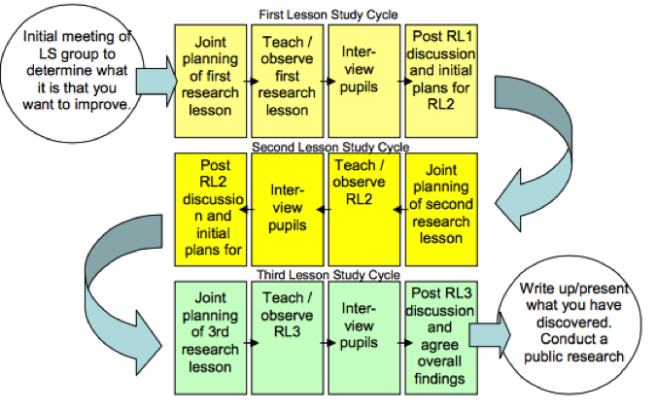

Image 1: The Lesson Study Cycle (2008)

Lesson studies are not a one-off event. It takes place over time and happens in real classrooms with real pupils. They help to engage teachers in developing various classroom techniques, with the underlying goal - aiding children’s learning and attainment. According to Cordingley et al (2004), lesson study blends all the features of professional learning that impact teaching and learning the most, as well as giving teachers ownership of their professional development by allowing them to choose their own research question. Lesson studies also reported by Dudley (2011), gives a much clearer and sharper detail on pupil learning than what is usually possible, distinguishing the gaps between what has always been assumed while pupils were learning and what is actually happening. It then allows teachers to be in a more superior position to plan learning more effectively and meet the needs to all learners as a result. In line with Dudley, Pollard (2014) encourages schools to adopt lesson studies as part of their continuous personal development plan (CPD) and formally share the outcomes with a wider audience of other teachers. Classrooms are one of the most complex and multi-faceted working environments. As teachers tend to practice in isolation as lone professionals within their own classrooms, other teachers rarely get an opportunity to see other professional’s expertise performed in action. The few occasions where a teacher’s practice is observed, Dudley (2011) claims it is often to merely judge their performance, rather than in a context of professional learning. In such contexts, teachers tend to play safe with the practices they put on view, highlighting the value of collaboration. The best schools use evidence-based research to evaluate their own teaching approaches and determine whether or not they have a positive impact on learning. Generating new opportunities to explore and reflect on teaching is therefore a crucial element in creating a self-improving school (ETW, 2016).

Lesson study
The lesson study involved two research lessons, focussing on the relationship between self-assessment and pupil’s understanding of the learning objectives. Each lesson was delivered by one member of the research team, while the other would observe. Observation which Grigg (2010:377) defines as a “process of carefully watching children, listening to what they say and making note of the findings,” played a key role in our research to best capture what was seen and heard such as a child’s needs, behaviour or social interactions. A combination of ‘non-participant’ and ‘inside-observer’ approaches were performed where one researcher observed discretely from the ‘outside’ without interfering, while the other was actively involved in the teaching of the activity, experiencing events first-hand. Erlandson et al (1993) advocates observations as you are able to use all of your senses and thus capture an authentic written picture. Despite Adler & Adler (1994:389) considering observation as the “fundamental base of all research methods,” the difficulty to observe and record results simultaneously was acknowledged particularly in a busy classroom environment. A notebook was therefore accessible at all times to help overcome this. In consonance with Palaiologu (2008) and DCSF (2007), it was important to detach personal views and emotional bias when observing to assure a true objective conclusion and to create a trusting rapport with pupils to assure an authentic and reliable context. This also helped to counter attack the argument made by Hopkins (2008) that a presence of an observer can disrupt and effect behaviour.
The observation process also involved assessing children’s level of well-being and involvement introduced by Dr. Ferre Laevers (see appendix A) following the notion made by RCEE (2012) that only when there are high levels of security and participation, can deep learning take place. Interviews were then carried out at first opportunity to gain participants perspectives on what they had achieved, what they found most challenging and what they could do in order to improve next time. The interviews were short and concise to assure attention levels were high and was performed in a group situation.
Ethical Considerations
Throughout this study, the ethical considerations were valued and planned in advance following the British Educational Research Association (2011) guidelines. Permission was granted from the university ethics committee prior to any research being carried out, while an explanatory letter to request parental consent was also issued.
Extra attention was made to ensure the well-being of participants, in line with Vetenskapsrådet (2009) notion that extra caution is needed when children are involved, especially as gaining consent can be more problematic. Ongoing assent occurred throughout the research where children were given the opportunity to show a ‘Thumbs up, Thumbs down’ representing their level of comfort and to give them a say in what affects them coinciding with UNCRC (1991) statement. It was made clear to participants that they had the right to withdraw at any time following the United Nations (1989) ‘Rights of the Child’ statement that all children should be treated equally and with respect at all times. Coinciding with the principles set by Bryman & Bell (2007), the results were precise and not exaggerated while the confidentiality of participants and schools involved remain anonymous compliant with the Data Protection Act (1998).
Literature Review
Following the work Black and William (1998b), Assessment for Learning (AFL) has become a major initiative backed by the UK Government in recent years, as a means of raising standards particularly among lower attainers. It was found that an inadequate amount of time was given to children, allowing them to reflect on their work and not enough quality feedback provided. As a result, four recommendations were put forward for practitioners: more thinking time for pupils to answer questions; provide clear and constructive feedback; encourage pupils to assess themselves and each other and involve pupils in the assessment process. Formative assessment is central to the foundation phase practice where teachers are constantly, where through observations can generate a wealth of information about their pupil’s interests and abilities. Department for Children (2007) however claimed assessment is the frailest part of teaching and learning due to teachers too often leaving ticks, smiley faces and comments of ‘well done’ in workbooks. Despite these expressing approval, Grigg (2010:386) argues it does not allow students to “bridge the gap” in their understanding. Yet research has shown that when AFL strategies are implemented in the classroom, children can improve up to four grades higher on standardised tests (Black and William, 1998b; Chappius, 2015). These improvements recorded are among the largest found for any educational intervention. Having said this, AFL will only be effective if acted upon early and contains clear and focussed feedback (Assessment Reform Group, 2002). AFL is ultimately about empowering children providing them with the tools needed to become autonomous learners.
One of the chief aims of primary education is to foster pupil independence, where students are encouraged to try new ideas and take risks. Self-assessment can play a key role in this process, in which Boud (1991) defines as the involvement of students in identifying the criteria that applies to their work and making judgements about the extent to which they have met that criteria. Involving children in the assessment process, giving them opportunities to reflect and make informed judgments about their own understanding, not only encourages them to set targets for themselves but offers teachers an increased insight into the child’s mind and can better meet their learning needs (Hanrahan and Isaacs, 2001). Focussing on areas of difficulty and what helped children gain success is at the heart of the learning process. By encouraging children to reveal these points and celebrate their accomplishments liberates them to perceive difficulties as necessary to learning.
In order for self-assessment to be effective, it must be linked to the learning objectives and success criteria, as only then students can have a clear picture of what is expected from the task and this become more “committed and more effective as learners” (Black & William 1998a:10). Furthermore, Estyn (2011) and Cousins et al (2004) suggest when correctly implemented, self-assessment can have a significant impact on pupil motivation, independence, self-esteem, attainment and more importantly empower them to guide their own learning. Studies conducted by Black and William (1998a) and Assessment Reform Group (1999) support this by reporting significant learning gains by those pupils who have been actively involved in self and peer assessment. Sharing lesson objectives and success criteria with children, makes it clear what they are aiming for, what quality looks like and what they need to do in order to achieve it. If self-evaluation is linked with the success criteria of a lesson, children’s progress, persistence and self-esteem will improve (Black and William, 1998a). Using visual aids as a means of communicating their level of understanding and involving them in discussions throughout activities are easily accessible in a foundation phase setting. Despite its complexities, even very young children have been found to be capable of thinking about how they feel about their learning and reflect upon the learning against agreed criteria (Harrison and Howard, 2009).
It should be noted that if performed too often, particularly when used at the end of every lesson can develop negative attitudes especially if it is felt that the assessment concentrates on comparing their own performance against others (Murphy 1998). Where in contrary, information about progress should be used towards future learning goals and ensure learners understand the goals they are pursuing and the criteria that will be applied when assessing (ARG, 2002). Self-assessment is not an innate skill however. It needs teaching to help children them get the most out of using evaluative techniques. James et al (2007) believes it is the ‘stepping back’ from the learning, where children discuss how they are working, that needs to be taught. He adds that this process when paired with a ‘step back in’ approach ultimately creates autonomous, confident individuals who are no longer dependent upon the teacher.
John Hattie (an academic researcher from New Zealand) believes ‘effect sizes’ are the best method to identify the most influential approaches implemented in the classroom. The table below (image 2) compares a variety of strategies that according to Hattie’s research, represent the most effective in relation to pupil achievement.
Strategy | Effect-Size | Influence
Feedback | 1.13 | High
Student’s prior cognitive ability | 1.04 | High
Formative evaluation | 0.70 | High
Self-Evaluation | 0.62 | Medium
Sharing success criteria | 0.58 | Medium
Teacher expectations | 0.43 | Medium
Reduced class size | 0.21 | Low
Subject matter knowledge | 0.09 | Low

(Image 2, edited from Petty 2009)

According to Hattie, an effect-size of 1.0 is typically associated with improving a student’s rate of attainment by 50%. To put this into context, this can be a potential growth of two grades at GCSE level, while an effect size of 0.7 would promote England from the middle of 41 countries, to the top 5 if applied to the international comparative studies in mathematics (Beaton et al, 1996).
As can be seen, self-assessment is seen as one of the top factors in raising standards (0.62) making it more influential than teacher’s subject knowledge (0.09) or reduced class sizes (0.21). Hattie however emphasised the importance of effective dialogue between teacher and student can have on a child’s academic performance, which plays a key role in ‘formative evaluation’ (0.70). This process involves not only clear feedback to students but giving opportunities for students to discuss what they have learned. This supports the argument made by Falchikov (1994) that self-assessment can play an integral role in pupils learning experience, especially when combined with effective feedback.
Despite over 300,000 students participating in this research, it should be noted that the results were only presented in quantitative data and would therefore be too simplistic to conclude that self-assessment as the greatest impact on learning. Black (1998b) for instance reported how it can take time for children to overcome their fear of tests and understand the criteria before they embrace self-evaluation. On the other hand, with its emphasis on student responsibility, making judgments is “a necessary skill for lifelong learning” (Boud, 1995:11), while the self-assessment process helps “prepare students not just to solve the problems we already know the answer to, but to solve problems we cannot at the moment even conceive” (Brew, 1995:57). Being able to successfully reflect upon work and achievements, can help establish where you are in the learning process, where you need to go and how best to get there.
Lesson 1 Analysis
The lesson study as can be seen in (appendix B), required students to design and create a container that would protect an egg from cracking or breaking from a high fall using various materials. Having a spread of pupils with a range of attainment levels and genders allowed for more reliable results and helped prevent McPhee (2013) of a gender performance gap. The success criteria were shared clearly with pupils at the beginning and at intervals throughout the lesson so that they could determine where best to spend their efforts.
Using the Leuven Scale of Engagement and Well-being enabled us to collect valuable quantitative data, while also recording any noticeable events on learning and/or behaviour. All pupils demonstrated good levels of well-being scoring 3 or above, indicating that all children felt comfortable and safe in their surroundings, giving the results generated reliability. Involvement levels were also high throughout the lesson with two pupils scoring 4 another 3, suggesting that the level of challenge was suitable for the learners and they clearly understood the lesson objectives. For instance, Child 1a (as can be seen in appendix C) was confident in sharing ideas to the group and demonstrated good problem-solving skills during the activity.
By the end of the lesson, pupils successfully produced a design that prevented the egg from breaking and met other essential criteria. Learners demonstrated good communication skills needed in a team-setting, as well as calling upon their creative and problem-solving attributes. During the plenary, the teacher posed questions to the group that encouraged children to evaluate their own performances and their work produced against the set criteria. Pupils exceeded expectations in their evaluation skills, showing a good understanding of the lesson objectives and success criteria. An example of this was when asked what the most important element of the activity was, Child 1a replied that “it needed to be a fair test” while Child 1b said “that all were dropped at 1 metre.” Despite students successfully meeting the success criteria, this shows good critical thinking in their work and could recognise clear areas for further improvement. Moreover, when asked what they would do differently next time, Child 1b stated that they “would not put straws at the bottom but make a cushion around the sides,” while in the same way Child 1a replied that next time they would “surround it with newspaper and create a “peep-hole.” This is a representation of a clear understanding of the success criteria, as by creating a hole they would still be able to see part of the egg.
After reflecting on lesson 1, the feelings were positive as the children enjoyed taking part in the activity and showed excellent levels of engagement throughout. By having three small groups with nine participants in total, helped us gain quality data that represented the class appropriately. The self-assessment process worked well in a group setting, whereby pupils felt less ‘on the spot’ and could add to what had been said by others. This supports the argument made by DfES (2004) who says effective teaching and learning is underpinned by interaction with others. They add the opportunity for peer group discussion offer children the chance to explore, justify and evaluate as they develop their understandings. Similarly, Arthur et al (2012:137) state collaboration in the assessment process “gives children the confidence to take risks, offer tentative thoughts and explore hypothetical avenues.”
For the self-evaluation to be effective, it was performed immediately after the lesson to ensure more rich and detailed responses were given as thoughts and feelings were fresh in their minds. Coinciding with the principles made by ARG (2002) we discussed the lesson objectives and success criteria with students in language they understand, providing visual examples of how the criteria can be met. However, it was thought that in order to improve the lesson for next time, we should involve pupils in the formulation of the success, avoiding the common mistake pointed out by Hattie (2012) that success criteria merely relate to completing the activity, rather than engaging children in the enjoyment of learning. Falchikov (2006) supports the notion of a more constructivist approach as when students are active participants in the assessment design and make judgments on their work, is a sustainable preparation for working life. It was acknowledged however that not all learners work at the same rate or start from the same level of prior knowledge.
Lesson 2 Analysis
After reflecting on lesson 1, a modelled example was used to give pupils an image of how the success criteria can be met and the specific areas they need to focus on. Learners again participated with enthusiasm but should be noted that a Leven Involvement score of 3 was given to Child 2a (as can be seen in appendix D), which represents a moderate level of engagement showing occasional signs of low energy levels and easily distracted. A possible reason for this was the difficulty level of the task. According to Hattie (2012) the challenge level should not be so difficult that the goal is seen as unattainable, while Burns (2002) argues the appropriate level is determined by the amount we already know. It is argued that a child needs to know approximately 90% of what they are aiming to do in order to enjoy and flourish a challenging goal. Anything less than 50% however, virtually assures students will not be engaged and therefore success hindered Burns (2002). While challenge is one of the key ingredients for effective learning, “the art is the level appropriate to the learner,” highlighting the need for eliciting prior knowledge at the start of lessons – a major technique in AFL (Hattie, 2012:57). At the end of the lesson, we were able to ask participants what they found most difficult, with Child 2a replying “working with girls.” This suggests that the dynamics of the group may have affect his concentration and enjoyment levels, while adding that they would have preferred to work independently.
The fact that questions were delivered in clear, accessible language appropriate for the ages of participants, allowed them to succeed expectations in their evaluative though processes. Pupils were confident in identifying strengths of their work as when asked what worked well, Child 2b responded that “the pompoms because they were squidgy and soft like a pillow.” Emphasising the success criteria at intervals throughout the activity coincided with Grigg’s (2014) argument that it helps make it clear and open to learners what will be looked at when assessing. Another example if this was from Child 2c who when asked what the most important thing about the activity was, replied “to see the egg” - a clear connection to the success criteria. After reflecting on the lesson, it was pleasing to see young children be encouraged to engage in self-assessment techniques, even though Grigg (2014) admits that younger children may find evaluative thinking challenging. Nevertheless, he supports children should getting into the habit of explaining how they arrived at answers and justify their choices throughout the curriculum. Self-assessment whether achieved orally on a one to one basis or as a group setting (as performed in this research), helps build a culture that values the process higher than the outcome. Learning is a continuous journey for both children and adults, with self-evaluation playing a key tole progression (Mclaughlin and Talbert 1993; Eraut 1994).
The level of challenge was shown to be pivotal in the success of self-assessment as if the task challenges students at an appropriate level when taking into account self-confidence and prior achievement, then the more powerful the feedback is. In contrast, if pupils find the activity too easy, then feedback and self-assessment in particular is of little value. Hence Hattie (2012) arguing that it is the challenge that keeps children committed to achieving goals. For future planning, it is suggested to allocate time at the beginning of lessons to explain the self-assessment process in more detail as promoted by Topping (2009); Boon (2016) and Black and William (2009b). For older children, a hard copy of the success criteria given to each pupil at the start of the lesson would be beneficial and using strategies such as ‘Two Stars and a Wish’ can produce quality feedback both orally and in written form. Students were engaged in the self-assessment process and took pride in discussing their successes and difficulties that they overcame, supporting the research conducted by Black and William (1998a). They found when students assess their own work, it encourages them to be independent and take ownership for their own learning as well as having a positive impact on motivation levels and self-esteem. A simple strategy in a Foundation Phase setting is a traffic-light system, which involves pupils indicating their level of confidence and understanding: red for uncertain; amber for partial understanding and green for full understanding. This enables the teacher to act upon the information immediately by grouping greens and ambers together to encourage collaboration and clear up uncertainties with each other. While those who signalled red on the other hand can be given more teacher support and had their individual needs responded to helping to reduce the risk of being distracted and disengaged. A similar technique can be to ask pupils to colour squares to indicate their confidence in achieving a given goal. Black and Harrison (2001) reported that pupils were found to be honest in their completion of this task because it was carried out as a private activity, the result of which was only seen by the pupil and the teacher. This method allowed pupils to alert the teacher as to who needed help whilst actively involving pupils in their own work and developing skills of metacognition.
Despite students showing a greater responsibility and interest when involving them in the assessment process, the accuracy of self-generated grades is the single most discussed issue in the literature of self-assessment (Boud, 1995; Boud & Falchikov, 1989). This criticism claims students do not possess the ability to assess themselves objectively and tend to either under-mark or over-mark their work (Segers and Dochy, 2001). Yet when Stefani (1994) investigated the outcomes of 87 students who had been exposed to self-assessment strategies, found that a reasonable level of teacher-pupil agreement was established when students were actively involved in the formulation of the success criteria. This also coincides with Brew et al (1999) and Longhurt (1997) who argue the involvement of students in the formulation of assessment criteria is critical in achieving an agreement between students and teacher’s assessment result.
Findings from the research concluded that when children are given the opportunity to evaluate and discuss what they have learnt and how they were able to overcome challenges, a much deeper thinking process was involved. In other words, Robson (2006) claims that a child’s cognitive development improves significantly when they talk about what they have been doing. The modern-day interest in thinking skills stemmed from Benjamin Bloom - an educational psychologist who was interested in exceptional talent and how high-level thinking could be promoted. He was specifically interested in finding out what students thought when they were being taught resulting in him challenging the existing protocols that compared student performance against each other. His most famous work was ‘Taxonomy of Educational Objectives’ (see image 2), where he identified a hierarchy of cognitive thinking skills (Bloom et al 1956). It is taxonomic in that each subsequent level depends upon student’s ability to perform at that level that precedes it.

Image 2, (Geib, 2006)

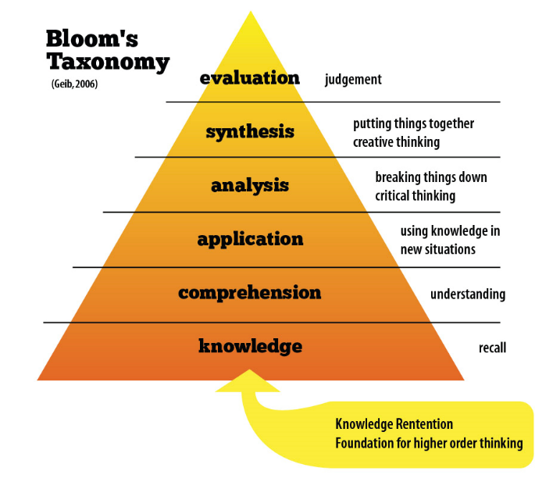
The concept of thinking skills has attracted considerable interest around the world in recent years, with evaluative thinking being considered among the main essential criteria that American employers look for in young people if they are to succeed in the workplace (Confederate Board, 2006). Similarly, in the UK, ‘The Guardian’ (22 April 2013) reviewed the top ten desirable skills that featured most in job advertisements and these included thinking flexibly, problem solving and ability to reflect.
Thinking skills has had a significant influence through the curriculums in Wales, Scotland and Northern Ireland. Blooms imact is particularly evident in the planning framework within the Scottish Curriculum for Excellence (Bloomer and McIlroy 2012) while Northern Ireland have invested heavily on resources. In Wales, ‘thinking skills’ feature in the Skills Framework (DCELLS, 2008) with guidance from the Welsh Government. However, following an evaluation report by inspectors, it was shown that the provision for thinking skills were ‘patchy’ and few schools used the non-statuary framework effectively (Estyn, 2011). The shift from knowledge-acquisition to thinking and leadership skills embodies the educational systems in Canada and Singapore who are looking to develop curricula strong on creative and critical thinking. This was also the case for England until recently as it was thought that thinking skills relied too extensively on factual knowledge and therefore emphasised a thorough grounding in subject knowledge (Johnson and Siegel, 2010). Johnson and Siegel add that thinking is spontaneous and intuitive, rather a set of processes to be taught and generalised while in the same way Willingham (2009) emphasises the importance of factual knowledge as the basis of critical thinking. Many believe however, that real life thinking is much more fluid than what Bloom’s Taxonomy suggests (Ritchhart et al, 2011). Grigg (2014:109) on the other hand compromises by acknowledging the importance of combining both thinking skills and subject knowledge, whereby “learners cannot achieve their potential if either is lacking.” There is no denying that the thinking and learning process is multi-faceted and dynamic, where despite knowledge providing the foundation for which higher thinking depend on, everyday thinking draws on a variety of different interrelated skills. Thinking skills needs to be connected to real-life contexts, giving opportunities to talk about their thinking to others. Eisner (2000) for example argues that in order to evaluate successfully, learners need to have the necessary information, understand that information and able to apply it, analyse it, synthesize it and then eventually evaluate it. Ultimately, when working hand in hand with self-assessment techniques, it helps creating a school culture that values the ‘thinking’ process which is crucial if children are to make progress.
Conclusion and Recommendations
It should be acknowledged that this was a small-scale study that was constrained by time and resources, so it is recommended that findings generated from this research should be used as further discussions with other professionals to continue the research. It is suggested to repeat a lesson study approach where a sequence of lessons could focus on one class throughout a longer period of time and once appropriate training has been given. This will help further the benefits of self-assessment and how it best helps children understanding the learning outcomes. Using a lesson study design in this investigation has been an enjoyable experience and an effective way to reflect on a specific area of my practice. as considered by Dudley (2015), I will look to use this approach during my CPD in order to further develop myself as a practitioner.
The use of a lesson study design allowed for a specific area to be targeted and refined, in real, authentic contexts. Collaborating with other professionals created a motivating and meaningful study, while also being able to enhance ideas through dialogue. Adapting and repeating the lesson gave more accurate results but should be recognised that due to time constraints, a wider spread of schools and students could not be pursued (Dudley, 2015). Nevertheless, multiple methods of data collection were used, which Taber (2007) says helps increase validity and reliability. In addition to observation technique, interviews generated qualitative data that gave real pupils a voice and an opportunity to share thoughts and feelings about the target area. The method did however pose some difficulties given the age and confidence of pupils highlighting the need to consider the complexity of questions and to expand on responses given to strengthen the data. It should be noted that as stated by Coe (2009), observations are subjective and even though collaboration after the lesson reduced this issue, results may have differed if the lesson was observed by a different person.
The research conducted has showed a clear positive impact among young children’s understanding of the success criteria, demonstrating advanced thinking skills and high engagement levels. It also brought to light the need to value the thinking process, rather than merely the result as this is how lifelong learners are created (Brew, 1995). Assessments that are meaningful to both teachers and pupils can provide a springboard for future learning experiences and develop a greater sense of ownership over one’s learning. It was evident from the research that when students are involved in the formulation of criteria for self-assessment tasks, it helps to deepen their understanding of what constitutes quality outcomes in a specified area. This in return according to Grigg (2014), leads pupils on the road to become independent learners - a key aim in Donaldson’s (2015) recent curriculum reform in Wales. This is why there has been increasing calls to move away from the concern of reliability in student self-assessment and to judge its value in terms of the learning benefits for children. Hence writers such as Stefani (1994) and Cowan (1988) arguing that the benefits of self-assessment are so great that we should trust students to evaluate themselves from an early age, even when there is a risk that there could be differences between a child’s mark and a teacher’s mark. In the same way, Orsmond et al (1997:357) states:
“It is far better to take the risk over the marks than to deprive students of the opportunity of developing the important skill of making objective judgments about the quality of their work and of generally enhancing their skills.”
Intensive conversations and training with students is required before introducing any self-assessment practices, with Boud (1995) highlighting the way it is applied is crucial to its acceptance by students. He goes on to recommend making the process should include a clear purpose for its use, where students know exactly what is expected of them. Creating a classroom environment where children feel confident to be honest and voice their opinions without fear of being compared to others is also vital. It is difficult to keep up with the pace of major social and economic changes such as the rise in digital lifestyles and environmental challenges whereby promoting reflection and critical thinking helps develop young people ready for the ever-changing 21st century.

Reference Page
Adler, P.A. and Adler, P. (1994) Observational Techniques. Thousand Oaks, CA: SAGE.
Assessment Reform Group (2002) Assessment for Learning: 10 Principles of Assessment for Learning. Available at: www.assessment-reform-group.org [Accessed: 3rd March 2018].
Arthur, J., Waring, M., Coe, R. and Hedges, L.V. (2012) Research Methods and Methodologies in Education. London: Sage.
Beaton, E., Mullis, S., Martin, M., Gonzalez, J., Kelly, L. and Smith, T. A. (1996) Mathematics Achievement in the Middle School Years. Boston MA: Boston College
Black, P. and Harrison, C. (2001) ‘Self and peer–assessment and taking responsibility’: the science student's role in formative assessment: School Science Review, 83, 302, pp.43-49.
Black, P. and William, D. (1998a) Assessment in Education: Principles, Policy and Practice. London: Kings College.
Black, P. and William, D. (1998b) Inside the Black Box: Raising Standards through Classroom Assessment. London: Kings College.
Bloom, B. S., Engelhart, M. D., Furst, E. J., Hill, W. H. and Krathwohl, D. R. (1956) Taxonomy of educational objectives: The classification of educational goals. New York: David McKay Company.
Bloomer, K. and McIlroy, C. (2012) Developing Skills. Edinburgh: Scottish Government
Boon, S. I. (2016) ‘Increasing the uptake of peer feedback in primary school writing’: findings from an action research enquiry: International Journal of Primary, Elementary and Early Years Education, 44, 2, pp.212-225.
Boud, D. and Falchikov, N. (1989) ‘Quantitative Studies of Student Self-assessment in Higher Education’: A Critical Analysis of Findings., Higher Education, 18, 5, pp.529-549.
Boud, D. (1991) ‘The use of self-assessment schedules in negotiated learning,’ Studies in Higher Education, 17, 22, pp.185-200.
Boud, D. (1995). Enhancing learning through self-assessment. London: Kogan Page.
Brew, A. (1999) Qualitatively Different Conceptions of Criteria Used to Assess Student Learning, Australian Association for Research in Education Annual Conference, 5, 2, pp.12-21.
British Educational Research Association. (2011) Ethical Guidelines for Educational Research. London: BERA.
Bryman, A. and Bell, E. (2007) Business Research Methods. Oxford: Oxford University Press.
Burns, M. (2012) Outstanding Teaching: Engaging Learners. London: Crown House Publishing.
Chappuis, J. (2015) Seven Strategies of Assessment for Learning, 2nd ed. London: Pearson
Confederate Board (2006) ‘Are They Really Ready to Work? Employers’ Perspectives on the Basic Knowledge and Applied Skills of New Entrants to the 21st Century U.S Workforce. Available at: www.p21.org/storage/documents/final_report_pdf09-29-06.pdf [Accessed 2nd April 2018].
Cordingley, P., Bell, M., Rundell, B., Evans, D. and Curtis, A. (2003) The Impact of Collaborative CPD on Classroom Teaching and Learning. London: Eppi Centre
Cousins, L., Buttriss, J., Callander, A. and Rouse, C. (2004) The Assessment Handbook: The complete guide to the successful use of assessment in your school. London: pfb publishing.
Cowan J. (1988) Struggling with self-assessment. London: Kogan Page
Data Protection Act (1998) ‘Your rights and the law.’ Available at: https://www.gov.uk/data-protection [Accessed: 21st March 2018].
DCELLS (2008) Observing Children. Cardiff: Welsh Assembly Government.
DCSF (2007) Early Years Foundation Stage Profile Handbook. London: DCSF.
Department of Education and Science and the Welsh Office (1988) ‘National Curriculum Task Group on Assessment and Testing’: London: DfES Available: www.educationengland. org.uk/documents/pdfs/1988-TGAT-report.pdf [Accessed: 2nd April 2018].
DfES (2004) Excellence and Enjoyment: Learning and Teaching in the Primary Years. London: DfES.
Donaldson, G. (2015) Successful Futures. Independent Review of Curriculum and Assessment Arrangements in Wales. Cardiff: WAG.
Dudley, P. (2008) ‘Lesson study in England’: from school networks to national policy. Presented at the World Association of Lesson Studies Annual Conference, Hong Kong: Institute of Education.
Dudley, P. (2011) ‘How Lesson Study orchestrates key features of teacher knowledge and teacher learning to create profound changes in professional practice,’ Presented at the World Association of Lesson Studies Annual Conference, Tokyo.
Eisner, E.W. (2000) The educational Imagination: on the design and evaluation of school programs, 3rd ed. New Jersey: Prentice Hall.
England: Department for Children (2007) The childrens plan. London: DCSF.
Eraut, M. (1994) Developing Professional Knowledge and Competence. London: Falmer Press.
Erlandson, B., David, A., Harris, H., Edward, L., Skipper, J., Barbara, L. and Steve, D. (1993) Doing Naturalistic Inquiry: a guide to methods. Newbury Park, CA: SAGE.
Estyn (2011) Developing Thinking Skills and Assessment for Learning. Cardiff: Estyn
Falchikov, N. (1994) Learning from peer feedback marking: student and teacher perspectives. Southampton: Computational Mechanics Publications.
Falchikov, N. (2006) Improving Assessment through Student Involvement: practical solutions for aiding learning in higher and further education London: RoutledgeFalmer.
Fernandez, C. and Yoshida, M. (2004) Lesson study: A Japanese approach to improving mathematics teaching and learning. London: Lawrence Erlbaum Associates
Grigg, R. (2010) Becoming an Outstanding Primary School Teacher. London: Pearson.
Grigg, R. (2014) Becoming an Outstanding Primary Teacher. Abingdon: Routledge
Hanrahan, S. J. & Isaacs, G. (2001) ‘Assessing self- and peer assessment’: the students' views, Higher Education Research and Development, 20, pp. 53-70.
Harrison, C. and Howard, W. (2009) Children's self– and peer–assessment. Hatfield: Association for Science Education.
Hattie, J. (2009) Visible Learning. London: Routledge.
Hattie, J. (2012) Visible Learning for Teachers. Abingdon: Routledge.
Hopkins, F. (2008) A Teacher’s Guide to Classroom Research. Maidenhead: Open University Press.
James, M., Black, P. and Pedder, D. (2007) ‘Learning How to Learn and Assessment for Learning,’ A Theoretical Inquiry. Research Papers in Education, 21, 2, pp.119-132.
Longhurst, N. (1997) ‘Self-assessment in Coursework Essays’, Studies in Educational Evaluation, 23, 4, pp.319-330.
McLaughlin, M.W. and Talbert, J.E. (1993) Contexts that matter for teaching and learning. Stanford: Stanford University.
McPhee, I., Marks, L. and Marks, D. (2013) Examining the Impact of the Apple iPad on Male and Female Classroom Engagement in a Primary School in Scotland. Glasgow: University of the West of Scotland.
Murphy, P. (1998) Learners, Learning and Assessment. London: Open University
Orsmond, P., Merry, S. and Reiling, K. (1997) ‘A study in self-assessment’, Tutor and students' perceptions of performance criteria. Assessment and Evaluation in Higher Education, 22, 4, pp.357-369.
Palaiologou, I. (2008) Childhood Observation. Exeter: Learning Matters.
Petty, G. (2008) John Hattie’s table of effect sizes: in evidence-based teaching, 2nd ed. Cheltenham: Nelson Thornes.
Pollard, A (2014). Reflective Teaching in Schools. London: Bloomsbury Academic.
Ritchhart, R. (2011) ‘Dispositions, Attitudes and Habits’, exploring how emotions shape our thinking. Harvard Project Zero, 1, 4, pp.33-42.
Robinson, S. (2009) Delving into Teacher Collaboration: Untangling Problems and Solutions for Leadership. London: Sage.
Robson, S. (2006) Developing Thinking and Understanding in Young Children. London: Routledge
Segers, M. and Dochy, F. (2001) ‘New Assessment Forms in Problem-based Learning’, Studies In Higher Education, 26, 3, pp.327-343.
Stefani, L. (1994) ‘Peer, Self and Tutor Assessment’, Relative Reliabilities. Studies in Higher Education, 19, 1, pp.69-75.
Stigler, J. W. and Hiebert, J. (1999) The teaching gap: Best ideas from the world’s teachers for improving education in the classroom. New York, NY: The Free Press.
Stobart, G. (2008) Testing Times: The Uses and Abuses of Assessment. London; Routledge.
Taber, K. (2007) Classroom-based Research and Evidence-based Practice. London: Sage
Tikknaz, Y and Sutton, A. (2006) Exploring the role of assessment tasks to promote formative assessment in Key Stage 3 Geography. London: Routledge
Topping, K. J. (2009) ‘Peer assessment between students in colleges and universities’, Review of Educational Research, 68, 3, pp.244-276.
United Nations (1989) The Convention on the Rights of the Child. London: UNICEF.
Vetenskapsrådet (2009) ‘Research involving children.’ Available at: http://www.codex.uu.se/oversikter/manniskor/barn.html [Accessed: 22nd March 2018].
Willingham, D. T. (2009) ‘Critical thinking’, Why is it so hard to teach? American Educator, 5, pp.8–19.

Appendices
Appendix A: Leuven Scale for Well-being and Involvement
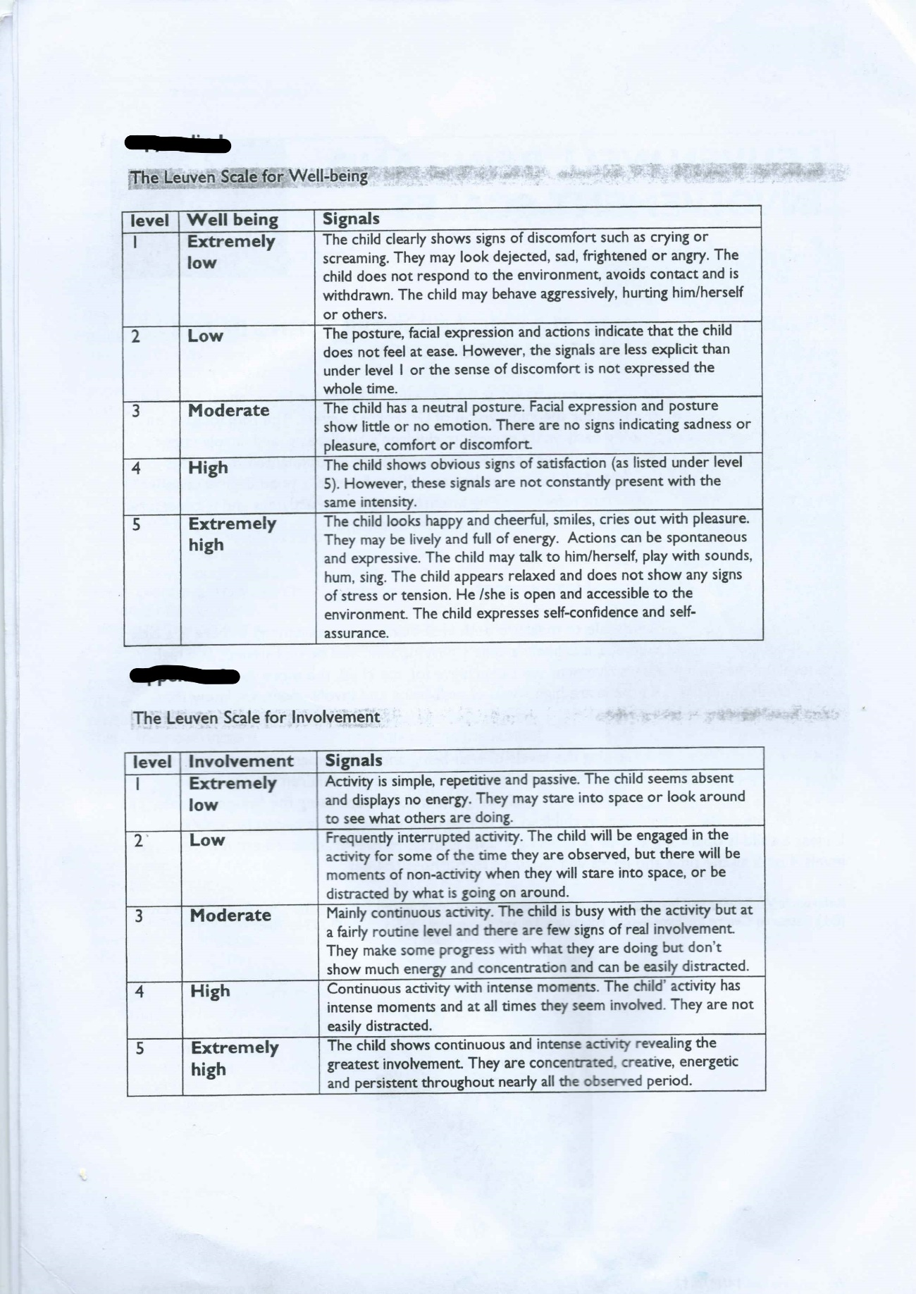


Appendix B: Lesson Plan

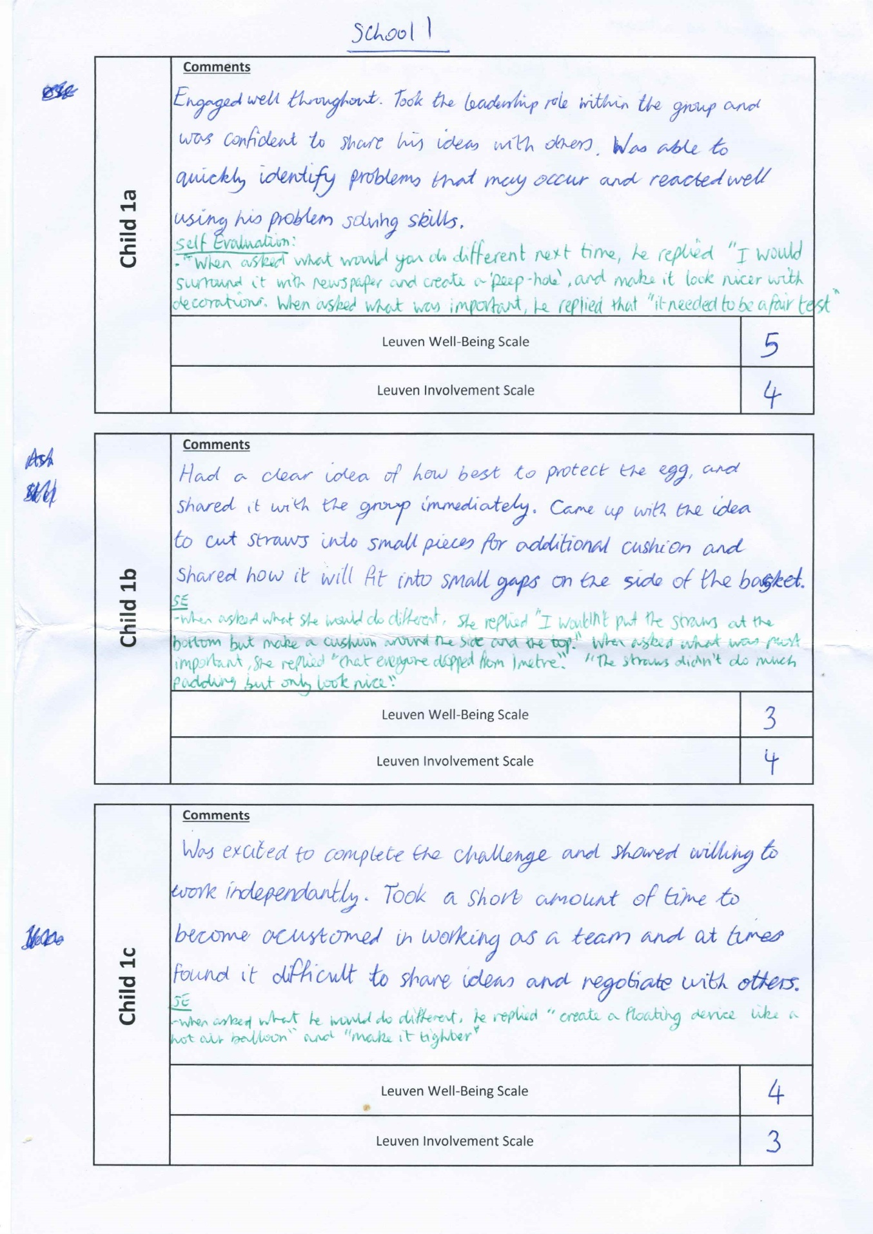
Appendix C: School 1 Observation Notes
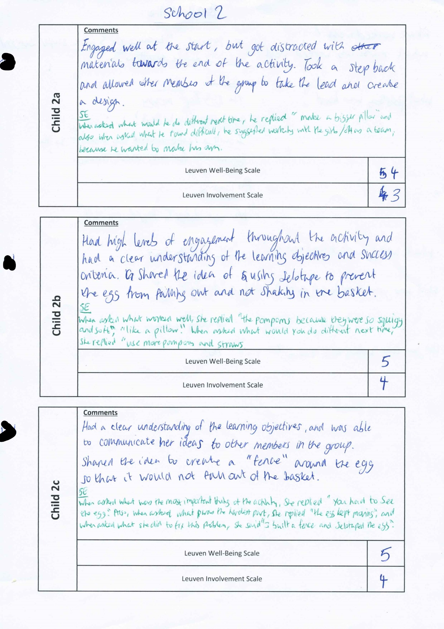
Appendix D: School 2 Observation Notes

