

Arron Simpson

ACDB 5007: Computer Aided Engineering

Parametric Study of a Convergent – Divergent Rocket Motor Nozzle Using ANSYS Fluent

University of Wales Trinity Saint David
Ordnance, Munitions and Explosives Professional Degree Apprenticeship

Academic Year: 2024- 2025

Supervisor: Andrew Noble
May 2025
Table of Contents

Table of Figures 1
Abstract 3
Introduction 3
Method 3
Results 7
Discussion 11
Conclusion 13
References 1

Table of Figures
Figure 1 – Nozzle Geometry 5
Figure 2 – Nozzle Mesh 5
Figure 3 – Pressure Inlet Conditions 6
Figure 4 – Pressure Outlet Conditions 7
Figure 5 – 60mm Throat Velocity XY Plot 8
Figure 6 – 60mm Throat Velocity Contour 8
Figure 7 – 80mm Throat Velocity XY Plot 8
Figure 8 – 80mm Throat Velocity Contour 8
Figure 9 – 90mm Throat Velocity XY Plot 8
Figure 10 – 90mm Throat Velocity Contour 8
Figure 11 – 60mm Throat Mach Number XY Plot 9
Figure 12 – 60mm Throat Mach Number Contour 9
Figure 13 – 80mm Throat Mach Number XY Plot 9
Figure 14 – 80mm Throat Mach Number Contour 9
Figure 15 – 90mm Throat Mach Number XY Plot 9
Figure 16 – 90mm Throat Mach Number Contour 9
Figure 17 – 60mm Throat Static Pressure XY Plot 10
Figure 18 – 60mm Throat Static Pressure Contour 10
Figure 19 – 80mm Throat Static Pressure XY Plot 10
Figure 20 – 80mm Throat Static Pressure Contour 10
Figure 21 – 90mm Throat Static Pressure XY Plot 10
Figure 22 – 90mm Throat Static Pressure Contour 10
Figure 23 – 60mm Throat Temperature XY Plot 11
Figure 24 – 60mm Throat Temperature Contour 11
Figure 25 – 80mm Throat Temperature XY Plot 11
Figure 26 – 80mm Throat Temperature Contour 11
Figure 27 – 90mm Throat Temperature XY Plot 11
Figure 28 – 90mm Throat Temperature Contour 11
Figure 29 – 60mm Throat Density XY Plot 12
Figure 30 – 60mm Throat Density Contour 12
Figure 31 – 80mm Throat Density XY Plot 12
Figure 32 – 80mm Throat Density Contour 12
Figure 33 – 90mm Throat Density XY Plot 12
Figure 34 – 90mm Throat Density Contour 12

Abstract
- This report presents a Computational Fluid Dynamics (CFD) investigation using ANSYS Fluent to analyse the effect of varying throat diameters in a Convergent-Divergent (CD) rocket motor nozzle. A parametric study was conducted by holding the inlet and outlet diameters constant while varying the throat diameter. The objective was to observe the impact of these changes on the Mach number, pressure, temperature, and density distributions throughout the nozzle. The simulations assumed steady, inviscid, compressible, isentropic flow of air, with an energy equation enabled. Results were validated against theoretical isentropic relations, showing agreement between simulated and predicted Mach numbers. The analysis also highlights the limitations of CFD tools like ANSYS Fluent in idealised assumptions and resource requirements. The study concludes that decreasing the throat diameter leads to higher expansion ratios and greater supersonic acceleration, which is critical for rocket motor nozzle performance optimisation in propulsion systems.

Introduction
- A CD nozzle, also known as a de Laval nozzle, is a fundamental component in rocket propulsion systems which supports the acceleration of exhaust gases to high velocities. The performance of rocket nozzles is dependent on their geometric configuration, particularly the throat diameter which will determine the flow rate and degree of expansion. Understanding the effects of the geometric variations is essential for optimising nozzle efficiency, thrust and structural compatibility [1].
- CFD tools, such as ANSYS Fluent have become essential in analysing and predicting complex fluid behaviours in engineering applications. CFD simulations offer a cost effective and detailed method of evaluating performance metrics, especially in high-speed compressible flows, where real world experimental setups are expensive and difficult to implement.
- This report presents a CFD-based parametric study using ANSY Fluent to study how variations in throat diameter affect the internal flow characteristics, such as Mach number, pressure, temperature and velocity with an aim of validating the results against theoretical isentropic flow predictions to determine the efficacy of ANSYS Fluent in modelling simulations.

Method
- Using ANSYS Workbench, the Fluid Flow (Fluent) analysis system was selected and the geometry of a basic CD nozzle was created in SpaceClaim. For the simulation, only half of the nozzle cross-section is required as the whole nozzle geometry is radially symmetrical and can be solved using the axisymmetric solver.
- The nozzle geometry parameters were set as:
  - Inlet: 100/2 = 50mm
  - Outlet: 140/2 = 70mm
  - Length: 200mm
  - Throat diameter: 60/2 = 30mm.
- The Throat diameter dimension was set as a design parameter, allowing the dimension to be adjusted later in the simulation. Split faces were set to allow for a more robust mesh to be applied. The resultant geometry is shown in Figure 1:
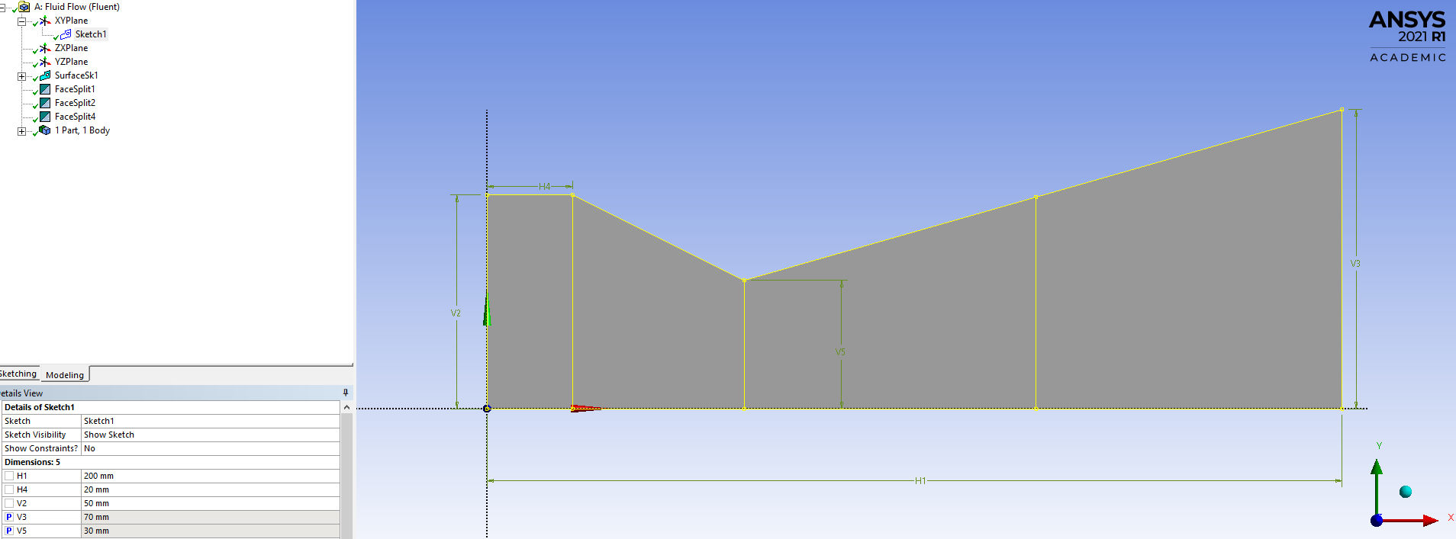
Figure 1 – Nozzle Geometry
- The geometry was imported in to the Meshing tool and a structured mesh was generated. As the default mesh was too coarse, the individual face walls were selected and the element type was adjusted to the number of divisions option and face meshing was applied. The resultant mesh is shown in Figure 2.
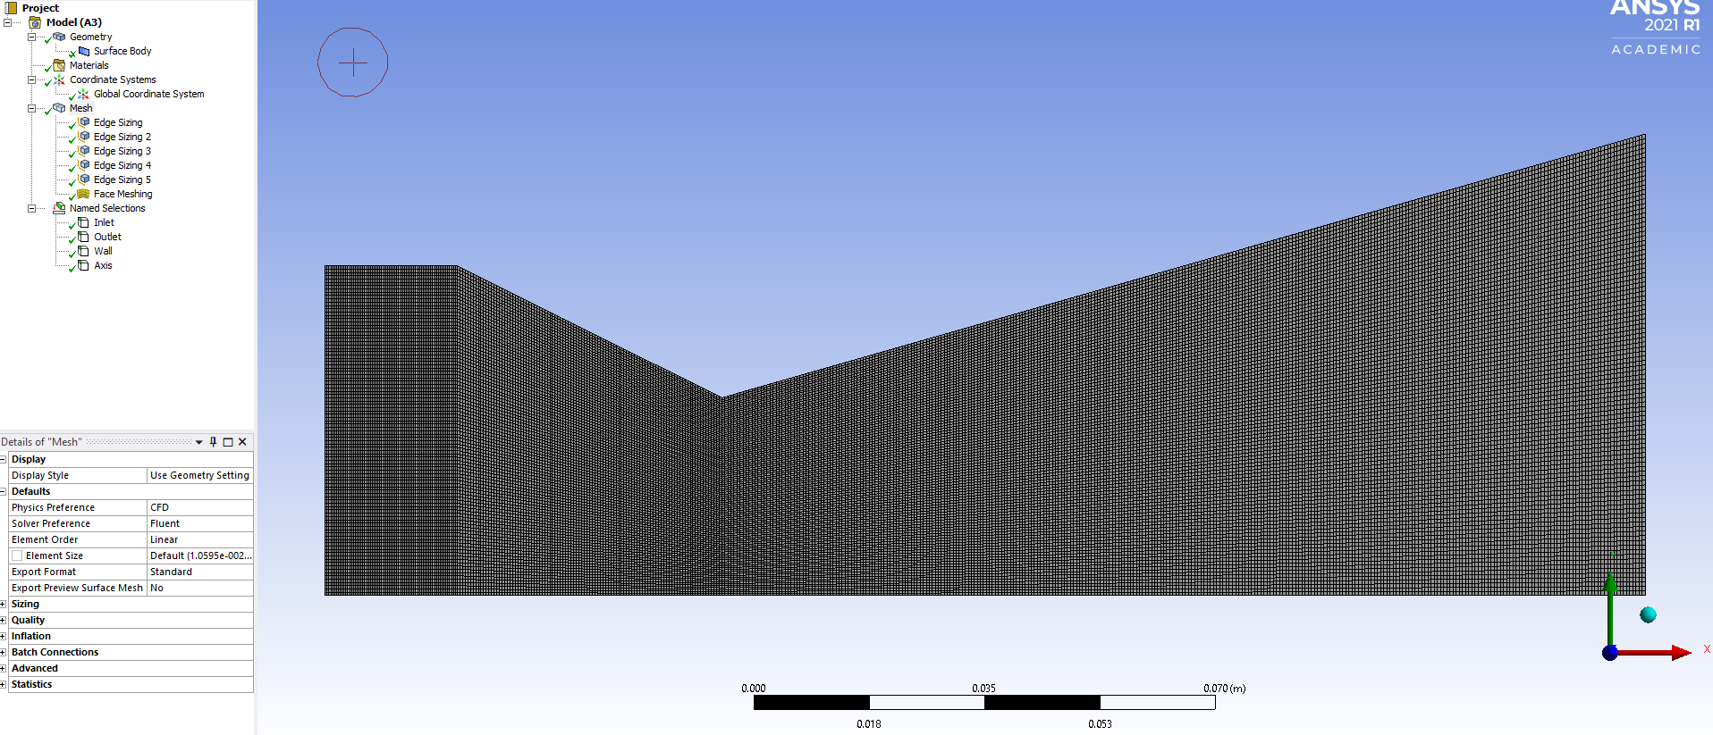
Figure 2 – Nozzle Mesh
- Using the edge selection tool, named selections were applied to the:
  - Far left edge = inlet;
  - Far right edge = outlet;
  - All upper edges = wall;
  - Bottom edge = axis, which allows the simulation tool to know that the results are symmetrical over the centre line.
- The meshing tool was exited and refreshed to ensure that the mesh was fully imported. The fluent launcher was launched from setup with double precision selected and the solver processes and GPGPU’s set.
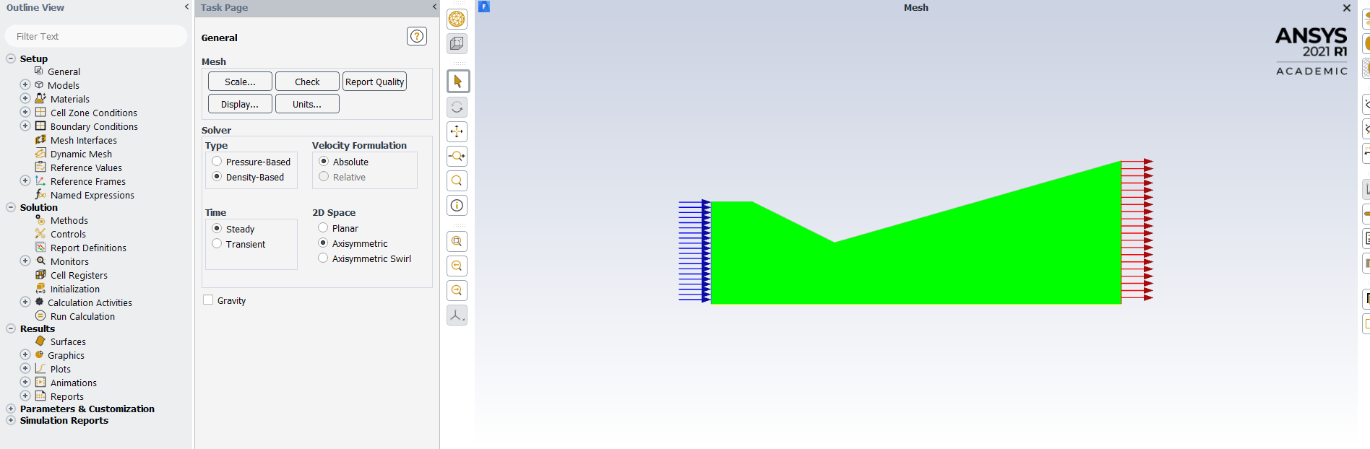
- The mesh check was run to ensure all the volume statistics were correct and would not interrupt the solver. The density-based solver type was selected as it will be dealing with compressible flow. In the model section, the energy equation was selected as on and viscous was selected to have inviscid. The remainder of the models were left as default.
- On the materials section the fluid was already selected as air but was set at constant density. As the simulation is considering compressible flow, this was changed to ideal gas.
- The boundary conditions section was selected next which showed the previously named selections. The inlet was set to pressure inlet and the conditions were set as shown in Figure 3.
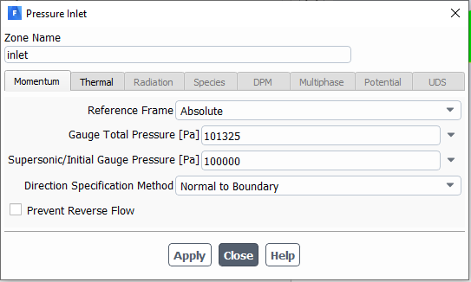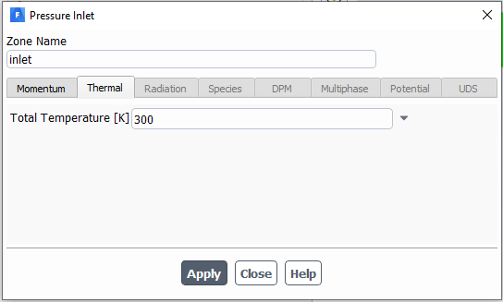
Figure 3 – Pressure Inlet Conditions
- The pressure outlet conditions were set as shown in Figure 4.
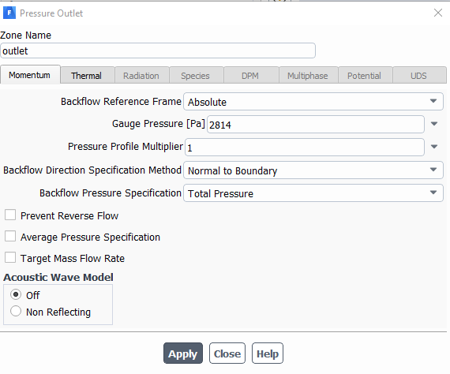
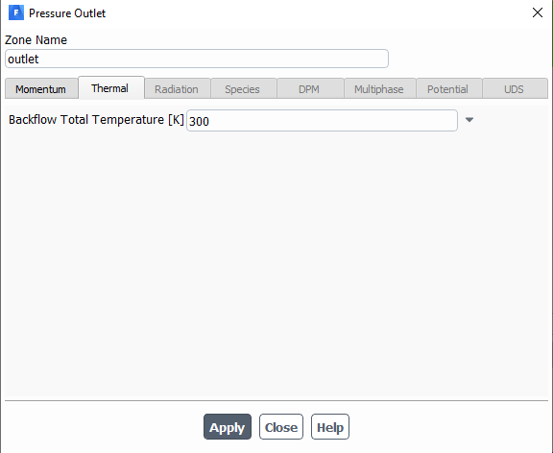
Figure 4 – Pressure Outlet Conditions
- The solution section – method was checked to ensure it was set at implicit and second order upwind, and then the residual monitors convergent criteria was set to 1E-6. Then initialisation was set as standard and initialised. The calculations were set to 2500 iterations and initiated.
- Once the calculation was complete, the results were interrogated to create XY plots and contours for the velocity, Mach number, static pressure, temperature and density. As the throat diameter was set as a design parameter, the fluent launcher can be closed and the throat diameter can be changed in the workbench window and the simulation run again to obtain the results. This was done for a throat diameter of 60mm, 80mm and 90mm.

Results
- Velocity Magnitude:
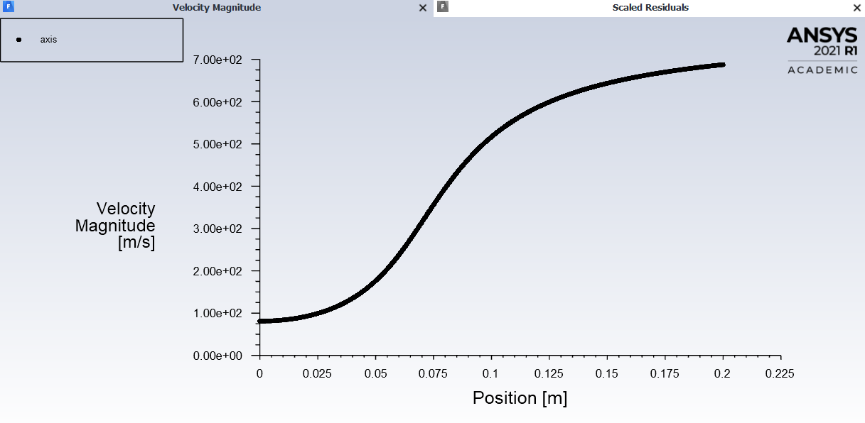  Figure 5 – 60mm Throat Velocity XY Plot | 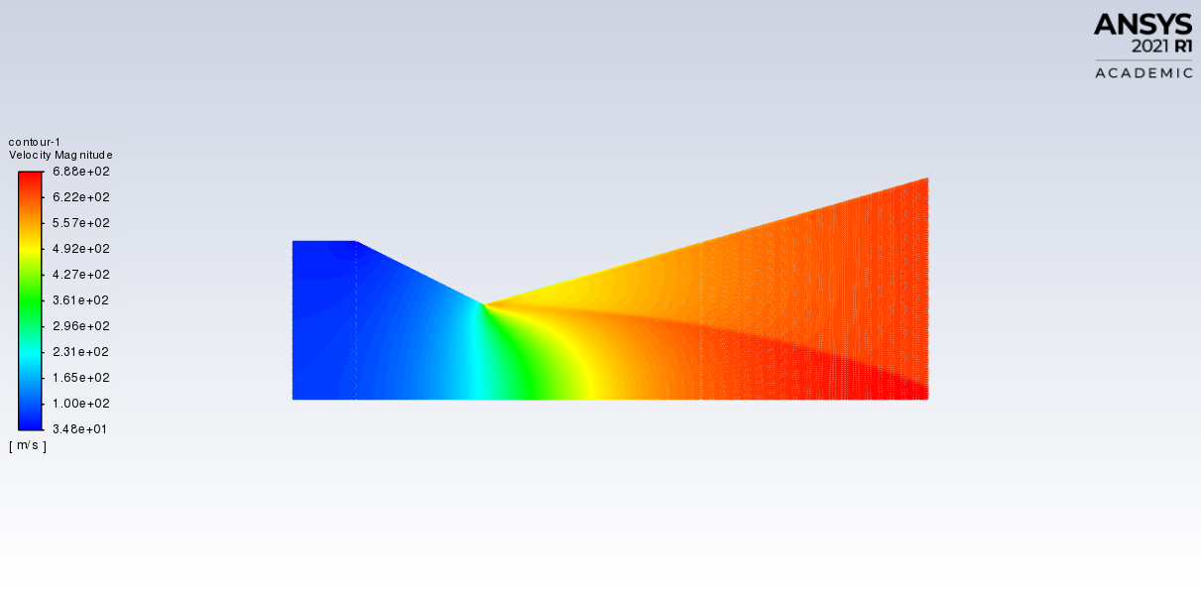  Figure 6 – 60mm Throat Velocity Contour
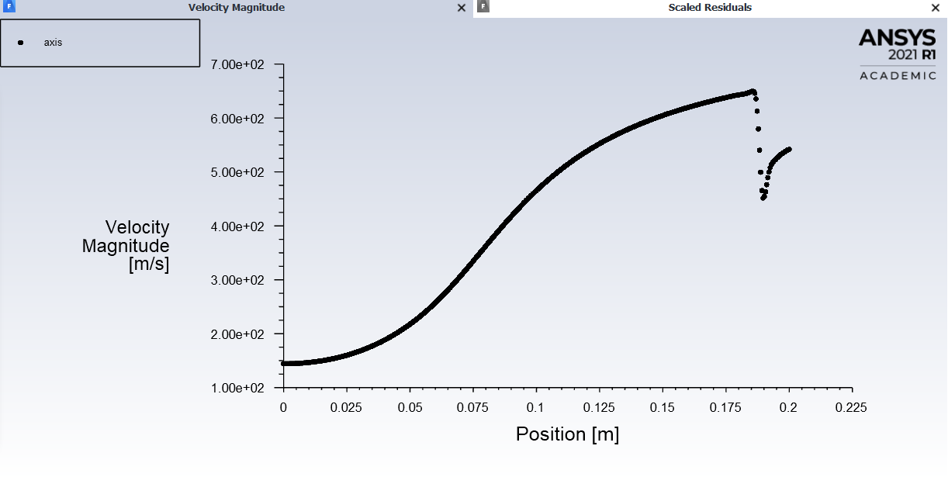  Figure 7 – 80mm Throat Velocity XY Plot | 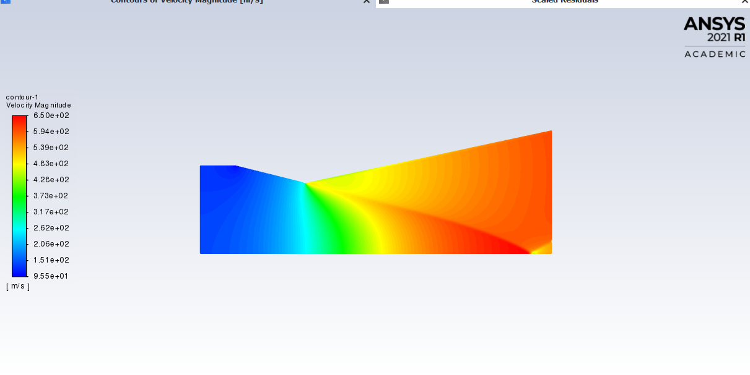  Figure 8 – 80mm Throat Velocity Contour
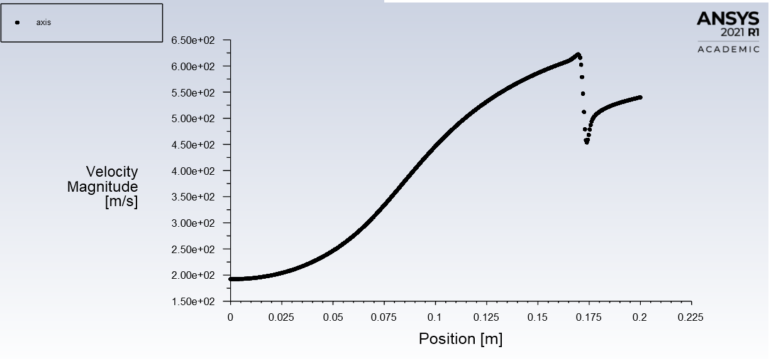  Figure 9 – 90mm Throat Velocity XY Plot | 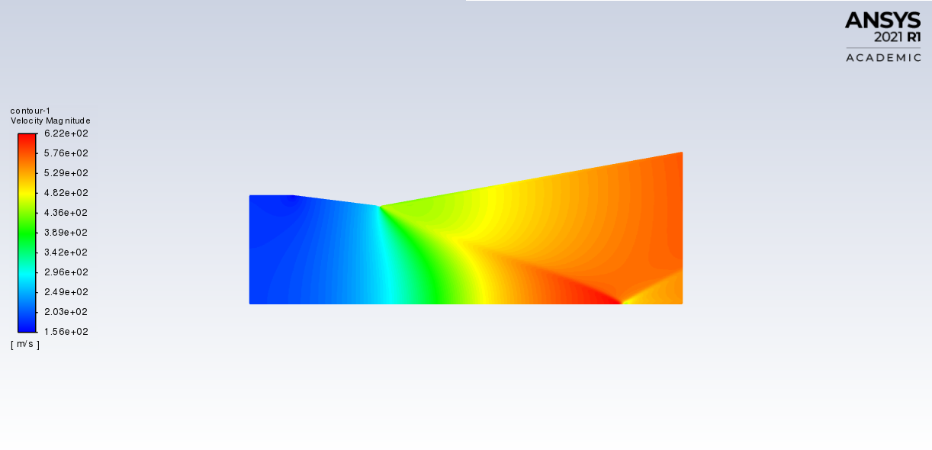  Figure 10 – 90mm Throat Velocity Contour
- The contour images show the increase in velocity from the throat through the divergent section, consistent with isentropic expansion. Isentropic expansion is closely related to Bernoulli’s principle, especially for ideal gases where an increase in the speed of fluid occurs with a decrease in pressure. to The XY plots confirm this trend with a peak velocity at the nozzle exit that increases as throat diameter decreases, especially in the smallest throat diameter case, which offers the highest expansion ratio.

- Mach Number:
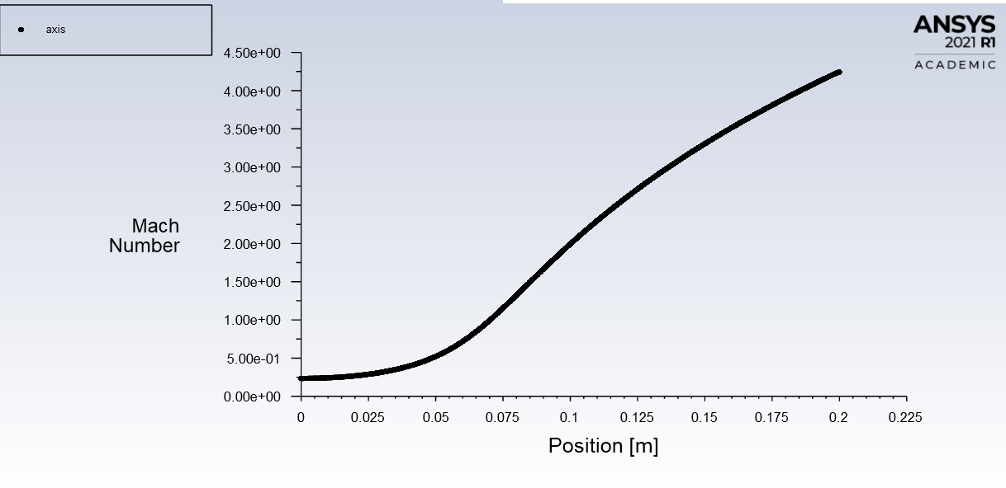  Figure 11 – 60mm Throat Mach Number XY Plot | 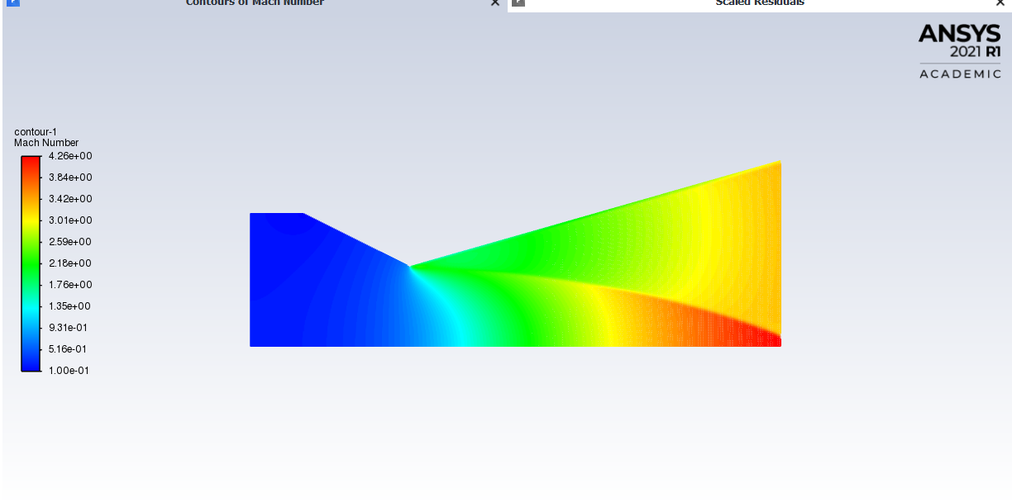  Figure 12 – 60mm Throat Mach Number Contour
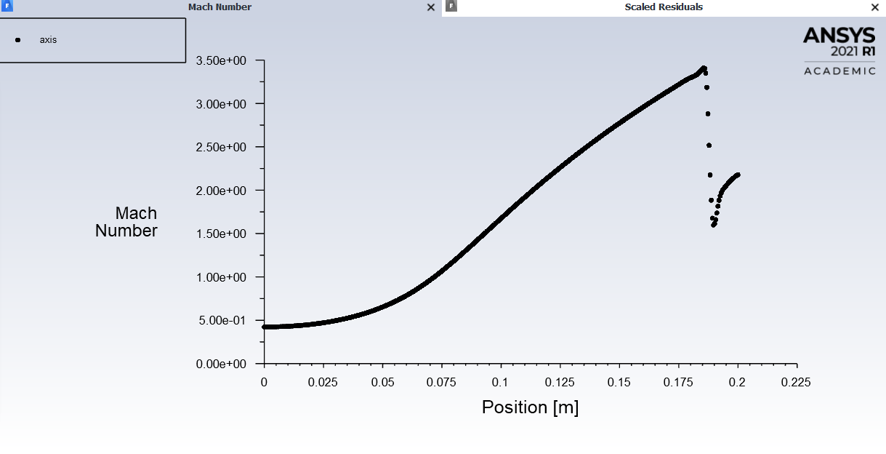  Figure 13 – 80mm Throat Mach Number XY Plot | 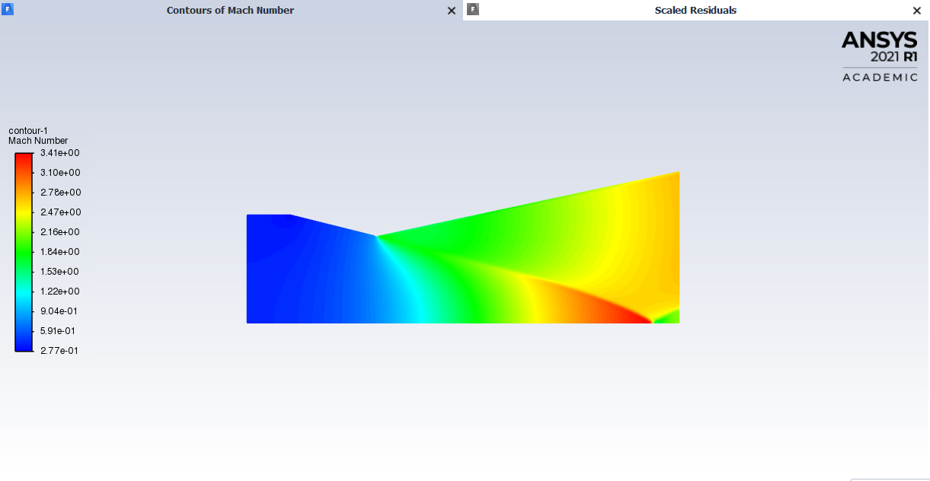  Figure 14 – 80mm Throat Mach Number Contour
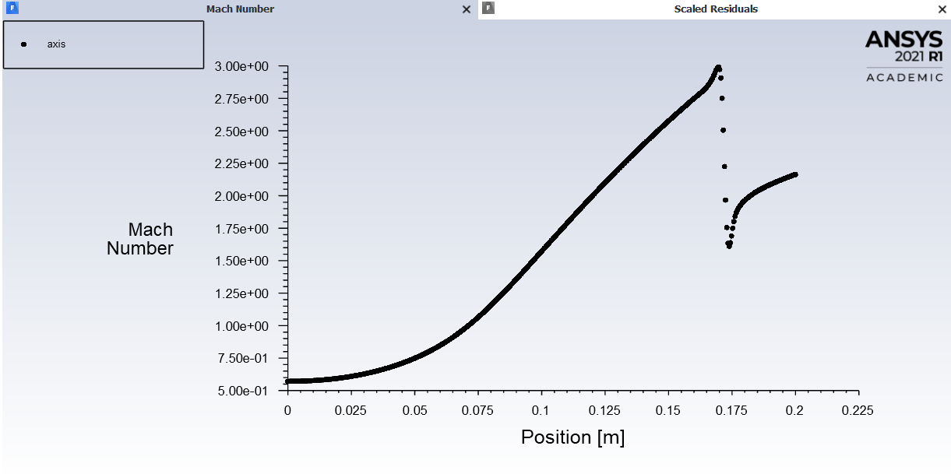  Figure 15 – 90mm Throat Mach Number XY Plot | 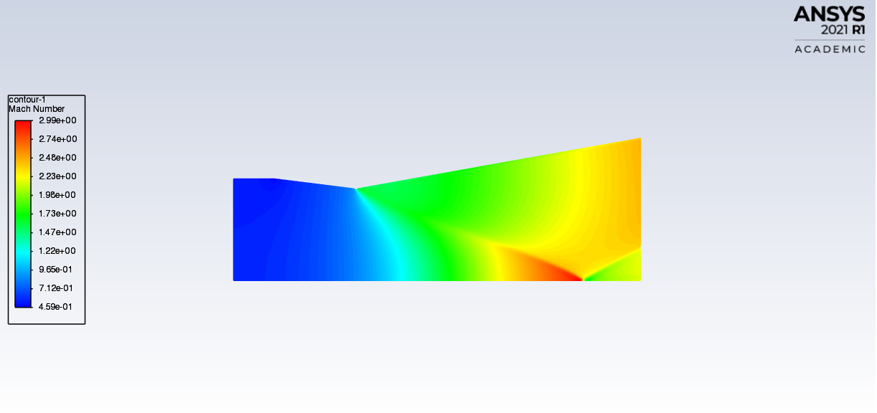  Figure 16 – 90mm Throat Mach Number Contour
- Contours depict the sonic condition (Mach 1) at the throat, as a result of a choked flow and supersonic expansion in the divergent section. This matches isentropic flow theory where the Mach number increases with area ratio in the diverging portion of the nozzle [2]. The XY plots illustrate how the Mach number distribution varies along the nozzle centreline with a higher Mach number achieved with the smallest throat diameter.

- Static Pressure:
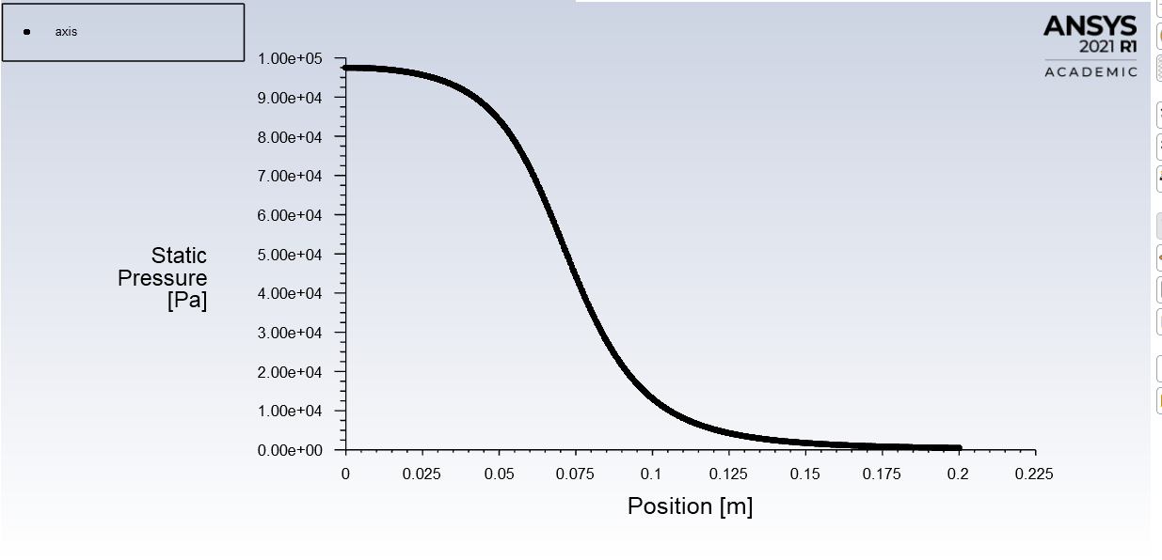  Figure 17 – 60mm Throat Static Pressure XY Plot | 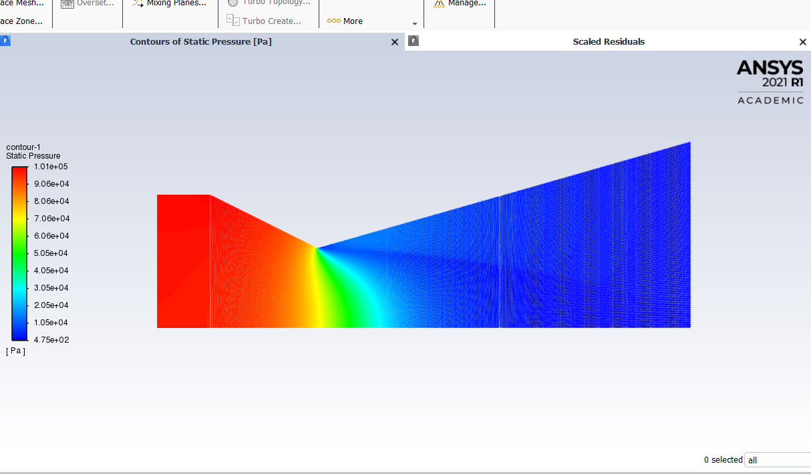  Figure 18 – 60mm Throat Static Pressure Contour
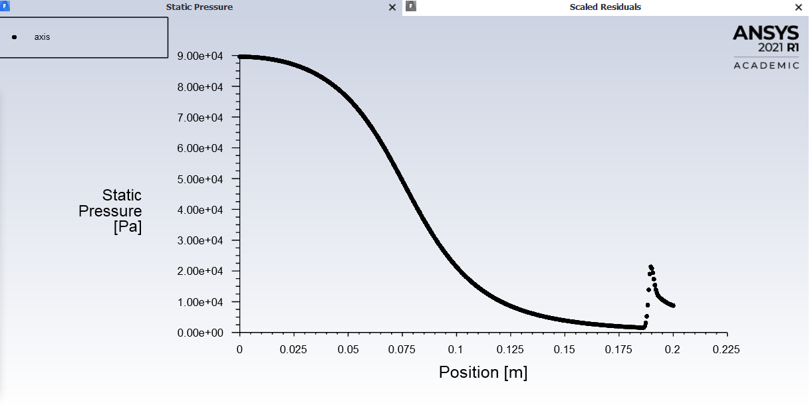  Figure 19 – 80mm Throat Static Pressure XY Plot | 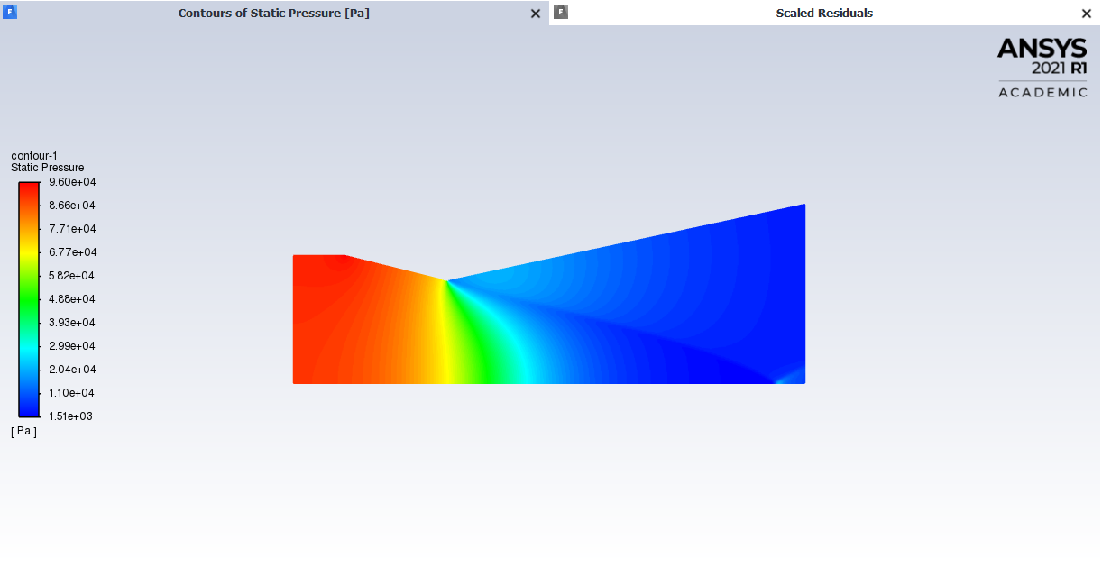  Figure 20 – 80mm Throat Static Pressure Contour
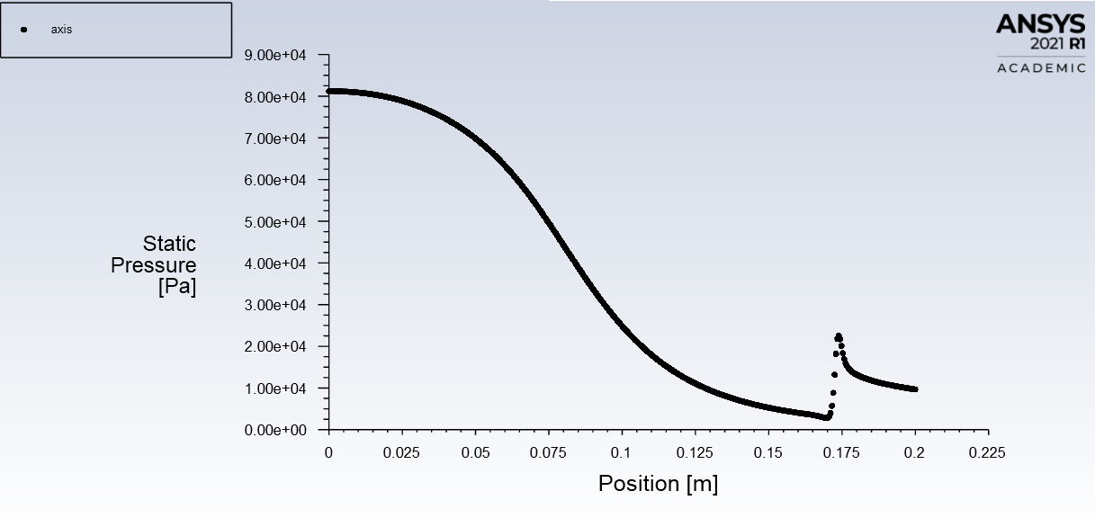  Figure 21 – 90mm Throat Static Pressure XY Plot | 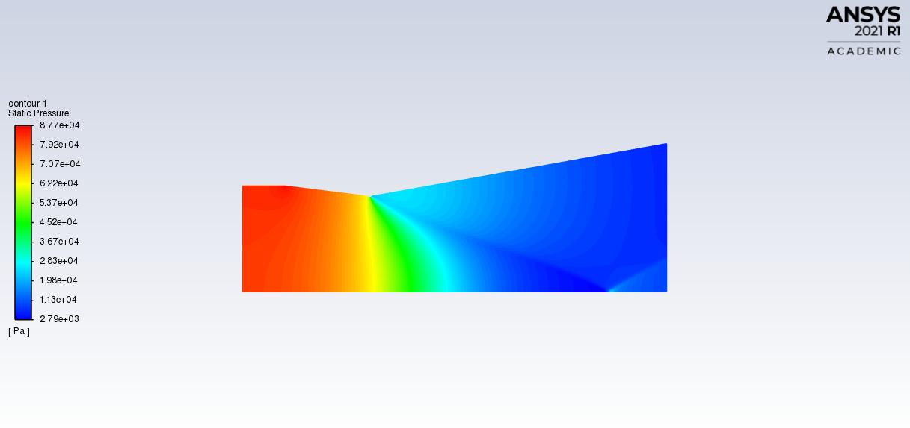  Figure 22 – 90mm Throat Static Pressure Contour
- The pressure plots demonstrate a sharp drop at the throat due to choked flow conditions, followed by continued reduction through the diverging section. This pressure drop drives the acceleration and agrees with the momentum equation and the isentropic relations.

- Temperature:
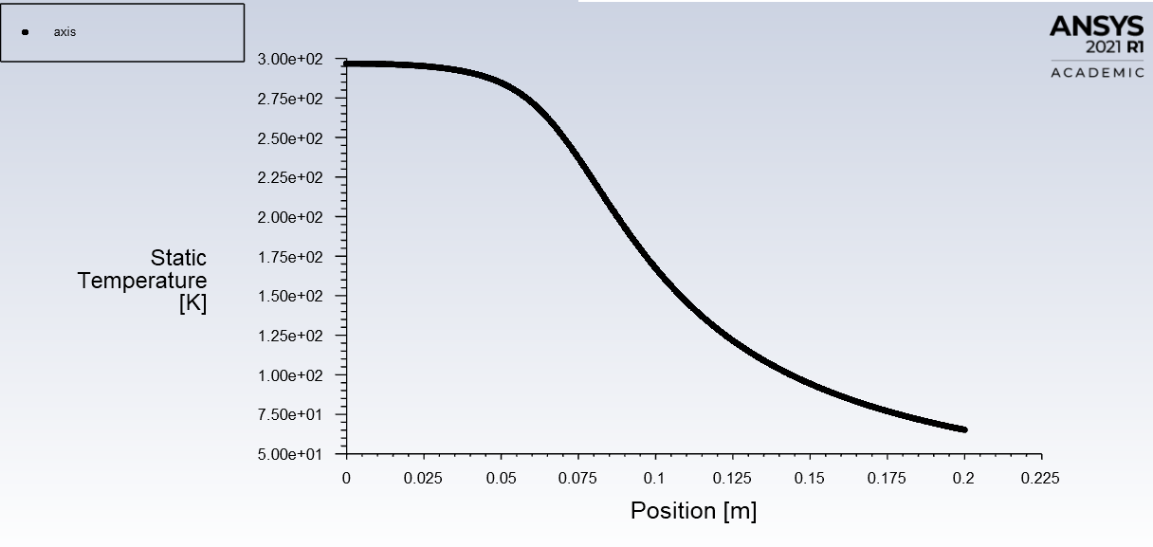  Figure 23 – 60mm Throat Temperature XY Plot | 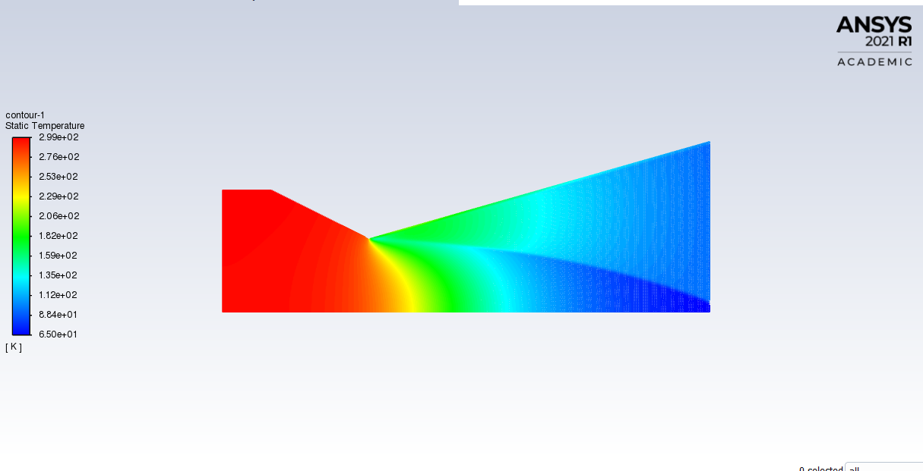  Figure 24 – 60mm Throat Temperature Contour
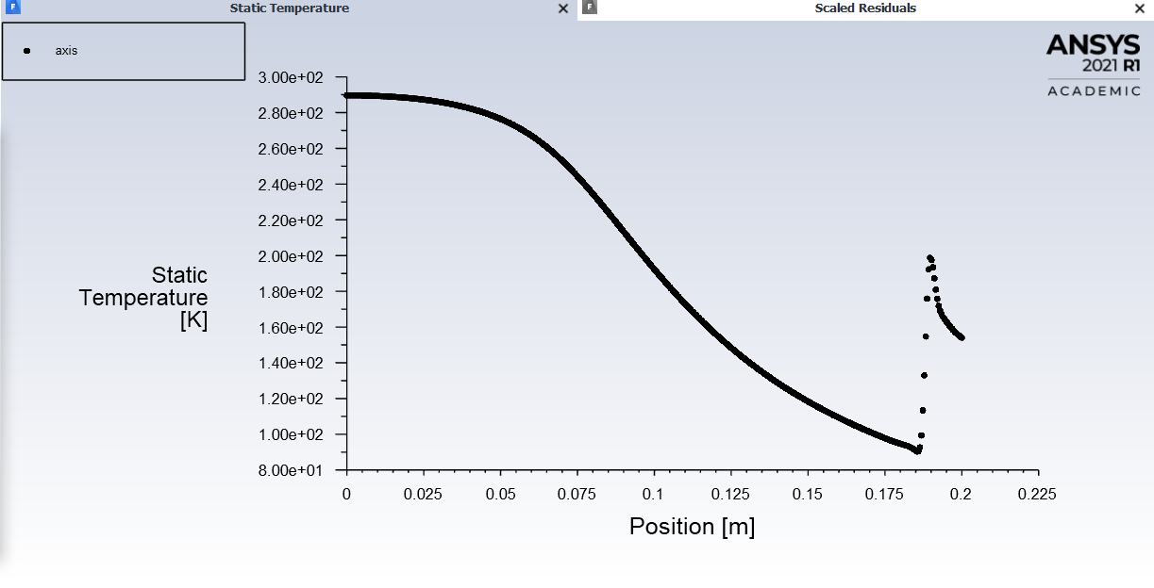  Figure 25 – 80mm Throat Temperature XY Plot | 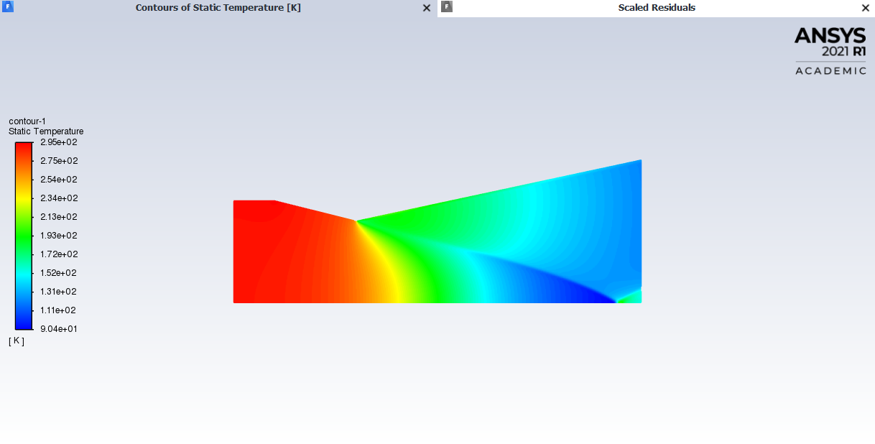  Figure 26 – 80mm Throat Temperature Contour
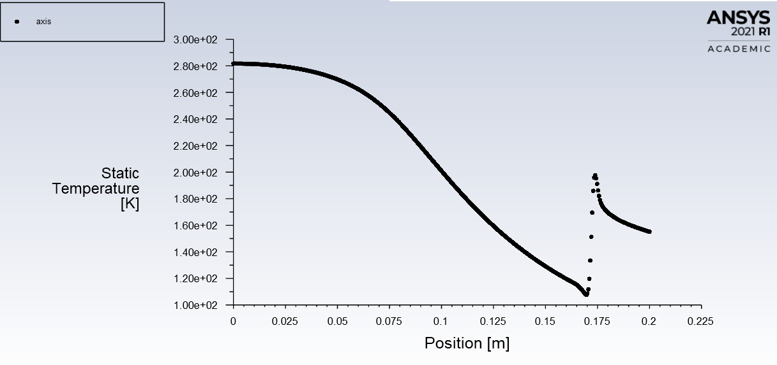  Figure 27 – 90mm Throat Temperature XY Plot | 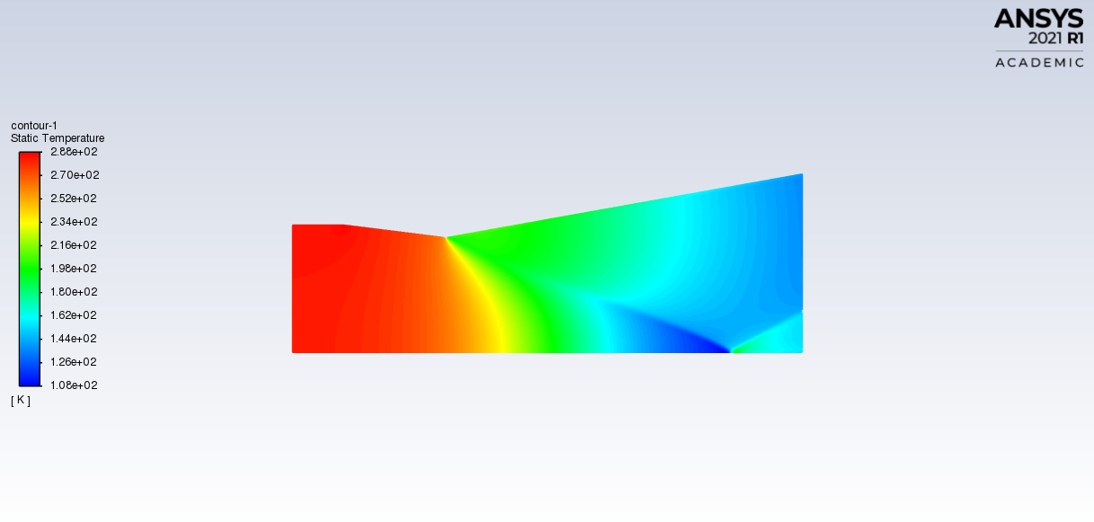  Figure 28 – 90mm Throat Temperature Contour
- The temperature decreases from the 300K values inputted progressively from the inlet to the outlet as shown in the contour and XY plots. This phenomenon is governed by the first law of thermodynamics and isentropic expansion, where the total enthalpy remains constant but the internal energy is converted into kinetic energy.

- Density:
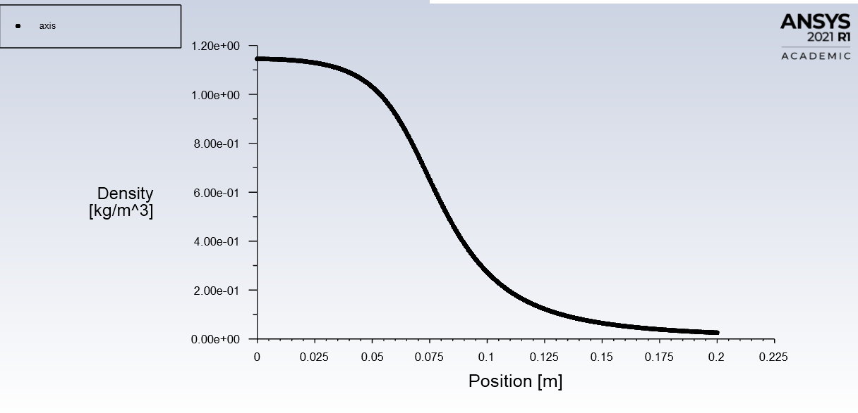  Figure 29 – 60mm Throat Density XY Plot | 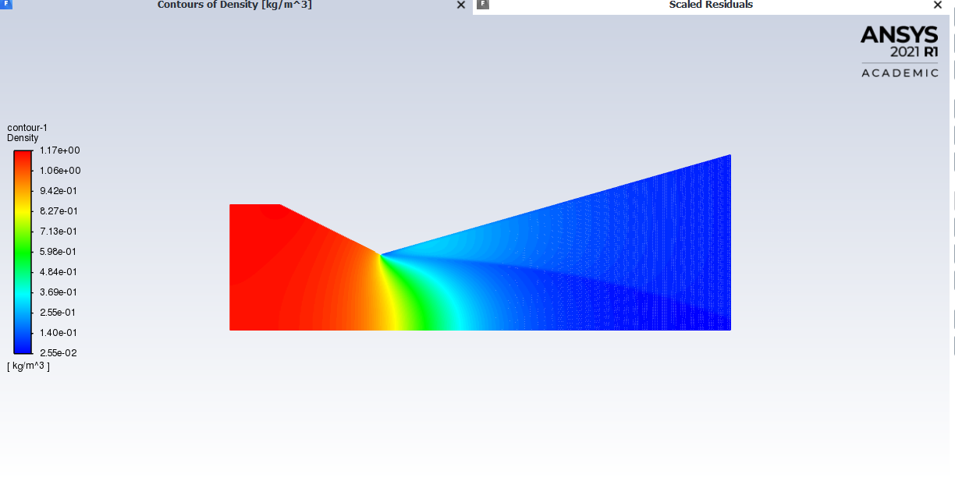  Figure 30 – 60mm Throat Density Contour
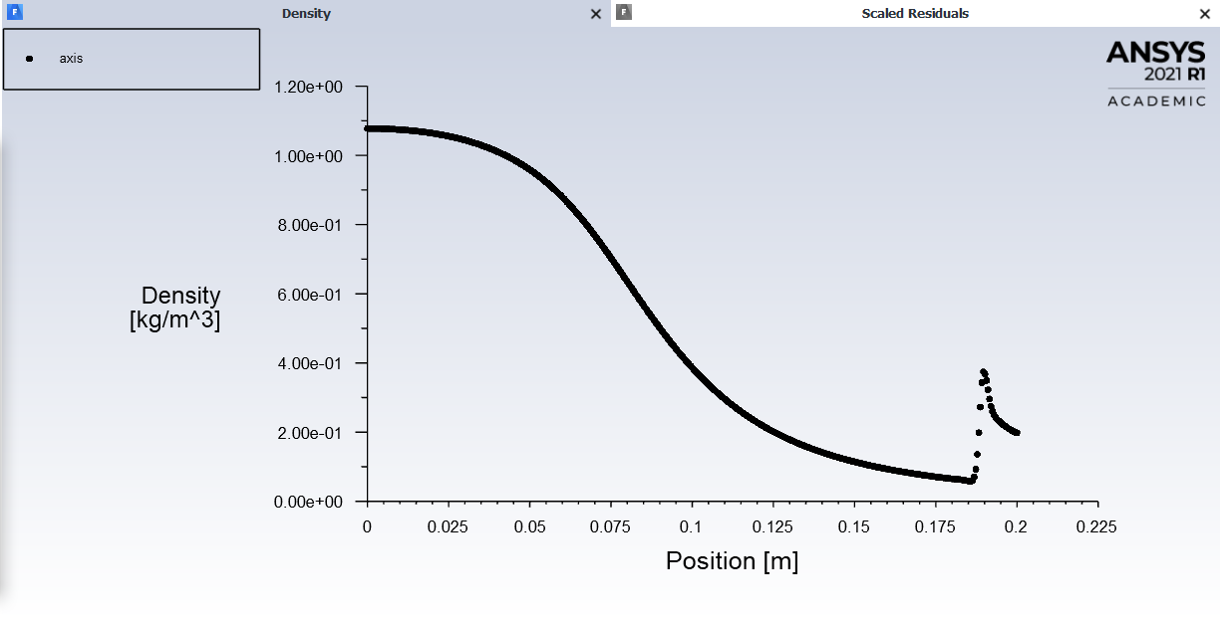  Figure 31 – 80mm Throat Density XY Plot | 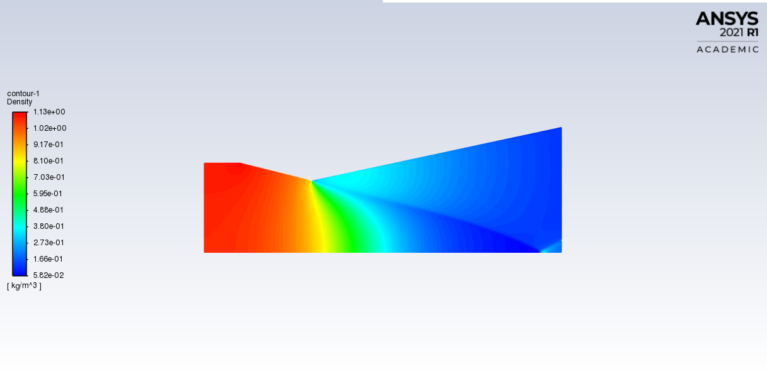  Figure 32 – 80mm Throat Density Contour
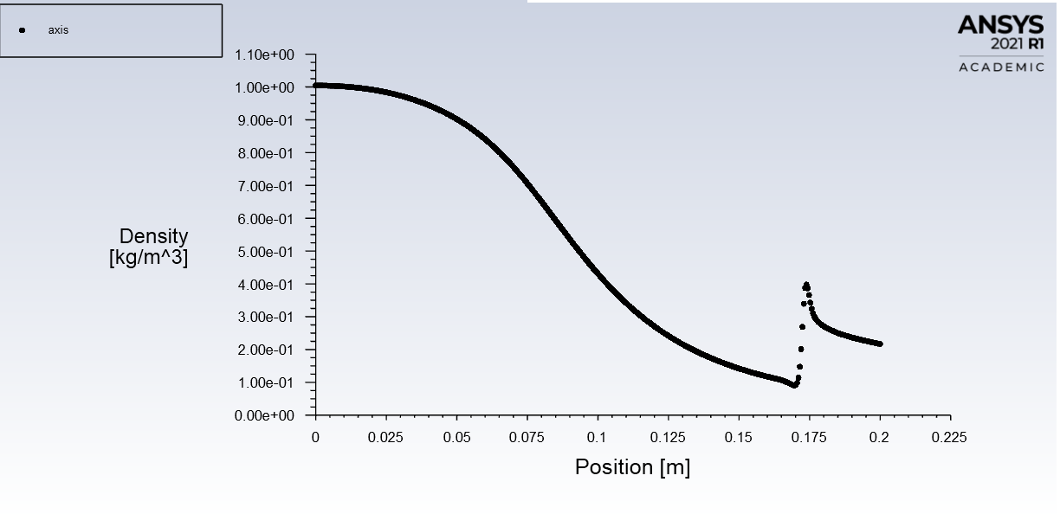  Figure 33 – 90mm Throat Density XY Plot | 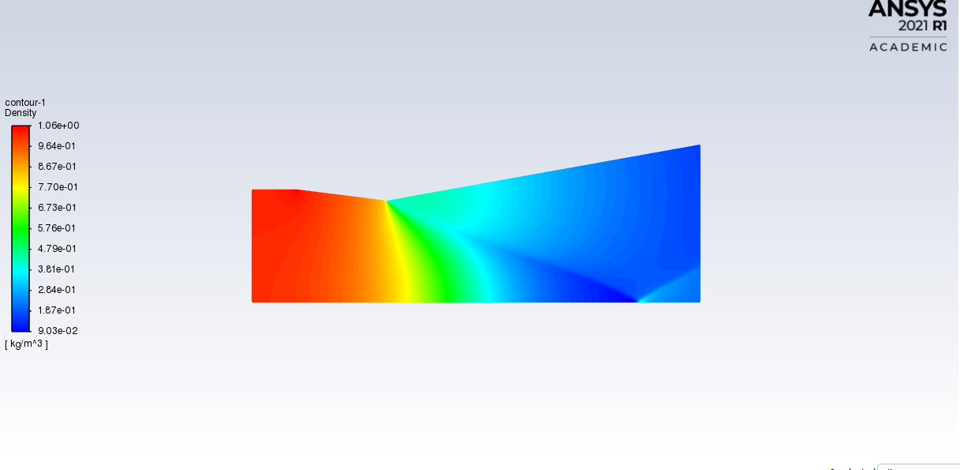  Figure 34 – 90mm Throat Density Contour
- As the velocity and Mach number increases, density decreases due to the expansion of gas. This inverse relationship is a direct consequence of the ideal gas law and conservation of mass under varying cross-sectional areas. These visualizations support theoretical principles of isentropic nozzle flow and correlate with literature which explain the effects of area variation on compressible flow properties [3].

Discussion
- In compressible flow theory, the flow accelerates in a converging nozzle section until it reaches Mach 1 at the narrowest point (throat), as long as the back pressure is sufficiently low. This phenomenon is known as choked flow. Once choked, no further decrease in downstream pressure can increase the mass flow rate or affect the upstream conditions, making Mach 1 a limiting condition at the throat for CD nozzles.
- The condition for choking is derived from conservation of mass, momentum, and energy for isentropic flows, which occurs when the flow speed reaches the local speed of sound. Beyond this point, the flow must expand through a diverging section to continue accelerating supersonically.
- The results of this study reveal the variation in throat diameter has a significant impact on the performance of a CD nozzle. Even though all conditions had a choked nozzle and the throat Mach number is limited to Mach 1, as the throat diameter decreases, the area ratio between the exit and throat increases, leading to higher Mach numbers at the outlet.
- For the 60mm throat, which had the highest area ratio (5.44), as determined with [4], the flow reached a higher Mach number at the exit. This high-speed supersonic expansion results in a lower exit pressure and greater conversion of thermal and pressure energy into kinetic energy, aligning with the conservation of energy and momentum laws. Conversely, the 90 mm throat, with the lowest area ratio (2.42), resulted in the lowest Mach number, demonstrating reduced acceleration potential.
- The mass flow rate through the nozzle is also influenced by the throat diameter. According to the conservation of mass, the mass flow rate is determined by the throat area and the stagnation conditions. Since all cases achieved choked flow at the throat, the mass flow rate remained relatively constant in each scenario, assuming equal stagnation pressure and temperature, but the distribution of energy and flow properties downstream varied.
- These findings have direct applications in rocket propulsion system design, where nozzle geometry must be tailored for altitude and thrust optimization. A higher area ratio is suitable for vacuum or high-altitude conditions, maximizing exhaust velocity and specific impulse. Lower expansion ratios are more effective at sea-level operation where over-expansion can lead to flow separation and instability [5].
- The trends and flow behaviours demonstrated in this study are supported by findings in peer-reviewed literature. Multiple experimental and numerical studies have confirmed that CD nozzles produce choked flow at the throat and supersonic expansion downstream when operating with sufficiently low back pressures. Extensive research has been undertaken which confirm that the Mach number distribution along the axis of axisymmetric nozzles closely follow isentropic predictions as per isentropic flow properties gas tables, especially under inviscid and ideal gas conditions [6] [7].
- The results in this report align with such studies, validating that:
  - Flow accelerates through the nozzle due to conversion of thermal and pressure energy into kinetic energy (1st Law of Thermodynamics).
  - Choked flow at the throat occurs in accordance with momentum conservation and compressibility theory.
  - Supersonic expansion is governed by the area-Mach number relation from isentropic flow equations.
- These validations strengthen confidence in the use of ANSYS Fluent for preliminary nozzle design, especially when supported by theoretical and published experimental comparisons.
- While ANSYS Fluent is an effective and adaptable CFD tool, it has limitations that can affect the accuracy or applicability of results:
  - Ideal Assumptions: Most models assume ideal gas behaviour and inviscid flow, which may not be accurate under certain conditions, such as, high-temperature, high-pressure, or chemically reacting conditions commonly found in rocket propulsion.
  - Grid Sensitivity: Simulation results can be highly sensitive to mesh quality and refinement, particularly near shock waves or boundary layers, resulting in numerical diffusion or instabilities.
  - Chemical Reactions and Combustion: Fluent can simulate reacting flows, but the inclusion of detailed chemical kinetics and multiphase combustion introduces complexity and increases computational cost.
  - Boundary Conditions: Setting realistic boundary conditions for rocket nozzles can be challenging, especially when modelling open or atmospheric boundaries or plume expansion.
  - Computational Resources: High-fidelity simulations, especially in 3D or with transient solvers, require significant computational power and time.
- These limitations mean that Fluent simulations should be interpreted as good approximations, and the results should be validated with experimental data or analytical methods whenever possible. In this studies case, the Mach numbers obtained for the various throat diameters followed the area ratio principle, but the Mach number achieved for the 60mm throat was significantly higher than numerically predicted; where the simulation resulted in a peak of 4.5 Mach and the calculations predicted 3.2 Mach. Though some variation would be expected [8], there was most likely some error introduced into the simulation by the user.

Conclusion
- The CFD analysis conducted using ANSYS Fluent demonstrated that the throat diameter has a significant impact on the performance of a CD nozzle. All tested configurations exhibited choked flow at the throat, with supersonic expansion occurring downstream. The 60mm throat, which provided the highest expansion ratio, achieved the greatest outlet Mach number, aligning with theoretical predictions. However, some discrepancies between simulated and theoretical results highlight the importance of careful setup and validation. This study confirms the utility of ANSYS Fluent in simulating ideal compressible flow within rocket nozzles, validating theoretical trends of isentropic expansion. Even so, attention must be paid to limitations such as mesh refinement, boundary condition selection, and the simplifying assumptions of ideal gas behaviour and inviscid flow. Future work should consider incorporating real gas effects, viscous modelling, and experimental validation for more comprehensive nozzle performance assessments.

References

[1] | T. S. Taylor, Introduction to Rocket Science and Engineering, Florida: CRC Press, 2009.
[2] | B. J. Cantwell, “Fundementals of Compressible Flow,” Stanford University, Stanford, 2022.
[3] | A. H. Shapiro, “The Dynamics and Thermodynamics of Compressible FLuid Flow,” The Ronald Press Company, Massachusetts, 2015.
[4] | K. D. S. B. N. S. Santosh Ranabhat, “Numerical and Experimental Investigation of Exhaust Flow from Convergent-Divergent Nozzle,” in Proceedings of 12th IOE Graduate Conference, 2022.
[5] | O. B. Geroge P Sutton, Rocket Propulsion Elements 9th Edition, Wiley, 2016.
[6] | R. S. P. B. S. S. Sathyapriya, “Flow Characteristic Through Convergent-Divergent Nozzle,” IJSRST, 2018.
[7] | E. K. S. E. S. M. E. A. V. Y. Mohini, “Performance Analysis of Converging Fiverging Nozzle,” International Research Journal of Engineering and Technology (IRJET) , vol. 6, no. 9, pp. 24 - 29, 2019.
[8] | J. S. A. P. D. R. A. P. Andrija Petrovic, “Comparison of novel variable area convergent-divergent nozzle performances obtained by analytic, computational and experimental methods,” Applied Mathematical Modelling, vol. 57, pp. 206-225, 2018.

