Name: Emma Carrington

Student Number: 1910725

CIPD Membership Number: 55478700

Qualification: CIPD Diploma in Applied Human Resources (CIPDL5)

Module: Resourcing and Talent Planning

Word Count: 3000

By signing below, I confirm that the work/evidence presented is my own, unaided work. I understand the regulations pertaining to candidate malpractice and the action that may be taken as a result.

Signed: Emma Carrington

Date: 16 April 2020

1. An employee is emigrating and asks you if the labour market trends of their destination country are the same as in the UK. Describe the key contemporary trends in both the UK labour market and in the labour market of any other country (of your choice).
The decision to leave the EU in 2016 had relatively low impact on employment levels within the UK (OECD, 2016). Employment levels continued to grow until 2019, when they started to slow down. The labour market remained tight (ONS, 2019; CIPD, 2020); however, the number of vacancies were still high. The CIPD labour market report highlights the portion of organisations reporting hard-to-fill vacancies increased from 56% in the Spring 2017 report to more than three in five (61%) organisations in the Spring 2019 report (Labour Market Outlook, 2019). As a result, numerous organisations increased salaries, particularly for key staff and new starters (59% of private sector employers reported raising salaries to help offset their recruitment difficulties) (LMO Autumn, 2019). The shortage of skills and labour indicates that workforce planning within organisations should be a priority (CIPD, 2018,2020, 2021). Also, the introduction of new migration restrictions this year (UK Government, 2020), means employers will need to ensure they have made the required arrangements to guarantee they have access to the skills their organisations need (Turner, 2020; CIPD, 2018). Its essential organisations continue to invest in training and development post Brexit to alleviate the risk of future skill shortages (Labour Market Outlook 2017/18).

The global pandemic has impacted on global labour markets (appendix 1).The UK’s employment rate during October 2019 was at its highest of over 75% and positioned towards the middle of the OECD range (13th out of 35 countries) (UK Economic outlook, 2019). As of February 2021, it was reported that there were 726,000 fewer employees employed within the UK compared with February 2020. Yet, latest reports indicate that this has increased slightly to 83,000 more people when compared with December 2020 (this is the second consecutive monthly increase). Evidence indicates 18-24-year olds seen the greatest decrease in payroll employment, since February 2020. Unemployment within the UK, estimated at 5.1%, continues to surge, (1.3 percentage points higher than a year earlier and 0.4 percentage points higher than the previous quarter). Consequently, employment rates, estimated at 75.0%, are falling (1.5 percentage points lower than a year earlier and 0.3 percentage points lower than the previous quarter) (Prospects, 2021).
Recruitment difficulties are slightly higher in the public sector (62%) compared to the private sector (56%). Most are prevalent in healthcare (75%), which could attribute to the pandemic (Kings Fund, 2021; Collins, A 2020). However, Government restrictions and national lockdowns recently have had an impact on vacancies in some private industries, particularly the hospitality industry. An estimated 599,000 vacancies were reported within the UK in November 2020 to January 2021; this is 211,000 fewer than a year ago and 64,000 increase than the previous quarter (Search, 2021; ONS, 2021; Prospects Luminate,2021); This is evident with only 26% of job vacancies within the UK between November 2020 to January 2021. However, reflects a development on the situation during summer 2020 when vacancies were down by nearly 60% year on year, yet the rate of improvement has slowed in the past few months) (LFS). Nevertheless, some public sector organisations remained working from home virtually.

The redundancy rate, in the three months to December 2020, was estimated at 12.3 people per thousand employees. Redundancy intentions has fallen significantly within the private sector, over the quarter (34% since the autumn, to 20% presently) (appendix 2). This is mainly due to the implementation of the furlough scheme (CIPD, 2020/2021). In disparity, the public sector (77%), recruitment aims in the private sector (51%) continue to delay. However, hiring within both the private and public sectors looks hopeful compared with the previous quarter. (appendix 3).

The pandemic has an impact on hard to fill labour and skill shortages during 2020/21. Compared to the same quarter last year, an additional 57% of organisations are experiencing vacancies (a 7% decrease this time last year- 64%).

Location-based salaries and compensation are now being questioned and re-evaluated considering the success of the massive work-from-home or anywhere-remotely trend (Kelly,2021). Haf (2021) suggests the ease of lock down resections and the rollout of the vaccine gives businesses an optimistic future outlook. His research highlights the 190% increase in job postings for remote roles since the start of the pandemic which demonstrates the successful transitions many organisations have made to working from. However, its essential technical aptitudes are accompanied by people-focused expertise, to form new hybrid skill blends.

The future outlook on pay remains passive with average basic pay increase prospects staying at 1%. Pay expectations in the private sector has increased from 0% last quarter to 1.5%. However, there has been a decrease in the public sector from 2% to 0%, a significant reversal of recent trends (CIPD, 200/2021; ONS, 2021).

Americas Labour market
Data reflects the impact the coronavirus (COVID-19) pandemic is having on Americas labour market (Hamermesh, 2000-2018). Wide-ranging sectors shut down as a result of the global pandemic. Broad elements of the economy stopped completely and suddenly; Travel immobilised, restaurants, gyms and hair salons closed etc). Employment dropped by more than 50% in the entertainment industry, personal and laundry services, dental offices, and clothing stores. At the same time, other sectors had to find ways to get food, medical care, household essentials, and utilities to people staying at home. According to indeed labour market review sectors within America have either gained, are rebounding have been damaged or paused as a result of the global pandemic (appendix 4) (Mitchell, 2020: OECD, 2020; AIER, 2020).
Similarly, within the UK, the coronavirus recession within America is dissimilar from other downturns, which resulted in moderately more job losses within goods-related economy areas, such as construction and mining (appendix 5).
In contrast, like the UK, service jobs have suffered the most, and much of the job loss temporary. This recession has especially hit leisure and hospitality sectors where employment is down 25%. Furthermore, those requiring face-to face interaction, such as the performing arts are down more than 40% (indeed, 2021) (appendix 6).
It’s also been identified that there are large proportion of city workers, i.e. finance / tech, who are now working from hope which has impacted on the retail and personal service sectors. A further gauge of long-term labour market damage is the job losses in industries where most employees can work from home (finance and tech) and therefore as a result are not directly affected by the pandemic. Employment was 3.5% lower in October than February (Department of Labour, USA, 2021). This is much lower than the low working from home sectors (restaurant / clothing) at 8.3% however, remote worker sectors have recovered much less. This may be linked to the cost of recruitment and the ability to retain highly skilled employees within an uncertain market force (indeed, 2021) (appendix 7).
Unemployment data indicates a higher level of unemployment compared to the UK; however, the US is a far bigger country with a larger population. According to latest unemployment data as of February 2021, there are currently 10 million Americans unemployed (6.2%). However, both are considerably lower than April 2020 and remain well above their pre-pandemic levels in February 2020 (3.5 percent and 5.7 million, respectively) (Mitchel, 2020;, 2020).
The number of long-term unemployed (those jobless for 27 weeks or more), at 4.1 million, changed little over the month but is up by 3.0 million over the year. At the start of the pandemic employment in March and April 2020 plummeted to 14.5% from February 2020. Alike, In February 2020, these long-term unemployed accounted for 14.7% of the total unemployed. The number of persons jobless less than 5 weeks, at 2.2 million, also changed little over the month. However, fell to 6.9% in October 2020.

In February 2020 (before the global pandemic was announced), most of the job gains occurred in leisure and hospitality, with smaller gains in temporary help services, health care and social assistance, retail trade, and manufacturing. Employment declined in state and local government education, construction, and mining. Midst the unemployed, the number of Americans on temporary layoff fell by 517,000 in February 21 to 2.2 million. Which is higher than the previous year, however, is down considerably from the recent high of 18.0 million in April 2020. The number of Americans that had permanently lost their jobs in February 21 was fundamentally unchanged at 3.5 million, however data indicates this is 2.2 million higher than the previous year. Since 2000 prime age employment (25-54) decreased to 69.7% (lower than the great recession) in April 2020 but has recently increased to 76%. This may be due to employee’s reluctance to work or search for a job due to fear of fae-to face contact or health reasons during the pandemic. Others may be reluctant to seek work if they have been laid off temporarily and are expecting to return to their job i.e. the arts industry. School closures have had an impact on parents and carers Labour market metrics indicate employment fell much more for mothers than for fathers, however, there was no gender gap evident for childless households (Department of Labour, USA, 2021; Indeed, 2021) (appendix 8).

Like the UK 2021/22 labour market outlook depends on the virus behaviour and vaccinations. Politics and policy decisions within the new Biden administration, may also have an impact. Furthermore, the extent to which organisations embrace permanent agile / remote working within the pandemic-era will also impact the future labour market, both within the UK and America. During February 2021, the labour force participation rate remained at 61.4 %, 1.9% lower that February 2020. However, most labour market measures are more than halfway back to pre-pandemic levels. According to the Wall street Journal forecasters, the service-led recession recovery is likely to be slower than previous goods led recessions. They anticipate the labour market won’t be as tight as pre-pandemic and unemployment is anticipated to be at 5.6% at the end of 2021 (2% points higher than its pre-pandemic level). Indicating more unemployed candidates applying for the same post. It may also mean that employers are less inclined to capitalise in training or hire from broader backgrounds. Persistent inequality gaps have broadened during the pandemic. This prediction could impact on equality of opportunity and those with less education / those with more education, racial and ethnical groups (statista research, 2021; Lee, 2021; indeed, 2021).

2. A new HR assistant asks you to explain the following aspects of workforce planning:
• key principles of workforce planning
• tools used in workforce planning
• how to develop a basic people plan, including succession planning
After organisations are aware of the labour market and sources of employees they can start to workforce plan.
Workforce Planning (WFP) balances skills (labour supply) with demand (numbers needed). WFP permits an organisation to make better decision-making, which enables long-term organisational performance. An organisation should examine their present workforce, establish future need, identify current and forthcoming gaps, and use tools to implement resolutions which can be achieved within an organisations business plan/objective along with long term objectives (CIPD, 2020). WFP benefits organisations in a number of ways (appendix 9). This can inform HR best practice (appendix 10a and b)
Effective Workforce planning (or human resource planning) aligns core organisational goals with the changing organisational and people strategy, which is needed to drive the strategic objectives of the organisation in a way which ensures that projects are managed effectively, and risks are mitigated (ibid: 37; Tichy et al, 1982: 47; Fombrun; Beer; Lengnick-Hall et al , 2009; Baird and Meshoulam, 1988; Wright and McMahan, 1992; Dyer and Holder, 1988; MacDuffie, 1995). Delery and Doty, 1996: 804; CIPD, 2020; Wright & Nishii, 2007) (appendix 11).
Operational workforce planning is a tool to manage business as usual. The planning has a rapider forecast horizon, characteristically three to twelve months. The emphasis is on identifying skill gaps, numbers of people needed to meet immediate organisational needs and mechanical processes such as recruitment or training spend. Not all WFP is the same (appendix 12), in contrast a strategic (soft) WFP advises good business decisions and yields, significant data (such as hiring ease or difficulty, time to hire, attrition rate) whilst balancing skills (labour supply) against numbers needed. This may be achieved by analysing workforce trends, gap analysis between current and future trends and implementing solutions which can help identify risks, contingency actions and ensure an organisation can achieve its strategic plan (CIPD,2021; Parry and Tyson, 2011); thus individuals who have the essential skills are employed at the right time, cost, contract, to deliver long and short-term organisational objectives (CIPD, 2020). Within the challenging climate CIPD (2020) recommends that talent planning is a crucial element of an organisations business planning process. Industry and market intelligence and metrics can provide intelligence which may help organisations focus on challenging issues and support longer term business objectives and goals (appendix 13). According to the Kings Fund (2015) talent management aims to create a high-performance sustainable organisation that meets strategic, organisational goals and objectives. This is achieved through a set of Integrated workforce processes are designed to attract, develop, motivate, and retain productive, engaged employees.
According to Taylor and Woodhams (2016) there are four stages an organisation should follow when developing a people plan in talent planning, as it can vary in terms of scope (size of department, number of sites, scalability – national or international) and timeframe (immediate or over a 10 year timeframe, such as the NHS Workforce plan) (Taylor & Woodhams, 2016) (appendix 14).
- Further skill demand forecasting
- Skill forecasting within an organisation
- Gap analysis of future skill supply and demand
- Plan to fill gaps
Workforce Planners or HR use techniques to establish future demand requirements; systematic requirements look at historic trends to predict future demand / need and work back from the outputs desired. Managerial judgement is essential and an vital part of WFP people management; applying their knowledge and experience of an organisation / industry and environment (mainly external) working back from costs (Taylor and Wilkinson, 2017) and analyses future budget against how many staff can be afforded. These activities allow WFP or HR to determine the job roles needed and the number of skills sets that need to be commissioned in particular roles. Effective communication between the organisation, HR teams and stakeholders is essential within the planning process. Bersin (by Deloitte- appendix 15) suggest, 90% of organisations conduct some level of workforce planning, however only 15% take a strategic approach to addressing the talent demand, talent supply, and the phases required to close the gap between the two (Fombrun et al, 1984: 26). Bersin debates, only 20% of the workforce planning produce useful results for business leaders while forecasting revenue and operating budgets. Nevertheless, CIPD (2020) suggest there are serious organisational risk and implications if WFP is not undertaken, and organisations should be adding greater urgency to undertaking WFP practices, that identify skills and knowledge e.g. Automation skill gaps (Ryanair; Skills for Health).
Forecasting demand is the first stage of the process. Employers need to establish what skills will be required in the future, what tasks will need doing and can these be divided into individual jobs, do they require full or part time positions whilst considering headcount.
Systematic techniques will establish past trends and predict future skill needs. It is advised an organisation should word back from their desired needs (Taylor, 2018). Managers are encouraged to use their judgement in line with the knowledge and experience of senior employees within the organisation, the sector i.e. private / public along with external environments (a PESTLE analysis (CIPD, 2020) could be undertaken to assess factors, such as Brexit). It’s advisable an organisation works back from future costs i.e. begin with future budget and determine how many employees can be afforded.
Forecast supply
Organisations need to establish the composition of the current workforce (Taylor & Woodhams, 2017) and the number of employees who are likely to remain within the organisation at that point in time. Organisations need to establish a head count of employees, the total wage and length of service (inc. age, grade, and length of service) whilst also considering the impact this has on delivery of service. Also need to assess employed skills within the organisation by consulting personal specification for current job roles).
Employee turnover (Kings Fund, 2021) should also be considered when assessing the number of employees that are likely to be employed in the future i.e. consider retirement age and general trends i.e. millennials. Also consider promotions and retention figures (leaveboard, 2021; Roder, 2019). After establishing current composition factors, organisations must assess the skills within the organisation, which can be achieved through consultation of personal specifications internal training records and appraisal information. An organisation should then look at employee turnover trends i.e. retirement data to establish how many employees are likely to still be employed in the future. Sophisticated analysis of lateral movers and promotions will allow organisations to consider job roles that employees will be working in, in the future.

Gaps
An organisation should determine future skills and job roles which are planned in contrast with present job roles and skills. This can be achieved through a competency framework inclusive of common organisational roles i.e. a list of competencies and skills required for the role. An organisation can then conduct a skills audit to determine and regulate the extent of the disparity between the two scenarios (scenario plan). It is best practice for an organisation to analyse the results to identify the current overall organisational skills available and the amount to which these ties in with the future organisational skills base need.
Succession planning
According to CIPD (2020) succession planning is the process of identifying critical posts and developing potential identified current members of the workforce (future leaders and senior managers, as well as individuals) to fill future positions (appendix 16-). Succession planning denotes a collection of activities which aim to ensure an organisation has adequate employee numbers with the skills, knowledge, and personal attributes (Hirsh, 2020; CIPD 2020, Croner, 2021; SHRM, 2021) (appendix 17). The purpose is to be able to fill business crucial roles efficiently and develop managerial capacity through a systematic evaluation and training process, from a pool of talent (contemporary rather than traditional approach) (Day, 2004), if a vacancy at a higher level becomes available. Succession planning schemes can focus on individual senior or key positions or take a more general approach by targeting a ‘pool’ of positions for which similar skills are needed or essential within emergencies such as the pandemic. It was wise for organisations such as the NHS to expand the pool of successors needed to ensure technical role, which potentially leave them vulnerable if not filed quickly. It was also essential they identified successors external to the organisation to ensure continuity if needed (Kings Fund, 2021; Groysberg et al, 2009).
It is vital that consideration is given during regular performance appraisal conversation of the employee’s aspirations, and whether or not any development can take place to support succession and career planning (HEIW, 2018; CIPD Good Work Index, 2020). (Succession planning programmes typically include practical, tailored work experience relevant for future roles (HEIW, 2018; Taylor, 2018), formal training programmes and on the job training, coaching, and mentoring, acting up, experiencing different areas within and organisation and lateral moves. Fair access and transparency are important as all opportunities will help an employee flourish and gain appropriate experience to move to the next level. However, in contrast, it could be debated that new employees external to the organisation may bring innovation and different perspectives into the organisation. CIPD (2012a) advocate organisations should aim for an 80:20 split of internal and external employees. However, suggest that organisations should avoid appointing external employees at board level due to lack of corporate culture knowledge.

3. Your Director asks for your thoughts on how the organisation can attract the talented people it requires and ensure that these people stay with the organisation. Explain different approaches an organisation can take to both attracting and retaining talent, and the strengths and weaknesses of each approach.
The current job market is extremely competitive (Kelly, 2021; Richmond, 2020; Miller Cole, 2018). However, according to Keller & Meaney (2017) almost one-third of senior leaders cite finding talent as their most significant managerial challenge (appendix 18).
There are a number of approaches an organisation can take to present and position itself within the labour market (appendix 19). According to both Taylor (2011) and Higgs (2004) approaches can differ on two factors; Organisational culture attracts talent and displays the degree employees are respected and ethically treated within an organisation (SHRM, 2021; SHRM Effective Practice Guidelines Series, 2021); Reward; the quantity of money an organisation is prepared to pay an employee. Employers of cash are sometimes treated dictatorially, with excessive hours but reimburses with good pay (Trebilcock, 2021). In contrast, employers of values are dedicated to treating employees well and offer security and impartial treatment, which is usually associated with the voluntary and public sectors. In disparity employer of churn are inclined to both pay unwell and treat employees unreceptively resulting in high turnover and dis-engaged employees. These are often targeted at low skilled workers, those working from overseas or students looking for temporary work. It could be suggested this environment is only possibly workable within a loose labour market when employees can be replaced.
However, an employer who sustains a positive position within the labour market over a lengthy period of time can judiciously claim they have achieved employer of choice status. An employer of choice has low attrition (Jackson, 2019; McCartney, 2018) and has the ability to attract and retain the best candidates, i.e. university student (who compete for graduate training programmes). They usually have a desirable company culture, bottom-up leadership style, high trust/ employee engagement / empowerment, learning and development opportunities and employee recognition schemes (The Times, 2021; Glassdoor, 2020; Shah, 2020; Carpenter, 2020; Sunday Times top 100 employers, 2020; Robinson, 2018). This can be evident within an employee of choices high engagement index score, which highlights responses to questions exploring features of their employment that may impact on their engagement i.e. development opportunities purpose, team relationships, inclusion and fair treatment, relationship with manager etc (CIPD, 2018; Kings Fund, 2015,2017 ). Through a talent management perspective, these organisations tend to attract a vast number of outstanding applicants wherever they advertise (Taylor, 2018). Taylor (2018) suggests providing an organisation recruitment selection processes are effective, and managers continue to engage effectively and listen to employees etc, an employer of choice ensures the presence of an highly talented and motivated workforce who perform well and are retained (Google, 2020) (appendix 20)
Organisations are competing for talent in a tight economy, where attracting and retaining talented employees is becoming increasingly challenging, therefore employee retention is a critical issue. An organisation can increase competitive advantage and maximise employee retention by focusing on delivering a modern benefits package (CIPD, 2018), such as flexible/agile working and options of a career break or sabbatical leave which is an extremely valued component and increasingly popular, particularly amid Generation Y. Wills Towers Watson (??)conducted a study to identify best practice from organisations across the Benelux region and found one out of three organisations has a formal policy on sabbatical leave in place.
More organisations are focusing on improving and promoting employee benefits to attract and retain talent (HEIW, 2018). During the pandemic health and well-being has become increasingly important to employees. A consequence more organisations have a workplace approach, including health benefits and EAP services, resulting in the right conditions for all employees of an organisation, increased productivity, commitment to their organisation’s goals and values, motivated to contribute to organisational success, with an enhanced sense of their own well-being, and the well-being of others.
This could also be achieved by observing outside the organisation to establish what competitors are implementing and look inside the organisation to establish why people are leaving (SHRM, 2021; Robinson,2018) (appendix 21). Marketing insights have a big impact on retaining talent compared to competitor organisations, their performance, culture, reward, benefits and learning offering have on retaining talent (CIPD, 2018).
Depending on the role, employee turnover can cost an organisation approximately 2.5 times an employer’s salary (Merhar, 2020; Dwomoh et al, 2013). Additionally, soft costs such as lowered productivity, cultural impact, decreased engagement are evident. Not all turnover is negative, functional turnover removes poor performers, savings on wages and facilitates the progression of other employees and new blood (Newton, 2019). However, dysfunctional turnover can be expensive, negative, and has direct and indirect costs associated (appendix 22). Organisations can use a variety of quantitative methods to determine their turnover (appendix 23). Organisations should follow this up with internal and external benchmarking to put data into context (Personnel Today, 2020; Hollinger, 2015; HRM Practice, 2021; Lerner,2017; Human Resource Today, 2019). Staff satisfaction surveys highlight employee satisfaction and dissatisfaction and are a pro-active tool to gauge turnover and can help organisations target retention initiatives, rather that those who have decided to leave the organisation. Organisations can also analyse surveys of ex-employees, stayers (to establish what keeps them engaged) and previous job surveys, to establish why employees left their las job (which will provide an organisation with key information that operate within key labour markets) (Insight Link, 2020; Sullivan, 2020; Groysberg & Spain, 2016). However, it could be debated that too much time passes from survey to results and some employees feel they create an expectation of change, however see no perceived value in them, as they have no expectation that taking part will improve conditions. Surveys also tend to measure satisfaction, not happiness and therefore do not highlight problem areas (Alexander, 2014).

Once an organisation has established their turnover levels, they are in the position to establish their recruitment strategy to meet the expectations of employees without losing sight of the organisations objectives to ensure maximum return on investment (Talentlyft, 2021; HRZone, 2021; Florentine, 2019 Half, 2020). Senior managers need to, demonstrate their support and recognise push and pull factors within the competitive labour market, identify appropriate initiatives, gain commitment from all managers, and appreciate no two employees will be the same (Moore, 2016; Florentine, 2019) (appendix 24). The strategy must align with all retention activities and strategy, HR strategy and organisational strategy.

It could therefore be debated employer of choice is not enough to attract talent, as all may offer recruits the same employer value proposition as their rivals. A bespoke approach would make an organisation unique (Ladjemi, 2014). This could be achieved with highly sophisticated employer branding and by subdividing the labour market the way marketing professionals subdivide target markets for products and services. It is essential recruitment messages are written prudently to appeal to the right callabra / audience at the right time (Appendix 25).

Employer branding is the highest recruitment trends of 2020 and is extremely important to both attract and retain employers (Walker, 2017) and is reflected within the percentage of new recruits joining organisation as a result of targeted role advertisements. In order to be effective, it should be aligned to values, strategy and policies and demonstrate horizontal and vertical integration (Appendix 26). The Wonderful Workplaces (2019) Employer Branding Insight report revealed that 94% of employees would consider an employer’s brand when applying for jobs, yet nearly half (46%) felt their most recent employer did not effectively communicate their brand. A LinkedIn study established more than 75% of job seekers research a company’s reputation and employer brand before applying (BMS Performance, 2021; Potentialpark, 2021; Post Beyond, 2021). Its therefore essential organisations market themselves consistently and truthfully as a dishonest brand message and bad reputation will discourage new recruits and obscure existing employees, thus over time the organisational reputation will diminish, and they will struggle to retain employees.
Discontented employees who criticize their employer impinge the employer brand of the organisation and make it more difficult to recruit positions (CIPD, 2020). Team members who are negative block creativity and reduce moral which can also have an impact on performance and the organisational brand. The effects of a negative attitude in the workplace can also have detrimental effects on employee Health and wellbeing. Its essential organisations establish the perceptions of existing employers experience to ensure the brand reflects reality. It’s essential to establish what they key aspects of employee experience are perceived to be, as they need to be both positive and unique in contrast to other employees. This will help retain existing employees and attract new talent. Consulting with existing employees from the beginning is important when creating an employer brand. Lievens et al (2007) suggests five options that organisations can align themselves to when deciding how to present themselves to potential employees (Appendix 27).
Haf (2021) research furthermore highlights, 89% of UK employers accept that hybrid working is imminent, considering the ongoing versatility of much of the labour market over the longer term. This will benefit employees from a wider talent pool, while employees will preserve flexibility and an improved work-life balance. However, Kelliher & Anderson (2010) report evidence of work intensification being experienced by those who work reduced hours and those who work remotely. Therefore, employees respond to work-life-balance by entering additional effort to return benefits to the employer. They reported that those employees who work flexibly, record higher levels of job satisfaction and organisational commitment (French, 2016). They conclude that employees adopt the social exchange theory to respond to the ability to work flexibly by exerting additional effort, to return benefit to the employer. However, research indicates employees don’t always respond negatively to intensification, especially whereas a consequence they believe they will gain some benefits (psychological theory) (ibid p99).
Building on an employee offer through non-financial benefits and enhancing an organisational brand along with more inclusive recruitment will address hiring difficulties in the short term and make an organisation more attractive as an employer in the future (CIPD, 2018).

4. In preparation for input at a managers meeting*, summarise the following: • key aspects of good practice in relation to developing job descriptions, person specifications and competency frameworks • different methods of recruitment and selection, and the strengths and weaknesses of each • good practice in relation to dismissal, redundancy and retirement.
According to CIPD (2020) the pandemic has had an impact on organisational recruitment, and there is a need for them to take a strategic approach to recruitment, selection and talent management. However, operative resourcing is not about filling a vacancy instantly. Employers need to ensure that the right people with the right skills are recruited for roles within their organisation (Watt, 2021; NHS England, 2013; Skills for Care, 2021; ACAS, 2021;), whilst ensuring the workforce has the appropriate knowledge and skills for current and future organisational needs and establish the long term success of an organisation (CIPD, 2020). When posts become available, Taylor suggests using the best practice recruitment and selection Traditional Approach model to systematically analyse a job, including; the duties that make up the vacant job, collates objective information on characteristics, helps fair selection, establishes how it fits into organisational structure and use workforce planning data to understand what skills are needed for organisational performance (MS Solicitors, 2021). Job descriptions and person specifications are derived from the job analysis and form main tools for hiring (Taylor, 2017; CIPD, 2020) (appendix 28)

Job Descriptions
Within recruitment and selection, the job description (JD) is an important organisational marketing tool which focuses on the nature of the role and should therefore be presented in a positive way which reflects the organisational brand; excellent learning and development opportunities and a pro-active employer (Business Balls, 2017; Astron Solution, 2015; Wright State University,2021; Johnson, 2020).

JDs are a written narrative that details the role of the job along with areas of responsibility of the position, performance criteria and a statement which details reporting lines. Job titles should avoid bias to a particular characteristic as defined by the Equality Act 2010 (Equality and Human Rights Commission, 2014; CHANGE, 2021; CIPD, 2021; UK Government, 2010). Consideration should be given to flexible working in accordance with Equality legislation (Unison, 2017; Equality and Human Rights Commission, 2009; Citizens Advice,2021). Working hours or patterns that are not necessary should not be stated (Daniels, 2019; CIPD, 2021). According to IRS (2003, p43) 75% of employees include copies of JDs in application packs and 82% use them whilst formatting job advertisements. The analysis of a JD considers knowledge, skills, and ability an employee needs to perform a job.
Its important best practice is adopted when writing a JD (Mckinley,2021; Glassdoor, 2021; Pote,2016). A well written JD is essential as it ensures solid organisational expectations are established and met. It also establishes a solid set of expectations for employers to communicate to their employees. An awareness of expectations for employees also helps employers evaluate performance (LBMC, 2019; Wilki Job, 2021). A well written JD is essential as it ensures organisations are recruiting the best candidates. They also ensure organisational expectations are established and met; They support greater employee accountability, promote greater productivity, mitigate risk, and limit liability. However, there are many limitations. JDs can sometimes be inflexible and sometimes individuals cannot demonstrate their full capability to undertake other tasks due to the limits within a JD. This can lead to employee frustration and the organisation does not benefit from the talents of the employee. JDs can also become outdated quickly, as they are time bound. They are formulated and analysed considering current organisational need at a particular point in time, however advances in technology, skills and knowledge requirements mean that organisations constantly need to keep these updated, which involves costs (Parikh, 2019).
The psychological contract is also applicable to retention and turnover, as its essential an employer does not breach their side of the psychological contract, which can result in distrust and low productivity (CIPD, 2021; Business Balls, 2010; HR Zone, 2021; Stevenson, 2018). Deceptive messages within a recruitment process can lead to unrealistic expectations and candidates accepting jobs which are unsuitable. Its therefore essential JDs are accurate, and expectations are discussed within the interview. It’s also, best practice to offer a job preview and permit a team member to be involved within the recruitment process (Wilkinson & Taylor, 2017).
Personal Specifications
In contrast, a personal specification focuses on the necessary human elements and attributes required for a potential employee to perform the specified role (appendix 29). 72% of employees make the use of personal specifications (IRS, 2003). Personal specifications detail the skills required (these are classified as essential or desirable within the role), such as an ability to use a specific toolkit, IT competence, experience of working in a similar role/industry, qualifications, minimum standards of education requirements, professional qualifications (SOAS, 2021). They can help organisations; select the most appropriate individual for the job; help screening of applications and save time when there are numerous applications by selecting those who are closest to the job specification; The interviewing process is more refined and streamlined; Helps organisations through performance appraisal and promotions. However, it can only give a framework of emotional characteristics and personality behaviours and cannot specify the experience or forecast complex issues (Reed Global, 2021; HEE, 2021).

Competency Framework Good Practice
According to Rees and French (2016) traditional models of recruitment try to match the ideal characteristics of a job to a role. This selects potential individuals who match a wide-ranging job description and personal specification, which may detail potential candidates to have a wide range of knowledge, skills, and personal qualities. However, it could be suggested that this method may create difficulties in application judgement if characteristics are suited to current rather than changing circumstances. Furthermore, difficulties may be created if an individual’s personality is characteristically subjective and open to error.
In contrast, a competency model identifies abilities needed to undertake a role rather than focus on characteristics (assertiveness / politeness). CIPD (2020) define competency as behaviour that employees must have or must acquire to apply to a situation in order to achieve high levels of performance. In contrast, competence relates to a minimum standard or is demonstrated by performance or outputs. Torrington et al (2014) suggests that competencies can be used in an integrated way so that following selection competency can be linked with employee development, performance and management including appraisal and also reward activities. However, he debates it is important to establish the necessary attributes to undertake a role or what attributes are shared by employees who have previously applied best practice within their role. Both CIPD and Torrington agree that a competency-based approach can present barriers within organisational equality and diversity objectives. They conclude innovation and creativity are essential and diverse characteristics could benefit organisations. Establishing which competencies are necessary for success within an organisation can plan adequately for succession, help safeguard that individuals demonstrate sufficient expertise, assist change management processes to work more efficiently (Mindtools, 2021; SHL, 2021; Strebler ,1997; Deloitte, 2015).
Competency based recruitment has become increasingly prevalent within graduate recruitment, to identify talent. Farnham and Stevens (2000) found managers in the public sector view traditional JDs and Personal Specification dated, ridged and infrequently a true reflection of job requirements. CIPD resource and Talent Planning surveys (2008-2015) established that next to interviews based on contents of a CV/application form, nearly 80% of organisations now use competency-based interviews. Suggesting that competency-based interviews were a popular method of selecting applicants within recruitment and development.
It could therefore be suggested that competency-based recruitment may be a more meaningful way of attracting talent and underpinning recruitment and selection within the current fast pace climate, which could ultimately contribute to securing high performance teams.
Method of Recruitment
There are a number of factors that affect recruitment (appendix 30). Employee referral schemes (appendix 31) offer existing employees the opportunity to assist within the recruitment of friends or contacts (CIPD, 2020, 2021). However, employees should balance other attraction retention techniques and should not depend on this scheme to the detriment of attracting a diverse workforce.

Internal recruitment occurs when an organisation fills a vacancy from within its existing workforce (promotion or lateral move) and thus always have a talent pool to fill gaps. In contrast, external recruitment looks to fill a vacancy, with a suitable candidate from outside the organisation, resulting in a diverse workforce (appendix 32). This can sometimes be outsourced to recruitment agencies or consultants (CIPD, 2020; Cappelli, 2019). An organisation should identify best practice and identify the most appropriate advertising method for the role and organisation (Bright HR, 2020) (appendix 33).
Social media helps organisations recruit potential candidates, either by relying on individual social networks or actively searching via publicly available information on social networks (HRZone, 2021). Social recruiting offers organisations opportunities to proactively search a wider audience for possible candidates, build a relationship with them and inspire them to apply for vacancies (Smart Recruiters, 2021; Talentlyft, 2021; CapePLC, 2021) (appendix 34). The tools offer help to organisations to engage, nurture, find and attract talented candidates into applicants. Social recruiting has become one of the top 2020 recruitment trends, due to all the possibilities it offers (Zojceska, 2018; Suff, 2013; CIPD, 2015). Using an organisation website to advertise jobs also increases applicant’s knowledge about the organisation and how it works. This is valued by perspective employees as it facilitates organisational branding (Businessballs, 2020, Strategy Marketing Agency. 2021). Social recruitment software can be used both internally and externally. Recruitment automation tools streamline the hiring process so that its faster and more efficient. 80% of UK employers use job boards to assist with their vacancies (Rees & French, 2016); Monster and Reed being the most common with employees (Suff, 2013b). Nevertheless, there are a number of advantages and disadvantages (Fletcher, 2020). Although recruitment and selection virtually have increased speed and efficiency along with reduction in cost and administration burden (Whiteford. 2003), this needs to be balanced with loss of personal communication (Johnson & Gueutal, 2004). It should also be noted that inclusivity (i.e. digital accessibility) should be considered and not everyone has access to the internet, thus there is still an need for conventional job advertising (IDS, 2006; Ability Net, 2020). Organisations need to evaluate and monitor their use of technology within recruitment and selection (YOH, 2019; Crail, 2007) (appendix 35). Employers can also use social media as a communication channel to support employees, nevertheless must consider the importance of data security, information management and safeguard, and be aware of inappropriate use of social media and the effect this can have on employee brand (CIPD, 2014, 2020;).
Method of Selection
In order to drive an organisation forward within the labour market and see a ROI, its crucial organisations follow best practice with effective selection to recruit people with the right skills and experience first time (Appendix 36) (Skills for Care, 2021; CIPD, 2020, 2021). According to the future of recruiting (2019) LinkedIn report, 57% of recruiting professionals use soft skills assessments, and 60% think these assessments will make a great impact in the next five years (LinkedIn, 2019).

Employers should ensure the selection methods are reliable, valid, consistent and measure what they set out to measure (Watt, 2021; Pulakos, 2005). There is no one-size-fits-all solution to selection and employers should choose the blend of selection tools most appropriate for the role and organisation.

Diversity and inclusion (CIPD, 2020; CIPD, 2015, 2018, 2021) should be considered throughout the process. Under the Equality Act 2010, every employer is lawfully responsible for ensuring that no unlawful discrimination happens within the recruitment and selection process on the grounds of protected characteristics. Its important organisations are aware that reasonable adjustments may need to be adapted within the recruitment process, for candidates. Such as those with physical difficulties (CIPD, 2018; ACAS, 2020; Tricres, 2020)

Practices and tools should be frequently revisited to safeguard applicants and ensure they are both inclusive and hidden bias is eliminated. It’s also best practice to ensure everyone involved within shortlisting and interviewing are aware of relevant legislation and the need to mitigate discrimination.

Its important organisations are aware of the strengths and weaknesses of recruitment and selection methods to establish the most appropriate method for their organisation. A recruitment and selection policy will ensure transparency within the process, consistency, organisational credibility and helps write appropriate JDs (Yoh, 2018).

Application procedure

Applying for a job is a process (Glassdoor, 2021). However, different jobs will have bespoke application procedures. Most will require submission of a CV or application form to register an interest. Organisations will follow their procedures for shortlisting applicants for an interview.

A variety of interview options are available depending on the type of role being advertised; Telephone Interviews; Face to face, one-to-one, interviews; panel interviews; group interviews; competency-based interviewing. (appendix 37).

Personality Test
CIPD (2015) Resource and Talen Management Survey recorded 50% of the UK labour market use forms of aptitude testing when selecting potential employees. The tests aim to test ability and measures may include IQ, literacy / numerous and skills specific to the role. The purpose is to measure the performers against the poorest within shortlisting (appendix 38). The technique is not used exclusively, it provides additional evidence for deliberation, combined with other recruitment techniques. The test is cost effective, standardised and may be an appropriate method within graduated schemes, where there are a high number of applicants to short list (Harver, 2021; Myers-Briggs, 2021). However, there is a risk of applicant task anxiety, incomplete assessments and the test does not demonstrate consideration for soft skills such as communication, emotional intelligence (Brooks, 2019; MindTools, 2021; Oxford Review, 2021), and diplomacy, which are essential within management roles (CFI, 2021). In contrast, personality tests are a popular technique when appointing management and trainee roles, where softer skills are tested. According to CIPD (2015) Resource and Talent Management Survey recorded 36% usage within UK organisations. Dissimilar to ability tests, there’s not a correct answer to questions within the selection process. An applicant’s personality, when answering questions, is matched to the nature of the specific post.
Assessment Centres
Organisations use assessment centres to examine and evaluate an applicant’s aptitude, performance, and suitability for a specific type of role i.e. management (Sharma, 2017). Candidates are usually asked to respond to a scenario-based question, and assessors can observe the applicant’s behaviour first-hand i.e. how an applicant would behave within a team, and how they would apply their skills and knowledge during a variety of activities. It could be suggested candidates can improve their performance and demonstrate their strengths and remove their weaknesses. This method benefits assessors as it’s an effective way of measuring a candidate’s suitability for the position, when cross-referenced with other information sources (Taylor & Wilkinson, 2017). However, as this technique is timely and costly, its only practicable when there are moderately vast number of candidates. There is also a risk an assessor may be biased, and candidates may not receive good feedback.
Irrespective of selections methods used by an organisation, once the suitable candidate has been identified the organisation will seek further appropriate checks i.e. references, DBS etc. It is common practice for organisations to seek two references for either both from previous employers or one professional and one personnel. However, recently employers have become more reluctant to include personal information and therefore tend to only outline dates of employment, job title and reason for leaving (i.e. voluntary or involuntary).
Dismissal
Dismissal refers to involuntary employee turnover (along with redundancy) (Mayhew, 2019; Heathfield, 2021; Bryan, 2018). Claims such as wrongful dismissal do not have to start in an employment tribunal. They can be brought to a County Court, High Court as well as Tribunal, however, wrongful dismissal cases of more than £25,000 cannot be brough to a tribunal (Daniels, 2019).
Dismissal relating to pregnancy is automatically unfair (Daniels, 2019). Dismissal due to transfer of undertakings would also be classed as automatically unfair. To take up a claim of unfair dismissal there’s a requirement that an employee must have qualifying service of one (2 years if employment commenced on after 6 April 2012).
Section 94 of the Employment Rights Act, states that an employee has the right not to be unfairly dismissed by their employer. There are exceptions; an employee must have worked for their employer for a minimum period of 2 years (as of 6th April 2012) before qualifying for the right to claim unfair dismissal at a tribunal. Some groups of employees are protected by discrimination laws thus protecting them from unlawful dismissal, even when the law of unfair dismissal does not e.g. dismissal on the grounds of gender, race or sexuality is unlawful. In contrast potentially fair reasons for dismissal include, capability, qualifications, conduct etc. An employer’s actions must demonstrate reasonableness has been established in case law thus, an employer must follow correct procedures (Taylor & Wilkinson, 2019; Daniels, 2019; ACAS.org).
During recruitment an employer should make sure an employee understands the job requirements, determining training needs and act on them. An employer should inform an employee of the consequences of failing to meet the required standards. If an employee does not meet the required standards an employer would be expected to try to assist the employee through further training and education before taking disciplinary action. If capability relates to ill health an employer must have due regard for the Equality Act 2010 (UK Government, 2020). An employer should take responsible steps in understanding the issue and investigate potential solutions. If capability remains an issue but the employer has taken reasonable steps to help the employee improve the standard of performance, dismissal can be potentially fair.
Misconduct (time-keeping etc) should be dealt with through disciplinary warnings. The ACAS Code of Practice suggest the following levels of procedure: Formal written warning, which remains on an employee’s record for 6 months; Final written warning, which remains on an employee’s record for 12 months; Dismissal, an employer must demonstrate they have fully investigated the situation meticulously, fairly and acted with a range of reasonable responses in reaching the decision (British Home Stores v Burchell (1980) IRLR 379; Daniels, 2019).
Gross misconduct (fighting / use of illegal substances etc) can result in dismissal without notice. However, lawful procedures should be followed. A full investigation should take place, a hearing should be convened (an employee has the right to be accompanied by a fellow worker or trade union representative (if the hearing falls within certain criteria) along with a legal right to appeal. If the hearing is informal there is no statutory right to be accompanied (Taylor & Woodhams, 2016; Daniels, 2019).

Redundancy
The definition of redundancy is set out within Section 139 (1) of the Employment Rights Act (1996). Redundancy occurs when, there has been or will be a closure of a business / workplace or employers reduce their headcount for economic reasons and employers can no longer afford to continue their employment (involuntary turnover). Therefore, employees are dismissed with compensation. Its best practice for an organisation to identify a pool of at-risk employees and a consultation should take place with those who are at risk. Employees should be notified of the proposed method of selection and ways of minimising the number of redundancies. Individual consultation is imperative (CIPD, 2019; Daniels, 2019 ACAS, 2021).
Trade Unions and Labour Relations Consultation Act 1992, Section188 (4) states that an employer must write to an employee at the start of a consultation to inform of the reason, numbers and type of job for redundancy along with the total number of employees that will be affected. Employers should also detail the proposed method of selection and the procedure that will be followed in dealing with redundancies, along with the method of calculating redundancy payment. The act also specifies that employers should spend a minimum of 45 days in consultation if potential redundancies affect more than 100 employees. More than 20 employees but fewer than 100 a consultation must take place over at least 30 days. Legislation does not cover fewer than 20 employees, however case law demonstrates that an employer should consult with potentially affected employees and the consultation must take place within a reasonable timeframe.
An organisation should ensure that redundancy selection is fair, objective, reasonable and justifiable. Employers could be selected based on a last in, first out basis or at-risk staff could be asked to apply competitively for jobs within a new structure.
Organisations should consider the minimum levels of compensation set out in employment statute which is based on age, length of service, notice to pay and current salary.
Section 98 of the Employment Rights At 1996 details five potentially fair reasons for dismissal, redundancy is one of them.
Retirement
According to ACAS (2021) there is no legal set retirement age (this ended in 2011). An employee does not need to retire when they reach their state pension age and therefore has the right to decide the age they would like to retire. However, an employer is legally entitled to set a retirement age for certain job if it can meet certain legal criteria (organisations business or societal need) (appendix 39). Nevertheless, this can be difficult to prove and very few organisations implement it. The retirement age is what the law calls 'a proportionate means of achieving a legitimate aim' (ACAS, 2019).
An employer must not instigate a conversation about when an employee might retire, nor ask questions such as when, nor put pressure on an employee to retire. However, if an employee approaches the subject without being prompted an employer or manager can initiate a discussion with an employee. An employer must not treat an employee adversely because they are thinking about retirement or could already take their work pension or state pension. Nor should they suggest an employee should retire before or during a dismissal process. It is unlawful for an employer to make changes to an employee’s contract once they take any pension (HR Inform, 2021; Businessballs, 2021; Oxford Brooks, 2011; Wilkinson & Taylor, 2016; Rees & French, 2016; CIPD, 2012; Equality and Human Rights, 2021; TUC, 2020).
In the instance an employee becomes unable to meet the needs of their job role, which are linked to age factors any exits should be managed through an organisation’s capability or performance procedure. However, its good practice for an organisation to engage with employees and discuss their short, medium, and long-term plans during an appraisal, when managing retirement within the organisation. An employee should be offered a range of options when they are considering retirement, such as reducing hours to a part time post, stepping down to a role with slightly less responsibility, retiring from permanent employment but remaining on an organisations payroll as a consultant (Age UK, 2021; CROW, CIPD, 2011). It is also important employers recognises an employee’s wealth of knowledge and experience and put WFP tools/mechanisms in place with new talent (i.e. training), to ensure this knowledge is passed on to other employees before gaps become evident.

References
Ability Net (2020) Accessibility and Inclusive Design Training. Available at: https://abilitynet.org.uk/accessibility-services/training?gclid=EAIaIQobChMIoOyD3vf_7wIVEgGLCh0c0wd1EAAYASAAEgK6RPD_BwE Accessed [15/04/21]

ACAS (2019) Age discrimination: key points for the workplace. Available at: https://archive.acas.org.uk/media/6118/Age-discrimination-key-points-for-the-workplace/pdf/Age_discrimination_key_points_for_the_workplace.pdf Accessed [15/03/21]
ACAS (2021) Retirement Available at: https://archive.acas.org.uk/retirement Accessed [15/03/21]

ACAS (2021) Redundancy. Available at: https://www.acas.org.uk/redundancy Accessed [15/03/21]

ACAS (2021) Hiring Someone. Available at: https://www.acas.org.uk/hiring-someone Accessed [5/04/21]

ACAS (2020) Neurodiversity in the workplace. Available at: https://www.acas.org.uk/archive/neurodiversity Accessed [01/04/21]

Age UK (2021) Retirement Age. Available at: https://www.ageuk.org.uk/information-advice/work-learning/retirement/retirement-age/ Accessed [10/04/21]

AIER (2020) The Devastating Economic Impact of Covid-19 Shutdowns. Available at: https://www.aier.org/article/the-devastating-economic-impact-of-covid-19-shutdowns/ Accessed [20/03/21]

Alexander (2014) Top 10 reasons why job satisfaction surveys are a waste of time. Available at: https://positivesharing.com/2014/03/top-10-reasons-job-satisfaction-surveys-are-a-waste-of-time/
Armstrong, M., Brown, D (2019) Strategic Human Resource Management: Back to the future? IES Report. CIPD. Available at: https://www.employment-studies.co.uk/system/files/resources/files/517_Strategic-Human-Resource-Management-Back-to-the-future-IES-CIPD-2019.pdf Accessed [15/03/21]

Astron Solution (2015) The importance of Job Descriptions. Available at: https://astronsolutions.net/the-importance-of-job-descriptions/
Baird L and Meshoulam I (1988), ‘Managing two fits of strategic human resource management’, Academy of Management Review, 13 (1).

Beer M (2015), ‘HRM at a crossroads: comments on “evolution of strategic HRM through two founding books: a 30th anniversary perspective on development of the field’, Human Resource Management, 54 (3)

Beer M, Boselie P, and Brewster C (2015), ‘Back to the future: implications for the field of HRM of the multi-stakeholder perspective proposed 30 years ago’, Human Resource Management, 54 (3)

Beer M, Spector B, Lawrence P, Quinn Mills D and Walton, R (1984), Managing Human Assets, New York, The Free Press

Bersin Available at: https://splashbi.com/what-are-the-steps-workforce-planning/ Accessed [26/03/21]

BMS Performance (2021) Employer Branding Matters. Available at: https://bmsperformance.com/blog/sales/employer-branding-matter/ Accessed [29/03/21]

Bright HR (2020) HR Recruitment Techniques. Available at: https://www.brighthr.com/articles/hiring/recruitment/popular-employee-recruitment-techniques/
Accessed [30/03/21]

Bryan, D (2018) Staff Attrition vs. Staff Turnover: What’s the Difference? Available at: https://jobzology.com/staff-attrition-vs-staff-turnover-whats-the-difference/ Accessed [08/04/21]

Brooks, C (2019) Emotional Intelligence Skills in Hiring: How to Spot Them. Available at: https://www.businessnewsdaily.com/15191-emotional-intelligence-hiring.html Accessed [30/03/21]

Business Balls (2017) Job Descriptions. Available at: https://www.businessballs.com/team-management/job-descriptions/ Accessed [30/03/21]

Business Balls (2010) The Psychological Contract. Available at: https://www.businessballs.com/building-relationships/the-psychological-contract/ Accessed [30/03/21]

Business Balls (2020) Advertising Tips and Secrets. Available at: https://www.businessballs.com/sales-and-marketing/advertising-tips-and-secrets/ Accessed [02/03/21]

Business Balls (2020) Flexible Retirement and Retirement: Age Positive Guide. Available at: https://www.businessballs.com/freespecialresources/Retirement_Guide_Age_Positive.pdf Accessed [02/04/21]

Cape PLC (2021) Facebook has transformed Cape’s hiring process and has help employee relations Available at: competitors:www.capeplc.com Accessed [10/04/21]

Cappelli, P (2019) Your Approach to Hiring Is All Wrong. Available at: https://hbr.org/2019/05/your-approach-to-hiring-is-all-wrong Accessed [26/03/21]

Carpenter, R (2020) The Sunday Times 100 Best Companies and Great Places to Work. Available at: https://awards-list.co.uk/sunday_times_100_best_companies_great_place_to_work/ Accessed [29/03/21]

CFI (2021) Aptitude Test: An exam used to understand an individual’s ability to successfully perform particular tasks. Available at : https://corporatefinanceinstitute.com/resources/careers/soft-skills/aptitude-test/ Accessed [29/03/21]

CHANGE (2021) Conscious and unconscious bias in the workplace. Available at: https://www.changerecruitmentgroup.com/knowledge-centre/conscious-and-unconscious-bias-in-the-workplace Accessed [29/03/21]

Collins, A (2020) NHS workforce plan at risk as covid scuppers overseas recruitment. Available at: https://www.hsj.co.uk/workforce/nhs-workforce-plan-at-risk-as-covid-scuppers-overseas-recruitment/7027683.article Accessed [26/03/21]

CROW Centre for Research into the Older Workforce (2021) Available at: https://www.hull.ac.uk/work-with-us/research/groups/centre-for-research-into-the-older-workforce Accessed [11/04/21]

Mayhew, R (2019) Employee Turnover Definitions & Calculations. Chrone. Available at: https://smallbusiness.chron.com/employee-turnover-definitions-calculations-11611.html
Accessed [26/03/21]

CIPD: Redundancy: An introduction, April 2020
CIPD (2021) Employment Law. Available at: https://www.cipd.co.uk/knowledge/fundamentals/emp-law Accessed [11/04/21]
CIPD (2011) Managing age. Factsheet. London: Chartered Institute of Personal Development.
CIPD (2012a) Succession Planning. Factsheet. London: Chartered Institute of Personal Development.
CIPD (2012) Performance and Retirement Practice: Get it right. Available at: Guide-Employers-Performance_Retirement-Practices.pdf (epsu.org) Accessed [1o/04/21]
CIPD (2013) Putting Social Media to Work: Explore the potential benefits of using social media within organisations. Available at: putting-social-media-to-work-lessons-from-employers_tcm18-10319.pdf (cipd.co.uk)Accessed [28/03/21]
CIPD (2015) Resourcing and Talent Planning. Annual Survey Report. London: Chartered Institute of Personal Development. Accessed [22/03/21]
CIPD (2015) HR Outlook: Winter 2014-15. Survey Report. London. CIPD. Available at: http://www.cipd.co.uk/banaries/hr-outlook_2015-winter-2014-15-views-of-our-profession.pdf Accessed [26/03/21]
CIPD (2018) Professional Map. Available at: https://peopleprofession.cipd.org/profession-map/specialist-knowledge/resourcing Accessed [18/03/21]
CIPD (2018) Neurodiversity. Available at: https://www.cipd.co.uk/knowledge/fundamentals/relations/diversity/neurodiversity-work Accessed [18/03/21]
CIPD (2018) PRACTITIONERS’ GUIDE TO THE LABOUR MARKET OUTLOOK. Available at: https://www.cipd.co.uk/Images/practitioners-guide-to-lmo-summer18_tcm18-45839.pdf Accessed [10/04/21]
CIPD (2018) Preparing for Brexit through Workforce Planning. Available at: https://www.cipd.co.uk/Images/brexit-workforce-planning-guide_tcm18-38797.pdf Accessed [10/04/21]
CIPD (2018) Brexit impact on Workforce Trends. Available at: https://www.cipd.co.uk/knowledge/brexit-hub/workforce-trends#gref Accessed [23/03/21]
CIPD (2018) COUNTERING SKILLS MISMATCHES THROUGH PEOPLE MANAGEMENT PRACTICE. Available at: https://www.cipd.co.uk/Images/countering-skills-mismatches-through-people-management-practice_tcm18-47752.pdf Accessed [18/03/21]
CIPD (2020) Diversity and Inclusion in the Workplace: Understanding what diversity and inclusion means in the workplace and how effective D&I strategy can support businesses. Available at: https://www.cipd.co.uk/knowledge/fundamentals/relations/diversity/factsheet Accessed [18/03/21]
CIPD (2020) Pestle analysis. Factsheet. Available at: https://www.cipd.co.uk/knowledge/strategy/organisational-development/pestle-analysis-factsheet Accessed [18/03/21]
CIPD (2020) Resourcing and Talent planning Survey. Available at: https://auth.cipd.co.uk/identity/connect/authorize?client_id=cipd.co.uk&redirect_uri=https%3a%2f%2fwww.cipd.co.uk&response_mode=form_post&response_type=id_token+token&scope=openid+cipd&state=OpenIdConnect.AuthenticationProperties%3d9eQo6V64dn5csqZIMEhgCzrOq7y17KBqKuxnqiICqozKwjgQSHSBlvwdzQJxOXe2Fh2FNlmyarBk0n7gYNZCX6YCTRQfZy2R9XqgqY4BnI2P7j7BIJXzn3NYAlpvXnZ2gfb5mZ3ImkK8tMTbuP49D1bm-muxsvN4uz7mj9WB9RkwAkLP4k0zF95lMGc6kTbGuEME9qJr52a6Rpb06hwP1A&nonce=637538405352120325.Mzg3Nzc5MTMtN2ZkOS00ZmJmLWJhMjctY2EwMWJiZjExYTQxOGY1NmE1MDQtOTE3Ni00NjY1LWI3YjItNTVhOTQxYzRmMWZm Accessed [18/03/21]
CIPD (2020) Employer Branding. Available at: https://www.cipd.co.uk/knowledge/fundamentals/people/recruitment/brand-factsheet#gref Accessed [18/03/21]
CIPD (2020) Competency and Competency Framework. Available at: https://www.cipd.co.uk/knowledge/fundamentals/people/performance/competency-factsheet#gref Accessed [19/03/21]
CIPD (2020) HR Outsourcing. Available at: https://www.cipd.co.uk/knowledge/fundamentals/people/hr/outsourcing-factsheet Accessed [19/03/21]
CIPD (2020) Selection Methods. Available at: https://www.cipd.co.uk/knowledge/fundamentals/people/recruitment/selection-factsheet Accessed [19/03/21]
CIPD (2020) Understanding Economy & Labour Market. Factsheet. CIPD. Available at: https://www.cipd.co.uk/knowledge/work/trends/economy-labour-market-factsheet Accessed [20/03/21]
CIPD (2021) Workforce Planning Guide. Available at: workforce-planning-guide_tcm18-42735.pdf (cipd.co.uk) Accessed [18/03/21]
CIPD (2021) Workforce Planning Practice. Available at: https://www.cipd.co.uk/knowledge/strategy/organisational-development/workforce-planning-practice?gclid=EAIaIQobChMIuanIvN7V7wIVwbTtCh3PKg5vEAMYASAAEgJ7rvD_BwE Accessed [18/03/21]
CIPD Transfer of undertakings (TUPE): an introduction - Looks at the law governing transfers of undertakings and gives introductory guidance on managing a TUPE situation. 28 March 2019.
https://www.cipd.co.uk/knowledge/fundamentals/emp-law/tupe/factsheet Accessed [ 18/03/21]

CIPD (2021) Recruitment and Selection Q&As. Available at: https://www.cipd.co.uk/knowledge/fundamentals/emp-law/recruitment/questions#gref
CIPD (2021) A practical immigration system for post-Brexit Britain. Available at: https://www.cipd.co.uk/knowledge/fundamentals/emp-law/recruitment/immigration-post-brexit Accessed [18/03/21]
CIPD (2021) Employment Law. Available at: https://www.cipd.co.uk/knowledge/fundamentals/emp-law/recruitment Accessed [23/03/21]
CIPD (2021) Employee Voice. Available at: https://www.cipd.co.uk/knowledge/fundamentals/relations/communication/voice-factsheet#gref Accessed [18/03/21]
CIPD (2021) Employee Viewpoint. Available at: https://www.cipd.co.uk/news-views/viewpoint/employee-voice#gref Accessed [18/03/21]
CIPD, 2021 Psychological contract Available at: https://www.cipd.co.uk/knowledge/fundamentals/relations/employees/psychological-factsheet#gref
CIPD (2021) Talent Planning. Available at: https://www.cipd.co.uk/knowledge/strategy/resourcing/talent-factsheet
CIPD (2020) Succession Planning. Available at: https://www.cipd.co.uk/knowledge/strategy/resourcing/succession-planning-factsheet#gref Accessed [18/03/21]
CIPD (2020/21) Labour Market Outlook: Views from Employers. Available at: https://www.cipd.co.uk/Images/labour-market-outlook-winter-2020-21.pdf_tcm18-90917.pdf Accessed [15/03/21]
CIPD (2020) Recruitment: an introduction. Available at: https://www.cipd.co.uk/knowledge/fundamentals/people/recruitment/factsheet Accessed [15/03/21]
CIPD (2020) Good Work Index 2020. Available at: https://www.cipd.co.uk/Images/good-work-index-summary-report-2020-1_tcm18-79211.pdf Accessed [15/03/21]
Citizens Advice (2021) Flexible Working – Discrimination. Available at: https://www.citizensadvice.org.uk/work/rights-at-work/flexible-working/flexible-working-discrimination/ Accessed [06/04/21]
Crail (2007) Online recruitment delivers more applicants and wins votes of most employers. Personnel Today. Available at: http://www.personneltoday.com/hr/online-recruitment-delivers-more-applicants-and-wins-votes-of-most-employers Accessed [02/04/21]
Croner-I (2021) Succession Planning – In Depth. Available at: https://app.croneri.co.uk/topics/succession-planning/indepth Accessed [2/04/21]
Day, D (2004) Developing Leadership Talent. SHRM. Available at: https://www.shrm.org/hr-today/trends-and-forecasting/special-reports-and-expert-views/Documents/Developing-Leadership-Talent.pdf Accessed [05/04/21]
Daniels, K. (2019) Introduction to Employment Law (5th Edition). London. CIPD.

Delery J E and Doty H D (1996), ‘Modes of theorizing in strategic human resource management: tests of universality, contingency and configurational performance predictions’, Academy of Management Journal, 39 (4), pp 802-35
Deloitte (2015) Competency Management at Its Most Competent. Available at: https://www2.deloitte.com/content/dam/Deloitte/za/Documents/human-capital/ZA_Competency_management_at_its_most_competent.pdf Accessed [05/04/21]
Department of Labour, Untited States of America (2021). Available at: THE EMPLOYMENT SITUATION — MARCH 2021 (bls.gov)
Dwomoh, G., Kusi, A., Agyeman, P. (2013) Assessing Involuntary Turnover and Its Effect on Employees’ Performance: Evidence from Coca Cola Ghana Limited. Available at: https://citeseerx.ist.psu.edu/viewdoc/download?doi=10.1.1.893.8158&rep=rep1&type=pdf Accessed [05/04/21]
Dyer L and Holder G W (1988), ‘Strategic human resource management and planning’, in Dyer L (ed.) Human Resource Management: evolving roles and responsibilities, Washington DC, Bureau of National Affairs
Ellis, C (2016) Contemporary Developments in Employee Relations in Human Resource Management: People and Organisations (2nd Edition).

Equality and Human Rights Commission (2014) What Equality Law Means for you as an Employer:

When You Recruit Someone to Work for You. Equality Act 2010 Guidance for Employers. Volume 1 0f 7. Equality of Human Rights Guidance.
Equality and Human Rights Commission (2009) A Short Guide to Flexible working. Available at: https://www.equalityhumanrights.com/sites/default/files/a_short_guide_to_flexible_working.pdf Accessed [29/03/21]
Equality and Human Rights Commission.
https://www.equalityhumanrights.com/en/advice-and-guidance/equality-act-guidance Accessed [29/03/21]

Equality of Human Rights Commission: What is the Equality Act?
https://www.equalityhumanrights.com/en/equality-act-2010/what-equality-act Accessed [30/03/21]

Equality and Human Rights: Retirement. Available at: https://www.equalityhumanrights.com/en/multipage-guide/managing-retirement Accessed [10/04/21]

Equality of Human Rights Commission: Direct Discrimination.
http://www.legislation.gov.uk/ukpga/2010/15/section/13 Accessed [30/03/21]

Equality of Human Rights Commission: Employees and applicants.
http://www.legislation.gov.uk/ukpga/2010/15/section/39 Accessed [30/03/21]

Equality Act 2010: Guidance Published 27 February 2013. Last updated 16 June 2015
https://www.gov.uk/guidance/equality-act-2010-guidance Accessed [30/03/21]

Fletcher, M (2020) Pros and Cons of Using Social Media in the Hiring Process. Available at: https://blog.newtontalent.com/the-pros-and-cons-of-using-social-media-in-the-hiring-process Accessed [15/03/21]
Florentine, (2019). Employee retention: 8 strategies for retaining top talent. Available at: https://www.cio.com/article/2868419/how-to-improve-employee-retention.html Accessed [15/03/21]
Fombrun C J, Tichy N M, and Devanna M A (1984), Strategic Human Resource Management, New York, Wiley
Glassdoor (2021) 5 tips on writing great job descriptions. Available at: https://www.glassdoor.com/employers/blog/5-tips-on-writing-great-job-descriptions/ Accessed [20/03/21]
Glassdoor (2021) How to apply for a job. Available at: https://www.glassdoor.com/blog/guide/how-to-apply-for-a-job/ Accessed [08/04/21]
Groysberg, B., Nohria, N., Fernandez-Araoz (2009) The Definitive Guide to Recruiting in Good Times and Bad. Available at: https://hbr.org/2009/05/the-definitive-guide-to-recruiting-in-good-times-and-bad Accessed [15/03/21]
Groysberg, B & Spain, E (2016) Making Exit Interviews count. Harvard Business Review. Available at: https://hbr.org/2016/04/making-exit-interviews-count
GOV.UK: Business transfers, takeovers and TUPE.
https://www.gov.uk/transfers-takeovers/transfers-of-employment-contracts Accessed [15/03/21]
GOV.UK: Employers: preventing discrimination.
https://www.gov.uk/employer-preventing-discrimination Accessed [15/03/21]

Half, R (2020) 14 Effective Employee Retention Strategies. Available at: https://www.roberthalf.com/blog/management-tips/effective-employee-retention-strategies Accessed [15/03/21]
Health Education England (2021) Personal Specifications. Available at: https://specialtytraining.hee.nhs.uk/Recruitment/Person-specifications Accessed [08/04/21]
Heathfield, S (2021) What Are the Key Causes of Employment Termination? Available at: https://www.thebalancecareers.com/what-causes-employment-termination-1918275 Accessed [05/04/21]
Hamermesh, D (2000) The labor market in the US, 2000–2018. Available at: https://wol.iza.org/articles/the-labor-market-in-the-us/long

Hemp P (2004), ‘Presenteeism: at work – but out of it’, Harvard Business Review, Vol. 82, pp. 49–58

Higgs, M (2004) Future trends in HRM. In Rees, D. and McBain, R (eds). People management: challenges and opportunities. Basingstoke: Palgrave Macmillan.
Hirsh, W (2020) Succession Planning Demystified. IES. Available at: https://www.employment-studies.co.uk/system/files/resources/files/372.pdf Accessed [02/04/21]
Hollinger, B (2015) Internal and External Benchmarking: What is the difference? Available at: https://chconsultinggroup.com/internal-or-external-benchmarking-what-is-the-difference/ Accessed [29/03/21
Harver (2021) Personality Questionnaire. Available at: https://harver.com/assessments/personality-questionnaire/?adgroup=personality-questionnaire&utm_campaign=assessments&utm_medium=ppc&utm_term=personality%20test&utm_source=adwords&hsa_net=adwords&hsa_ver=3&hsa_kw=personality%20test&hsa_cam=8640056837&hsa_src=g&hsa_grp=100247716313&hsa_acc=5872220100&hsa_tgt=kwd-21705371&hsa_mt=e&hsa_ad=424320970998&gclid=EAIaIQobChMImbKBuovz7wIVCrh3Ch0SkAGkEAAYASAAEgKVy_D_BwE Accessed [02/04/21
HR Inform (2021) Retirement. Available at: https://www.hr-inform.co.uk/employment_law/retirement

HRM Practice (2021) External Benchmarking. Available at: http://hrmpractice.com/external-benchmarking/ Accessed [29/03/21]
HRZone (2021) What is a Retention Strategy? Available at: https://www.hrzone.com/hr-glossary/what-is-a-retention-strategy Accessed [29/03/21]
HRZone (2021) What is the Psychological Contract. Available at: https://www.hrzone.com/hr-glossary/what-is-a-psychological-contract Accessed [30/03/21]
HRZone (2021) What does Social Recruitment Mean. Available at: https://www.hrzone.com/hr-glossary/what-does-social-recruitment-mean#:~:text=Social%20recruitment%20is%20concerned%20with,channels%20and%20social%20media%20networks.&text=Social%20recruitment%20software%20is%20a,a%20single%20screen%20or%20application.
Human Resource Today (2019) Benchmarking and turnover solutions. Available at: https://www.humanresourcestoday.com/benchmarking/retention-and-turnover/ Accessed [29/03/21]
Indeed (2021) US Labour Market Trends. Available at: https://www.indeed.com/lead/labor-market Accessed [20/03/21]
IDS (2006) Online Recruitment. IDS Study 819. April. London. Incomes data Service.
Insight Link (2020) Getting the Most from Employee Exit Surveys to Reduce Employee Turnover. Available at: https://www.insightlink.com/exit-interviews-employee-turnover.html
Jackson, J (2019) How to position your organisation as an employer of choice. PM Jobs. Available at: https://pmjobs.cipd.co.uk/article/how-to-position-your-organisation-as-an-employer-of-choice/ Accessed [ 21/03/21]
Johnson, R & Gueutal, G.H (2004) Transforming HR Through Technology. Available at: https://www.shrm.org/hr-today/trends-and-forecasting/special-reports-and-expert-views/Documents/HR-Technology.pdf Accessed [ 29/03/21]
Johnson, W (2020) Write a Job Description That Attracts the Right Candidate. Harvard Business Review. Available at: https://hbr.org/2020/03/write-a-job-description-that-attracts-the-right-candidate Accessed [ 18/03/21]
Keller & Meaney (2017) Attracting and retaining the right talent McKinsey and Company. Available at: https://www.mckinsey.com/business-functions/organization/our-insights/attracting-and-retaining-the-right-talent Accessed [ 15/03/21]
Kelly, J (2021) Game Changing Predictions for the Job Market and The Way We’ll Work In 2021. Forbes. Available at: https://www.forbes.com/sites/jackkelly/2021/12/30/game-changing-predictions-for-the-job-market-and-the-way-well-work-in-2021/ Accessed [ 21/03/21]
Labour Market Outlook Report (views from employers) (2019) CIPD. Available at: https://www.cipd.co.uk/Images/labour-market-outlook-autumn-2019_tcm18-67336.pdf Accessed [ 26/03/21]
Labour Market Outlook 2017/18. CIPD. Available at: https://www.cipd.co.uk/Images/labour-market-outlook_2018-winter-2017-1_tcm18-38214.pdf Accessed [ 26/03/21]
LBMC (2019) The Importance of Writing and Maintaining Job Descriptions. Available at: https://www.lbmc.com/blog/writing-and-maintaining-job-descriptions/ Accessed [05/04/21]
Leaveboard (2021) Employee turnover: Definition, Types, Reasons, and Consequences. Available at: Employee turnover: Definition, Types, Reasons, and Consequences | Leave Board Accessed [01/04/21]
Lee, Y (2021) 7 charts show how the coronavirus pandemic has hit the global economy. CNBS. Available at: https://www.cnbc.com/2020/04/24/coronavirus-pandemics-impact-on-the-global-economy-in-7-charts.html Accessed [19/03/21]
Lengnick-Hall M L, Lengnick-Hall C A, Andrade L A and Drake B (2009), ‘Strategic human resource management: The evolution of the field’, Human Resource Management Review 19 (2), pp 64–85
Lerner, B (2017) Benchmarking (Internally and Externally) to Improve the Quality of Patient Care. Available at: https://ortoday.com/benchmarking-internally-and-externally-to-improve-the-quality-of-patient-care/ Accessed [ 21/03/21]
Levanon, G (2020) Top 10 pandemic market trends. Forbes. Available at: https://www.forbes.com/sites/gadlevanon/2020/10/19/the-top-10-pandemic-job-market-trends/
Lievens, F., Van Hoye, G and Anseel, F (2007) Organisational Identity and Employer Image: towards a unifying framework. British Journal of Management. Vol 18. pp45-59
LinkedIn (2019) The future of recruitment. Available at: Future-of-Recruiting-report-LinkedIn.pdf Accessed [ 21/03/21]
MacDuffie J P (1995), ‘Human resource bundles and manufacturing performance’, Industrial Relations Review, 48 (2), pp. 199-221
McCartney, C (2018) How to be an employer of choice in an increasingly competitive jobs market. Personnel Today. Available at: https://www.personneltoday.com/hr/employer-choice-increasingly-competitive-jobs-market/ Accessed [ 21/03/21]
Merhar, C (2020) Employee retention: The real cost of losing an employee. Available at: https://www.peoplekeep.com/blog/employee-retention-the-real-cost-of-losing-an-employee
MindTools (2021) Developing a Competency Framework Linking Company Objectives and Personal Performance. Available at: https://www.mindtools.com/pages/article/newISS_91.htm
MindTools (2021) Emotional Intelligence in Leadership. Available at: https://www.mindtools.com/pages/article/newLDR_45.htm Accessed [ 24/03/21]
Miller Cole, B (2018) 10 ways to stand out in a highly competitive job market. Forbes. Available at: https://www.forbes.com/sites/biancamillercole/2018/12/05/10-ways-to-stand-out-in-a-very-competitive-job-market/
Mitchel, B (2020) US labour market data – an uncertain and pessimistic future. Available at: https://www.bls.gov/news.release/pdf/empsit.pdf Accessed [ 20/03/21]
Mitchel, J (2020) State Shutdowns Have Taken at Least a Quarter of U.S. Economy Offline. The Wall Street Journal. Available at: https://www.wsj.com/articles/state-coronavirus-shutdowns-have-taken-29-of-u-s-economy-offline-11586079001 Accessed [ 22/03/21]
Myers-Briggs (2021) MBTI® – the Myers-Briggs Type Indicator Available at: https://eu.themyersbriggs.com/en/tools/MBTI?gclid=EAIaIQobChMI-syXqozz7wIVVbvVCh0UQgNpEAAYAiAAEgIax_D_BwE Accessed [ 21/03/21]
Moore, V (2016) Push and Pull factors. Available at: https://app.croneri.co.uk/feature-articles/push-pull-factors-employment. Accessed [ 21/03/21]
Mckinley, M (2021) Best Practice writing job-descriptions. Available at: https://www.morganmckinley.com/uk/best-practices-writing-job-description
MS Solicitors (2021) Factsheet: Diversity & Equality & The Recruitment Process. Available at: https://www.ms-solicitors.co.uk/employer/employer-responsibilities/factsheet-diversity-and-equality-and-the-recruitment-process/
Newton, C (2019) The Advantages of Recruiting New Employees. Chrone. Available at: https://smallbusiness.chron.com/advantages-recruiting-new-employees-17413.html

NHS Employers (2020) Improving performance by improving staff wellbeing. Available at: https://www.nhsemployers.org/case-studies-and-resources/2020/08/improving-performance-by-improving-staff-wellbeing
NHS England (2013) How to ensure the right people, with the right skills, are in the right place at the right time A guide to nursing, midwifery and care staffing capacity and capability. Available at: https://www.england.nhs.uk/wp-content/uploads/2013/11/nqb-how-to-guid.pdf
OECD (2016) THE ECONOMIC CONSEQUENCES OF BREXIT: A TAXING DECISION. Available at: https://www.oecd.org/unitedkingdom/The-Economic-consequences-of-Brexit-27-april-2016.pdf Accessed [ 21/03/21]
OECD (2020) Evaluating the initial impact of COVID-19 containment measures on economic activity. Available at: https://www.oecd.org/coronavirus/policy-responses/evaluating-the-initial-impact-of-covid-19-containment-measures-on-economic-activity-b1f6b68b/ Accessed [ 21/03/21]
ONS (2019) Labour market economic Commentary: December 2019. Available at: https://www.ons.gov.uk/employmentandlabourmarket/peopleinwork/employmentandemployeetypes/articles/labourmarketeconomiccommentary/december2019 Accessed [ 21/03/21]
ONS (2021) Vacancies and Jobs in the UK: February 2021. Available at: https://www.ons.gov.uk/employmentandlabourmarket/peopleinwork/employmentandemployeetypes/bulletins/jobsandvacanciesintheuk/february2021 Accessed [ 21/03/21]
Oxford Brooks (2001) Managing flexible retirement and working lives. Available at: managing-flexible-retirement-resource-guide.pdf (ecu.ac.uk) Accessed [ 21/03/21]
Oxford Review (2021) How Managers Develop Emotional Intelligence and Apply it. Available at: https://www.oxford-review.com/blog-how-managers-develop-emotional-intelligence/ Accessed [ 29/03/21]
Pulakos, E (2005) Selection Assessment Methods: A guide to implementing formal assessments to build a high-quality workforce. SHRM. Available at: https://www.shrm.org/hr-today/trends-and-forecasting/special-reports-and-expert-views/Documents/Selection-Assessment-Methods.pdf Accessed [ 01/04/21]
Parry E and Tyson S (2011), ‘Desired goals and actual outcomes of e-HRM’, Human Resource Management Journal, 21 (3), pp 335–54.
Parikh, V (2019) Advantages and Disadvantages of Job Descriptions. Available at: https://www.letslearnfinance.com/advantages-disadvantages-of-job-description.html Accessed [ 22/03/21]
Personnel Today (2002) How to …. HR Benchmark. Available at: https://www.personneltoday.com/hr/how-to-hr-benchmarking/ Accessed [ 25/03/21]
Post Beyond (2021) The definitive guide to employer branding. Available at: https://www.postbeyond.com/employer-branding-guide/ Accessed [ 01/04/21]

Pote, P (2016) Roles and responsibilities in a best practice performance management process
Available at: https://www.linkedin.com/pulse/roles-responsibilities-best-practice-performance-management-phil-pote Accessed [ 23/03/21]

Potentialpark (2021) Branding. Available at: https://www.potentialpark.com/employer-branding/employer-branding-statistics-you-need-to-know
Prospects (2021) Job Hunting in a pandemic. Available at: https://www.prospects.ac.uk/careers-advice/getting-a-job/job-hunting-in-a-pandemic Accessed [ 22/03/21]
Prospects Luminate (2021) UK graduate labour market update: 1 March 2021. Available at: https://luminate.prospects.ac.uk/uk-graduate-labour-market-update-1-march Accessed [ 21/03/21]
Reed Global (2021) Key things to consider for a person specification. Available at: https://www.reedglobal.com/blog/2017/07/the-purpose-of-a-person-specification Accessed [ 06/04/21]
Richmond, A (2020) How to get hired in a highly competitive job market. Forbes. Available at: https://www.forbes.com/sites/forbescoachescouncil/2020/12/14/how-to-get-hired-in-a-highly-competitive-job-market/ Accessed [ 21/03/21]
Robinson, P (2018) Talent Retention: How to Reduce Attrition. Management Insights. Available at: https://www.youtube.com/watch?v=OhFjv2VgokE Accessed [ 21/03/21]

Roder, N (2019) What Is Employee Turnover (and Why It Matters). Available at: What Is Employee Turnover (and Why It Matters) | Workest (zenefits.com) Accessed [ 21/03/21]

Statista research (2021) U.S. Employment - Statistics & Facts. Available at: https://www.statista.com/topics/771/employment/
Strebler, M., Robinson, D., Heron, P (1997) Getting the best out of your competencies. IES. Available at: https://www.employment-studies.co.uk/system/files/resources/files/334.pdf Accessed [29/03/21]
Shah, O (2020) The Sunday Times Best Companies to Work For 2020. Available at: https://appointments.thetimes.co.uk/article/best100companies/ Accessed [ 23/03/21]
Search (2021) 7 Coronavirus employment facts for HR. Available at: https://www.search.co.uk/blog/2021/03/7-coronavirus-employment-facts-for-hr Accessed [ 24/03/21]

Sharma (2017) Assessment Centres: Meaning, Types and Advantages. Available at: https://www.businessmanagementideas.com/staffing/assessment-centres-meaning-types-and-advantages/7681 Accessed [ 24/03/21]

SHRM (2020) Effective Practice Guidelines Series: Shaping an Ethical Workplace Culture. Available at: https://www.shrm.org/hr-today/trends-and-forecasting/special-reports-and-expert-views/Documents/Ethical-Workplace-Culture.pdf

SHRM (2021) Managing for Employee Retention. Available at: https://www.shrm.org/ResourcesAndTools/tools-and-samples/toolkits/Pages/managingforemployeeretention.aspx Accessed [ 24/03/21]

SHRM (2021) Understanding and Developing Organizational Culture. Available at: https://www.shrm.org/ResourcesAndTools/tools-and-samples/toolkits/Pages/understandinganddevelopingorganizationalculture.aspx Accessed [29/03/21]

SHRM (2021) Engaging in Succession Planning. Available at: https://www.shrm.org/ResourcesAndTools/tools-and-samples/toolkits/Pages/engaginginsuccessionplanning.aspx Accessed [02/04/21]

SHL (2021) Competency Framework Best Practice. Available at: https://www.shl.com/en/c/united-kingdom/universal-competency-framework/guide/ Accessed [ 30/03/21]

Skills for Care (2021) Recruiting the right people. Available at: https://www.skillsforcare.org.uk/Recruitment-retention/recruiting-the-right-people/recruiting-the-right-people.aspx Accessed [ 28/03/21]

Skills for Care (2021) Selecting Candidates. Available at: https://www.skillsforcare.org.uk/Recruitment-retention/recruiting-the-right-people/selecting-candidates.aspx Accessed [ 28/03/21]

Skills for Health (2021) Six Step Methodology to Integrated Workforce Planning. Available at: https://skillsforhealth.org.uk/info-hub/six-steps-methodology-to-integrated-workforce-planning/ Accessed [ 25/03/21]

Suff, R. (2013) Uusing Corporate Websites for recruitment: 2013. XpertHR survey. Available at: http://www.xperthr.co.uk/survey-analysis/usingcorporate-wedsites-for-recruitment-2013-xperhr-survey/115260/ Accessed [ 26/03/21]

Suff, R. (2013b) Using job boards for recruitment:2013. XpertHR survey. Available at: www.xpertHR.co.uk/articuleusingjobboardforrecruitment Accessed [ 26/03/21]

Sullivan, J (2020) Stay Surveys, Exit Surveys, Post-Exit Surveys…
Establishing Why People Stay in Their Jobs. Available at: https://peoplepulse.com/resources/useful-articles/stay-surveys-exit-surveys-post-exit-surveys/

Smart Recruiters (2021) Social Recruiting. Available at: https://www.smartrecruiters.com/resources/glossary/social-recruiting/ Accessed [ 29/03/21]

SOAS (2021) Personal Specifications. Available at: https://www.soas.ac.uk/hr/procedures/recruitment/bestpractice/personalaspecs/ Accessed [ 29/03/21]
Sonnentag S (2003), Recovery, work engagement, and proactive behaviour: anew
look at the interface between non‐work and work, Journal of Applied
Psychology, 88(3), 518–528
Stevenson, M (2018) The Importance of the Psychological Contract. Available at: https://www.hrexchangenetwork.com/employee-engagement/articles/the-importance-of-the-psychological-contract Accessed [ 25/03/21]

Taylor, S (2011) Contemporary issues in HRM. London. Chartered Institute of Personnel and Development.

Taylor and Wilkinson (2017) Resourcing and Talent Planning. London. Chartered Institute of Personnel and Development.

Taylor and Woodhams (2017) Human Resource Management: People and Organisations. London. Chartered Institute of Personnel and Development.

Totah, Z (2021) What is Succession Planning? Key Strategies and Benefits. Available at: https://www.selecthub.com/talent-management/succession-planning-means-nurturing-talent-pipeline-throughout-organization/ Accessed [ 24/03/21]

Talentlyft (2021) What is Retention Strategy? Available at: https://www.talentlyft.com/en/resources/what-is-retention-strategy#:~:text=Retention%20strategies%20definition-,Retention%20strategies%20refer%20to%20policies%20companies%20follow%20in%20order%20to,ensure%20maximum%20return%20on%20investment.
Accessed [ 24/03/21]

Talentlyft (2021) What is Social Recruiting? Available at: https://www.talentlyft.com/en/resources/what-is-social-recruiting

The Times (2020/21) The Times Top 100 Graduate Employers 2020/21. Available at: https://www.top100graduateemployers.com/ Accessed [ 25/03/21]

The Kings Fund (2015; 2017): Six building blocks for harnessing the creativity and enthusiasm of NHS staff. Available at:
https://www.kingsfund.org.uk/sites/default/files/field/field_publication_file/staff-engagement-feb-2015.pdf [Accessed 7 May 2020].
The Kings Find (2017) Caring to change: How compassionate leadership can stimulate
innovation in health care. Available at: https://www.kingsfund.org.uk/sites/default/files/field/field_publication_file/Caring_to_change_Kings_Fund_May_2017.pdf
The Kings Fund (2021) The NHS workforce in England is in crisis: urgent action is required to tackle a vicious cycle of shortages and increased pressures on staff, which has been exacerbated by the Covid-19 pandemic. Available at: https://www.kingsfund.org.uk/projects/positions/nhs-workforce Accessed [26/03/21].
Torrington, D., Hall, L., Taylor, S and Atkinson, C. (2014) Human Resource Management. 9th ed. Harlow: FT/Prentice Hall.
Tricres (2020) Neurodiversity: The Hidden Asset for Businesses. Available at: https://www.tricres.com/neurodiversity-the-hidden-asset-for-businesses/?gclid=EAIaIQobChMIwvLzl_Lm7wIVghh7Ch2dOAnqEAAYAiAAEgKBfPD_BwE Accessed [5/04/21]

Trebilcock, A (2021) LABOUR RELATIONS AND HUMAN RESOURCES MANAGEMENT: AN OVERVIEW. Available at: http://www.ilocis.org/documents/chpt21e.htm

TUC (2020) Managing Age: A guide to good Employment Practice. Available at: *managingage.pdf (tuc.org.uk) Accessed [10/04/21]

Turner, B (2020) 2021 Recruitment and the new Immigration system - Time is running out to get your Licence! Available at: https://www.lexology.com/library/detail.aspx?g=56e64e71-e88d-4937-864d-8a71b0fc8b8c Accessed [23/03/21]

The Wonderful Workplaces (2019) Employer Branding Insights Report Employer brand is priority for 94% of jobseekers, says new report - (recruitingtimes.org) Accessed [5/04/21]

UK Government (2020) New immigration system: What you need to know. Available at: https://www.gov.uk/guidance/new-immigration-system-what-you-need-to-know Accessed [3/04/21]
UK Government (2010) Equality Act Explanatory Notes. Available at: https://www.legislation.gov.uk/ukpga/2010/15/notes/division/3?view=plain Accessed [5/04/21]
Unison (2017) Flexible working: Legal rights and gaps in the law. Available at: https://www.unison.org.uk/content/uploads/2017/01/Flexible-Working-Guide-Jan-2017.pdf Accessed [5/04/21]
Walker, P. (2007) Employer branding: a no-nonsense approach. London: Chartered Institute of Personal Development
Watt (2020) Recruitment and Selection Techniques. Available at: https://www.xperthr.co.uk/good-practice-manual/recruitment-selection-techniques/151923/ Accessed [ 24/03/21]

West, M. A. Dawson, J.F. (2012) Employee Engagement and NHS performance: Lancaster University & University of Sheffield. The Kings Fund. Available at:
https://www.kingsfund.org.uk/sites/default/files/employee-engagement-nhs-performance-west-dawson-leadership-review2012-paper.pdf [Accessed 21 September 2020].

West, M. A. Dawson, J.F. (2018) “Employee engagement, sickness absence and agency spend in NHS trusts”. The King’s Fund. Available at: https://www.england.nhs.uk/wp-content/uploads/2018/03/wres-engagement-absence-agency-spend.pdf [Accessed 20 September, 2020].

Whiteford, A (2003) Why Can’t you Ignore Internet Recruitment. One-stop guide. Available at: http://www.xperthr.co.uk/commentary-and-analysis/online-recruitment-why-you-cant-ignore-internet-recruitment/38314 Accessed [ 25/03/21]

Woodham C, Perkins G & Wilkinson K (2016) Developing the knowledge and skills of the HR Professional in Taylor and Woodham (2nd Edition) Studying Human Resource Management. London: CIPD.
Wilkinson, K & Taylor, S (2016) Employment Law in Taylor and Woodham (2nd Edition) Studying Human Resource Management. London: CIPD.

Wilkinson, K & Taylor, S (2016) Managing and Co-ordinating the HR Function in Taylor and Woodham (2nd Edition) Studying Human Resource Management. London: CIPD.

Wonderful workplaces (2021) Available at: https://www.wonderfulworkplaces.co.uk/
Wilki Job (2021) What is a Job Description? Available at: https://www.wikijob.co.uk/content/application-advice/job-applications/what-job-description Accessed [ 04/04/21]
Wright P M and McMahan G C (1992), ‘Theoretical perspectives for SHRM’, Journal of Management, 8 (2), 295-320
Wright P M and Nishii L H (2007), ‘Strategic HRM and organisational behaviour: Integrating multiple levels of analysis’, Working Paper 06-05, Ithica NY, Cornell University
Wright State University (2021) Writing an Effective Job Description. Available at: https://www.wright.edu/human-resources/policies-and-resources/writing-an-effective-job-description Accessed [ 4/04/21]
YOH (2018) 5 Reasons why every organisation needs a Recruitment and Selection Policy. Available at: 5 Reasons Why Every Organization Needs A Recruitment and Selection Policy (yoh.com) Accessed [ 6/04/21]
YOH (2019) The pros and cons of using social media in the recruitment process. Available at: https://www.yoh.com/blog/the-pros-and-cons-of-using-social-media-in-recruitment-process
Zojceska, A (2018) 15 New Recruiting-trends you should implement in 2020. Available at: https://www.talentlyft.com/en/blog/article/87/15-new-recruiting-trends-you-should-implement-in-2020

Appendix 1 – UK Recruitment and Redundancy Outlook
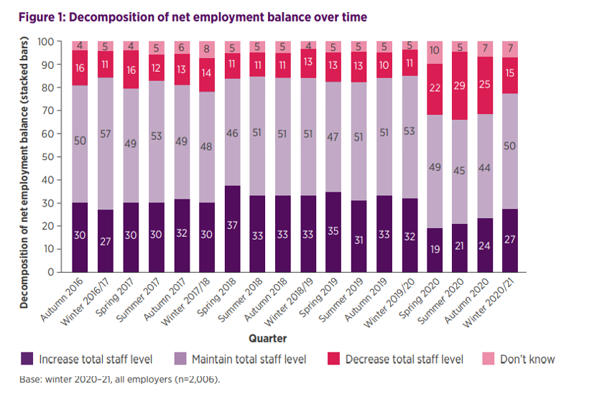
Labour Market Outlook: Winter 2020–21 (cipd.co.uk)

Appendix 2
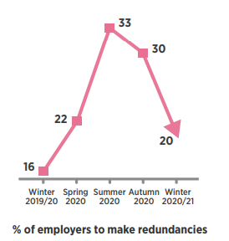

Appendix 3
Public | Private | Voluntary
Healthcare (80%), public administration and defence (78%) and ICT (67%) | Hiring intentions remain subdued in the hospitality (36%), construction (44%), administration and support service activities (45%), and manufacturing (49%) sectors. | Almost two-thirds of voluntary sector respondents (63%) are planning to recruit, which is consistent with the last quarter (64%).

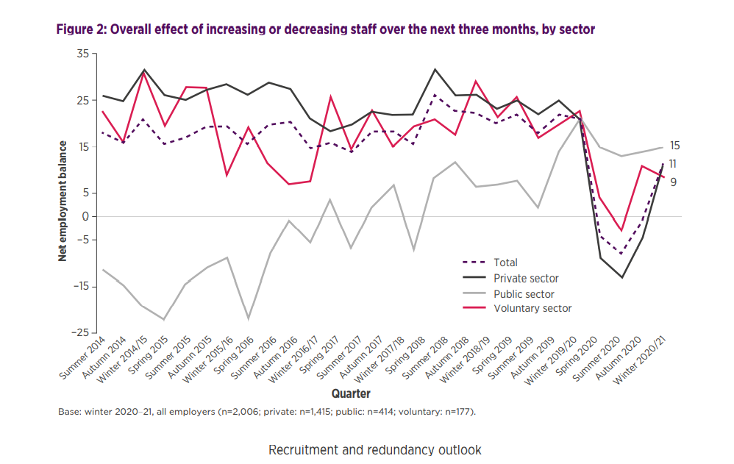
Labour Market Outlook: Winter 2020–21 (cipd.co.uk)

Appendix 4
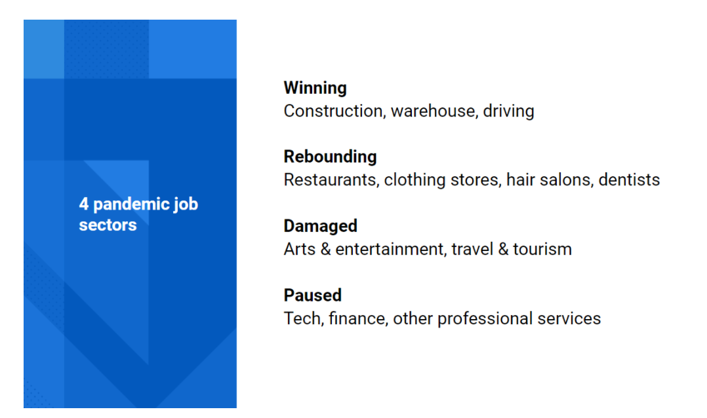
Appendix 5
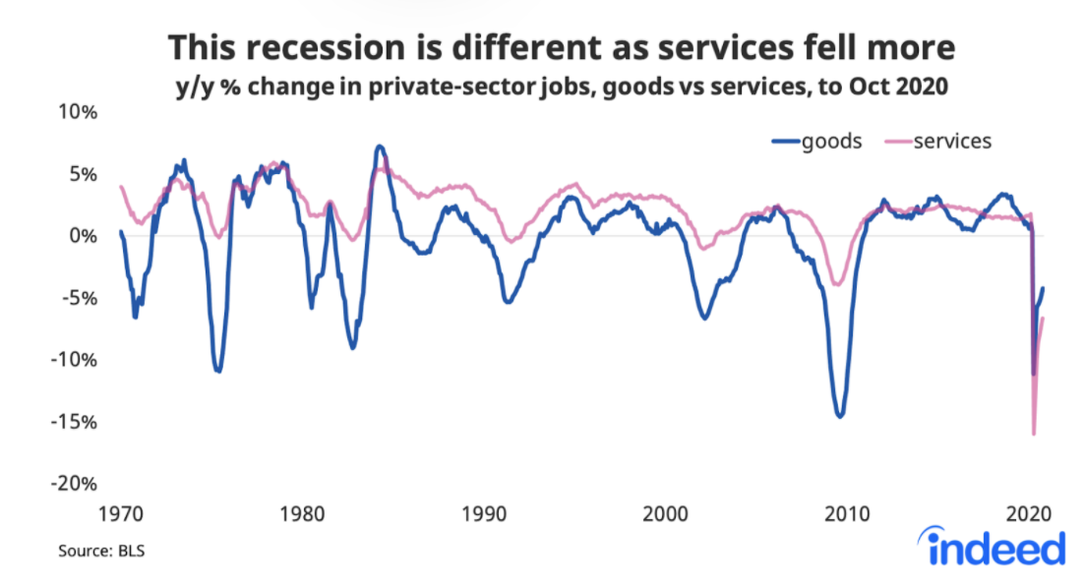

Appendix 6

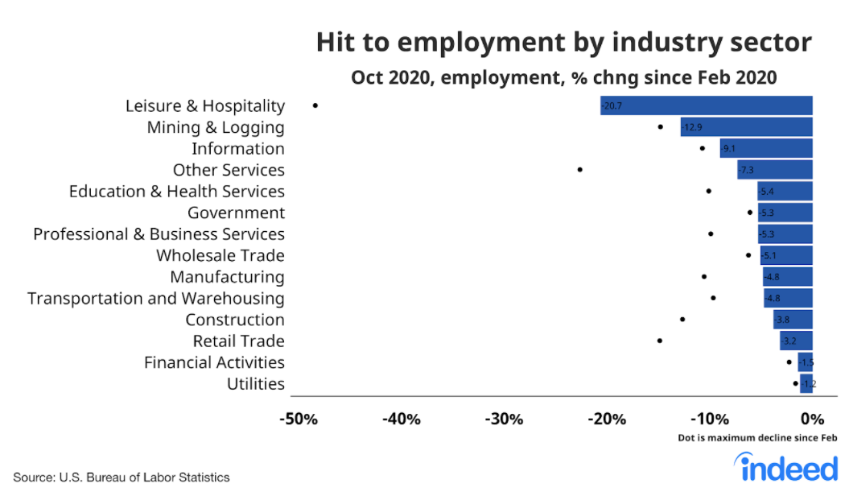

Appendix 7

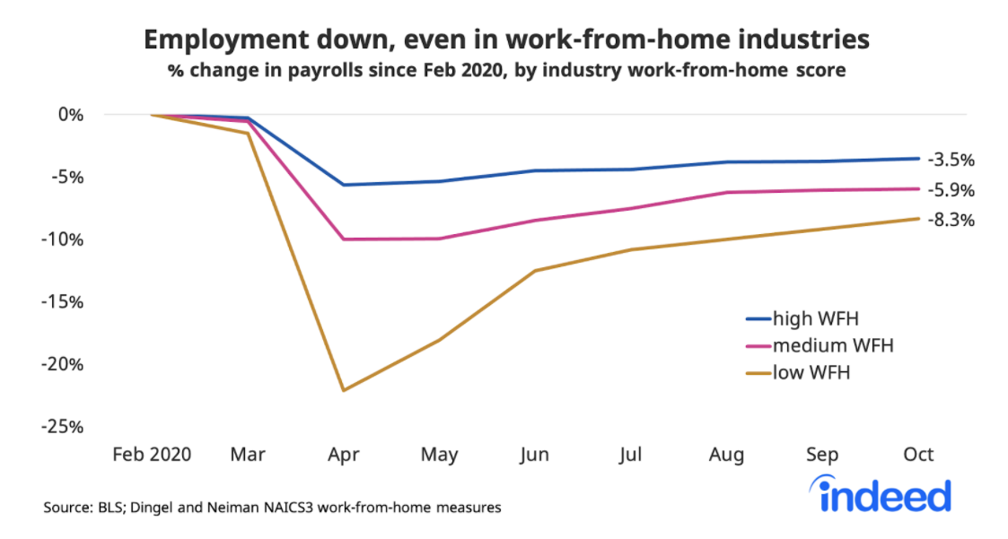

Appendix 8
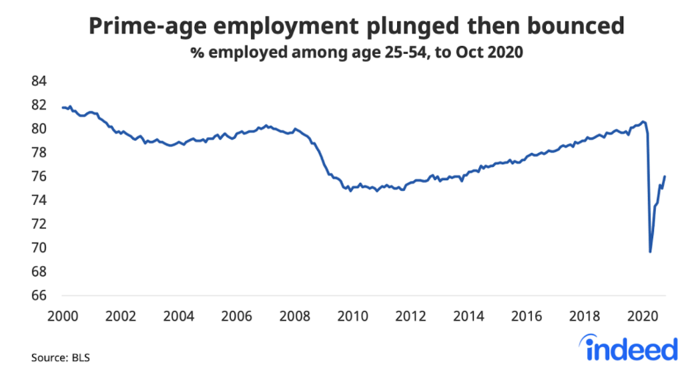
Appendix 9 CIPD (2020) Workforce Planning
Workforce Planning can offer market and industry intelligence and help organisations to focus on:

Reducing labour costs in favour of workforce deployment and flexibility
Responding to the needs of their customer base
Identifying skills gaps and areas of succession risk
Relevant strategies for talent management and people development
Targeting specific and identified inefficiencies
Employee retention initiatives.
improving the quality of outputs
Improve organisational retention, employee productivity, output, and work-life balance
Recruitment and training responses to changes in the education system
Organisations can identify appropriate strategies for focused people development
Make recommendations to deliver strategic value (ROI) through talent

Appendix 10a – Taylor & Woodham (2016)
This can inform HR best practice:
Retention planning initiatives, such as learning and development, flexible working and well-being.

Recruitment and selection processes, along with job design

Talent and succession planning

Organisational design and development

Reward and recognition

Appendix 10b continued - Stages of Workforce Planning

3. Determine future workforce Need:

Identify future capabilities and skills and forecast the timeframe needed. Undertake scenario planning to establish how different situations may impact the workforce and requirements. This will help facilitate and formulate contingency / adaptive organisational plan to achieve aspirational future business case goals.

6. Monitor, evaluate action plans and solutions:
Organisations should formulate, develop, and agree actions with suitable support and information manager can use detailing regular updates of outcomes. Evaluation processes should be clearly embedded into all stages of the process.

4. Identify gaps in workforce skills and knowledge:
Look a factors such as the gig economy and the future impact; future roles will require better digital and technological awareness.

5. Develop an action plan that has functional, numerical, and adaptable flexibility:
A flexible / agile workforce can aid a proactive change- ready organisation to adapt to change when required.

2. Analysing the workforce
Analysing the workforce: undertake a workforce analysis and identify talent profile, skills, and knowledge along with attrition rates. Also engage with employees and gather information on employee views such as a staff survey, satisfaction surveys, Health needs assessments. This will produce information regarding how employees feel about job security, health and wellbeing, organisational culture, satisfaction, and intention to leave. Assess how work is resourced, demographics differences such as age, geographical location etc and contractual arrangement / differences and impacts this may have on the workforce.

1. Understand the organisation and the operating environment:
Consider factors such as organisational structure currently and in the future. Consider future plans such as organisational structure / change etc.

CIPD (2021) Available at: workforce-planning-guide_tcm18-42735.pdf (cipd.co.uk)

Appendix 11
Workforce planning practice | CIPD | Guidance

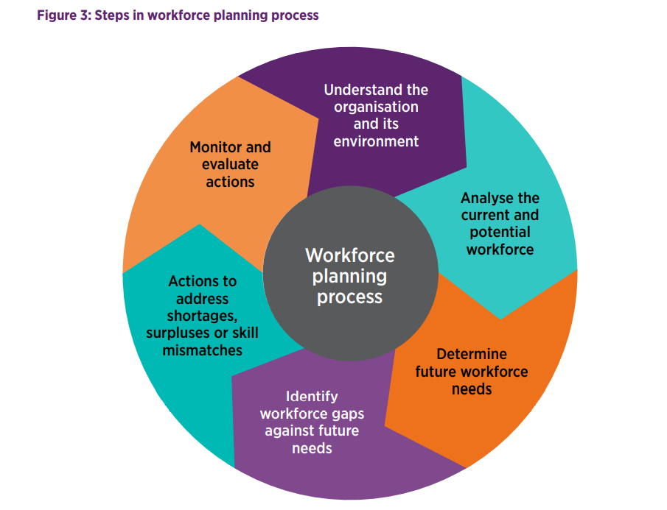

Appendix 12
Strategic vs operational workforce planning

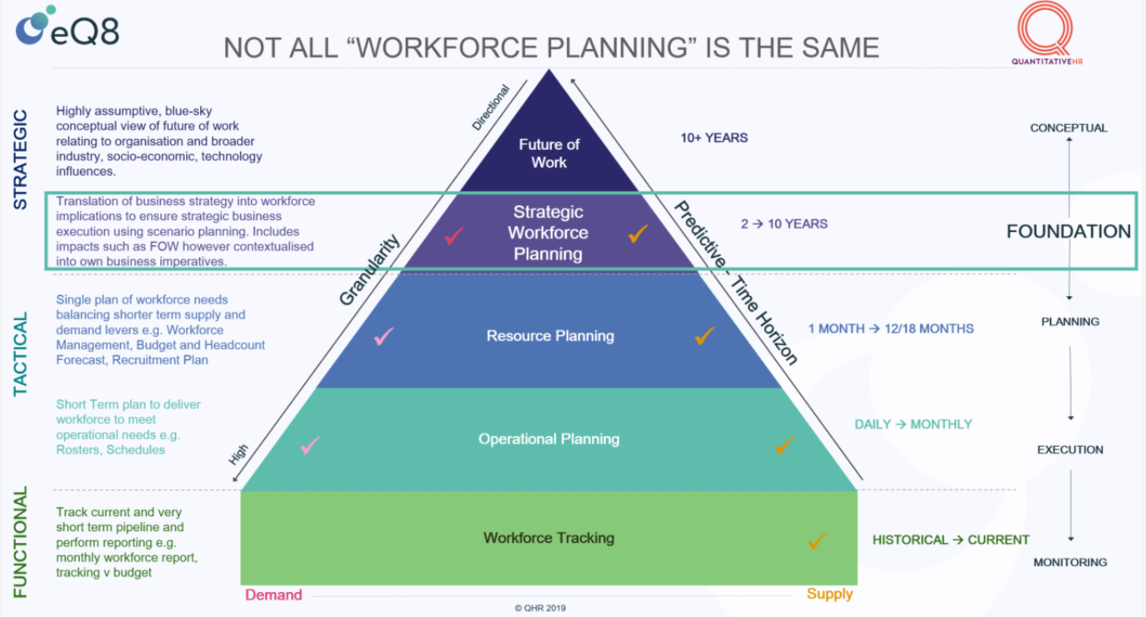

The Path to Transformation and Organisational Effectiveness? (aka Strategic Workforce Planning) | myHRfuture

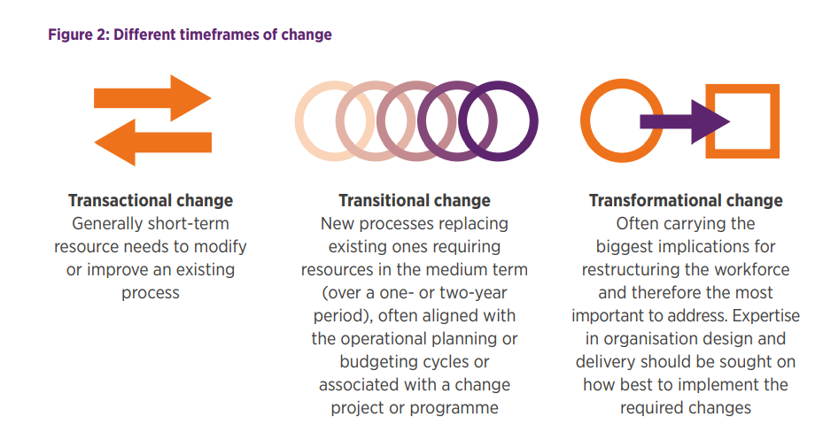
Strategic workforce planning guarantees an alignment to an organisation’s business strategy. It is a holistic approach to assessing and analysing the internal business drivers and goals, and external environment developments impacting upon your business. It primarily focuses on identifying critical job roles and families and the strategic capabilities required to meet future goals. It typically has a three- to five-year forecast horizon. Effective and timely quantitative and qualitative data capture will inform potential future risks by predicting possible alternative futures. Actions can then be taken today to mitigate against future workforce risks. Timeframes for change initiatives Another important consideration to address is the distinctive issues that occur within different timeframes of change, the type of change involved and over what period of time.

workforce-planning-guide_tcm18-42735.pdf (cipd.co.uk)

Appendix 13
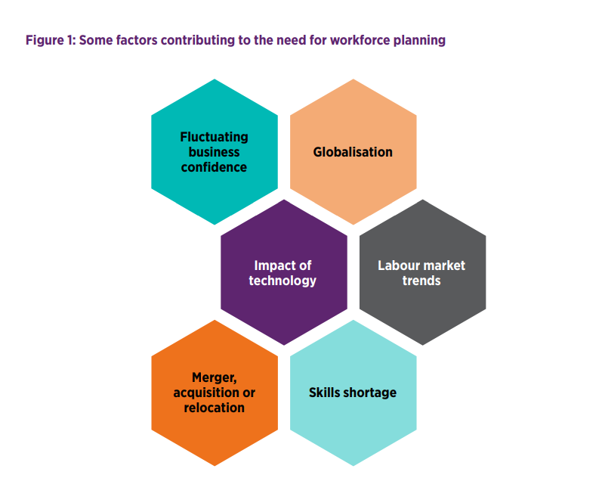

Appendix 14
Developing Resourcing Strategies: 4 Steps to Strategic Human Resource Planning | Lucidchart

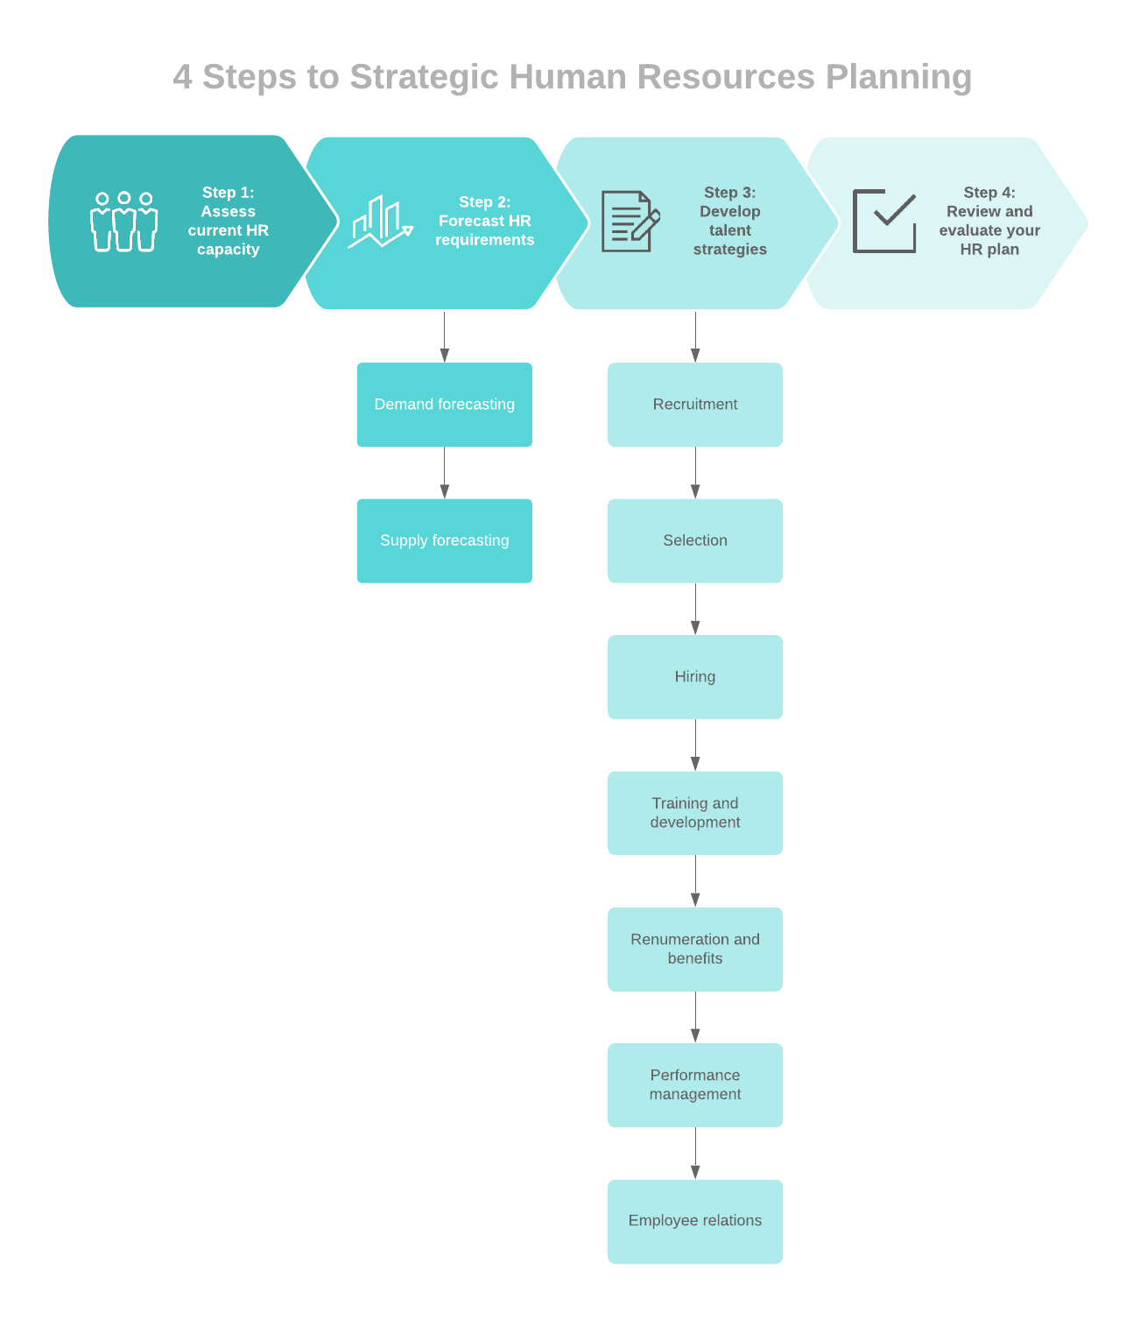

Appendix 15
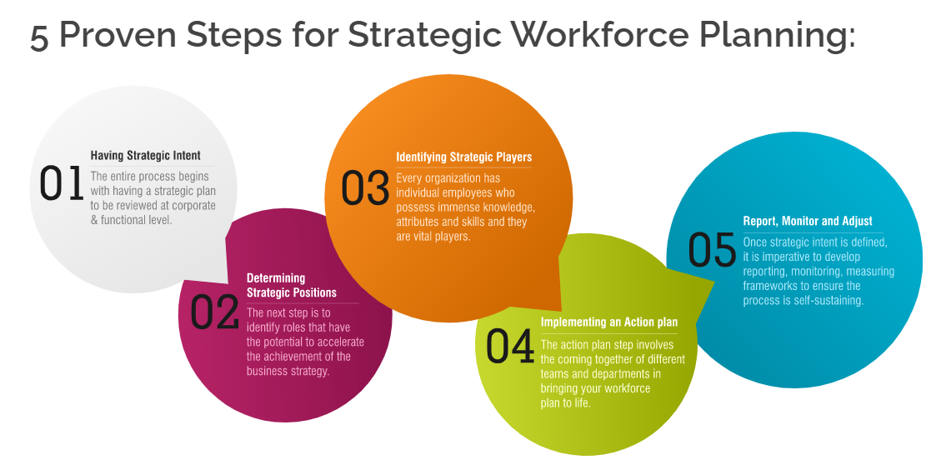

Appendix 16 - Approaches to succession planning diagram traditional / contemporary
Traditional | Contemporary
Bigger organisations | Less secrecy, open communication
Top down approach | Bottom up approach
Continuousness of leadership | Devolution to line managers
Managers recognise and nurture individuals with talent | Pools of talent
Steady and predictable environment | Management development techniques
Subjective and selective | Modern selection techniques which embraces the importance of organisational culture
 | Encompasses all

Appendix 17
Totah, Z (2021) Available at: Succession Planning | Nurturing Your Talent Pipeline In 2021 (selecthub.com)
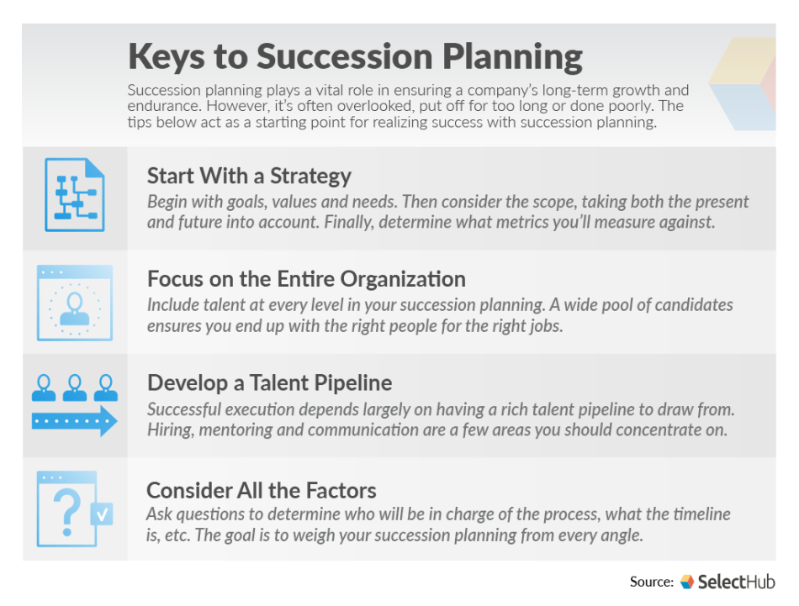
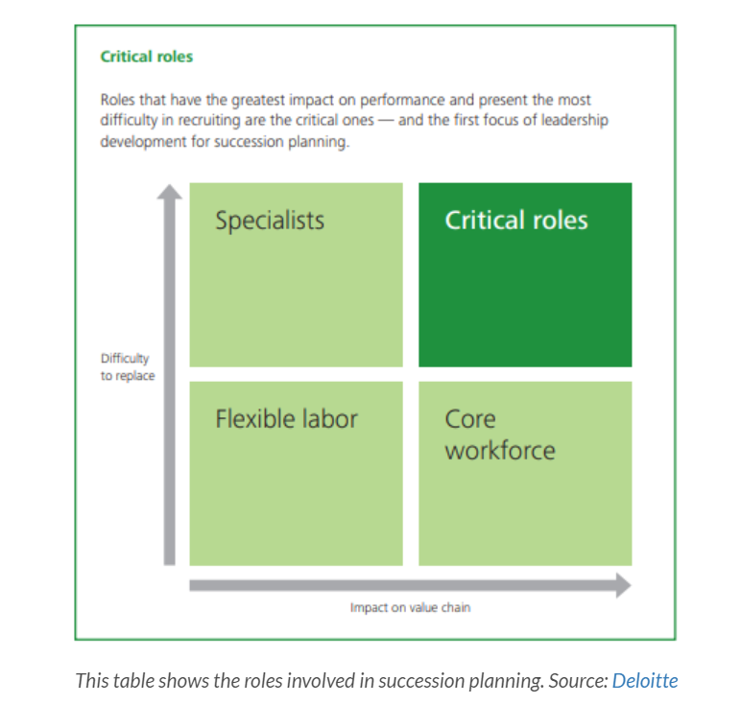

Appendix 18
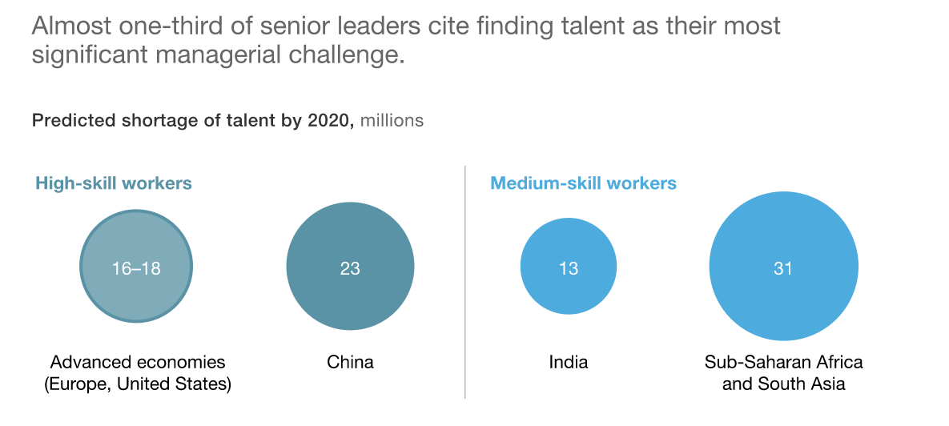
Appendix 19

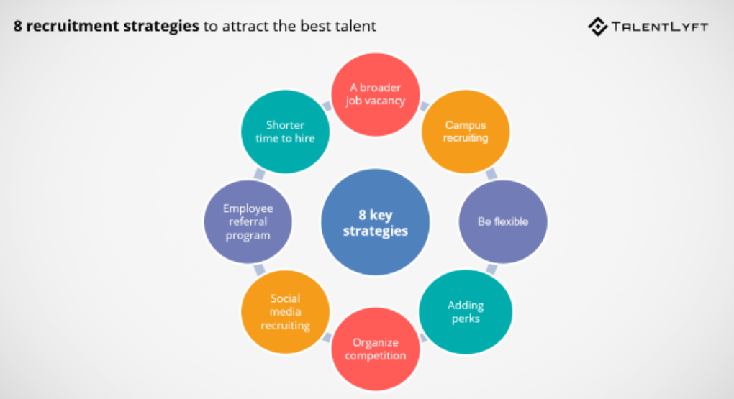
Appendix 20
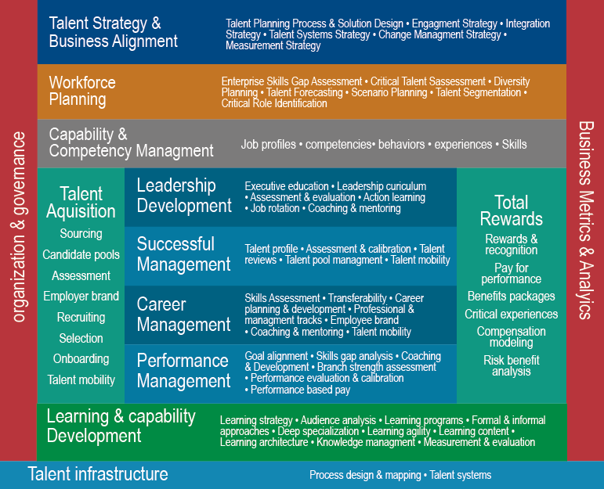

Talent Management strategy and its implications on an increasingly competitive workplace | SuccessDart

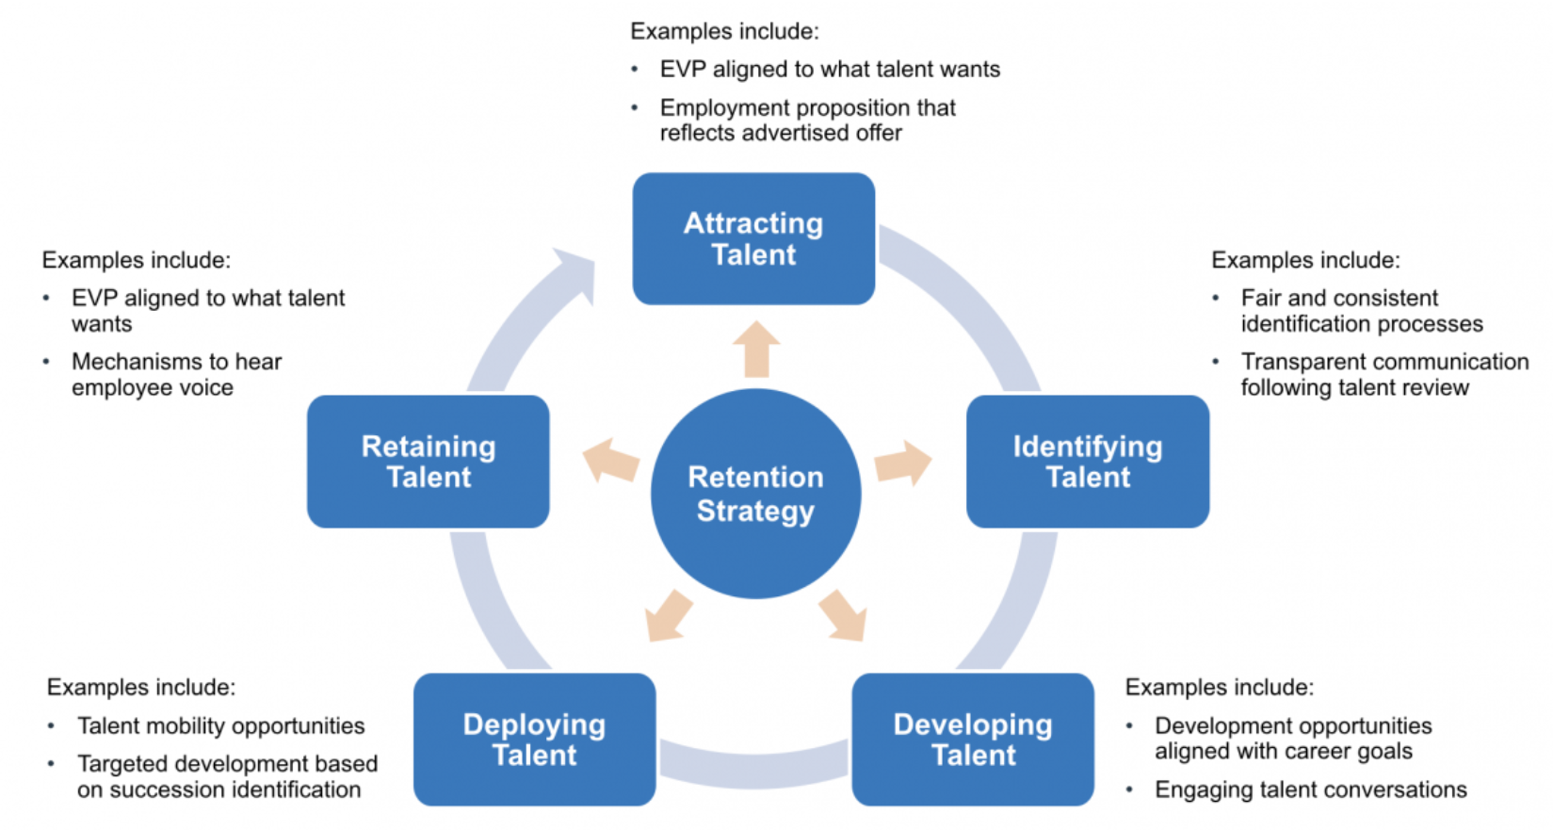

Retaining Talent | London Leadership Academyb

Appendix 21
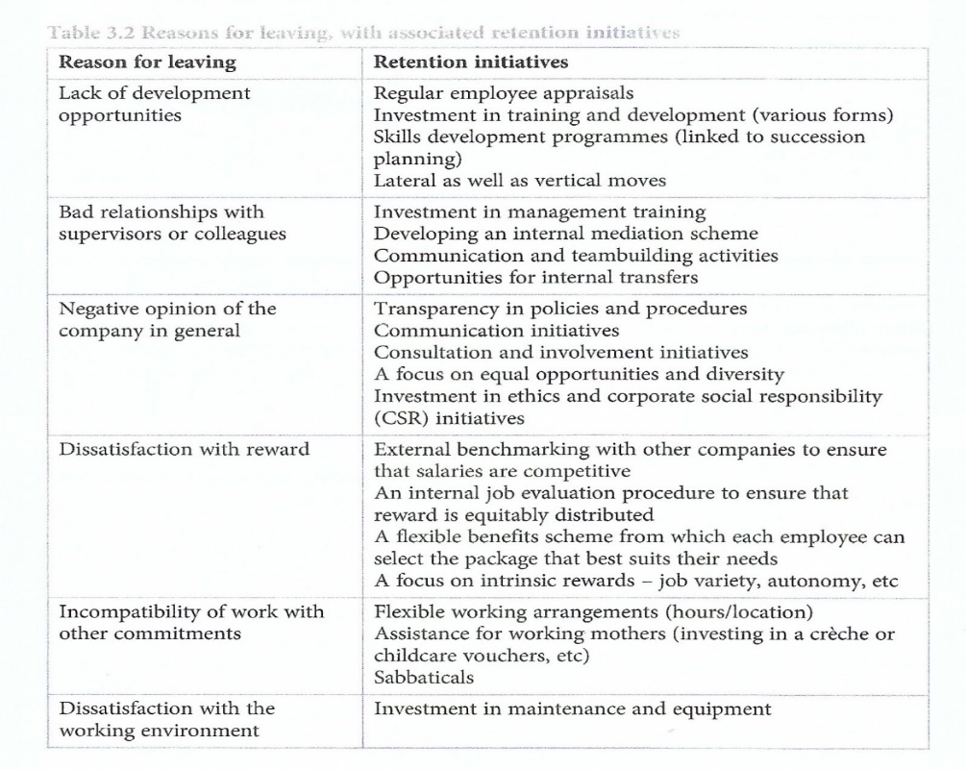

Appendix 22
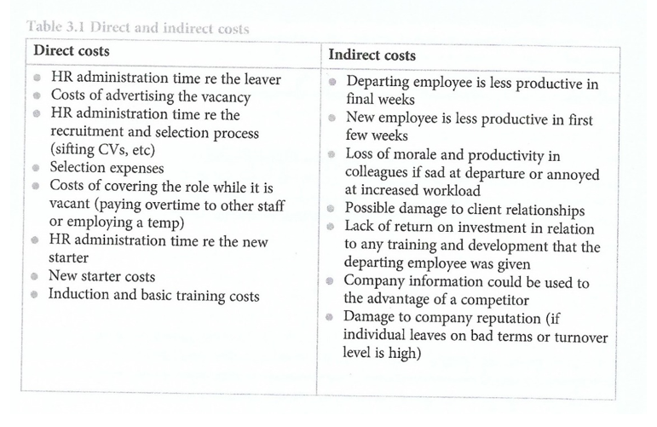

Appendix 23 Turnover calculation
Crude turnover rate calculation | Establishing the percentage of the workforce left in a year
Stability rate | Establishing the length of time employees tend to stay within the organisation. This is vital as the action that is taken when employees are lost within the first few months of employment is different to that if they have been with the organisation for a long time.
Cohort analysis | Establishing the stability rate of a specific cohort of employees (graduate intake) , to track the retention rate of these employees over time.

Appendix 24
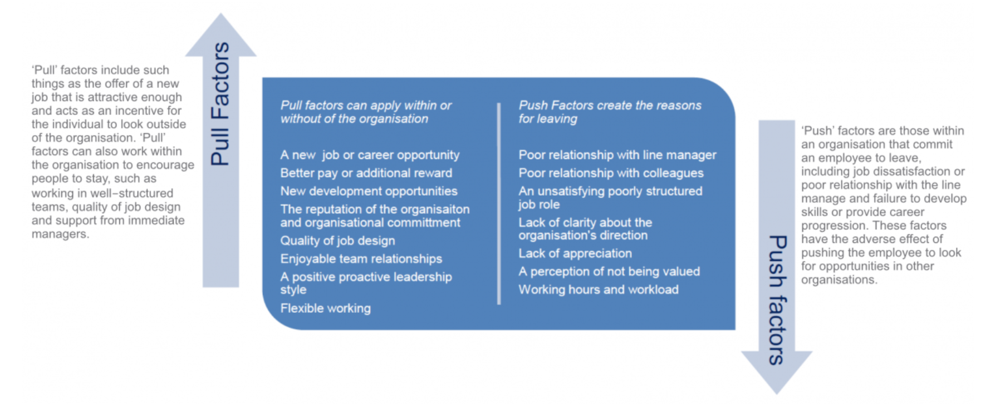
Appendix 25 Bersin’s Talent Management Maturity Model
Talent Management strategy and its implications on an increasingly competitive workplace | SuccessDart)
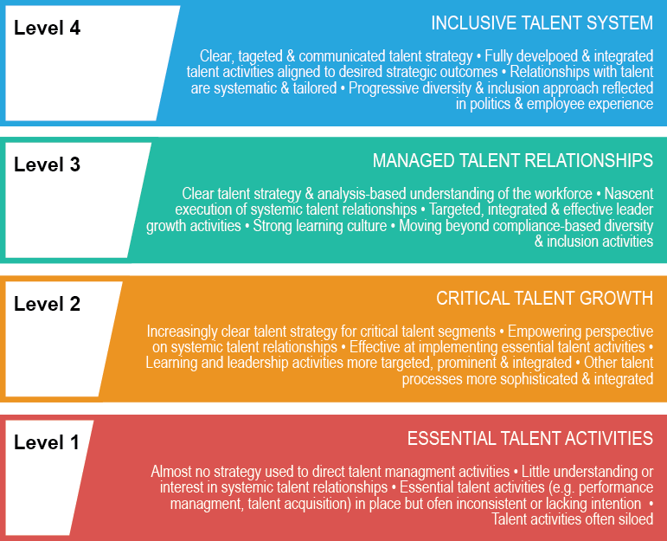

Talent Management system Advantages | Talent Management system Disadvantages
- Help in ascertaining the right person is deployed in the right position. | - The implementation of talent management program could be expensive in terms of time, resources, and financial costs.
Contributes in retaining their top talent. | Lack of support from line managers can impede the level of commitment from employees.
Better hiring by hiring assessments | A core drawback of talent management is, it can contribute in raising the conflicts between HR and management by not reaching to proper agreement or consensus
Helps in understanding employees better and shaping their future
Promotes effective communication across different disciplines.

Talent Management strategy and its implications on an increasingly competitive workplace | SuccessDart
Appendix 26
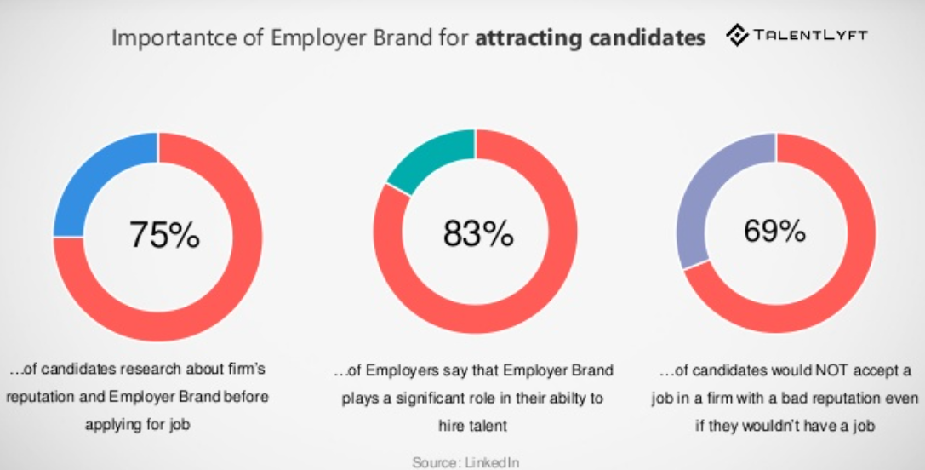
https://www.talentlyft.com/en/blog/article/87/15-new-recruiting-trends-you-should-implement-in-2020
Appendix 27
Lievens et al (2007) suggests five options that organisations can align themselves to when deciding how to present themselves to potential employees (Appendix 15 p 62 Zebra Book).
Sincerity | Truthful and welcoming branding
Excitement | Innovative, modern branding i.e. Google welcomes innovation and creative freedom that is applied to future web technologies in an organisational culture that embraces collaboration, creativity, well-being and contentment
Competence | Attainable and successful
Sophistication | Respected branding
Ruggedness | Masculine and tough branding

Appendix 18 been moved to q 4
Appendix 28 CIPD Intermediate Studies - ppt download (slideplayer.com)
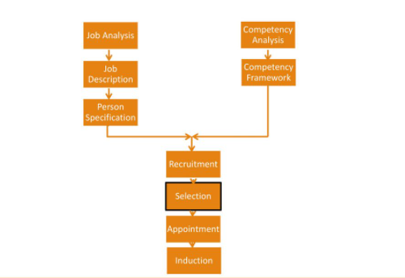
Appendix 29
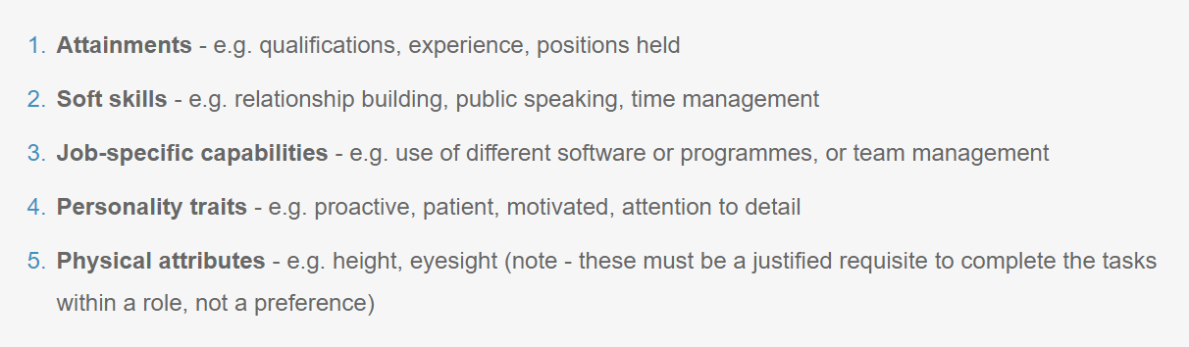
https://www.reedglobal.com/blog/2017/07/the-purpose-of-a-person-specification

Appendix 30
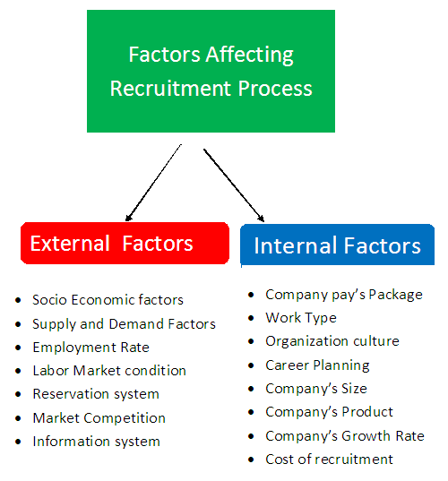

Appendix 31
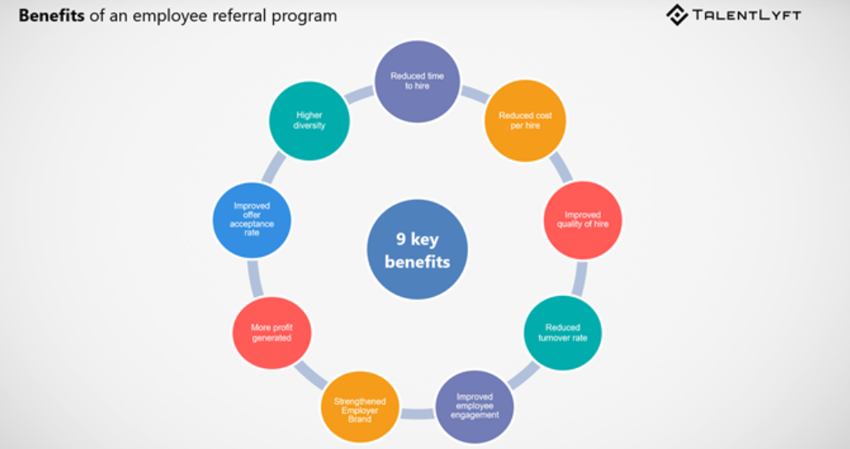
https://www.talentlyft.com/en/blog/article/211/8-recruitment-strategies-to-attract-the-best-talent

Appendix 32
People Management: Methods of Recruitment (GCSE) | tutor2u

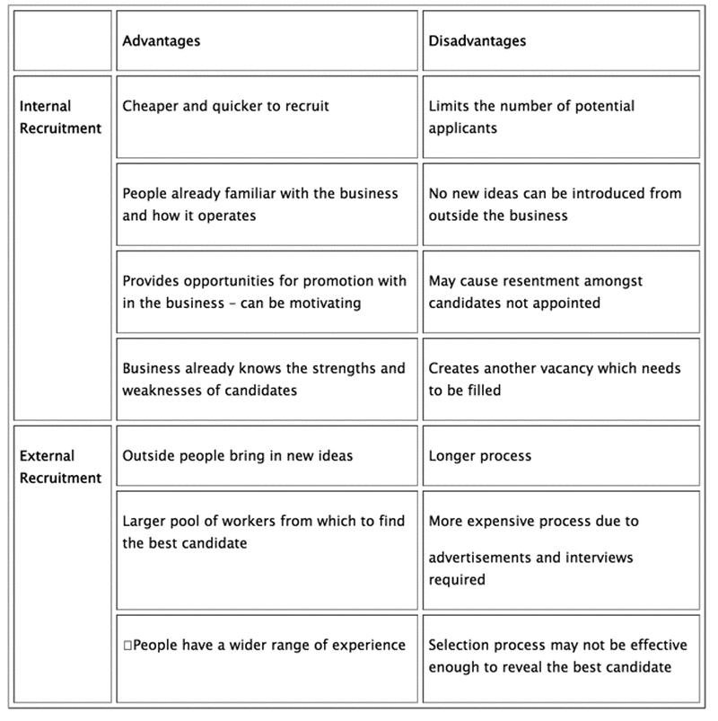

Appendix 33
Internal Recruitment | External Recruitment
Vacancies filled by existing employees. | Recruitment agencies
May involve promotion or sideward moves | Headhunting, linked in
Advertised via staff notice board / staff intranet page etc. | Online advertisement
Word of mouth – encouraging current employees to recommend the organisation to other internal applicants (refer a friend scheme) | Word of mouth – encouraging current employees to recommend the organisation to other external applicants (refer a friend scheme)
 | Job centre
Internal graduate schemes | External Graduate schemes
 | Employment agencies
 | Educational liaison – career fairs, student societies etc.
 | Personal recommendation

Taylor & Woodhams (2016)
HRM _ Recruitment & Selection (slideshare.net)

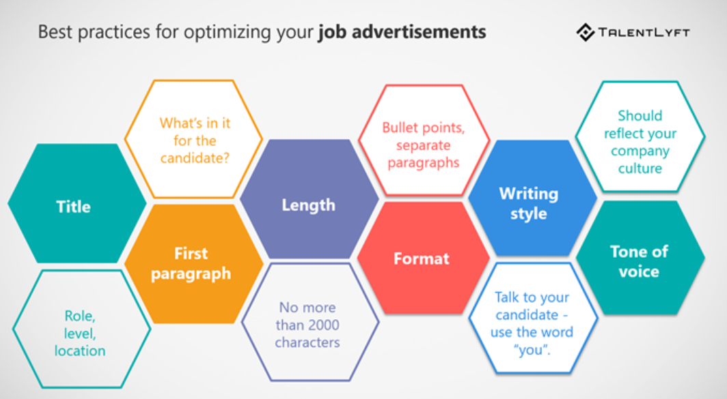

Appendix 34

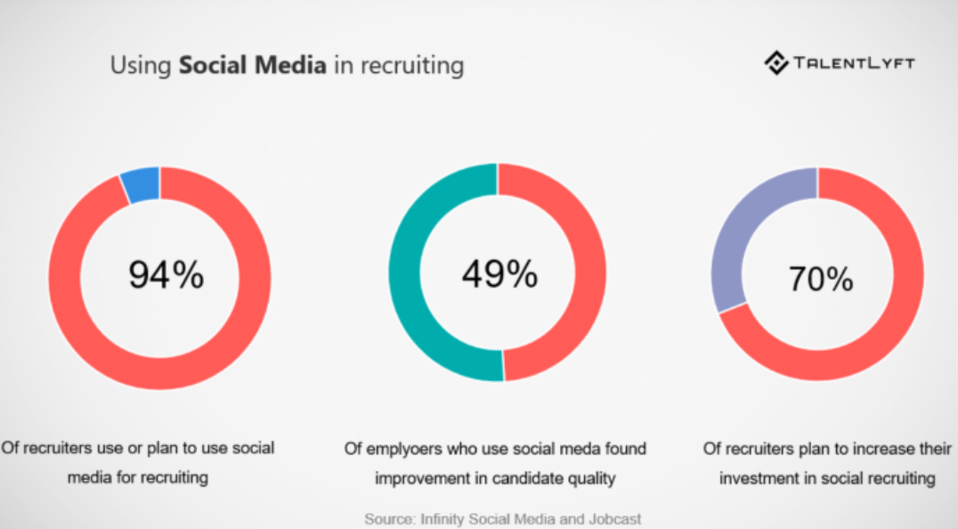

Make sure to implement an employee advocacy program. Employers need employees for a successful talent attraction strategy.
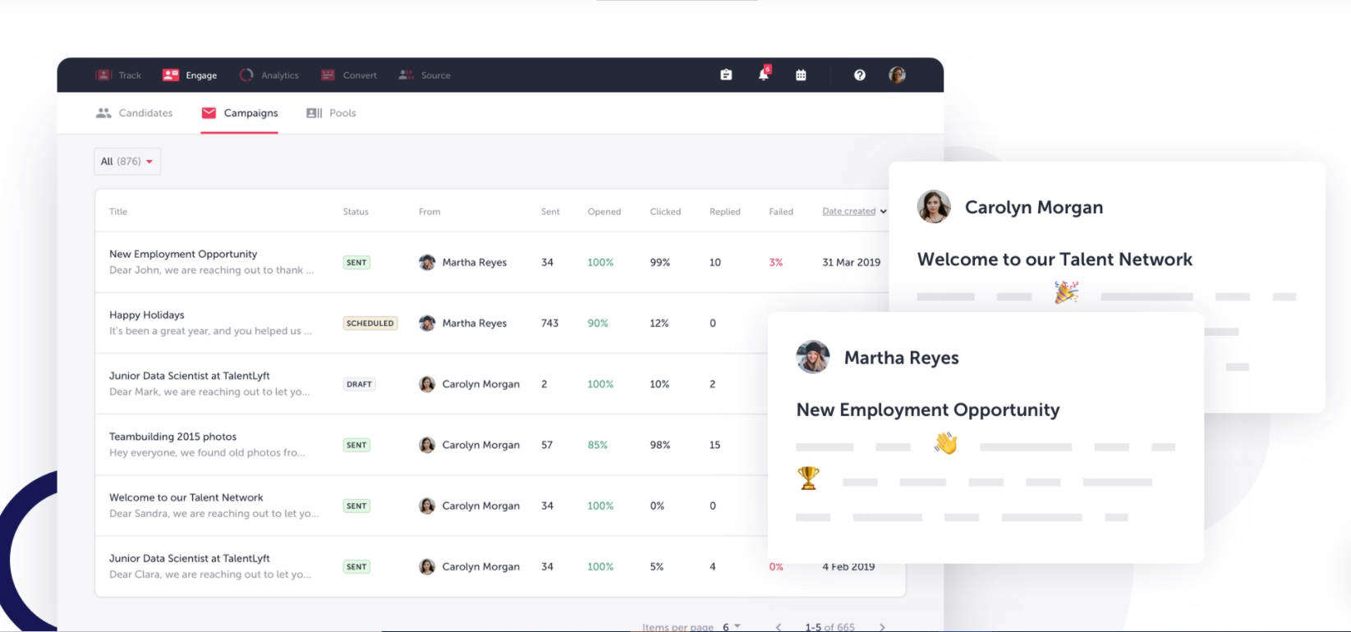
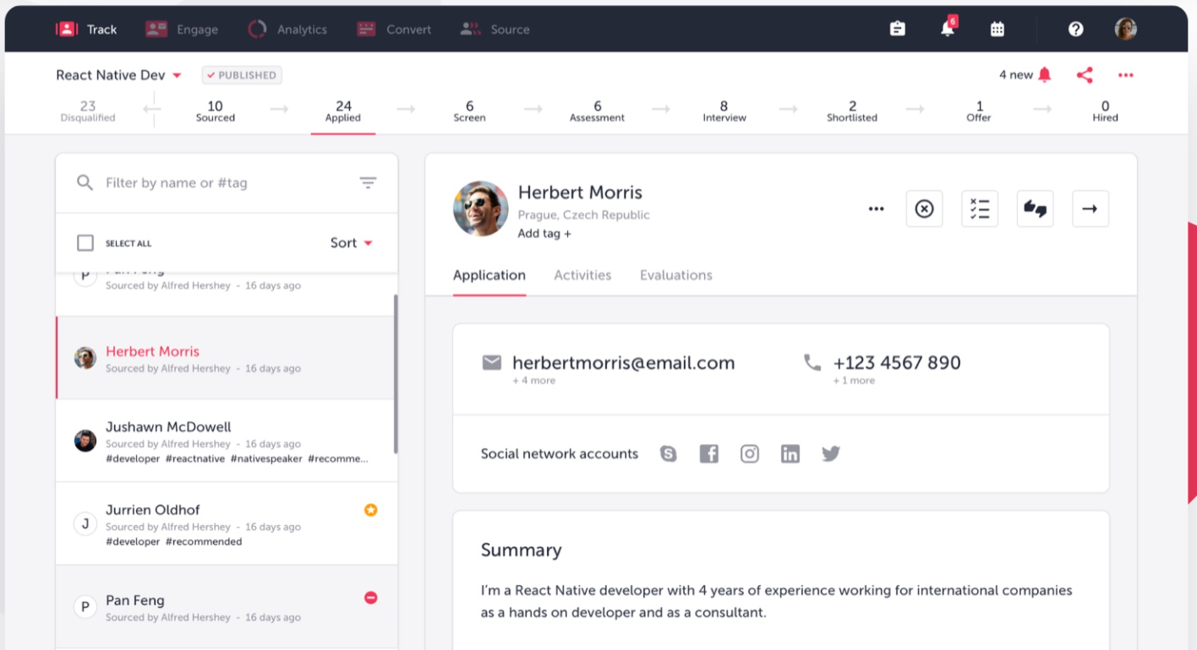

Appendix 35 - The Pros and Cons of Using Social Media in the Hiring Process (newtontalent.com)
Pros | Cons
Social media can easily rule out candidates  Some candidates can be ruled out based on their social media posts before the interviewing and hiring process has even begun. | Your timing could leave you open to legal problems  Once an employer has viewed a candidate’s online profile, a court will assume they are aware of that person’s “protected characteristics” that are often part of their online postings. These characteristics include gender and race as well as those that are not always evident in a face-to-face interview such as religion, age, sexual orientation, or disability. Most experts recommend reviewing social media as part of organisational screen (if a chosen method), after individuals have met face-to-face in an interview.
Social media checks can highlight discrepancies | Social media might not be relevant to the job
 | Information might be inaccurate or out of date
 | It could be seen as an invasion of privacy
 | Privacy Concerns
 | According to ACAS (2013) Job seekers do not believe that avoiding social media presence or keeping one that is fake or neural, is not a prerequisite to getting into a new job.
 | Although the internet is public reclaim, individuals consider them as personal bubbles.
Appendix 36
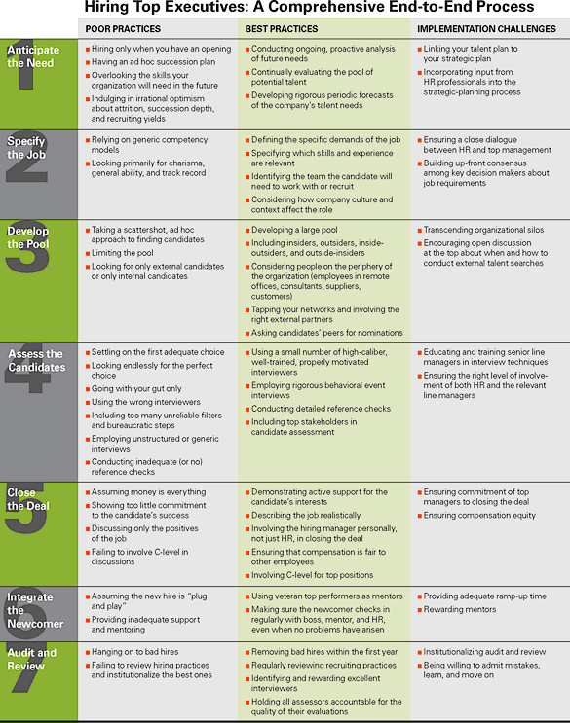 HHiring Top Executives: A Comprehensive End-to-End Process
The Definitive Guide to Recruiting in Good Times and Bad (hbr.org)

Appendix 37
Type of Interview | Overview
Telephone interview | This is sometimes used during the first stage of the process to establish an applicant suitability for a more substantial interview or when applicant are being recruited from overseas.
Face-to-Face interview / one-to-one interview | This is usually led by a HR employee or a line manager of the vacant role.
Panel Interview | More than one organisation representative attends the interview.
Group Interview | Recruitment teams interview a group of applicants at the same time. There is not a set format to these interviews. Tasks may sometimes be set, which is observed by the interviewers.
Competency-based interviewing | Applicants are asked to provide examples of how they have demonstrated competency in the past or alternatively answer a scenario-based question which highlights / demonstrates their ability to deal with a particular situation.

To ensure consistency and fairness interviews have changed structure. Rather than questions structured around individual’s CV and application form, interview now follow a structure and tailor discussions when looking for answers.
Appendix 38
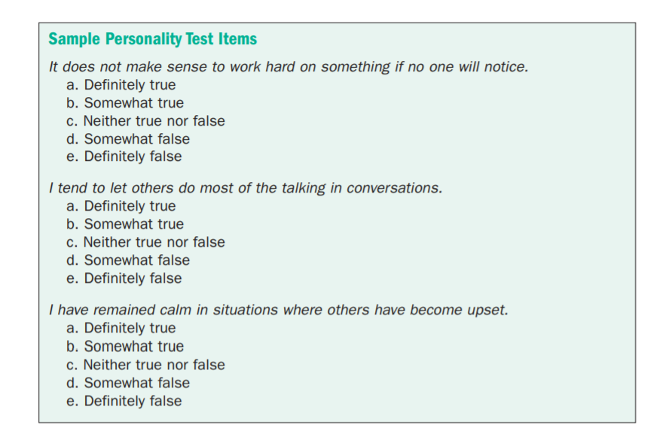
https://www.shrm.org/hr-today/trends-and-forecasting/special-reports-and-expert-views/Documents/Selection-Assessment-Methods.pdf

Appendix 39 - *managingage.pdf (tuc.org.uk)


