Data Warehousing & Data Mining (ACCA6026)
Assignment: Data Warehousing

Student: Marina Munteanu (2222673)
Lecturer: Balendran Kandasamy

dhl supply chain - enhancing uk &
European logistic efficiency with data analysis

CONTENT

Introduction 2
TASK 1 – Data Warehouse Strategy for DHL 2
1.1 OLTP vs Data Warehouse 2
1.2 Data Warehouse Architecture & ETL 4
1.3 Data Marts for Management Decision-Making 7
1.4 OLTP Normalisation vs Dimensional Modelling 8
TASK 2 – Data Warehouse Design and Implementation 10
2.1 Source System Identification 10
2.2 Star Schema Design 11
2.3 Data Marts and Schema 13
2.4 ETL Plan 14
2.5 Data Quality and Governance 15
Conclusion 15
References 16

Introduction

DHL Supply Chain is one of the largest logistics companies in the world. The company operates a wide network of warehouses and transport services across the UK, Europe and globally. These operations generate large volumes of data every day from activities such as parcel scanning, warehouse handling and transportation processes.
DHL manages several important logistics hubs across the UK and Europe, including Daventry, Heathrow Logistics Park and Eurocentral in Glasgow. In Europe, hubs such as Rotterdam and Lyon also play a major role. These locations generate operational data related to shipments, warehouse activities and transport routes.
To manage daily operations, DHL uses several operational systems, including Warehouse Management Systems (WMS), Transportation Management Systems (TMS) and Order Management Systems (OMS). These systems process transactions such as order processing, inventory movement and shipment tracking. However, the data is typically stored separately across different systems. As a result, managers do not always have a clear and complete view of performance. Data fragmentation makes it more difficult to identify operational issues and limits the ability to analyse key performance indicators such as on-time delivery, fleet usage and warehouse efficiency. To address these challenges, DHL Supply Chain UK & Ireland is considering the implementation of a data warehouse. A data warehouse integrates data from multiple systems into a single platform for analysis, enabling organisations to analyse historical data and support business intelligence activities [1]. In this report, I act as a data warehousing consultant for DHL Supply Chain. The report explains the differences between OLTP systems and data warehouses and describes the architecture of a data warehouse solution. It also proposes a dimensional model and an ETL approach for integrating DHL’s operational data. Overall, integrating operational data into a data warehouse can help DHL gain a clearer understanding of performance across its logistics network and support more effective strategic planning.

TASK 1 – Data Warehouse Strategy for DHL
  - OLTP vs Data Warehouse
OLTP systems are used for daily business operations. In DHL, these include WMS, TMS and OMS. These systems process transactions in real time. For example, they record orders, stock movements and deliveries. OLTP is designed for speed and accuracy. Data is updated continuously and is highly detailed. This helps DHL run its daily operations more efficiently.
However, OLTP is not suitable for analysis. The data is stored separately in each system. In practice, this makes it difficult to obtain a complete view. Managers cannot easily see overall performance across regions. Also, complex queries can slow down operational systems. Because of this, OLTP systems are not used for decision-making.
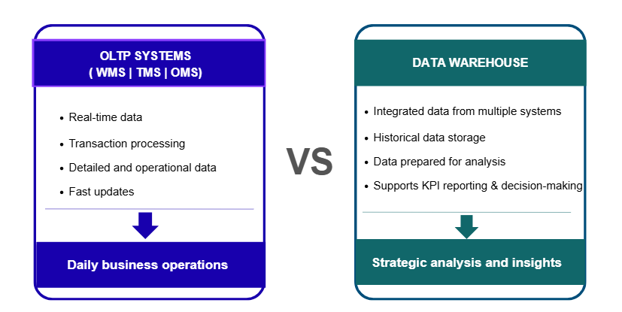
Figure 1: OLTP Systems vs Data Warehouse

As shown in Figure 1, OLTP systems support daily operations, while the data warehouse supports analytical processing and business insights. It has a different role, as it integrates data from multiple systems. Data is combined into a single platform. In many cases, the data is cleaned and prepared before analysis. This makes the information easier to use and more reliable for analysis. A data warehouse is a subject-oriented and integrated collection of data designed to support business analysis [2].
A data warehouse is designed for analysis, not for transactions. It allows complex queries without affecting daily operations. Managers can analyse trends and performance over time. For example, DHL could analyse on-time deliveries between the Daventry and Lyon hubs or compare warehouse efficiency across different regions [1], [3].
Another important difference is how the data is organised. OLTP uses normalised structures. A data warehouse uses dimensional models, such as a star schema [1]. This makes analysis faster and easier to understand.
In conclusion, OLTP systems and data warehouses have different roles. OLTP supports daily operations. A data warehouse supports strategic decisions. For DHL, using both together means smoother daily operations and better strategic decisions based on complete and integrated data across its logistics network. Modern cloud-based data warehouse architectures, such as those implemented on Azure, demonstrate how such integration can be achieved at scale, supporting real-time insights and scalable analytics [4].
  - Data Warehouse Architecture & ETL
According to Inmon [2], a data warehouse architecture describes how data is collected, integrated and prepared for analysis. WMS is used in locations such as Daventry and Lyon and stores inventory data and warehouse performance data.
- TMS is used for route planning and fleet management. It stores delivery times, routes and vehicle data.
- OMS is used to manage customer orders and delivery status.
Additional data comes from financial systems, client systems and external sources. External sources include weather and customs data from locations such as Rotterdam. Integrating data from multiple different systems is a key characteristic of modern data warehouse architectures [4].
This architecture solves the problem of fragmented data by integrating information from multiple systems into a single platform. As a result, it creates a consistent view of operations, which is essential for DHL across the UK and Europe. It supports better decisions in complex situations. Examples include Brexit, e-commerce growth and sustainability targets.
As shown in Figure 2, data flows from operational systems to analytical tools through a structured ETL process.
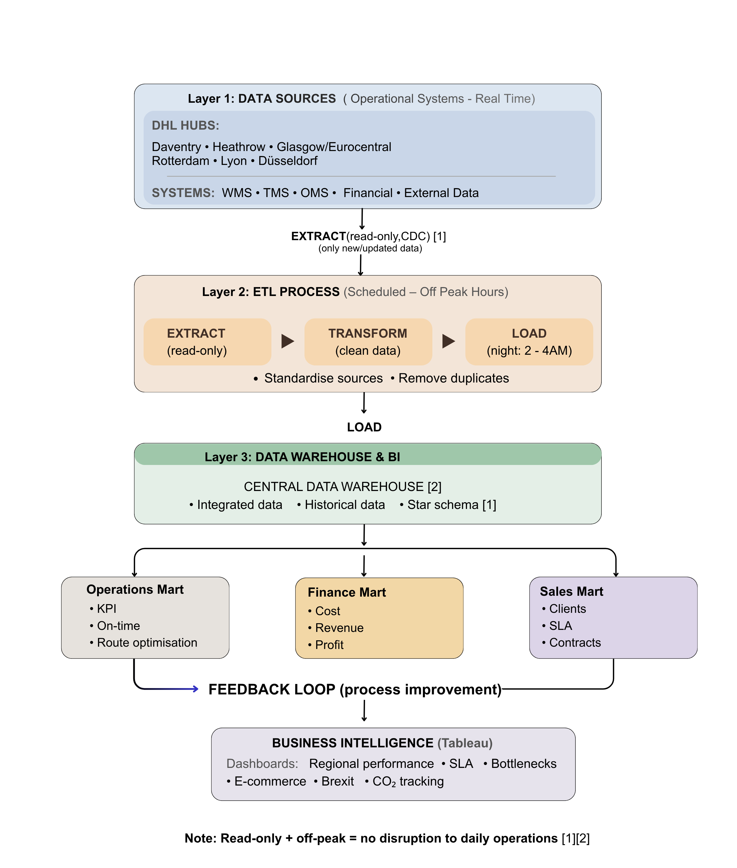
Figure 2: DHL Data Warehouse Architecture and ETL Process (adapted from Inmon [2] and Kimball [1])

The architecture has three main layers. Each layer has a clear role. This separation protects daily operations and supports analysis. This layered approach is widely used in data warehouse design to ensure efficient data processing and analytical performance [5].
- Layer 1: Data Sources
The first layer includes operational systems. These systems work in real time. They support daily logistics activities. They store detailed and transactional data. This includes shipment data, warehouse data, transport data, client data and financial data. This matches the DHL case study.
WMS stores inventory levels and warehouse performance. It also stores cold chain data from the pharmaceutical hub at Heathrow. TMS stores route data and delivery times. It also supports just-in-time deliveries for automotive clients in Glasgow and Eurocentral. OMS stores customer orders and delivery status. Financial systems store invoices, costs and revenue data. External systems provide weather data and customs data from Rotterdam.
- Layer 2: ETL Process (Extract, Transform, Load)
The second layer prepares the data for analysis. ETL is a core component of a data warehouse [1]. This process is designed not to disrupt daily operations.
- Extract
Data is copied from source systems. The process is read-only. This means operational systems continue to run normally. Only new or updated data is extracted. This reduces system load and improves efficiency [1].
- Transform
The data is cleaned and standardised. Errors are corrected. Duplicate data is removed. Data from different systems is combined. This creates a consistent format. This improves data quality [2]. For example, WMS and TMS data can be combined. This helps DHL analyse delivery performance between locations such as Daventry and Lyon.
- Load
The data is loaded into the data warehouse. This happens during off-peak hours. For example, between 2:00 AM and 4:00 AM. This avoids impact on operational systems [1]. However, ETL introduces a small delay. The data is updated in batches. This means the data is not fully real-time.
- Layer 3: Data Warehouse and Business Intelligence
The third layer stores and uses the data. The central data warehouse integrates data from all systems and stores historical data for analysis [2].
Data is organised using a star schema [1], where fact tables store measurable data such as shipment time, cost and volume, and dimension tables provide context such as time, location, client and product. This structure makes analysis faster and easier.
Business intelligence tools such as Tableau are used to create dashboards.
An important feature of this layer is the feedback loop. Insights from dashboards are used to improve operations. For example, routes can be optimised based on delivery performance, warehouse processes can be improved based on efficiency data, and pricing decisions can be adjusted based on profitability analysis.
Why daily operations are not disrupted
This architecture protects operational systems because data extraction is read-only and ETL processes run during off-peak hours. Only relevant data is processed, which ensures that daily operations continue normally.
In conclusion, this architecture provides DHL with an integrated data environment. It removes data fragmentation and creates a single and reliable view of operations. This supports better decision-making across DHL. This also aligns with industry best practices in modern data warehousing design and architecture, supporting efficient and scalable analytics [5].
  - Data Marts for Management Decision-Making
Different managers in DHL require different types of information for decision-making. A central data warehouse stores integrated data, but it is not always efficient for specific analysis. Data marts are smaller subsets of the data warehouse designed for specific business needs [1]. According to Bhatia [6], data warehousing helps organisations organise and analyse large volumes of operational data more effectively.
For the managing director, an operations data mart would include key performance indicators such as delivery times, on-time delivery rates, warehouse utilisation and route efficiency. This allows a high-level view of performance across regions. For example, DHL can compare delivery performance between Daventry and Lyon and identify bottlenecks in the supply chain. It also helps monitor the impact of external factors such as Brexit and e-commerce growth. This supports strategic decision-making and operational improvement.
The finance director would benefit from a finance data mart containing cost, revenue and profitability data. This includes transport costs, warehouse costs, fuel consumption and client revenue. This enables the analysis of profit margins and cost drivers. For example, the finance director can compare profitability between the Daventry e-commerce hub and the Lyon fresh produce hub. This supports better pricing strategies and financial planning.
The sales and marketing director requires a sales data mart with customer data, contract details, order volumes and SLA performance. This allows the analysis of customer behaviour and service usage. DHL can identify high-value clients and monitor SLA compliance. It also supports the analysis of e-commerce demand in Daventry and customer service performance across regions.
Data marts improve performance by reducing query complexity and allowing access only to relevant data. They support faster analysis and clearer insights. According to Kimball and Ross [1], dimensional structures such as data marts improve query performance and make data easier to understand.
In conclusion, data marts provide targeted insights for different management roles. For DHL, this improves decision-making, operational efficiency and service quality across the UK and Europe, supporting more effective strategic planning.

  - OLTP Normalisation vs Dimensional Modelling

OLTP systems and data warehouses use different data structures because they have different purposes. In DHL, OLTP systems such as WMS, TMS and OMS support daily operations. These systems record transactions such as orders, deliveries and inventory updates in real time.
OLTP systems use normalisation. This means data is stored in many small tables to reduce duplication and improve accuracy. For example, shipment data, client data and route data are stored separately and connected using keys. This structure is efficient for daily operations, but it is complex for analysis because it requires many joins.
In contrast, data warehouses use dimensional modelling. This model is designed for analysis and reporting. It is easier to understand and faster to query. According to Kimball and Ross [1], dimensional models improve performance and make data easier to analyse.
A common structure is the star schema, as shown in Figure 3. In DHL, the central table is the Shipment Fact, which stores measurable data such as delivery time, shipment cost, shipment volume and on-time performance.
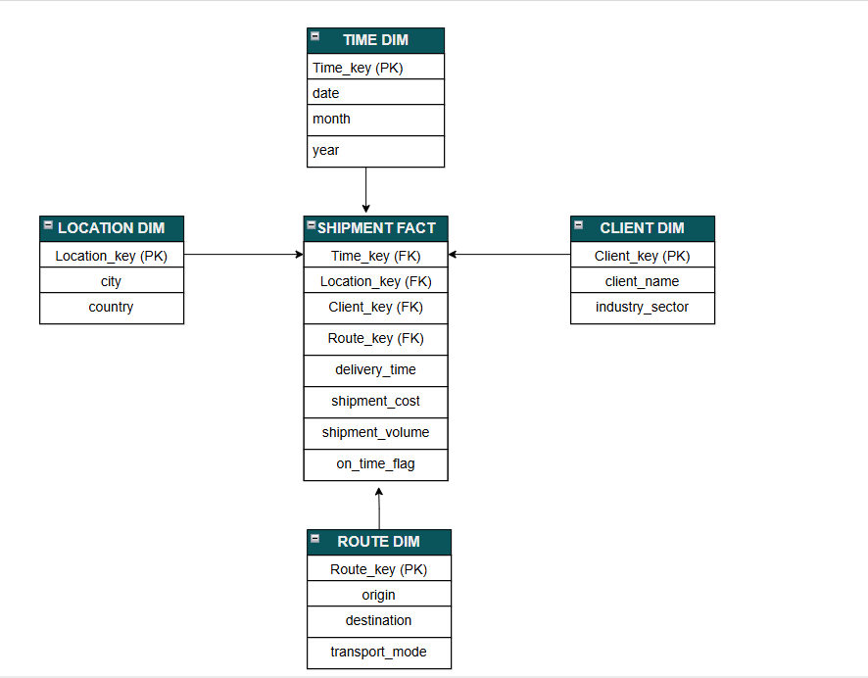
Figure 3: Star Schema for DHL Logistics Data (adapted from Kimball [1])
This structure makes data easier to understand and analyse. Around this table are dimension tables that provide context, such as Time, Location, Client and Route.
For example, managers can analyse delivery performance between Daventry and Lyon, compare routes, or evaluate client profitability. This makes it easier to identify problems and improve operations.
According to Bhatia [6], data warehousing helps organisations analyse large volumes of operational data more effectively.
In conclusion, OLTP normalisation supports fast and accurate transactions, while dimensional modelling supports simple and efficient analysis. Both are essential for DHL to operate successfully and make data-driven decisions.

TASK 2 – Data Warehouse Design and Implementation
Based on the data warehouse strategy presented in Task 1, the next step is to design and implement a practical data warehouse solution for DHL.

2.1 Source System Identification
DHL’s data warehouse will be built on data collected from several internal and external source systems. These systems operate across key DHL hubs such as Daventry, Heathrow, Glasgow (Eurocentral), Rotterdam, Lyon and Düsseldorf, supporting daily logistics operations and generating large volumes of data.
The main internal systems include Warehouse Management Systems (WMS), Transportation Management Systems (TMS) and Order Management Systems (OMS). WMS provides data about inventory levels, storage locations and warehouse activities in hubs such as Daventry and Lyon. TMS provides data about routes, delivery times, vehicle usage and transport performance, while OMS provides data about customer orders, delivery status and service requests.
Financial systems also provide important data on costs, revenue and invoicing, which is essential for analysing profitability and operational efficiency.
External data sources also play an important role in modern data warehousing [2]. These include client portals, weather data and customs information, especially for international shipments through hubs such as Rotterdam.
By integrating these different data sources, DHL can create a complete and consistent view of its operations. This provides the foundation for the star schema design and data analysis described in the next sections.

2.2 Star Schema Design

The star schema for DHL’s data warehouse is designed to support efficient analysis of logistics operations across multiple hubs. The model is based on the operational data identified in the previous section and focuses on shipment performance as the central business process.
At the centre of the schema is the Shipment Fact table. This table stores measurable data that is important for decision-making. Key measures include delivery time, shipment cost, shipment volume and on-time performance. These measures are critical because they allow DHL managers to evaluate operational efficiency and service quality across different regions.
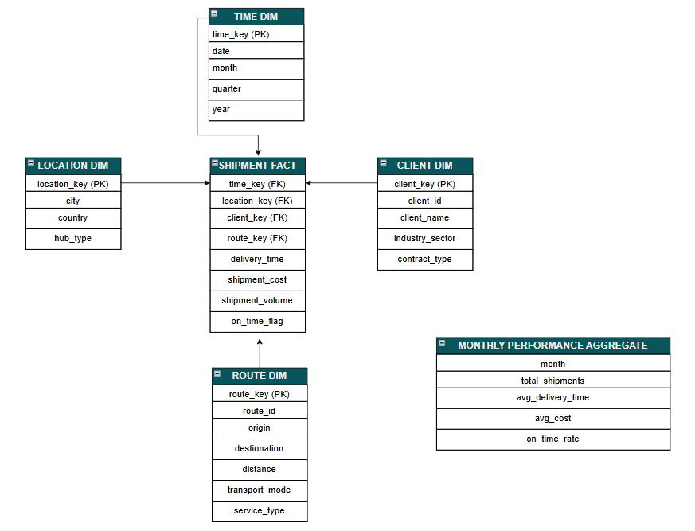
Figure 4: Star Schema for DHL Data Warehouse Design (adapted from Kimball [1])
As shown in Figure 4, the star schema organises data into a central fact table and multiple dimension tables to support efficient analysis.
The Shipment Fact table is linked to several dimension tables that provide context for the data. Each dimension is designed based on DHL’s logistics activities.
The Time Dimension includes attributes such as date, month, quarter and year. This allows managers to analyse trends over time, such as monthly delivery performance or seasonal demand patterns.
The Location Dimension includes information about hubs such as Daventry, Heathrow, Glasgow (Eurocentral), Rotterdam, Lyon and Düsseldorf. It also includes attributes such as city, country and hub type. This dimension allows DHL to compare performance across different locations and regions.
The Client Dimension stores data about customers, including a surrogate key (client_key) and a business identifier (client_id) from operational systems, as well as client name, industry sector and contract type. The surrogate key is used for internal data warehouse processing, while the client_id represents the original identifier from source systems. This structure supports the analysis of customer behaviour and profitability. For example, managers can compare high-value clients with standard contract clients.
The Route Dimension includes a business route ID, distance, transport mode and service type. This dimension is important for analysing delivery efficiency and identifying optimal transport strategies.
In addition to these core dimensions, the schema also includes master data and metadata across the organisation [5]. Master data includes stable entities such as clients and vehicles. Metadata includes service types, delivery categories and transport modes. This ensures that the data is consistent and standardised across the organisation.
The design can also support aggregate tables, such as monthly delivery performance summaries. These tables store pre-calculated metrics and improve query performance. For example, managers can quickly analyse average delivery time per month without scanning all detailed records.
This star schema design supports fast and simple queries because it reduces the need for complex joins. According to Kimball and Ross [1], dimensional models improve query performance and make data easier to understand.
In practice, this schema allows DHL managers to analyse key business questions. They can compare delivery performance between Daventry and Lyon, evaluate route efficiency, analyse client profitability and monitor service levels. This supports better decision-making across operations, finance and sales.
In conclusion, the proposed star schema provides a clear and efficient structure for DHL’s data warehouse. It integrates data from multiple sources and supports both detailed and aggregated analysis, helping DHL improve performance and strategic planning.

2.3 Data Marts and Schema

Data marts are subsets of the data warehouse designed to support specific business functions. In DHL, different departments require different types of information, so separate data marts can be created based on the star schema designed in the previous section. According to Kimball and Ross [1], data marts provide focused access to relevant data and improve query performance.
An Operations Data Mart supports the managing director and focuses on logistics performance. It is structured as a simplified star schema based on the Shipment Fact table, with dimensions such as Time, Location and Route. It includes measures such as delivery time, shipment volume and on-time performance. This allows managers to compare performance across hubs such as Daventry, Lyon and Rotterdam and identify operational bottlenecks.
A Finance Data Mart supports the finance director and focuses on cost and profitability. It uses a subset of the central schema, including the Shipment Fact table and dimensions such as Client and Location. It also includes aggregated data, such as monthly cost and revenue summaries. In addition, it can analyse cost per shipment by transport mode and compare profitability between hubs, for example the Heathrow pharmaceutical hub and the Lyon fresh produce hub.
A Sales Data Mart supports the sales and marketing director and focuses on customer activity and service performance. It is based on the Client dimension and the Shipment Fact table, combined with metadata such as service type and contract type. It includes measures such as shipment volume per client and SLA performance. For example, managers can analyse on-time delivery rates by client industry sector, such as retail, automotive and life sciences.
All data marts are built from the same central data warehouse, ensuring consistency while providing simplified and relevant views for each department [2].

2.4 ETL Plan

The ETL process extracts data from source systems, transforms it, and loads it into the star schema tables. This process ensures that data is clean, consistent and ready for analysis. Below is a simplified plan for DHL's main tables. As shown in Table 1, data is extracted from multiple source systems, transformed, and then loaded into the data warehouse.
Table | Source System | Transformations
Shipment Fact | TMS (delivery times), WMS (volumes), Financial (costs) | Join keys, calculate on_time_flag, remove duplicates, integrate data from multiple sources
Client Dimension | OMS, Client Data Systems | Clean names, standardise industry sectors, enrich with contract type
Location Dimension | WMS, TMS, External | Standardise hub names (Daventry, Heathrow, Glasgow, Rotterdam, Lyon, Düsseldorf), add hub type and country
Route Dimension | TMS | Clean route IDs, standardise transport modes, calculate distance, classify transport mode
Time Dimension | Generated | Create date records, add month, quarter, year attributes
Monthly Aggregate | Shipment Fact | Group by month, calculate totals, averages and on-time rate
Table 1: Simplified ETL Plan for DHL Data Warehouse
The ETL process runs during off-peak hours (2:00–4:00 AM) using read-only CDC to avoid disrupting operations [1]. This ensures that operational systems continue to function normally while providing reliable and updated data for analysis.

2.5 Data Quality and Governance

Data quality is very important for reliable decision-making in DHL’s data warehouse. During ETL, the data needs to be accurate, complete and consistent. For example, hub names should be standardised across locations such as Daventry, Lyon and Rotterdam. Errors and duplicate records should be removed to improve data quality.
Data governance ensures that data is used safely and correctly. Access should be limited to authorised users only, especially when working with sensitive customer contracts and shipment information. In addition, DHL must follow regulations such as GDPR when handling client data across the UK and Europe. Regular monitoring, validation rules and data quality controls help maintain data quality over time [2].

Conclusion

This report explained how a data warehouse can help DHL improve its operations and decision-making. It showed the difference between OLTP systems and data warehouses, and presented a clear architecture, star schema design and ETL plan. The use of data marts allows different managers to access the information they need in a simple and efficient way.
Integrating data from multiple systems helps DHL gain a better understanding of its performance across hubs such as Daventry, Lyon and Rotterdam. This supports faster decision-making, improved operational efficiency and better customer service. It also provides a consistent and reliable data environment that supports strategic planning, data-driven decision-making and long-term business growth.
The proposed solution aligns with modern data warehousing best practices and supports scalable and efficient analytics for DHL.

References

[1] | R. Kimball and M. Ross, The Kimball Group Reader: Relentlessly Practical Tools for Data Warehousing and Business Intelligence, Indianapolis, IN: Wiley, 2016.
[2] | W. H. Inmon, Building the Data Warehouse, New York, NY: Wiley, 2005.
[3] | S. Chaudhuri and U. Dayal, “An overview of data warehousing and OLAP technology,” ACM SIGMOD Record, vol. 26, no. 1, pp. 65-74, 1997.
[4] | Microsoft, “Data warehousing and analytics architecture,” 2023. [Online]. Available: https://learn.microsoft.com/en-us/azure/architecture/example-scenario/data/data-warehouse. [Accessed 21 March 2026].
[5] | M. Golfarelli and S. Rizzi, Data Warehouse Design: Modern Principles and Methodologies, New York: McGraw-Hill, 2009.
[6] | P. Bhatia, Data mining and data warehousing : principles and practical techniques, Cambridge: Cambridge University Press, 2019.

