7004 Assignment- Researching the Learning

Research Question- How might we enhance student behaviour using positive reinforcement methods in the classroom?

Aim and Purpose of the Research/ Research Context
In this essay I will be covering the topic where I aim to research the question on how might we enhance student behaviour using positive reinforcement methods in the classroom. The context of the school that this research activity took place in is an English medium comprehensive school with 1,200 mixed gendered students from the ages of 11-18. To do this I observed several lessons in this school and then gave a questionnaire out to the teachers to answer to find out their opinion on using positive reinforcement in the classroom to help with behaviour or whether they do not think this would work in this school in particular which was the purpose of this essay. The observation that took place was in a business studies lesson with a class of 24 mixed gendered students aged 18 in an average classroom. Students and teachers were aware that I was present to observe and the questionnaire for the teachers was optional and they could withdraw at any time.
Due to the placement school that I observed lessons in I saw how behaviour can be an issue in the classroom and students can be seen to be disruptive in lessons. Therefore, I was interested in this topic because it was a way to find out teaching methods that would work when I do my lessons and it would also help me reach my intended learning outcomes by focusing on ways to better students behaviours in my lessons and get the students to do the work that was set. This is why I chose to do my essay on this topic. From observing I was able to see if students needed the teachers to use negative reinforcement more such as detentions to help the teacher with control and getting the students to finish the work as using negative reinforcement gives the teachers authority and is a way of getting students to listen. I aim on doing questionnaires on the teachers to see their personal opinion on using positive reinforcement to help enhance the behaviour in the classroom and their opinion on what methods works best for them which then will help to improve my understanding for when I come do to my lesson in this particular school.
The objective of this essay is to look into the research on the topic of how positive reinforcement helps to enhance the behaviour in a classroom, this is because I find it interesting to see how different students react differently to feedback whether it is positive or negative. From these objectives I can identify the strategies that I find work the best and overall, how reinforcement will link to student behaviour. I chose to do observations and questionnaires as a way of finding out information for my essay as the observation was a way of seeing how positive reinforcement was being used in action and I was able to see whether it worked or not in certain classes with certain pupils. I also chose to do a questionnaire on teachers because I got to find out their personal opinions on positive reinforcement and find out what they work best in lessons to help with behaviour. These research methods can be seen to be broad, and they are relevant when undertaking varied processed ways to do the research (Zohrabi, 2013). By applying these methods to my research, it has helped me as a researcher to be able to achieve the qualitative and quantitative data from my answers (Zohrabi, 2013). This links to my professional learning passport because I have undertaken wider reading and research findings to support my research throughout this essay.
Overview of Relevant Literature
Positive reinforcement can be defined as “the presentation of a reward immediately following a desired behaviour intended to make that behaviour more likely to occur in the future” (Diedrich, 2010, p.6). It is a method that can be seen to be used in many schools and classrooms by teachers to help with the behaviour of students and to help them to reach their intended learning outcomes by the end of their lessons. This is because classroom management can be seen to be one of the biggest issues for teachers in schools and it can have a negative effect on their lessons due to the pupils being unsettled (Gunaretnam, 2021). As a result of this, the lesson can be disrupted and more importantly the time for the children’s education is lost (Gunaretnam, 2021).
Therefore, to help prevent and limit this from happening, pupils can have particular forms of positive reinforcement in place in the lessons which will help the outcome for both the teachers and students to be seen as a bonus because it can be more efficient in having that pupil to achieve copying their behaviour that resulted in the positive reinforcement to be used (Morin, 2017). This shows with teachers using positive reinforcement in their lessons then it could be a way to inspire the pupils to carry on doing good performances and work with the aim of encouraging the students behaviour to become a consistent routine and used more often in the classroom (Morin, 2017). These points of literature show how positive reinforcement can be linked to behaviour of the students and is an example of this type of teaching method being an advantage to the teacher’s and their lessons as students are being encouraged to repeat their good behaviour and performance which is a technique to motivate the students to do well which is the main aim of using positive reinforcement.
Types of Positive Reinforcement used in Schools.
“The purpose of positive reinforcement always, and has been to have students actively contributing and learning in the classroom” (Rumfola, L., 2017. P.9). From doing research into positive reinforcement, Gunaretnam, 2021 has stated how there are techniques of positive reinforcement used by many teachers to help with the behaviour of students in the classroom (Gunaretnam, 2021). Sensory, natural, material, generalized and social reinforcements are all examples of how teachers can use positive reinforcement to help to enhance the wanted actions from students which will help with the overall behaviour of the pupils, and it will help to better their educational accomplishments (Gunaretnam, 2021). This shows how there are many ways that teachers can use positive reinforcement and not all teachers might use the same technique, it might depend on the class they have and the students that are involved. This is because not everyone reacts the same and different strategies work on different people.
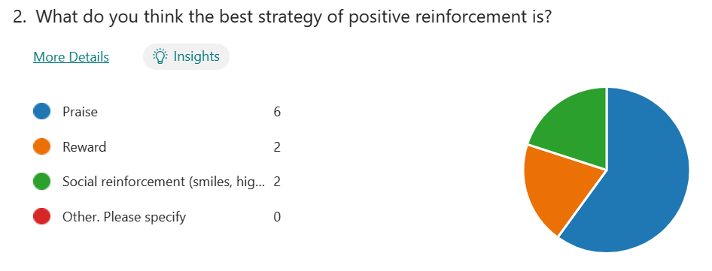
A common method of positive reinforcement used in classrooms by teachers is praise. This is a way to connect positive reinforcement to the students by voicing the praise across to them which is important in using the method of praise correctly which then impacts the education and performance actions of the pupil (Stringer & Hurt, 1981). Praise can be seen to motivate the students; this is because if a student sees another student being praised in the lesson for their work, then it becomes target for that pupil because they will want to achieve the same praise (Rumfola, 2017). This is an example of how it motivates the students and encourages them to work hard in the lessons, due to them wanting a result in positive reinforcement from the teacher. Using praise as a technique of reinforcement, teachers can indicates for the behaviour and performance of the pupil to be strengthened (Sutherland et al., 2000).

This is from my results of my questionnaire where it shows how praise is used 60% of the time as a method of positive reinforcement in my placement school.
How Does Positive Reinforcement link to Behaviour?
There are two types of reinforcement used by teachers to help with the behaviour of students, positive and negative. However, the use of positive reinforcement is the most advised form of reinforcement due to it increasing the pupils good actions and performances in lessons instead of negative reinforcement, for example detentions (Ningsih, 2016). This research shows how positive reinforcement utilizes good behaviour from students and motivates them to do well in their work whereas negative reinforcement might make the pupils behaviour worse.
From doing research into these literatures, it helped to form my research questions because it was relevant in my placement school due to behaviour being an issue. This has helped me with my own study and preparing for lessons because in a school where behaviour is disruptive in lessons, positive reinforcement does not always work. However, it is the most commonly used and when used correctly it has the better outcome with students. This shows that there are strengths to my research because it has relevance to my personal experience and from many literatures, they give a balanced argument on the topic but overall, all academics strongly agree that methods of positive reinforcement are the most beneficial in schools to help with behaviour in the classroom. This why I chose to do my research on this topic and to find out for myself what works best for me and in my placement school.
Explanation of Case Study
Case study research can be seen to concentrate on the case and the researchers involved in case study research may develop several of the origins of the data collection, for example these can involve interviews and observations (Mills et al., 2009). During my case study, I chose to use the methods of observations and questionnaires. Case study research features the key variances between qualitative and quantitative case study research through investigation and understanding (Mills et al., 2009). To discover the distinctiveness and the exclusivity of a particular case is the main reason people carry out case studies, the case studies might involve an individual, a teaching space, an establishment, a plan, a strategy and an organisation (Simons, 2009). In my case study the participants included a 24 mixed gendered class of students at the aged 18. These students and the teachers were aware that I was observing the lesson and when I gave the teachers my questionnaire on positive reinforcement, I informed them that it was optional and that they can withdraw at any time. From research into BERA (2018) it made this clear that as a researcher I should inform and remind the people involved that they could withdraw at any time whether they have reason or not, it is also important to note that the contributors can withdraw at any stage that they would like as it is their right (BERA, 2018).
Using case study research has some strengths for researchers for example, it allows them to achieve an integrated outlook on a particular experience or sequence of occurrences which have happened and therefore it can offer an all-encompassing perspective due to there being several examples that confirm with the case that are being utilised (Noor, 2008). I found this when I undertook my case study research as what I observed agreed with the results of the questionnaires done by the teachers.
However, there are some limitations involved with case studies. For example, we cannot forget about other descriptions of the case that is happening (Simon & Goes, 2013). It is also said that it can be uncertain about the simplifications of the results of the case study (Simon & Goes, 2013). This is why I decided to use more than one source of evidence when carrying out my case study, to help make the results more accurate and specific to my research.
The methods I used for my case study research included qualitative and quantitative questionnaires due to asking a combination of questions to the teachers. This gave me the results of their personal opinions and experiences and helped me to collect their perceptions and experiences relating to the behaviour which happens in lessons and if they thought positive reinforcement methods are efficient. Also, by observing the lessons in my placement school, I was able to see positive reinforcement in action in other classes dealing with different teachers and pupils. From this I could see whether positive reinforcement was class dependent, and this method involves directly observing classroom dynamics, the way the teachers interact with students and the student behaviours in the lessons.
Research Methods
The research methods that I chose to include in my research study on the use of positive reinforcement to enhance the behaviour of students were observations and questionnaires.
Firstly, I chose observations because I was able to sit in lessons and see the environment of each classroom and I was also able to see the interaction with the teacher and students. The first point I made when I was observing was where I was going to position myself in the classroom. This is because typically, your aim is to be in a place where you can oversee the majority of the class activities with minimal interference (Adelman et al.,2003). Therefore, I decided to position myself at the back and side of the classroom, so I was still able to see the students. Then from this observation it helped me to see whether the students react well to positive reinforcement and help them to repeat the good performance or whether behaviour was still an issue and therefore, I could see whether teachers had to bring in techniques of negative reinforcement. When we refer to “observation” it expends beyond simple observation and the description of classroom activities it involves making an effort to acknowledge and understand our own emotions and reactions to these events (Adelman et al.,2003). The observation method that I undertook can be seen as structured and unstructured, this is because it was focused and specific on looking at positive reinforcement being used in the lesson and how it affects the behaviour of students but it also open ended and natural because I could also see if negative reinforcement was used or what other techniques the teacher used. Therefore, I was being critical in my observation with looking at the positive and negative attributes to positive reinforcement.
However, there are limitations with this research method as it might change the way people act in the classroom if they know that they are being observed so therefore, behaviour might not be an issue as much as it would if the class was not being observed. Also, it could make the teacher nervous knowing that they are being observed so might not perform as well as they would have liked. Another limitation of using observations is in relation to their reliability, this is because considering the significance of reliability in assessing teachers and inadequacy of single-lesson visits in ensuring reliability, we explore three evaluation methods that are aimed at improving the reliability of classroom observations (Van der Lans et al., 2016). This is why I chose to do more than one observation of positive reinforcement in action to help make my results more reliable.
As another method of research, I used questionnaires. I chose to do questionnaires on the teachers in the school to gather information on their personal opinion on whether they think that positive reinforcement enhances behaviour or whether they need to use negative reinforcement in their lessons. Questionnaires can be seen as a research method and they are composed of a set of inquiries and are typically self-administered (Slattery et al.,2011). These inquiries cover specific topics of interest or items considered admirable of investigation and can be distributed using several methods such as mail, the internet, or verbally reading them to participants for them to answer (Slattery et al.,2011). I chose to use questionnaires as my research method because they can be qualitative or quantitative with the questions being open-ended or close-ended. I looked at the likert scale as a type of question at the end of my questionnaire so that the teachers could rate their overall opinion on how effective using positive reinforcement to help the behaviour of students is in the classroom. The method of a likert scale is a psychometric tool which contains various categories which allows the participants answering the questionnaire to express their opinion, attitudes or the way they feel towards a certain matter which concerns a specific issue (Nemoto & Beglar, 2014).
However, the limitations of questionnaires are that the participants might not be honest with their answers and might just answer to help favour the results the questioner asks so therefore they can be seen as bias. The significant drawback of questionnaires, especially when questionnaires are done online, is the unavoidable self-selection bias (Dewaele, 2018). Therefore, I made my questionnaire anonymous so that the teachers could be honest, and their answers would be kept confidential. I did this to help with the reliability of the questionnaire and my results as the teachers could give their personal opinion on the topic of how positive reinforcement helps the behaviour of students in the classroom. Also, another limitation of questionnaires is that they can be seen as boring so respondents might just answer the questions quickly without thinking of the answer just to get it done, this would have a negative impact on the results because it would make them a waste as there are not true.
This shows how it is important to look into the research methods in detail before deciding which method to use for the particular research study. To do this you need to be critical in the decision by highlighting the strengths and limitations of each study. This is how I found that observations and questionnaires were the methods that I was going to use due to them being the best way for me to get to my results on finding out whether positive reinforcement helps with the behaviour of the students in the classroom. I also had to take age into consideration with my research because all participants were over 18 and I had the teachers as participants for the questionnaire, therefore I had to make sure it covered everything that I wanted answered in a way that the teachers were comfortable with answering. I also had to make sure that they were aware that answers would not be shared to prevent them being biased with their answers.
Data Presentation and Analysis Methods
The primary focus on the rationality and trustworthiness of data collection tools is to improve the overall quality of the data (Lynnette et al., 2021). It is important for the data to be high quality to help the overall results that have been found from doing research methods are accurate.
Having written text serves as the primary means of interpreting discoveries, describing patterns and when offering details of the background of the data (In & Lee, 2017). Conversely, a table is the most appropriate way to present data when it includes specific data points, encompassing both quantitative and qualitative material (In & Lee, 2017).
Firstly, we could use graphs to present the data. Graphs can be seen to symbolise larger amounts of the material that is being measured and this is done through increased area, lines which are lengthier, or greater presence of another visual element; greater representation along a visual scale signifies a higher quantity of the represented object (Kosslyn, 1989). Secondly, we could use charts to present the data. Charts can be seen to delineate specific relationships between distinct objects (Kosslyn, 1989). They possess an inherent organization where entities must be visibly connected to one another through lines or relative positions, serving as connections (Kosslyn, 1989). There are other methods of how to present numerical data such as maps and diagrams however, I think that graphs and charts work best with the results of my research study.
With presenting qualitative data, it can be seen to be very different from quantitative data. This is because the information that is gathered from doing the qualitative research can be reformulated utilizing various patterns or frameworks, which then can provide structure, cohesion, and flow to the written presentation (Sandelowski, 1998). It is a fact that qualitative data is time consuming, and it is important to present it right in a language which is understandable for all participants if they are different ages. This type of presentation of data includes detail of the results and if the time and effort has not gone into the presentation then the inadequate presentation can significantly impede readers' understanding of the results or even deter their interest in engaging with the discoveries (Sandelowski, 1998).
To help with the reliability, credibility and confirmability of my data, I made sure to use more than one source of data in my results. For example, more than one observation and questionnaire. This helped my results to be more accurate and trustworthy which resulted in an overall advantage for my findings.
Ethical Issues and Considerations
With having ethical conduct in research, it entails careful consideration of the appropriate course of action in various circumstances, it extends beyond merely refraining from unethical behaviour or complying with rules (McGinn, 2015). It is important to see ethical decision-making evolves into a continually reflective and repeated process, where the situation and problems are continuously evaluated and reevaluated as they unfold (BERA, 2018). Therefore, ethical evaluation procedures should, be executed with a mindset that is receptive and broad (BERA, 2018).
It is important to have informed consent off the research participants which is where they are provided with accurate and adequate information to assist them in determining whether they want to participate in the research or not. These participants must be able to freely choose whether to give or deny their informed consent, without any influence or pressure (Behi & Nolan, 1995). In my ethics form I stated any risk assessments that could happen and what I would do to prevent them from happening which shows action into ethical considerations.

Anonymity and confidentiality
Throughout this research task it was important to keep the anonymity of teachers and students confidential to respect their privacy and I made all participants aware of this. This is because the participants involved in the research might prefer not to have their personal information, viewpoints, and beliefs disclosed and accessible to the public (Behi & Nolan, 1995). Therefore, the data that is gathered must be handled, deposited, utilized and revealed in a manner that safeguards the privacy of the individual, ensuring that only the individual is aware of the origin (Behi & Nolan, 1995). It is important that if a participant is under the age of 18 then a parent or guardian needs to sign a consent form before they take part in the research activity. I also have completed an ethics form stating all the considerations that need to be thought of.
An example of the anonymity used in my research case study is that teachers do not have to use their names when answering my questionnaire. I chose to do this because anonymity can be seen as a significant consideration in many social research endeavours, commonly regarded as vital and it is a fundamental principle aimed at safeguarding research contributors from potential harm that could happen and therefore removing the names of these contributors is frequently depicted as the routine technical procedure aimed at achieving this objective (Moore, 2012).
An example of the confidentially used in my research case study is that everyone will be stored on my personal computer with all contributors having their own unique identifier which will be kept safely in a password protected folder. Also, data will be removed straight away after results or if any participant requested this before, which means it will be removed from results. It was important I followed this because failing to uphold the commitment to confidentiality can also jeopardize the safety and welfare of each of the members involved in the research (McClelland & Bruckert, 2022).
Results/ Analysis of Results/ Discussion
As a result of my observations, I was able to see positive reinforcement in action and the outcome it had on the students that were involved. I discovered that it worked in the majority of lessons and students felt that they had a relationship with the teacher when they were being praised so therefore it got them to repeat the good performance. This helped with the overall behaviour of the class, and it resulted in there being less disruption from the students. I saw the teachers using praise as a method of positive reinforcement and also rewards such as positive points on the system. From observing these lessons, I could see how it was important that when the positive reinforcement was being used in lessons that it has to be meaningful and depending upon the desired behaviour to effectively encourage its recurrence.
From the questionnaires, I was able to see the opinion of teachers on positive reinforcement with how it affects the behaviour of students. Overall, from collecting the data from the questionnaires I was able to come to the result that positive reinforcement is the best method of bettering the behaviour of students because they will want to carry on getting the rewards and praise, so the behaviour is repeated. However, some teachers believed that it does not work for every class and can be dependent on the pupils. These were seen as anomaly results. For example, some students behaviour can be disruptive to the lesson that they need to use negative reinforcement such as detentions to get those students to do the work. This links to the classroom management and is dependent of the school and participants that are involved in this research study so therefore, results could be different if this research study was done elsewhere.
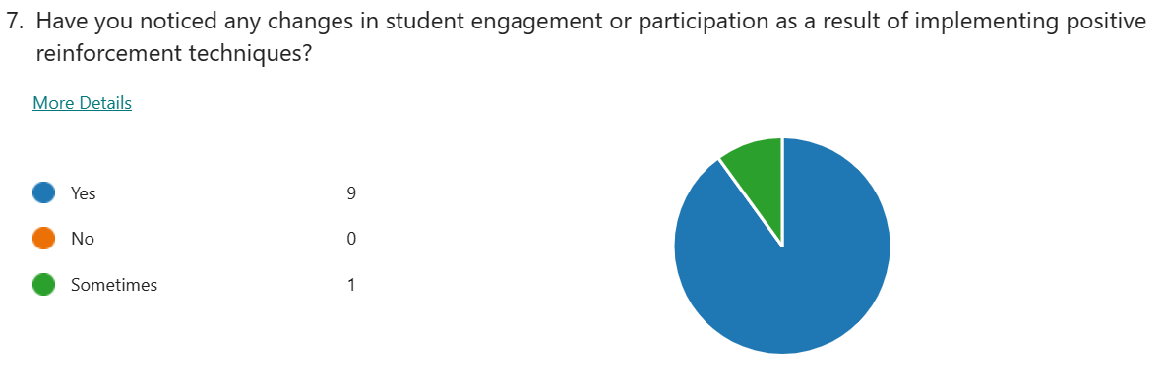
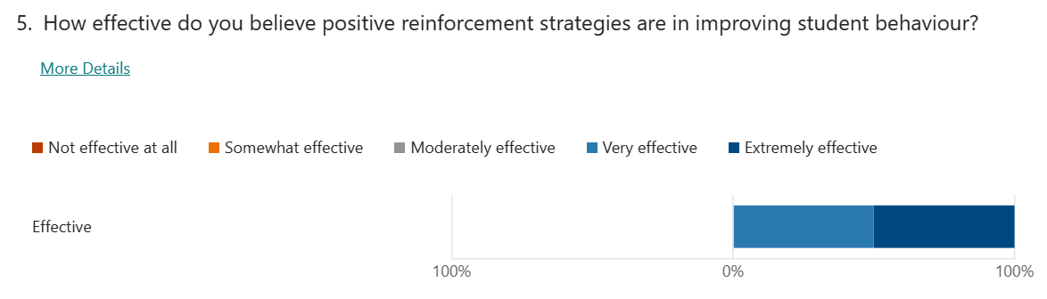
These are results from my questionnaire.

Conclusions and Recommendations
In conclusion, the research methods that I used for my research study were valid and reliable and carrying out the method more than once was crucial in helping me to get my accurate results. From these results I was able to critically examine the use of positive reinforcement to help the behaviour of students in the classroom and I was able to see that it is the best method for the majority of classes. This is because 90% of teachers see a difference in the students and from using the likert scale 100% think it is effective.
Overall, I agree with the results that I found when doing my research study and I think that the results are accurate and reliable. I found it interesting when going through the questionnaires to see the personal opinion of the teachers in my placement school and seeing what methods they think work best for the students behaviour. Also, the results that I found from my discoveries agrees with research and literature and is something that is important to look into before using the methods in my own lessons. From doing the research, I would not change anything that my placement school is doing to help with behaviour however, if negative reinforcement needs to be used then teachers should use it to help decrease the disruptiveness of students in their lessons.

Word count- 4,500

Reference List

McClelland, A. and Bruckert, C., 2022. ‘Ethics and Confidentiality: Reflections and Lessons Learned Post-Parent and Bruckert v R and Magnotta’, Canadian journal of law and society, 37(2), pp. 187–208. Available at: https://doi.org/10.1017/cls.2021.41.

Adelman, C., Adelman, C. and Walker, R., 2003. A guide to classroom observation. Routledge.

Behi, R. and Nolan, M., 1995. Ethical issues in research. British Journal of Nursing, 4(12), pp.712-716.

British Educational Research Association (BERA)., 2018. Ethical Guidelines for Educational Research, fourth edition, London.

Dewaele, J.M., 2018. Online questionnaires. The Palgrave handbook of applied linguistics research methodology, pp.269-286.

Diedrich, J.L., 2010. Motivating students using positive reinforcement (Doctoral dissertation, SUNY College at Brockport).

Gunaretnam, V., 2021. A Study on Increasing Positive Behaviors Using Positive Reinforcement Techniques. International Journal of Research and Innovation in Social Science, 5(7), p.22.

Helen Simons., 2009. Case Studt Research in Practice. Los Angles: SAGE Publications Ltd.

In, J. and Lee, S., 2017. Statistical data presentation. Korean journal of anesthesiology, 70(3), p.267.

Kosslyn, S.M., 1989. Understanding charts and graphs. Applied cognitive psychology, 3(3), pp.185-225.

Lynnette, R.A., Otara, A. and Otengah, P.W., 2021. Effectiveness Of School Principals’ Positive Reinforcement Approach On Management Of Students’ Discipline in Public Secondary Schools In Migori County. Kenya, 4(11), pp.17-43.

McGinn, M.K., 2015. Considering ethics for social science research. The SAGE handbook of research management, pp.153-172.

Mills, A.J., Durepos, G. and Wiebe, E. eds., 2009. Encyclopedia of case study research. Sage publications.

Moore, N., 2012. The politics and ethics of naming: questioning anonymisation in (archival) research. International Journal of Social Research Methodology, 15(4), pp.331-340.

Morin, D., 2017. The effects of inclusion and positive reinforcement within the classroom.

Nemoto, T. and Beglar, D., 2014, November. Likert-scale questionnaires. In JALT 2013 conference proceedings (pp. 1-8).

Ningsih, D.A.P.A., 2016. Developing Students' Positive Behaviour Through the Implementation of Positive Reinforcement in Efl Class. Journal of English Language Learning, 5(1), p.421948.

Noor, K.B.M., 2008. Case study: A strategic research methodology. American journal of applied sciences, 5(11), pp.1602-1604.

Rumfola, L., 2017. Positive reinforcement positively helps students in the classroom. Thesis, State University of New York. Retrieved on April 15, p.2019.

Sandelowski, M., 1998. Writing a good read: Strategies for re‐presenting qualitative data. Research in nursing & health, 21(4), pp.375-382.

Simon, M.K. and Goes, J., 2013. Scope, limitations, and delimitations.

Slattery, E.L., Voelker, C.C., Nussenbaum, B., Rich, J.T., Paniello, R.C. and Neely, J.G., 2011. A practical guide to surveys and questionnaires. Otolaryngology--Head and Neck Surgery, 144(6), pp.831-837.

Stringer, B.R. and Hurt, H.T., 1981. To Praise or Not to Praise: Factors to Consider before Utilizing Praise as a Reinforcing Device in the Classroom Communication Process.

Sutherland, K.S., Wehby, J.H. and Copeland, S.R., 2000. Effect of varying rates of behavior-specific praise on the on-task behavior of students with EBD. Journal of Emotional and Behavioral Disorders, 8(1), pp.2-8.

Van der Lans, R.M., van de Grift, W.J., van Veen, K. and Fokkens-Bruinsma, M., 2016. Once is not enough: Establishing reliability criteria for feedback and evaluation decisions based on classroom observations. Studies in Educational Evaluation, 50, pp.88-95.

Zohrabi, M., 2013. Mixed method research: Instruments, validity, reliability and reporting findings. Theory and practice in language studies, 3(2), p.254.

