The Harder Styles

Contents
The Harder Styles 1
Login & Register 2
Artists Database 5
Events Database 8

Login & Register

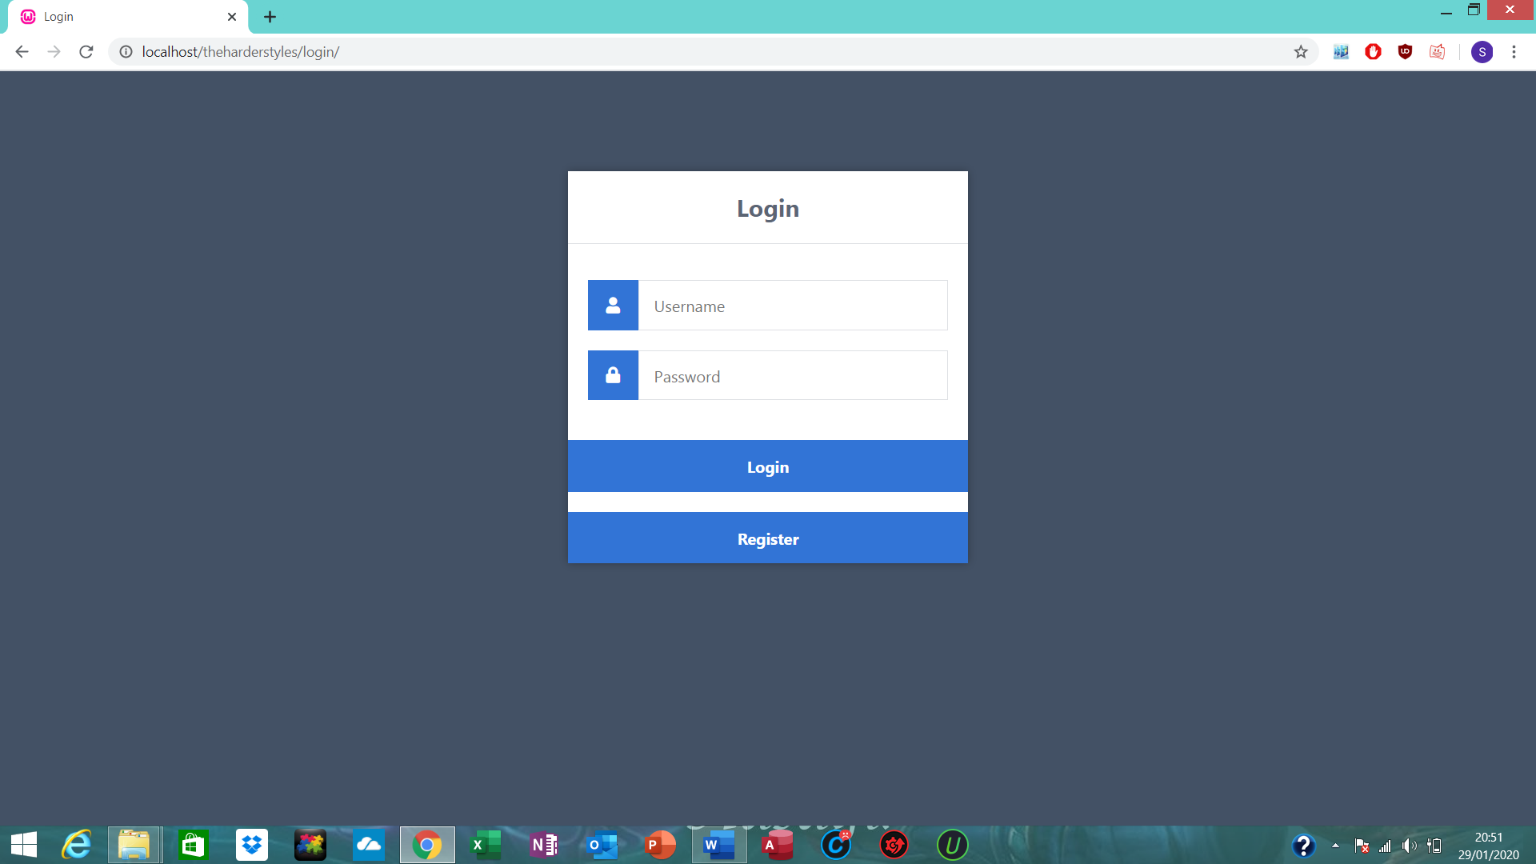

When you first go to my website using “localhost/theharderstyles”, it will take you to my login page.

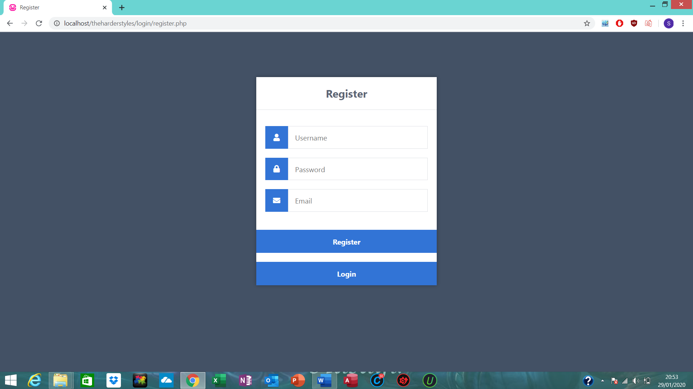
Clicking the register button will take you to my register page. You are able to create an account here that will allow you to access my website.

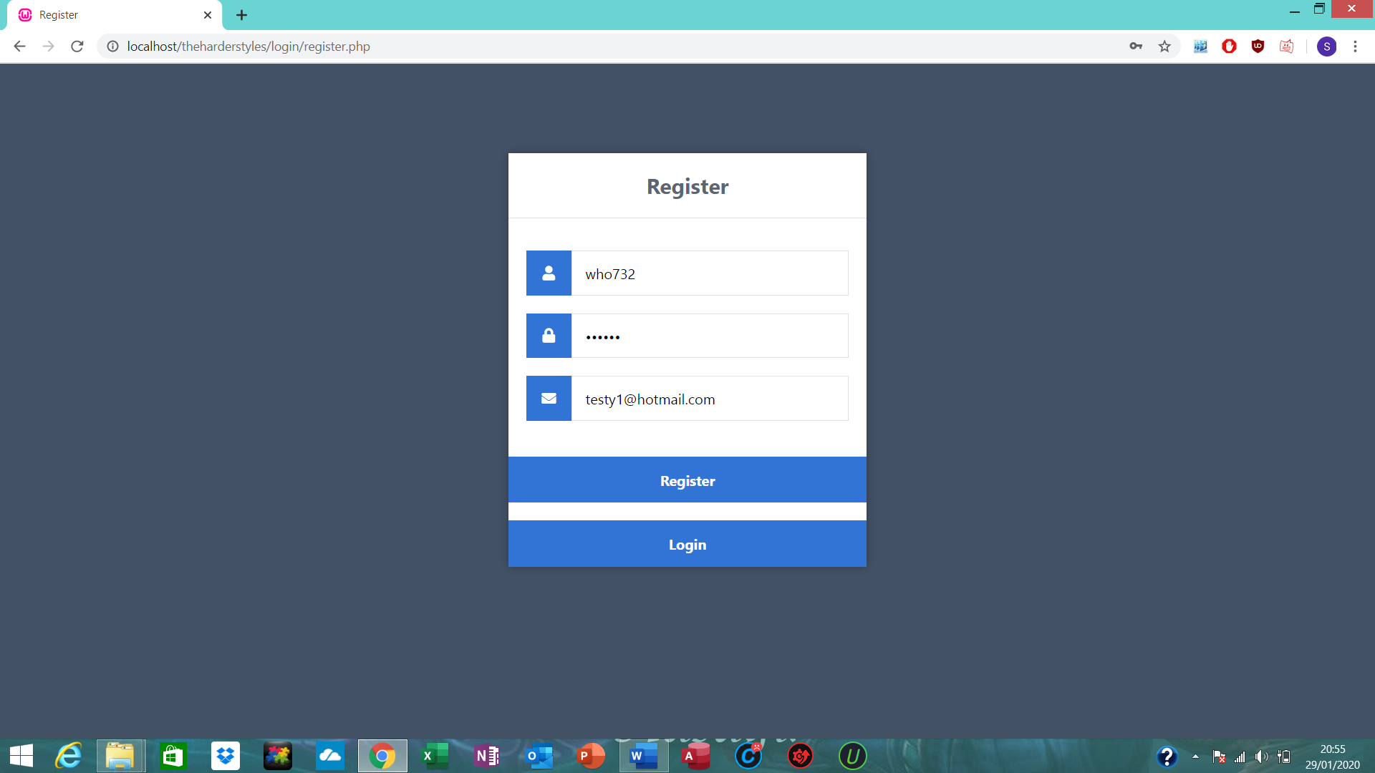
Creating an account.

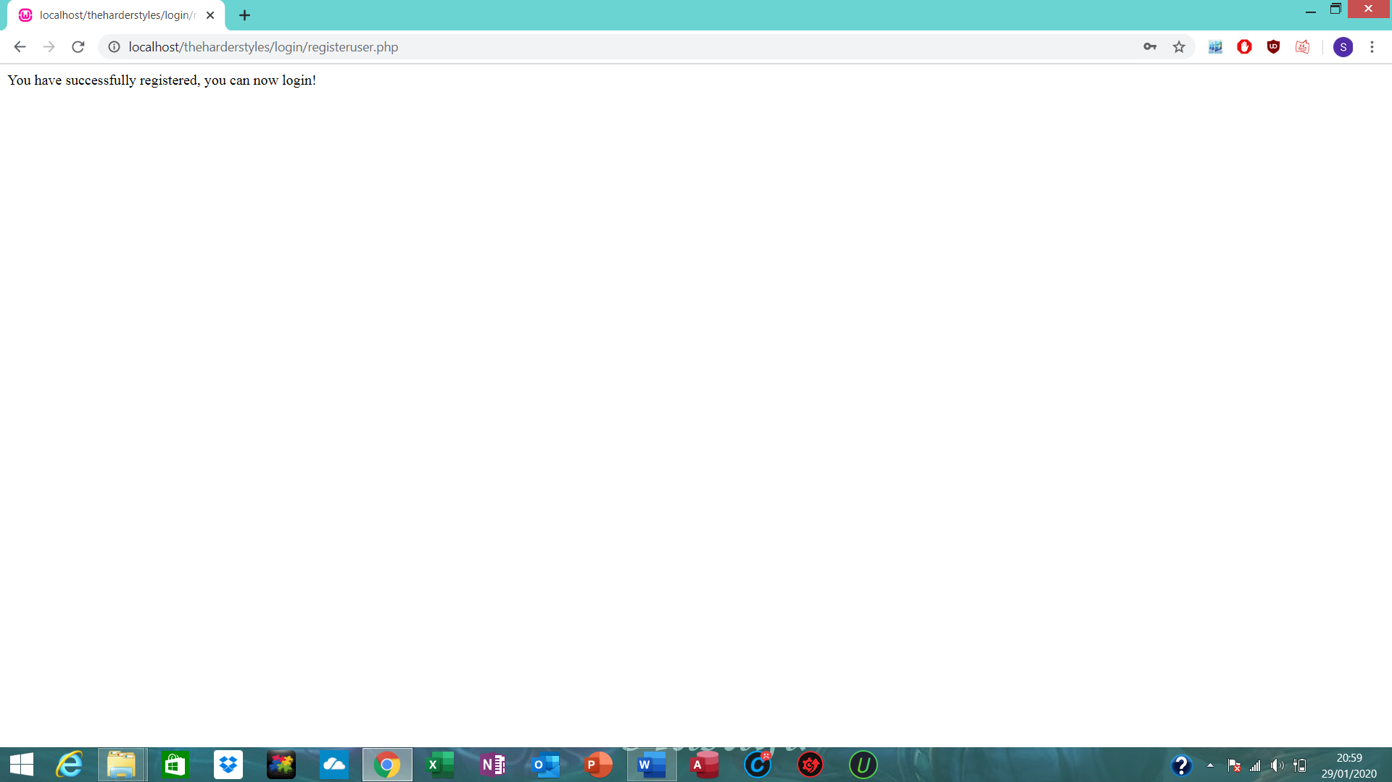

Account has been created.

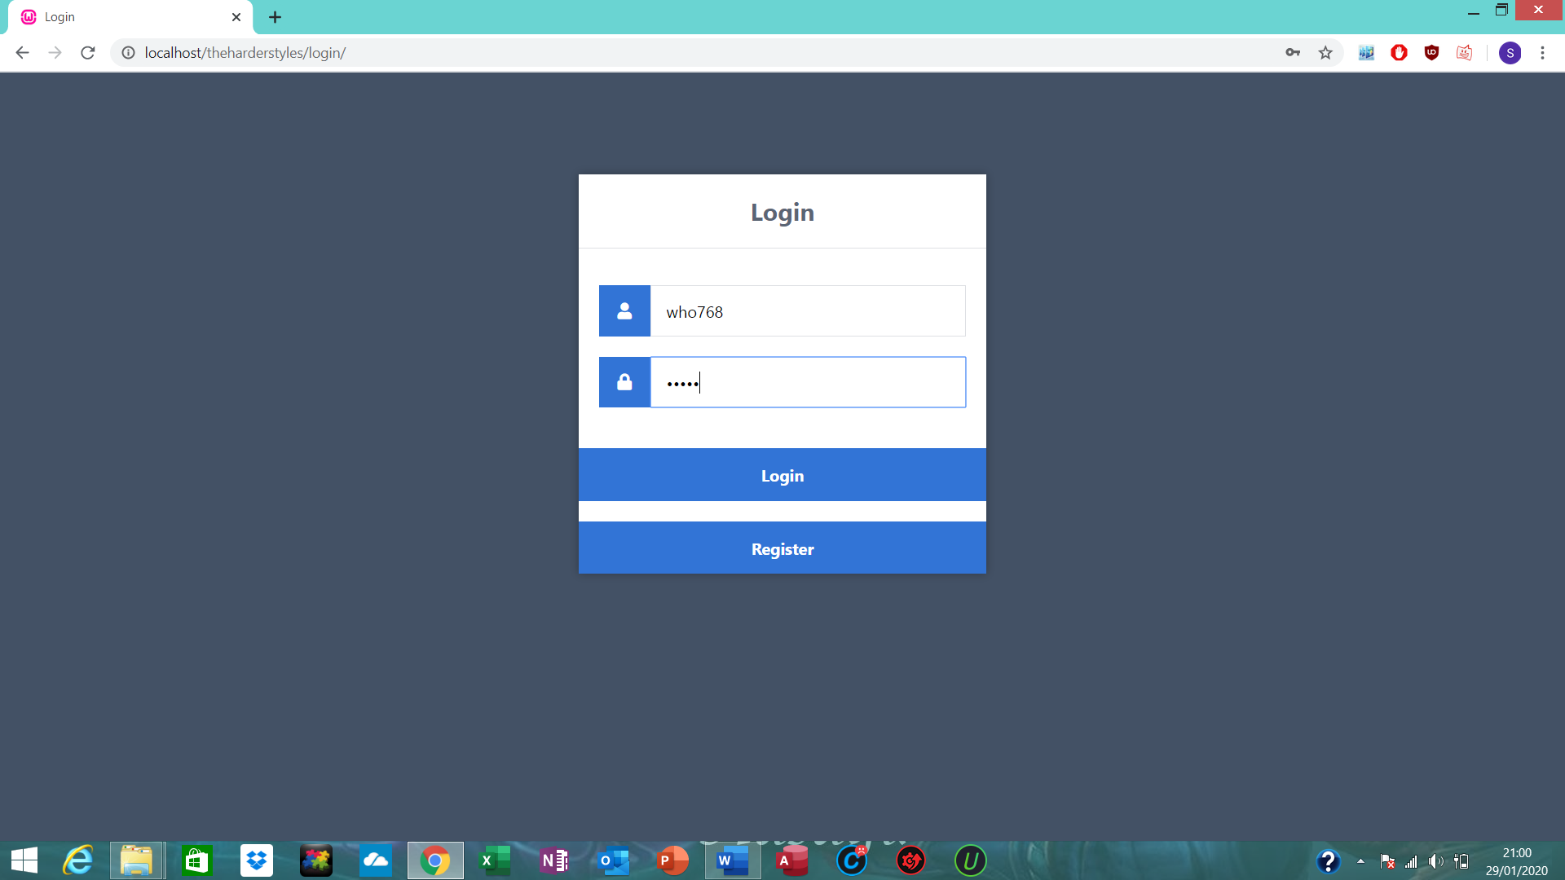
Logging in with admin account.

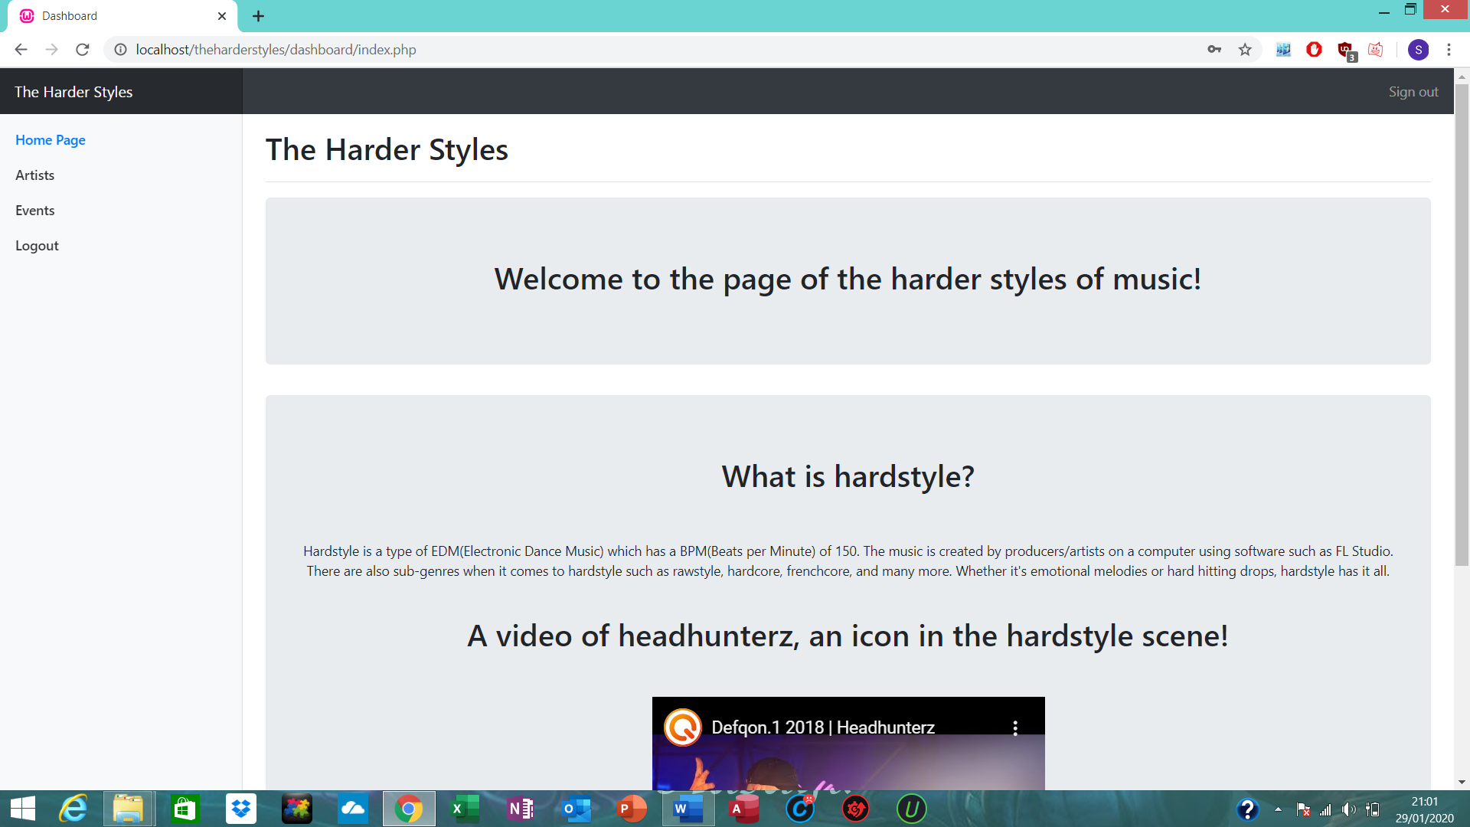

Takes you to the home page of my website.

Artists Database

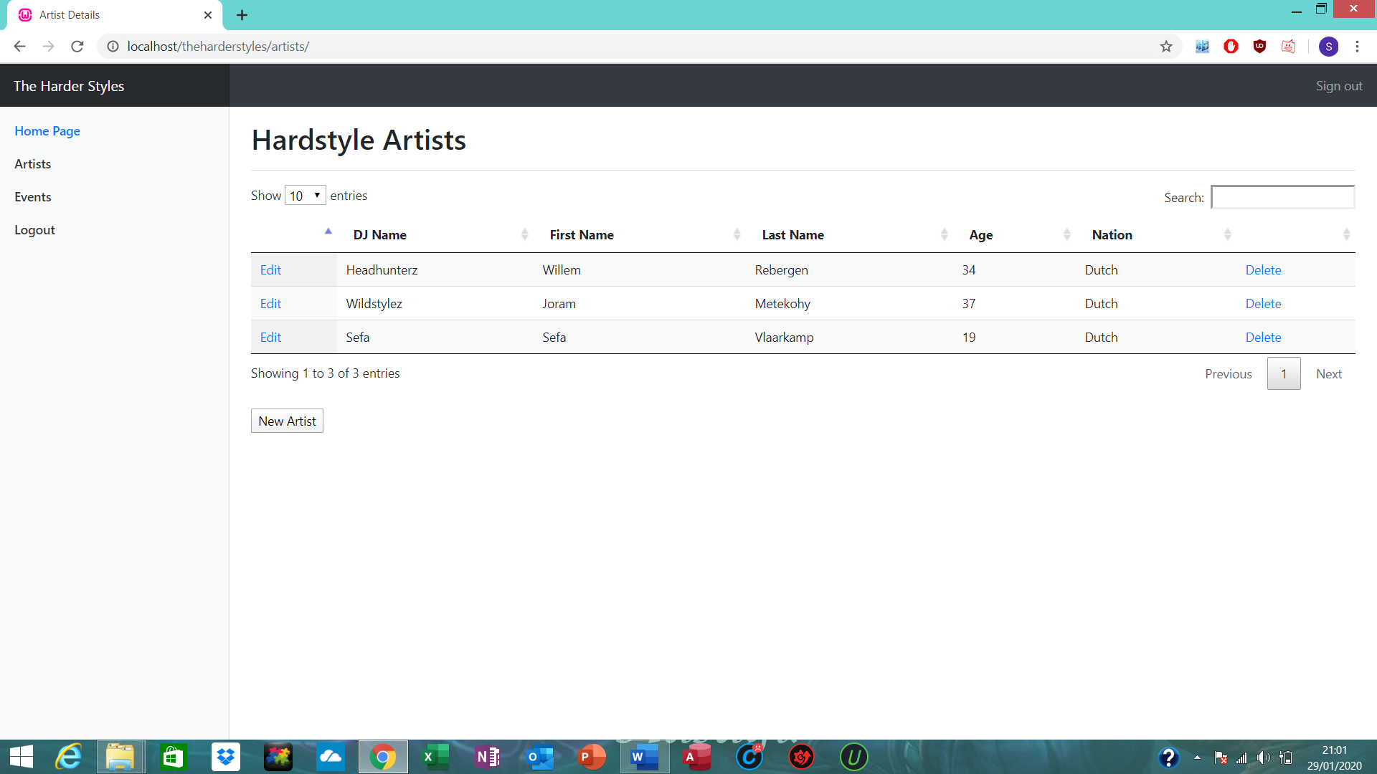
One of my databases displaying data about DJ artists.

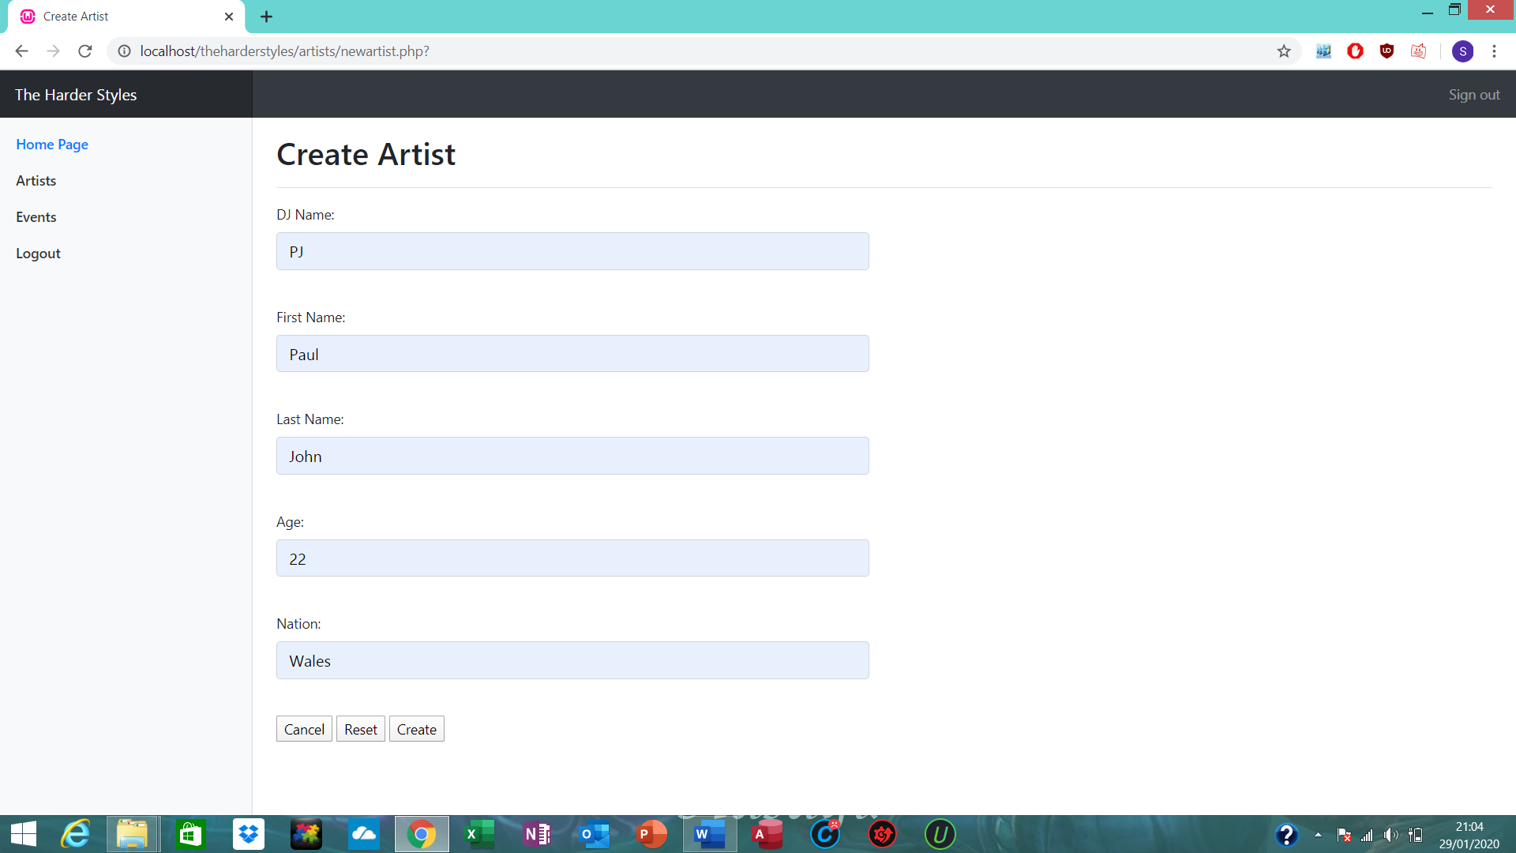
Creating an artist.

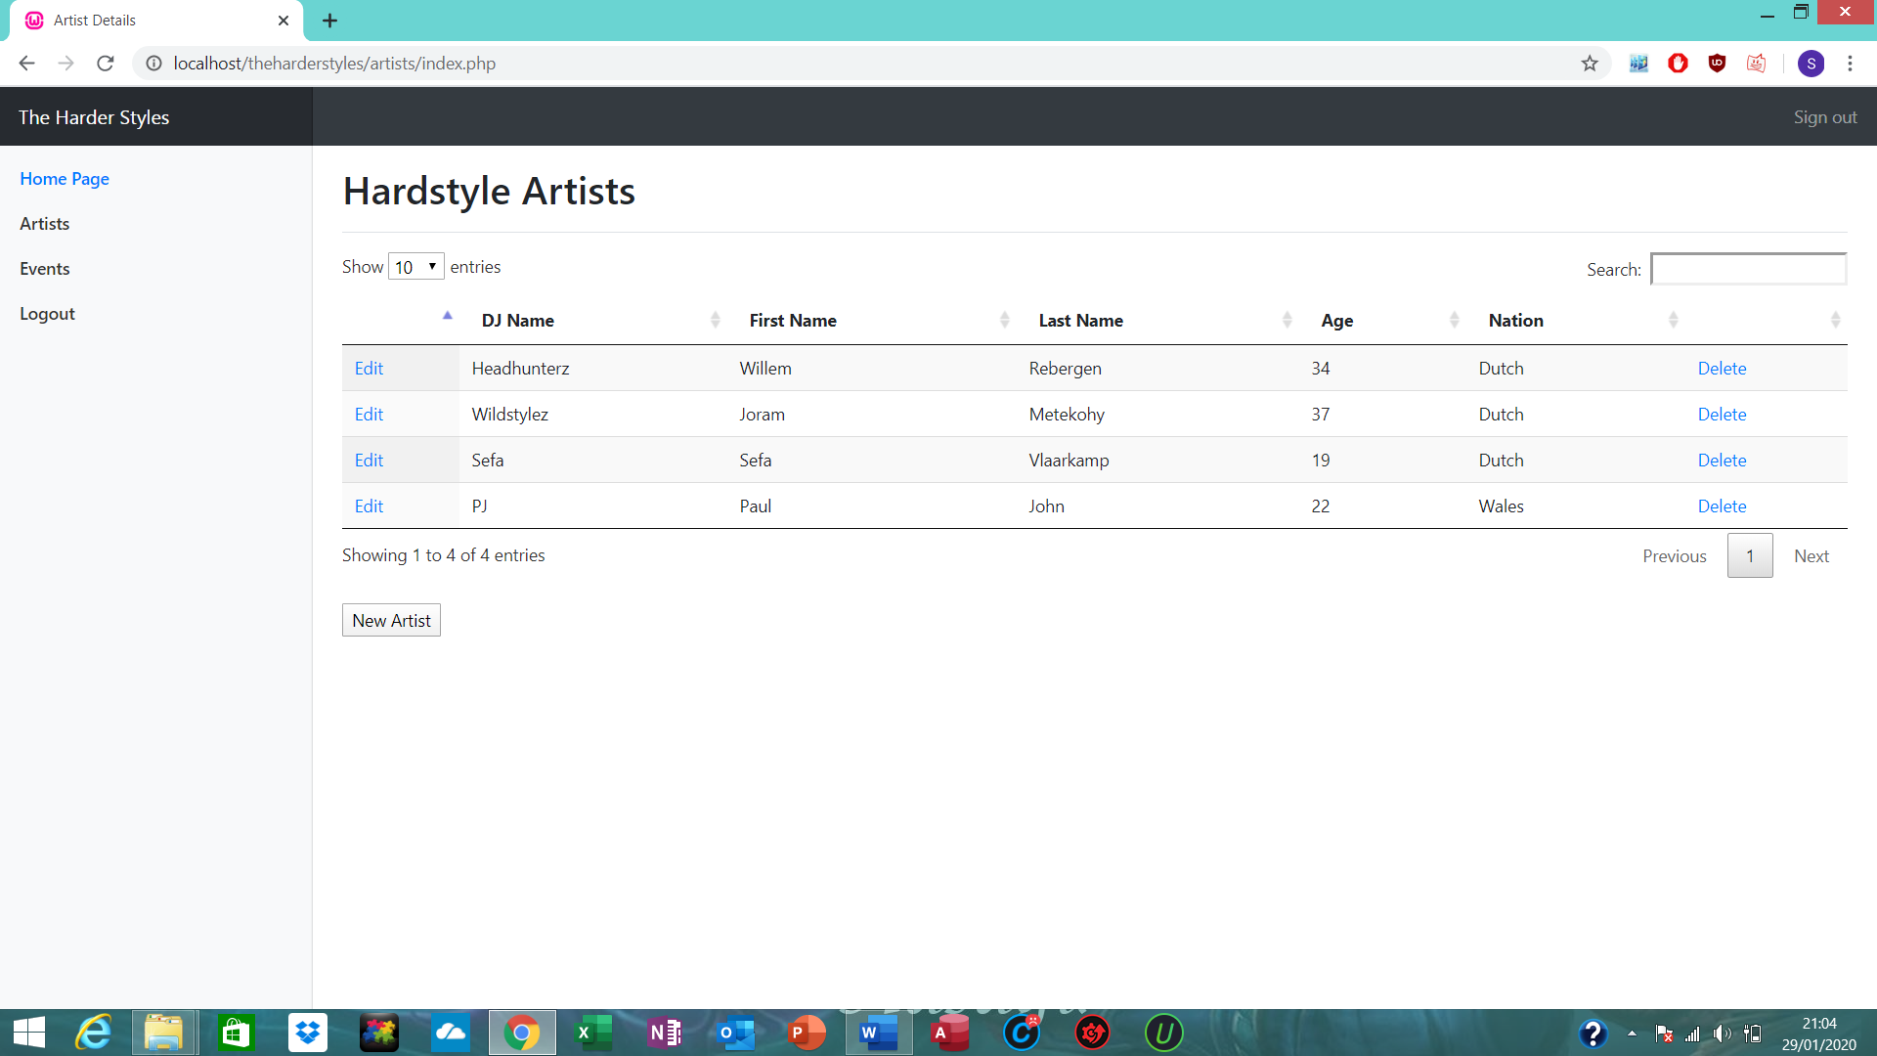
Artist now showing in database.

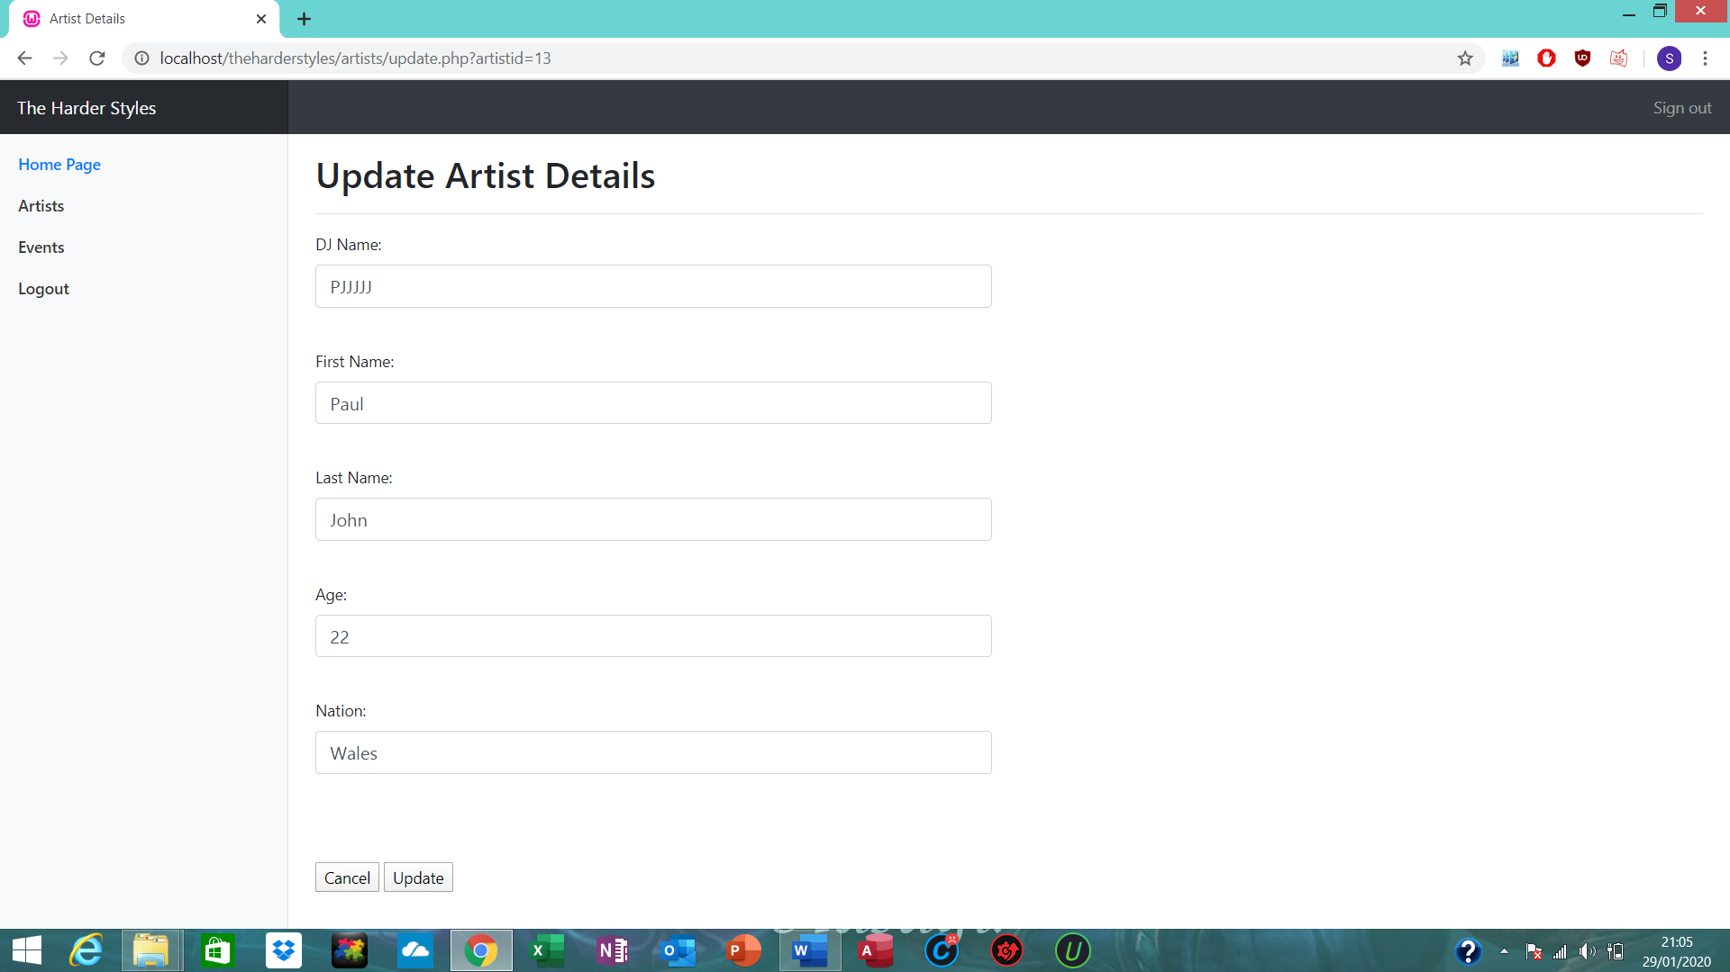
Editing Artist.

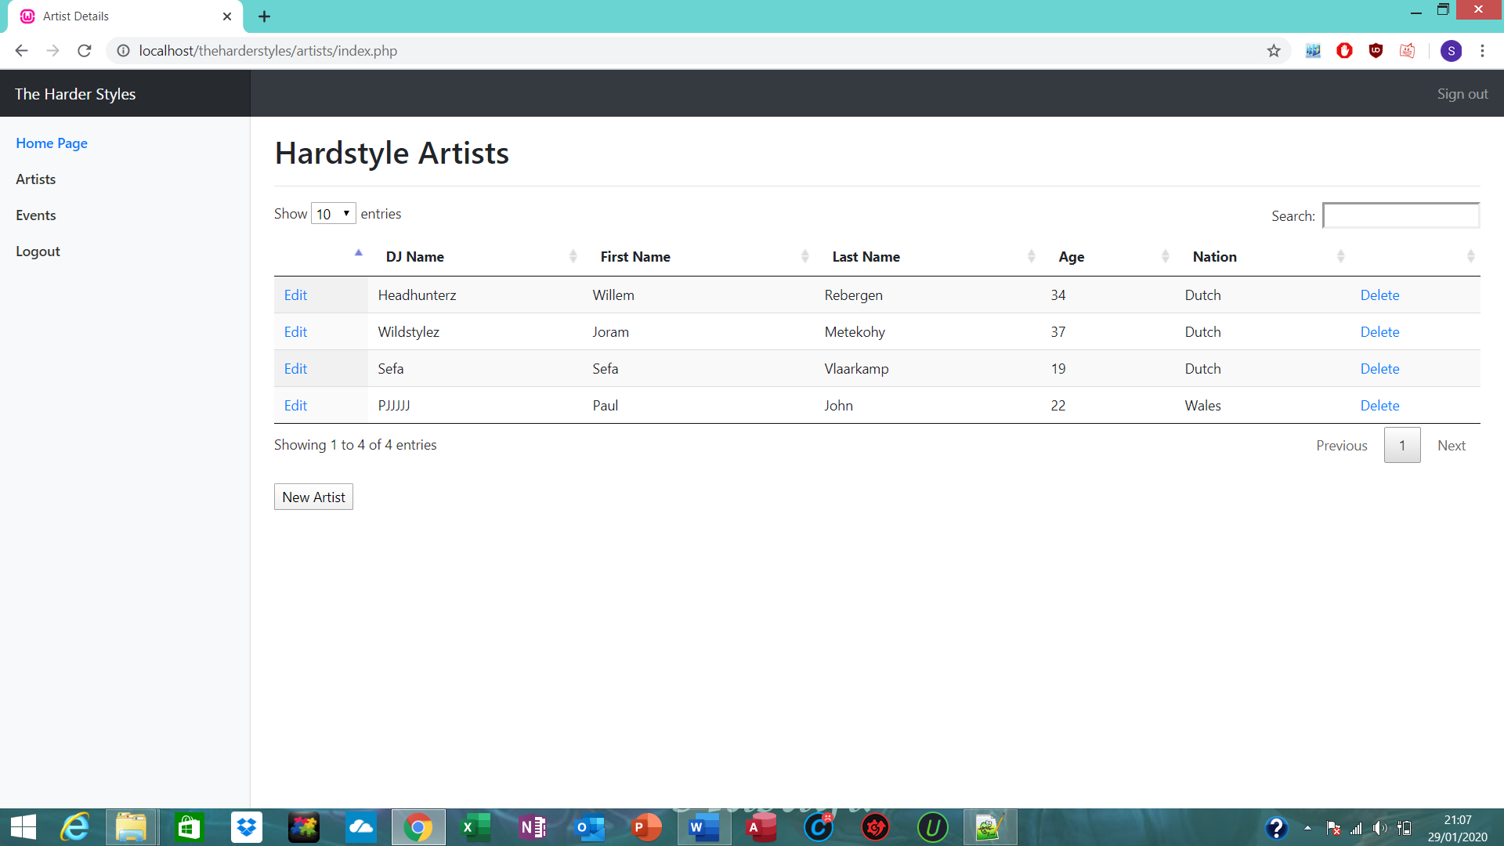
Artist edited.

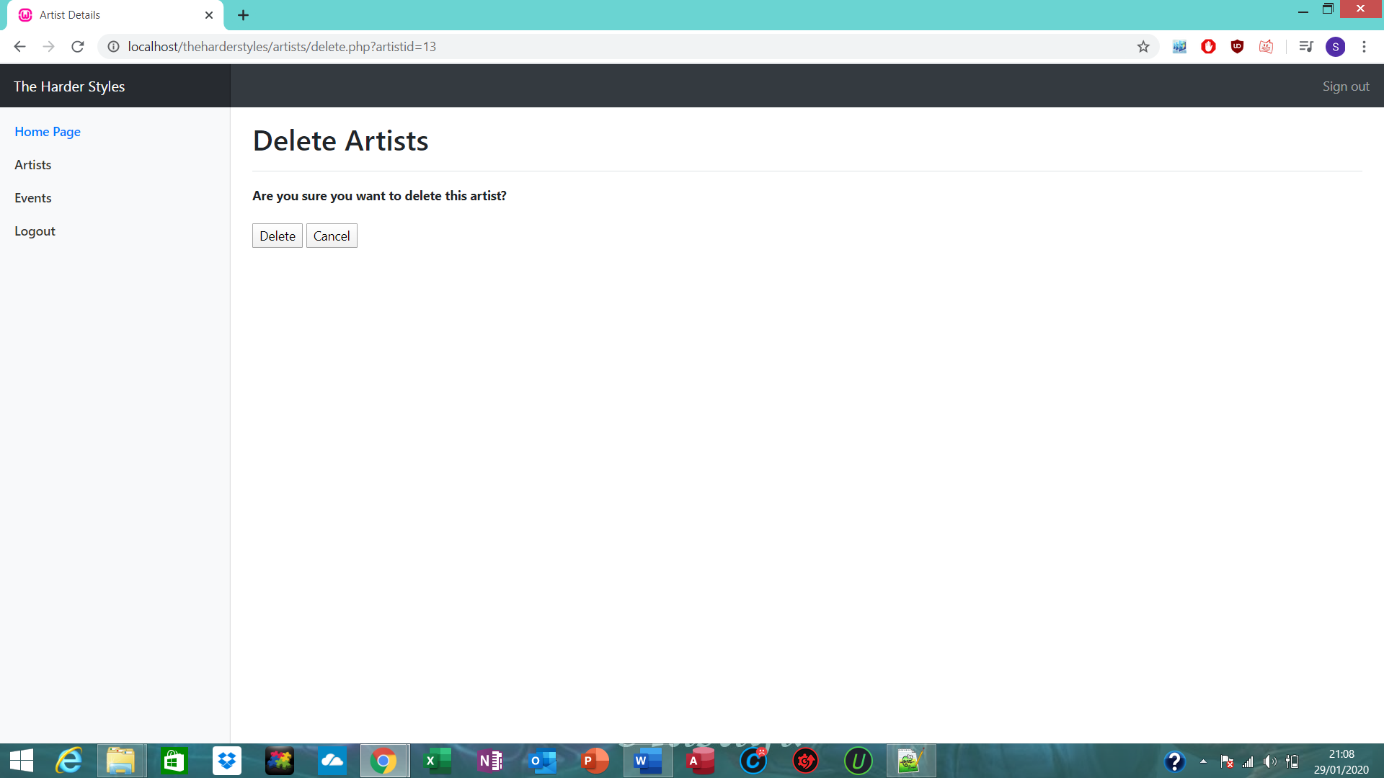
Deleting artist.

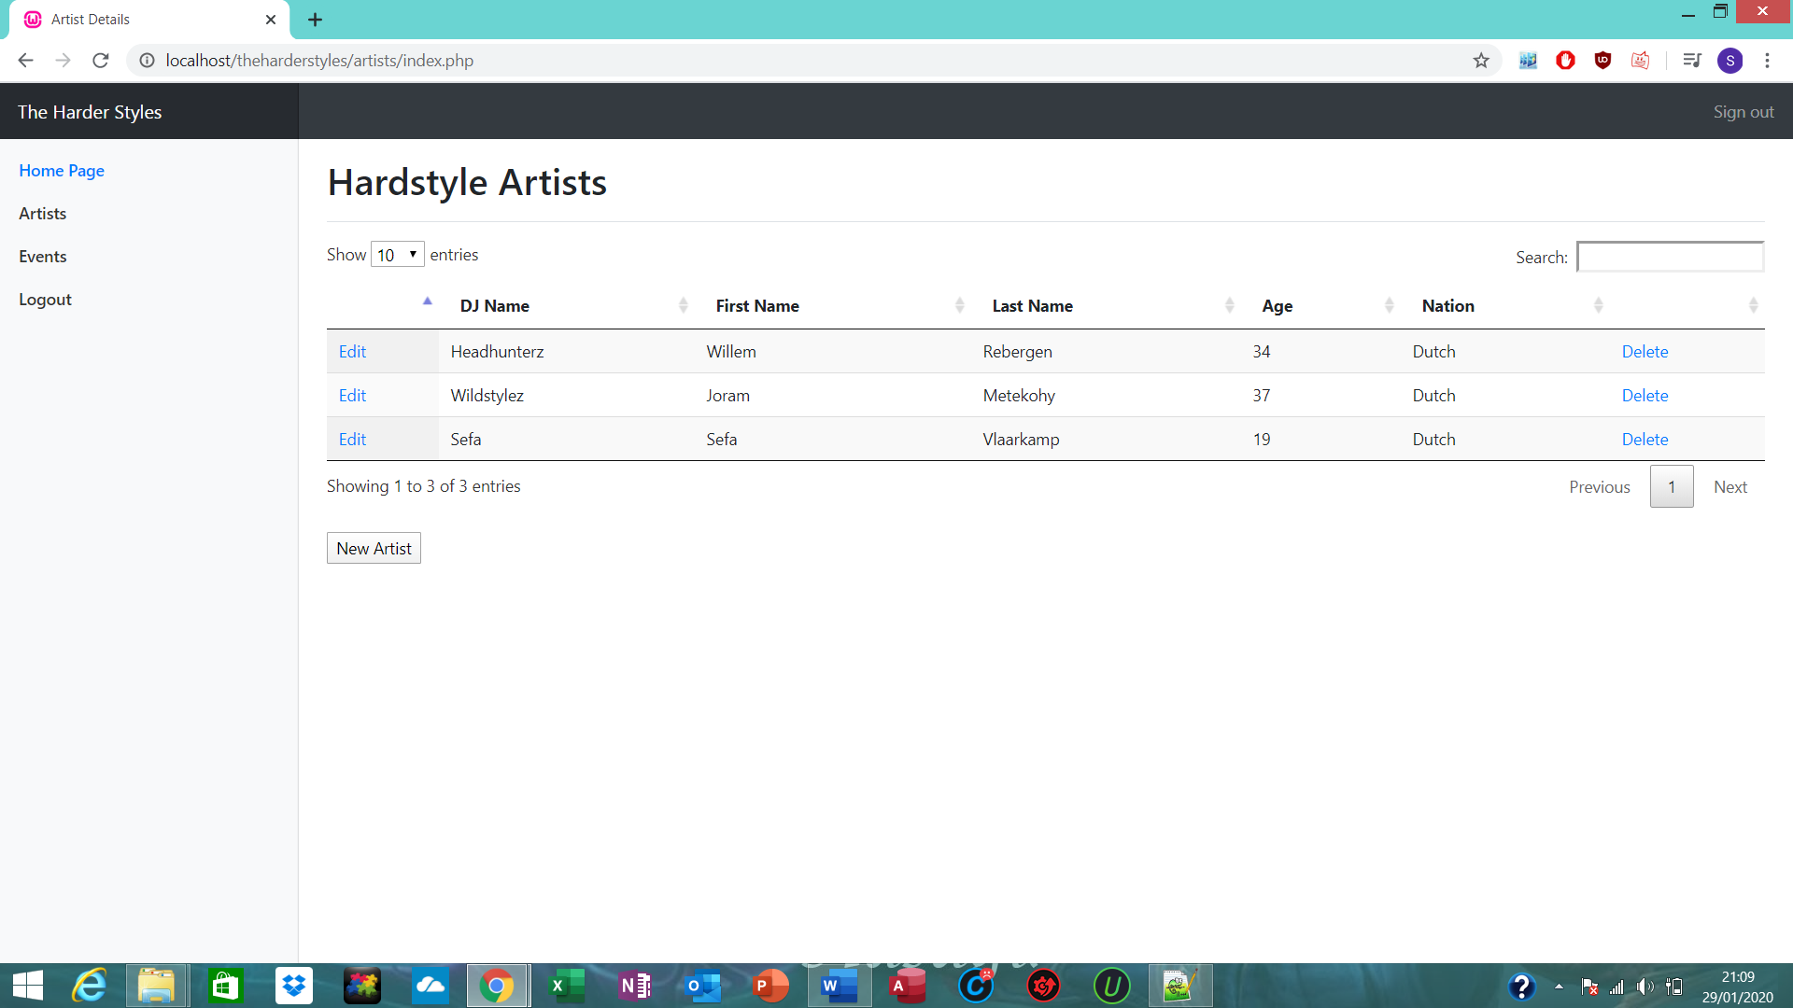
Artists deleted.

Events Database

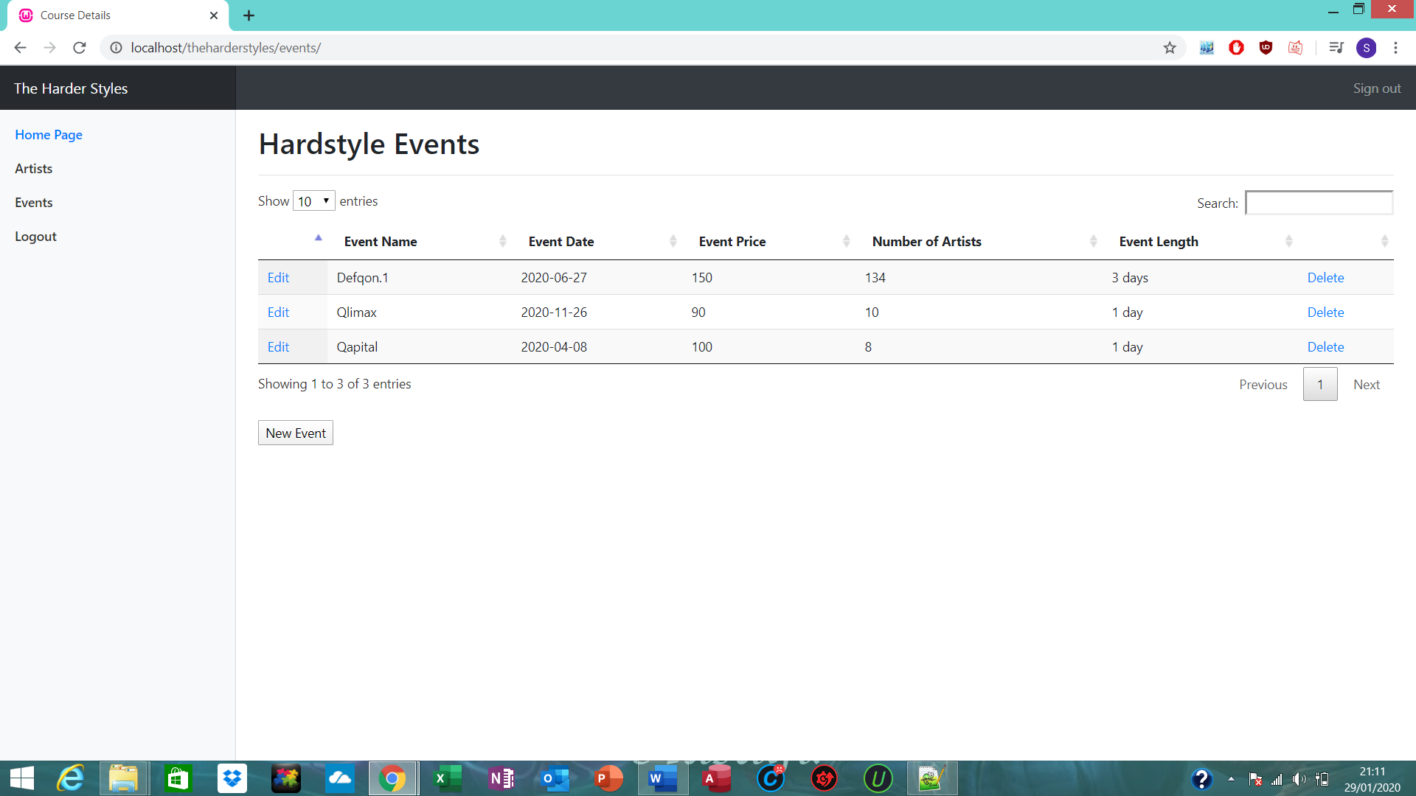
Events Database.

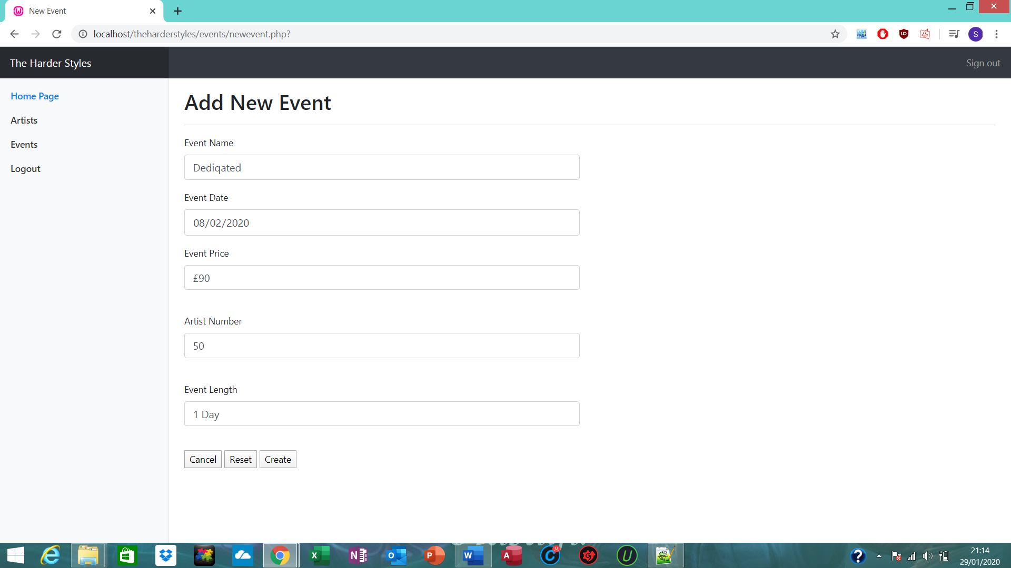
Creating event.

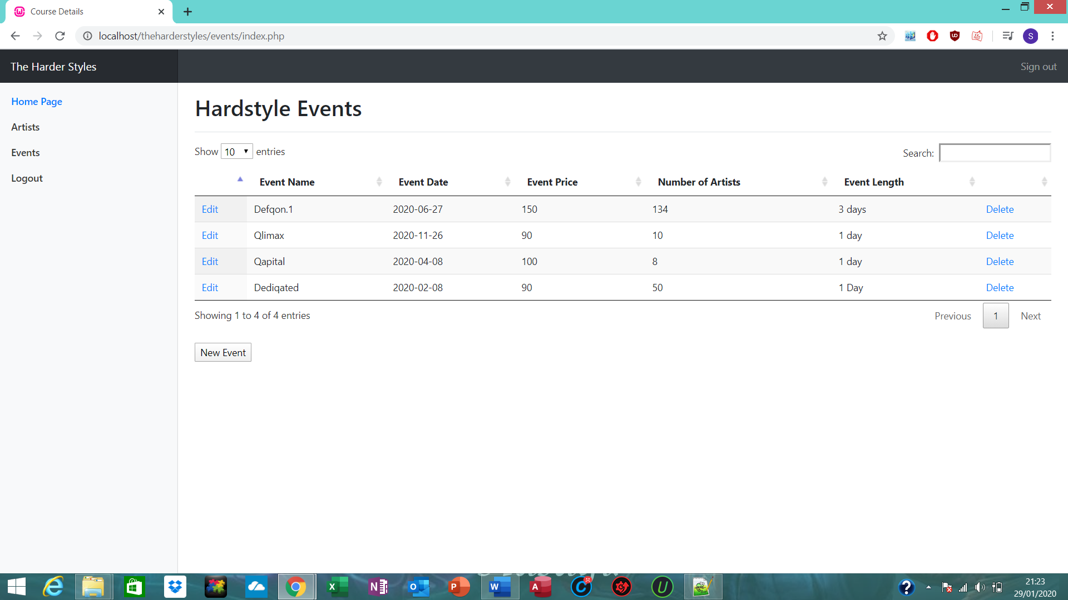

Event now displaying in database.

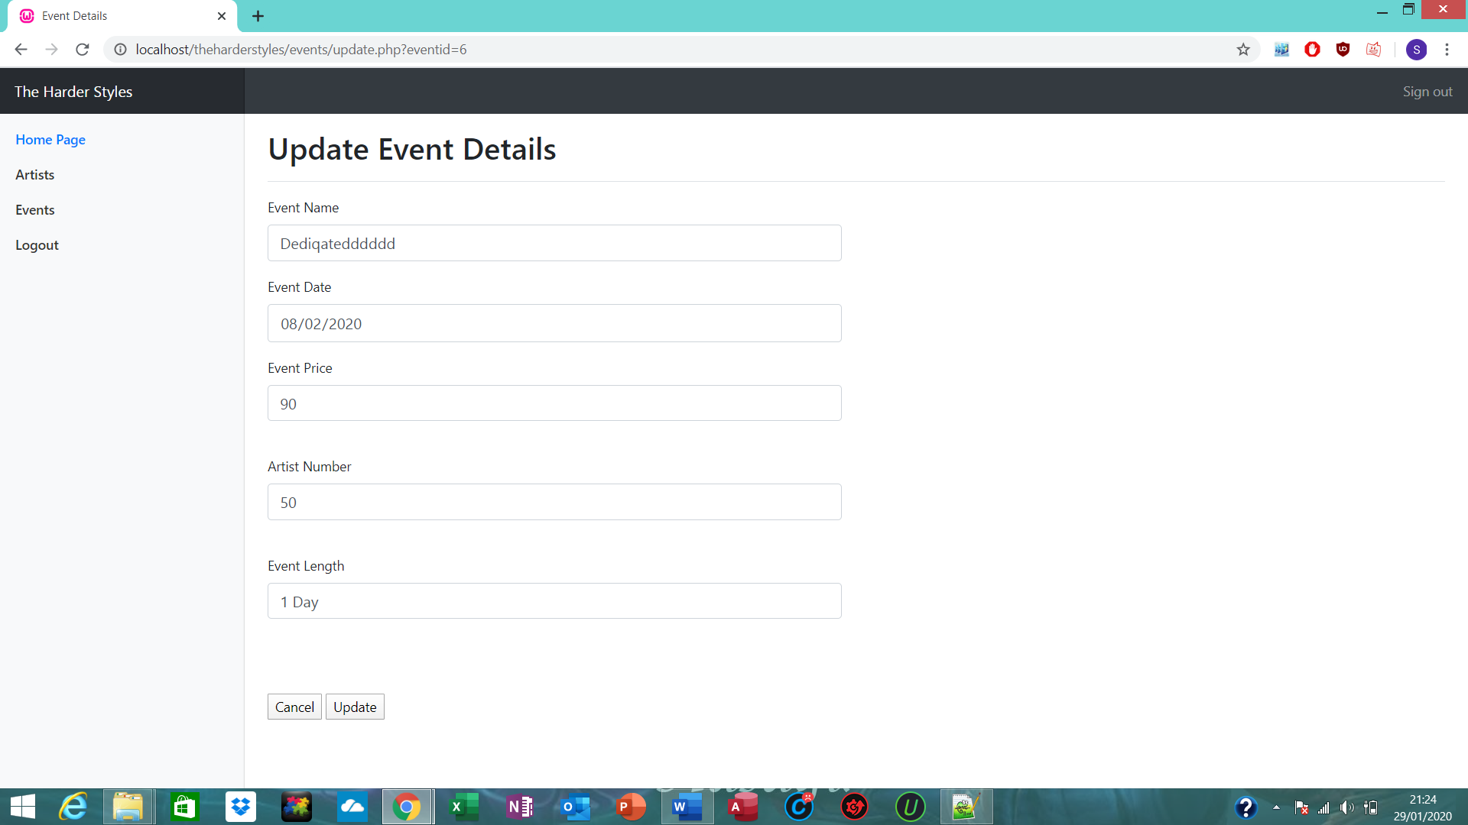
Editing event.

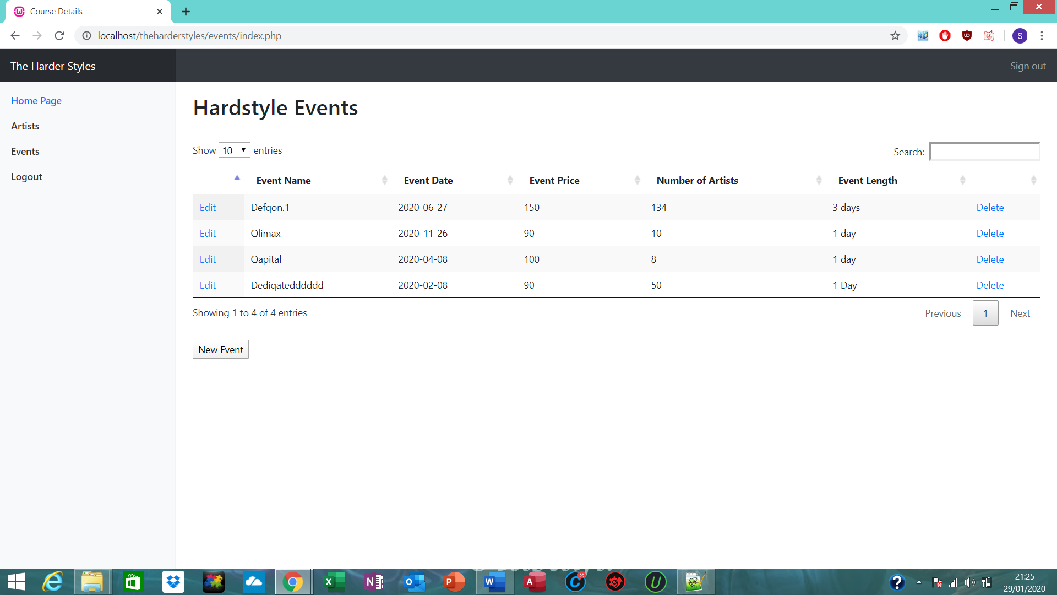
Event has been edited.

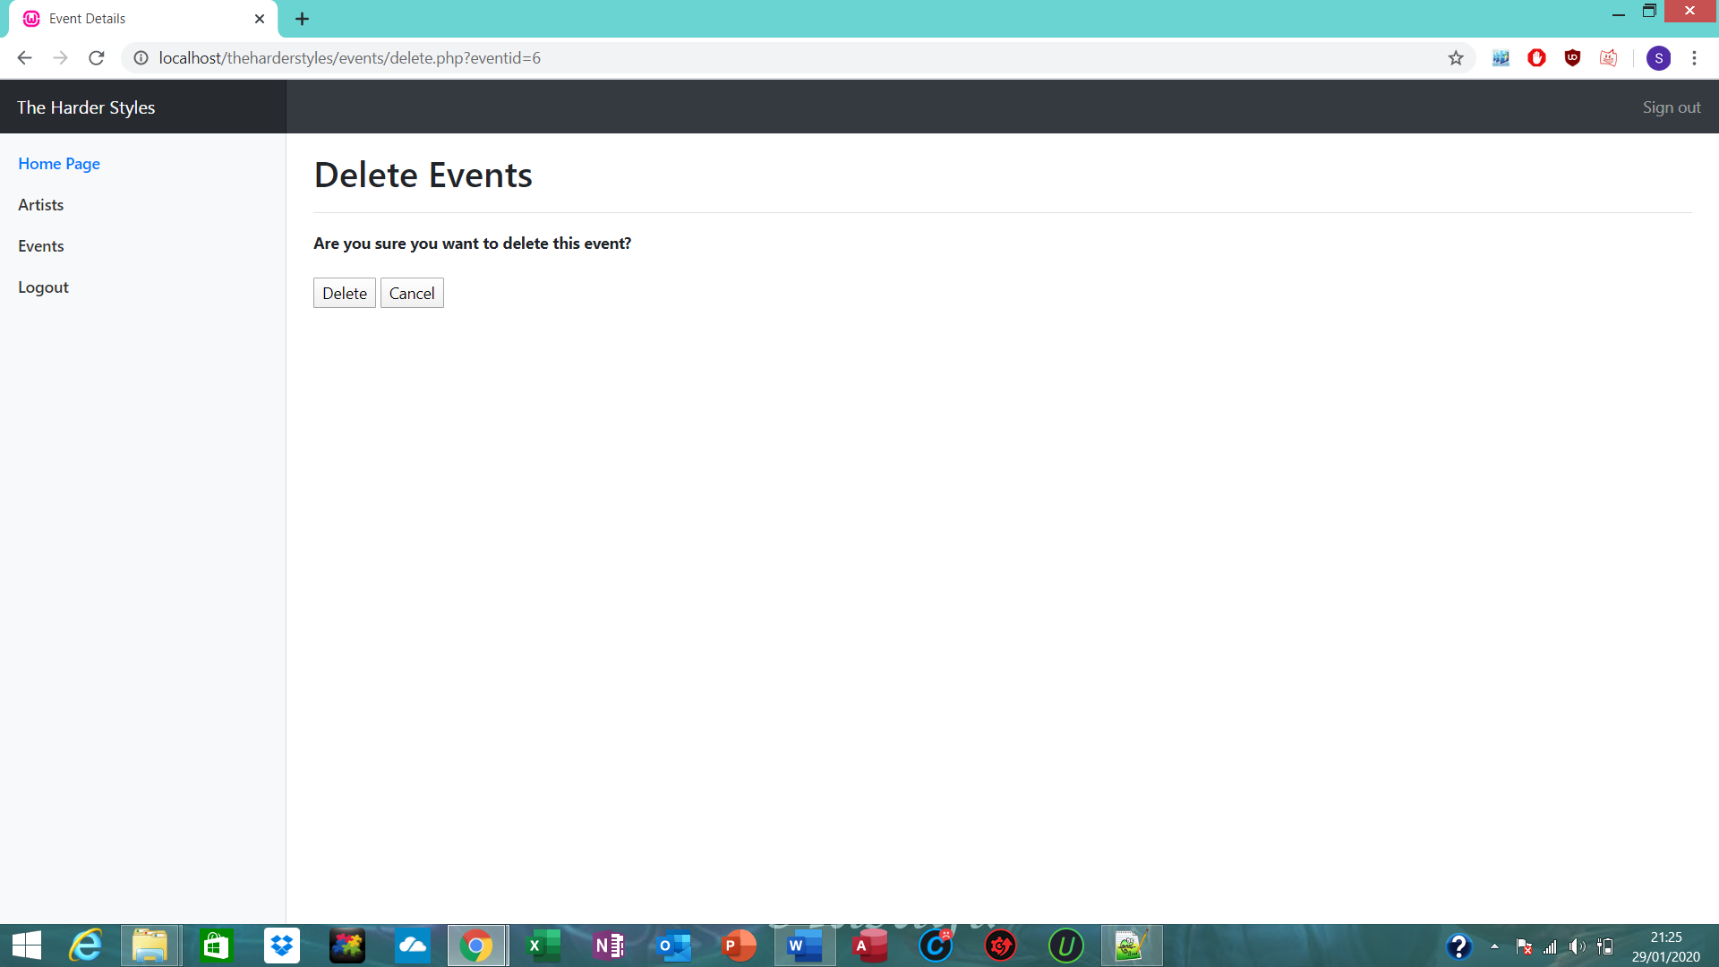
Deleting event.

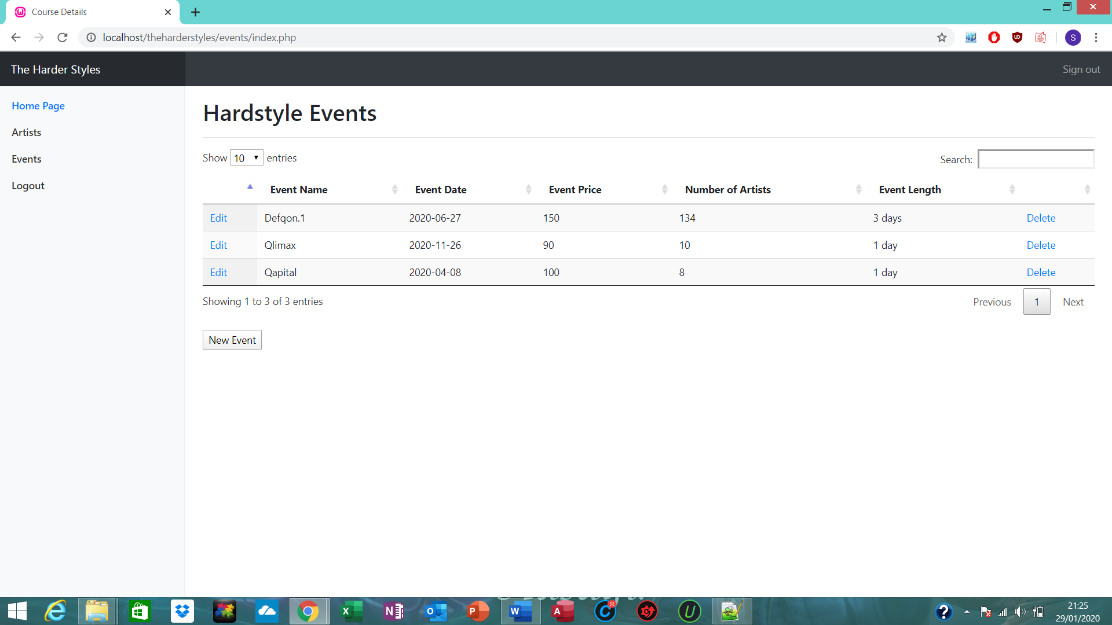
Event has been deleted.

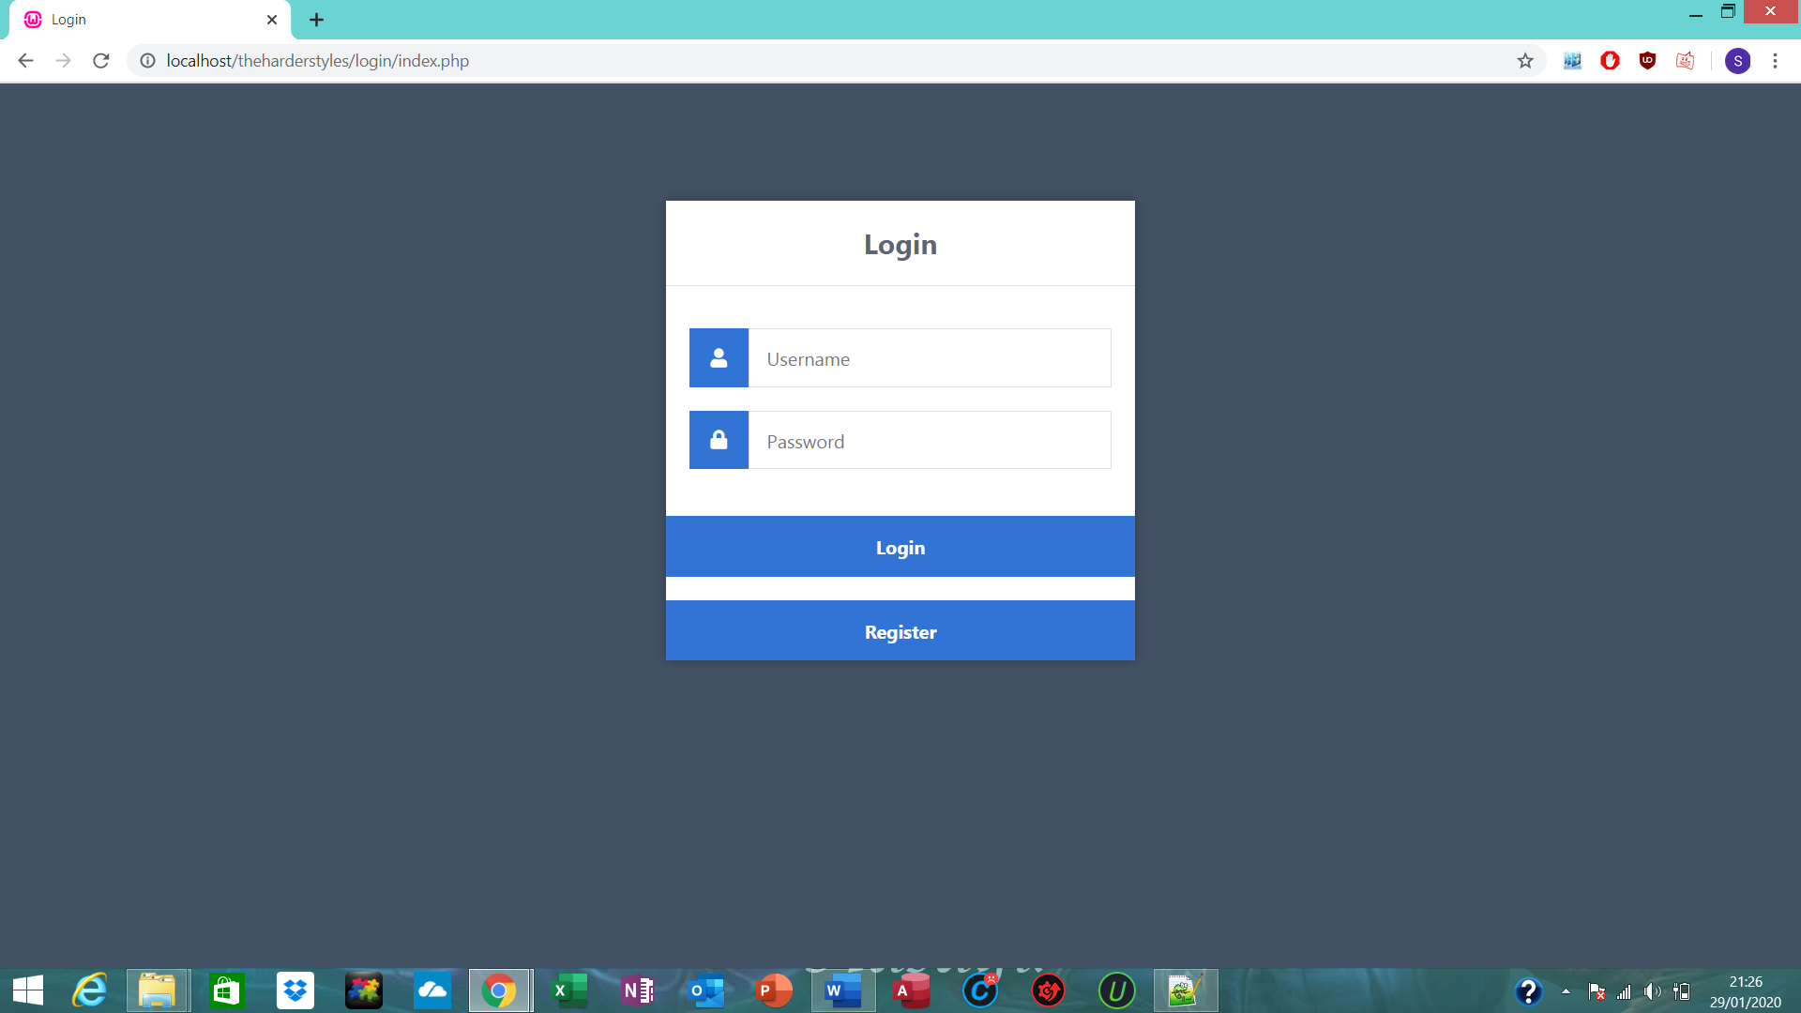
Clicking the log out or sign out button will take you back to the home page.

