

Why Innovation is Essential for Business
Success.
DEVELOPING INNOVATION AND
CREATIVITY FOR BUSINESS ADVANTAGE
Student: Zilvinas Miksys
Student nr.:1815997
Module Code: BMSW6102
Tutor: Lect. Davina Evans
Date of report publication: 25/03/2022
Word count: 2746

Executive summary

Tesla's ability to innovate would be evaluated through a critical literature evaluation. Tesla is the world’s most innovative corporation, according to Forbes. (Forbes, 2016). Despite its infancy, Tesla is presently the fastest growing global firm. Tesla's technological and administrative innovations are flawless. Forbes named it the world's most innovative firm in 2016. The company's invention is valued as a market leader. In addition to PayPal, Elon Musk founded Zip2, X.com, Space X, and Tesla, and invested in Everdream and SolarCity. It also encompasses solar power generation, energy storage, and other solar power generation components, which sets Tesla apart from other automakers. (Tesla, 2016).

Table of Contents

1.Introduction 4
1.1 Terms of Reference 4
2.0 Main Findings 4
2.1 Overview of the Innovation Opportunity 4
2.2 Type of Innovation 5
2.3 The Creativity Thinking Process 6
2.4 Models of Innovation 7
2.4.1 Open and Closed Innovation 7
2.4.2 The Innovation Process 8
2.4.3 4P’s to Innovation 9
2.5 Assessment of the Effectiveness 10
2.5.1 Barriers & Risks 10
2.6 Leadership & Management 11
3.0 Conclusions 11
4.0 Appendices 12
5.0 References 15

1.Introduction

1.1 Terms of Reference

Davina Wyn Evans requested this report on January 10, 2022. Zilvinas Miksys filed this report on March 25, 2022. Secondary sources included the Chartered Institute of Personnel and Development (CIPD), academic textbooks, industry journals, trustworthy news sources, and other websites. This document lacks major research. This study will compare innovation and creativity, examine an inventive possibility, and appropriate innovation methods. It will reveal an organization's estimate of its own innovation potential. This section will examine attitudes toward creativity and innovation considering the risks and challenges they bring. We'll look at the leadership style that inspired the inventive idea. Based on these data, we must make conclusions.

2.0 Main Findings

2.1 Overview of the Innovation Opportunity

Corporate innovation occurs when a company creates new procedures, services, or products to affect real change in their industry. This could be done by changing or adding new practises, or a mix of both. (Baregheh et al., 2009). Every day, we face diverse difficulties that demand innovative answers. We feel more alive when we are involved in something than when we are not. (Csikszentmihalyi, 2015). The services of a product can be improved through innovation to address current issues. As a result, entrepreneurs either generate new wealth-generating resources or invest in existing ones with high growth potential.
Tesla's business approach makes it one of the world's most innovative. (Forbes, 2016). A forward-thinking management style and subcategory for green technology items are offered by the company. Tesla is a well-known and globally recognised electric vehicle company. (Cendrowski, 2017). Energy storage walls, electric cars, and solar panels are some of Tesla's major business activities (Tesla, 2021). Tesla has built a valuable resource for the future by adding autonomous driving to its software upgrade. Tesla's value proposition is presented using the Powerwall storage technology as an example. It has changed its focus from EV manufacture to energy production and storage with the acquisition of SolarCity. (Battisti and Giulietti, 2015).

2.2 Type of Innovation

Electric vehicle manufacturers can utilise the Tesla Ansoff Matrix marketing planning model to help guide their long-term strategy. According to Ansoff Matrix, organisations can pursue four separate strategies: market penetration, product development, market development, and diversification:

1.Market penetration. This strategy involves selling established products to established customers. Market penetration is a major strategy employed by Tesla. As well as offering electric automobiles in the US and 35 other countries, Tesla also sells energy storage devices including the Model S, Model X, and Model 3, along with solar panels, inverters and racking and electrical hardware and monitoring devices. (Tesla, 2021)

2.Product development. This method involves creating new products for existing markets to boost sales. Tesla releases new products infrequently. The cost of developing new electric vehicle and energy storage technologies is out of control. Tesla CEO Elon Musk confirmed his company's plans to enter mining market during Battery Day in September 2020.
The business bought a 10,000-acre Nevada ranch. A lithium refinery will be developed in Texas. Tesla may sell lithium to third parties in addition to using it internally.

3. Market development. Finding new markets for current products is an important part of any successful market development plan. New countries are being considered for expansion, with India at the top. Deepak Ahuja, Tesla's Indian-born CFO, oversees the electric carmaker's entry into the Indian market, according to Elon Musk. The country's rapidly developing economy makes it a smart decision for the company to enter the market. (Barhat, 2018).

4. Diversification. Businesses that pursue diversification produce new products for new markets. Tesla has employed a strategy of diversification in recent years. Tesla Motors Inc. was founded in 2003 only as an electric vehicle manufacturer and then changed its name to Tesla Inc. after acquiring solar start-up SolarCity in 2016 to join the energy storage market.

2.3 The Creativity Thinking Process

The term "creativity" has become more widely used and accepted. When a company is looking for a new employee, creativity is one of the most sought-after qualities. Creativity is essential in nearly every aspect of life, from raising a child to running a company. The creative process is broken down into four separate stages: 1. Preparation, 2. Incubation, 3. Illumination and 4. Verification, which are discussed in detail below:
- PREPARATION: First, a person or organisation must identify the issue or topic being addressed, as well as any desired objectives (Shively et al., 2018). The primary purpose is to gain more knowledge and expertise on the issue or topic. Data is collected, examined, categorised, and summarised. At this stage of the company's electric vehicle development, management recognises the issue of pollution and seeks solutions. The first step in preparation is to gather essential information and try to incorporate it into the original idea. (Tesla, 2021)
- INCUBATION: The analysis of the previously obtained material generates new ideas and concepts in this phase. The answers and proposals are discussed here, stepping aside from the main issue and topic. The unconscious mind begins to shape the creative thought process at this stage. To sort through the data and generate new concepts, Tesla is already in the second phase of study. This step will help the organisation come up with a creative solution.

- IILUMINATION: A person's creative solutions and ideas are shaped during this period, which occurs when they are not actively considering the solution or concept (Kaufman, 2019). Emotional reactions are linked to the discovery of a solution or idea. This concept comes to me out of the blue and with a sense of certainty.
At this point, Tesla is developing electric vehicles as a means of lowering pollution. To reduce carbon emissions and protect the environment, the firm is working to create self-driving electric cars.

- VERIFICATION: This is the last step in the creative thought process, where the imaginative concept is evaluated. This step tests, validates, and evaluates the lighting stage's idea. Effective ideas and solutions require critical and analytical thinking skills. If an answer or concept doesn't work as intended, start over. The corporation evaluates and confirms the success of the Tesla electric car after a solution, or an original idea is found. The corporation spends a lot of money researching whether the electric car will succeed in the market.

2.4 Models of Innovation

2.4.1 Open and Closed Innovation

High-end technology companies, according to Chesbrough (2003), have adjusted their approach to innovation significantly. Rather than using a closed innovation strategy, these companies are now using an open innovation model. This paradigm shift from closed to open innovation has been examined by several researchers since then (Herzog, 2011). The Closed Innovation flowchart is depicted in Figure 1.1.
Open innovation is founded on the idea that invention must be made public. "The planned influx and outflow of knowledge for the purpose of speeding internal innovation and developing markets for external application of invention" is a broad definition of the term. (Chesbrough, Vanhaverbeke and West, 2006). The terms "open innovation" and "closed innovation" are often used interchangeably. The Open Innovation flowchart is depicted in Figure 1.2 (as shown).

Tesla's Open Innovation Policy addresses the need for innovation among electric vehicle manufacturers. Tesla guaranteed its competitors and the public in 2014 that "good faith" usage of its technology would not be grounds for a Tesla patent litigation. Given that alternative fuel vehicles accounted for fewer than 1% of total vehicle sales at major automakers, Tesla felt that this endeavour would not constrain its innovation (Musk, 2014). As a result, the company didn't see much competition in the EV industry. Tesla’s Open Innovation Policy may be essential in resolving industry-wide and company-specific challenges related with electric vehicle development. According to a 2017 Harvard Business Review study, electric vehicle battery performance may be 50 years behind gasoline-powered vehicles. (Downes and Nunes, 2017). The analysis also highlights Tesla's present battery technology, which are neither superior nor cheaper than current internal combustion options. (Downes and Nunes, 2017). Instead of focusing on industry-wide difficulties, Tesla may focus on developing its own competitive advantages.

2.4.2 The Innovation Process

The innovation process is broken down into numerous stages, which are summarised here:
Step 1: Idea Generation and Mobilization- New ideas are developed as part of the idea generation process. It takes both competitive pressure and the ability to experiment successfully to generate new ideas.
The term mobilisation refers to the process of moving an idea from one place to another. Self-driving electric cars are already being developed by other automakers, so Tesla focuses on competing with them. It is possible that this unique idea could be a huge success if the company employs the right advertising methods and approaches.
Step 2: Advocacy and Screening – Advocacy and screening help determine the feasibility of a company idea, as well as its related risks and benefits...
An idea's future can be decided as a result. A few recommended practises can be implemented by companies looking to build a culture.
Step 3: Experimentation – The viability of ideas for a particular organisation at a given point in time is determined during the experimentation stage. As a result of testing the feasibility and effectiveness of an initial concept, new ideas are generated through experimentation.
Step 4: Commercialization – Impact-focused commercialization boosts an idea's market value. Any concept's specs are an essential aspect of the development process.
The focus moves from development to persuasion during commercialization. It is time to disseminate and put into action the concept that has been developed and the business strategy that has been drafted.
Step 5: Diffusion and Implementation – An organization's acceptance of a creative idea is referred to as diffusion, while implementation sets the stage for its growth.
Implementation and diffusion allow companies to anticipate future consumer demands. Giving and receiving feedback is an essential component in fostering creativity inside a company.

2.4.3 4P’s to Innovation

The 4 P’s of innovation are products, processes, positions, and paradigms (Lestari et al., 2020). Tesla can launch its new electric vehicle and create a market value proposition by embracing all four areas of innovation:
Product innovation. Product innovation and technological developments are a priority for the company to maintain its competitiveness. Tesla's electric motors, longer range on a single charge, charging technology, and self-driving system are the most enticing features. Tesla Motors places a high priority on battery safety and reliability, which includes not only the 'cell' pack but also the charge and discharge control components as well.
Position Innovation refers to a change in the way new products and services are introduced to the market. Position Innovation Products and services are repositioned in the market as the primary focus of this strategy (Thabit and Raewf, 2018). To promote Tesla's upcoming electric car, position Innovation will assist the company in formulating marketing tactics and ideas.
Paradigm. Tesla customers are introduced to a new concept: improving quality of life should not affect the environment. Governments and society must construct a new method of creating infrastructure around autos. However, changing social infrastructure may cause a host of issues. Tesla helped people's brains embrace this new sort of transportation, causing a paradigm shift. They provided great automobile testing services and promoted their eco-friendly and simple approach on social media. Many governments, like those in America, have recognised that as more people develop an environmental concern and begin to purchase electric vehicles, electric charging stations may become essential in communities.
Process innovation. Tesla improved their production and delivery methods. Initially, they switched from a closed to an open innovation process. Tesla has formed partnerships with Panasonic, Daimler AG, and Toyota. Tesla worked with these companies and some of their R&D teams to open their product and technology development. This process innovation resulted in more resources and help from outside the firm for Tesla. As a result, Tesla is more likely to produce new products and improve existing ones.

2.5 Assessment of the Effectiveness

Lewin's force field analysis is used to ascertain which aspects inside a scenario or organisation influence an individual's behaviour toward or away from a desired state, and which factors act in opposition to the driving forces. Tesla's mission is to accelerate the global switch to electric vehicles to help the company become the most desirable automaker in the twenty-first century (Rowland, 2018). Electric vehicles will become more accessible to mainstream consumers through Tesla's three-pronged strategy: selling its vehicles through company-owned showrooms and online, promoting its electric powertrain components to other automakers, and showing how enjoyable and socially responsible driving can be with a Tesla. Tesla's innovative culture of problem-solving encourages employees to develop solutions for present and future market issues (Meyer, 2019). People in the culture can move rapidly, accomplish the impossible and continually innovate, reason from "first principles," think like owners, and are all in on the decision-making process (Meyer, 2019). Elon Musk is always there to lend a helping hand to his co-workers as they strive to accomplish impossible feats (Gayathri, 2019).

2.5.1 Barriers & Risks

Using the Five Forces Analysis, a strategic management methodology, Michael Porter analysed how external variables affected companies and the competitive landscape in their industry. (Hadi, 2022). External factors affecting the automobile and energy solutions industries are examined, as is Tesla's impact on both:
1 – THREAT OF NEW ENTRANTS: The risk of new entrants is VERY HIGH, as the entry barrier is VERY LOW. Tesla's competitors include electric vehicle (EV) start-ups, conventional automobiles fuelled by fossil fuels, and incumbent automakers transitioning to electric vehicles.
2 – BARGAINING POWER OF SUPPLIERS: Due to the small supply chain network, suppliers' bargaining power is HIGH. The electric vehicle sector is still in its development. Most Tesla vehicle components are currently obtained from German vendors. Tesla's production will be negatively impacted by any disruptions to the German economy, such as the COVID-19 closure and energy constraint.
3 – BARGAINING POWER OF BUYERS: Buyers' bargaining power is LOW, as Tesla's products are segmented at the upper end of the market with premium price.
4 – THREAT OF SUBSTITUTES: Since Tesla has a 1.2 % share of the total automotive market and a 14.55 % stake of the global electric vehicle industry, the threat of replacements is HIGH. Tesla, on the other hand, relies on customer loyalty as its primary competitive edge.
5 – INDUSTRY RIVALRY AMONG COMPETITORS: Start-ups, major automakers, and significant car brands are all moving to electric vehicles, making it a highly competitive market and it’s very INTENSE. Efforts by rivals to undercut Tesla's pricing and differentiate their products are hurting the company's market share and profitability.

2.6 Leadership & Management

Elon Musk, the current CEO, and other Silicon Valley technology leaders founded Tesla Motors in 2003. By leading by example and using his desire for excellence to move the company ahead, he is recognised as a transformational leader. Transformational leaders have a favourable impact on their organisations and the marketplace. For example, this is exactly what Elon Musk has done with Tesla Motors, Space X and PayPal, as well as his other businesses (Holmberg, 2011). The leadership issue at Tesla Motors is a result of the company's over-reliance on Elon Musk to provide guidance and inspiration (Liu et al., 2014). There are going to be a wide range of executives in different divisions who are going to be needed to drive the company's global expansion. Leaders and managers who can embrace Tesla's long-term goals must be trained and nurtured through a variety of techniques. Tesla needs more transformative leaders who can propel the company's global expansion in a wide range of areas. Additionally, Tesla Motors must figure out ways to keep its top executives and managers in a field with a high turnover rate (Holmberg, 2011).

3.0 Conclusions

Innovation and originality are essential to a company's growth and success, according to this analysis. Using Tesla Inc. as a case study, this research examined the concept of innovation potential in all its guises. For this study, the creative process is shown in context with Tesla Inc.'s original ideas, which is a good example of this. The research also examined the various invention models and their influence on the growth of the innovative concept. The 4 Ps of innovation are also discussed in this study, which help determine the various Ps of innovation. The leadership and management traits and skills needed to perform the assignment were also evaluated in this paper.

Appendices

1. Tesla Ansoff Growth Matrix:

MARKET  PENETRATION | PRODUCT  DEVELOPMENT
MARKET  DEVELOPMENT | DIVERSIFICATION

2. Figure 1.1 Closed Innovation flowchart (Chesbrough, 2003):
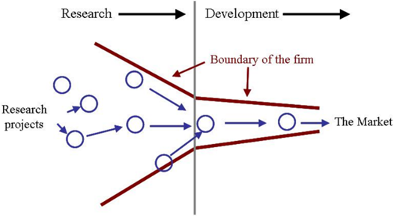

Figure 1.2 Open Innovation flowchart (Chesbrough 2003):
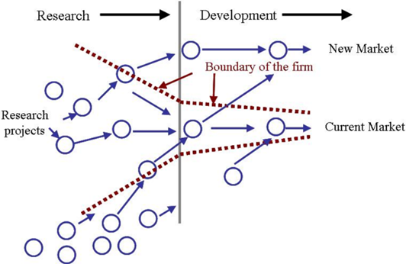

3. 4P’s to Innovation:

Position
Product

Paradigm
Process

4. Five Forces Analysis
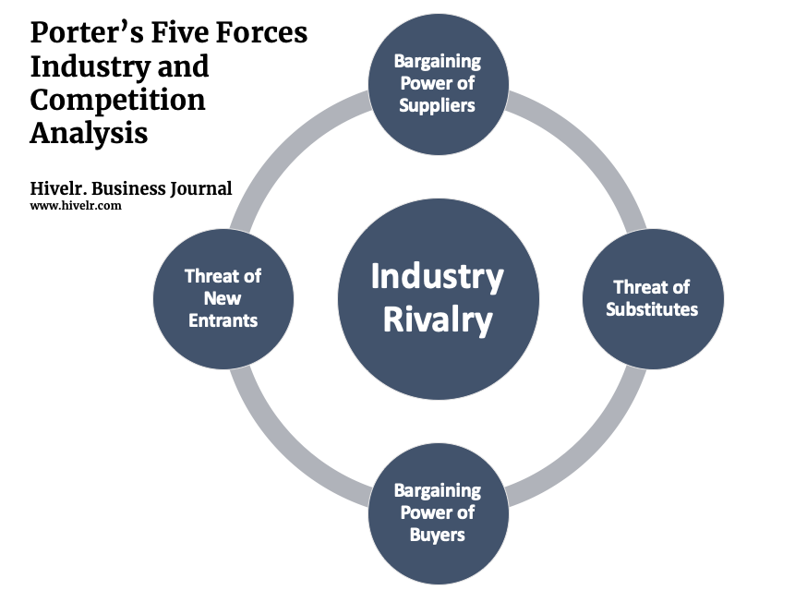
- Force Field Analysis (LEWIN)

Forces for change
Forces resisting change

4 3 2 1 1 2 3 4
Cost
Improved production speed

Upgrade new and existing factories

Independency from suppliers
Long waiting time

Staff demoralization
More robots on site

Total: 10
Total: 11

5.0 References

- Baregheh, A., Rowley, J. and Sambrook, S., (2009). Towards a Multidisciplinary Definition of Innovation. [online] ResearchGate. Available at: <https://www.researchgate.net/publication/41104662_Towards_a_Multidisciplinary_Definition_of_Innovation> [Accessed 10 March 2022].
- Barhat, V., (2018). From a single Elon Musk tweet, the keys to Tesla’s India strategy. [online] CNBC. Available at: <https://www.cnbc.com/2018/06/18/in-a-single-elon-musk-tweet-the-key-to-teslas-india-strategy.html> [Accessed 6 March 2022].
- Battisti, G. and Giulietti, M., (2015). Tesla Is Betting on Solar, Not Just Batteries. [online] Harvard Business Review. Available at: <https://hbr.org/2015/07/tesla-is-betting-on-solar-not-just-batteries> [Accessed 11 March 2022].
- Cendrowski, S., (2017). Tesla Takes Off in China. [online] Fortune. Available at: <https://fortune.com/2017/06/07/fortune-500-tesla-china/> [Accessed 8 March 2022].
- Chesbrough, H., (2003). Open Innovation. Boston (Massachusetts): Harvard Business School Press, pp.21-25, 43-57.
- Chesbrough, H., Vanhaverbeke, W. and West, J., (2006). Open innovation. Oxford: Oxford University Press, pp.3-5, 17-19.
- Csikszentmihalyi, M., (2015). Creativity. New York, NY: Harper Perennial Modern Classics.
- Downes, L. and Nunes, P., (2017). Is Tesla Really a Disruptor? (And Why the Answer Matters). [online] Harvard Business Review. Available at: <https://hbr.org/2017/08/is-tesla-really-a-disruptor-and-why-the-answer-matters?registration=success> [Accessed 5 March 2022].
- Duggan, W., (2018). Tesla Is Losing Money on the Model 3, Report Says Production of the long-awaited Model 3 hasn't solved Tesla's cash burn problem. [online] Available at: <https://money.usnews.com/investing/stock-market-news/articles/2018-05-10/tesla-inc-tsla-stock> [Accessed 24 February 2022].
- Forbs, R., (2016). Forbes Releases Sixth Annual List Of The World's Most Innovative Companies. [online] Forbes. Available at: <https://www.forbes.com/sites/forbespr/2016/08/24/forbes-releases-sixth-annual-list-of-the-worlds-most-innovative-companies/?sh=70b298b04177> [Accessed 12 March 2022].
- Gayathri, S. (2019). Electric vehicles- An introduction of the tesla for strategy and leadership. International Journal of Recent Technology and Engineering, 8(2), 1522-1524.
- Hadi, L., (2021). Tesla: Porter’s Five Forces Industry and Competition Analysis. [online] Hivelr. Available at: <https://www.hivelr.com/2021/12/tesla-porters-five-forces-industry-and-competition-analysis/> [Accessed 26 February 2022].
- Herzog, P. (2011). Open and Closed Innovation, Different Cultures for Different Strategies (2nd ed.). Heidelberg, Germany: Gabler.
- Holmberg, S., (2011). EMERGING GREEN-TECHNOLOGY ENTREPRENEURS: - ProQuest. [online] Proquest.com. Available at: <https://www.proquest.com/docview/922565981/fulltextPDF/E4E33DE8354F4DD4PQ/1?accountid=130472> [Accessed 12 March 2022].
- Kaufman, J., (2019). Self-assessments of creativity: Not ideal, but better than you think. [online] ResearchGate. Available at: <https://www.researchgate.net/publication/332682556_Self-assessments_of_creativity_Not_ideal_but_better_than_you_think> [Accessed 8 March 2022].
- Lestari, S.D., (2020). Antecedents and consequences of innovation and business strategy on performance and competitive advantage of SMEs. The Journal of Asian Finance, Economics and Business. 7(6), pp.365-378.
- Liu, Y. E., Kang, Y., Wu, H., Chen, C., & Hon, E. (2014). Tesla Motors Inc. Case Synopsis. Burnaby BC: Simon Fraser University. Retrieved, 10(18), 2014.
- Meyer, P., (2019). Tesla Inc.’s Organizational Culture & Its Characteristics (Analysis) - Panmore Institute. [online] Panmore Institute. Available at: <http://panmore.com/tesla-motors-inc-organizational-culture-characteristics-analysis> [Accessed 10 March 2022].
- Musk, E., (2014). All Our Patent Are Belong To You. [online] Tesla.com. Available at: <https://www.tesla.com/blog/all-our-patent-are-belong-you> [Accessed 7 March 2022].
- Nellis, S., Shirouzu, N. and Lienert, P., (2020). Exclusive: Apple targets car production by 2024 and eyes 'next level' battery technology - sources. [online] Available at: <https://www.reuters.com/article/us-apple-autos-exclusive/exclusive-apple-targets-car-production-by-2024-and-eyes-next-level-battery-technology-sources-idUSKBN28V2PY> [Accessed 26 February 2022].
- Rowland, C., (2018). Tesla, Inc.’s Mission Statement & Vision Statement (An Analysis) - Panmore Institute. [online] Panmore Institute. Available at: <http://panmore.com/tesla-motors-inc-vision-statement-mission-statement-analysis> [Accessed 7 March 2022].

- Shively, K., Stith, K.M. and Rubenstein, L.D., (2018). Measuring what matters: Assessing creativity, critical thinking, and the design process. Gifted Child Today, 41(3), pp.149-158.
- Tesla, (2014). Factory Upgrade. [online] Tesla.com. Available at: <https://www.tesla.com/en_GB/blog/factory-upgrade> [Accessed 8 March 2022].
- Thabit, T. and Raewf, M., (2018). The evaluation of marketing mix elements: A case study. International Journal of Social Sciences & Educational Studies, 4(4).
- Young, J., (2021). The Economics of Tesla’s Batteries Business. [online] Investopedia. Available at: <https://www.investopedia.com/articles/investing/050715/economics-tesla-batteries.asp> [Accessed 24 February 2022].

