Iconography of fringe movements within Russian Orthodox Christianity

Icons and iconography are deeply important to worship in the Russian Orthodox church. An icon is seen as a way of communicating with God, an image of the divine, according to Orthodox doctrine, is revered on the same level as the Word. Orthodox icons are painted with the use of specific techniques, as every brushstroke is a sign of its own, regulated by canon instead of realism. In essence, icons attempt to provide a look into the spiritual world and portray etentity. Rules of tone and perspective are abandoned, as icon shows the soul instead of flesh. However, there are icons which defy canon and are even banned by the official church. Some are heretical by accident, while others belong to sectarian groups only close to Orthodoxy on the surface. In this research, some of such iconography will be explore.
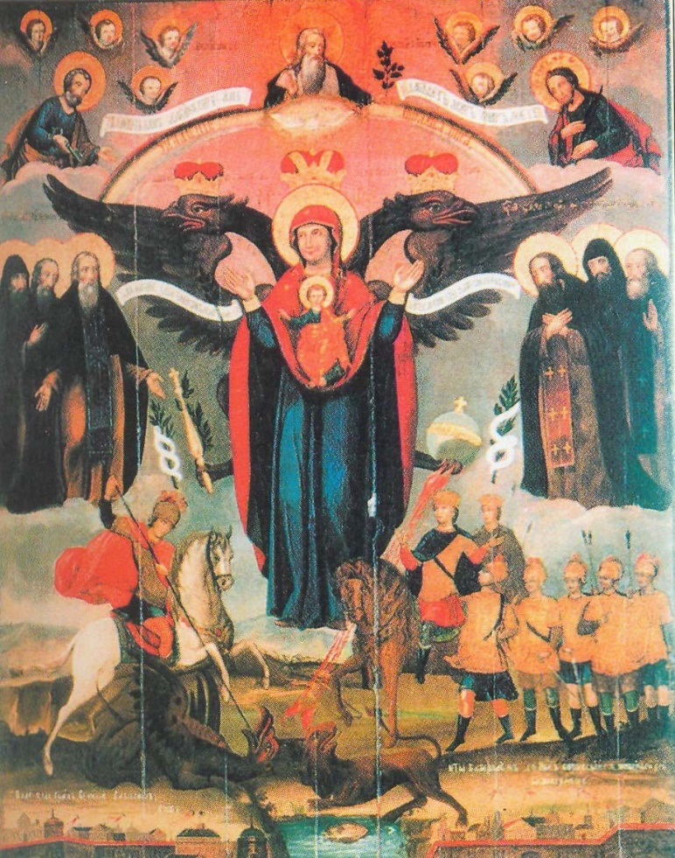
Not all visually “odd” iconography is necessarily outside of the realm of church canon. One of the examples is the icon of Mother of God Azovskaya (Our Lady of Azov). It portrays the Virgin Mary and Jesus with the two-headed eagle, emblem and the coat of arms of the Russian Empire, behind them. The eagle is also holding a scepter and orb, both symbols of monarchy and power. The icon appeared in the late seventeenth century and followed the trend of showcasing the coat of arms, it likely references a parsuna (portrait) of Sophia Alexeyevna, regent of Russia, which also features the two-headed eagle behind her. The icon exemplifies the use of religious art to further the agenda of the government, as portrays monarchy power of seventeenth century as divinely legitimate and God-given. Furthermore, the icon spread in the eighteenth century after Mikhail Golitsyn’s military campaign against the Ottoman Empire in Azov, granting the icon its name. The campaigns against Ottoman Muslims were seen as a crusade for the Christian faith and therefore the icon can be viewed as an example of religious propaganda. The prototype of Our Lady of Azov likely stems from the portrayals of The Woman of the Apocalypse, also known as Woman Clothed with the Sun, first described in Revelations 12:1-2, associated with Mary in Christian thought. Mary in the Azov icon looks like she has wings as she overlaps with the eagle and Woman of the Apocalypse is also occasionally portrayed with wings.
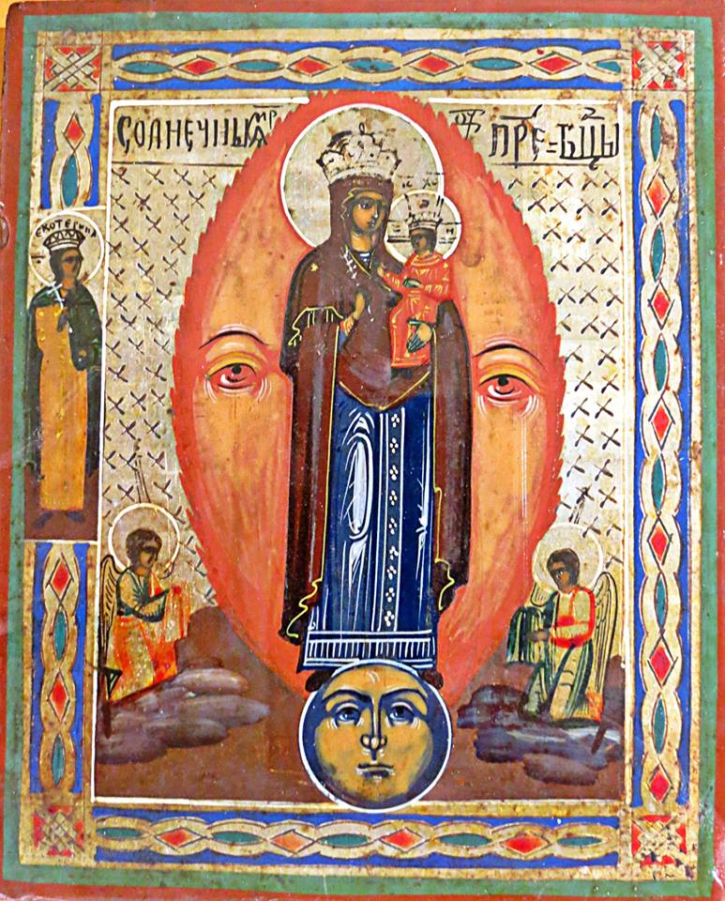
Another peculiar Apocalyptic Marian iconography is Mother of God Solnechnaya (Our Lady of the Sun). It is another variation of Woman Clothed with the Sun recognized by the Orthodox Christian canon. In this icon, Mary holds Jesus as she stands on the moon, depicted as a blue sphere with a human face and behind Her is a similar red sphere with a face that represents the sun. Often, the sun is elongated rather than circular and almost creates a sort of mandorla around Mary. Our Lady of the Sun can be viewed as a Russian Orthodox take on Apocalyptic imagery that is also popular in Western Christan art.
Patriarch Nikon’s reforms of the 1660s have caused the biggest split in the Eastern Church since the great Schism of 1054, which separated Orthodoxy from Catholicism. The reforms implemented the Greek canon instead of the local Russian tradition. Following the Schism of the Russian Orthodox Church two groups of Old Believers (Old-Rite Christians) emerged: Popovtsy and Bezpopovtsy. Popovtsy, those with clergy, created an alternative church that followed old rites and had their own clerical hierarchy; Bezpopovtsy, those without clergy, on the other hand, believed that after the schism God’s power could no longer flow through any clergy and therefore it was no longer needed. Due to the lack of rigid structure, Bezpopovtsy would soon split into countless communes and sects, some would go as far as not associate with Russian Orthodoxy at all. It appears that the Khlysty sect emerged as a group of clergyless Old Believers before going their own way. Khlysty believed that Jesus Christ, God the Father (Sabaoth), Holy Spirit (called Spirit-God) and Virgin Mary were to be reborn an unlimited number of times, furthermore, Jesus Christ was only one of many reincarnated Christs. Khlysty saw flesh as the enemy of the soul, so they practiced mortification of the flesh by whipping themselves. Whip, Khlyst in Russian is believed to be the origin of the cult’s name. The movement was started by Danila Phillipov in 1645 after he announced himself to be the incarnation of Sabaoth. Influential leaders of the Khlysty were Prokopiy Lupkin, seen as Christ and his wife Akulina Petrovna, seen as Mary, they lead to the spread of the cult all over Russia in the 1730s. A Khlysty commune was called a ship, which would be headed by a Christ or a Virgin Mary. Khlysty would worship God by assembling in an act known as radenie (rejoicing), they would dance, run around and jump, causing themselves to enter a trance state and be possessed by The Holy Spirit and speak in tongues, which likens their worship to the Pentecostals. Russian Orthodox Church sources also accused them of having orgies during worship.
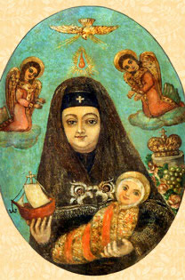
Skoptsy (castrates) were perhaps the most infamous Orthodox Russian cult due to their extreme practices and beliefs. They emerged from the Khlysty sect in 1772, lead by Selivanov (first name disputed). He extended some ideas of Khlysty, for example, he stated that the spiritual world was created by God and the physical world by the devil. According to him, Adam and Eve were first ethereal beings with no sexual characteristics and were made physical through the downfall of Original Sin. Therefore, reproductive organs were to be destroyed to get rid of sin. Selivanov preached that Jesus Christ was baptized through castration and castrated his apostles during the Last Supper. Both male and female Skoptsy would have their sexual organs cut off, they also strongly opposed marriage, so the cult sustained itself only by drawing in new members. Another idea introduced by Selivanov was a connection to royalty. Selivanov presented himself as Peter III in hiding after escaping assassination, his birth was seen as miraculous, as his mother, Elizaveta Petrovna was thought to be a virgin and also part of the Skoptsy. Their narrative and depictions closely paralleled Virgin Mary and Jesus, as well as Prokopiy Lupkin and Akulina Petrovna. In the rest of their worship, Skoptsy did not differ from Khlysty.
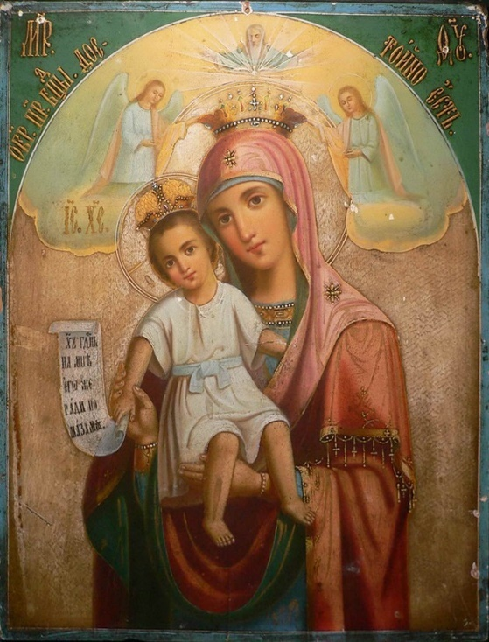
Both Khlysty and Skoptsy aren’t known for their iconography, however, one icon of the Skoptsy from the eighteenth century exists. The icon is painted with non-traditional materials, as most canonical icons are oil tempera on wood, the Skoptsy icon is oil on copper. It depicts Akulina Petrovna/Elizaveta Petrovna as Mother Mary. In her left hand she holds a ship, symbol of the Skoptsy community and the church, those who will be saved, in her left hand she holds infant Peter III/Jesus Christ. Mary’s clothes look more like Orthodox Christian nun’s rather than traditional clothes on the icons of Mary, above her head is a flame, symbolizing the Holy Spirit coming onto her and present in Orthodox iconography of the Pentecost. At Mary’s left and right are kneeling on clouds, from above descends the Holy Spirit as a white dove. Behind Mary sit a crown, showing her ties to Russian Imperial royalty and some flowers and grapes, both feature in canonical Marian iconography, associated with Mary’s title of the Rose of Sharon and wine of the Eucharist, respectively. This icon most closely resembles that called Dostoyno Yest (Axion Estin in Greek), which portrays Virgin and Child with two kneeling angels on clouds, crowning Mary. Above them is God the Father. Mary’s face on the Skoptsy icon varies from canon, as the proportions of her face are different, her features are softer, skin is paler and her chin is reduced. This opens up the possibility that the Virgin of Skoptsy deliberately bears resemblance to either portraits of Elizaveta Petrovna or Akulina Petrovna herself. Both smaller size of objects in the background, complex shading and blue, rather than gold background show the departure of Skoptsy from Russian Orthodox iconographical canon, together with overall departure from theological canon.

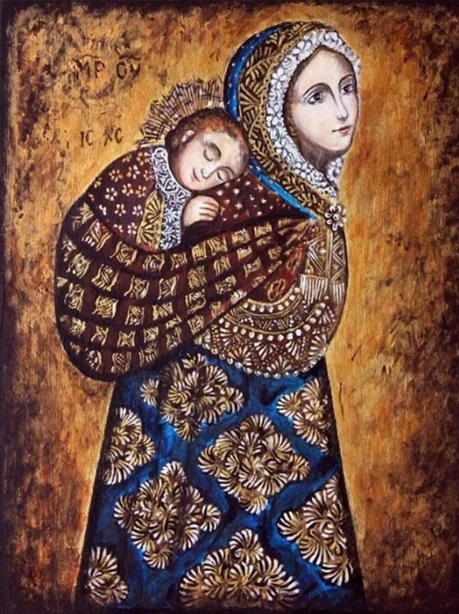
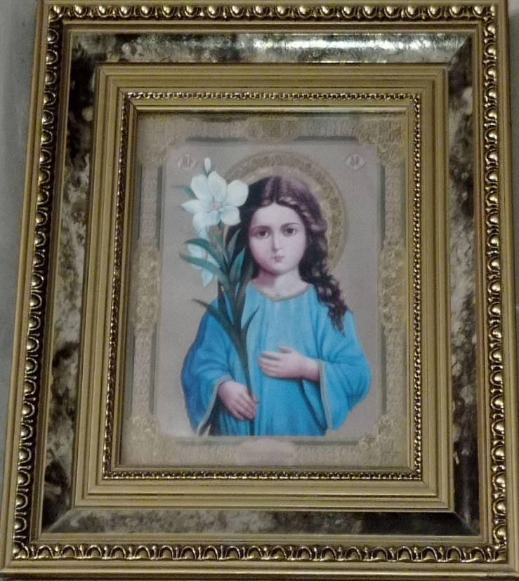
Just like some unconventional icons are canonical, so are some seemingly acceptable icons outside the Church canon. A good example would be the icon of Virgin Mary and Jesus nicknamed ‘The Peruvian’ or ‘The Lullaby’. It portrays Mary carrying infant Jesus on her back in a sling. The child is asleep while Mary gazes away with a subtle smile. Both figures wear patterned clothing, Mary’s head covering varies in shape from the acceptable canon. The image has been criticized by Protoiereus Alexander Saltykov, who described it as a beautiful painting but lacking in Christian imagery and message. According to Saltykov, Mary is portrayed here as a young mother with a baby rather than a Virgin Mother who has birthed God, the image lacks in solemnity. The Peruvian is also non-canonical as it has no textual base. There are no similar descriptions of the infancy of Jesus neither in the Scriptures, nor in the apocrypha, so the painting can be simply seen as a product of the anonymous author’s imagination. The second example of modern iconography breaking religious canon would be another icon of Mary, called “Three years of age”. Notably, its distribution has been banned by church officials in local parishes. Yelena Kuleshova, head of the Eparchy’s center of information and apologetics, describes the icon as:

“It’s more of a picture, which portrays a little chubby girl with unnaturally large brown eyes, loose hair, with her hair uncovered, in a blue tunic, standing with her face to the viewer with a giant white lily in her right hand.”
The icon is rumored to have been based on a postcard brought from Jerusalem. Its iconography is derived from the apocryphal narrative of three-year-old Virgin Mary entering The Jerusalem Temple. The main criticism of the icon, coming from Kuleshova, bishop Aristarch and Iereus Dmitriy Vladimirov is that the image portrays a child, rather than a girl beyond her years regarding her seriousness and piety. In contrast with “Three years…”, the canonical iconography shows Mary as a child-sized adult, highlighting her maturity and the seriousness of her mission.

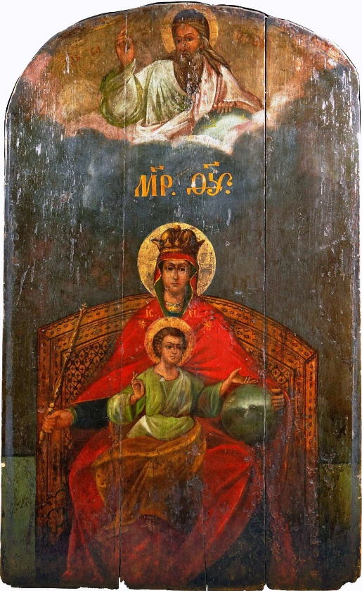
After the fall of the USSR religion became safe to practice. This led to the emergence of many new religious movements, often similar to traditional Russian Orthodox Christianity. One of these several movements is the somewhat controversial Mother of God center. Scholars like Leschinsky, who are close to the Mother of God movement, have spoken positively of the movement, citing their charity work and focus on traditional family values. The officials from the Russian Orthodox Church, however, have accused the movement of being a totalitarian cult, with Archbishop Father John as its prophet and leader. Accounts of the sect’s theology also vary from source to source. Apparently, Father John’s revelation began in 1984, when he received messages from Virgin Mary in front of the Hodigitria icon. The Mother of God center views itself as a different branch of the Russian Orthodox Church, the identity of such catacomb churches, which appeared in the Soviet era, are based on the martyrdom of persecuted Christians, who were sent to prison camps and GULAGs. The Mother of God center is no different, they view the prison on the islands of Solovki as the Golgotha of Russian Christendom. What makes the sect stand out is their particular Marian devotion. Members believe that the Third Covenant was made, now between humanity and Mary, which is put above the previous covenants. Father John speaks of Mary as “the most eternal Virgin, who stood at the creation of the world”. This strongly parallels the prologue of John in the New Testament Gospels. Mary is seen as a manifestation of the Holy Spirit, providing her grace on Earth, she is also described as a “co-crucified” “co-Redeemer” who “carried the cup of Adam’s sins”, this gives Mary a role almost equal to that of Jesus.
From the beginning, the Mother of God movement has had developed religious art. The community’s official name even references the icon “Derzhavnaya” (Our Lady the Sovereign), pointing to strong reverence for it. Some icons worshipped by the sect are variations of canonical iconography, but Mary is portrayed without Jesus, for example, there have been icons of “Znameniye” (Our Lady of the Sign), focusing the attention of worship on Mary alone. Another icon described in Leschinsky’s account of the movement is Mary as the Woman of the Apocalypse:
“On this icon Mother of God stands above the Solovetsky island with sun as her background. In one of her hands is the Ark, in her other hand is a spear with which she impales the serpent.”
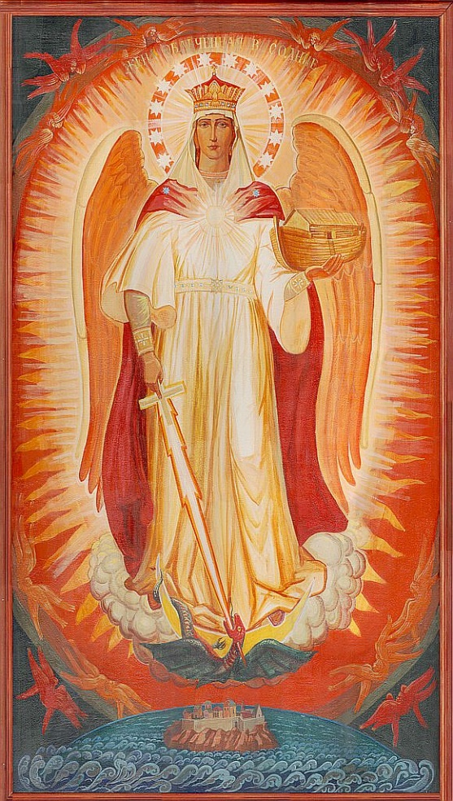
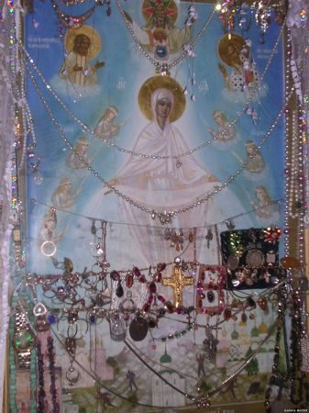
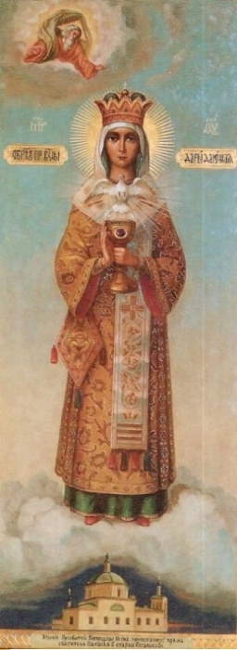
A very similar icon was provided by the Mother of God center via email, it matches Leschinsky’s description, except Mary holds a flaming sword rather than a spear. Notably, she is again shown without Jesus Christ. Several icons of the movement have seeped into mainstream Russian orthodox worship. One such icon is “Our Lady resurrecting Rus”. It shoes Mary, wearing only white, standing above Russia, above her is Christ, sometimes she is accompanied by saints. The backround is blue, rather than gold, which is atypical, Mary drops little crosses, those who accept them live, those who don’t shrivel and die. The iconography is reminiscent of the Intercession of the Theotokos, however, shows Mary in a much more significant position as she has the ability to give life and take it away. The Orthodox Church criticized the icon due to Mary wearing pure white, a color reserved only for Christ. Proponents of the icon believe it to be miracle-bringing, as the word of mouth is that it myroblytes, however, the official Church refutes that evil forces may cause the false miracles. “Our Lady the Gift Giving” is much clearer with its message of Mary’s importance. In this image, Mary stands on a cloud above a church, above her is God the Father and Holy Spirit, she is wearing the robes of an archiereus, a position in the clergy available strictly to men. Such iconography is seen by the Russian Orthodox Church as completely unacceptable and even offensive. Furthermore, Mary is holding a chalice with wine and bread for the Eucharist, which the church regards as her completely replacing the sacrifice of Christ.
In conclusion, Marian iconography appears to be the most widespread both within and outside canon, especially with certain groups venerating her above Christ. Not all icons, however, present fringe religious movement, some simply display the blurred lines between iconography and fine arts in the modern world. One may also conclude, that new religious sects are much more concerned with iconography compared to older similar movements.

Bibliography
Chadwick, Henry, The Early Church, revised edition. (London: Penguin Books, 1993)

Klyuchevsky, Vasily Osipovich, ‘Lecture LIV’, in The course of Russian history (Leningrad: State socio-economic publishing house, 1937) https://www.spsl.nsc.ru/history/kluch/kluch54.htm [accessed 6 January 2025]
Cross, Frank Leslie, The Oxford dictionary of the Christian Church, 3rd edn., ed. by Elizabeth A. Livingstone (Oxford: Oxford University Press, 2009) <DOI: 10.1093/acref/9780192802903.001.0001>
Zotov, Sergey, Iconographical Mayhem. (Moscow: Bombora, 2021)
Brettler, Marc Z. and Carol A. Newsom, The New Oxford annotated Bible, 4th edn., ed. by Michael D. Coogan (Oxford: Oxford University Press, 2018) https://archive.org/details/the-new-oxford-annotated-bible-with-apocrypha-new-revised-standard-version-2018/page/n3/mode/2up [accessed 6 January 2025]
Bezhan, E. M., ‘The classification of Old-Rite agreements and sectarian communities, their development and expansion in the territory of West Siberia in the first half of the nineteenth century’, Omsk University Herald, 3 (2007), 87-95 https://cyberleninka.ru/article/n/klassifikatsiya-staroobryadcheskih-soglasiy-i-sektantskih-obschin-ih-razvitie-i-rasprostranenie-na-territorii-zapadnoy-sibiri-v-pervoy/viewer [accessed 6 January 2025]
Berman, Andrey G., Khlysty. (Moscow: Common Place, 2022)
Andrey G. Berman, Khlysty. (Moscow: Common Place, 2022)
Bulgakov, Sergei Nikolayevich, ‘Skoptsy’ in The handbook of heresies, cults and schisms (Kyiv: The Typography of the Kyiv-Pechersk Lavra of Dormition, 1913) https://azbyka.ru/otechnik/Sergej_Bulgakov/spravochnik-po-eresjam-sektam-i-raskolam/171 [accessed 6 January 2025]
Bulgakov, Sergei Nikolayevich, ‘Khlysty’ in The handbook of heresies, cults and schisms (Kyiv: The Typography of the Kyiv-Pechersk Lavra of Dormition, 1913) https://azbyka.ru/otechnik/Sergej_Bulgakov/spravochnik-po-eresjam-sektam-i-raskolam/205 [accessed 6 January 2025]
Kulikov, Igor, New religious organizations of Russia of destructive, occult and neopagan nature (Moscow: The Missionary departament of the Moscow Patriarchy, 1997) https://web.archive.org/web/20160924072642/http://dl.biblion.realin.ru/text/34_Sektovedenie/Novye_religioznye_obrazovaniya._Entsiklopediya/ANC/t2/o260.html [accessed 6 January 2025]
Sidorov, Daniel, Khorkova, Maria, ‘Sentimental icons: what is wrong with them?’, Miloserdie.Ru, 17 February 2022. https://www.miloserdie.ru/article/sentimentalnye-ikony-chto-s-nimi-ne-tak/ [accessed 6 January 2025]
Regnum, The icon of Mother of God “Three years of age” banned in the churches of Kuzbass’ (4 May 2012) https://regnum.ru/news/1527699 [accessed 6 January 2025]
Centralized religious organization Orthodox Church of Mother of God Derzhavnaya, The revelations of the Holy Virgin Hodigitria in Smolensk, 1984 (1999) https://avemaria.ru/news-eng.htm [accessed 6 January 2025]
Centralized religious organization Orthodox Church of Mother of God Derzhavnaya, Innocent Heart – The area of Reign (2003) https://avemaria.ru/neporochn_2.htm [accessed 6 January 2025]
Centralized religious organization Orthodox Church of Mother of God Derzhavnaya, Short recital of the doctrine of the Centralized religious organization The Orthodox Church of Mother of God Derzhavnaya about the Holiest Virgin Mary (2003) https://avemaria.ru/neporochn_16.htm#9 [accessed 6 January 2025]
The Orthodox Encyclopedia, The Mother of God center, 2009. https://www.pravenc.ru/text/149549.html [accessed 6 January 2025]
Kononov, Andrey, ‘False Icons and heartfelt prayer’, The Church of St. John the Forerunner in Vyatki (2011) https://hram-predtecha.ru/index.php/stati/%D0%B0%D1%80%D1%85%D0%B8%D0%B2-%D1%81%D1%82%D0%B0%D1%82%D0%B5%D0%B9/1448-lozhnyye-ikony-i-serdechnaya-molitva [accessed 6 January 2025]
Leschinsky, Anatoly N., ‘On the Mother od God movement in Russia: several questions of researching origins, modern conditions and social service’, RASR (2005) http://www.rusoir.ru/news/23-03-2005-8.html [accessed 6 January 2025]
Dobrosotskikh, Alla, ‘The temptation of “Special worship”, or how reverence of the icon “Resurrecting Rus” is imposed’, K-istine, 2003. https://k-istine.ru/pseudoconfession/pseudoconfession-045.htm [accessed 23 December 2024]
Sokolov, Dmitry, ‘Can a lie be helpful to the church? Of myroblysia, the true and the false’, Kievskaya Rus, 16 June 2010. https://web.archive.org/web/20100616114039/http://kiev-orthodox.org/site/spiritual/216/ [accessed 23 December 2024]

Daniel Sidorov, Maria Khorkova, ‘Sentimental icons: what is wrong with them?’, Miloserdie.ru, 17 February 2022
Sergey Zotov, Iconographical Mayhem (Moscow: Bombora, 2021), p. 31
Ibid, p. 32
Ibid, p. 32
Ibid, p.198
Ibid, p.199
Frank Cross, The Oxford dictionary of the Christian Church, 3rd edn., ed. by Elizabeth Livingstone (Oxford: Oxford University Press, 2009)
Vasyly Klyuchevsky, ‘Lecture LIV’ in The course of Russian history (Leningrad: State socio-economic publishing house, 1937)
E. Bezhan, ‘The classification of Old-Rite agreements and sectarian communities, their development and expansion in the territory of West Siberia in the first half of the nineteenth century’, Omsk University Herald, 3 (2007), p. 88
Ibid, p. 89
Andrey Berman, Khlysty, p. 133
Ibid, p. 134
Sergei Bulgakov, ‘Khlysty’ in The handbook of heresies, cults and schisms (Kyiv: The Typography of the Kyiv-Pechersk Lavra of Dormition, 1913)
Igor Kulikov, New religious organizations of Russia of destructive, occult and neopagan nature (Moscow: The Missionary department of the Moscow Patriarchy, 1997)
Bulgakov, ‘Khlysty’
Kulikov, New religious organizations
Berman, Khlysty, p. 19
Sidorov, Khorkova, ‘Sentimental icons’, 2022
Regnum, The icon of Mother of God “Three years of age” banned in the churches of Kuzbass’ (4 May 2012)
Ibid.
Anatoly Leschinsky, ‘On the Mother of God movement in Russia: several questions of researching origins, modern conditions and social service’, RASR (2005)
Ibid.
The Orthodox Encyclopedia, The Mother of God center, 2009
Centralized religious organization Orthodox Church of Mother of God Derzhavnaya, The Revelations of of the Holy Virgin Hodigitria in Smolensk, 1984 (1991)
The Orthodox Encyclopedia, 2009
Ibid.
Marc Brettler and Carol Newsom, The New Oxford annotated Bible, 4th edn., ed. by Michael Coogan (Oxford: Oxford University Press, 2018)
The Orthodox Encyclopedia, 2009
Leschinsky, ‘On the Mother of God movement’, 2005
Ibid.
Ibid.
Andrey Kononov, ‘False icons and heartfelt prayer’, The Church of St. John the Forerunner in Vyatki (2011)
Ibid.

