A Blog Post on the Marketing Communications among the Target Audience of Tesco
Student: Ivan Hristov Stoyanov
Student ID: 2111872
University: University of Wales Trinity Saint David
Due Date: 05.01.2022

Table of Contents
Blog Post 1- What is Tesco? 3
Blog Post 2-Customer-friendliness 3
Blog Post 3-Futuristic Projects 4
Blog Post 4- Mitigating Climate Change 5
Blog Post 5- The Future of the Grocery Shopping in the UK 6
Blog 6- Revolution of Grocery Shopping 8
What are the Key Takeaways? 10
References 12

Blog Post 1- What is Tesco?
Tesco is a British-origin company that deals with a lot of areas such as merchandise retailing, grocery, software, and clothes. It is headquartered in Welwyn Garden City, England, and is the third-largest retailer in the globe in terms of gross revenues (Aiello et al. 2020). The business of Tesco is spread in over five countries in Europe, and India (for its software business). It is the market leader of the UK and is one of the biggest brands of the UK and has around 29% of the UK’s market share. Jack Cohen founded the company in 1919 with the first shop of the company in Burnt Oak of Barnet (Singh 2019). The business of Tesco has grown over the years and has reached that height by a lot of ups and downs, hurdles, adversities, and resilience that have collectively placed them at the top of the UK’s grocery industry. Since the 1960s, Tesco has diversified its business across different dimensions, and have expanded their range of business. Clothing, financial services, telecoms, internet services, and software are added to Tesco’s business to extend their range of business from just groceries and consumer retail business. In the later phases of 1993, the company grew remarkably because of globalization and unbridled access to foreign markets and an incredible boost to their consumers and range of products sold (Alam and Raut-Roy 2019).

Blog Post 2-Customer-friendliness
Tesco seeks to create a value-based work of the “low-cost” but quality products and services that are called “Tesco Value”. In doing so, Tesco attempts to deliver very customer-friendly and affordable prices for people with good quality. Hence, the company created the tags “Tesco Value” and the “Finest range” based on the exact requirement of the consumers (Sultan 2020). The company is proudly listed on the London Stock Exchange. The impressive history of the company is filled with its glorious past with a very bright future for the consumer sector of the UK, and the sector of retail merchandising. Sophisticated products, household products, all cosmetics, and clothing are available with the stores of the company ensuring the delivery of a wide range of products and supplementing the essential goods to the millions of customers across Europe (Adamyk 2018). Tesco also seeks to deliver a quality relationship with the consumer and tries to ensure that they revisit the stores with a long-term relationship with the brand. The company’s customer-friendliness is also reflected in their approach of home delivery and “Click + Collect” initiative to save the time of the customers and reduce congregation of the shopping units in the times of the pandemic. On a long-term basis, the company seeks to end the gaps in global retailing and groceries units by integrating under a single-window management and flawless customer service (Junxiong and Gareth 2019).

Blog Post 3-Futuristic Projects
As said earlier, the company is one of the global leaders that invest in future and sustainability be it in business, marketing, operations or consumption and utilization of energy. Tesco is planning to launch a renewable power generation project in the UK for transforming its stores and the entire operations and functioning of its businesses for the future (Mackenzie 2018). Also, the project seeks to partner with the like-minded players and visionist of business that not only live in the present and blame on others for the conditions and outcomes, but are the ones that actively engage, frame, and act for a sustainable future of business and consumer retailing. Combatting climate change is one of the biggest challenge for the globe and its people, though there are a few minds that are actively doing something to deal with the catastrophic adumbrations related to global warming, change in the weather and climatic cycles, and the attached implications from thereto (Rosnizam et al. 2020). Partnering with the major renewable energy investors and acting for the immediate future in terms of energy and its safe and re-generable use are the way forwards form the present that is already impacted largely by the 18-month long repercussions of the COVID-19 pandemic, and the challenges of fossil-fuel driven energy that is giving way to an acute shortage of energy and power. Being a retail business, the company has a lot of challenges to invest that high amount of money in green-energy resources (Sreenivasan et al. 2018). All the other players in this segment are to a large extent dependable on each other for more funds and the right know-how of installation of such high-capacity renewable-energy plants. However, the project managers of Tesco are visionaries and are investing more of their energy and efforts in such futuristic projects and reduction of emissions, dependency of the traditional power-grids and even a total shift of their logistics form fossil-fuel-based trucks into electrically-run transports across the entire UK. Addressing food waste is also a major objective for the futurist project, which they have already started with prior help from the “Food and Agricultural Organization (FAO)”, and the Government of the United Kingdom (UK) (Aiello et al. 2020).

Blog Post 4- Mitigating Climate Change
The goal is aimed for the greater good of the people of the world at large irrespective of the birth, creed, religion, consumer nature, ethnicity, and nationality. Climate change is a pervasive phenomenon across the world and if the world is collapsed, it will consume everyone inside, and is irrespective of if one is the citizen of the UK or the US (lowcarbon.com 2021). So, the global aim is at the heart of this project keeping in mind the benefits of the consumers of the UK in the sense that if the energy sources would come from a renewable source, it will be ultimately lead to the cut down of the prices of a lot of commodities and products because of less charge of maintenance, operations, and power requirements along with low-cost logistics and transportation. A fully electrified delivery system is aimed by the company by 2028, and Tesco will install over 2400 charging points along with 600 stores across the nation for rapid charging of the logistics vans and trucks that will carry Tesco’s goods (retail-insight-network.com 2021).
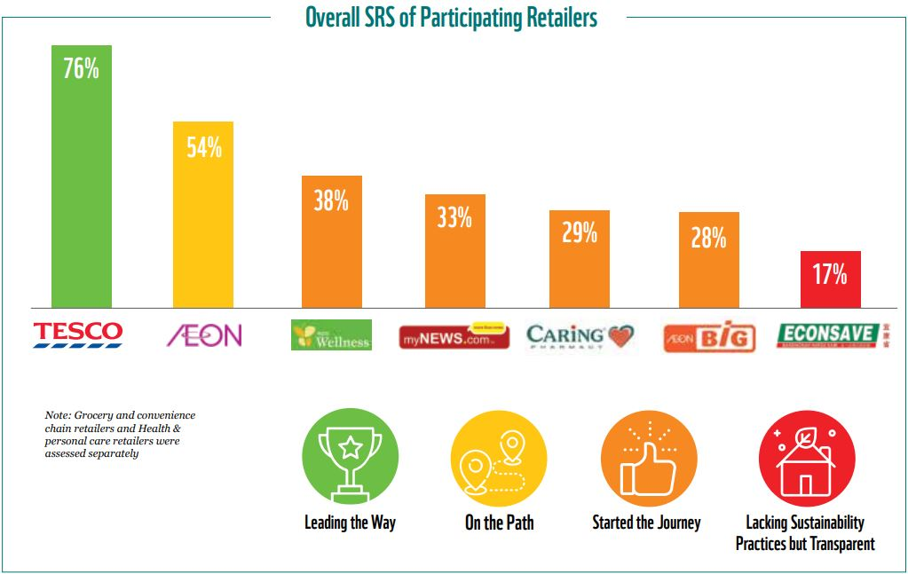
Figure: Tesco bagged the first price in sustainable retailing (retail-insight-network.com 2022)
Tesco’s CEO Ken Murphy said that the future vision of the company will contribute greatly in achieving a remarkable reduction of carbon emissions by the use of re-generable power sources and will enhance the UK’s image vis-à-vis climate change and action commitments. Oxfordshire, Anglesey, and Essex are the three areas where, Tesco will install solar firms in partnership with the energy investor Low Carbon (Zhongming, Wangqiang and Wei 2018). That is how, they will directly contribute to a reduction of 30,300 tons of annual CO2 reduction which is commensurate to the replace the emissions of around 14500 cars per year. Tesco will do the project not just as a measure of its CSR initiatives, but also on the ground of strategic vision for future business and cutting down the operational and transportation cost that will jointly reduce the prices of the products benefitting the affordability of the customers to a large extent (edie.net 2021).

Blog Post 5- The Future of the Grocery Shopping in the UK
Tesco will revolutionize the way of grocery shopping in the future. Ending slavery, reducing the emissions in transport and logistics are the new way of dealing with the future challenges of retail business in the kingdom. Also, the way grocery shopping is being changed by reducing the excess congregation in the shopping malls are other example of how people are availing their goods right at their doorstep by a single click (Sultan 2020). The strategy has helped millions of people and families across the Europe to receive their essential goods of daily requirement. This updated strategy will also upscale the tough legislations, effective grievance redressal mechanisms of the consumers right under one-tap, and a very robust and organized grocery shopping right from anywhere in the UK (Adamyk 2019).
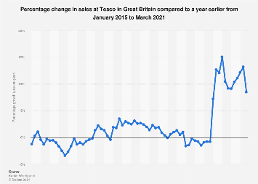
Figure: Graph showing the increasing trends of Tesco’s grocery shopping in the UK (Sultan 2020)
The post-Brexit challenge for the UK’s economy is already acting like an alarm for the strategists, which will need a more comprehensive response to the changing times and reforming nature of the economy and consumer behaviour at large. Further, people will also require other areas of deliverables such as the smart use of their time which will save excess crowding of people in shopping malls and Tesco’s outlets in the tough time of the pandemic, and the rise of shifting shopping habits of the consumers form their homes. People now a days wants a more consumer-friendly approach of delivering goods, more products in their cart, and the right and congenial option in case of a return or refund process right form their smartphones or systems for hassle-free shopping and grievance redressal mechanisms (Rosnizam et al. 2020).

Blog 6- Revolution of Grocery Shopping
The blog post will discuss the various dimension of Tesco’s business in the UK with special reference to grocery shopping and their new project of effective utilization of green-energies and reduction of food wastes. Tesco is a British-origin company that deals with a lot of areas such as merchandise retailing, grocery, software, and clothes. It is the market leader of the UK and is one of the biggest brands of the UK and has around 29% of the UK’s market share (Alam and Raut-Roy 2019). Tesco seeks to create a value-based work of the “low-cost” but quality products and services that are called “Tesco Value”. In doing so, Tesco attempts to deliver very customer-friendly and affordable prices for people with good quality. Hence, the company created the tags “Tesco Value” and the “Finest range” based on the exact requirement of the consumers. The company is proudly listed on the London Stock Exchange. The impressive history of the company is filled with its glorious past with a very bright future for the consumer sector of the UK, and the sector of retail merchandising (Evans and Mason 2018). Sophisticated products, household products, all cosmetics, and clothing are available with the stores of the company ensuring the delivery of a wide range of products and supplementing the essential goods to the millions of customers across Europe. However, Tesco is planning to launch a renewable power generation project in the UK for transforming its stores and the entire operations and functioning of its businesses for the future.

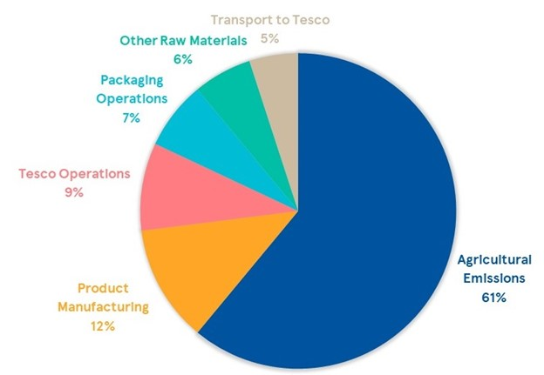Figure: Tesco’s Sustainability Steps (Alam and Raut-Roy 2019)
Also, the project seeks to partner with the like-minded players and visionist of business that not only live in the present and blame on others for the conditions and outcomes, but are the ones that actively engage, frame, and act for a sustainable future of business and consumer retailing. Furthermore, Tesco will revolutionize the way of grocery shopping in the future (Wood, Wrigley and Coe 2017). Moreover, ending slavery, reducing the emissions in transport and logistics are the new way of dealing with the future challenges of retail business in the kingdom. Also, the way grocery shopping is being changed by reducing the excess congregation in the shopping malls are other example of how people are availing their goods right at their doorstep by a single click with an effective mechanism of refund or return, and other options for grievance redressal (Guo and Wang 2019).

What are the Key Takeaways?
The blog post has discussed the various dimension of Tesco’s business in the UK with special reference to grocery shopping and their new project of effective utilization of green-energies and reduction of food wastes. Tesco is a British-origin company that deals with a lot of areas such as merchandise retailing, grocery, software, and clothes. It is the market leader of the UK and is one of the biggest brands of the UK and has around 29% of the UK’s market share (Alam and Raut-Roy 2019). Tesco seeks to create a value-based work of the “low-cost” but quality products and services that are called “Tesco Value”. In doing so, Tesco attempts to deliver very customer-friendly and affordable prices for people with good quality. Hence, the company created the tags “Tesco Value” and the “Finest range” based on the exact requirement of the consumers. The company is proudly listed on the London Stock Exchange. The impressive history of the company is filled with its glorious past with a very bright future for the consumer sector of the UK, and the sector of retail merchandising (Evans and Mason 2018). Sophisticated products, household products, all cosmetics, and clothing are available with the stores of the company ensuring the delivery of a wide range of products and supplementing the essential goods to the millions of customers across Europe. However, Tesco is planning to launch a renewable power generation project in the UK for transforming its stores and the entire operations and functioning of its businesses for the future. Also, the project seeks to partner with the like-minded players and visionist of business that not only live in the present and blame on others for the conditions and outcomes, but are the ones that actively engage, frame, and act for a sustainable future of business and consumer retailing. Furthermore, Tesco will revolutionize the way of grocery shopping in the future (Wood, Wrigley and Coe 2017). Moreover, ending slavery, reducing the emissions in transport and logistics are the new way of dealing with the future challenges of retail business in the kingdom. Also, the way grocery shopping is being changed by reducing the excess congregation in the shopping malls are other example of how people are availing their goods right at their doorstep by a single click with an effective mechanism of refund or return, and other options for grievance redressal (Guo and Wang 2019).

References
Adamyk, K., 2019. PESTLE Analysis on Tesco PLC.
Aiello, L.M., Quercia, D., Schifanella, R. and Del Prete, L., 2020. Tesco Grocery 1.0, a large-scale dataset of grocery purchases in London. Scientific data, 7(1), pp.1-11.
Alam, S. and Raut-Roy, U., 2019. Evaluating the Effectiveness of Reward Strategy at Tesco: Evidence from Selected Stores in UK. Indian Journal of Industrial Relations, 55(1).
Evans, B. and Mason, R., 2018. The lean supply chain: managing the challenge at Tesco. Kogan Page Publishers.
Guo, L. and Wang, Z., 2019. Ratio analysis of J Sainsbury plc financial performance between 2015 and 2018 in comparison with Tesco and Morrisons. American Journal of Industrial and Business Management, 9(2), pp.325-341.
Junxiong, L. and Gareth, S., 2019. Consumer decision making in the use of mobiles for grocery shopping in the UK.
Mackenzie, A., 2018. Personalization and probabilities: Impersonal propensities in online grocery shopping. Big Data & Society, 5(1), p.2053951718778310.
Rosnizam, M.R.A.B., Kee, D.M.H., Akhir, M.E.H.B.M., Shahqira, M., Yusoff, M.A.H.B.M., Budiman, R.S. and Alajmi, A.M., 2020. Market Opportunities and Challenges: A Case Study of Tesco. Journal of the Community Development in Asia (JCDA), 3(2), pp.18-27.
Singh, R., 2019. Why do online grocery shoppers switch or stay? An exploratory analysis of consumers’ response to online grocery shopping experience. International Journal of Retail & Distribution Management.
Sreenivasan, R., Ludbrook, L., Fisher, B., Declosmenil, F., Knower, K.C., Croft, B., Bird, A.D., Ryan, J., Bashamboo, A., Sinclair, A.H. and Koopman, P., 2018. Mutant NR5A1/SF‐1 in patients with disorders of sex development shows defective activation of the SOX9 TESCO enhancer. Human mutation, 39(12), pp.1861-1874.
Sultan, A., 2020. Effective leadership and its impact on organisational performance: retail industry (Tesco) (Doctoral dissertation, University of the West of Scotland).
Tesco and Low Carbon Announce Major New Sustainable Energy Project with the Creation of Three New Solar Farms by 2021 - 1 | Low Carbon (2020). Available at: https://www.lowcarbon.com/news-feed/tesco-and-low-carbon-announce-major-new-sustainable-energy-project-with-the-creation-of-three-new-solar-farms-by-2021/ (Accessed: 15 December 2021).
Tesco launches new manifesto to tackle climate change (2021). Available at: https://www.retail-insight-network.com/news/tesco-manifesto-climate-change/ (Accessed: 15 December 2021).
Tesco unveils climate manifesto to assist net-zero target (2021). Available at: https://www.edie.net/news/9/Tesco-unveils-climate-manifesto-to-assist-net-zero-target/ (Accessed: 15 December 2021).
Wood, S., Wrigley, N. and Coe, N.M., 2017. Capital discipline and financial market relations in retail globalization: insights from the case of Tesco plc. Journal of Economic Geography, 17(1), pp.31-57.
Zhongming, Z., Wangqiang, Z. and Wei, L., 2018. UK’s largest companies pledge hundreds of millions of pounds to tackle climate change.

