University of Wales Trinity Saint David

School of Engineering

Optimisation of a high speed 3 cylinder using the Ricardo WAVE engine development software

Advanced Computational Methods

M6X00408
Ryan James 0751093

16.01.20
Contents
1 Introduction 1
1.1 Aims 1
1.2 Objectives 1
2 Ricardo Wave software 2
2.1 Basic settings 2
3 Advanced Wave settings 3
3.1 Combustion 3
3.1.1 Wiebe 3
3.2 Heat transfer 4
3.2.1 Woschni 4
3.3 Friction 4
4 Real data and Given model 4
5 Methods to asses simulation accuracy 4
5.1 Comparing initial with original 5
5.1.1 Pressure Graph 5
5.1.2 Burn Rate Graph 5
5.1.3 Log PV Graph 5
5.2 Repairing Faults 5
6 Initial adjustments 5
6.1 Overall percentage change Graph 7
6.1.1 Worst Log PV 7
6.1.2 Best Log PV 8
7 FARD study 8
7.1.1 Overall Percentage change Graph 8
7.1.2 Best Log PV 8
8 Increasing the Performance 9
8.1 Port Length selections 9
8.1.1 10250 RPM 3d power increase 9
8.1.2 13000 RPM 3d power increase 10
8.1.3 14400 RPM 3d power increase 10
8.1.4 Overall all RPMS 3d power increase 11
9 Exhaust wall and Piston Head Temperature Study 11
10 Exhaust Gas and Piston Head Temperature Study 11
10.1 Table of selected study Temperatures 11
10.2 Difference in Max Pressure % 12
10.3 Difference in Area of Pressure % 13
11 Conclusion 13
12 References 14
13 Appendices 14
13.1 Initial Graphs 14
13.2 Overall Graphs for 49 cases at 3 RPMs 14
13.2.1 Max Pressure Difference in bar from original every Run all RPMs 14
13.2.2 Max Pressure Difference in % from original every run all RPMs 14
13.2.3 Area of Pressure Difference in % from Original Every Run all RPMs 14
13.2.4 % Difference compression Polytropic index every graph all RPMs 14
13.2.5 % Difference Expansion Polytropic index every graph all RPMs 14
13.2.6 Total Percentage Differences for every Run all RPMs 14
13.3 Port Length Study 14
13.4 Exhaust Gas and Piston Head Temperature Study 14
13.5 Exhaust Wall land Piston Head Temperature Study 14

Figure 1 Results From Experiment 2

Table 1 Results From Experiment 4

Introduction

Aims
- Gain understanding of modelling software
- Prove the software’s relevancy and use to predict trends
- Find the limitations of the software and what operators should know when modelling.
- Show the limitations and advantages of 1 dimensional fluid dynamics and how representative it is.

Objectives
- Analyse the given real data
- Analyse the given Wave model
- Match and validate wave model to real data with realistic settings
- Improve the performance of the engine
- Carry out multiple studies on a variety of settings

Real data for comparison
Real dynamometer data has been given to validate the wave software and model. This data has cylinder pressure, mass fraction of fuel burnt and volume of cylinder all per degree at 3 engine speeds 10250rpm, 13000rpm and 14400rpm. It has been assumed it was an engine dyno test at full throttle, fuel quality, ambient temperatures and pressures were not given but a PDF of another dyno output has been given so those settings were assumed to be the same.
To compare with future wave data gauge pressure was converted absolute and volume percentage was converted to m³ in MATLAB.

Ricardo Wave software
- The assignment has been given with a pre-built model of triumph Daytona 675
- The model is loaded in and the given exhaust and cam profiles are loaded in
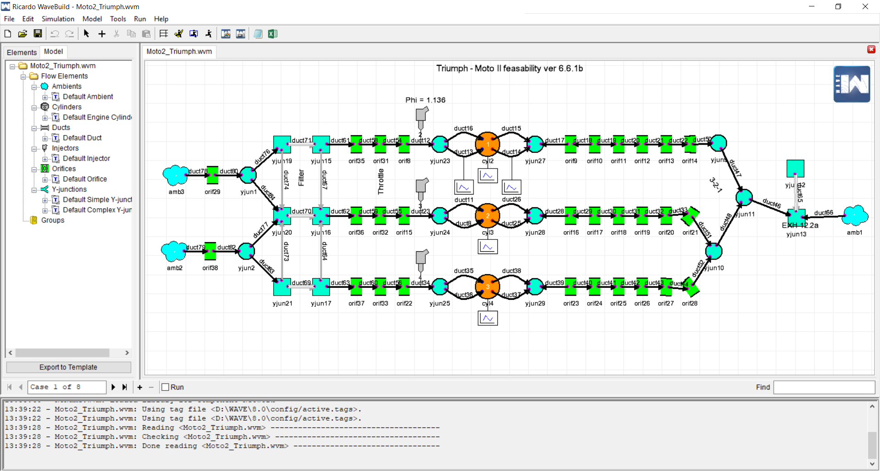
Figure 1 Wave model Design screen

Basic settings
- Figure 1 shows the model once loaded in.
- The lest hand side (ambient 2 and 3) in the model window shows the beginning of the air intake. Here the outside air pressure and temperature can be set.
- The intake ducting can be altered for length and wall temperature to model actual size and engine heat.
- The air filter provides resistance to flow with porosity blocks (as does the exhaust silencers), to help simulate reality causing a pressure difference either side.
- After the air filter the orifices, junctions and ducts represent the intake manifold and throttle body assemblies (a variety of different throttle positions can be simulated).
- Junctions are added to create intake and exhaust branch joints giving joint angles, that help simulate resistance to fluid flow.
- Injectors are added to the air intake (non-direct injection) from this point on the fluid is a fuel mixture set within its settings.
- Fuel type is selected within the injector this has not been changed as the dyno data does not say what type is used.
- Junctions and ports contain cylinder head geometry
- Valve sections contain valve diameters and here the lift profiles of the cam shafts can be added.
- The cylinders contain the main engine and valve geometry (bore, stroke, con-rod length and clearance volume). This has a massive effect on the increase in pressure of the engine as $PV=nR_{u}T$ it can be seen that volume is inversely proportional to pressure.
- The exhaust system is split into ducts, junctions and orifices to allow control of wall temperatures and gas temperatures throughout the simulation. The silencer sections have porosity as previously stated.
- The exhaust exit conditions can be set independently from the intake as the surrounding temperature may be different or at high vehicle speeds drag may create lower pressure behind the exhaust compared to the intake if this need to be simulated.

Advanced Wave settings

Combustion model

SI Wiebe
Adjusting the m exponent and the 10, 50 and 90% burn points have a massive effect on the way the combustion is modelled. It simulates how the fuel is burnt which drives the pressure increase.

Heat transfer

Woschni
The standard Woschni is the closest available in wave, the Woschni GT model would be more realistic according to (Zak, Emrich, Takats, & Macek, 2016). Within the Woschni model the heat transfer multipliers can be altered to give more representative figures to match test data.

Friction
Multipliers can be adjusted to correct the power output once the pressure is matched.

Real data and Given model

Difference across cylinders
Above shows the difference in results on wave across each cylinder and RPM for 1 run. As it is not known which cylinder is given in the dyno data an average of theses 3 was used to compare with dyno data.

Base run
Bellow shows the actual data and Simulated Data from the first run with no settings changed.
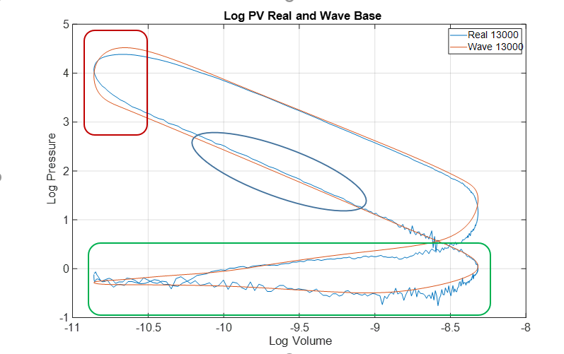
- Log PV has been chosen to compare data as it shows in more detail the difference that is happening during the entire cycle than the pressure graph that just shows the difference in maximum pressures, the polytropic index can be calculated from it the difference in maximum pressure can be seen on it, the difference in valve opening positions can be seen and a prediction of output and loss can be made from the size of the pumping loop and power loop.
- The wave data shows a greater increase in pressure at combustion (within Red box) the departure from the straight line shows the start of combustion (Heywood, 1988), from this it can be seen the wave model burns its fuel faster at a later starting point.
- The poly tropic index for compression is lower in the wave data (blue circle) $N= \frac{\log{P2- \log{P1}}}{\log{V1}- \log{V2}}$
- The wave Data does not model the turbulence during intake and exhaust strokes, that is noise within real data (Green Box).
- The maximum pressure is higher in the Wave simulation.

Comparing Burn Rates
The rate at which the fuel burns drives the increase in pressure with the decrease in volume. If the burn rate is too fast the quick increase in pressure risks a pre detonation event.

Mass Fraction Burn Graph
- To create the MFB graph the burn rate from wave needs to be accumulatively totalled, this is done simply with the MATLAB “cumtrapz” function.
- The burn rate graph shows what the LogPV diagram predicted that the wave model has a faster burn rate at a later starting point.

Methods to asses simulation accuracy
A MATLAB script was created to automatically asses the data, speeding up the process and reducing human error. The criteria are:
- Difference in maximum pressure from original for each RPM (%).
- Difference in area of the pressure graph from original for each RPM (%).
- Difference in compression poly tropic index from original for each RPM (%).
- Difference in expansion poly tropic index from original for each RPM (%).
- The absolute sum of all above changes to calculate overall closest.
The crank angles selected to take the polytropic index were from the original data as automating this did risk when using the same crank angles would pull data in the burn zone. But this would further illustrate the difference in percentage change from original Polytropic index and how inaccurate that wave run was.
This allowed many “runs” to be performed and the change monitored quickly without having to plot multiple graphs. Selected runs have been analysed in detail.
Later the power % difference was analysed to modify the engine and increase the power.

Repairing Faults
Errors in the command window were found that were not fatal stopping the run but could easily be fixed.
- ‘Diameter junction 20 duct 84’ Changing duct 84 diameter from “Auto” to 101.7mm (the size of its connecting piece)
- ‘Duct 65 y junction 13 volume’ Adjusting Duct 65 left and right Diameter from 5.64mm to 2.2117mm this is back calculated from the required volume.

Initial adjustments
- Adjust settings to PDF provided for 10250RPM
- Analyse real data and extract fuel burn information for settings.
Run name | Setting | before | Changed to | Reason
Base | - | - | - | Analyse the difference between wave model and Real Data
Rod | Con-Rod Length | 98mm | 104.6mm | Match PDF
Rod | Inlet Valve Diameter | 29mm | 31mm | Match PDF
Rod | Inlet Valve Port | 28.3mm | 30.3mm | Match PDF
Burn 1 | Burn Duration (BDUR) 10° to 90° | 20° | 37° | Match PDF
Burn 2 | BDUR 10250 RPM | 37° | 26.5° | Interpolating Real DATA
Burn 2 | BDUR 13000 RPM | 37° | 28.2° | Interpolating Real DATA
Burn 2 | BDUR 14400 RPM | 37° | 27.2° | Interpolating Real DATA
Burn 2 | Crank angle at 50°(THB50) 10250 RPM | 8° | 9.2° | Interpolating Real DATA
Burn 2 | THB50 13000 RPM | 8° | 10.5° | Interpolating Real DATA
Burn 2 | THB50 14400 RPM | 8° | 7.2° | Interpolating Real DATA
Ambient | Ambient Temperature | 300 k | 293 k | Match test DATA
Ambient | Ambient Pressure | 1.065 bar | 1 bar | Match test DATA
M 1 | M exponent of Wiebe function 10250 | 2 | 3.2 | Curve Fitting in MATLAB Toolbox (A exponent was below 1)
M 1 | M 13000 RPM | 2 | 3 | Curve Fitting in MATLAB Toolbox (A exponent was below 1)
M 1 | M 14400 RPM | 2 | 3.95 | Curve Fitting in MATLAB Toolbox (A exponent was below 1)
M 2 | M 10250 RPM | 2 | 2.65 | Curve Fitting in MATLAB Toolbox (A exponent 5)
M 2 | M 13000 RPM | 2 | 2.85 | Curve Fitting in MATLAB Toolbox (A exponent 5)
M 2 | M 14400 RPM | 2 | 2.9 | Curve Fitting in MATLAB Toolbox (A exponent 5)

- The first settings were all changed with information given on a PDF.
- The 10 50 and 90% burn points were gained from interpolating the original data
%% 10 50 and 90 burn rate percent degrees

br = [10;50;90];

for i = 1:3

BR_num(:,i) = interp1(Burn_Rate_O(324:389,i),Ca_O(324:389,:),br,'pchip');

end

- The ‘m’ exponent of the Wiebe function can be found by curve fitting the MFB graph. As wave uses the 10 and 90 positions to drive the ‘a’ exponent what is selected in curve fitting makes a large difference.
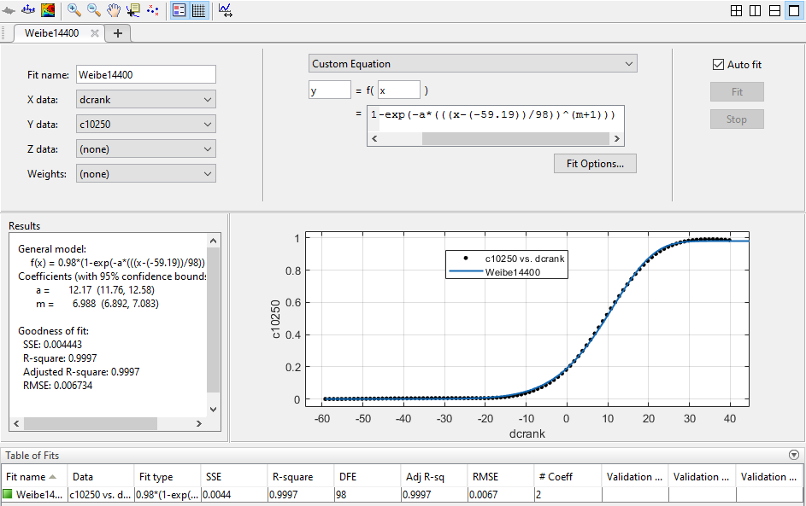
- From the curve fitting tool it can be seen when the entire MFB graph is selected ‘a’ works out to be 12 this seems too high as Heywood indicates ‘a’ should be around 5 and ‘m’ around 2. Forcing ‘a’ to be 5 creates a be curve fit and ∴a poor R squared value. Alternatively selecting DATA around 5 to 95% MFB gives the values used in M1 this gives ‘a’ around 8. Then selecting values closer to the 10 to 90% give ‘a’ closer to 5 and the values of the ‘m’ exponent seen in M2.

Overall percentage change Graph
- This graph shows the previously mentioned percentage differences totalled and absolute for each run.
- The changes made in general brought the overall difference closer to zero.
- At 10250 the change in m caused the difference from original to increase.
- Looking at the individual parts that drive the 10250 the maximum pressure increases as the total pressure area decreases. The change in m brought the polytropic index values closer.

10250 M2 Log PV
- Investigation the Log PV diagram shows the burn section is more curved and looks less like the ideal isochoric burn seen in the base Log PV earlier.
- The increased pressure rises even though realistic burn timing was given is believed to be due to the quantity of fuel.
- At 13000 RPM the effect of all the changes has brought the cycle very close.
- The air fuel ratio changes throughout RPMs as the faster cycles need a richer mix to propagate the flame quicker in the reduced time.
- When making the mixture richer wave mainly increases the pressure as the burn time is driven from the ‘m’ exponent and the 10, 50 and 90% burn points.

FARD study
The Fuel Air Ratio was adjusted between rich and lean and then an optimum was selected from those results for each RPM.
Run name | Setting | before | Changed to | Reason
F1 | 10250 FARD | 0.078 | 0.075 | Lean off to see effect
F1 | 13000 FARD | 0.078 | 0.075 | Lean off to see effect
F1 | 14400 FARD | 0.078 | 0.075 | Lean off to see effect
F2 | 10250 FARD | 0.075 | 0.08 | Richer To see the effect
F2 | 13000 FARD | 0.075 | 0.08 | Richer To see the effect
F2 | 14400 FARD | 0.075 | 0.08 | Richer To see the effect
F3 | 10250 FARD | 0.08 | 0.07 | From Previous adjust to best
F3 | 13000 FARD | 0.08 | 0.073 | From Previous adjust to best
F3 | 14400 FARD | 0.08 | 0.085 | From Previous adjust to best

Percentage change Graph
- This study proves that the engine on the dyno runs richer as the RPM increases and when that is added to wave the model becomes closer to reality.

Increasing the Performance
For this study it would have been easy to increase ambient pressure or change the fuel to increase the pressure and power output. This technique shows the limitations of the software as with 100bar ambient pressure, 100,000bhp is obtained which is unrealistic from the engines physical point of view or combustion modelling.
The study conducted was on the cylinder head port length to see the effect it would have on the performance and how the software models pulse tuning (although most pulse tuning is done within manifolds and intake and exhaust systems). the lengths were only changed by 10mm in each direction, but they were done at 5mm intervals and the results were interpolated to find the optimum lengths and see if trends could be observed.

Port Length selections
Performance Study |  | Exhaust port length (mm)
 |  | 19 | 24 | 29 | 34 | 39
inlet port length (mm) | 32 | Run1 |  | Run2 |  | Run3
inlet port length (mm) | 37 |  | Run4 |  | Run5
inlet port length (mm) | 42 | Run6 |  | Original |  | Run7
inlet port length (mm) | 47 |  | Run8 |  | Run9
inlet port length (mm) | 52 | Run10 |  | Run11 |  | Run12

10250 RPM 3d power increase
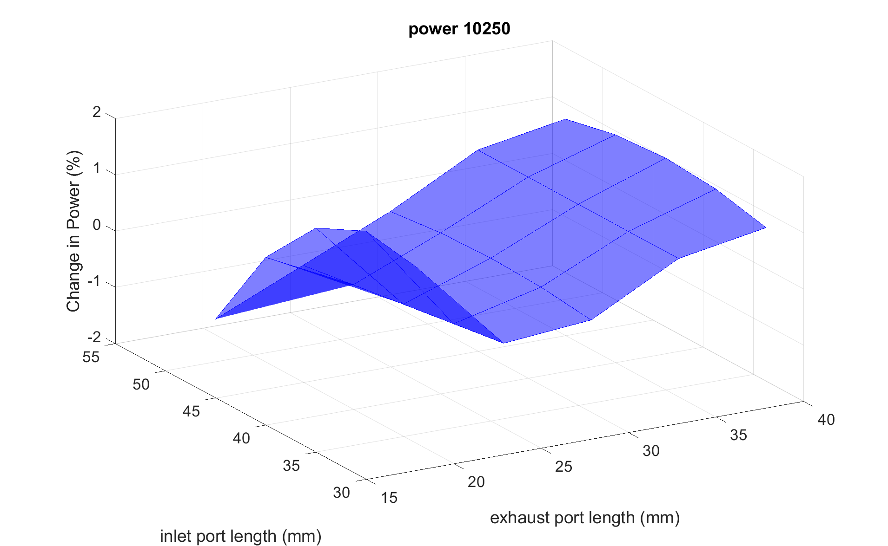
- This shows at 10250 a longer exhaust port gives the freedom to select any inlet port length without any real penalties.

13000 RPM 3d power increase
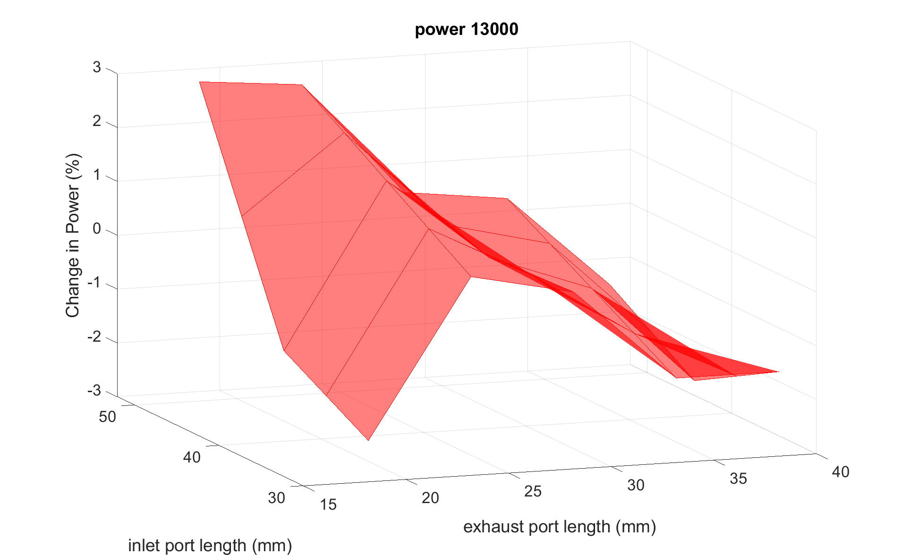
- This shows a shorter inlet port length and medium exhaust port length are optimum at 13000RPM

14400 RPM 3d power increase
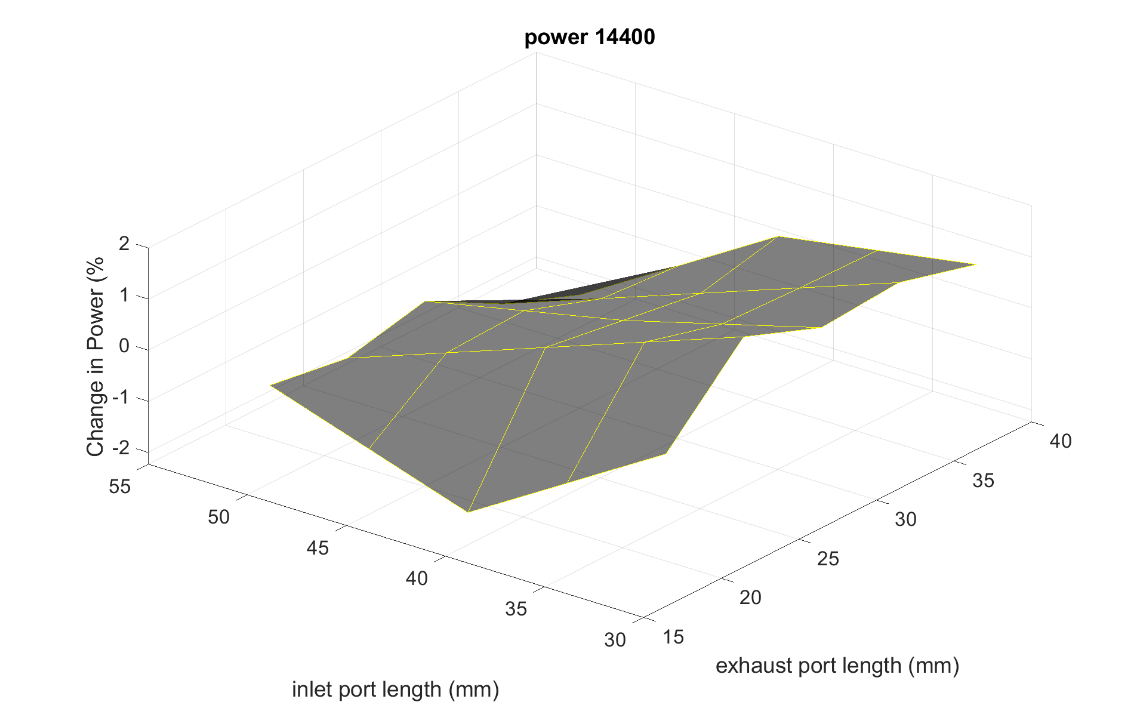
- At 14400 RPM a shorter inlet port is optimum to provide less restriction to the high-speed gases entering.

Overall all RPMS 3d power increase
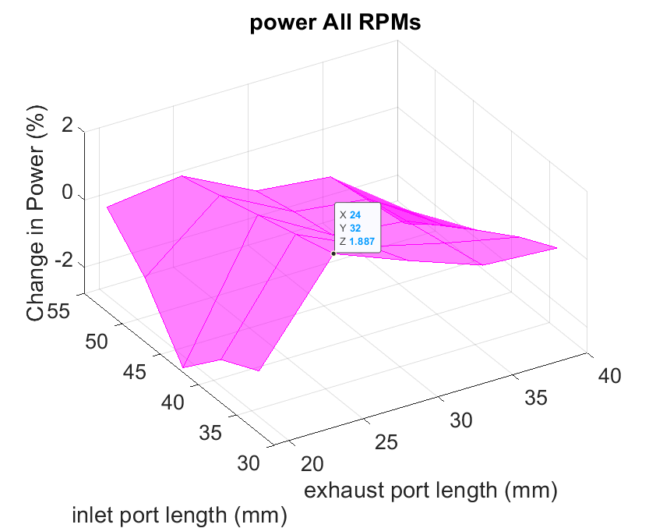
- When the change in power is averaged across all RPMs for each port length, 32mm inlet port and 24mm exhaust port would be the best.
- This would result in a 1.6% increase at 14400RPM a 0.5% increase at 13000RPM but a 0.27% decrease in power at 10250RPM.

Exhaust wall and Piston Head Temperature Study
An additional study has been carried out on changing the temperature on the piston head as this should increase cylinder temperatures and ∴ increase the pressure. With piston head the exhaust wall temperature has been adjusted to see if a hotter exhaust will allow a faster speed of sound and better scavenging and higher pressures.
Exhaust Wall and Piston Head Study |  | Exhaust wall temperature (K)
 |  | 750 | 800 | 850 | 900 | 950
Piston Head temperature (K) | 450 | Run1 |  |  |  | Run3
Piston Head temperature (K) | 500
Piston Head temperature (K) | 550 |  |  | Original
Piston Head temperature (K) | 600
Piston Head temperature (K) | 650 | Run4 |  |  |  | Run2

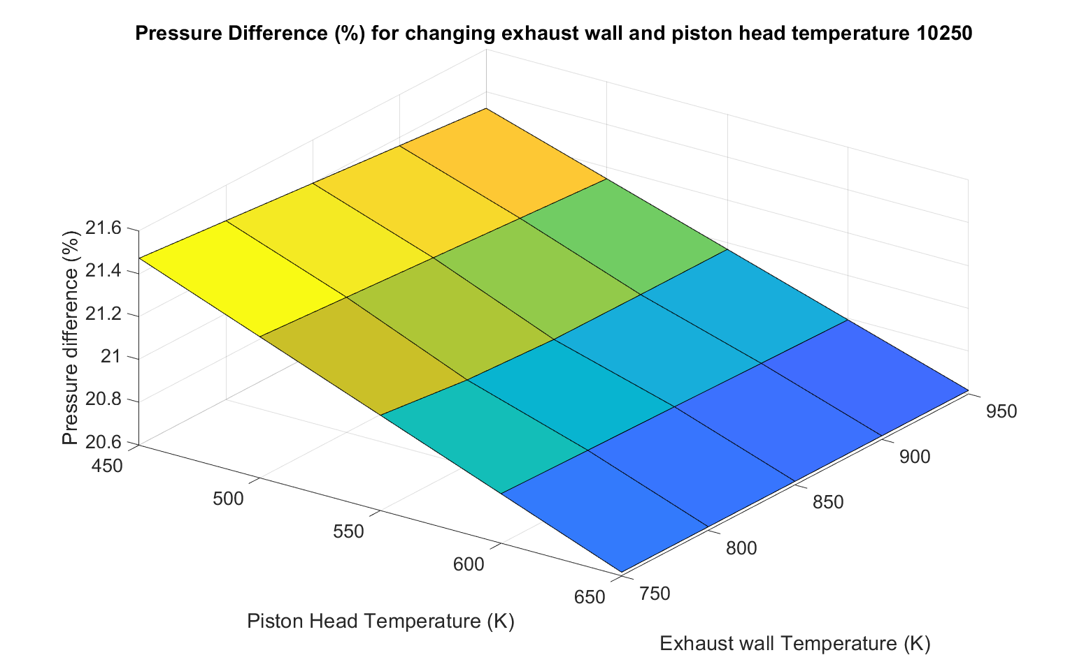
- This shows the piston head temperature make a massive difference to the pressures. This would be useful when trying to work out a material for a piston.
- The exhaust wall temperature has little effect.

Exhaust Gas and Piston Head Temperature Study

Table of selected study Temperatures
As the user has to set all boundary conditions and changing the exhaust wall temperature does not increase the gas temperature. This would be why the previous study exhaust wall temperature had little effect on pressures. So, the following study has been conducted on piston head and exhaust gas temperature.
Exhaust Gas and Piston Head Study |  | Exhaust wall temperature (K)
 |  | 600 | 650 | 700 | 750 | 800 | 850 | 900 | 950 | 1000 | 1050 | 1100 | 1150
Piston Head temperature (K) | 350 | Run 2 |  |  |  |  | Run 3 |  |  | Run 4 |  |  | Run 5
Piston Head temperature (K) | 400
Piston Head temperature (K) | 450 |  |  |  | Run 6 |  |  | Run 7 |  |  | Run 8
Piston Head temperature (K) | 500 |  |  |  |  |  |  |  |  |  |  | Run 9
Piston Head temperature (K) | 550 |  |  |  |  | Run 10 |  | Run 11 |  |  | Run 12
Piston Head temperature (K) | 600 |  |  |  |  |  |  |  |  |  |  |  | Run 13
Piston Head temperature (K) | 650 | Run 14 |  |  | Run 15 |  |  |  | Run 16 |  |  | Run 17

Difference in Max Pressure %
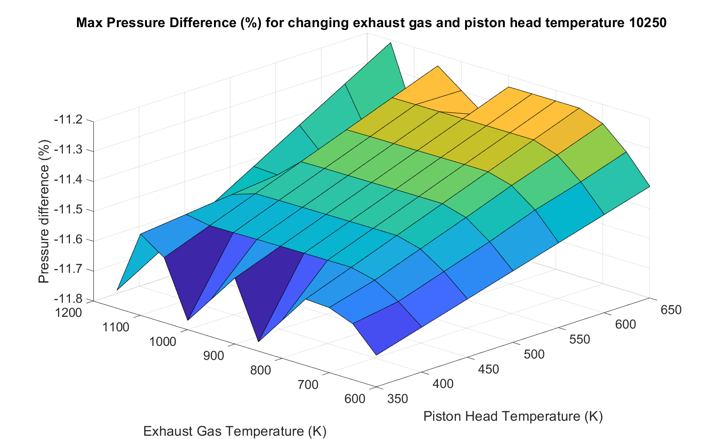
- Again, this show the temperature of the piston head has a massive effect on pressures as expected.
- Apart from at extreme gas temperatures there was little effect on cylinder pressure.

Conclusion
- Wave generally predicts trends well that would be seen when changing boundary conditions.
- Wave does not limit the boundary conditions and allows bad data in bad data out this means any user should have a good grasp of a powertrain system to avoid this.
- When validating a model, the more information available from the dyno run the better as settings like ambient pressure have a massive influence on the results.
- The intake and exhaust pumping loops were always the least matched part of the Log PV diagram it would be interesting to adjust the valve timing and add swirl to see if turbulence can be modelled and the loops better aligned.
- The fast computation of wave and the fact it is not full 3 dimensional CFD does mean it won’t be able to create accurate turbulence and wall friction of the gases but the “ correction factors” wave applies do aid simplicity of use and are representative in the change of results up to a point.

References
Zak, Z., Emrich, M., Takats, M., & Macek, J. (2016). In Cylinder Heat Transfer Modelling. Journal of Middle European Construction and Design of Cars, 14(3), 2-10.

Heywood, J. (1988) Internal combustion engine fundamentals, Choice Reviews Online. McGraw-Hill. doi: 10.5860/choice.26-0943.

Heywood, J. (1988) Internal combustion engine fundamentals, Choice Reviews Online. McGraw-Hill. doi: 10.5860/choice.26-0943.

