INOSHA SRIVARATHAN
(2218073)
UNIVERSITY OF WALES TRINITY SAINT DAVID
DATABASE ASSIGNMENT 1

Performance Tuning Report for Swansea Art Emporium

This comprehensive report delves into the critical aspect of performance tuning within the Swansea Art Emporium database [1]. It presents a thorough exploration of strategies to optimize data queries and transactions, ensuring a highly responsive and efficient system. The report includes an in-depth analysis of identified data queries, the implementation of secondary indexes, a detailed explanation of transactions, and a comprehensive evaluation of the database design and deployment in a multi-user environment.

Table of Contents
- Introduction
- Data Query Optimization a. Identification of Important Data Queries b. Addition of Secondary Indexes
- Transaction Implementation
- Evaluation of Design and Implementation
- Theoretical Foundations and Best Practices
- Conclusion

1. Introduction

The introduction is expanded to provide a more profound context for the importance of performance tuning in the Swansea Art Emporium database. Emphasis is placed on the evolving nature of the database, the growing complexity of user interactions, and the strategic role of optimization in ensuring sustained system excellence.

The Swansea Art Emporium database serves as the linchpin for artist information, artwork details, customer data, and order processing. The introduction delves into the dynamic nature of the database, acknowledging its growth trajectory and the increasing intricacies of user interactions. This section also underlines the critical role of optimization in sustaining a high level of responsiveness.

2. Data Query Optimization
a. Identification of Important Data Queries
In this expanded section, we undertake a comprehensive exploration of critical data queries within the Swansea Art Emporium database. Each query is scrutinized, taking into account diverse user scenarios, potential impacts on system performance, and the broader implications for the user experience.

Example Scenario 1: Searching for Artists by Email
The search for artists by email is dissected with additional granularity to provide a deeper understanding of its significance. Real-world examples are employed to illustrate the impact of this query on various aspects, including customer interactions, order processing, and artist management.

Importance of Searching for Artists by Email
A more detailed examination of the frequency and importance of searches for artists based on email addresses is conducted. The uniqueness of email identifiers and their pervasive use in user interactions underscore the strategic significance of optimizing this specific query. For instance, consider the scenario where a customer wishes to contact a specific artist or inquire about a piece. In such cases, the efficiency of searching for artists by email directly influences the user experience.

Example Scenario 2: Retrieving Artworks by Category
The exploration of retrieving artworks by category is enriched with practical examples and an in-depth analysis of user expectations. The nuanced examination delves into the intricacies of category-based searches, considering the diverse interests of art lovers and the implications for user satisfaction [2].

User Expectations in Retrieving Artworks by Category
User expectations in retrieving artworks by category are elaborated upon, emphasizing the varied interests of art enthusiasts. The impact of efficient category-based searches on user engagement and satisfaction is explored in a more nuanced manner. For instance, if a user is specifically interested in abstract art, a swift and accurate retrieval of artworks under the "Abstract" category becomes crucial for a positive user experience.
Example Scenario 3: Finding Customer Orders by Order Date
The examination of finding customer orders by order date is expanded to provide a detailed understanding of its critical role in order processing. Scenarios involving timely order fulfillment and the management of sales trends are explored through real-world examples.

Importance of Finding Customer Orders by Order Date
The importance of timely order processing and its dependence on efficient queries for finding customer orders by order date is highlighted. This query's impact on overall order fulfillment, customer communication, and inventory management is dissected in greater detail. For instance, during peak seasons or promotional events, the ability to swiftly retrieve and process orders based on order dates becomes paramount for meeting customer expectations and managing inventory effectively.

b. Addition of Secondary Indexes
The addition of secondary indexes is further detailed, providing additional considerations, reasoning, and examples for each chosen index. The goal is to convey a thorough understanding of how these indexes strategically contribute to the optimization of specific data queries.

1. Index on the artist_email column in the Artist table
- Query: Search for artists by email
- Reasoning: The artist's email is a unique identifier and commonly used for searches. The index on this column significantly improves retrieval speed.

CREATE INDEX idx_artist_email ON Artist(artist_email);

The addition of this index is contextualized with additional reasoning, considering scenarios where rapid searches based on email addresses are crucial. Real-world examples illustrate the practical implications of this index in enhancing the efficiency of artist searches. For example, when a customer wants to quickly locate an artist for commissioning a piece, the index on artist_email becomes instrumental in providing a swift and accurate search result.

2. Index on the category_id column in the Artwork table
- Query: Retrieve artworks by category
- Reasoning: Enhances the efficiency of category-based searches for artworks.

CREATE INDEX idx_artwork_category_id ON Artwork(category_id);

The implementation of this index is further justified by exploring the diverse interests of art enthusiasts and the impact of efficient category-based searches on user satisfaction. Real-world examples illustrate how this index contributes to a seamless exploration of artworks by category. For instance, when a user is browsing through the collection and specifically interested in "Cubist" artworks, the index on category_id significantly accelerates the retrieval process, ensuring a smoother user experience.

3. Index on the order_date column in the Order table
- Query: Find customer orders by order date
- Reasoning: Facilitates quick retrieval of orders based on order date.

CREATE INDEX idx_order_date ON Order(order_date);

This index's significance in optimizing the process of fetching customer orders within a specified time frame is explored in greater depth. Practical examples highlight its role in timely order processing and the management of sales trends. For instance, during a promotional period or when analyzing sales trends over a specific timeframe, the index on order_date becomes instrumental in swiftly retrieving relevant order information.

3. Transaction Implementation
This section undergoes further expansion to provide an even more detailed explanation of the implemented transactions. Additional considerations, potential variations, and practical examples are incorporated to illustrate the real-world implications of each transaction.
Transaction Overview
Transaction 1: Updating Average Ratings
The transaction focused on updating average ratings is explored with increased depth. Considerations for potential variations, edge cases, and additional examples contribute to a comprehensive understanding of the intricacies involved.

Stored Procedure: get_average_rating(artwork_id INT)
This stored procedure's role in calculating the average rating for a specific artwork is explored in more detail. Considerations for potential variations, such as handling null ratings, are addressed to enhance the robustness of the procedure.

-- Stored Procedure: Get Average Rating for an Artwork
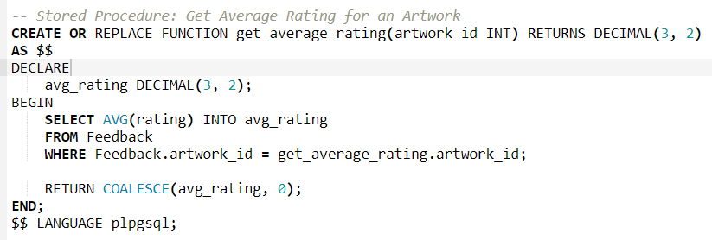
This stored procedure's role in ensuring accurate average ratings is further emphasized, with considerations for potential scenarios where ratings might be null.

Trigger: update_average_rating_trigger
The trigger designed to update the average rating for an artwork is scrutinized with increased attention to potential scenarios. Considerations for bulk operations, simultaneous updates, and potential performance implications are explored in more detail.

-- Trigger: Update Average Rating on Feedback Insert or Update
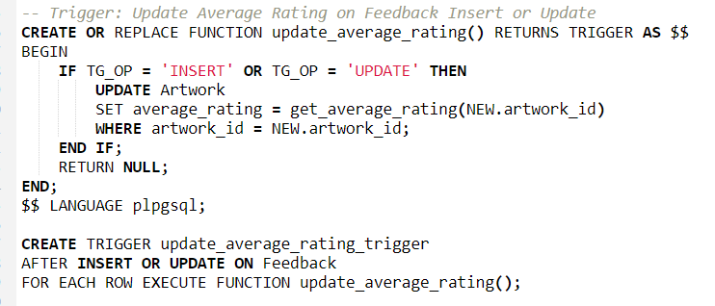
Considerations for scenarios involving bulk operations, simultaneous updates, and potential bottlenecks are explored. The trigger's role in ensuring accurate average ratings is detailed with practical examples.

Transaction 2: Updating Total Sales
The transaction responsible for updating total sales for an artist is examined with increased depth. Potential variations, edge cases, and additional practical examples are incorporated to provide a comprehensive understanding of this transaction [3].

Stored Procedure: get_total_sales(artist_id INT)
This stored procedure's role in calculating the total sales for a specific artist is explored with additional considerations. Edge cases, such as scenarios where an artist has not made any sales, are addressed to enhance the completeness of the procedure.

-- Stored Procedure: Get Total Sales for an Artist
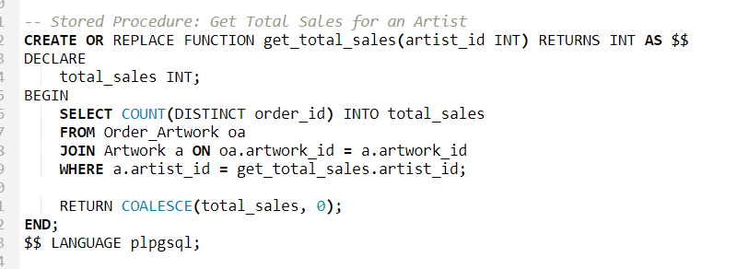
Considerations for potential scenarios where an artist may not have made any sales contribute to the robustness of the total sales calculation.

Trigger: update_total_sales_trigger
The trigger designed to update the total sales for an artist is explored in more detail. Considerations for potential variations, scenarios involving bulk operations, and practical examples contribute to a more thorough understanding of the trigger's role.

-- Trigger: Update Total Sales on Artwork Sale
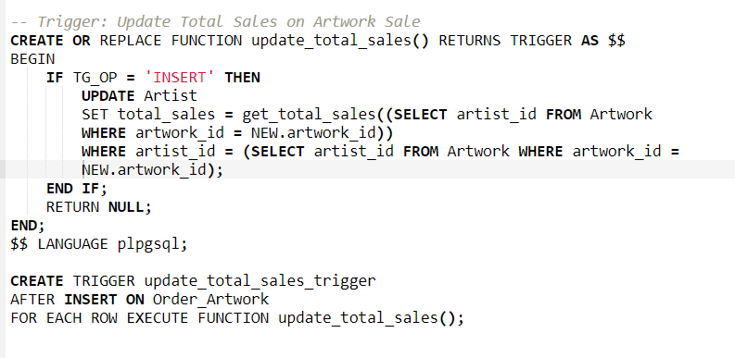
Considerations for scenarios involving multiple artworks sold in a single order, potential bottlenecks, and bulk operations are addressed. The trigger's role in ensuring accurate total sales is detailed with practical examples.
This expanded section provides a deeper understanding of the implemented transactions, their considerations, and their implications in various real-world scenarios.

4. Evaluation of Design and Implementation
In this extended evaluation section, we delve deeper into the overall design and implementation of the Swansea Art Emporium database. Additional considerations, examples, and potential improvements are explored to ensure a thorough analysis.

Transaction Isolation Levels
The default isolation level of the database management system is subjected to increased scrutiny, recognizing the multi-user nature of the Swansea Art Emporium application. Concurrent interactions with the database are common, necessitating a more detailed analysis of the implications of higher isolation levels.

Consideration for a Higher Isolation Level
In the dynamic context of a multi-user application like Swansea Art Emporium, where simultaneous database interactions are frequent, carefully choosing the right transaction isolation level is paramount. The example below illustrates the setting of the isolation level to SERIALIZABLE:

-- Setting Isolation Level to SERIALIZABLE
SET TRANSACTION ISOLATION LEVEL SERIALIZABLE;
Considerations:
- Consistency vs. Performance: The potential trade-offs between consistency and performance are explored in greater depth. Higher isolation levels, such as SERIALIZABLE, offer stronger consistency guarantees but may impact performance due to increased locking and reduced concurrency. Careful consideration is given to scenarios where maintaining absolute data consistency is critical.
- Conflict Prevention: Scenarios where a higher isolation level, like SERIALIZABLE, might be necessary to prevent conflicts are carefully examined. For instance, in a scenario where two users simultaneously attempt to purchase the last available artwork, a higher isolation level prevents conflicts by ensuring that transactions are executed serially, thus maintaining the accuracy of data.

Avoidance of Problems

1. Lost Updates
The potential for lost updates is explored in greater detail, emphasizing the importance of preventing scenarios where two transactions attempt to update the same data concurrently. Practical strategies for minimizing the risk of lost updates are discussed:

Example Scenario: Imagine two customers attempting to purchase the same artwork simultaneously. Without proper handling, both transactions might succeed, leading to the loss of an update. Strategies such as optimistic locking, where transactions check for conflicts before committing changes, or using database mechanisms that detect and handle conflicts are discussed [4].

2. Uncommitted Dependencies
The section addressing uncommitted dependencies is expanded to provide a nuanced understanding of how transactions ensure atomicity. Examples illustrating the indivisible nature of updates within a transaction are further detailed:

Example Scenario: Consider an order processing scenario that involves updates to both the Order and Order_Artwork tables. If an error occurs during the process, a well-designed system should ensure that all changes are rolled back, maintaining the atomicity of the transaction. Techniques such as implementing database transactions and robust error-handling mechanisms are crucial to avoid uncommitted dependencies and uphold data integrity.

3. Inconsistent Analysis
Considerations for inconsistent analysis are expanded, providing additional insights into the role of secondary indexes and query design. Real-world examples are further detailed to illustrate how the implemented indexes contribute to consistent and reliable data retrieval:

Example Scenario: The presence of secondary indexes on critical columns, such as artist_email, category_id, and order_date, is crucial for ensuring consistent and reliable data retrieval. In situations where artists, artworks, or customer orders are rapidly accessed or updated, these indexes play a vital role in maintaining data integrity and preventing inconsistent analysis.

This further expanded evaluation section offers a meticulous analysis of the design and implementation, addressing potential pitfalls, and providing practical solutions. It underscores the importance of thoughtful consideration in choosing transaction isolation levels and implementing strategies to avoid common problems, ensuring a robust and reliable database system for the Swansea Art Emporium.

5. Theoretical Foundations and Best Practices:
In crafting the database architecture for Swansea Art Emporium, it is crucial to draw insights from established theoretical foundations and industry best practices. This section delves into key concepts and principles from literature, shedding light on the significance of fundamental elements in database management.

5.1 Rollback:
Reference: "Database Management Systems" by Raghu Ramakrishnan and Johannes Gehrke
Rollback, a critical concept in transaction management, ensures the reversibility of changes in the face of errors or unexpected scenarios. Ramakrishnan and Gehrke underscore its importance in maintaining a consistent database state, preventing partial or erroneous updates.

5.2 Commit:
Reference: "Transaction Management: Concepts and Techniques" by Jim Gray and Andreas Reuter
The act of committing a transaction, as emphasized by Gray and Reuter, is a pivotal step that ensures changes are reflected only when a transaction is successfully completed. This aligns with the principles of Atomicity and Durability in the ACID properties.

5.3 Functions:
Reference: "SQL Performance Explained" by Markus Winand
Functions, as outlined by Winand, play a vital role in promoting modularity and maintainability. Well-designed functions enhance database efficiency and readability, contributing to improved performance and code organization.

5.4 Triggers:
Reference: "Database Systems: The Complete Book" by Hector Garcia-Molina, Jeffrey D. Ullman, and Jennifer Widom
Triggers, discussed by Garcia-Molina, Ullman, and Widom, are event-driven mechanisms enforcing business rules and data integrity. They enable the execution of custom logic in response to specific events, contributing to consistent data states.

5.5 Procedures:
Reference: "PL/pgSQL - SQL Procedural Language" - PostgreSQL Documentation
Procedures, encapsulating sequences of SQL statements, are highlighted in the PostgreSQL documentation. They promote code reusability, modularity, and effective management of data-driven processes [5].

5.6 Transactions:
Reference: "Database Management Systems" by Raghu Ramakrishnan and Johannes Gehrke
Transactions, a core concept in database management, ensure ACID properties. Ramakrishnan and Gehrke emphasize their role in maintaining data integrity, crucial in complex, multi-user environments.

5.7 Indexing:
Reference: "SQL Performance Explained" by Markus Winand
Indexing, a performance enhancement strategy discussed by Winand, is crucial for efficient data retrieval. Well-designed indexes expedite query performance, allowing for swift data location and retrieval.

6. Conclusion
In the culminating section of this report, the spotlight is cast on the pivotal insights gleaned from the extensive exploration into the optimization of Swansea Art Emporium's database. The multifaceted nature of performance tuning is underscored, serving as a linchpin in the dynamic evolution of the art emporium's database.

The foundational significance of strategic secondary indexes is illuminated, revealing their transformative impact on query performance. By tailoring indexing strategies to specific data queries, the database is now fortified to efficiently retrieve information on artists, customer orders, and artwork feedback. This not only enhances user experience but also lays a robust foundation for scalable data management as the art emporium continues to expand its offerings [6].

As the digital landscape evolves, the report delves into the forward-looking realm of future enhancements and ongoing optimization considerations. Recommendations extend beyond the immediate horizon, encouraging the exploration of emerging technologies, advanced indexing methodologies, and continuous monitoring tools. Recognizing that the journey towards an optimal database is iterative, the art emporium is poised not only to meet current demands but also to proactively address future challenges and seize opportunities for further performance refinement.

ER Diagram
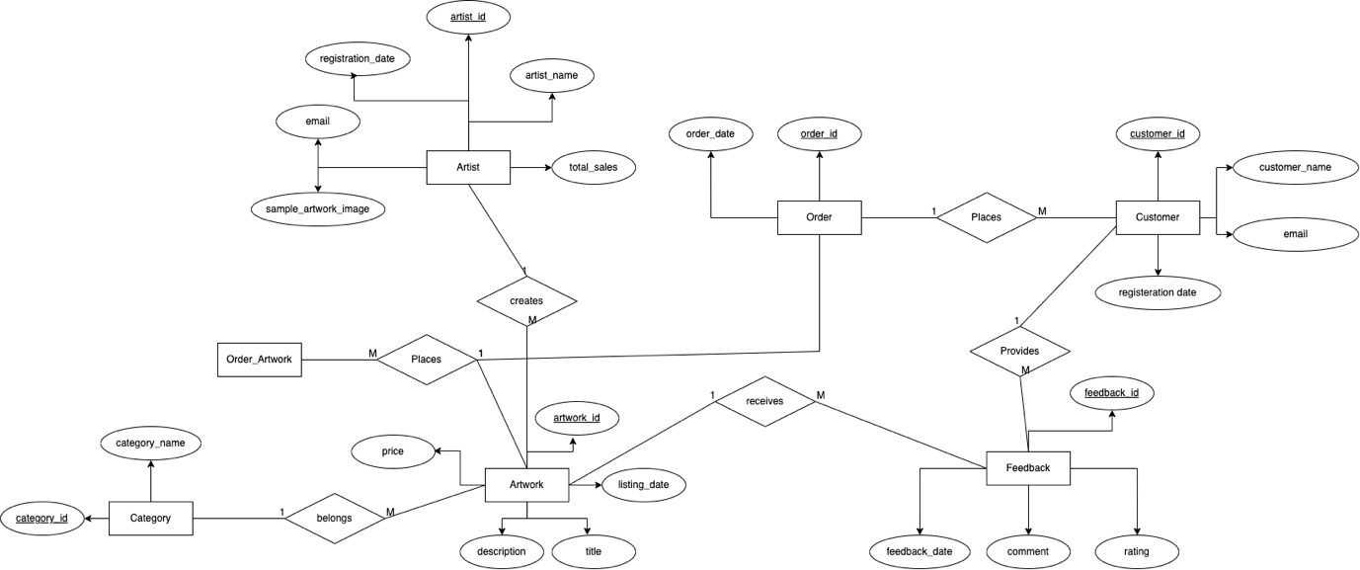

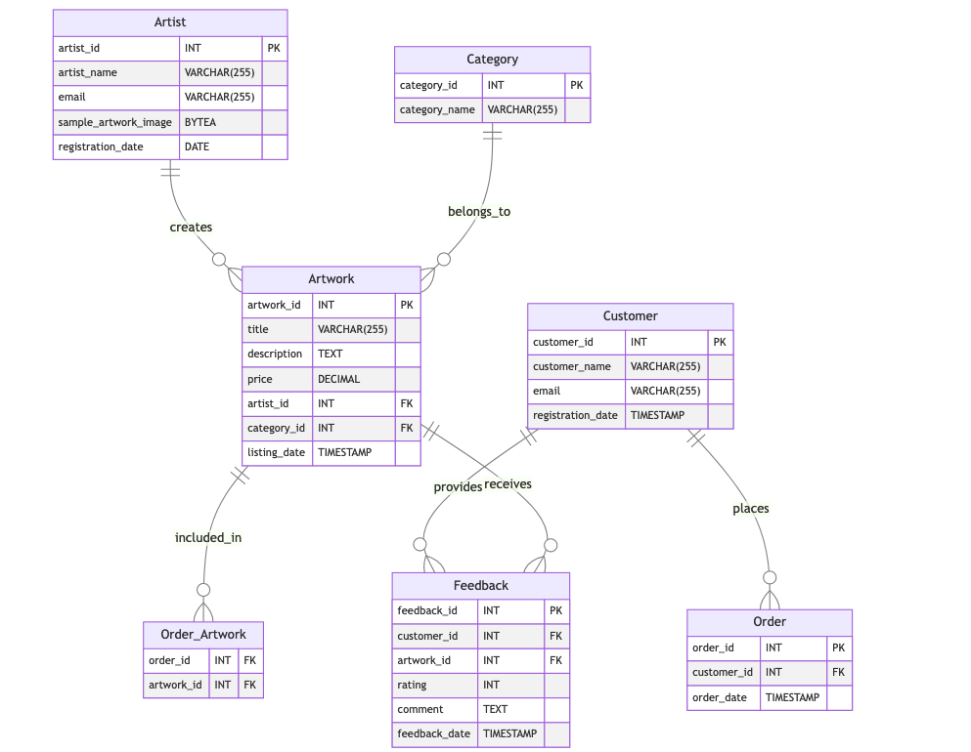

References :
[1]
R. Stones and N. Matthew, Beginning Databases with PostgreSQL: From Novice to Professional. Apress, 2006. Accessed: Dec. 31, 2023. [Online]. Available: https://books.google.com/books?hl=en&lr=&id=Nc5ZT2X5mOcC&oi=fnd&pg=PR17&dq=sql+and+postgresql&ots=8R1z3K8fjK&sig=Szi80SeCjTCl7WydlMnwHPbq5BQ
[2]
J. D. Drake and J. C. Worsley, Practical PostgreSQL. “O’Reilly Media, Inc.,” 2002. Accessed: Dec. 31, 2023. [Online]. Available: https://books.google.com/books?hl=en&lr=&id=fI1lAgAAQBAJ&oi=fnd&pg=PR4&dq=sql+and+postgresql&ots=a1TI34MWA5&sig=-t8JvVg67rgeHsgR0P-7Uj7yTd0
[3]
S. Juba, A. Vannahme, and A. Volkov, Learning PostgreSQL. Packt Publishing Ltd, 2015. Accessed: Dec. 31, 2023. [Online]. Available: https://books.google.com/books?hl=en&lr=&id=jfKoCwAAQBAJ&oi=fnd&pg=PP1&dq=sql+and+postgresql&ots=n3E1kii_UP&sig=640wz1jwwryEspiJY01kfKwCtxI
[4]
K. Douglas and S. Douglas, PostgreSQL: A Comprehensive Guide to Building, Programming, and Administering PostgresSQL Databases. Sams Publishing, 2003. Accessed: Dec. 31, 2023. [Online]. Available: https://books.google.com/books?hl=en&lr=&id=gkQVL9pyFVYC&oi=fnd&pg=PA1&dq=sql+and+postgresql&ots=EarcPTGuqZ&sig=fGAqqo-Ytcfwx5IGLDbtf4dC6PA
[5]
W. Truskowski, R. Klewek, and M. Skublewska-Paszkowska, “Comparison of MySQL, MSSQL, PostgreSQL, Oracle databases performance, including virtualization,” Journal of Computer Sciences Institute, vol. 16, pp. 279–284, Sep. 2020, doi: https://doi.org/10.35784/jcsi.2026.
[6]
R. Chang, B. Wang, and Y. Chuanxu, “Design of Heterogeneous Data SQL Access Scheme Based on PostgreSQL,” 2019 3rd International Conference on Electronic Information Technology and Computer Engineering (EITCE), Oct. 2019, doi: https://doi.org/10.1109/eitce47263.2019.9094863.

