Benefits and Drawbacks of KM to organisations
Knowledge management is a process to share individual perspective, ideas and information with other people. (Gray, et al. 2004).
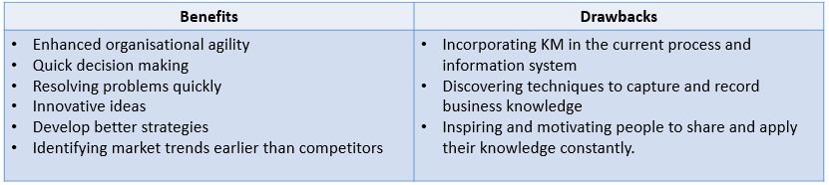
(Garfield, 2019) & (Newman, 1999)

KM in Marks and Spencer
Marks and Spencer in 2003 has rolled out an information sharing portal which is used to share knowledge and ideas to be more efficient. The aim of this was to improve communications between employees of all levels as well as having all the knowledge available to make a quicker decision. (Thomas, 2003).
Although the main aim of M&S was to improve communication and boost efficiency there are a few drawbacks to this system as not everyone is motivated or willing to share the knowledge. In addition to that some people are reluctant to change and find the system complex and hard to understand.
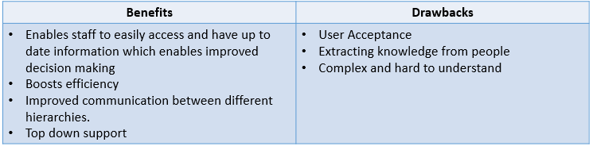

(Thomas, 2003).

Benefits and Drawbacks of KM to M&S Customers

Knowledge management is an important part of customer relationship management. KM assists M&S to better understand the needs of the customers making it relatively easy to find information when responding to customers, analysing trends and solving customer problems. Some of the main benefits are:
- Presenting to customers how KM is used for their advantage
- Showing widespread expertise in the field
- Speed of delivery of a product or service to customers
Some of the drawbacks are:
- Not being able to demonstrate knowledge to benefit customers
- Delayed response in solving customer problems
(Garfield, 2014)
M&S believe the key principle in sharing knowledge is to avoid previous mistakes. (M&S, 2016).

M&S has introduced a networking tool Yammer to share knowledge and interact with other colleagues within the organisation. (Jones, 2016).
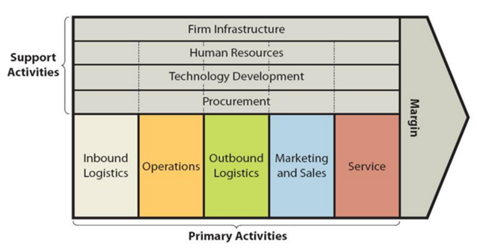
The main element of the Value chain that is beneficial to customers is service. M&S provide consistent service as they believe it will help maintain loyalty of customers. (M&S, 2009).
Some of which are:
- Shop your way
- Free delivery and returns over £30

References
Collomb, J. (2018). How Knowledge Management Improves Customer Relations. [Online]
Available at: https://www.myfeelback.com/en/blog/knowledge-management-improves-customer-relations
[Accessed 26 05 2019].

Garfield, S. (2014). LinkedIn - 15 Knowledge Management Benefits. [Online]
Available at: https://www.linkedin.com/pulse/20140811204044-2500783-15-knowledge-management-benefits
[Accessed 26 05 2019].

Gray, D., Cundell, S., Hay, D. & O' Neill, J. (2004). Learning Through The Workplace - A guide to Work-Based Learning. Cheltenham: Nelson Thornes LTD.

Howes, T. & Knight, T. (2011). Knowledge Management - A Blueprint for Delivery. London: Routledge
John Lewis Partnership, (2019). The Partnership Difference , UK: John Lewis

Jones, R. (2016). Barrow Monkey and the power of Yammer. [Online]
Available at: https://corporate.marksandspencer.com/stories/blog/barrow-monkey-and-the-power-of-yammer
[Accessed 28 05 2019].

King, S. (2017). Don’t just be a Colleague, be a Buddy. [Online]
Available at: https://corporate.marksandspencer.com/stories/blog/don-t-just-be-a-colleague-be-a-buddy
[Accessed 28 05 2019].

Lyke-Ho-Gland, H. (2016). Want Better Process Management? Think Knowledge Management. [Online]
Available at: https://www.apqc.org/blog/want-better-process-management-think-knowledge-management
[Accessed 26 05 2019].

M&S, (2016). Building Partnerships. [Online]
Available at: https://corporate.marksandspencer.com/sustainability/delivering-plan-a/leading-with-others-to-accelerate-change/building-partnerships
[Accessed 27 05 2019].

M&S, (2009). MARKS & SPENCER UNVEILS NEW-LOOK WEBSITE AND EXTENDS ‘SHOP YOUR WAY’ SERVICE. [Online]
Available at: https://corporate.marksandspencer.com/media/press-releases/2009/newlookwebsite
[Accessed 08 06 2019].

Newman, V. (1999). South African Journal of Information Management. Limitations of Knowledge Management , 1(1), pp. 1-10.

Thomas, D. (2003). M&S rolls out knowledge management network. [Online]
Available at: https://www.computerweekly.com/news/2240052101/MS-rolls-out-knowledge-management-network
[Accessed 26 05 2019].

