Component 2 - Research Report
Student Name: Imtiaz Begum
Student Number: 2128130
Lecturer Name: Munodzinesa Zuwirai
LCHS4002_BIRM
Digital Skills and Research Methods.

Contents
Introduction 2
Research design 3
Research Question 4
Method 4
Results: The survey results conducted by the students at the UWTSD. 5
1. Discussion 7
Appendix A – A blank copy questionnaire. Digital skills quiz 8
2. Reference List 10

Introduction
Different digital tools are used by students to collaborate at the UWTSD.This research will provide an insight into, which digital tool is most used by students at the UWTSD. University students use many different digital tools to collaborate, such as MS Teams, Moodle, One Drive, MS Word, MS PowerPoint, Zoom. Digital tools have become very popular and very helpful for students at the UWTSD to connect and collaborate with other students and staff.
Primary data was used to carry out the research. A survey was conducted among the students to collect information directly from the students to analyse which digital tools is most used by the students at UWTSD.The purpose of this survey is to discover which digital tool is mostly used. In order to gain a full understanding, a wide range of literature sources will be explored to help gain critical analysis of the research project.
According to recent reports, Logics Monitor (2020) researched which collaboration tool is most used, and if students were satisfied, 46% respondents said they were using MS Teams, 29% MS Powepoint,25%, admitted using combination of digital tools. Looking at the research provided by logic Monitor, it is most certain Microsoft Teams collaboration tool are very popular with individuals for collaboration, a high percentage of individuals claiming they are satisfied. Jones (2021) Microsoft Teams were the most popular collaboration tools used during the 2020-21 lockdown, a survey undertaken by TechRadar Pro and SmartBrief has found, 75% of respondents said they use Teams. It is very clear that MS Teams has become very popular among students and staff during lock down.
As stated by Klemm (2022) collaboration tool that can bring content, conversations, is MS Teams, it improves communication, productivity, and teamwork. There are great features of MS Teams this includes audio and video chat, documents, shared files, and meetings which allows individuals to stay connected, anytime, anywhere. The recordings of the meetings are available in the same tab, any missed meetings will be right there, with the meeting notes.
An increasing number of students have joined Microsoft Teams for their education, Microsoft Teams continues to grow within the education market, Endicott (2021). According to Business insider, Eran Megiddo, corporate vice president Windows Product & Education at Microsoft, told Microsoft employees that 100 million students now use Microsoft Teams. That figure shows an increase of 30 million students since the start of the 2020 in September of last year.MS Teams is the most popular communication service in the world.

.

Research design
This survey was carried out by students to collect information on, different digital tools used by students and which digital tool is most used at the UWTSD. A questionnaire was created and sent to all participants; responses were collected to analyse which digital tool is most used by students. Primary research methods were utilized, and quantitative data was used to collected data. A literature review was explored to gain a clear understanding of the topic and knowledge of the research.

Research Question
Which digital tool is most used by students at the UWTSD to collaborate?
This research will analyse which digital tool is most used by students to collaborate at the UWTSD. A questionnaire was created, and a survey was conducted by the students. Data was then directly collected.
It was hypothesised that most students would use MS teams at the UWTSD However the results conducted from the students show Moodle was the most common digital tool used by university students.

Method
A survey was created, and the student's responses were electronically collected to analyse which digital tool is most used by students at the UWTSD. Several students were approached only nine responses were received back. The methods of data collection are Primary and quantitative research, the finding of this study suggests that it is almost certain that primary data is accurate, reliable and up to date. Quantitative method provides numerical data, and a descriptive data. The responses from the closed ended survey, allowed the collection of accurate data. Using closed ended questions through the research helps remove biases and creates a more accurate finding.
These are examples of some of the questions in the survey conducted by students at the UWTSD.
Do you use WhatsApp more to collaborate with your peers than any other digital tool?
Yes: No
Do you use MS Teams more than other digital tools?
- 1. Strongly Agree:
- 2. Agree:
- 3. Disagree
- 4. Strongly Disagree

- Are you confident using different digital tools at the UWTSD?
- Yes: No:
Which digital tool do you most use at the UWTSD?
- 1. MS Teams
- 2. WhatsApp:
- 3. One Drive
- 4. Moodle.
- 5. PowerPoint
Do you find digital tools difficult to collaborate with peers.
- Yes: No
More questions attached to the Appendix
A number of literatures was also explored to understand the background, how university students collaborate using different digital tools and which digital tool is most used by students. Analysing from the literature review, most authors results show, MS Teams is most used by students at the UWTSD to collaborate. Surprisingly this contrasted with the survey conducted by the students, the results show Moodle was most used by students at the UWTSD. This could be, there were not enough students that took part in the survey to achieve the final maximum results. Several students were approached only 9 responded. Having enough people to respond to a survey is essential for getting an adequate sample size to get statistical validity. Therefor a lot more students need to participate to get maximum and accurate results.

Ethical Considerations
Ethical considerations are vital and mandatory in any project. Ethical considerations are there to diminish risk and harm to participants, as well as advance positive results by increasing trust and determining long term success. All individuals conducting a research survey have a duty to keep their participants information confidential.
All participants gave consent to participate voluntarily in this survey. All participants have the right to privacy, all personal data should be protected, this Prevents misuse of information and keeps all data secure and safe, under the general data protection regulation (GDPR). All survey respondents should be informed of all risks and must voluntarily consent to participate, ensuring participants privacy and confidentiality and anonymity is protected. This will build trust with the participants.
At UWTSD all students, must ensure that they do not share data outside the organisation, and do not falsify the results, respect people's beliefs, traditions and cultures. It is important when collecting data to treat people equally regardless of their race, gender, disability, or religion, avoidance of harm and accurate analysis when reporting data.
All participants have a right to withdraw.

Results: The survey results conducted by the students at the UWTSD.

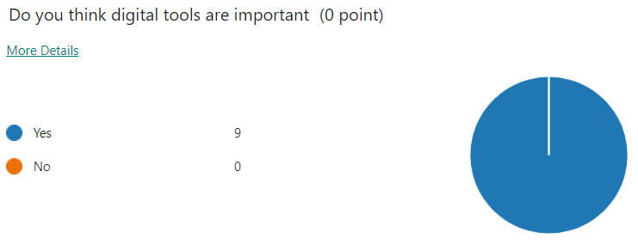
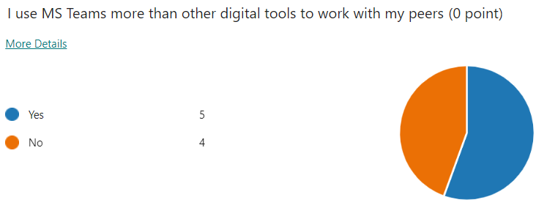

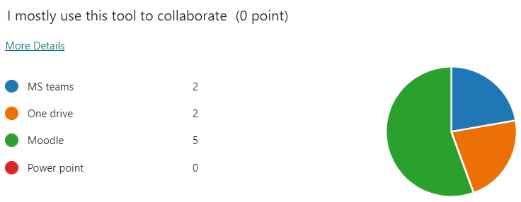

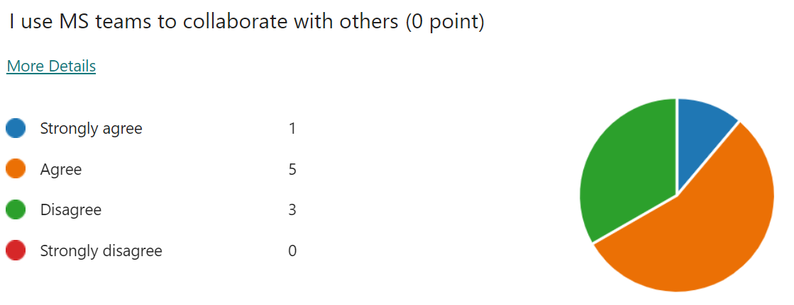
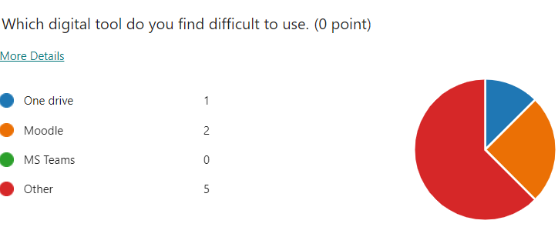

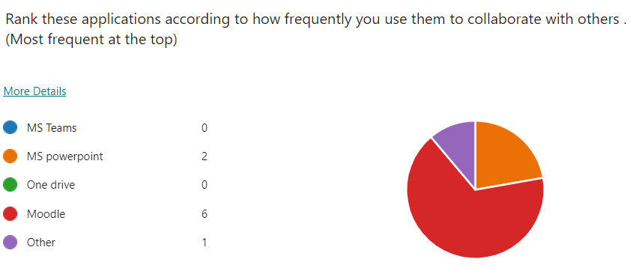
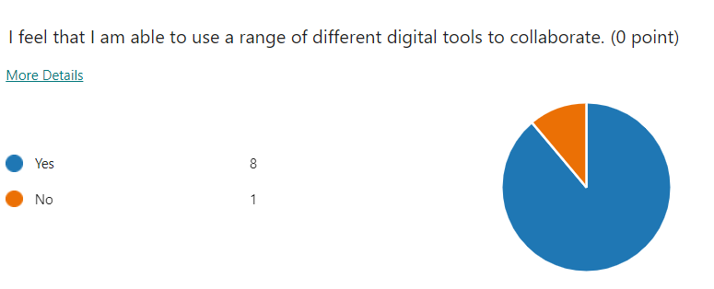

Discussion
This study was carried out to determine which digital tool is most used by students at the UWTSD. It was hypothesised before the start of the survey that most students at the UWTSD use MS teams, however after conducting the survey based on 9 responses it appeared that Moodle was the most common tool used by students at the UWTSD.The survey results are in contrast to the literature review, Unfortunately, very limited responses from students were received. More students need to participate to get statistically valid results.
According to Waugh (2019) digital tools are becoming more and more popular among students it enables more effective communication and increases productivity, 78% said access to technology helps them work more effectively. Microsoft News Centre Europe (2022) more than 13 million people are now using Microsoft Teams every day to help them in today’s modern workplace and educational institutions, people come together from all corners of the world to work on projects and get things done. Integrating chat, video meeting, calling and files into their daily lives. Rummel (2019) teachers play an important role during students' collaboration by monitoring and stimulating interactions between students. Many students use Microsoft teams because it's an easy software that allows students to collaborate, not every student has the same computer knowledge some may need additional training.
100% of students surveyed from the results, did feel digital technology is useful, and most were able to use a range of different tools to collaborate. The survey also shows that more students replied yes, using MS Teams more than other digital tools to work with peers. Another interesting observation that was observed in the analysis, most students found Power Point difficult tool to use, this may be that students did not use Power Point in their earlier education and could be unfamiliar with this digital tool.
The final results reveal Moodle is mainly used by students within the university. Over all students at the UWTSD preferred Moodle for their first choice. Additionally, a number of literatures was explored to understand the background, how university students collaborate, using different digital tools and which digital tool is most used by students. It showed that overall, MS Teams is the most commonly used tool by students. Surprisingly, the survey results are in contrast with the literature review. It could be because, not enough students took part in the survey to achieve an adequate sample size. Having enough students to respond to a survey is essential, to achieve statistical valid results. This could be the reason why the results contrasted.

CONCLUSION
A survey was conducted, and several students were approached, due to a very small number of student feedback, the results revealed that Moodle was the most used among students to collaborate. Analysis revealed from the literature review, show MS Teams is the most commonly used tool by students. Therefore, the survey results are in contrast with the literature review. To achieve better results more students need to participate to get statistically valid results.

Appendix A – A blank copy questionnaire. Digital skills quiz

1. Do you think digital tools are important.
Yes
No

2. I use MS Teams more than other digital tools to work with my peers.
Yes
No

3. I mostly use this tool to collaborate.
MS teams
One drive
Moodle
Power point

4. I use MS teams to collaborate with others.
Strongly agree
Agree
Disagree
Strongly disagree

5. Which digital tool do you find difficult to use.
One drive
MS PowerPoint
MS Teams
Moodle
MS word

6.Rank these applications according to how frequently you use them to collaborate with others.
MS teams
MS Word
MS power point
One drive
Moodle

7. I feel that I am able to use a range of different digital tools to collaborate
Yes
No

- Reference List

Klemm, A., 2022. Why Microsoft Teams is The Best Tool for Team Collaboration - Surety IT. [online] Tailored IT Services Brisbane. Available at: <https://suretyit.com.au/blog/why-microsoft-teams-is-the-best-tool-for-team-collaboration/> [Accessed 22 July 2022].
LogicMonitor. 2022. The Best Collaboration Tools for IT: MS Teams vs. Zoom vs. Slack. [online] Available at: <https://www.logicmonitor.com/blog/best-collaboration-tools-for-it-ms-teams-vs-zoom-vs-slack> [Accessed 22 July 2022].
Microsoft News Centre Europe. 2022. The features that make Microsoft Teams the ultimate collaboration tool - Microsoft News Centre Europe. [online] Available at: <https://news.microsoft.com/europe/2019/08/30/the-features-that-make-microsoft-teams-the-ultimate-collaboration-tool/> [Accessed 29 July 2022]

TechRadar. 2022. Zoom and Microsoft Teams were the big software winners in pandemic. [online] Available at: <https://www.techradar.com/nz/news/zoom-and-microsoft-teams-were-the-big-software-winners-in-pandemic> [Accessed 22 July 2022].
van Leeuwen, A. and Rummel, N., 2022. Orchestration tools to support the teacher during student collaboration: a review.

Waugh, B., 2022. [online] Available at: <https://www.vevox.com/blog/10-effective-communication-tools-to-increase-productivity By Ben waugh> [Accessed 29 July 2022]

Windows Central. 2022. Microsoft Teams reportedly has 100 million student users. [online] Available at: <https://www.windowscentral.com/microsoft-teams-reportedly-used-100-million-students> [Accessed 22 July 2022].

