An Investigative Report Into The Leadership Of Alan SUgar

Georgina Buckland
1404838
Leadership and Management, Theory and Practice
SBUS6114
Executive Summary
This report aims to provide a consideration on what leadership encompasses. Both past and present theories will be discussed and critically evaluated which will assist in gathering a comprehensive understanding. Following this discussion, Alan Sugar will be used as a case study and his identified styles of leadership will be investigated. Suitable discussion will be present to debate if power in leadership sacrifices his title as an effective leader. To round off this investigation, I will conclude on my findings and offer three recommendations to advance or support the leadership approaches of Alan Sugar.

Contents Page

1.0 Introduction 3
1.1 Definitions of Leadership 3
1.2 Overview of Alan Sugar 3
2.0 Main Findings 4
2.1 History of Leadership 4
2.2 Current and Emerging Themes 5
2.3 Leadership Approach of Alan Sugar 7
2.4 Alternative Methods 9
2.5 Leadership and Power 10
3.0 Conclusion 10
4.0 Recommendations 11
5.0 References 12

- Introduction

  - Definition of Leadership
“At the end of the first decade of the 21st Century have we cracked the problem of leadership development? Not on the evidence so far.”
(Cunningham, 2005)
The topic of leadership has proved extremely complex. Perhaps it is so subjective in nature, each individual’s impression on what a leader should be is diverse. (Stogdill, 1990) reinforces there is no consensus on a single definition to explain a leader. However, I would argue there is somewhat of a shared understanding.
Prevailing classifications of leadership include, ‘a property or set of properties possessed in varying degrees by different people’. (Jago, 1982) Yet, the generalisations of this offering make it undescriptive and of limited benefit. More recent elucidations seem more enlightening whereby they describe leadership as, ‘a process whereby an individual influences a group of individuals to achieve a common goal’. (Northouse, 2015) This definition, of which I am a particular enthusiast, is successful in highlighting the differing skills and abilities of individuals and explains how a leader is in essence, the driver behind the group of uniquely talented individuals.
However, for the sake of this investigation into Alan Sugar, I would like to consider a definition that is somewhat contrasting to its predecessors; ‘The only definition of a leader is someone who has followers’. (The Druker Foundation, 1996)

  - Overview of Alan Sugar
Alan Sugar is one of the best known British businessmen in the world. In school, Sugar ‘isolated himself and concentrated on his moneymaking ventures, showing that he wished to become a leader and an affluent man from a very young age.’ (Anon., 2019) From the age of 12, balancing three part-time jobs, Sugar has since developed into, ‘an English business magnate, media personality and political advisor.’ (Brown, 2010) Sugar has received a series of notable honours. ‘In 2000, he was knighted as part of the Queen’s New Year Honours List for services to the electronics industry. Nine years later, he became Baron Sugar.’ (Independant, 2018)

- Main Findings

  - History of Leadership
Whilst the topic of leadership and management has been a subject of interest since the dawn of man, ‘leadership studies were taken up in earnest in the early 20th century.’ (Coggings, 2016) The Trait Approach was one of the first systematic attempts to study leadership, whereby ‘great’ individuals were said to possess specific traits.
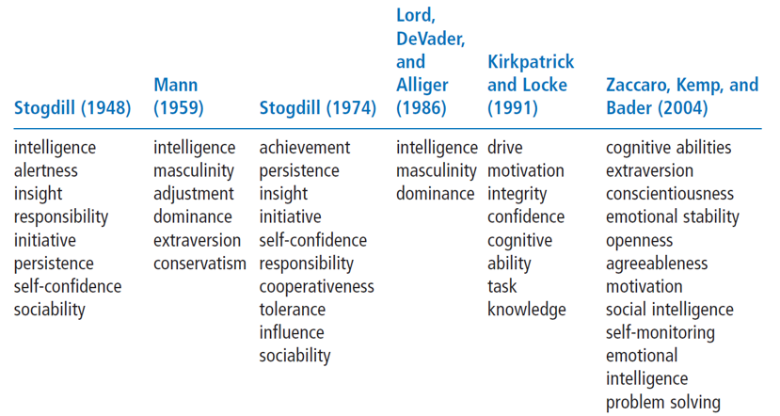
Adapted from (French and Raven, 1962)
It is fascinating how this timeline acts to tell a story of how the representation of leadership has adapted. Notice how earlier representations of a leader greatly emphasise an impression of power and supremacy; qualities I will later be relating to Alan Sugar. Although, more contemporary ideas illustrate a much more socially-aware, understanding individual. However, (Jung and Sosik, 2018) have since proposed an idea unalike to its predecessors where self-actualisation, impression management and the attention of social power are all more relevant to a current day leader. This trait approach lends itself to Kotter’s born vs made theory. Are these natural qualities in which you possess from birth, or are they learned along the way? Where this concept is beneficial by providing “benchmarks” for what to look for in a leader, to focus on traits alone would be a mistake as this fails to account for situational effects.
These former theories have since been challenged by (Stogdill, 1990) whereby he proposed there are, ‘no specific traits that differentiates leaders from followers.’ Instead, Stogdill concentrated on leaders in various circumstances and implied that they will change dependant on the situation. Other offerings have diverged further by, ‘recognising that leaders need to solve complex organizational problems’. (Mumford, 2000) Therefore, not only will a leader change based on their situation, but also, they possess the skills to make them capable to do so. A theory in itself, that suggests many people hold the potential to be a leader.

  - Current and Emerging Themes
Subsequently from these early theories, the essence of leadership has since progresses. While still placing emphasis on leaders themselves, later propositions show considerations to followers.
The situational leadership approach sparks great interest. This concept believes that, ‘leaders match their style to the competence and commitment of subordinates’. (Hersey and Blanchard, 1969)
Delegating Style
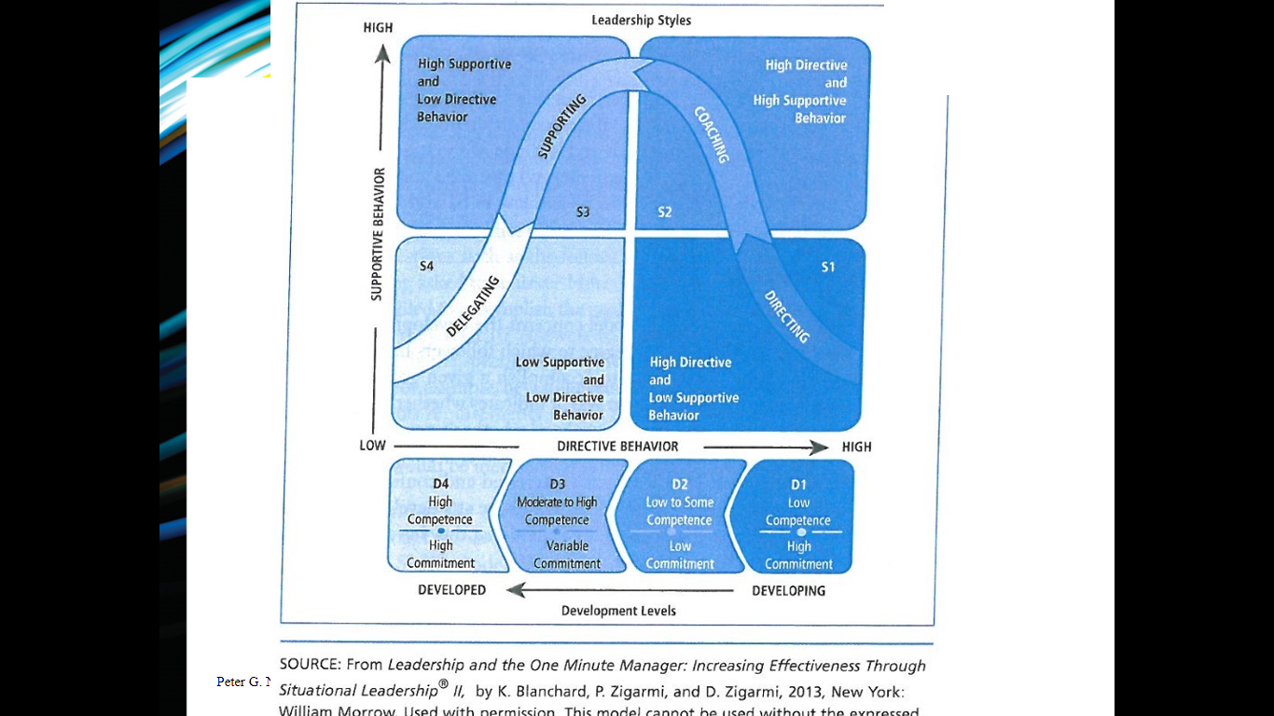

(Hersey and Blanchard, 1969)

This diagram illustrates how the directing style of a leader develops through key stages. From providing direction, which primarily focusses on goal achievement, this theory recognises that through coaching and supporting, the delegating stage can be reached, which passes responsibility to the subordinate and refrains the leader from intervention. However, in my opinion, this approach would only be applicable for some leaders as it is extremely difficult to demonstrate such a strong degree of flexibility. (Wile, 2016)

Development Levels

(Hersey and Blanchard, 1969)
This model exemplifies ‘the degree to which followers have the competence and commitment necessary to accomplish a given task or activity’. (Hersey and Blanchard, 1969) This provides reason as to why this leadership style provides a credible model for training employees to become successful and effective leaders. Though, some would criticise this model though its lack of explanation to the relation of commitment and competence. Perhaps this labels this concept as “ambiguous conceptualization”. (Northouse, 2015)

The Path Goal Theory differs from this contribution by centering itself on ‘how leaders motivate followers to accomplish designated goals’. (House, 1997) The last approach suggested that leaders had to adjust based on the follower’s development level, this idea accounts for the relationship of the subordinates in the organisational setting. Motivation is key to this notion whereby employee motivation is closely linked to performance. (Indvik, 1986) believes, ‘leaders should choose a leadership style that best fits the needs of followers and their work’. However, there is a huge implementation drawback to this notion whereby interpreting the meaning of leadership can be so complex and demanding to so. (Massarik, 1961)

  - Leadership Approach of Alan Sugar

“A strong believer in the power of ownership, Sugar understands the importance of inclusion and good communication. Leading from the front, he expects self-discipline, relentless effort and ‘hard graft’ from all those on his team. Those who live up to his expectations are rewarded with both his respect and his loyalty.”
(Smith, 2017)
Alan Sugar has consistently demonstrated signs of authoritarian leadership, with The Apprentice exemplifying his absolute power over his followers. He makes no attempts to disguise his ‘my way or the high way’ approach. (Gitman, 2008) Some may initially see this as a failing to Sugar’s approach, however I would like to challenge that reasoning and offer an alternate viewpoint.

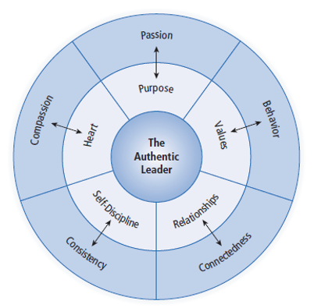
The Authentic Leader

Adapted from (Thompson, 2015)

Understanding a Purpose
The AL approach believes that key to understanding a purpose, is passion. In respects to the trait approach, one characteristic that has appeared multiple times is motivation. (Kemp and Bader, 2004) Lord Sugar is not only passionate towards his work, but his position as a motivational speaker reinforces his understanding that, ‘there is no substitute for hard work’. (Sugar, 2017) Part of understanding a purpose is having courage to engage in difficult issues. Sugar shows a clear consideration for this whereby his ability to approach sensitive matters reveals connotations to a situational leadership approach whereby ensuring competence and commitment acts to renew people’s commitment to the organisation. (Hersey and Blanchard, 1969)

Strong Values
An authentic leader leads from conviction. Yes, some would use words such as rude, ruthless and bombastic to describe Sugar, but I believe this only reinforces his strong values and high expectations. He, ‘probes his potential apprentices to demonstrate their skills whilst he encourages them to gain further skills needed to be successful in the business world’. (Anon., 2019) If, ‘the function of leadership is to produce more leaders, not more followers’, (Nader, 2002) it would appear this provides a basis for Sugar’s leadership approach.

Trusting Relationships
Many would question the relationships between Sugar and his subordinates. The Apprentice has created the impression of a cold, callous milieu and Lord Sugar has become a caricature of himself. However, I encourage you to consider, how real is this representation? Sugar’s ethos states you, ‘must be honest, straightforward, tell it how it is. It might not be what people want to hear, but in the end they’ll respect it.’ (Sugar, 2017) Not only does this demonstrate social judgement skills (Northouse, 2015), but what is an authentic leader, if not honest? As (Jago, 1982) suggested, part of leadership is impressions management and social power.

Self-Discipline
From a young age Sugar has demonstrated determination and commitment. As a child, he would balance three part time jobs, signifying his ever-present hardworking and ambiguous nature. Sugar admits, ‘you have to have morals and self-discipline and put your head on your pillow at night and think ‘I’m happy with myself’.’ (Sugar, 2017) This has clear connotations to the trait approach whereby (Kemp and Bader, 2004) suggested a characteristic of a leader is their ability to be self-monitoring. ‘Sir Alan could offer tips on being self-serving, ruthless and bombastic – and these are not entirely failings. All leaders needed to be self-serving to a degree.’ (Business Matters, 2019)

Acting from the Heart
Compassion is not a word commonly associated with Lord Sugar. However, ‘great ideas are often developed from what people love to do’, (Gleeson, 2016), Sugars enthusiasm and genuine love for his work has been a key driver throughout his impressive career and has recurrently inspired fervour and devotion to his employees. ‘Coming from humble origins and working his way up, he is a growing inspiration who is well-regarded by entrepreneurs.’ (Business Matters, 2019)

  - Alternative Methods
Where Alan Sugar shows characteristics of AL, it is still difficult to determine to what extent as the theory itself is still in the formative stages. (Northouse, 2015) Due to this, I can only discuss Sugar’s link to the existing concept where some notions are yet to be fully developed. Therefore, it is of use to note similarities to other decipherable approaches.
Elements of Psychodynamic leadership are recognisable through Sugar’s style. The term, ‘constructive narcissists’ could be used to describe Sugar whereby he is, ‘well-balanced, has healthy self-esteem, a capacity for introspection and inspires others to be better and even change what they do.’ (Northouse, 2015) He is very much a driver behind his followers and his relationship with leadership act as a prime example where, ‘leaders and followers are not one-dimensional but complex and paradoxical’. (Northouse, 2015) This leadership style may well be uniquely belligerent however, Sugar wants to produce, ‘originals, not copies’. (The Druker Foundation, 1996)
The Path Goal Theory also seems relevant to this discussion. Perhaps motivation methods do not comply an emotionally aware leader however, Sugar offers high financial rewards and his respect is something subordinates constantly strive for. Yes, to some this method can seem somewhat demoralising, yet this technique has proved hugely successful in engaging employees and encouraging determination in such a cut-throat environment.

  - Leadership and Power

“The truth is that Sir Alan Sugar and his sour-faced side-kicks are a model of bad management. Negative, bullying and narrow-minded, they are the antithesis of what today's most successful workplaces are about.”
(Smith, 2017)
Although the likes of (Nader, 2002) have implied that, ‘power is no longer the domain of leaders’, it seems Lord Sugar is an exception to this rule. Where the above quotation defines him as a “model of bad management”, it leaves me questioning, is this a fair statement? (Zaleznik, 1977) used the term ‘unidirectional authority’ to describe management, yet I would argue there is a clear sense of direction throughout Sugar’s work. It is clear to see how Sugar diverges greatly from the more contemporary viewpoint on leaders however, his approach- reasonable or not, shows irrefutable leadership behaviours.
Many people disagree to Sugar’s somewhat belittling leadership approach. Additionally, some would go so far as to describe his treatment as a degree of coercion. However, (French and Raven, 1959) propose that coercive power forms one of the six basses of social power and that this simply provides the power to influence in a viewpoint where, ‘leadership is influence’, (Maxwell, 1976).
Nevertheless, despite Sugar’s autocratic style, it leaves the question as to why Alan Sugar is one of the most respected entrepreneurs in the business world. (Business Matters, 2019) It is no secret that there are a multitude of aspiring entrepreneurs who would jump at the opportunity to work alongside him.

- Conclusion
It is no secret that Lord Sugar is a very controversial character. His techniques have been criticised and questioned, and yet he is still an inspirational figure to many. His abrupt nature does not match all leaders. Yet, this is the beauty of leadership, the essence of a leader is so difficult to pinpoint that no single leadership style is correct. For those who can handle such a dominant character, Sugar provides inspiration, motivation and a clear sense of respect towards his employee relationships. ‘Love or hate him, you have to admire the achievements of Alan Sugar no matter how convincing he has been to get to where he is today.’ (Business Matters, 2019)

- Recommendations

- Consider a ‘softer’ leadership style.
Becoming more emotionally aware would reduce criticism and increase employee commitment.
- Continue to implement trust into all relationships.
Enforces respect within the organisation and provides a clear, professional environment.
- Allow employees more responsibilities.
Providing support rather than direction could further motivate and engage subordinates.

References
Anon., 2019. Lord Alan Sugar and Leadership. [Online]
Available at: http://alansugar-leadership.blogspot.com/p/alan-sugar-was-born-on-24th-march-1947.html
[Accessed 14 March 2019].
Anon., 2019. Why is Alan Sugar a Successful Entrepreneur?. Live and Learn Consultancy LTD.
Brown, H., 2010. Alan Sugar: the Essex boy who showed 'em all. The Telegraph.
Business Matters, 2019. Lord Sugar is UKs most searched company director for third year running. Business Matters .
Coggings, E., 2016. The History of Leadership Studies and Evolution of Leadership Theories. ToughNickel.
Cunningham, W., 2005. Educational Leadership. 3rd ed. s.l.:Allyn & Bacon .
French and Raven, 1959. The Bases of Power and the Power/Interaction Model of Interpersonal Influence. Analyses of Social Issues and Public Policy, 8(1).
French and Raven, 1962. The Bases of Social Power. Group Dynamics: Research and Theory.
Gitman, L., 2008. The Future of Business: The Essentials. Business & Economics.
Gleeson, B., 2016. 10 Unique Perspectives On What Makes A Great Leader. Forbes.
Hersey and Blanchard, 1969. Life cycle theory of leadership. Training and Development Journal, II(23).
House, R., 1997. The Social Scientific Study of Leadership: Quo Vadis?. Journal of Management, Volume 23.
Independant, 2018. Alan Sugar Latest. Independant.
Indvik, J., 1986. Path-Goal Theory of Leadership: A Meta-Analysis.. Academy of Management Annual Meeting Proceedings , Volume 1.
Jago, 1982. Leadership: Perspectives in theory and research.. Journal of management science , Volume lll.
Jung and Sosik, 2018. Full Range of Leadership Development. 2nd ed. s.l.:Routledge.
Kemp and Bader, 2004. Leader traits and attributes. 2nd ed. s.l.:Sage Publications.
Massarik, F., 1961. A Behavioral Aproach. 1st ed. s.l.:McGraw-Hill.
Maxwell, J., 1976. The 5 Levels of Leadership: Proven Steps to Maximize Your Potential. 3rd ed. New York: Center Street.
Mumford, M., 2000. PATTERNS OF LEADER CHARACTERISTICS: IMPLICATIONS FOR PERFORMANCE AND DEVELOPMENT. Journal of Management Research Institute, II(11).
Nader, R., 2002. Leadership an Motivation. s.l.:s.n.
Northouse, P., 2015. Leadership: Theory and Practice. 7th ed. s.l.:SAGE.
Smith, B., 2017. The Controversy of Alan Sugar. Lord Alan Sugar and Leadership.
Stogdill, R., 1990. Handbook of Leadership: A Survey of Theory and Research. 3rd ed. New York: The Free Press.
Sugar, A., 2017. “I’ve made loads of mistakes, trust me” [Interview] 2017.
The Druker Foundation, 1996. The Leader of the Future. 2nd ed. s.l.:Business Week.
Thompson, N., 2015. The Authentic Leader. 1st ed. s.l.:Macmillan Education.
Wile, E., 2016. Negatives of a Situational Leadership Style. Chron.
Yukl, G., 1989. Leadership in Organizations. 2nd ed. s.l.:Prentice Hall International Paperback Editions.
Zaleznik, 1977. Managers and Leaders: Are They Different?. Blom & Alvesson.

